- Một số Research Questions tham khảo

Research  Questions | Expected Output
 | Research artifacts | Architecture artifacts | Prototype | Evaluation metrics | Final output
RQ1: Can microservices architecture improve scalability compared with monolithic architecture in e-commerce systems? | - Problem statement  - Literature review (7 papers)  - Hypothesis | - Monolithic architecture diagram  - Microservices architecture diagram | 2 systems:  - Monolith  - Microservices | - response time  - throughput  - CPU usage  - error rate | - benchmark charts  - research paper
RQ2: Does clean architecture improve maintainability compared with layered architecture in student management systems? |  |  | 2 implementations:  - Layered  - Clean | - coupling  - cohesion  - maintainability index  - cyclomatic complexity | - code quality comparison report
RQ3: Can event-driven architecture reduce communication latency compared with REST-based communication in distributed systems? |  |  |  | - latency  - throughput  - retry success | - performance dashboard
RQ4: Can NoSQL databases improve write performance compared with relational databases in social media systems? |  |  | 2 storage approaches:  - MySQL  - MongoDB | - write latency  - read latency  - storage efficiency
RQ5: Can refactoring from monolithic architecture reduce module coupling? |  |  |  | - coupling  - dependency graph  - maintainability index
RQ6: Can Large Language Models assist architecture decision-making more effectively than manual architecture analysis? |  |  |  | - accuracy  - architecture completeness  - expert evaluation score
RQ7: How does service granularity affect system performance in microservices architecture? |  |  |  | - response time  - network calls  - CPU  - memory
RQ8: Does service granularity influence deployment complexity in microservices systems? |  |  |  | - deployment time  - number of containers  - rollback effort
RQ9: Does asynchronous communication improve scalability compared with synchronous REST communication in microservices systems? |  |  |  | - latency  - throughput  - fault recovery
RQ10: Can Large Language Models assist service decomposition more effectively than manual architecture design? |  |  |  | - cohesion  - coupling  - expert score

- Quy trình triển khai RBL
Quy trình trình triển khai đề xuất 6 bước như hình dưới.
Tuy nhiên, do nhiều yếu tố khách quan, yêu cầu tối thiểu team thực hiện RBL phải đạt được đến giai đoạn 3 (khuyến khích teams giỏi triển khai toàn bộ quy trình nếu có thể). Các lớp học kỳ sau sẽ sử dụng (kế thừa) kết quả đã hoàn thiện từ giai đoạn 3 để xem xét triển khai toàn bộ quy trình (nếu có thể).
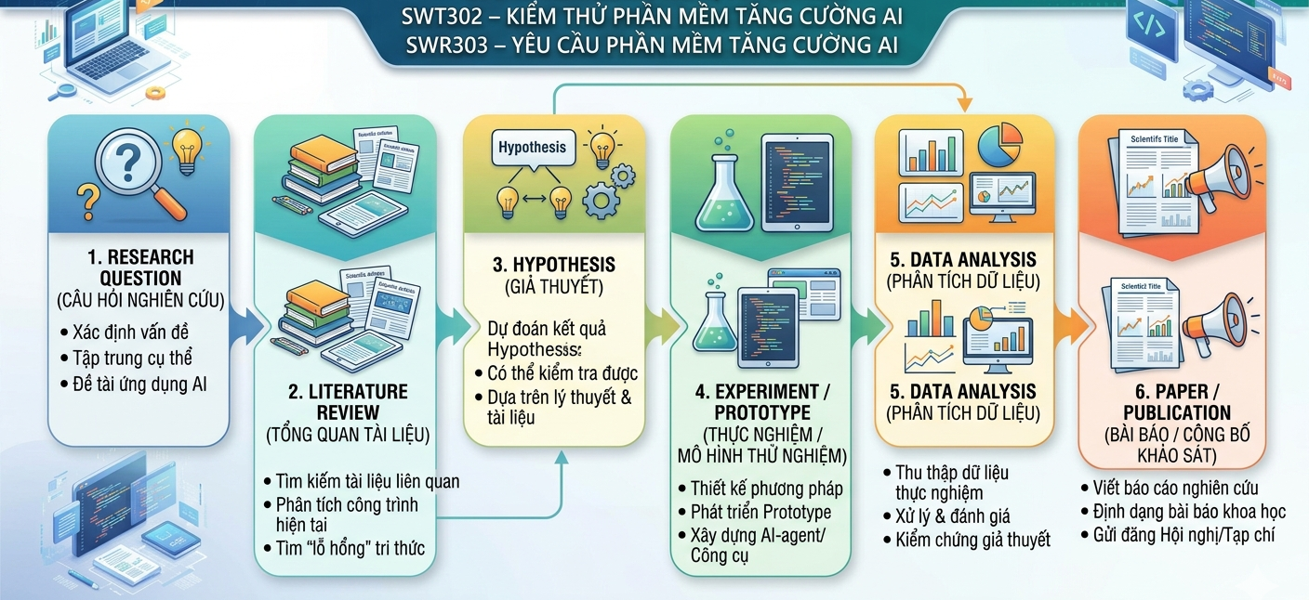

- RBL Assessment Plan (10 Weeks)
Kế hoạch thực hiện đánh giá RBL mang tính tham khảo, quý thầy cô khi triển khai có thể linh hoạt. Tuy nhiên, trọng số đánh giá Total Score sẽ thống nhất chung.
Phase | Week | Main Activities | Deliverables | Assessment Criteria (Rubric) | Weight
Phase 1  Research Question | 1 | Problem identification, domain selection | D1. Problem Statement  (1 - 2 pages) | Problem relevance (5%)  Problem clarity (5%) | 10%
 | 2 | Search papers, identify research gap | D2. Initial Paper Collection Sheet  (15–20 papers) | Search strategy (5%)  Paper relevance (5%) | 10%
 | 3 | Formulate research | D3. Research Proposal v1  (RQ + motivation + gap) | RQ clarity (5%)  Research novelty (5%)  PICOC correctness (5%) | 15%
Phase 2  Literature Review | 4 | Paper screening using PRISMA | D4. PRISMA Screening Report | Inclusion/exclusion criteria (5%)  Screening consistency (5%) | 10%
 | 5 | Extract and compare studies | D5. Literature Matrix | Data extraction quality (5%)  Comparison accuracy (5%) | 10%
 | 6 - 7 | Thematic synthesis, gap identification | D6. Literature Review Report  (4 - 5 pages) | Synthesis quality (10%)  Critical analysis (10%)  Gap identification (5%) | 25%
Phase 3  Hypothesis | 8 | Variable definition | D7. Variable Definition Sheet | Variable correctness (5%)  Operational definition (5%) | 10%
 | 9 | Hypothesis formulation | D8. Hypothesis Statement | H0/H1 correctness (5%)  Testability (5%) | 10%
 | 10 | Experiment planning | D9. Research Proposal v2  (Methodology + hypothesis + metrics) | Experimental design (5%) (*)  Metric selection (5%)  Statistical plan (5%) | 15%
(*) Mặc dù chưa bước sang Experiment, ở phase Hypothesis sinh viên phải thiết kế trước cách kiểm định. Tùy thuộc vào team sinh viên mà quý thầy cô có thể cho thực hiện nội dung này.
Total Score Distribution
Assessment Component | Weight
Research Question | 35%
Literature Review | 45%
Hypothesis | 20%
Total | 100%

Đề xuất: Mapping to IEEE Paper Sections
Deliverable | Corresponding IEEE Section
D1-D3 | I. Introduction
D4-D6 | II. Relatsed Work
D7-D9 | III. Research Methodology

Papers tham khảo: tại đây

- Chi tiết
Architecture Decision Research: tức sinh viên không chỉ “thiết kế kiến trúc”, mà phải nghiên cứu và chứng minh tại sao kiến trúc A tốt hơn B trong một context cụ thể.
RBL Framework for Software Architecture & Design
Research Workflow
Problem Context
↓
Research Question
↓
Literature Review
↓
Architecture Hypothesis
↓
Architecture Prototype
↓
Architecture Evaluation
↓
Research Report / Paper

PHASE 1: Problem Context + Research Question
(Week 1–3)
Mục tiêu:
Xác định một architectural problem có tính nghiên cứu.
Week 1 - Domain Selection
Mỗi nhóm chọn một hệ thống thực tế.
Ví dụ:
- E-commerce platform
- Smart healthcare system
- Ride-sharing platform
- Online learning platform
- Banking system
- Game backend

Deliverable D1: Problem Context Document (2 pages)
Nội dung:
Business Context
Ví dụ:
Một nền tảng e-commerce có:
- 50,000 users/day
- flash sale events
- payment integration

Technical Challenges
Ví dụ:
- scalability
- fault tolerance
- deployment complexity
Quality Attributes
Dựa trên Software Architecture in Practice:
- performance
- scalability
- availability
- modifiability
- security

Week 2 - Research Question
Sinh viên chuyển business problem thành research question.
Example RQ 1
Can microservices architecture improve scalability compared with monolithic architecture for e-commerce systems?
Example RQ 2
Does event-driven architecture improve fault tolerance in IoT healthcare systems?
Example RQ 3
Can clean architecture reduce maintenance effort in mobile application development?
Deliverable D2
Research Proposal v1
Bao gồm:
- background
- problem
- RQ

PHASE 2 - Literature Review
(Week 4–6)
Mục tiêu:
Sinh viên tìm evidence.
Week 4
Sinh viên tìm papers từ:
- IEEE
- ACM
- Google Scholar

Example search strings
Microservices
("microservices")
AND
("software architecture")
AND
("scalability")

Event-driven
("event driven architecture")
AND
("software architecture")

Clean Architecture
("clean architecture")
AND
("maintainability")

Deliverable D3
Paper Collection Sheet
20 papers.
Week 5-6
Sinh viên phân tích:
Architecture styles
Ví dụ:
- Layered Architecture
- Microservices
- Event-Driven
- Hexagonal
- CQRS
Quality attributes
- latency
- throughput
- maintainability
- deployment complexity

Deliverable D4
Literature Review Report
(4–5 pages)

PHASE 3 - Architecture Hypothesis
(Week 7–8)
Mục tiêu:
Sinh viên đưa ra giả thuyết kiến trúc.
Example
RQ:
Can microservices improve scalability?

H0:
No significant difference exists between monolithic and microservices architecture in system scalability.

H1
Microservices architecture significantly improves system scalability compared with monolithic architecture.

Variables
Independent Variable
Architecture style:
- Monolith
- Microservices

Dependent Variables
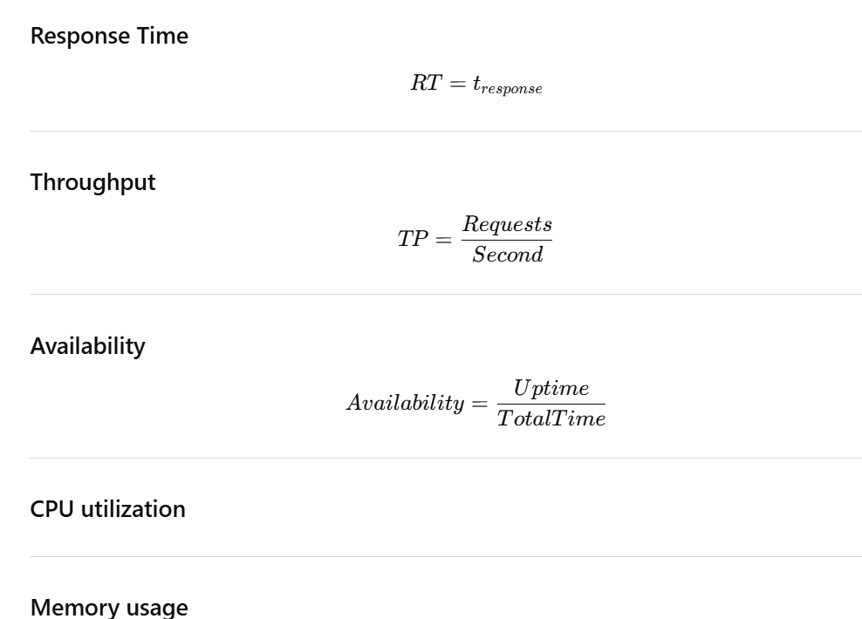

Deliverable D5
Hypothesis Report

PHASE 4 - Architecture Prototype
(Week 9–11)
Mục tiêu:
Prototype 2 architectural alternatives.

Example
Prototype A
Monolithic
Tools:
- ASP.NET Core
- Spring Boot

Prototype B
Microservices
Tools:
- Docker
- Kubernetes

Deliverable D6
Architecture Prototype

PHASE 5 - Architecture Evaluation
(Week 12–13)
Mục tiêu:
Đo quality attributes.
Performance testing
Ví dụ với:
- Apache JMeter
Architecture review

Deliverable D7
Evaluation Report

PHASE 6 - Research Report / Paper
(Week 14–15)
Sinh viên viết paper.
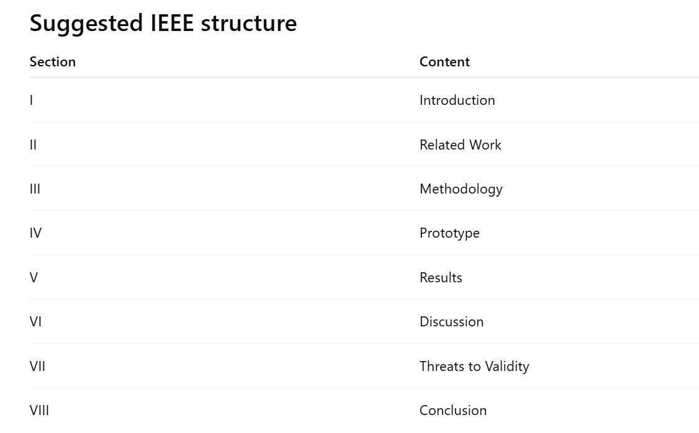

- Ví dụ cụ thể
Topic: Can Microservices Architecture Improve Scalability Compared with Monolithic Architecture in E-Commerce Systems?
Example RBL Project: Software Architecture & Design
Project Title:
An Empirical Comparison Between Monolithic and Microservices Architecture for E-Commerce Scalability

Business Context
Một công ty thương mại điện tử đang gặp vấn đề khi tổ chức:
Flash Sale Campaign
Hệ thống hiện tại có:
- 20,000 users/day
- peak traffic during promotions
- payment processing
- inventory synchronization

Current Problems
Khi số lượng user tăng cao:
- response time tăng
- checkout bị timeout
- deployment downtime
- difficult maintenance

Business Goal
Công ty muốn biết:
Có nên chuyển từ monolithic architecture sang microservices architecture hay không?
Phase 1 - Research Question
(Week 1–2)
Step 1: Problem Identification
Nhóm xác định:
Functional Requirements
Ví dụ:
- User can browse products.
- User can place orders.
- User can pay online.

Non-functional Requirements
Ví dụ:
- Support 1000 concurrent users.
- Response time < 2 seconds.
- Availability > 99%.

Step 2: Quality Attributes
Dựa trên Software Architecture in Practice
Nhóm chọn:
- scalability
- performance
- availability

Step 3: Research Question
RQ1: Can microservices architecture improve scalability compared with monolithic architecture in e-commerce systems?

Deliverable 1
Research Proposal v1

Example content
Problem Statement
E-commerce systems often experience performance degradation during high-traffic events.
Motivation
Architecture selection directly affects scalability.
Research Question
RQ1.

Phase 2 - Literature Review
(Week 3–4)
Step 1: Search Strategy
Sinh viên tìm papers trên:
- IEEE
- ACM
- Google Scholar
Search String
("microservices")
AND
("monolithic")
AND
("scalability")
AND
("software architecture")
Selected Papers
Ví dụ 7 papers.
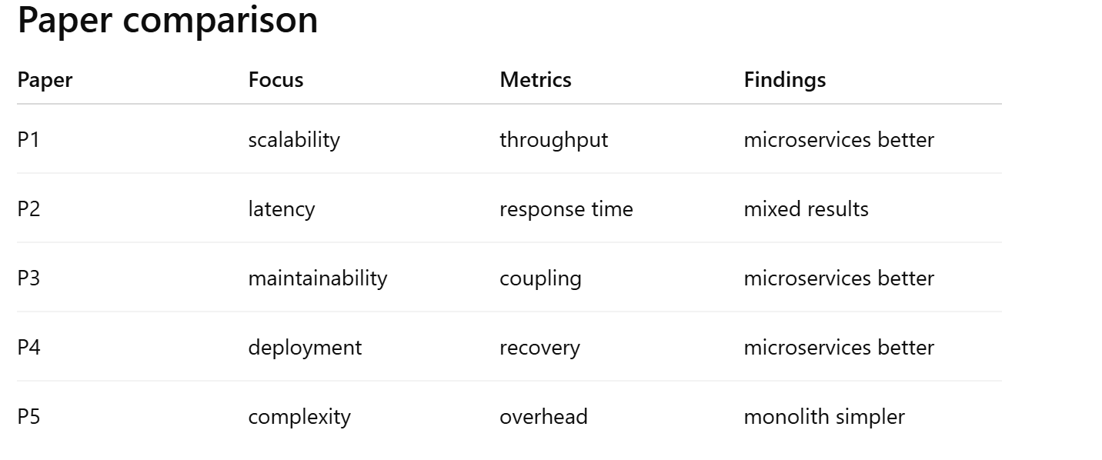
Research Gap
Nhóm viết:
Existing studies mainly focus on industrial systems. Few studies evaluate scalability differences using student-built prototypes in educational settings.

Deliverable 2: Literature Review Report

Phase 3: Hypothesis
(Week 5–6)
Variables:
Independent Variable
Architecture Style
2 levels:
- Monolithic
- Microservices
Dependent Variables
Response Time
(ms)
Throughput
(requests/second)
CPU Usage
(%)
Error Rate
(%)
Hypotheses
H0: No significant scalability difference exists between monolithic and microservices architectures.
H1: Microservices architecture significantly improves scalability compared with monolithic architecture.

Experimental Design
Dataset
1000 simulated requests.
Load levels
- 100 users
- 500 users
- 1000 users

Deliverable 3: Hypothesis Report

Phase 4 - Prototype
(Week 7–8)
Prototype A
Monolithic
Modules:
Product Module
Order Module
Payment Module
Architecture Diagram
Client
↓
Monolithic Application
↓
Single Database

Prototype B
Microservices
Services:
Product Service
Order Service
Payment Service
Architecture Diagram
Client
↓
API Gateway
↓
Product Service
Order Service
Payment Service
Recommended tools
- ASP.NET Core
- Docker

Deliverable 4: Source Code + Deployment Guide

Phase 5: Evaluation
(Week 9)
Tool
Apache JMeter
Test Plan

Scenario 1
100 users.
Scenario 2
500 users.
Scenario 3
1000 users.
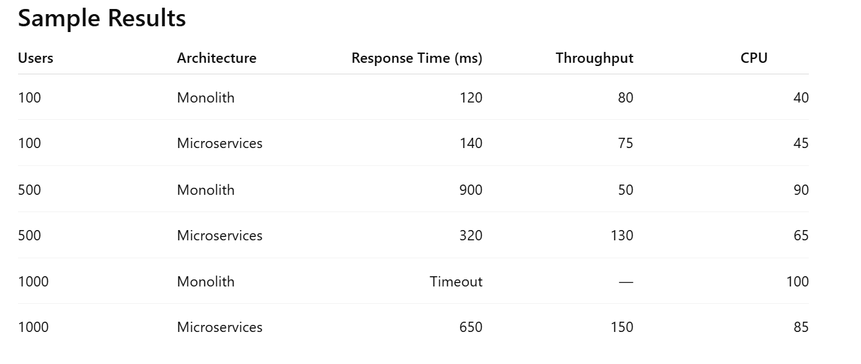
Interpretation
Nhóm viết: Microservices showed better scalability under medium and high workloads, although monolithic architecture performed slightly better under low traffic.
Deliverable 5: Evaluation Report

Phase 6: Mini Paper
(Week 10)
IEEE Structure
I. Introduction
Problem.
II. Related Work
7 papers.
III. Methodology
Variables + hypothesis.
IV. Prototype
Architecture.
V. Results
Tables + charts.
VI. Discussion
Trade-offs.
VII. Conclusion

