Họ và tên: Lương Cao Pháp - 24521288
ASSIGNMENT 1
6.2, 6.3, 6.7, 6.8, 6.9, 6.10, 6.11 (English texthook)
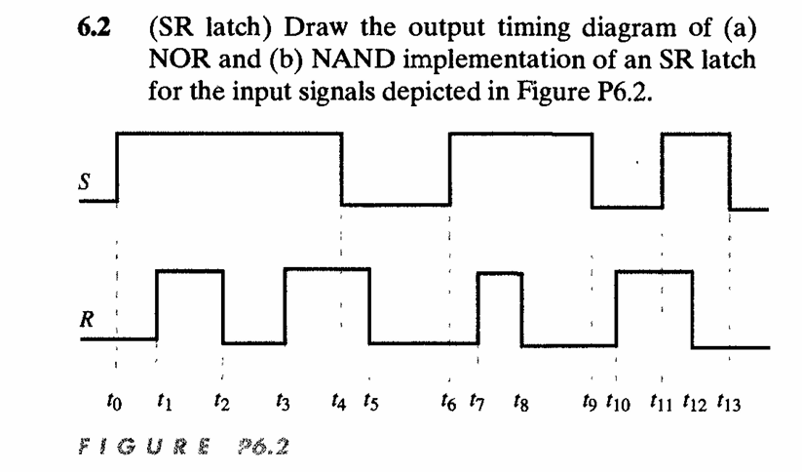

Solution:
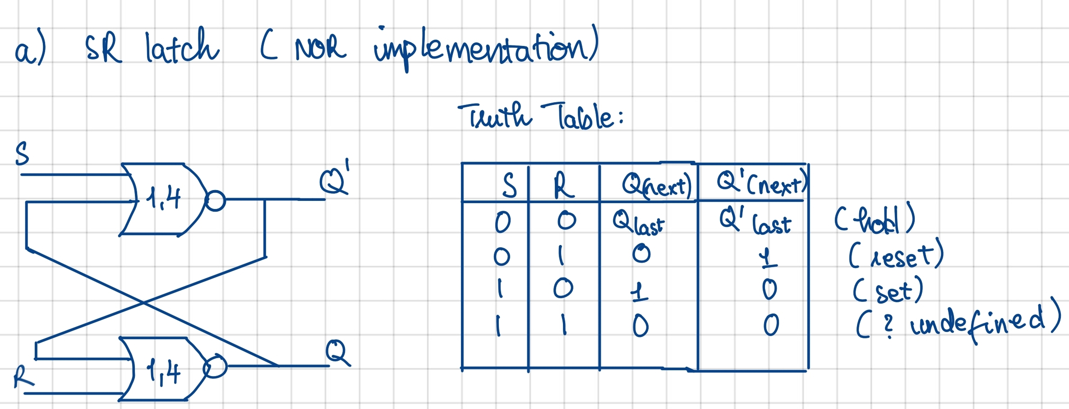
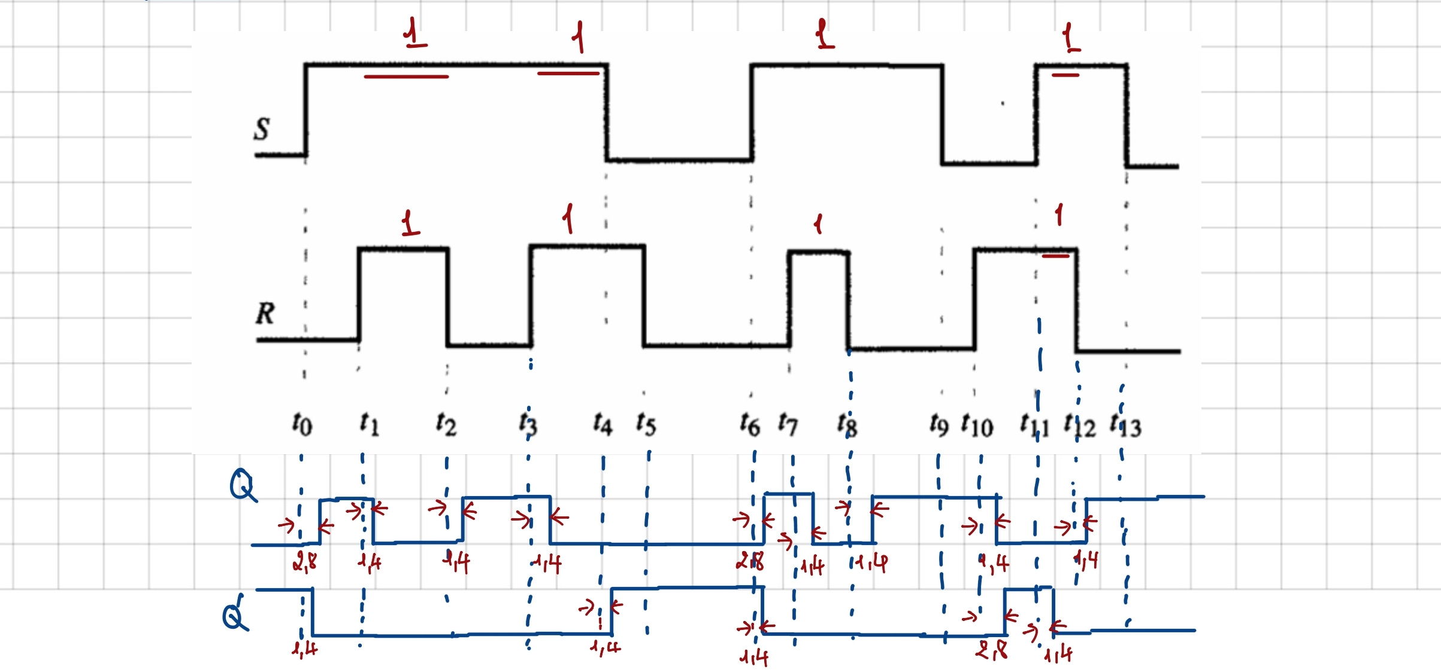
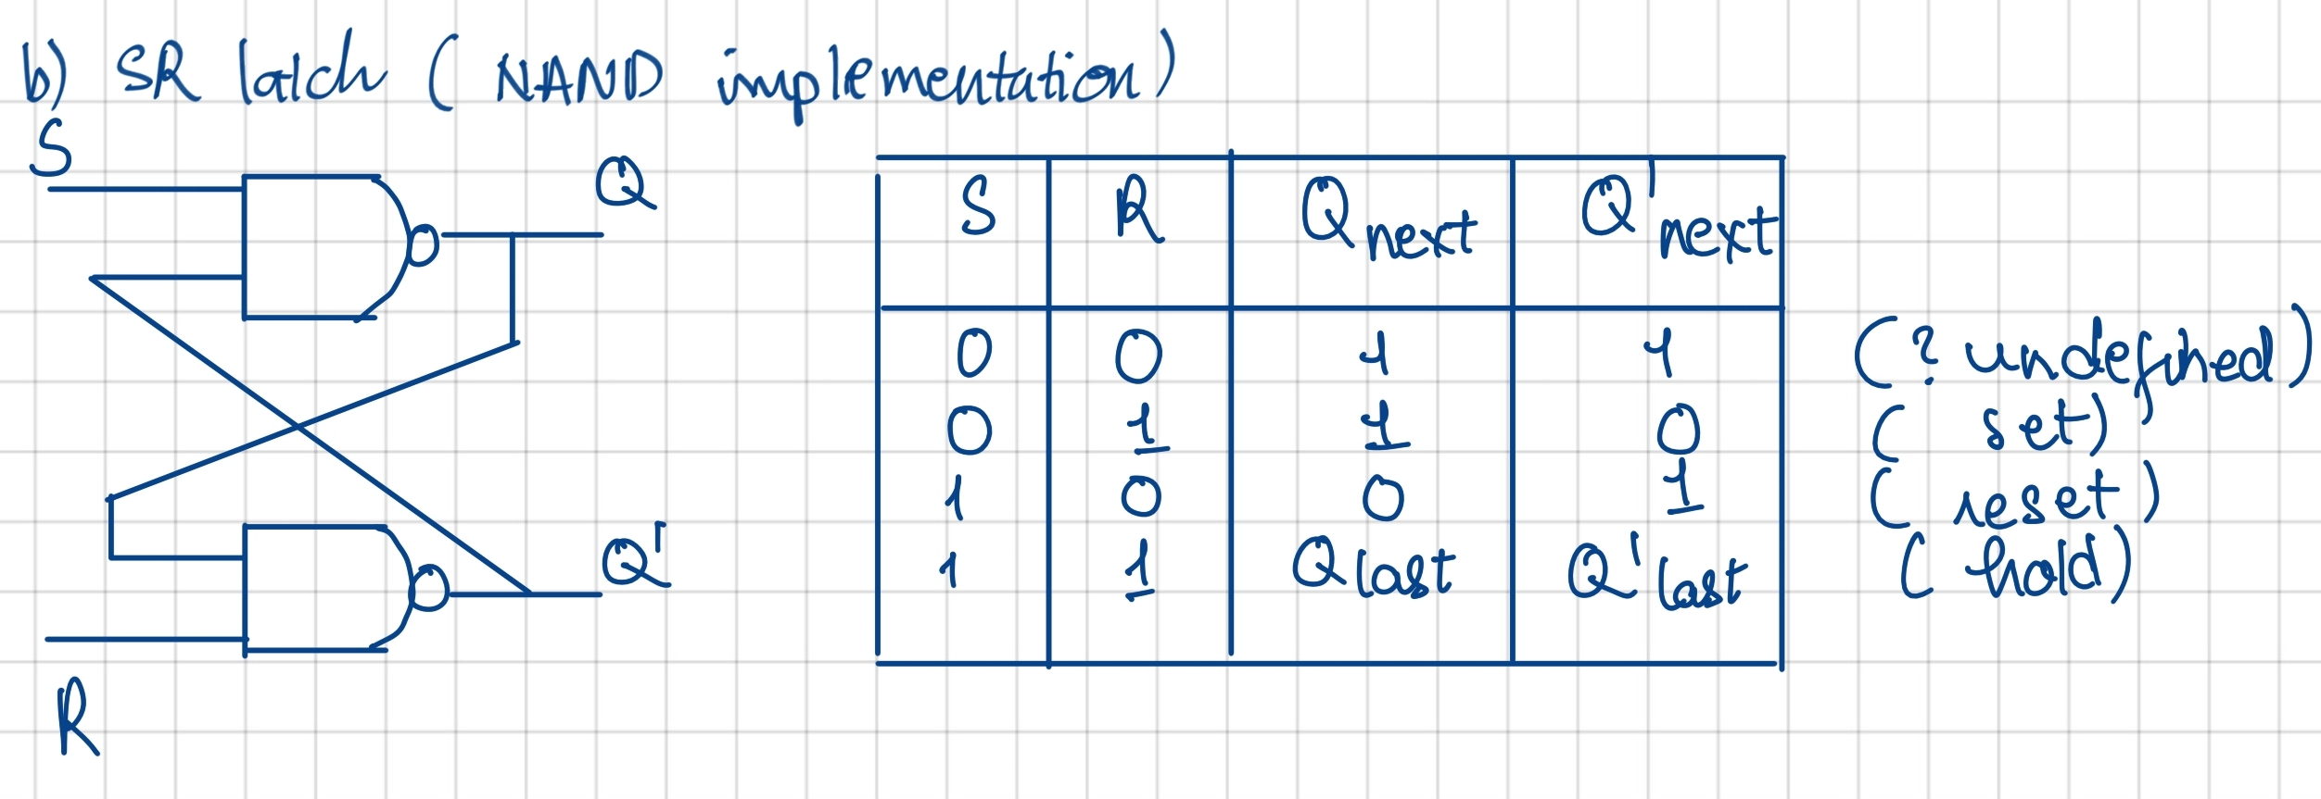
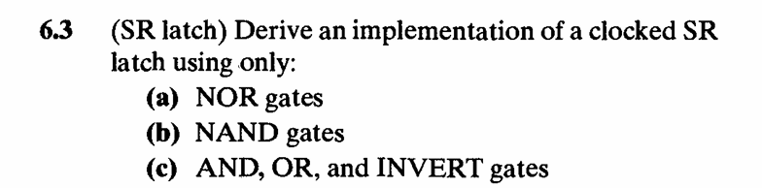
Solution:
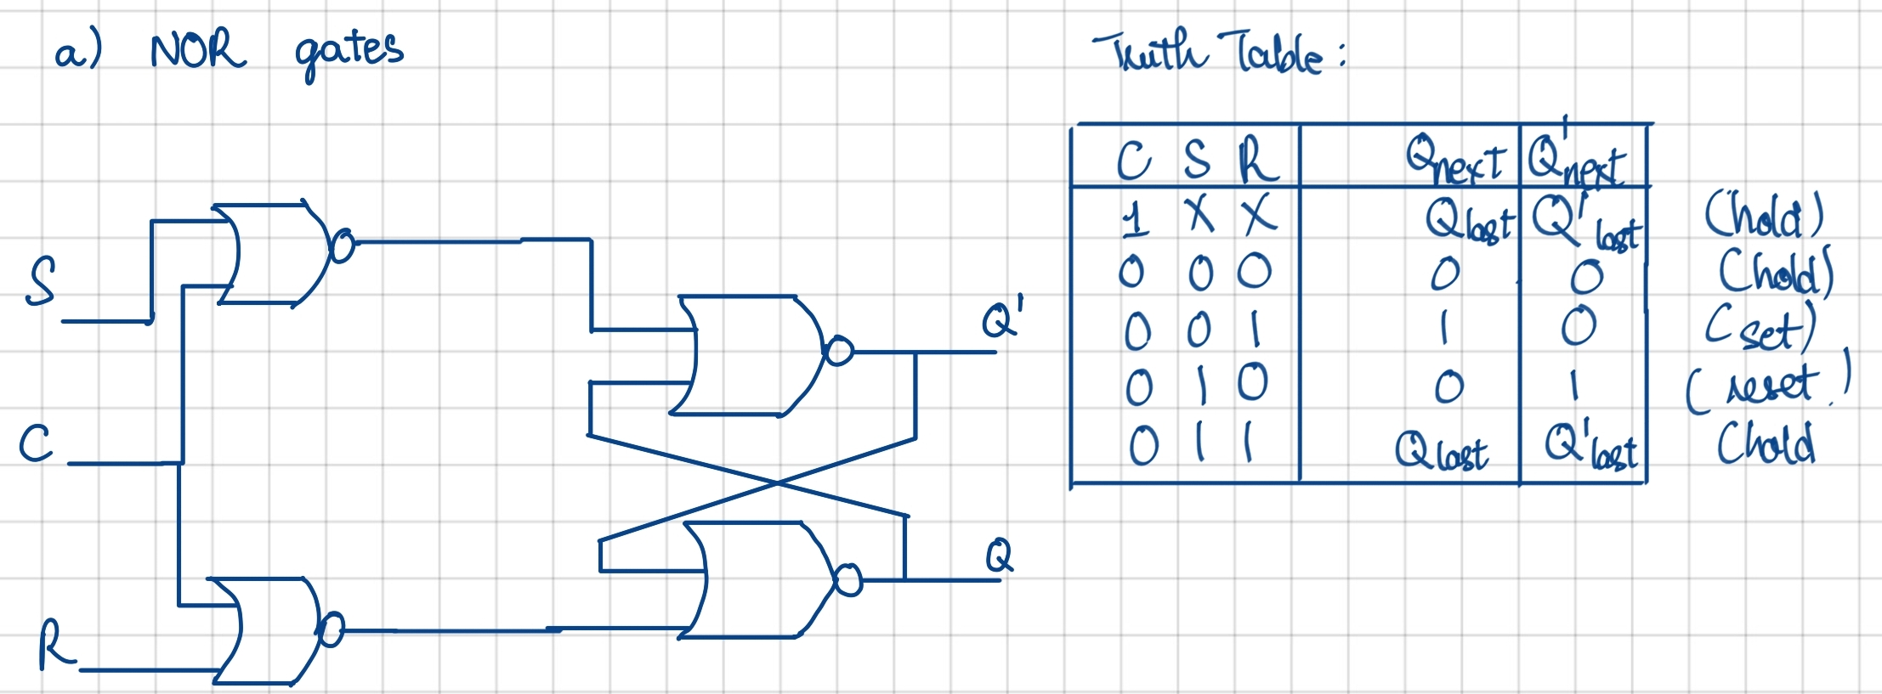
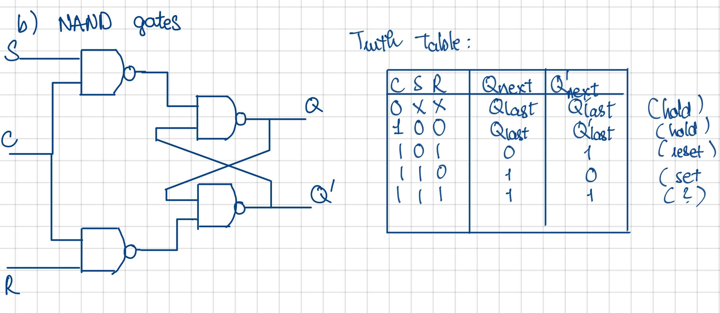
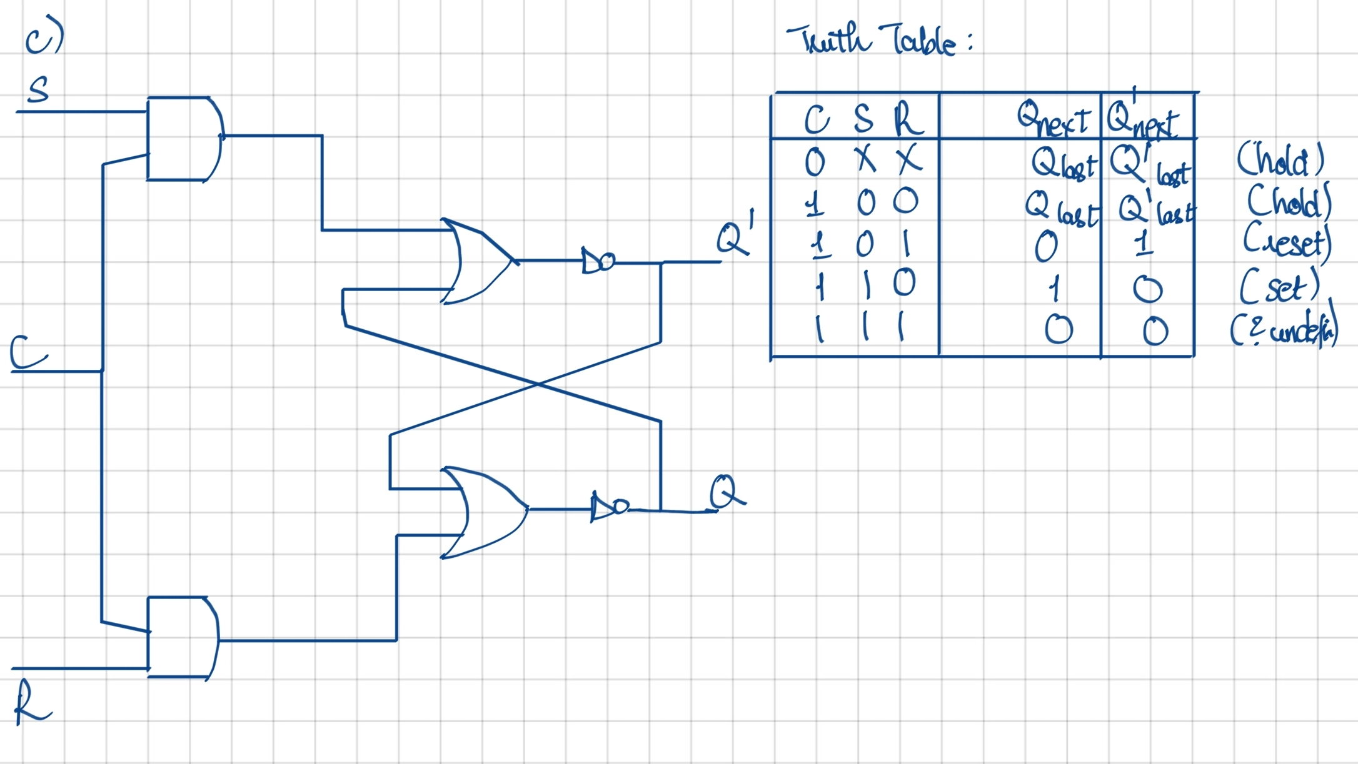
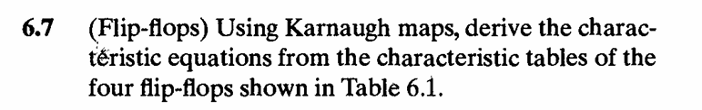
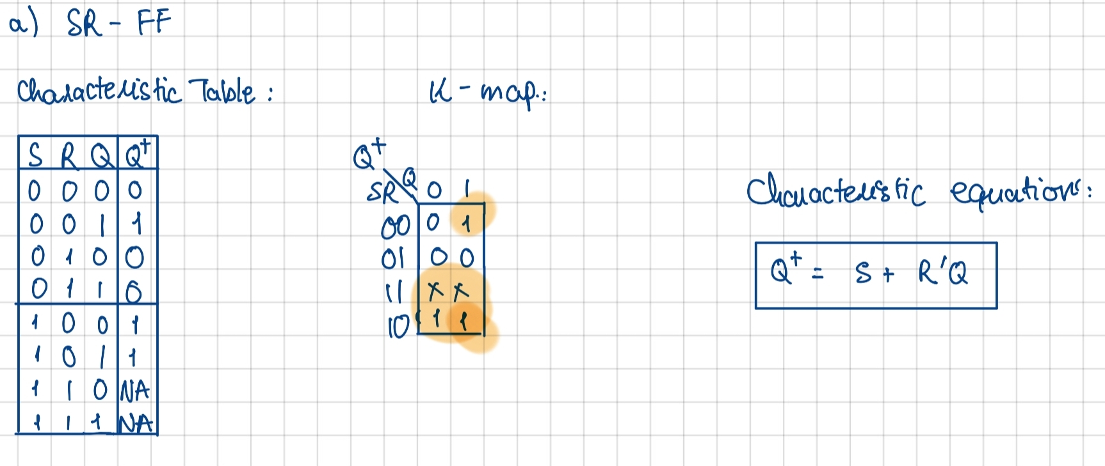
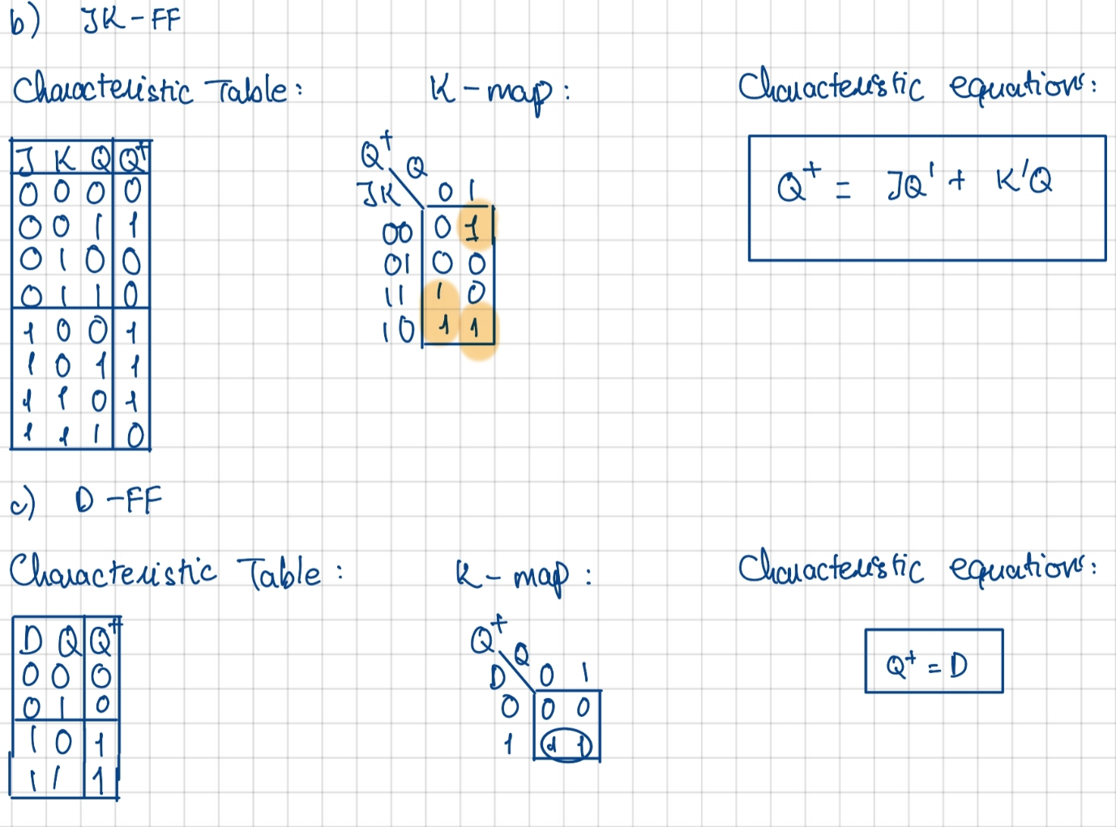
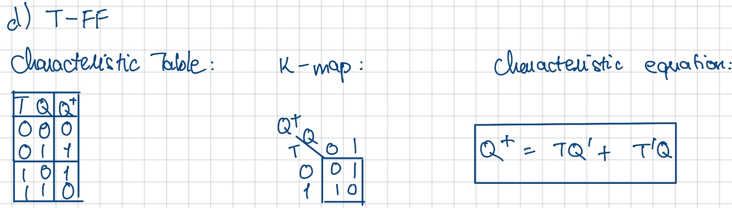

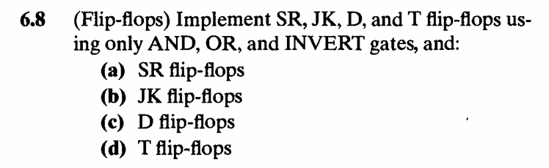
Solutions:
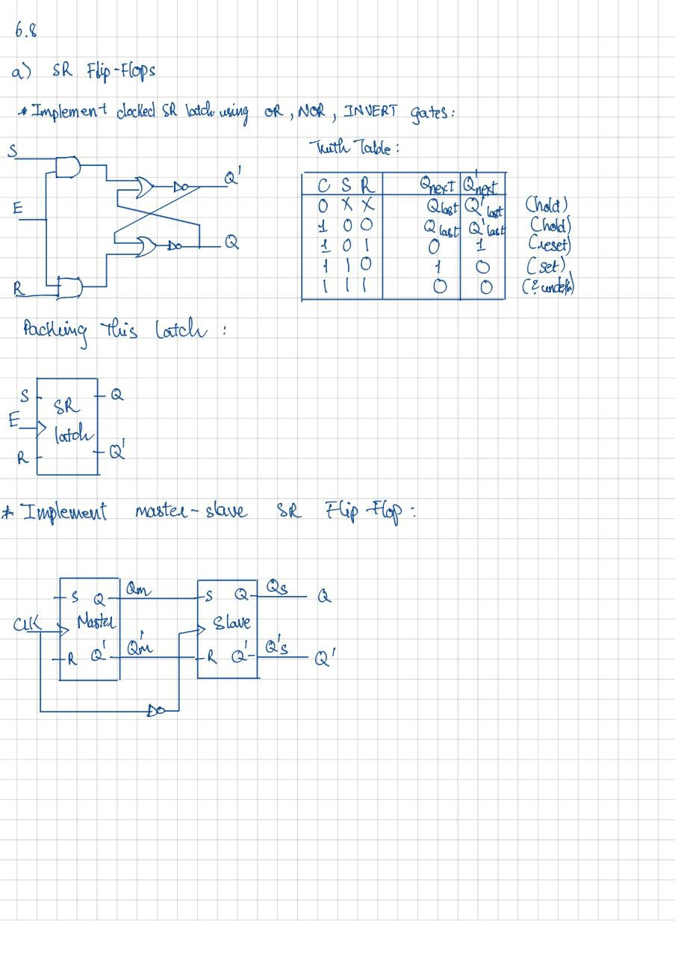

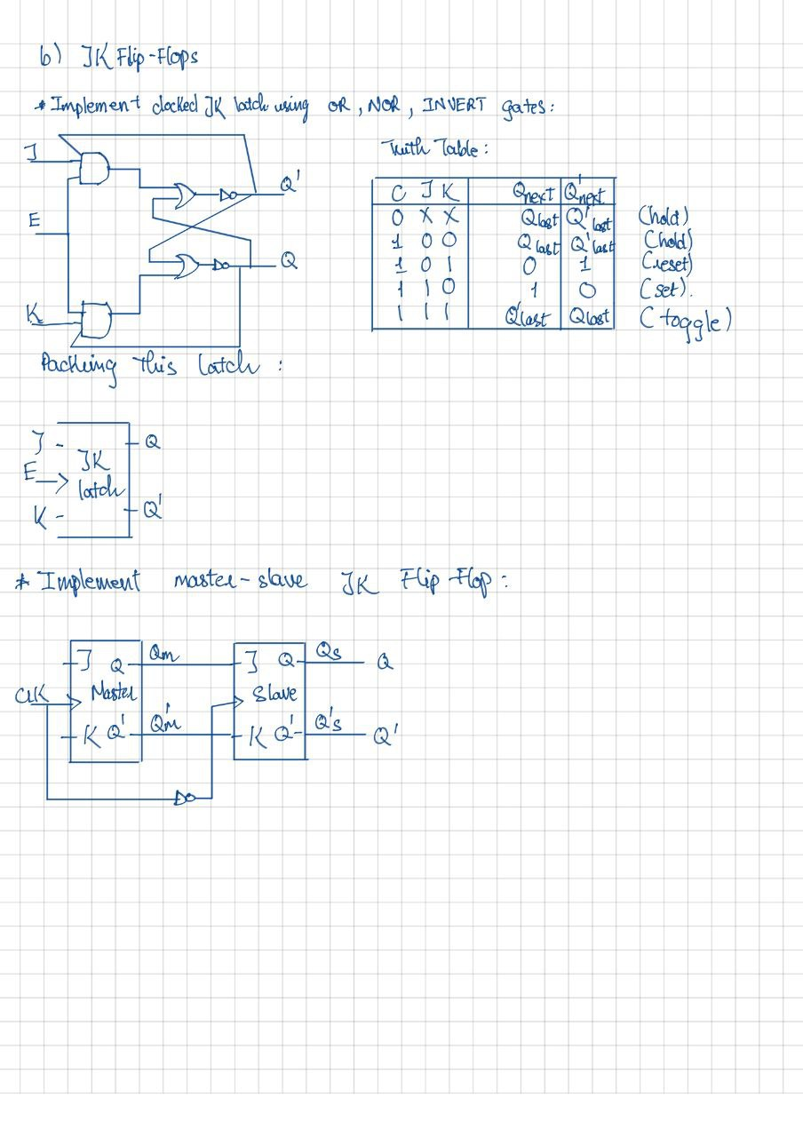
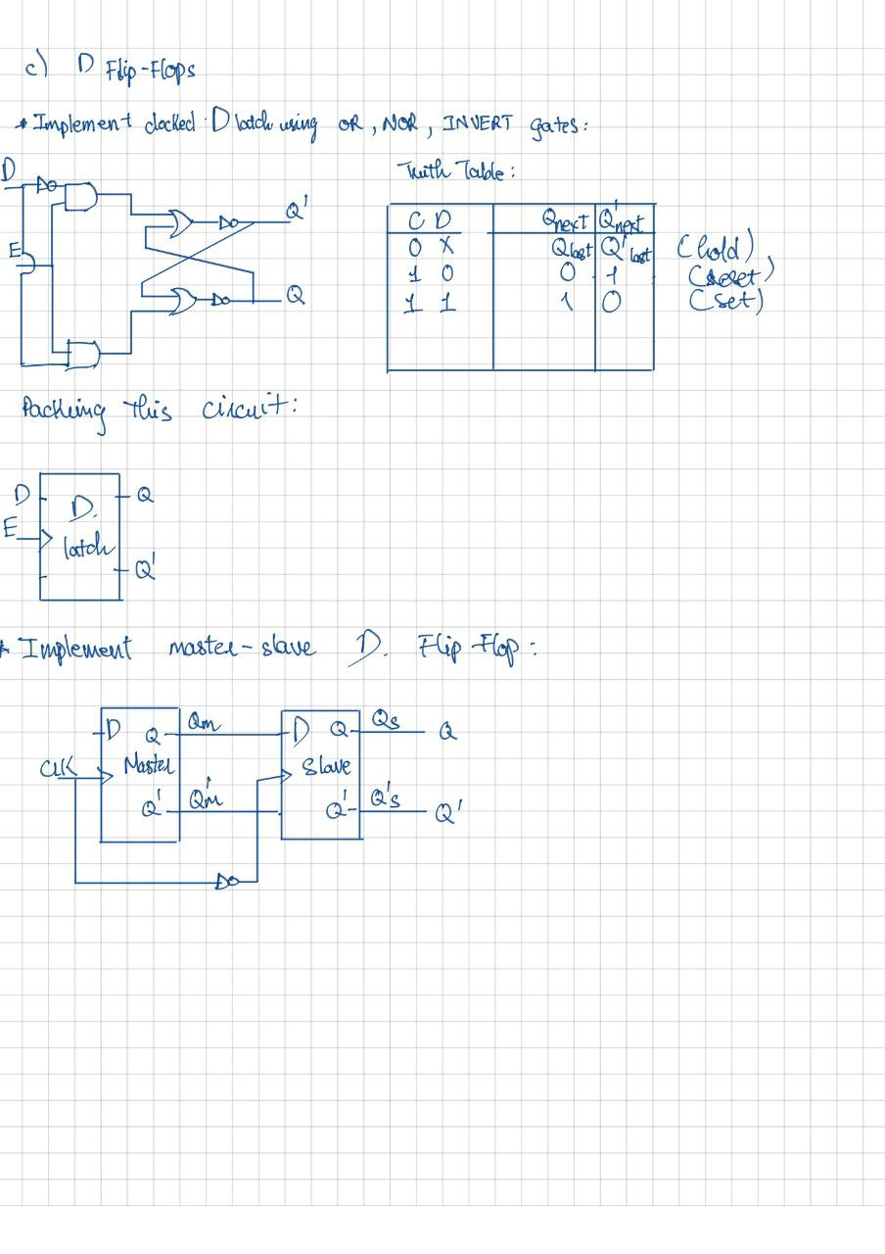

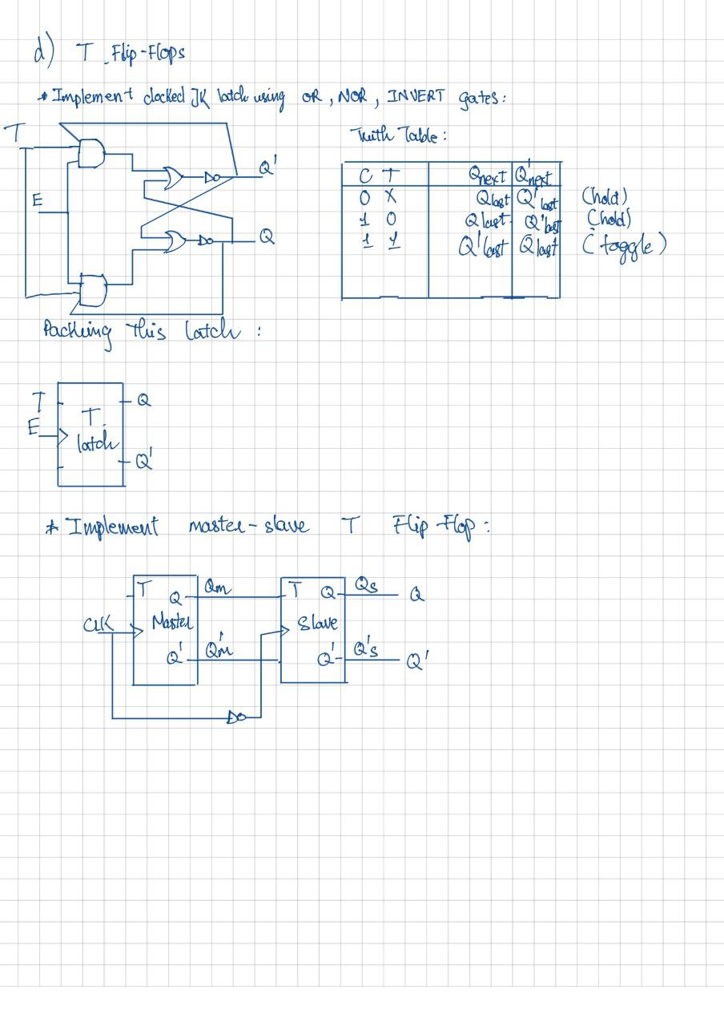
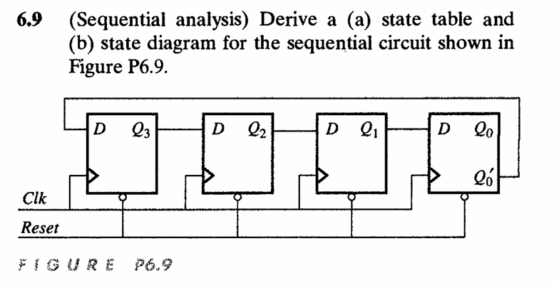
Solutions:
- Excitation Equations:
$$D_{3}={Q^{'}}_{0}$$
$$D_{2}= Q_{3}$$
$$D_{1}= Q_{2}$$
$$D_{0}= Q_{1}$$
State Table:
$$Q_{3}$$ | $$Q_{2}$$ | $$Q_{1}$$ | $$Q_{0}$$ | $$D_{3}$$ | $$D_{2}$$ | $$D_{1}$$ | $$D_{0}$$ | $$Q_{3}^{+}$$ | $$Q_{2}^{+}$$ | $$Q_{1}^{+}$$ | $$Q_{0}^{+}$$
0 | 0 | 0 | 0 | 1 | 0 | 0 | 0 | 1 | 0 | 0 | 0
0 | 0 | 0 | 1 | 0 | 0 | 0 | 0 | 0 | 0 | 0 | 0
0 | 0 | 1 | 0 | 1 | 0 | 0 | 1 | 1 | 0 | 0 | 1
0 | 0 | 1 | 1 | 0 | 0 | 0 | 1 | 0 | 0 | 0 | 1
0 | 1 | 0 | 0 | 1 | 0 | 1 | 0 | 1 | 0 | 1 | 0
0 | 1 | 0 | 1 | 0 | 0 | 1 | 0 | 0 | 0 | 1 | 0
0 | 1 | 1 | 0 | 1 | 0 | 1 | 1 | 1 | 0 | 1 | 1
0 | 1 | 1 | 1 | 0 | 0 | 1 | 1 | 0 | 0 | 1 | 1
1 | 0 | 0 | 0 | 1 | 1 | 0 | 0 | 1 | 1 | 0 | 0
1 | 0 | 0 | 1 | 0 | 1 | 0 | 0 | 0 | 1 | 0 | 0
1 | 0 | 1 | 0 | 1 | 1 | 0 | 1 | 1 | 1 | 0 | 1
1 | 0 | 1 | 1 | 0 | 1 | 0 | 1 | 0 | 1 | 0 | 1
1 | 1 | 0 | 0 | 1 | 1 | 1 | 0 | 1 | 1 | 1 | 0
1 | 1 | 0 | 1 | 0 | 1 | 1 | 0 | 0 | 1 | 1 | 0
1 | 1 | 1 | 0 | 1 | 1 | 1 | 1 | 1 | 1 | 1 | 1
1 | 1 | 1 | 1 | 0 | 1 | 1 | 1 | 0 | 1 | 1 | 1

- State diagram
$$Q_{3}Q_{2}Q_{1}Q_{0} \\ =1110$$

$$Q_{3}Q_{2}Q_{1}Q_{0} \\ =1100$$

$$Q_{3}Q_{2}Q_{1}Q_{0} \\ =1000$$

$$Q_{3}Q_{2}Q_{1}Q_{0} \\ =0000$$

$$Q_{3}Q_{2}Q_{1}Q_{0} \\ =1111$$

$$Q_{3}Q_{2}Q_{1}Q_{0} \\ =0111$$

$$Q_{3}Q_{2}Q_{1}Q_{0} \\ =0011$$

$$Q_{3}Q_{2}Q_{1}Q_{0} \\ =0001$$

$$Q_{3}Q_{2}Q_{1}Q_{0} \\ =0010$$

$$Q_{3}Q_{2}Q_{1}Q_{0} \\ =1001$$

$$Q_{3}Q_{2}Q_{1}Q_{0} \\ =0100$$

$$Q_{3}Q_{2}Q_{1}Q_{0} \\ =1010$$

$$Q_{3}Q_{2}Q_{1}Q_{0} \\ =0101$$

$$Q_{3}Q_{2}Q_{1}Q_{0} \\ =1011$$

$$Q_{3}Q_{2}Q_{1}Q_{0} \\ =0110$$

$$Q_{3}Q_{2}Q_{1}Q_{0} \\ =1101$$

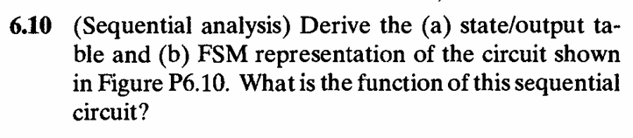
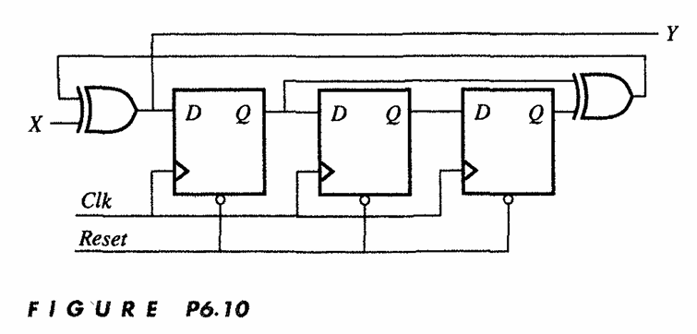

Solutions:
- Excitation Equations:
$$Y={X ⊕ Q}_{0}⊕ Q_{2}$$
$$D_{2}=Q_{0} ⊕ Q_{2}$$
$$D_{1}= Q_{2}$$
$$D_{0}= Q_{1}$$

State Table:
Reset | $$Q_{2}$$ | $$Q_{1}$$ | $$Q_{0}$$ | $$D_{2}$$ | $$D_{1}$$ | $$D_{0}$$ | $$Q_{2}^{+}$$ | $$Q_{1}^{+}$$ | $$Q_{0}^{+}$$ | Y
 |  |  |  |  |  |  |  |  |  | X = 0 | X =1
0 | 0 | 0 | 0 | 0 | 0 | 0 | 0 | 0 | 0 | 0 | 1
1 | 0 | 0 | 0 | 0 | 0 | 0 | 0 | 0 | 0 | 0 | 1
1 | 0 | 0 | 1 | 1 | 0 | 0 | 1 | 0 | 0 | 1 | 0
1 | 0 | 1 | 0 | 0 | 0 | 1 | 0 | 0 | 1 | 0 | 1
1 | 0 | 1 | 1 | 1 | 0 | 1 | 1 | 0 | 1 | 1 | 0
1 | 1 | 0 | 0 | 1 | 1 | 0 | 1 | 1 | 0 | 1 | 0
1 | 1 | 0 | 1 | 0 | 1 | 0 | 0 | 1 | 0 | 0 | 1
1 | 1 | 1 | 0 | 1 | 1 | 1 | 1 | 1 | 1 | 1 | 0
1 | 1 | 1 | 1 | 0 | 1 | 1 | 0 | 1 | 1 | 0 | 1
1 | 0 | 0 | 0 | 0 | 0 | 0 | 0 | 0 | 0 | 0 | 1
1 | 0 | 0 | 1 | 1 | 0 | 0 | 1 | 0 | 0 | 1 | 0
1 | 0 | 1 | 0 | 0 | 0 | 1 | 0 | 0 | 1 | 0 | 1
1 | 0 | 1 | 1 | 1 | 0 | 1 | 1 | 0 | 1 | 1 | 0
1 | 1 | 0 | 0 | 1 | 1 | 0 | 1 | 1 | 0 | 1 | 0
1 | 1 | 0 | 1 | 0 | 1 | 0 | 0 | 1 | 0 | 0 | 1
1 | 1 | 1 | 0 | 1 | 1 | 1 | 1 | 1 | 1 | 1 | 0
1 | 1 | 1 | 1 | 0 | 1 | 1 | 0 | 1 | 1 | 0 | 1

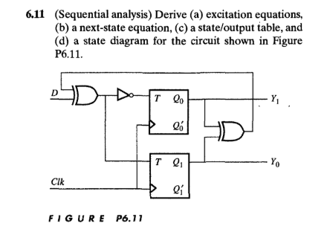
Solution:
- Excitation equations:
$$T_{0}=\overline{D⊕( Q_{0 }⊕ Q_{1})}$$
$$T_{1}=D⊕\left( Q_{0 }⊕ Q_{1}\right)= \overline{T_{0}}$$
$$Y_{1}{=Q}_{0}$$
$$Y_{0}{=Q}_{1}$$
- Next-State equation:
$$Q_{0}^{+}{={T'}_{0}Q}_{0}+{T_{0}Q'}_{0}$$
$$Q_{1}^{+}{={T'}_{1}Q}_{1}+{T_{1}Q'}_{1}$$
- State/Output Table:
$$D$$ | $$Q_{1}$$ | $$Q_{0}$$ | $$T_{1}$$ | $$T_{0}$$ | $$Q_{1}^{+}$$ | $$Q_{0}^{+}$$ | $$Y_{0}{=Q}_{1}$$ | $$Y_{1}{=Q}_{0}$$
0 | 0 | 0 | 0 | 1 | 0 | 1 | 0 | 0
0 | 1 | 0 | 1 | 0 | 0 | 0 | 1 | 0
0 | 0 | 1 | 1 | 0 | 1 | 1 | 0 | 1
0 | 1 | 1 | 0 | 1 | 1 | 0 | 1 | 1
1 | 0 | 0 | 1 | 0 | 1 | 0 | 0 | 0
1 | 1 | 0 | 0 | 1 | 1 | 1 | 1 | 0
1 | 0 | 1 | 0 | 1 | 0 | 0 | 0 | 1
1 | 1 | 1 | 1 | 0 | 0 | 1 | 1 | 1

