**Project**

**LockedMe.com**

***Developer: Sandeep Pharande***

***Email: pharandess@gmail.com***

***Date: 15-Aug-2020***

Contents

1. Revision History 2

2. Project Description 2

3. Algorithm and flow chart of application. 2

4. Sprint Planning 6

5. Concepts used in the project 8

6. Application work flow screen shots. 9

7. GIT Repository details. 14

# Revision History

|  |  |  |  |
| --- | --- | --- | --- |
| Version | Date | Author | Description |
| 1.0 | 15-Aug-2020 | Sandeep Pharande | Initial version |

# Project Description

The LockedMe.com project allows users to manage the files on the operating system through user interaction. The application presents user with option to list the files, add files, remove file and search files. User can perform the operation of his choice and exit application. Application is developed using core java programming language and user interaction will be via command prompt.

Project is developed using agile framework to deliver the product incrementally.

# Algorithm and flow chart of application.

Flow chat of application is presented in below diagram.

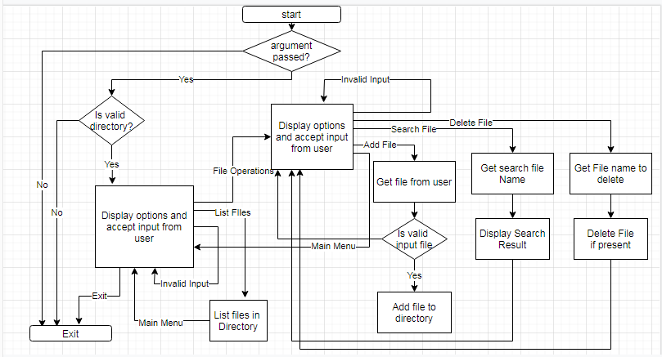

Pseudo code for the application is as below

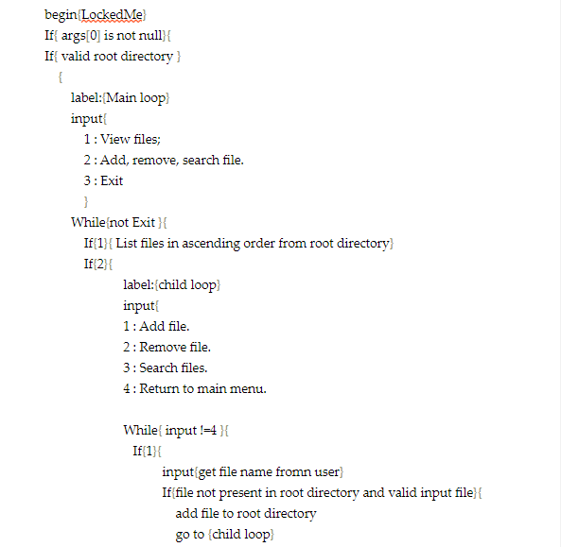

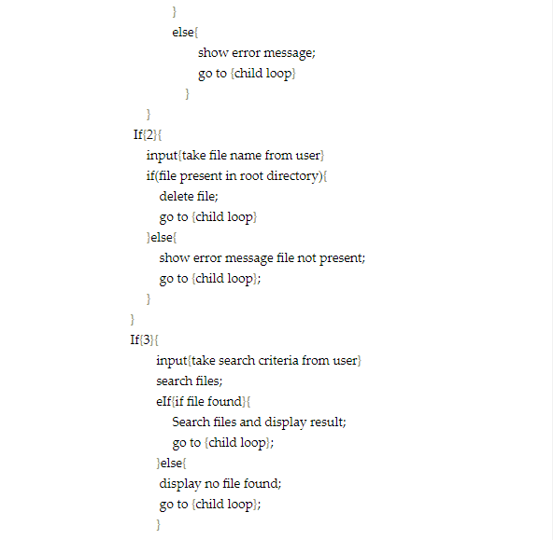

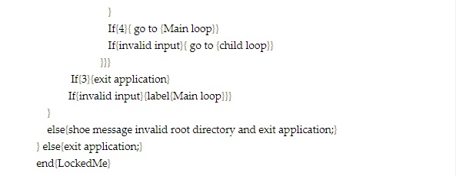

# Sprint Planning

**Sprint 1**

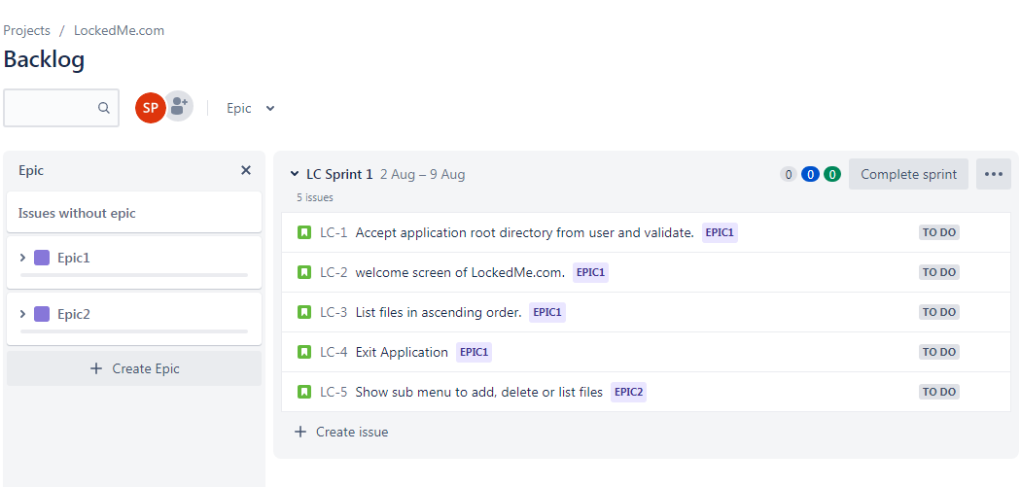

**Stories included in the Sprint 1**

1. Accept application root directory from user and validate.
2. Welcome screen of LockedMe.com.
3. List files in ascending order.
4. Exit Application.
5. Show sub menu to add, delete or list files.

**Sprint 2**

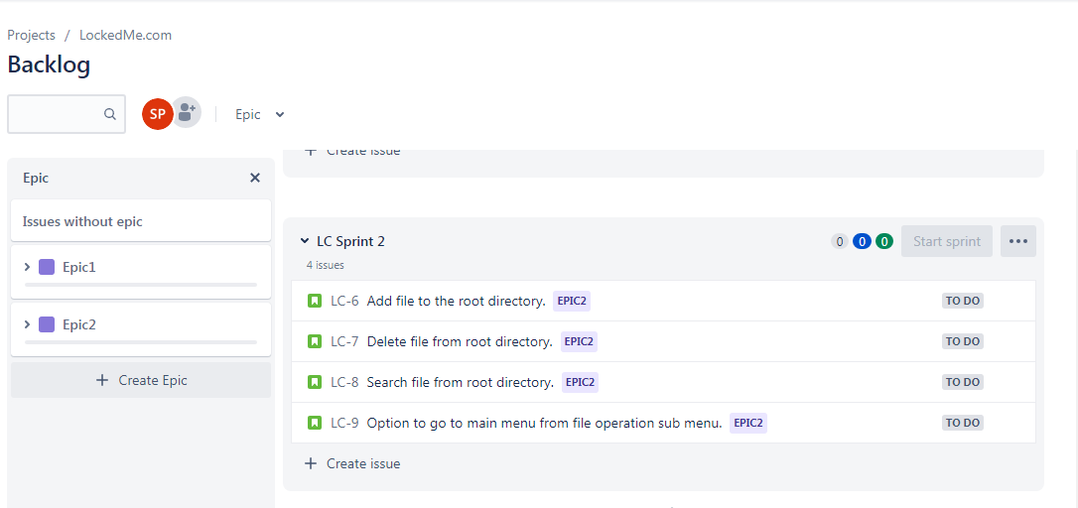

**Stories included in Sprint 2**

1. Add file to the root directory.
2. Delete file from root directory.
3. Search file from root directory.
4. Option to go to main menu from file operation sub menu.

# Concepts used in the project

This section describes concepts used in the project LockecMe.com

1. Objects and classes.

Oops concept‘s such as object and classed used in the project to write the logic.

1. Enum.

Enum are used to define the constants. Enum are used in the switch case to perform actions based on the user input. User input is converted into the Enum and used in the switch statement.

1. Exception handling.

Exception handling is used at various places in order for the program not to through exception and terminates unexpectedly. While taking input from the user exception handling is used to handle invalid input. While performing file operations such as reading file, deleting file exceptions are handled.

1. Collections.

Collections are used to store the files present in the directories. Collections method are used to perform operation like sorting files in the ascending order. Collections addAll method is used append array result in to collection.

1. Scanner.

Scanner utility is used to take various inputs from the user.

1. Queue data structure.

While searching files in the directories and sub directories Queue data structure is used to store the directories. Once the files are listed from the directory its entry is removed from queue and sub directories are added to queue. This process repeated until all the files in the subdirectories are listed.

1. Static methods and static variables.

Public static main is used to initiate the program. Static variable is used to store the root directory which is shared by the all application methods.

1. File operations, input stream and output stream.

File I/O features of the java are used to perform various activities like adding, deleting, searching files from root directory.

1. Packages.

The source code is packaged into the package.

1. Conditional statements and flow control statements.

Conditional statement and flow structure are used to control the flow of application and perform various actions based on user input. IF ELSE, WHILE LOOP, SWITCH STATEMENT are some of the examples.

1. Wrapper Classes.

Wrapper classed are used in the application to convert user input to the correct datatype.

1. Access modifiers.

Access modifiers are used to control the access of data members of the class. Public setter and getter method are provided to perform action on the data members

1. Arrays.

Arrays are used in the applications to store file from the directories.

# Application work flow screen shots.

**Launch Application**

While launching application provide the root directory as input argument.

**If correct operating path is provided then launch application and show options of users**

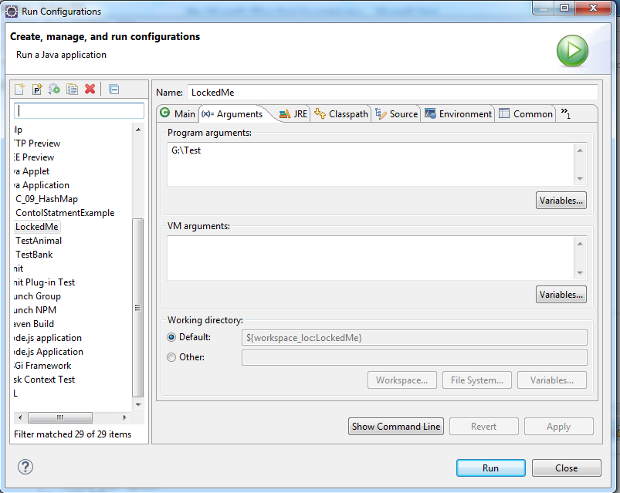

**If incorrect path is provided then application exit**

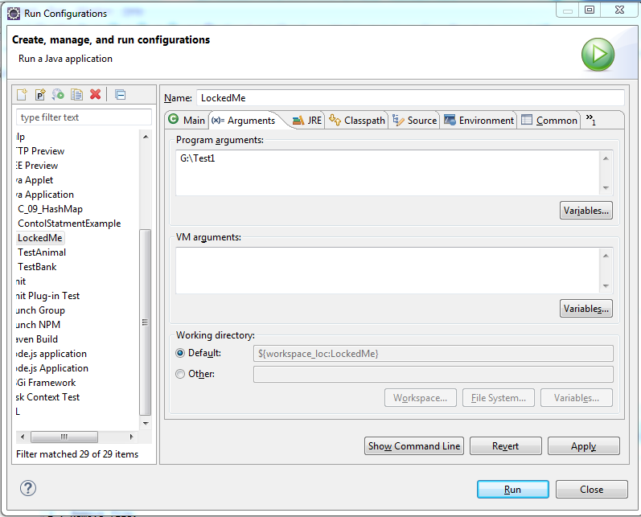

**Path G:\Test1 does not exist so application exit.**

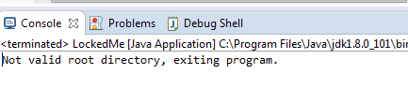

**Application Startup Screen after successful startup.**

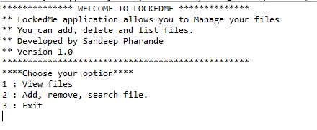

**1 View Files (This option display files in root directory in ascending order)**

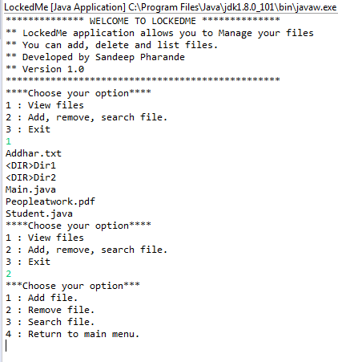

**2) Add, remove, search file. (This option allows user to add, remove or search file)**

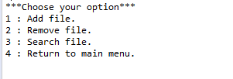

**2.1: Add file. (This option allows you to add file)**

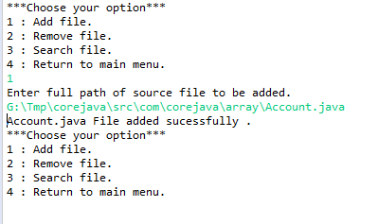

**2.2 Remove File (This option allows you to delete file from root directory)**

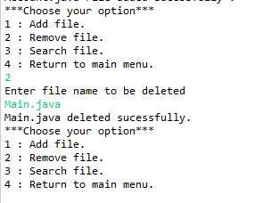

**If invalid file name provided**

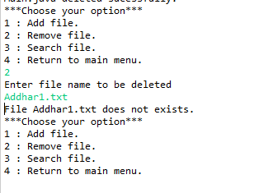

**2.3 Search file. (This option allows you to search file in the root directory)**

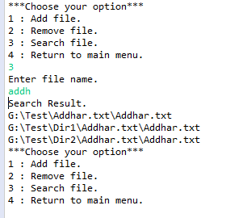

**If search criteria does not match.**

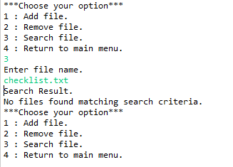

**2.4 Return to main menu**

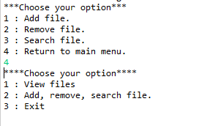

**3. Exit (Exit Application)**

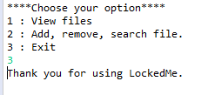

**Invalid Input handling**

If user provides invalid input then user is presented with message invalid input and asked to input again.

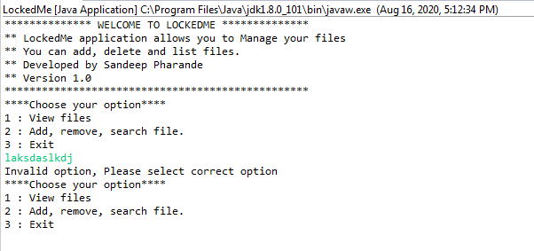

# GIT Repository details.

<https://github.com/pharandess/LockedMe.git>

# Conclusion.

This project is very useful for the user to easily manage their files. User can manage any type of file using this project. Application is user friendly.

This application is build using the basic java programming and user interface is command line interface which is not very attractive option. This application needs better front end for better user experience.