Study Population Demographics
Age and Sex Distribution
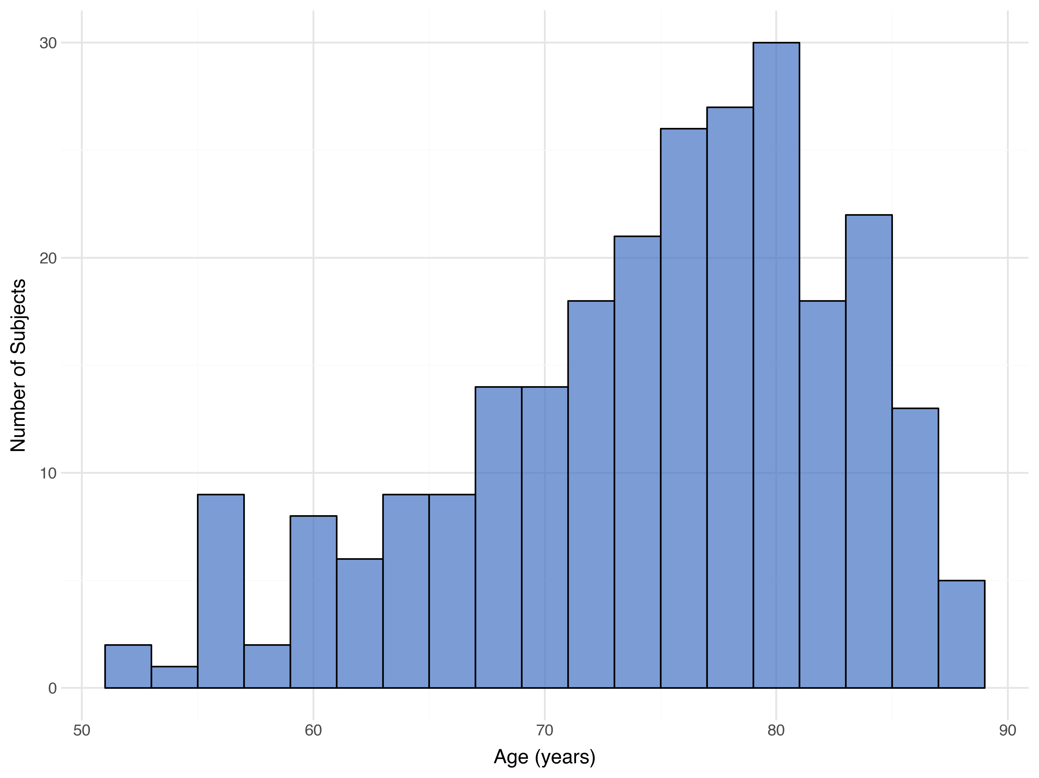

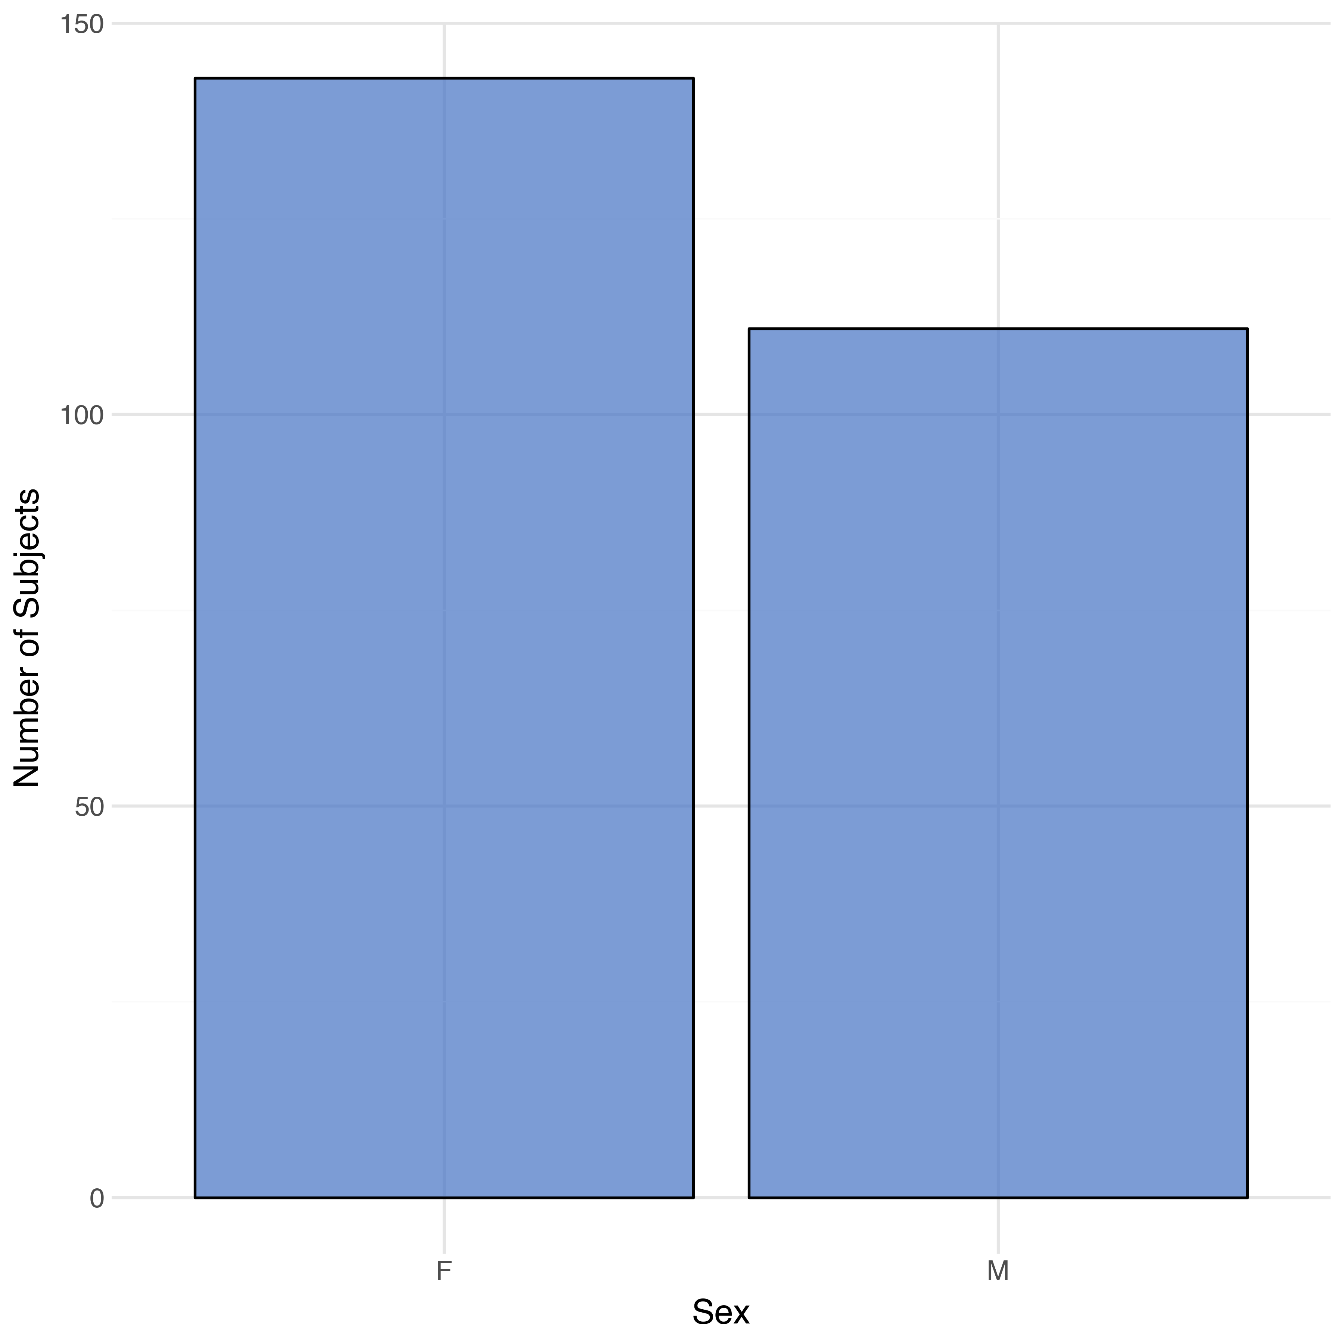
Figure 1: Age distribution histogram
Figure 2: Sex distribution histogram
Source: ADSL dataset analysis

