Clinical Study XYZ-123
Age Distribution by Treatment Group
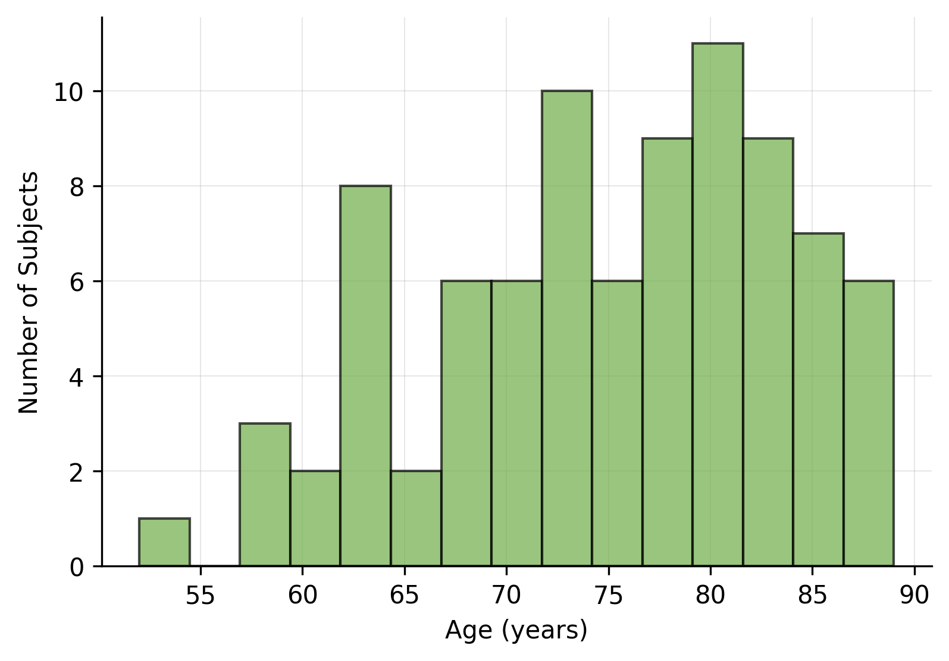
Note: Each histogram represents age distribution for one treatment group
Source: ADSL dataset, Clinical Database Lock Date: 2023-12-31
Clinical Study XYZ-123
Age Distribution by Treatment Group
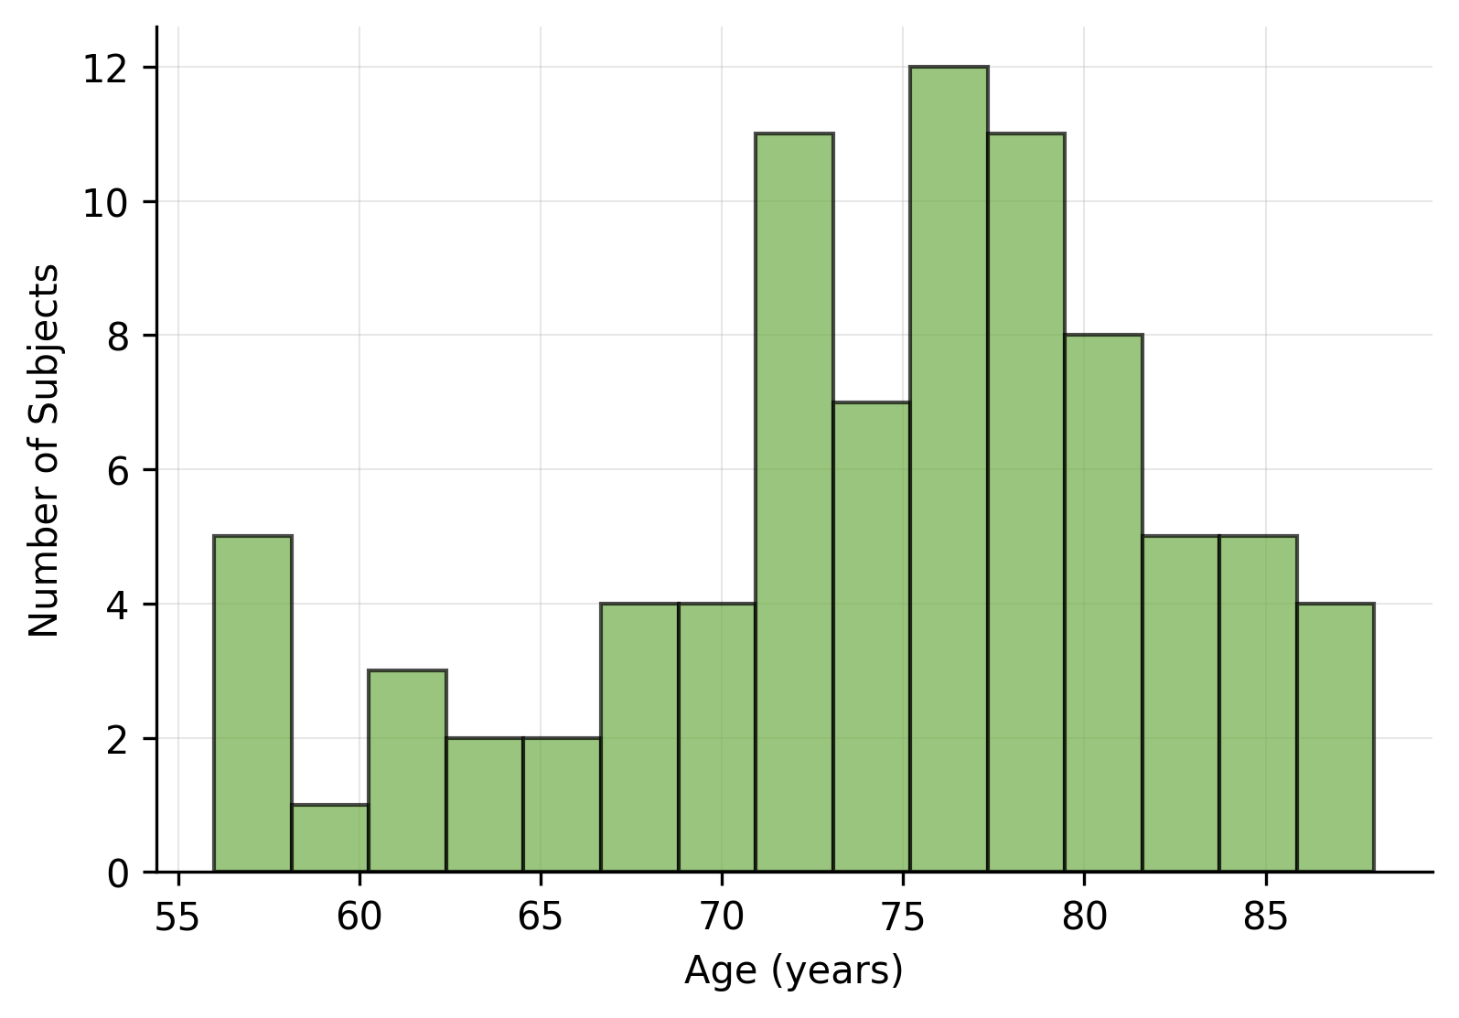
Note: Each histogram represents age distribution for one treatment group
Source: ADSL dataset, Clinical Database Lock Date: 2023-12-31
Clinical Study XYZ-123
Age Distribution by Treatment Group
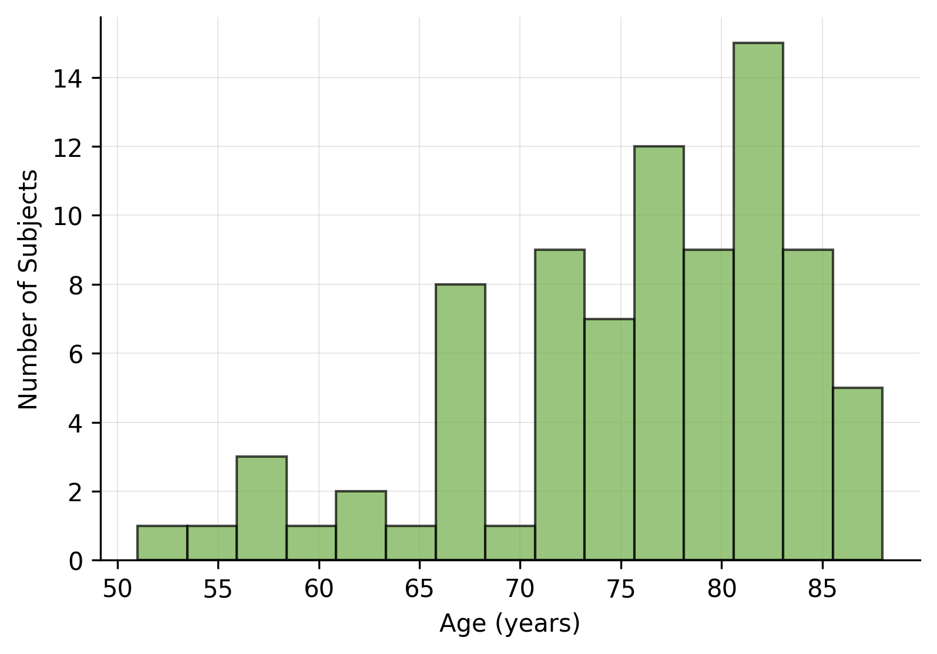
Note: Each histogram represents age distribution for one treatment group
Source: ADSL dataset, Clinical Database Lock Date: 2023-12-31

