Graph01: Scatter Plot of Baseline Body Weight and Height
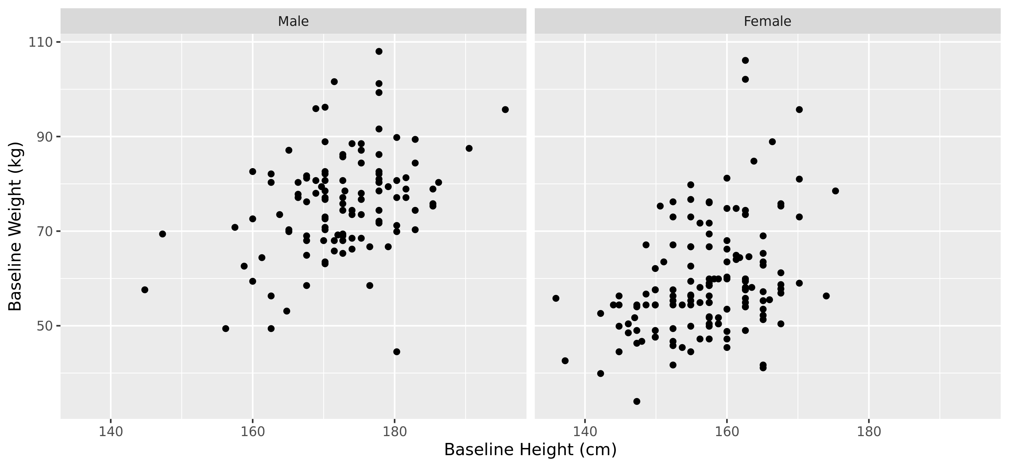
[graph01.rtf][] 25OCT2022, 13:49

