1. Create AFTER UPDATE trigger to track product price changes· Create product_price_audit table with below columns:

audit_id SERIAL PRIMARY KEY,

product_id INT,

product_name VARCHAR(40),

old_price DECIMAL(10,2),

new_price DECIMAL(10,2),

change_date TIMESTAMP DEFAULT CURRENT_TIMESTAMP,

user_name VARCHAR(50) DEFAULT CURRENT_USER

· Create a trigger function with the below logic:

INSERT INTO product_price_audit (product_id,product_name, old_price, new_price )

VALUES (OLD.product_id, OLD.product_name, OLD.unit_price, NEW.unit_price );

· Create a row level trigger for below event:

AFTER UPDATE OF unit_price ON products

· Test the trigger by updating the product price by 10% to any one product_id

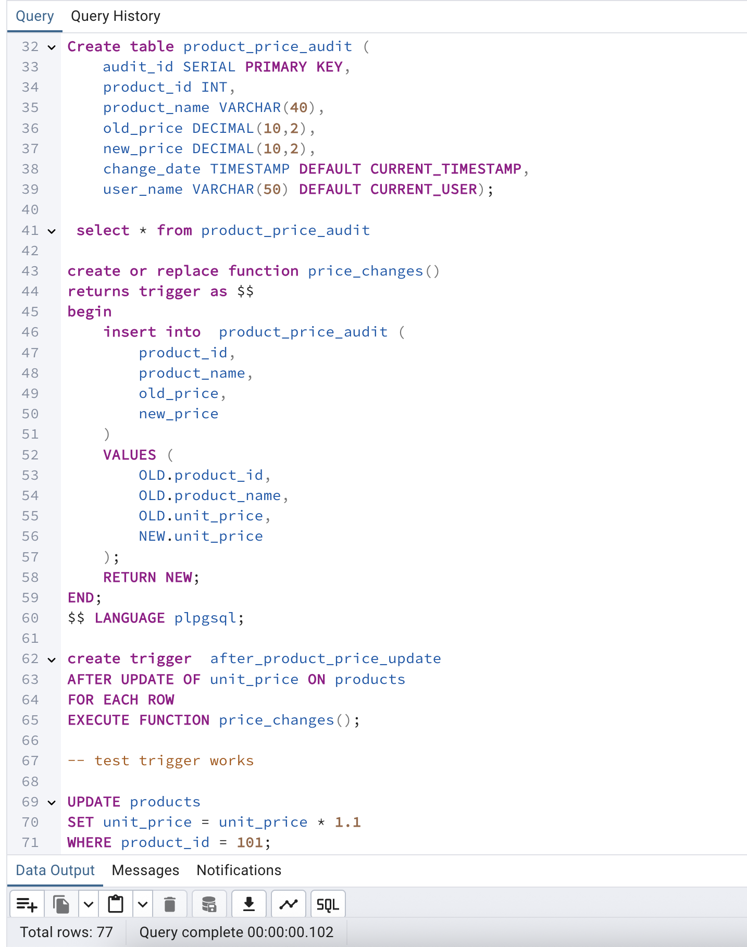

2. Create stored procedure using IN and INOUT parameters to assign tasks to employees

· Parameters: IN p_employee_id INT,

IN p_task_name VARCHAR(50),

INOUT p_task_count INT DEFAULT 0

· Inside Logic: Create table employee_tasks:

CREATE TABLE IF NOT EXISTS employee_tasks (

task_id SERIAL PRIMARY KEY,

employee_id INT,

task_name VARCHAR(50),

assigned_date DATE DEFAULT CURRENT_DATE

);

· Insert employee_id, task_name into employee_tasks

· Count total tasks for employee and put the total count into p_task_count .· Raise NOTICE message:  
 RAISE NOTICE 'Task "%" assigned to employee %. Total tasks: %',p_task_name, p_employee_id, p_task_count;

After creating stored procedure test by calling it: CALL assign_task(1, 'Review Reports');

You should see the entry in employee_tasks table.

CREATE TABLE IF NOT EXISTS employee_tasks (

task_id SERIAL PRIMARY KEY,

employee_id INT,

task_name VARCHAR(50),

assigned_date DATE DEFAULT CURRENT_DATE );

