**/*1. GROUP BY with WHERE - Orders by Year and Quarter**

**Display, order year, quarter, order count, avg freight cost only for those orders where freight cost > 100*/**

**SELECT**

**EXTRACT(YEAR FROM Order_date) AS OrderYear,**

**EXTRACT(QUARTER FROM Order_date) AS OrderQuarter,**

**COUNT(*) AS OrderCount,**

**AVG(freight) AS AvgFreightCost**

**FROM**

**Orders**

**WHERE**

**freight > 100**

**GROUP BY**

**EXTRACT(YEAR FROM Order_date),**

**EXTRACT(QUARTER FROM Order_date)**

**ORDER BY**

**OrderYear,**

**OrderQuarter;**

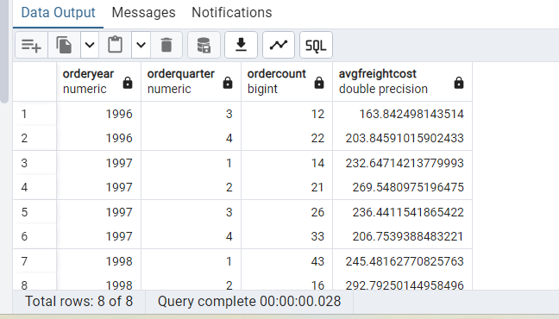

**2. GROUP BY with HAVING - High Volume Ship Regions**

**Display, ship region, no of orders in each region, min and max freight cost**

**Filter regions where no of orders >= 5**

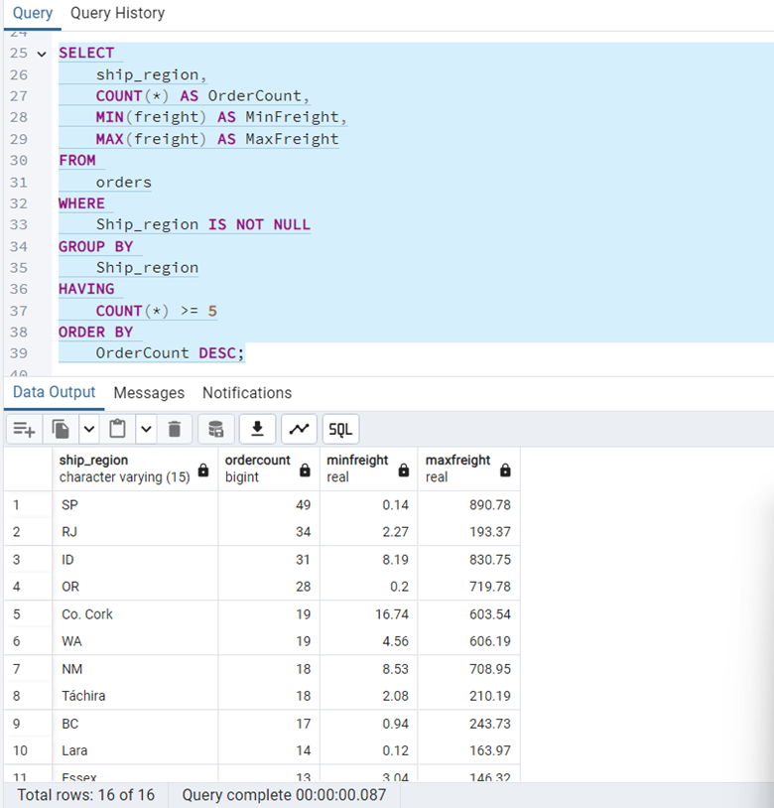

**3. Get all title designations across employees and customers ( Try UNION & UNION ALL)**

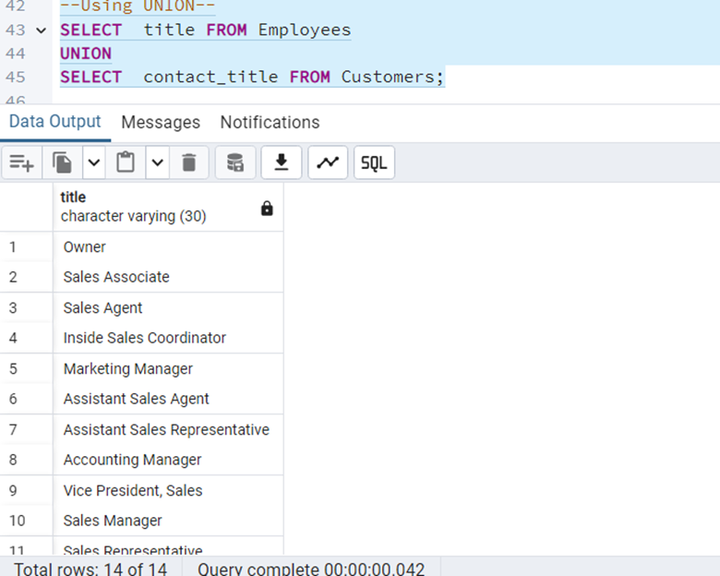

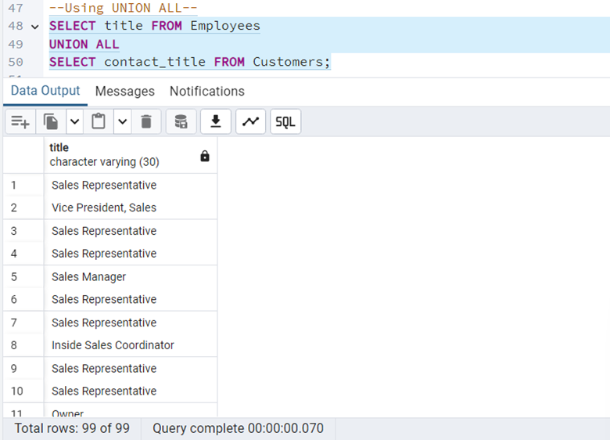

**4. Find categories that have both discontinued and in-stock products**

**(Display category_id, instock means units_in_stock > 0, Intersect)**

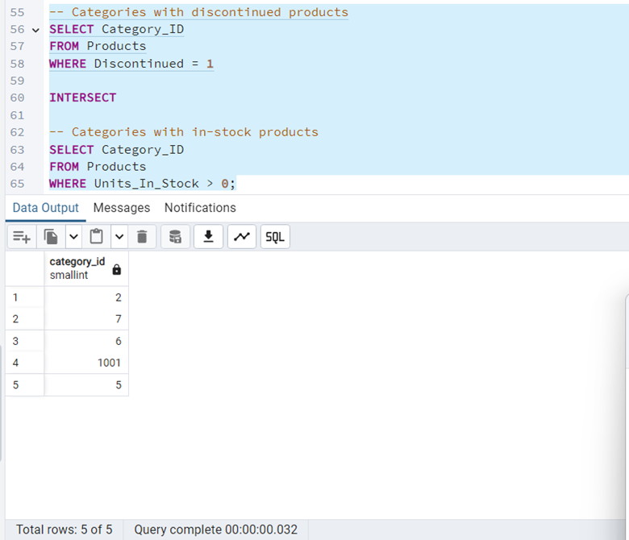

**5. Find orders that have no discounted items (Display the order_id, EXCEPT)**

