**1. Categorize products by stock status**

**(Display product_name, a new column stock_status whose values are based on below condition**

**units_in_stock = 0 is 'Out of Stock'**

**units_in_stock < 20 is 'Low Stock')**

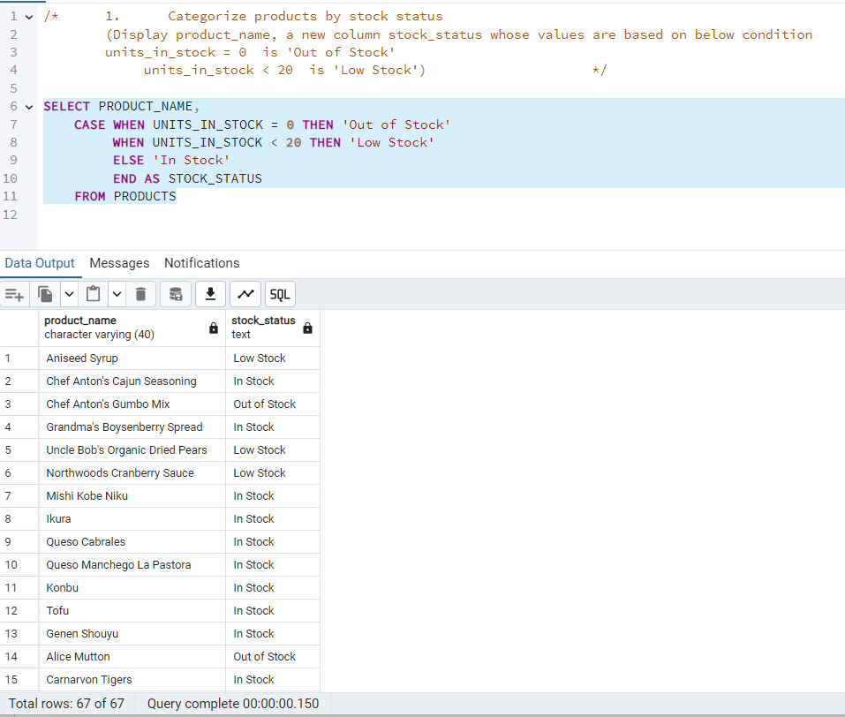

**2. Find All Products in Beverages Category**

**(Subquery, Display product_name,unitprice)**

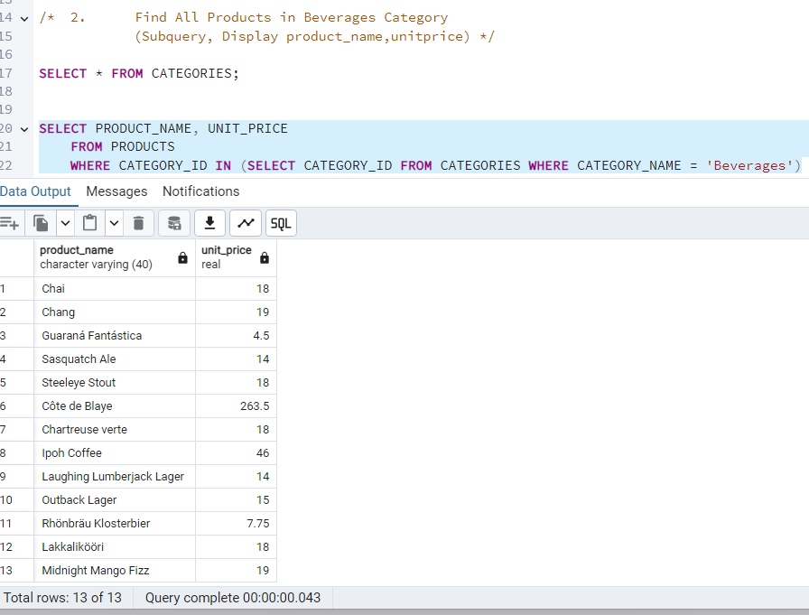

**3. Find Orders by Employee with Most Sales**

**(Display order_id, order_date, freight, employee_id.**

**Employee with Most Sales=Get the total no.of of orders for each employee then order by DESC and limit 1. Use Subquery)**

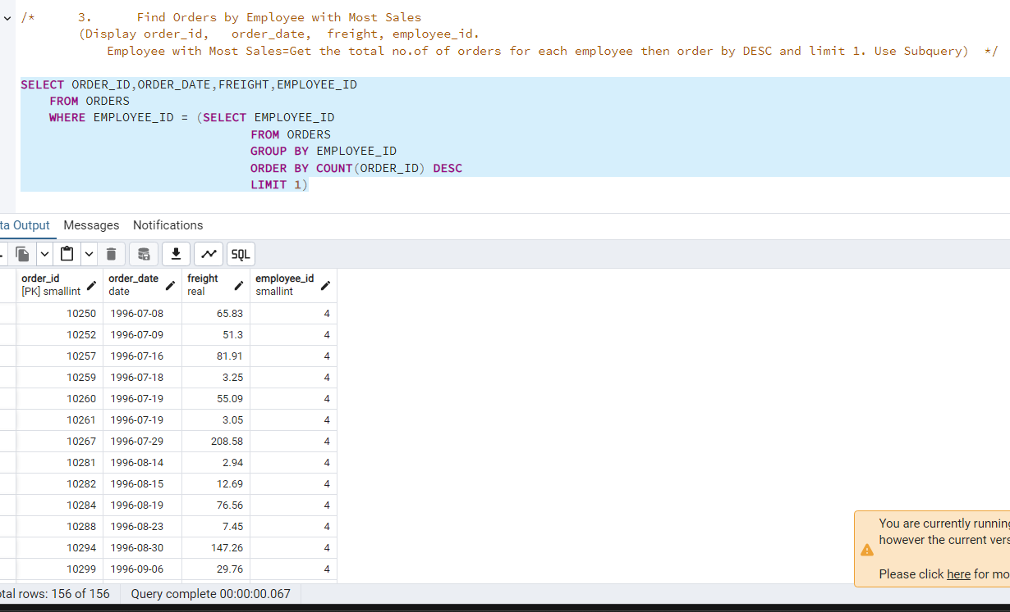

**4. Find orders where for country!= ‘USA’ with freight costs higher than any order from USA. (Subquery, Try with ANY, ALL operators)**

