**1. Rank employees by their total sales**

**(Total sales = Total no of orders handled, JOIN employees and orders table)**

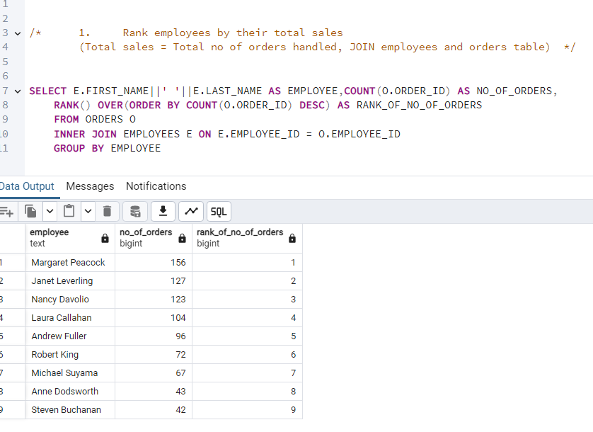

**2. Compare current order's freight with previous and next order for each customer.**

**(Display order_id, customer_id, order_date, freight,**

**Use lead(freight) and lag(freight).**

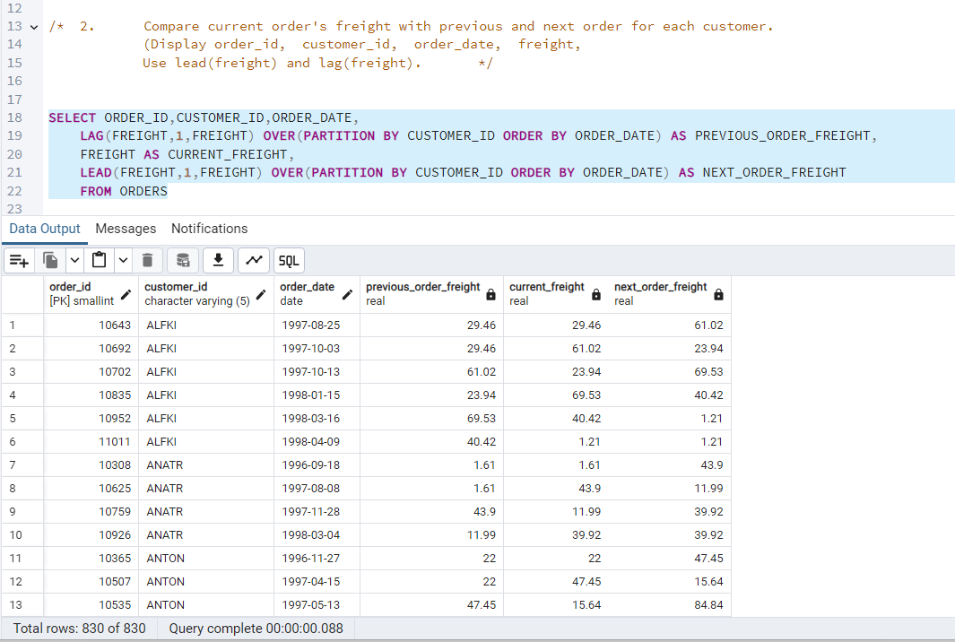

**3. Show products and their price categories, product count in each category, avg price:**

**(HINT:**

**· Create a CTE which should have price_category definition:**

**WHEN unit_price < 20 THEN 'Low Price'**

**WHEN unit_price < 50 THEN 'Medium Price'**

**ELSE 'High Price'**

**· In the main query display: price_category, product_count in each price_category, ROUND(AVG(unit_price)::numeric, 2) as avg_price)**

