**1. Create view vw_updatable_products (use same query whatever I used in the training)**

**Try updating view with below query and see if the product table also gets updated.**

**Update query:**

**UPDATE updatable_products SET unit_price = unit_price * 1.1 WHERE units_in_stock < 10;**

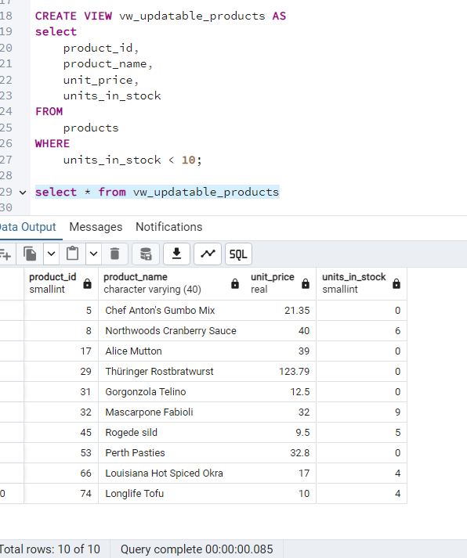

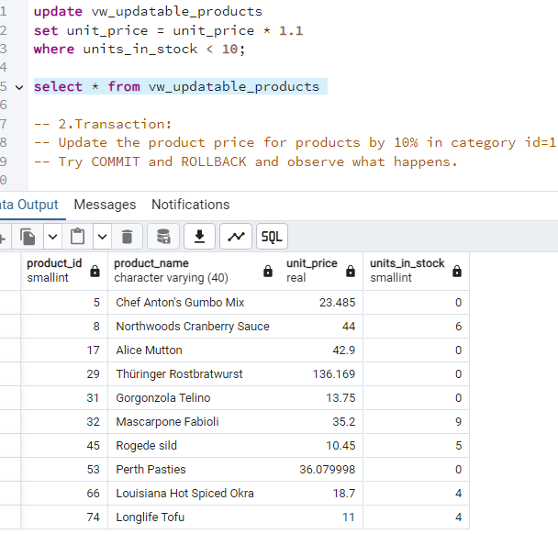

**2. Transaction:**

**Update the product price for products by 10% in category id=1**

**Try COMMIT and ROLLBACK and observe what happens.**

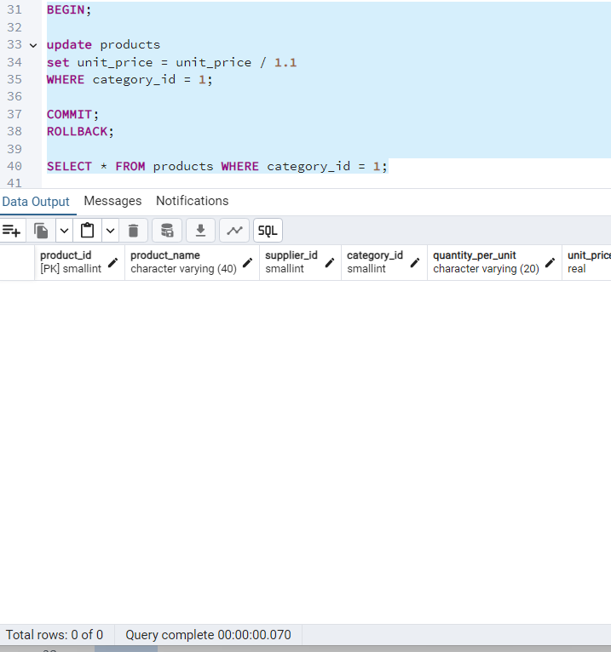

**3. Create a regular view which will have below details (Need to do joins):**

**Employee_id,**

**Employee_full_name,**

**Title,**

**Territory_id,**

**territory_description,**

**Region_description**

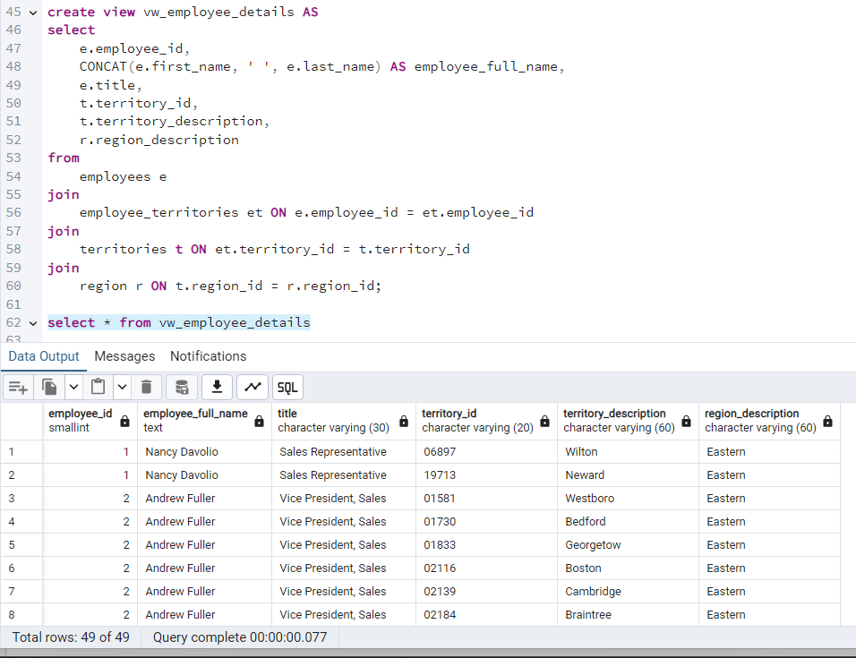

**4. Create a recursive CTE based on Employee Hierarchy**

