**IHC :**

To represent it in a simplified manner, there are 3 separate stages here.

1. **Back-end or Admin module**
2. **Front-end data collection form or view module**
3. **Dashboard module, where we showing summarised data &**

**Back-end or Admin module :**

Backend module has several parts which are :

* Adding IHC general information
* Adding IHC related areas
* Adding IHC area related services
* Adding IHC services related tables
* Adding IHC tables related questions

**Front-end data collection form or view module :**

* Left panel
* Global in page options

**Dashboard module :**

* Scorecard
* Previous assessment
* Trend analysis graph

**Back-end or Admin module :**

**Adding IHC general information :**

A certain IHC may have different customer view name than its main title because the backend may have different title for distinguishing which IHC post is for which company but on front-end the user will show the meaningful title for them. An image field is added to show the BIA logo in different places and could be changed in future and a global criteria definition button is added to regulate whether the criteria definition should be added or not on front-end.

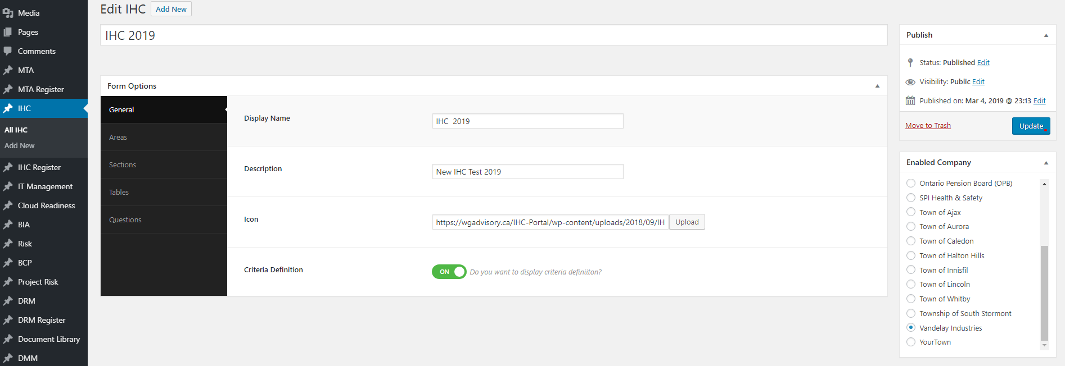

**Adding IHC related areas :**

We made this option repetitive because there may have multiple areas for each IHC. There are two different icon uploading options for showing on front-end; one for the left menu item and other one is for placing alongside the page title.

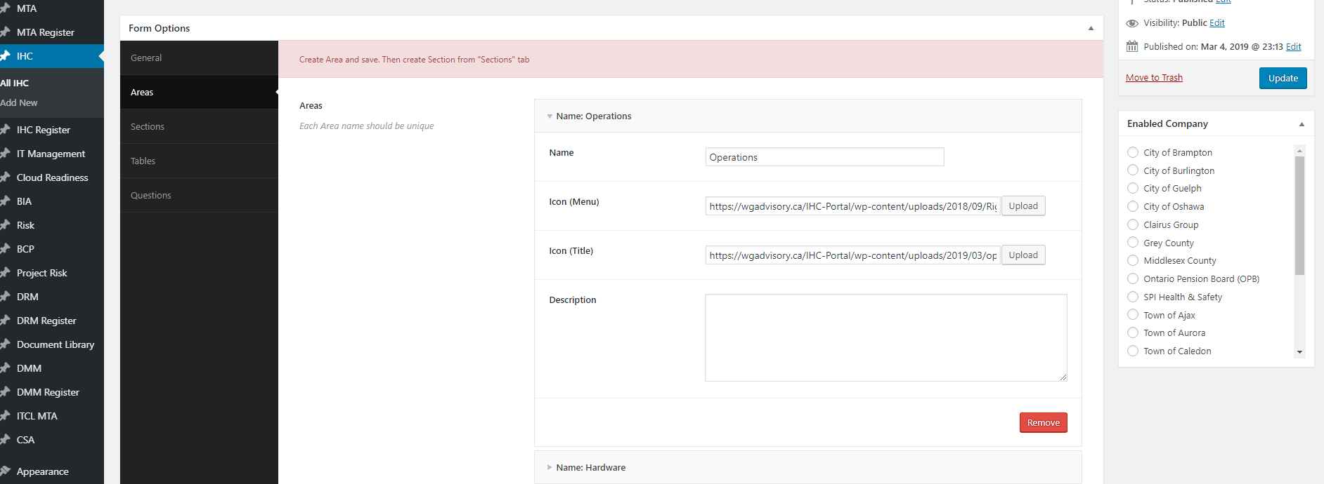

**Adding IHC related sections :**

We had to make this item repetitive again for each ares because there may have multiple sections for each area of IHC. Each section contains name, description and documentation upload field to show definition for the current section in a popup option.

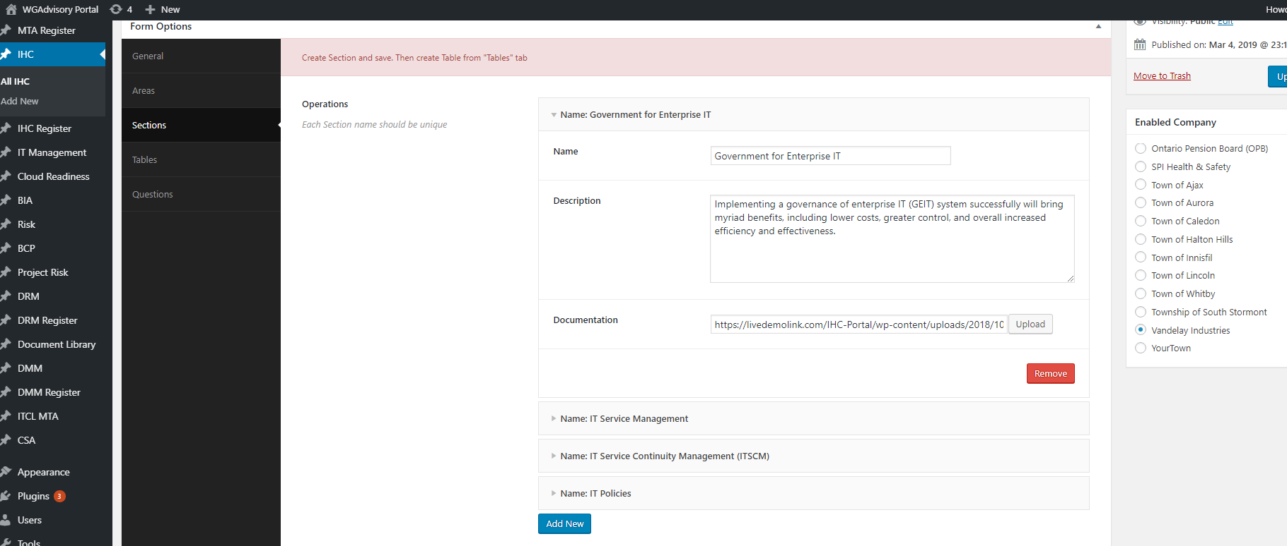

**Adding IHC related tables :**

We made this item repetitive like before for each section for further adding question.

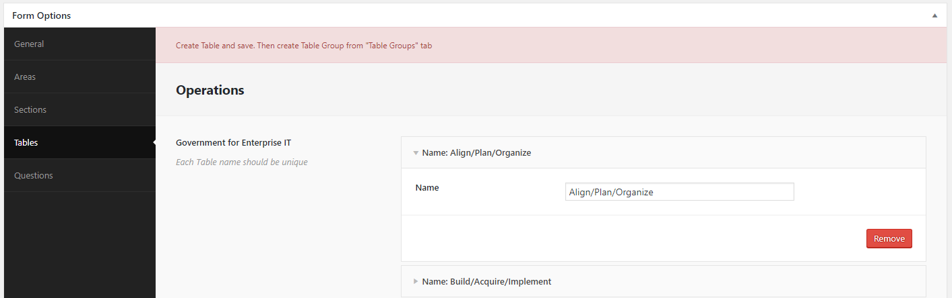

**Adding IHC related questions :**

We made this item repetitive as others for each table for adding questions which has title and description.

