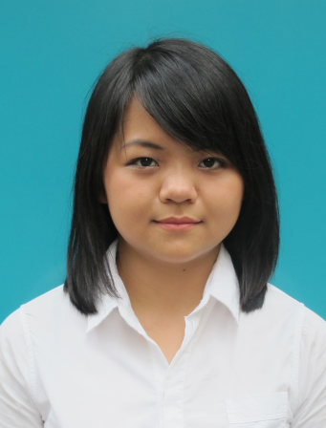**CURRICULUM VITEA**

**Le Thi Bao Quyen**

86/36/11 Pho Quang Street,

Ward 2, Tan Binh District,

Ho Chi Minh City, Vietnam.

Mobile: 0948488118

Gmail: [quyenle2103@gmaiil.com](mailto:quyenle2103@gmaiil.com)

**Career objective**

* To obtain an Operation and/or Customer Relation position in a professional organization where my skills and knowledge are beneficial to the company.
* To develop a foundation for professional growth with opportunities to build up a long term career in Operation and Customer Relation.
* To improve my proficiencies in a dynamic and established work environment.

**Skills**

Customer relation management: good at build relationship and trust each other through communication (verbal, writing in both Vietnamese and English)

* Organizing data, figure and present in reports;
* Time management;
* Problem-solving;
* Microsoft Office: Excel, Word, Powerpoint…
* Presentation;
* Motivate others and self-motivation.

**Experience:**

April 2014- July 2014: Internship in New Star Logistics Company: logistics employee, sales assistant

* Handle Customs Clearance.
* Collaborate with other functions: finance, warehouse, trucking,.... to cope with customers’ requests.
* Deal with customers’ requests and complain.
* Learned how to adapt to new working environment.

Dec 2013: Did my own business to get profit: bought imported products to be retailer, most of them are souvernirs, teddy bears,...

* Talked to many types of customers to convince them of buying products.
* Worked under enormos pressure to keep balance between study and doing business.
* Be more patient.

**Activities:**

May 2013 - now: Collaborator of the Non-Governmental Organization called “Xe Bus Yeu Thuong”: support the Organization to hold programs for poor children across Vietnam, do activities to raise the budget.

* Raising awareness of social responsibility.
* Sympathy of others’ situations, especially children living under conditions.

Feb 2012- now: Coordinator of The Asia Pacific Talent Youth Training: was trained to be a leader of groups of teenagers, paticipate in training programs to improve social skills.

* Having chances to build and improve presentation skills as well as use effective presentative methods.
* Usually work as a team member and do it well.

Sep 2008- May 2011: Secretary of class: made plans and manage almost all activities of class related the Youth Union and School.

* Proven leadership and organizational abilities.
* Motivate class members to work in team with pleasure.

**Education**

2014: College Graduation Certificate. GPA: 2.52 out of 4.00

College of Foreign Economic Relations, Ho Chi Minh City

Major: Export- Import

2011: Certificate of High School Graduation. GPA: 8.3 out of 10

Chu Van An High School, Dak Nong Province

**Hobbies**

* Making friends;
* Travelling;
* Meditation;
* Playing sports: cycling

**Signature**

**Le Thi Bao Quyen**