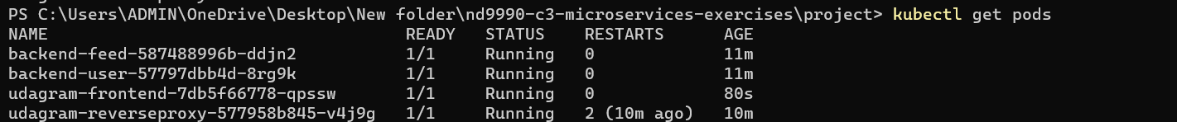

HPA

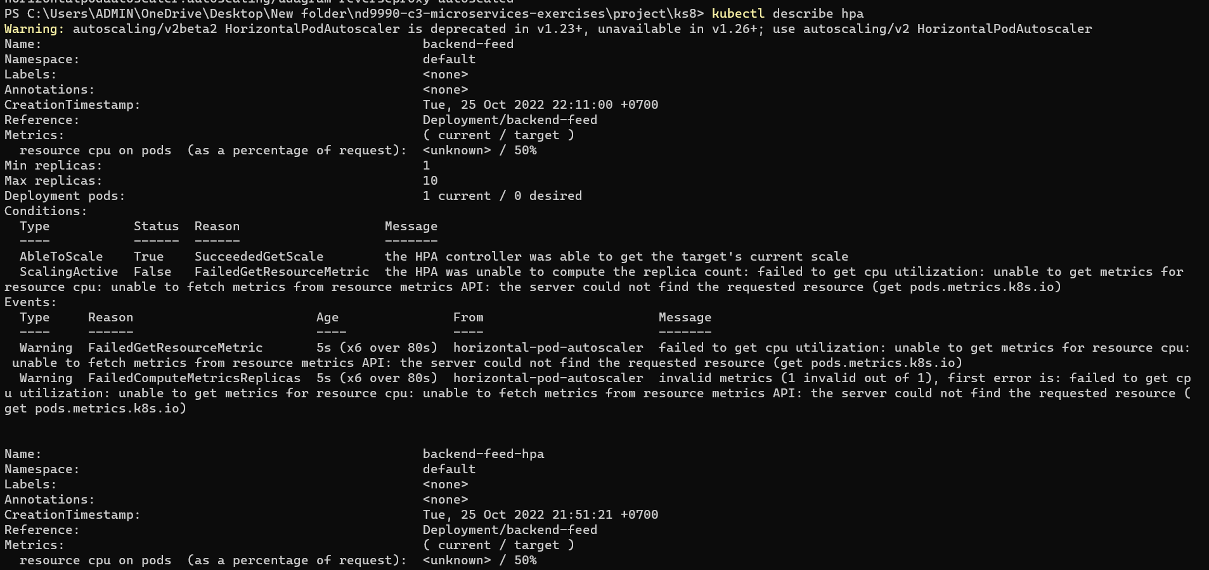

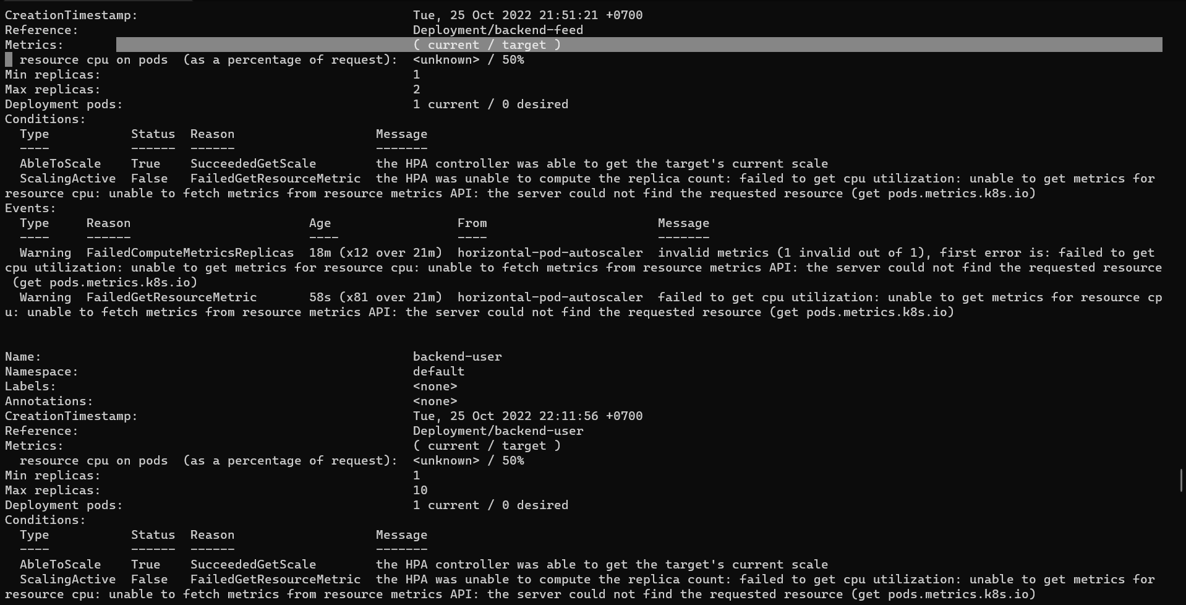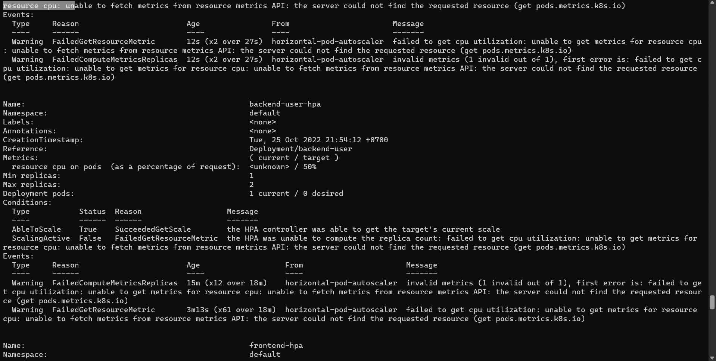

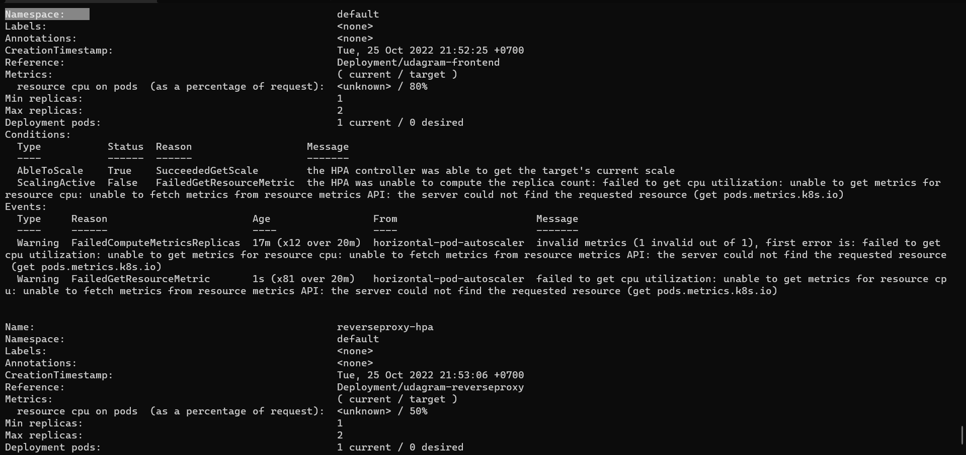

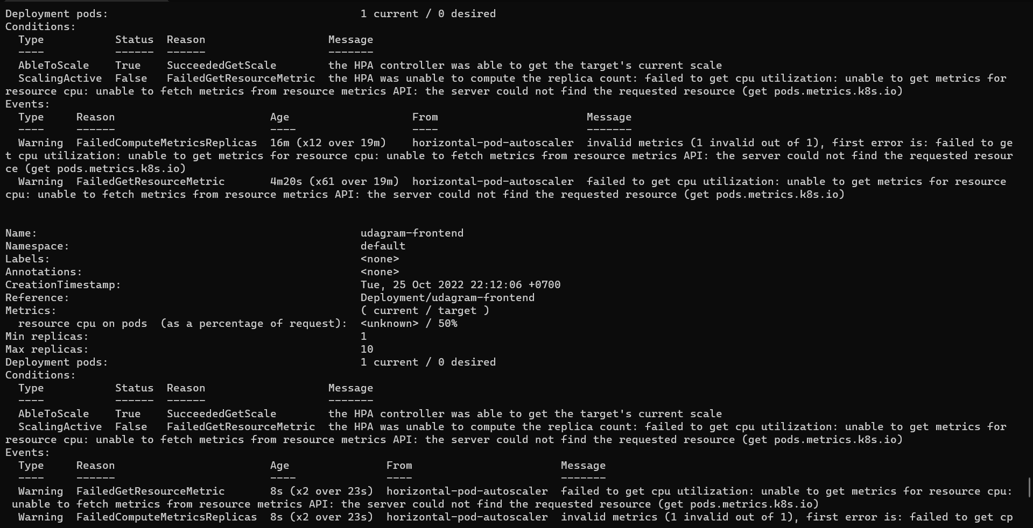

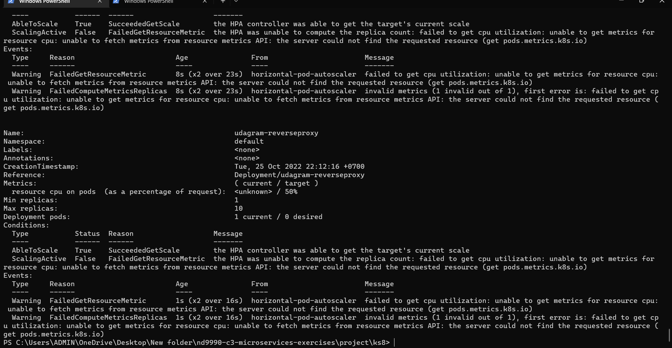

END HPA

