Literature Review

Heart disease and blood pressure are of the most concern today, here are some statistics from Vietnam in 2015. Cardiovascular disease is the leading cause of death worldwide more than cancer, whether in developed or developed countries. In Vietnam, according to statistics of the Ministry of Health each year about 200,000 people die from cardiovascular disease, accounting for 33% of deaths. According to the Institute of Cardiology 2015, the rate of hypertension in adults aged 18-65 years accounts for 25%, so one in 4 adults has increased blood pressure. Hypertension increases the risk of death from stroke 4 times and increases the risk of death from cardiovascular disease by 3 times compared with people without the disease. [4]

Hypertension is considered to be the main risk factor for cardiovascular disease, especially heart attack and stroke. Systolic blood pressure levels of 115mg Hg or higher are estimated to contribute 49% of total coronary heart disease cases and 62% of all strokes. Hence, the burden of morbidity and mortality due to hypertension and related non-communicable diseases is one of the most pressing public health problems today. [4]

Definition of Hypertension: A person is defined as having hypertension (THA) when a systolic blood pressure is ≥ 140 mmHg and / or diastolic pressure is 90 mmHg or is taking medication to lower blood pressure. [4]

Consequences of Hypertension: High blood pressure is a major risk factor for coronary artery disease and stroke. These are common complications and have a high mortality rate or leave serious sequelae such as loss of consciousness, hemiplegia ... losing the ability to work, even requiring long-term care and service.

Hypertension also causes complications such as heart failure, peripheral vascular disease, kidney failure, retinal hemorrhage and vision damage...

Since the level of danger cannot be expected, I am working on a smart wearable project to measure heart rate, blood pressure, blood oxygen levels and body activities for everyone suitable for most ages.

With this smart wearable, you'll be able to take care of family members far away. They can share their health data like activity logs, sleep quality, weight, nap heart rate, deep sleep heart rate, and instant heart rate with you. With these data, you can see if family members are sleeping well, blood oxygen levels circulate, whether they exercise regularly or feel uncomfortable during the day past (according to their activity log or an abnormally increased heart rate). It's good to call to take care of your family members based on their health data. It will notify you of unusual things. You will receive notifications on your basis. Alternatively, you can use it to see where your family members are. [5]

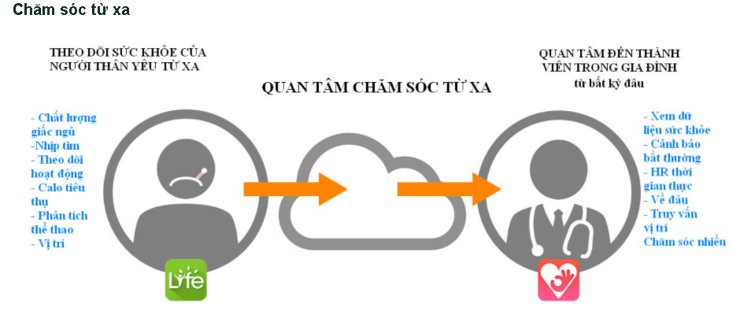

Next, we go through specific and detailed descriptions of the functions that we have studied and produced results. First, we studied a heart rate monitor operation by measuring heart rate parameters (SpO2- vital parameters). From these parameters, we can know the condition of the disease and can be given first aid before being taken to the hospital. Because of realizing the need for mobile devices to measure survival parameters anytime, anywhere, warning the user status inevitably. We have studied the oxygen transport in the blood and the activity of PO (Pulse Oximeter), the spectroscopic absorption process Hb and HbO2 as shown below.

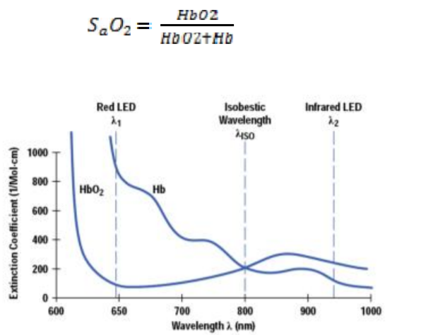

*The absorption spectrum of Hb and HbO2 [6]*

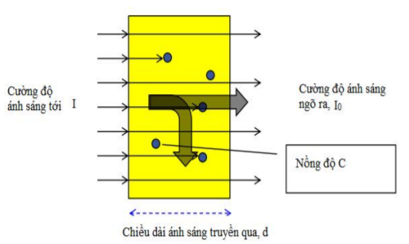

*Light absorption intensity of blood*

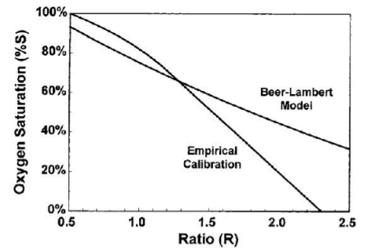

*The relation curve of R / IR and% oxygen saturation of Beer-Lambert law*

By experimenting, we find a simplified technique as follows:

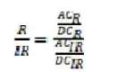[6]

The above equation is simplified by the LED line so that the DC level of the red LED is equal to the Dc level of the infrared LED (R / IR0 is summarized as follows:

[6]

After finding out R, the SpO2 equation is calculated as follows:

 [6]

Second, we analyze how sleep affects the body and health of each person. Indeed, sleep has a very good role for health, every day the body needs at least 8 hours of sleep to ensure all body activities and keep the mind awake. Sleep health is an infrequently used term and even less defined. Sleep health can be defined in such terms. The sleep health concept integrates with other health care programs, such as empowering individuals and communities, improving population health and reducing healthcare costs.

**There are five stages of sleep during the sleep cycle**. Scientists categorized the stages of sleep based on the characteristics of the brain and body during sleep. Stage 1, 2, 3, and 4, are categorized as ‘non-REM sleep’, and the fifth stage, is REM sleep. Generally, brainwave frequencies and amplitudes from an electroencephelogram (EEG) are used to differentiate the different stages of sleep, along with other biologic rhythms including eye movements (EOG) and muscle movements (EMG).

Stage 1 of the sleep cycle is the lightest stage of sleep. The EEG brain frequency is slightly slower than during wake time. There is muscle tone present in the skeletal muscles. Breathing occurs at a regular rate.

Stage 2 usually follow Stage 1 and represents deeper sleep. During Stage 2 sleep, the sleeper is less able to be awakened. Stage 2 sleep is characterized by 'saw tooth waves' and sleep spindles.

Stage 3 and Stage 4 sleep of the sleep cycle are progressively deeper stages of sleep. These stages of sleep are also called ‘Slow Wave Sleep’ (SWS), or delta sleep. During SWS, the EEG shows a much slower frequency with high amplitude signals (delta waves). A sleeper in SWS is often difficult to awaken. Some studies have demonstrated that very loud noises, sometimes over 100 decibels, will not awaken some during SWS. As humans get older they spend less time in slow wave deep sleep and more time in Stage 2 sleep.

Slow-wave sleep is generally referred to as [deep sleep](https://sleepassociation.org/about-sleep/stages-of-sleep/deep-sleep/), and is comprised of the deepest stage of NREM. In stage three we see the greatest arousal thresholds, such as difficulty in awakening, and so on. After being awoken, the person will generally feel quite groggy, and cognitive tests that have been administered after being awoken from the third stage show that for up to half an hour or so, and when compared to awakenings from the other stages, mental performance is moderately impaired. This is a phenomenon known as sleep inertia. When sleep deprivation has occurred there’s generally a sharp rebound of slow-wave sleep, which suggests that there’s a *need* for slow-wave sleep. It now appears that slow-wave sleep is a highly active state, and not a brain quiescence as previously believed. In fact, brain imaging data shows that regional brain activity during non-REM sleep is influenced by the most recent waking experience

Stage 5 of the sleep cycle, or [REM sleep](https://sleepassociation.org/about-sleep/stages-of-sleep/rem-sleep/), is the stage of sleep associated with [dreaming](https://sleepassociation.org/about-sleep/dreams/). It is very different physiologically from the other stages of sleep. The EEG resembles wake time. However, the skeletal muscles are atonic, or without movement. The breathing is more erratic and irregular. The heart rate often increases. It is theorized that muscle atonia evolved in order to protect the individual from injury during sleep.

According to the above sleep research results, there is a formula that calculates to help people sleep well:

Time to wake up = time to sleep + (90 minutes multiplied by the cycle) + 14 minutes of waiting to fall asleep

For example, if you go to bed at 2am and want to wake up at the end of the 3rd cycle, calculate the time to set the alarm clock = 2am + 90 minutes multiply 3 = 6 hours 44 minutes. Thus, just 4 hours of brain rest, you can be alert and productive.

Next I will talk about the basic energy metabolism of the body. Physical activity is the most important factor affecting energy expenditure of the body. In physical activity, the weight of the human body is a type of load. Physical activity requires muscles and other organs to work. This process, in addition to the loss of muscle energy, cells and related organs when forming many energy carriers such as protein, lipid, glycogen... Also requires energy expenditure. The stronger the muscle activity and the more active time it takes, the more energy is spent. The proficiency of manual labor also affects energy consumption. The precise method of measuring energy consumption is relatively complex, and can only be used in scientific research. The relatively simple method is to use the "living observation method" denoted by the energy expenditure for physical activity in the table below.

|  |  |
| --- | --- |
| Type of labor | Energy consumption (Kcal / kg / hour) |
| Lie to rest  Sit still  Read aloud  Stand comfortably  Hand sewing  Sleep  Stand strictly  Knitting with knitting rods  Sing  Eat  Sewing machine  Listening to lecture, recording  Fast typing  Iron clothes (2.5 kg iron)  Dish washing 1.06 2.06  Sweeping (138 movements / minute)  Bind book binding  Light exercise  Shoe stitching  Take a leisurely walk (4km / hour)  Physical training is quite heavy  Carpenters, mechanics  Going fairly fast (6 km / h)  Stone worker  Heavy labor  Cut down the tree  Swim  Running (nearly 8.5 km / h)  Labor is very heavy | 1,10  1,43  1,50  1,50  1,50  1,57  1,63  1,66  1,74  1,84  1,95  1,96  2,00  2,06  2,06  2,41  2,43  2,43  2,57  2,86  4,14  3,43  4,28  5,71  6,43  6,43  7,14  8,14  8,57 |

*Energy consumption by adult's Kcal / kg weight / hour while performing various activities and resting*

Through the above studies, I have a formula that calculates the amount of calories the body needs to consume daily, TDEE (Total Daily Energy Expenduture) which includes base calories (ie energy when the body is resting) and The formula for your exercise level is: TDEE = BMR x R[10]

In which, the BMR (Basal Metabolic Rate) rate is the base caloric intake depending on height, weight, age and gender.

+ In the South: BMR = (13,397 x N) + (4,799 x C) - (5,677 x T) + 88,362

+ In Women: BMR = (9,247 x N) + (3,098 x C) - (4,330 x T) + 447,593

>>> N is weight (kg); C is height (cm) and T is age.

- R is the number of exercise calories that the body needs in a day

In conclusion, during the research process, I have synthesized the formulas I have found and integrated the algorithm into the device to give the appropriate results to improve the health of the user. Moreover, family members can monitor their grandparents or parents in a better and more effective way through which a reasonable living regime can be proposed. Because living a happy life is what everyone wants.

References:

1. Netmeds. 2020. Medical Devices: 5 Must-Have Health Monitors In Every Household. [online] Available at: <https://www.netmeds.com/health-library/post/medical-devices-5-must-have-health-monitors-in-every-household> [Accessed 6 October 2020].
2. Dl.acm.org. 2020. Designing A Desirable Smart Bracelet For Older Adults | Proceedings Of The 2013 ACM Conference On Pervasive And Ubiquitous Computing Adjunct Publication. [online] Available at: <https://dl.acm.org/doi/abs/10.1145/2494091.2495974> [Accessed 7 October 2020].
3. 2020. [online] Available at: <https://www.amazon.com/Bracelet-Pressure-Monitoring-Fitness-Tracker/dp/B07NWYJSMR> [Accessed 7 October 2020].
4. 2020. Thực Trạng Và Xu Hướng Tăng Huyết Áp Và Bệnh Tim Mạch Trên Thế Giới Và Ở Việt Nam. [online] Available at: <http://viendinhduong.vn/vi/tin-tuc/thuc-trang-va-xu-huong-tang-huyet-ap-va-benh-tim-mach-tren-the-gioi-va-o-viet-nam.html> [Accessed 9 November 2020].
5. Tinduc.vn. 2020. *Vòng Tay Theo Dõi Sức Khỏe, Đo Nhịp Tim Cao Cấp Q-Band Q69HR New - Taiwan*. [online] Available at: <https://www.tinduc.vn/vong-theo-doi-suc-khoe/vong-tay-theo-doi-suc-khoe-do-nhip-tim-cao-cap-q-band-q69hr-new-day-mau-den.html> [Accessed 14 November 2020].
6. Tailieuso.udn.vn. 2020. [online] Available at: <http://tailieuso.udn.vn/bitstream/TTHL_125/4926/3/Tomtat.pdf> [Accessed 20 November 2020].
7. Support.garmin.com. 2020. *Chức Năng Giám Sát Giấc Ngủ Nâng Cao Trong Garmin Connect | Garmin Trung Tâm Hỗ Trợ*. [online] Available at: <https://support.garmin.com/vi-VN/?faq=mBRMf4ks7XAQ03qtsbI8J6> [Accessed 20 November 2020].
8. Reviewers, A., 2020. *Stages Of Sleep: The Sleep Cycle | American Sleep Association*. [online] American Sleep Association. Available at: <https://www.sleepassociation.org/about-sleep/stages-of-sleep/> [Accessed 21 November 2020].
9. VINAMATTRESS. 2020. *CÔNG THỨC “VÀNG” TÍNH CHỈ SỐ GIẤC NGỦ NGON MỖI ĐÊM*. [online] Available at: <https://vinamattress.vn/vi/tin-tuc/tin-cong-ty/cong-thuc-vang-tinh-chi-so-giac-ngu-ngon-moi-dem.html> [Accessed 21 November 2020].
10. Ggfc.vn. 2020. *CÁCH TÍNH LƯỢNG CALO NẠP VÀO CƠ THỂ HÀNG NGÀY BẠN CẦN BIẾT*. [online] Available at: <https://ggfc.vn/kiem-tra-calories/cach-tinh-luong-calo-nap-vao-co-the-hang-ngay-ban-can-biet-ida596> [Accessed 26 November 2020].