**Higher Nationals in Computing**

**UNIT 13**

Computing Research Project

ASSIGNMENT

No.1

Learner’s name: Nguyễn Thành Phát

Assessor name: Hồ Nguyễn Phú Bảo

Class: GCS0704B

Learner’s ID: GCS18681

Subject’s ID: 1639

Assignment due: Dec 12, 2020

Assignment submitted: Dec 12, 2020

**ASSIGNMENT 1 FRONT SHEET**

|  |  |  |  |
| --- | --- | --- | --- |
| **Qualification** | **BTEC Level 5 HND Diploma in Computing** | | |
| **Unit number and title** | Unit 13:Computing Research Project | | |
| **Submission date** | Dec 12, 2020 | **Date Received 1st submission** |  |
| **Re-submission Date** |  | **Date Received 2nd submission** |  |
| **Student Name** | Nguyễn Thành Phát | **Student ID** | GCS18681 |
| **Class** | GCS0704B | **Assessor name** | Hồ Nguyễn Phú Bảo |
| **Student declaration**  I certify that the assignment submission is entirely my own work and I fully understand the consequences of plagiarism. I understand that making a false declaration is a form of malpractice. | | | |
|  |  | **Student’s signature** |  |

**Grading grid**

|  |  |  |  |  |  |  |  |  |  |
| --- | --- | --- | --- | --- | --- | --- | --- | --- | --- |
| P1 | P2 | P3 | P4 | P5 | M1 | M2 | M3 | D1 | D2 |
|  |  |  |  |  |  |  |  |  |  |

|  |  |  |
| --- | --- | --- |
| **❒ Summative Feedback: ❒ Resubmission Feedback:** | | |
| **Grade:** | **Assessor Signature:** | **Date:** |
| **Internal Verifier’s Comments:** | | |
| **Signature & Date:** | | |

**ASSIGNMENT 1 BRIEF**

|  |  |  |  |
| --- | --- | --- | --- |
| **Qualification** | **BTEC Level 5 HND Diploma in Computing** | | |
| **Unit number** | UNIT 13: Computing Research Project | | |
| **Assignment title** | Proposing and conducting a research project | | |
| **Academic Year** | 2020 | | |
| **Unit Tutor** | Ho Nguyen Phu Bao | | |
| **Issue date** |  | **Submission date** |  |
| **IV name and date** |  | | |

|  |
| --- |
| **Submission Format:** |
| *Format:* The submission is in the form of 1 document  You must use font *Calibri size 12, set number of the pages and use multiple line spacing at 1.3. Margins must be: left: 1.25 cm; right: 1 cm; top: 1 cm and bottom: 1 cm.* The reference follows Harvard referencing system.  *Submission* Students are compulsory to submit the assignment in due date and in a way requested by the Tutors. The form of submission will be a soft copy posted on <http://cms.greenwich.edu.vn/>  *Note:* The Assignment *must* be your own work, and not copied by or from another student or from  books etc. If you use ideas, quotes or data (such as diagrams) from books, journals or other sources, you must reference your sources, using the Harvard style. Make sure that you know how to reference properly, and that understand the guidelines on plagiarism. *If you do not, you definitely get failed* |
| **Unit Learning Outcomes:** |
| **LO1** Examine appropriate research methodologies and approaches as part of the research process  **LO2** Conduct and analyse research relevant for a computing research project  **LO3** Communicate the outcomes of a research project to identified stakeholders |
| **Assignment Brief and Guidance:** |
| **Scenario**  Digital Wellbeing is about fashioning and sustaining a healthy relationship with technology. As technology plays a big part in our lives we find ourselves spending an increasing amount of time online and on our devices. Our wellbeing is dependent upon our mental and physical health and thereby our digital wellbeing is influenced by our online interactions and the amount of time we spend on our devices.  Whilst technology and the internet can simplify and enhance our lives they can also be distracting, be a cause of anxiety, and make us feel upset. Being in control of technology enables us to use its full potential and gain all the benefits of it.  This unit will enable students to explore some of the areas of digital wellbeing from the standpoint of a prospective computing professional. It will provide the opportunity for students to investigate digital wellbeing within computing systems and explore the responsibilities and solutions to the problems presented.  The range of topics discussed cover the following   * How to find the balance towards a healthy relationship with devices? * Are tech companies responsible for the health, safety and wellbeing of users? * What tools and strategies can a company use to develop a system(s) that addresses digital wellbeing for users? * What impact will future digital tech have on human wellbeing?   You have to set you own research question in the research proposal base on the previous range of topic. The research question must be specific enough example: the audience of the research(job, age..), kind of devices(personal devices, household appliances, or combination of some kinds)  **Marking Process**  The assignment will be marked based on holistic assessment approach:   * Holistic marking is when the tutor makes academic judgements on grading based on the assignment **as a whole and how criteria contribute to the quality of the work, rather than as individual parts** * Assessment criteria **are not completed** and marked as individual tasks. * Assessment criteria are holistic in context but may also contain reference to specific content matter to provide guidance for the student if required   **Report structure**  The recommended outputs of the research are two reports. The first report should cover at least the following sections:   1. Introduction the purpose of the research   Introduce the research’ purpose, main aims and objectives of the project. What the research will do and don’t   1. Literature review    * Discuss research methodologies: primary research, secondary research, qualitative, quantitative, scientific method, research processes, population in research…    * Specify which research methods will be used to carried out the research    * Do a secondary research about      + Discuss Wellbeing: wellbeing and related products      + AI in your selected topic(for example: the relationship of Wellbeing and smartphones)    * Conclusion, propose **initial hypothesis** after the literature review and need to confirm in primary research 2. Primary research    * Design of primary research: which techniques will be used to collect data such as interview, questionnaire, experiment,..; the population of the research. All the data collected in this stage must be supplied in the appendix 3. Analyse the result of the primary research  * Provide the research ‘result with diagrams, numbers * It should confirm or reject the hypothesis in the literature part * Provide recommendations for improving the system or future research which could enhance the results of the current research. * Suggest the research’s results to some audience(how it is useful for them)  1. Approved project proposal-appendix 2. Approved project plan-appendix 3. Ethical form 4. Other materials which collected while conducting primary research: interview scripts, audio, experiment notes-appendix |
|  |

|  |  |  |
| --- | --- | --- |
| Learning Outcomes and Assessment Criteria | | |
| Pass | Merit | Distinction |
| **LO1** Examine appropriate research methodologies and approaches as part of the research process | | **LO1 & 2**  **D1** Critically evaluate research methodologies and processes in application to a computing research project to justify chosen research methods and analysis. |
| **P1** Produce a research proposal that clearly defines a research question or hypothesis supported by a literature review.  **P2** Examine appropriate research methods and approaches to primary and secondary research. | **M1** Evaluate different research approaches and methodology and make justifications for the choice of methods selected based on philosophical/theoretical frameworks. |
| **LO2** Conduct and analyse research relevant for a computing research project | |
| **P3** Conduct primary and secondary research using appropriate methods for a computing research project that consider costs, access and ethical issues.  **P4** Apply appropriate analytical tools, analyse research findings and data. | **M2** Discuss merits, limitations and pitfalls of approaches to data collection and analysis. |
| **LO3** Communicate the outcomes of a research project to identified stakeholders | | **D2** Communicate critical analysis of the outcomes and make valid, justified recommendations. |
| **P5** Communicate research outcomes in an appropriate manner for the intended audience. | **M3** Coherently and logically communicate outcomes to the intended audience demonstrating how outcomes meet set research objectives. |

**Table of Contents**

**1. Introduction.** 8

**2. Literature review.** 8

**3. Primary research.** 15

**4. Analyze the result of the primary research** 20

**5. Approved project proposal-appendix** 22

**6. Approved project plan-appendix** 27

**7. Ethical form** 28

1. **Introduction.**

Digital Wellbeing: Health is a device that builds and maintains healthy relationships between people and technology. As technology plays an important role in our lives, we find ourselves spending a lot of time online and on our devices. Our happiness depends on our mental and physical health and therefore our digital wellness is influenced by our online interactions and the amount of time we spend with our devices. . Human health and wellness problems are often considered to be inadequately addressed. With the goal of "Health at your fingertips" Digital Wellbeing: Health tracks your activity data, nutrition and heart rate, blood concentration and sleep. Helps you to better manage your exercise regimen, fitness, physical and mental stability, and explore health-related content. Besides, this device is very easy to use, you just need to use Android with Bluetooth connection to use the functions in the device.

In addition, we seek to answer research questions:

• Find out about the causes of heart disease and problems with blood pressure.

• Explore smart wearable devices that monitor specific user health such as heart rate, blood pressure, blood oxygen concentration, sleep and daily calorie consumption.

• Learn about the device's features and how they work.

• Use and connect with device users and patient care followers.

1. **Literature review.**

Heart disease and blood pressure are of the most concern today, here are some statistics from Vietnam in 2015. Cardiovascular disease is the leading cause of death worldwide more than cancer, whether in developed or developed countries. In Vietnam, according to statistics of the Ministry of Health each year about 200,000 people die from cardiovascular disease, accounting for 33% of deaths. According to the Institute of Cardiology 2015, the rate of hypertension in adults aged 18-65 years accounts for 25%, so one in 4 adults has increased blood pressure. Hypertension increases the risk of death from stroke 4 times and increases the risk of death from cardiovascular disease by 3 times compared with people without the disease. [4]

Hypertension is considered to be the main risk factor for cardiovascular disease, especially heart attack and stroke. Systolic blood pressure levels of 115mg Hg or higher are estimated to contribute 49% of total coronary heart disease cases and 62% of all strokes. Hence, the burden of morbidity and mortality due to hypertension and related non-communicable diseases is one of the most pressing public health problems today. [4]

Definition of Hypertension: A person is defined as having hypertension (THA) when a systolic blood pressure is ≥ 140 mmHg and / or diastolic pressure is 90 mmHg or is taking medication to lower blood pressure. [4]

Consequences of Hypertension: High blood pressure is a major risk factor for coronary artery disease and stroke. These are common complications and have a high mortality rate or leave serious sequelae such as loss of consciousness, hemiplegia ... losing the ability to work, even requiring long-term care and service.

Hypertension also causes complications such as heart failure, peripheral vascular disease, kidney failure, retinal hemorrhage and vision damage...

Since the level of danger cannot be expected, I am working on a smart wearable project to measure heart rate, blood pressure, blood oxygen levels and body activities for everyone suitable for most ages.

With this smart wearable, you'll be able to take care of family members far away. They can share their health data like activity logs, sleep quality, weight, nap heart rate, deep sleep heart rate, and instant heart rate with you. With these data, you can see if family members are sleeping well, blood oxygen levels circulate, whether they exercise regularly or feel uncomfortable during the day past (according to their activity log or an abnormally increased heart rate). It's good to call to take care of your family members based on their health data. It will notify you of unusual things. You will receive notifications on your basis. Alternatively, you can use it to see where your family members are. [5]

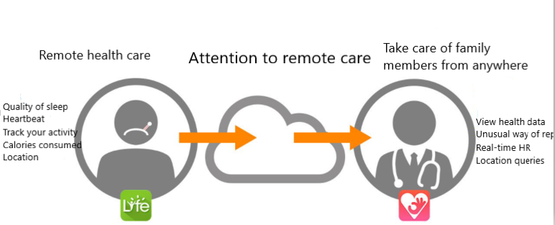

Next, we go through specific and detailed descriptions of the functions that we have studied and produced results. First, we studied a heart rate monitor operation by measuring heart rate parameters (SpO2- vital parameters). From these parameters, we can know the condition of the disease and can be given first aid before being taken to the hospital. Because of realizing the need for mobile devices to measure survival parameters anytime, anywhere, warning the user status inevitably. We have studied the oxygen transport in the blood and the activity of PO (Pulse Oximeter), the spectroscopic absorption process Hb and HbO2 as shown below.

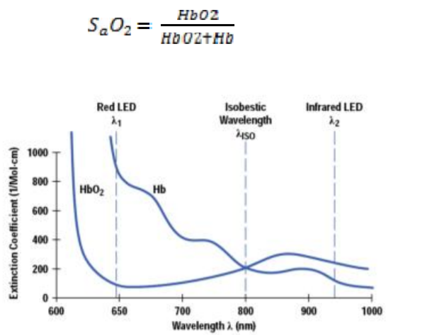

*The absorption spectrum of Hb and HbO2 [6]*

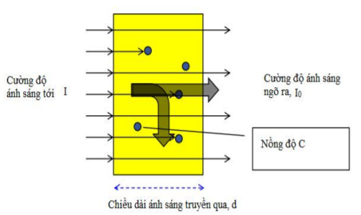

*Light absorption intensity of blood*

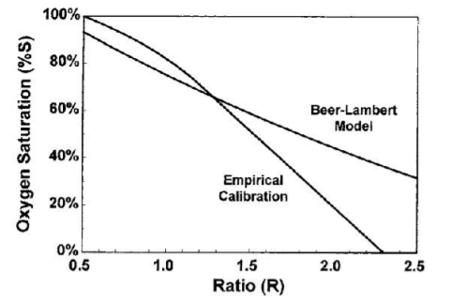

*The relation curve of R / IR and% oxygen saturation of Beer-Lambert law*

By experimenting, we find a simplified technique as follows:

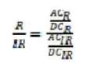[6]

The above equation is simplified by the LED line so that the DC level of the red LED is equal to the Dc level of the infrared LED (R / IR0 is summarized as follows:

[6]

After finding out R, the SpO2 equation is calculated as follows:

[6]

Second, we analyze how sleep affects the body and health of each person. Indeed, sleep has a very good role for health, every day the body needs at least 8 hours of sleep to ensure all body activities and keep the mind awake. Sleep health is an infrequently used term and even less defined. Sleep health can be defined in such terms. The sleep health concept integrates with other health care programs, such as empowering individuals and communities, improving population health and reducing healthcare costs.

**There are five stages of sleep during the sleep cycle**. Scientists categorized the stages of sleep based on the characteristics of the brain and body during sleep. Stage 1, 2, 3, and 4, are categorized as ‘non-REM sleep’, and the fifth stage, is REM sleep. Generally, brainwave frequencies and amplitudes from an electroencephelogram (EEG) are used to differentiate the different stages of sleep, along with other biologic rhythms including eye movements (EOG) and muscle movements (EMG).

Stage 1 of the sleep cycle is the lightest stage of sleep. The EEG brain frequency is slightly slower than during wake time. There is muscle tone present in the skeletal muscles. Breathing occurs at a regular rate.

Stage 2 usually follow Stage 1 and represents deeper sleep. During Stage 2 sleep, the sleeper is less able to be awakened. Stage 2 sleep is characterized by 'saw tooth waves' and sleep spindles.

Stage 3 and Stage 4 sleep of the sleep cycle are progressively deeper stages of sleep. These stages of sleep are also called ‘Slow Wave Sleep’ (SWS), or delta sleep. During SWS, the EEG shows a much slower frequency with high amplitude signals (delta waves). A sleeper in SWS is often difficult to awaken. Some studies have demonstrated that very loud noises, sometimes over 100 decibels, will not awaken some during SWS. As humans get older they spend less time in slow wave deep sleep and more time in Stage 2 sleep.

Slow-wave sleep is generally referred to as [deep sleep](https://sleepassociation.org/about-sleep/stages-of-sleep/deep-sleep/), and is comprised of the deepest stage of NREM. In stage three we see the greatest arousal thresholds, such as difficulty in awakening, and so on. After being awoken, the person will generally feel quite groggy, and cognitive tests that have been administered after being awoken from the third stage show that for up to half an hour or so, and when compared to awakenings from the other stages, mental performance is moderately impaired. This is a phenomenon known as sleep inertia. When sleep deprivation has occurred there’s generally a sharp rebound of slow-wave sleep, which suggests that there’s a *need* for slow-wave sleep. It now appears that slow-wave sleep is a highly active state, and not a brain quiescence as previously believed. In fact, brain imaging data shows that regional brain activity during non-REM sleep is influenced by the most recent waking experience

Stage 5 of the sleep cycle, or [REM sleep](https://sleepassociation.org/about-sleep/stages-of-sleep/rem-sleep/), is the stage of sleep associated with [dreaming](https://sleepassociation.org/about-sleep/dreams/). It is very different physiologically from the other stages of sleep. The EEG resembles wake time. However, the skeletal muscles are atonic, or without movement. The breathing is more erratic and irregular. The heart rate often increases. It is theorized that muscle atonia evolved in order to protect the individual from injury during sleep.

According to the above sleep research results, there is a formula that calculates to help people sleep well:

Time to wake up = time to sleep + (90 minutes multiplied by the cycle) + 14 minutes of waiting to fall asleep

For example, if you go to bed at 2am and want to wake up at the end of the 3rd cycle, calculate the time to set the alarm clock = 2am + 90 minutes multiply 3 = 6 hours 44 minutes. Thus, just 4 hours of brain rest, you can be alert and productive.

Next I will talk about the basic energy metabolism of the body. Physical activity is the most important factor affecting energy expenditure of the body. In physical activity, the weight of the human body is a type of load. Physical activity requires muscles and other organs to work. This process, in addition to the loss of muscle energy, cells and related organs when forming many energy carriers such as protein, lipid, glycogen... Also requires energy expenditure. The stronger the muscle activity and the more active time it takes, the more energy is spent. The proficiency of manual labor also affects energy consumption. The precise method of measuring energy consumption is relatively complex, and can only be used in scientific research. The relatively simple method is to use the "living observation method" denoted by the energy expenditure for physical activity in the table below.

|  |  |
| --- | --- |
| Type of labor | Energy consumption (Kcal / kg / hour) |
| Lie to rest  Sit still  Read aloud  Stand comfortably  Hand sewing  Sleep  Stand strictly  Knitting with knitting rods  Sing  Eat  Sewing machine  Listening to lecture, recording  Fast typing  Iron clothes (2.5 kg iron)  Dish washing 1.06 2.06  Sweeping (138 movements / minute)  Bind book binding  Light exercise  Shoe stitching  Take a leisurely walk (4km / hour)  Physical training is quite heavy  Carpenters, mechanics  Going fairly fast (6 km / h)  Stone worker  Heavy labor  Cut down the tree  Swim  Running (nearly 8.5 km / h)  Labor is very heavy | 1,10  1,43  1,50  1,50  1,50  1,57  1,63  1,66  1,74  1,84  1,95  1,96  2,00  2,06  2,06  2,41  2,43  2,43  2,57  2,86  4,14  3,43  4,28  5,71  6,43  6,43  7,14  8,14  8,57 |

*Energy consumption by adult's Kcal / kg weight / hour while performing various activities and resting*

Through the above studies, I have a formula that calculates the amount of calories the body needs to consume daily, TDEE (Total Daily Energy Expenduture) which includes base calories (ie energy when the body is resting) and The formula for your exercise level is: TDEE = BMR x R[10]

In which, the BMR (Basal Metabolic Rate) rate is the base caloric intake depending on height, weight, age and gender.

+ In the South: BMR = (13,397 x N) + (4,799 x C) - (5,677 x T) + 88,362

+ In Women: BMR = (9,247 x N) + (3,098 x C) - (4,330 x T) + 447,593

>>> N is weight (kg); C is height (cm) and T is age.

- R is the number of exercise calories that the body needs in a day

In conclusion, during the research process, I have synthesized the formulas I have found and integrated the algorithm into the device to give the appropriate results to improve the health of the user. Moreover, family members can monitor their grandparents or parents in a better and more effective way through which a reasonable living regime can be proposed. Because living a happy life is what everyone wants.

1. **Primary research.**

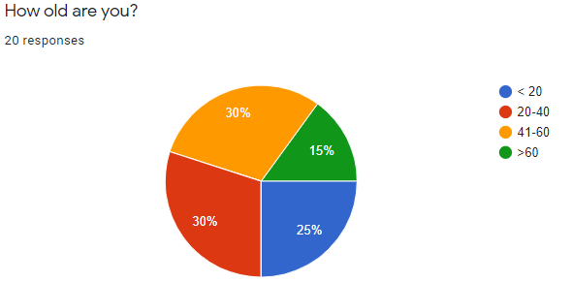

*We did the survey around Binh Thanh district, 20 participants were mostly in the 20-40 year old group, accounting for 30% and the 41-60 year old group accounted for 30%.*

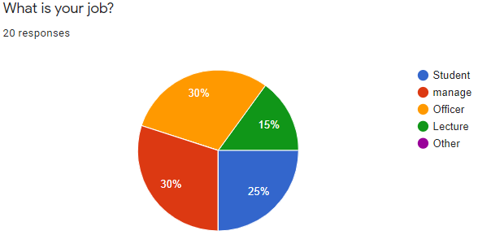

*Next, answer the question "What is your job?"**the majority are managers and office workers (30%).*

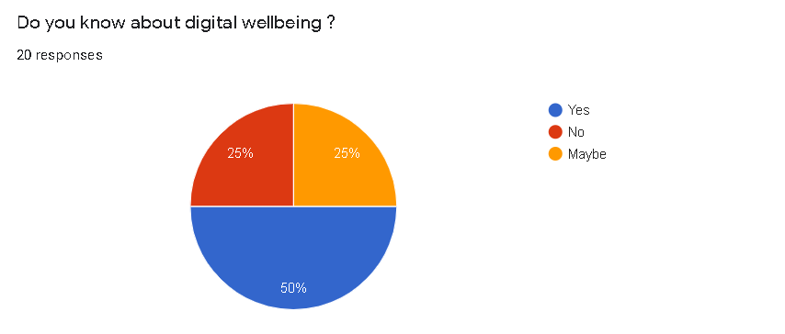

*According to the survey, people seem to know about digital happiness with those who know it as high as 50%, who guess they probably know 25%, and some who still don't. Through this it can be seen that people are quite interested in this new issue.*

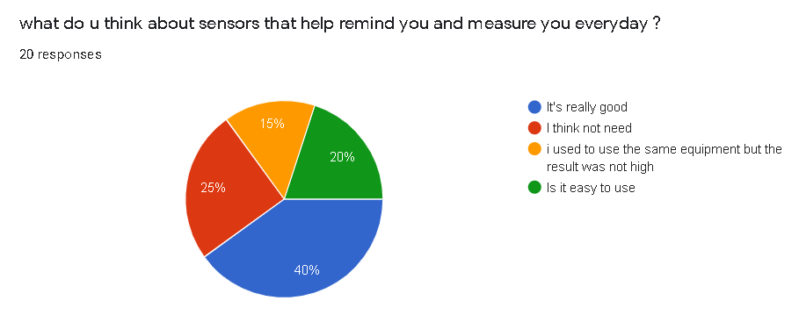

*As you can see on the 40% survey, you feel that using the health meter is really good, but the rest are still not enough reason to convince them so they still find the device unnecessary. About 20% still do not know how to use it.*

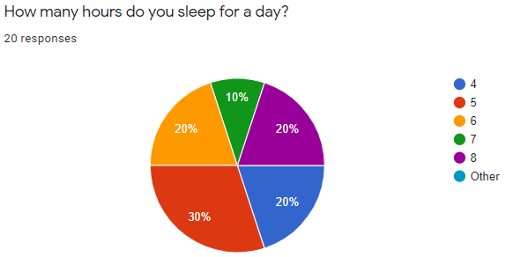

*Out of the 20 responses we got were 30% of people sleeping 5 hours a day, 20% (6, 4, 8) hours a day, 10% sleeping 7 hours a day. According to statistics, the majority of Vietnamese have poor sleep quality such as difficulty sleeping, sleepwalking, loud snoring, etc. Maybe these reasons affect your scientific sleep hours.*

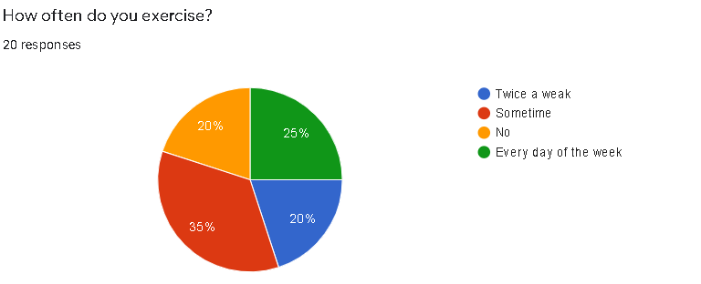

*Through this map we can see that today people have consciously exercising to improve their health and prevent diseases with up to 80%. But of these, only 45% exercise regularly, and still 20% of the rest do not exercise at all for various reasons.*

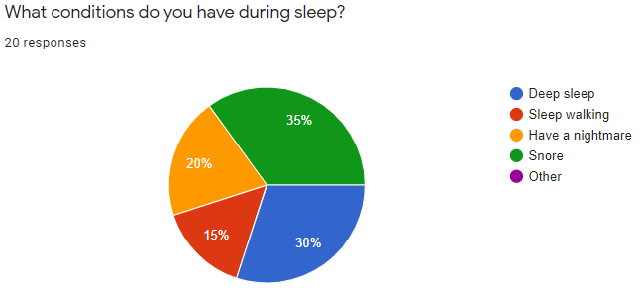

*Indeed, 35% out of 20 answers to the question "What conditions do you have during sleep?" snoring and 30% deep sleep. A third person is 20% of people sleepwalking. These are the factors that cause sleep problems leading to poor quality of sleep in Vietnam. Digital Wellbeing: Health device helps you reduce symptoms such as insomnia, sleepwalking, etc, by scientific methods such as listening to soft music without words, scheduling for you before bed, monitoring cycle sleep and report back to you. The average sleep / wake cycle is the five stages of sleep, with stages 1-2 of light sleep, 3-4 deep sleep, and the fifth stage of REM sleep (rapid eye movement).*

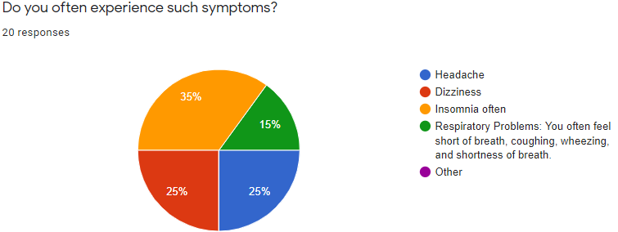

*Number of most answers to the question "Do you often experience such symptoms?"**35% of people often lose sleep, 25% experience dizziness and headache. Typically, these symptoms are due to the relatively low oxygen levels in the blood of about 88% (alarming level). Therefore, our Digital Wellbeing: Health device can measure and give you some tips to reduce the chance of stroke.*

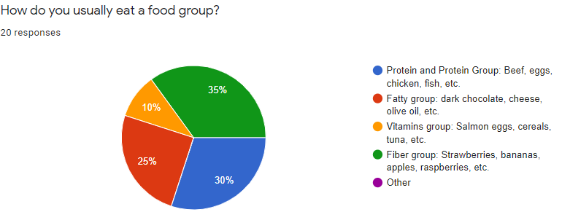

*In addition to monitoring sleep cycles, measuring blood concentration, heart rate, we can learn about nutrition for the elderly and useful advice synthesized. According to the survey diagrams we see that most people have a daily diet high in fiber that is good for the digestive system (35%).*

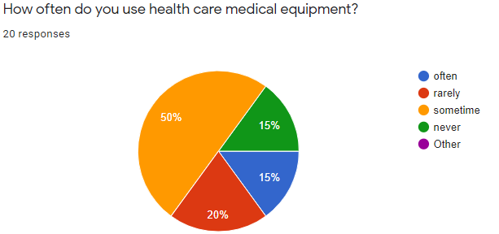

*50 out of 100% sometime use health care equipment. That shows the effectiveness and important value of health care device for teenagers.*

# **4. Analyze the result of the primary research**

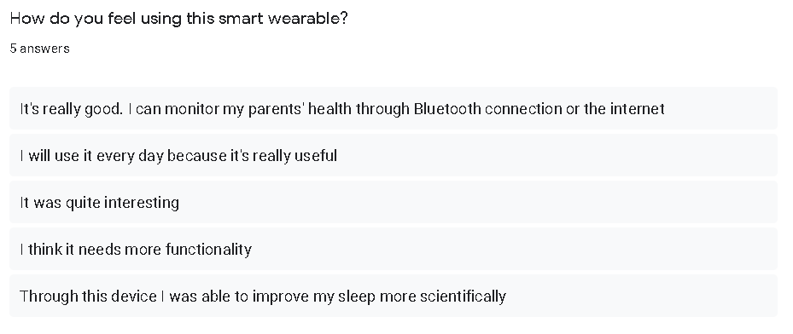

*Through interviews from 5 people out of 20 that I have surveyed before. The results showed quite clearly that the users who used it quite liked this product, it was really useful in their lives. It has contributed to making their lives better through indirect or direct way depending on how they feel.*

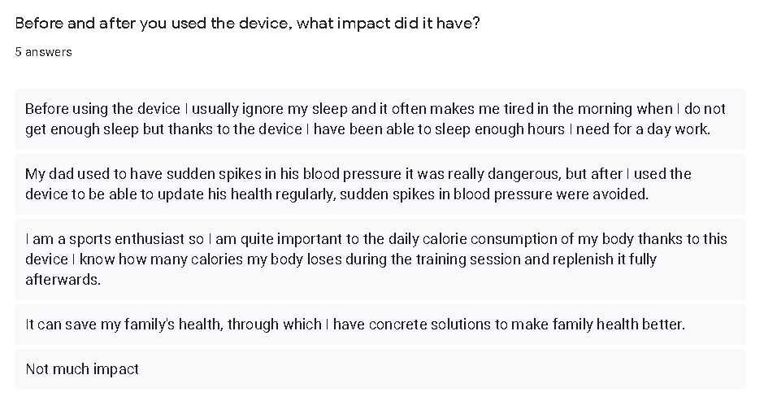

*I am quite happy to see my device having quite a bit of an impact on the users. My product has made it easier for people to track the health of their family members as well as their personal health, so that they can take better measures or ways to deal with them. Improving essentials for the health of their loved one.*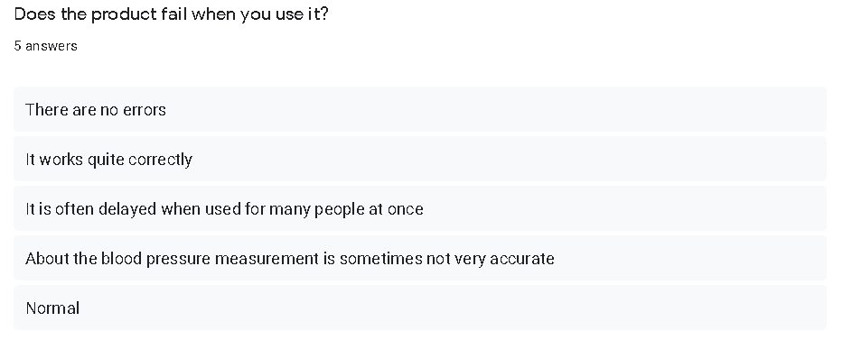

*On the other hand, my device still has small errors like the answer table above, sometimes making a product will always have small or big errors but I will try to fix it to bring the best device for everyone.*

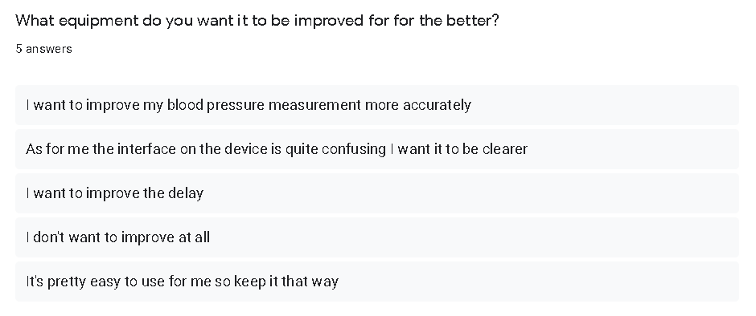

*Finally, on product improvement, their users gave good reasons to somehow help me improve my app better and more relevant to direct users. And indirectly of the application, I will update the shortcomings quickly and efficiently.*

**Recommendations after analysis.**

* Regularly update information from different rating sources of equipment to know what to upgrade or change.
* Test equipment regularly for the best results
* Evaluation and review should supplement funding for necessary parts of this research activity
* Identify research options to minimize duplication with other devices.
* Maximize the use of manpower and equipment

**Conclusion**

After analyzing data from two surveys before and after using the device, it is possible to see how important fitness tracking devices are today. Digital Wellbing equipment in general has been improving the health of patients as well as those who want to enhance their health with high accuracy. At the same time, this device should be further improved such as fixing delays, inaccuracies and the interface will be completed according to reasonable layouts for easy user use. The purpose of this device is to make everyone's health better in order to do the things they love in the most refreshing way.

# **5. Approved project proposal-appendix**

Research Proposal Form

Student name: Nguyễn Thành Phát

Centre name: University of Greenwich (Vietnam) - Ho Chi Minh

Tutor: Ho Nguyen Phu Bao

Unit: Computing Research Project

Student number: GCS18681

Date: 12 Dec 2020.

Proposed title: Smart bracelet health monitoring

|  |
| --- |
| **Section One: Title, objective, responsibilities** |
| Project title: Smart wearable device to monitor health  - The purpose of using the smart bracelet is to actively monitor the health of family members, its functions include measuring heart rate, blood pressure, blood oxygen concentration and muscle activity can. And how this bracelet works is you choose the heart rate function on the bracelet and hold for a few seconds then the bracelet will give the result or choose the blood pressure measurement mode and keep the bracelet on the wrist, waiting one minute will give results.  The bracelet also displays the concentration of oxygen in the blood, helping you to avoid the risk of hypoxia in the blood; Equipped with Bluetooth 4.0 low energy standard that allows you to connect with your phone to receive notifications and display content of calls and messages.  From there, family members such as children can know the health of their parents and grandparents through text messages and take measures to intervene, improve, and improve their lifestyle health for each person. |
| **Section Two: Reasons for choosing this research project** |
| Section Two: Reasons for choosing this research project  The reason for me to choose this project is that I really value my health and everyone, too, can be healthy and can do many useful things for themselves, family and society. Your health is not good it can affect your life so much as at work or conversations or traveling it is not complete and you will not be able to do your best with it. So this project will partly help users improve their health in the best way. |
| **Section Three: Literature sources searched** |
| 1. Netmeds. 2020. Medical Devices: 5 Must-Have Health Monitors In Every Household. [online] Available at: <https://www.netmeds.com/health-library/post/medical-devices-5-must-have-health-monitors-in-every-household> [Accessed 6 October 2020]. 2. Dl.acm.org. 2020. Designing A Desirable Smart Bracelet For Older Adults | Proceedings Of The 2013 ACM Conference On Pervasive And Ubiquitous Computing Adjunct Publication. [online] Available at: <https://dl.acm.org/doi/abs/10.1145/2494091.2495974> [Accessed 7 October 2020]. 3. 2020. [online] Available at: <https://www.amazon.com/Bracelet-Pressure-Monitoring-Fitness-Tracker/dp/B07NWYJSMR> [Accessed 7 October 2020]. 4. 2020. Thực Trạng Và Xu Hướng Tăng Huyết Áp Và Bệnh Tim Mạch Trên Thế Giới Và Ở Việt Nam. [online] Available at: <http://viendinhduong.vn/vi/tin-tuc/thuc-trang-va-xu-huong-tang-huyet-ap-va-benh-tim-mach-tren-the-gioi-va-o-viet-nam.html> [Accessed 9 November 2020]. 5. Tinduc.vn. 2020. *Vòng Tay Theo Dõi Sức Khỏe, Đo Nhịp Tim Cao Cấp Q-Band Q69HR New - Taiwan*. [online] Available at: <https://www.tinduc.vn/vong-theo-doi-suc-khoe/vong-tay-theo-doi-suc-khoe-do-nhip-tim-cao-cap-q-band-q69hr-new-day-mau-den.html> [Accessed 14 November 2020]. 6. Tailieuso.udn.vn. 2020. [online] Available at: <http://tailieuso.udn.vn/bitstream/TTHL_125/4926/3/Tomtat.pdf> [Accessed 20 November 2020]. 7. Support.garmin.com. 2020. *Chức Năng Giám Sát Giấc Ngủ Nâng Cao Trong Garmin Connect | Garmin Trung Tâm Hỗ Trợ*. [online] Available at: <https://support.garmin.com/vi-VN/?faq=mBRMf4ks7XAQ03qtsbI8J6> [Accessed 20 November 2020]. 8. Reviewers, A., 2020. *Stages Of Sleep: The Sleep Cycle | American Sleep Association*. [online] American Sleep Association. Available at: <https://www.sleepassociation.org/about-sleep/stages-of-sleep/> [Accessed 21 November 2020]. 9. VINAMATTRESS. 2020. *CÔNG THỨC “VÀNG” TÍNH CHỈ SỐ GIẤC NGỦ NGON MỖI ĐÊM*. [online] Available at: <https://vinamattress.vn/vi/tin-tuc/tin-cong-ty/cong-thuc-vang-tinh-chi-so-giac-ngu-ngon-moi-dem.html> [Accessed 21 November 2020]. 10. Ggfc.vn. 2020. *CÁCH TÍNH LƯỢNG CALO NẠP VÀO CƠ THỂ HÀNG NGÀY BẠN CẦN BIẾT*. [online] Available at: <https://ggfc.vn/kiem-tra-calories/cach-tinh-luong-calo-nap-vao-co-the-hang-ngay-ban-can-biet-ida596> [Accessed 26 November 2020]. |
| **Section Four: Activities and timescales** |
| Activities to be carried out during the research project (e.g. research,  development, analysis of ideas, writing, data collection, numerical analysis,  tutor meetings, production of final outcome, evaluation, writing the report) and likely durations:      Milestone one: Identify the problem  • Project objectives  • Request  • Feasibility of the application  Target Date: October 6 to 11 Otc. (2020)  Milestone two: Plan  • Prepare related documents  • Choose a research method  • Decide on sample design  Target Date: October 12 to October 22 (2020)  Milestone three: Data collection  • Collects existing data through news, videos, books, etc.  o Causes of cardiovascular disease, increased or decreased blood pressure, health and sleep problems  o Scope and rating of smart wearable devices.  • Survey  • Interview  Target Date: October 22 to November 26 (2020)  Milestone four: Data analysis  • Aggregate data collected  • Identify the main problem of the data  • Draw map  • Proposing a solution to the problem  Target Date: November 26 to December 19 (2020)  Year mark: Report writing  • Synthesize the above information and write into a complete report  Target Date: December 1 to December 21 (2020) |
| **Section Five: Research approach and methodologies** |
| Types of approaches and research methods you are likely to use and the reasons for your choice:  • Search and get statistics from expert studies, newspapers, magazines.  • Survey the popularity and needs of devices and applications to manage blood pressure, heart rate, and health needs of the population.  • Interview people who have used the app to improve future features.  What your area of ​​study will include:  • Participants are required to use a smart wearable regardless of age or job sex.  • Research on Causes of High Blood Pressure and Cardiovascular Disease  • Research integrated into the device functions such as measuring sleep, calories consumed during the day to infer whether the health is stable or not. |

# **6. Approved project plan-appendix**

|  |
| --- |
| Section One: Basic detail |
| Project title: Smart wearable device to monitor health  Student name: Nguyen Thanh Phat  Student number: GCS18681  Development phase: Data income and user surveys  For approve: Ho Nguyen Phu Bao  Date: 12/12/2020 |
| Section two: Scope |
| The project is studied for 3 months from the project start date. Research focuses on cardiovascular diseases and blood pressure. Moreover, the device also has integrated health monitoring functions such as measuring sleep, oxygen concentration and calories consumed in a day. I surveyed 20 people around Binh Thanh district to better understand user needs before scaling up and contacted several people who used the device to check the accuracy of the device bring and improve the device for the better one. |
| Section three: Time |
| The project will be delivered within 3 months from the date of start of the project |
| Section four: Cost |
| This project 30.000US we invest, we must complete the project within 3 months. Salary per employee was 600 US 1 month and the rest are costs incurred in the implementation process. |
| Section five: Quality |
| Standard   * Precision tools and techniques. * Measurement capacity. * Conclusion after completing the project   Planning   * Estimate the scope of the project * Determine and divide the tasks to be performed. * Methods and approaches to conducting research. |
| Section six: Resource Requirements |
| Financial resources   * Includes machinery equipment for equipment design * Capital money to spend the necessary things   Human resources   * Technical team * Construction team * Human Resource Management * Accounting department |
| Section seven: Risk |
| Personal information may be exposed  The user's current location is connected to the internet  Personal camera hacking is possible |

# **7. Ethical form**

|  |
| --- |
| **Section One: Basic details** |
| Project title: Smart wearable device to monitor health  Student name: Nguyen Thanh Phat  Student number: GCS18681  Programme: Computing Research Project  School: FPT Greenwich University  Intended research start date: 5/9/2020  Intended research end date: 21/12/2020 |
| **Section Two: Project summary** |
| Please select all research methods that you plan to use as part of your project:  • Interviews ☒  • Questionnaires ☒  • Observations ☐  • Use of personal records ☐  • Data analysis ☒  • Action research ☐  • Focus groups ☒  • Other (please specify): Survey by Google form |
| **Section Three: Participants** |
| **Please answer the following questions, giving full details where necessary.**   * Will your research involve human participants?   Yes: ☒ No: ☐   * Who are the participants? Tick all that apply:   Children/legal minors (anyone under the age of 18 years): ☒  Students or staff of this University: ☒  Adults (over the age of 18 years and competent to give consent): ☒  • How will the participants be recruited?  Participants are people with smartphones and from all walks of life. They will answer questions to research the project and all of that data will be saved on the Google Form system  • Describe the processes you will use to inform participants about what you are doing:  Participants in the survey are in a completely voluntary state. We went around the Binh Thanh area to track down the subjects, after obtaining the consent of the participants. We will send the subjects a link to take the survey. In order to protect audience information, we will not publish results displayed. Subjects reserve the right to withdraw from the study at any time and for any reason.  **Studies involving questionnaires:**   * Will you give participants the option of omitting questions that they do not want to answer?   Yes: ☒ No: ☐  *If No please explain why below and ensure that you cover any ethical issues arising from this:*  **Studies involving observation:**   * Will you debrief participants at the end of their participation (i.e. give them a brief explanation of   the study)?  Yes: ☒ No: ☐   * Will participants be given information about the findings of your study? (This could be a brief   summary of your findings in general.)  Yes: ☐ No: ☒ |
| **Section Four: Data storage and security** |
| * Confirm that all personal data will be stored and processed in compliance with the Data Protection Act (1998):   Yes: ☒ No: ☐   * Who will have access to the data and personal information?   The professor who is in charge of the subject, the leader of the project.  **During the research:**   * Where will the data be stored?   Cloud storage - DropBox   * Will mobile devices (such as USB storage and laptops) be used?   Yes: ☒ No: ☐  If yes, please provide further details:  For people who are allowed to bring data out of the company, they must sign a statement about this and if the data is lost or leaked out then they will be responsible.  **After the research:**   * Where will the data be stored?   Cloud storage - DropBox   * How long will the data and records be kept for and in what format?   The data and records be kept for 3 months in cloud storage of company   * Will data be kept for use by other researchers?   Yes: ☒ No: ☐  If yes, please provide further details:  The data will be inherited by other researchers but must be approved by the supervisor, who is  Responsible for the project. |
| **Section Five: Ethical issues** |
| Are there any particular features of your proposed work which may raise ethical concerns? If so,  please outline how you will deal with these:  It is important that you demonstrate your awareness of potential risks that may arise as a result of  your research. Please consider/address all issues that may apply. Ethical concerns may include, but  are not limited to the following:   * Informed consent. * Potentially insecure respondents. * Sensitive subjects. * Risks to respondents and / or scientists. * Anonymity / secrecy. * Disclosures / restrictions on privacy. * Storage and protection of data, both during and after studies (including transmission, sharing, Security, encryption). * Reporting. * Disseminate your results and use them. |
| **Section Six: Declaration** |
| I have read, understood and will abide by [Harvard] Research Ethics Policy:  Yes: ☒ No: ☐  I have discussed the ethical issues relating to my research with my Unit Tutor:  Yes: ☒ No: ☐  I confirm that to the best of my knowledge:  The above information is correct and that this is a full description of the ethics issues that may arise  in the course of my research.  Name: Nguyen Thanh Phat  Date: 12/12/2020  Please submit your completed form to: ..................Ho Nguyen Phu Bao........................... |