Lab5:
Bài 1:
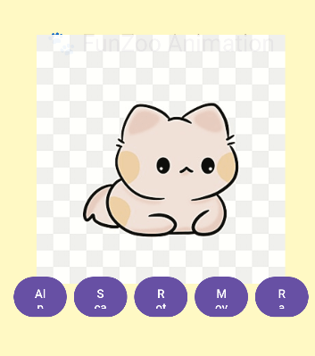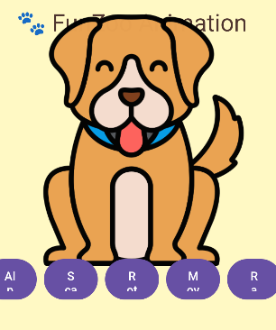
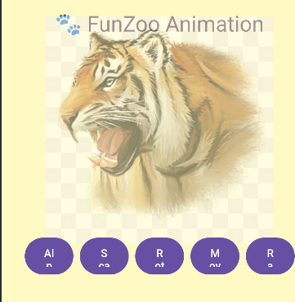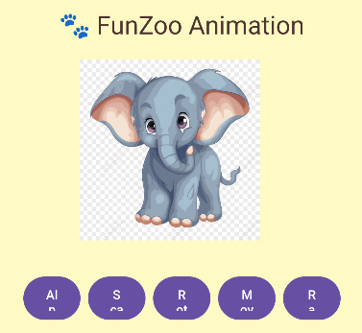

Code:
MainActivity
package com.example.lab5app;
import android.content.Intent;
import android.os.Bundle;
import android.view.View;
import android.view.animation.AnimationUtils;
import android.widget.ImageView;
import androidx.appcompat.app.AppCompatActivity;
import java.util.Random;
public class MainActivity extends AppCompatActivity implements View.OnClickListener {
private ImageView ivAnimal;
private int[] anims = {R.anim.alpha, R.anim.rotate, R.anim.scale, R.anim.translate};
private int[] animals = {
R.drawable.ic_cat, R.drawable.ic_dog, R.drawable.ic_elephant, R.drawable.ic_tiger
};
private Random random = new Random();
@Override
protected void onCreate(Bundle savedInstanceState) {
super.onCreate(savedInstanceState);
setContentView(R.layout.activity_main);
ivAnimal = findViewById(R.id.iv_animal);
ivAnimal.setImageResource(animals[random.nextInt(animals.length)]);
findViewById(R.id.bt_alpha).setOnClickListener(this);
findViewById(R.id.bt_scale).setOnClickListener(this);
findViewById(R.id.bt_rotate).setOnClickListener(this);
findViewById(R.id.bt_trans).setOnClickListener(this);
findViewById(R.id.bt_random).setOnClickListener(this);
// Nhấn nhẹ: animation vui
ivAnimal.setOnClickListener(v ->
ivAnimal.startAnimation(AnimationUtils.loadAnimation(this, R.anim.pulse))
);
// Nhấn giữ: mở thông tin chi tiết
ivAnimal.setOnLongClickListener(v -> {
Intent intent = new Intent(this, QuickInfoActivity.class);
intent.putExtra("name", "Elephant 🐘");
intent.putExtra("phone", "0966-888-123");
intent.putExtra("avatar", R.drawable.ic_elephant);
startActivity(intent);
overridePendingTransition(R.anim.slide_in_right, android.R.anim.fade_out);
return true;
});
}
@Override
public void onClick(View v) {
int id = v.getId();
int animRes = 0;
if (id == R.id.bt_alpha) {
animRes = R.anim.alpha;
} else if (id == R.id.bt_scale) {
animRes = R.anim.scale;
} else if (id == R.id.bt_rotate) {
animRes = R.anim.rotate;
} else if (id == R.id.bt_trans) {
animRes = R.anim.translate;
} else if (id == R.id.bt_random) {
ivAnimal.setImageResource(animals[random.nextInt(animals.length)]);
animRes = anims[random.nextInt(anims.length)];
}
ivAnimal.startAnimation(AnimationUtils.loadAnimation(this, animRes));
}
}
alpha
<alpha xmlns:android="http://schemas.android.com/apk/res/android"
android:duration="1000"
android:fromAlpha="1.0"
android:toAlpha="0.2"
android:repeatCount="infinite"
android:repeatMode="reverse"/>
pulse
<set xmlns:android="http://schemas.android.com/apk/res/android">
<scale
android:duration="300"
android:fromXScale="1"
android:toXScale="1.2"
android:fromYScale="1"
android:toYScale="1.2"
android:pivotX="50%"
android:pivotY="50%"
android:repeatCount="1"
android:repeatMode="reverse"/>
<rotate
android:duration="300"
android:fromDegrees="-10"
android:toDegrees="10"
android:repeatCount="1"
android:repeatMode="reverse"/>
</set>
rotate
<rotate xmlns:android="http://schemas.android.com/apk/res/android"
android:duration="1000"
android:fromDegrees="0"
android:toDegrees="360"
android:repeatCount="infinite"/>
scale
<scale xmlns:android="http://schemas.android.com/apk/res/android"
android:duration="800"
android:fromXScale="1"
android:toXScale="1.5"
android:fromYScale="1"
android:toYScale="1.5"
android:pivotX="50%"
android:pivotY="50%"
android:repeatCount="infinite"
android:repeatMode="reverse"/>
slide_in_right
<translate xmlns:android="http://schemas.android.com/apk/res/android"
android:fromXDelta="100%"
android:toXDelta="0%"
android:duration="400"/>
translate
<translate xmlns:android="http://schemas.android.com/apk/res/android"
android:duration="800"
android:fromXDelta="-80"
android:toXDelta="80"
android:repeatCount="infinite"
android:repeatMode="reverse"/>
activity_main
<?xml version="1.0" encoding="utf-8"?>
<LinearLayout xmlns:android="http://schemas.android.com/apk/res/android"
xmlns:tools="http://schemas.android.com/tools"
android:layout_width="match_parent"
android:layout_height="match_parent"
android:orientation="vertical"
android:gravity="center"
android:padding="16dp"
android:background="#FFF9C4"
tools:context=".MainActivity">
<TextView
android:text="🐾 FunZoo Animation"
android:textSize="28sp"
android:textColor="#4E342E"
android:layout_marginBottom="20dp"
android:layout_width="wrap_content"
android:layout_height="wrap_content"/>
<ImageView
android:id="@+id/iv_animal"
android:layout_width="200dp"
android:layout_height="200dp"
android:src="@drawable/ic_elephant"
android:contentDescription="@string/app_name"/>
<LinearLayout
android:orientation="horizontal"
android:layout_marginTop="40dp"
android:gravity="center"
android:layout_width="match_parent"
android:layout_height="wrap_content"
android:weightSum="5"
android:paddingHorizontal="10dp">
<Button
android:id="@+id/bt_alpha"
android:layout_width="0dp"
android:layout_weight="1"
android:layout_height="48dp"
android:text="Alpha"
android:textAllCaps="false"
android:textColor="#FFFFFF"
android:background="@drawable/bg_button_pill"
android:layout_marginHorizontal="4dp"/>
<Button
android:id="@+id/bt_scale"
android:layout_width="0dp"
android:layout_weight="1"
android:layout_height="48dp"
android:text="Scale"
android:textAllCaps="false"
android:textColor="#FFFFFF"
android:background="@drawable/bg_button_pill"
android:layout_marginHorizontal="4dp"/>
<Button
android:id="@+id/bt_rotate"
android:layout_width="0dp"
android:layout_weight="1"
android:layout_height="48dp"
android:text="Rotate"
android:textAllCaps="false"
android:textColor="#FFFFFF"
android:background="@drawable/bg_button_pill"
android:layout_marginHorizontal="4dp"/>
<Button
android:id="@+id/bt_trans"
android:layout_width="0dp"
android:layout_weight="1"
android:layout_height="48dp"
android:text="Move"
android:textAllCaps="false"
android:textColor="#FFFFFF"
android:background="@drawable/bg_button_pill"
android:layout_marginHorizontal="4dp"/>
<Button
android:id="@+id/bt_random"
android:layout_width="0dp"
android:layout_weight="1"
android:layout_height="48dp"
android:text="Random"
android:textAllCaps="false"
android:textColor="#FFFFFF"
android:background="@drawable/bg_button_pill"
android:layout_marginHorizontal="4dp"/>
</LinearLayout>
</LinearLayout>
Bài 2:
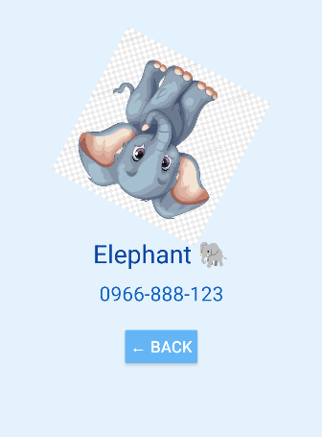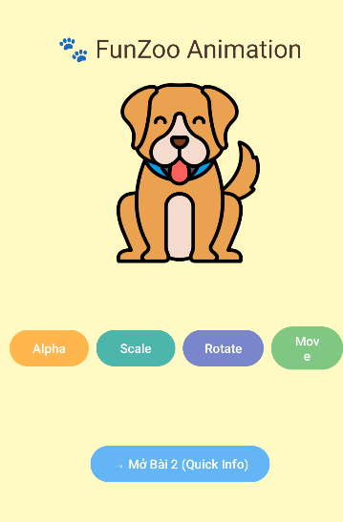
QuickInfoActivity
package com.example.lab5app;
import android.os.Bundle;
import android.view.animation.AnimationUtils;
import android.widget.Button;
import android.widget.ImageView;
import android.widget.TextView;
import androidx.appcompat.app.AppCompatActivity;
public class QuickInfoActivity extends AppCompatActivity {
@Override
protected void onCreate(Bundle savedInstanceState) {
super.onCreate(savedInstanceState);
setContentView(R.layout.activity_quick_info);
ImageView ivAvatar = findViewById(R.id.iv_avatar);
TextView tvName = findViewById(R.id.tv_name);
TextView tvPhone = findViewById(R.id.tv_phone);
Button btnBack = findViewById(R.id.btn_back);
// Lấy dữ liệu từ Intent
String name = getIntent().getStringExtra("name");
String phone = getIntent().getStringExtra("phone");
int avatar = getIntent().getIntExtra("avatar", R.drawable.ic_person);
tvName.setText(name);
tvPhone.setText(phone);
ivAvatar.setImageResource(avatar);
// Animation khi mở activity
ivAvatar.startAnimation(AnimationUtils.loadAnimation(this, R.anim.rotate));
// Nút Back có hiệu ứng scale
btnBack.setOnClickListener(v -> {
v.startAnimation(AnimationUtils.loadAnimation(this, R.anim.scale));
finish();
overridePendingTransition(android.R.anim.fade_in, android.R.anim.fade_out);
});
}
}
rotate
<rotate xmlns:android="http://schemas.android.com/apk/res/android"
android:duration="1000"
android:fromDegrees="0"
android:toDegrees="360"
android:pivotX="50%"
android:pivotY="50%"
android:repeatCount="infinite" />
scale
<scale xmlns:android="http://schemas.android.com/apk/res/android"
android:duration="800"
android:fromXScale="1"
android:toXScale="1.5"
android:fromYScale="1"
android:toYScale="1.5"
android:pivotX="50%"
android:pivotY="50%"
android:repeatCount="infinite"
android:repeatMode="reverse" />
activity_quick_info
<?xml version="1.0" encoding="utf-8"?>
<LinearLayout xmlns:android="http://schemas.android.com/apk/res/android"
xmlns:tools="http://schemas.android.com/tools"
android:orientation="vertical"
android:gravity="center"
android:padding="20dp"
android:background="#E3F2FD"
android:layout_width="match_parent"
android:layout_height="match_parent"
tools:context=".QuickInfoActivity">
<ImageView
android:id="@+id/iv_avatar"
android:layout_width="180dp"
android:layout_height="180dp"
android:src="@drawable/ic_person"
android:layout_marginBottom="20dp" />
<TextView
android:id="@+id/tv_name"
android:text="Name"
android:textSize="28sp"
android:textColor="#0D47A1"
android:layout_marginBottom="10dp"
android:layout_width="wrap_content"
android:layout_height="wrap_content" />
<TextView
android:id="@+id/tv_phone"
android:text="Phone"
android:textSize="22sp"
android:textColor="#1565C0"
android:layout_marginBottom="20dp"
android:layout_width="wrap_content"
android:layout_height="wrap_content" />
<Button
android:id="@+id/btn_back"
android:text="← Back"
android:textSize="18sp"
android:backgroundTint="#64B5F6"
android:textColor="@android:color/white"
android:padding="8dp"
android:layout_width="wrap_content"
android:layout_height="wrap_content" />
</LinearLayout>

