**LAB 01**

**Table of picture**

Picture 1: Main camera 2

Picture 2: Camera Controller code 2

Picture 3: Camera attribute 3

Picture 4: Plane 4

Picture 5: Plane attribute 4

Picture 6: Player (Sphere) 4

Picture 7: Player Controller code 5

Picture 8: Player attribute 1 Picture 9: Player attribute 2 6

Picture 10: Walls 6

Picture 11: West wall attribute Picture 12: East wall attribute 7

Picture 13: North wall attribute Picture 14: South wall 7

Picture 15: Pick Up 8

Picture 16: Ratotor Pick Up code 8

Picture 17: Pick Up attribute 9

Picture 18: Count Text 9

Picture 19: Count Text attribute 1 Picture 20: Count Text attribute 2 10

Picture 21: Win Text 10

Picture 22: Win Text attribute 1 Picture 23: Win Text attribute 2 11

Picture 24: Assets folder 11

**Picture**

1. Main camera

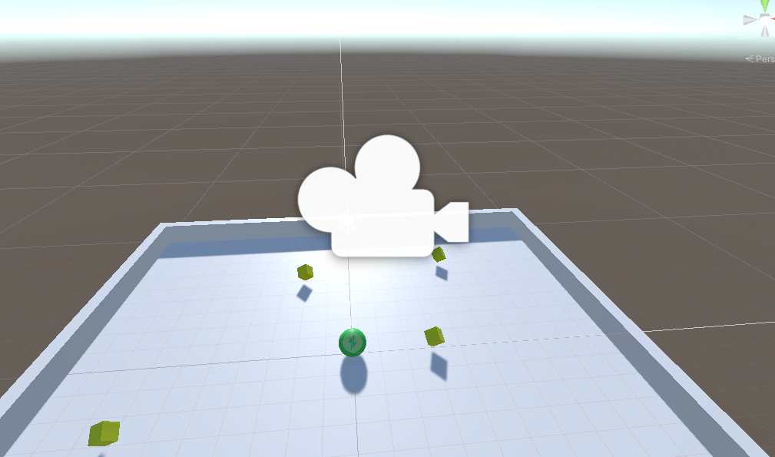

Picture 1: Main camera

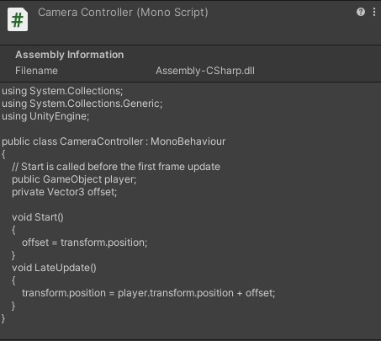

Picture 2: Camera Controller code

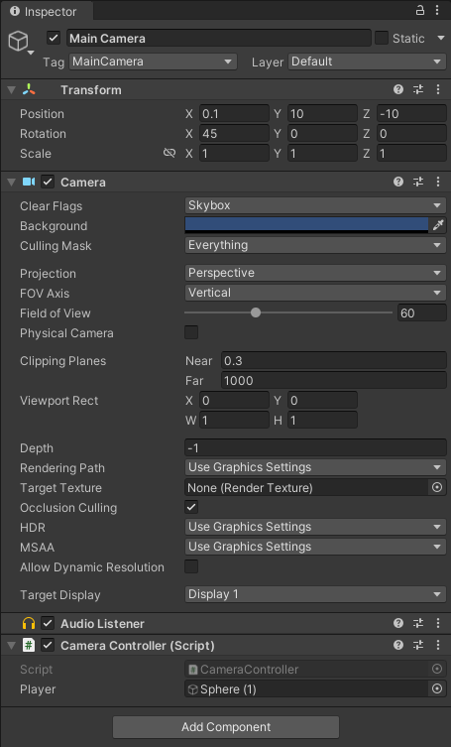

Picture 3: Camera attribute

1. Plane

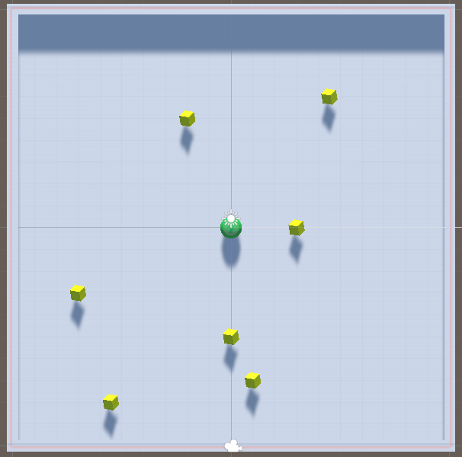

Picture 4: Plane

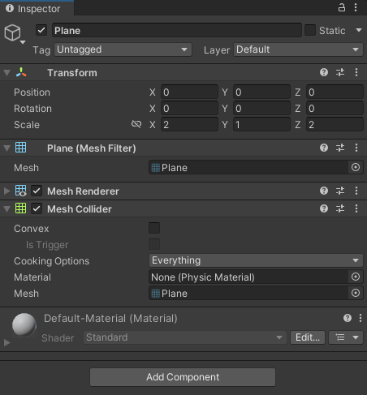

Picture 5: Plane attribute

1. Player

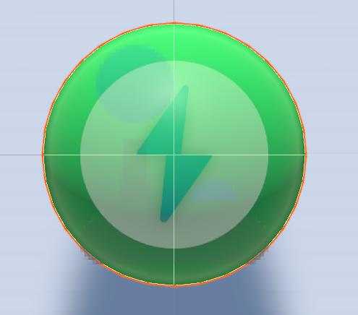

Picture 6: Player (Sphere)

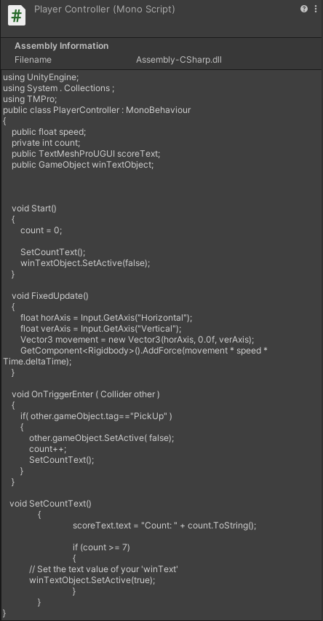

Picture 7: Player Controller code

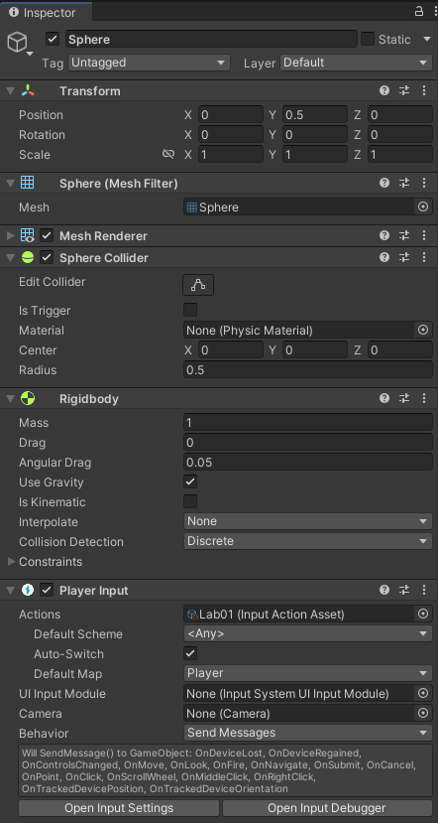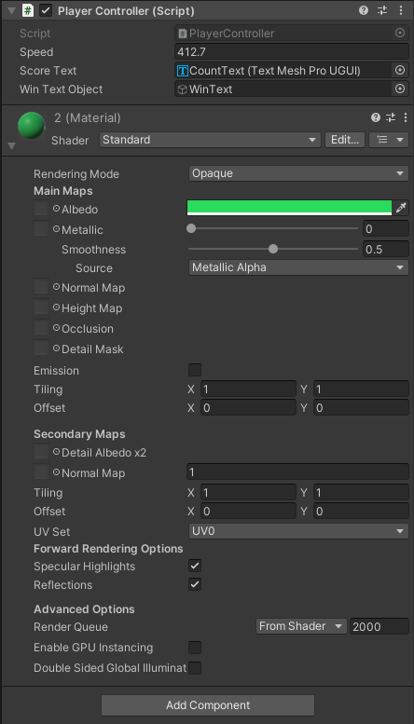

Picture 8: Player attribute 1 Picture 9: Player attribute 2

1. Walls

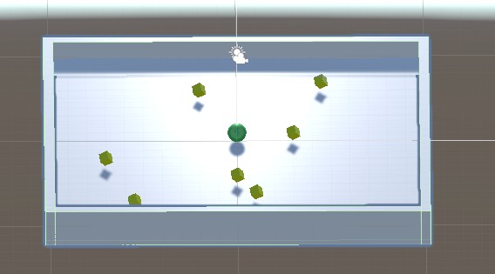

Picture 10: Walls

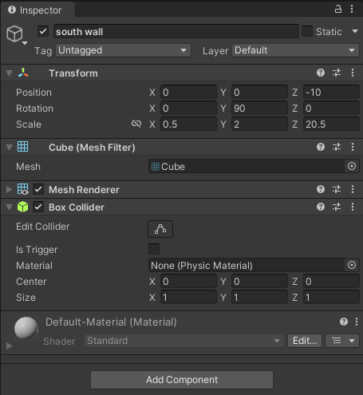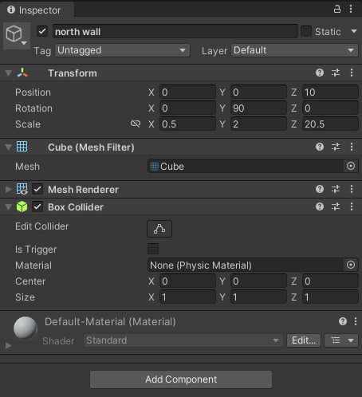 Picture 11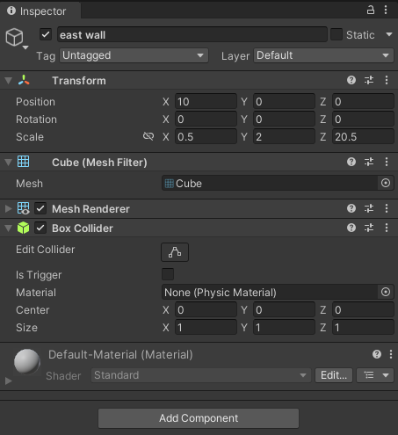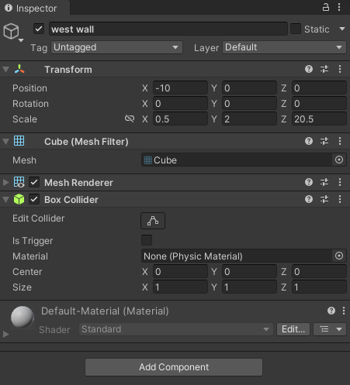: West wall attribute Picture 12: East wall attribute

Picture 13: North wall attribute Picture 14: South wall

1. Pickup

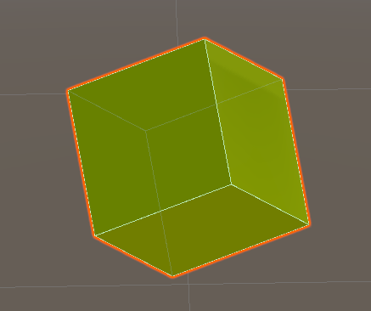

Picture 15: Pick Up

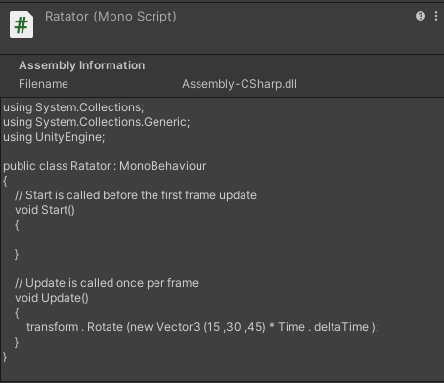

Picture 16: Ratotor Pick Up code

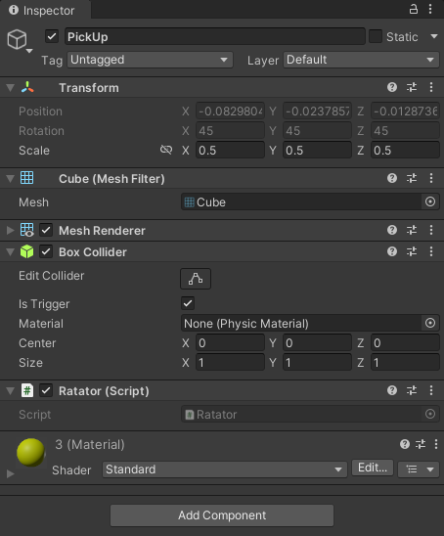

Picture 17: Pick Up attribute

Note: other pick ups are only different positions, the rest are mostly the same.

1. Count Text

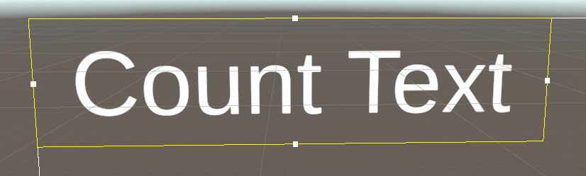

Picture 18: Count Text

Picture 19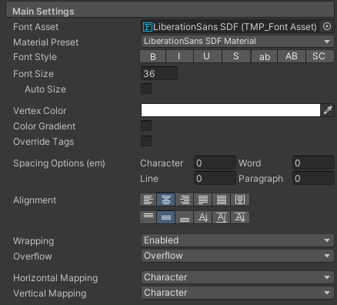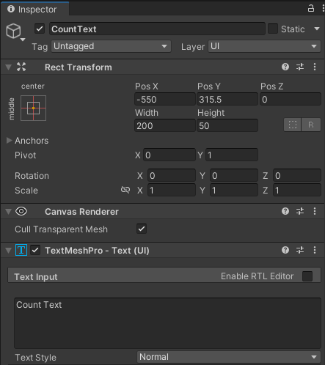: Count Text attribute 1 Picture 20: Count Text attribute 2

1. Win Text

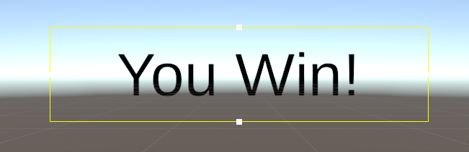

Picture 21: Win Text

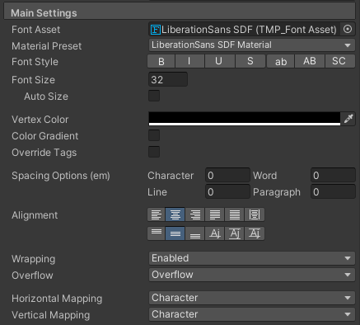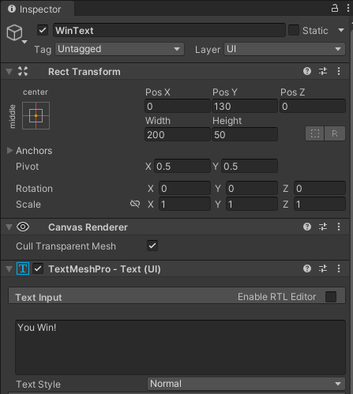 Picture 22: Win Text attribute 1 Picture 23: Win Text attribute 2

1. Assets folder

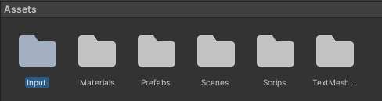

Picture 24: Assets folder