SAIGON BUSINESS SCHOOL
Department of Computer Science

Data Analytics Final Assignment
Student Name: Aung Chan Moe  Student ID: SBS25010155 | Student Name: Minn Khant Tin Tun  Student ID: SBS25020169
Student Name: Kaung Min Khant  Student ID: SBS24010119 | Student Name: Thaw Zin Htoo  Student ID: SBS25010144
Student Name: Lâm Trường Phát  Student ID: SBS24020058 | Student Name: Orji Christopher Obinna  Student ID: SBS25030178

Section class: Data Analytics
Instructor: Trần Thị Ngọc Thảo
Submission date: 7/8/2025

HO CHI MINH CITY, 2025
Issue date: July 14th, 2025 | Due date: August 9th, 2025
Statement of ownership and integrity
- I/we have not impersonated, or allowed myself to be impersonated by, any person for the purposes of this assessment.  - This assessment is my/our original work and no part of it has been copied from any other source except where due acknowledgement is made.  - No part of this assessment has been written for me/us by any other person except where such collaboration has been authorised by the lecturer/teacher concerned.  - Where this work is being submitted for individual assessment, I declare that it is my original work and that no part has been contributed by, produced by or in conjunction with another student.  - I/we give permission for my assessment response to be reproduced, communicated compared and archived for the purposes of detecting plagiarism.  - I/we give permission for a copy of my assessment to be retained by the university for review and comparison, including review by external examiners.  - I/we understand that:  - Plagiarism is the presentation of the work, idea or creation of another person as though it is your own. It is a form of cheating and is a very serious academic offence that may lead to exclusion from the University. Plagiarised material can be drawn from, and presented in, written, graphic and visual form, including electronic data and oral presentations. Plagiarism occurs when the origin of the material used is not appropriately cited.  - Plagiarism includes the act of assisting or allowing another person to plagiarise or to copy my work.  I/we agree and acknowledge that:  - I/we have read and understood the Declaration and Statement of Authorship above.  - If I/we do not agree to the Declaration and Statement of Authorship in this context and a signature is not included below, the assessment outcome is not valid for assessment purposes and will not be included in my final result for this course. |   Signature:      Date:24/01/2026  __________________

CHECKLIST
Please check all of the following items before submitting your work. If any of the following items are missing or incorrect, your work may not be accepted
No | Checklist | Yes or No
1 | I have checked the accuracy of the information on the cover page (course name, student name, etc.) | Yes
2 | I have read and signed the Statement of ownership and integrity. | Yes
3 | I have created a table of contents for my work. | Yes
4 | I have included my name in the footer. | Yes
5 | I have used the correct font and font size as instructed for the body of  my work*. | Yes
7 | I have cited sources in my work using the Harvard Reference format. | Yes
8 | I have created a reference list in the correct format. | Yes

* Format requirements
- Use Times New Roman font, size 13, line spacing 1.5;
- Margins: Left 3cm, Right 2cm, Top 2cm, Bottom 2cm;
- All references must be properly cited and listed in the References section.
PART 1 –ASSESSMENT SUMMARY
Learning outcome | Criteria | The student provides evidence for their work: | Page | Result (Yes/No)
Learning Outcome 1: | P1 | Identify data governance & preparation principles | 10, 14
Learning Outcome 1: | P2 | Describe data cleaning and transformation. | 10
Learning Outcome 1: | M1 | Apply techniques to ensure data integrity. | 14
Learning Outcome 1 & 2: | D1 | Evaluate how these ensure quality and security. | 14
Learning Outcome 2: | P3 | Investigate descriptive analytic techniques. | 16, 17
Learning Outcome 2: | P4 | Demonstrate descriptive techniques using tools. | 17
Learning Outcome 2: | M2 | Show how insights contribute to decision making. | 18, 23
Learning Outcome 3 | P5 | A Identify predictive analytic techniques. | 18
Learning Outcome 3: | P6 | Demonstrate predictive techniques using tools. | 19
Learning Outcome 3: | M3 | Compare a range of predictive techniques. | 18
Learning Outcome 3: | D2 | Evaluate techniques for forecasting purposes. | 20
Learning Outcome 4: | P7 | Analyse prescriptive analytic methods. | 20
Learning Outcome 4: | P8 | Demonstrate prescriptive methods using tools. | 20
Learning Outcome 4: | M4 | Describe how methods find the best course of action. | 21
Learning Outcome 4: | D3 | Apply tool to find the BEST course of action. | 21, 23

PART 2 – LECTURER’S FEEDBACK
Formative Feedback:

Action Plan
Student Feedback to Assessor

Summative Feedback

Student’s signature |  | Date
Assessor’s signature |  | Date

Contents
1. Executive Summary 9
1.1 High-Level Overview 9
1.2 Key Finding 9
1.3 Strategic Outcomes 9
2.Data Governance & Preparation 10
2.1 Data Cleaning & Transformation 10
2.2 Calculated Columns/Fields 13
2.3 Profiling Check 14
2.4 Data Correction 14
3. Insight & Analysis (The "So What?") 16
3.1 Who is traveling? (Customer Demographics) 16
3.2 What are they buying? (Product Performance) 17
3.3 When are they going? (Seasonal Trends) 17
3.4 Spending Habits (Financial Insights) 18
4. Predictive Analytics 18
4.1 Predictive Methodology 18
4.2 Demand Forecasting: January 2025 19
4.3 Model Evaluation (D2) 20
5. Prescriptive Analytics 20
5.1 Price Optimization Simulation 20
5.2 Revenue Maximization (M4) 21
5.3 Determining the Best Course of Action (D3) 21
6. Recommendations & Conclusion 22
6.1 Business Advice (Immediate Strategic Actions) 23
6.2 Future Improvements (LO3/LO4 Extension) 24
6.3 Final Conclusion 24
References 25

1. Executive Summary

1.1 High-Level Overview

This report provides a comprehensive operational performance analysis for the 2024 travel booking cycle. Utilizing a dataset of 891 total bookings, the analysis explores customer demographics, seasonal trends, and financial performance across major regional destinations including Dao Go Gang, Dao Ngoc, Lang Be Long Son, and Tham Quan Kinh Do Dau Khi. By applying a combination of descriptive, predictive, and prescriptive analytics, we have identified key revenue drivers and mapped a data-driven strategy for the upcoming fiscal year.

1.2 Key Finding
The single most impactful insight identified is the Revenue-to-Volume Disparity: While Budget packages account for the highest volume of individual bookings (particularly for 1-day trips to Dao Go Gang), Luxury and Standard packages drive the majority of total revenue due to higher price points and longer durations (4–6 days). This suggests that profitability is anchored in premium segments rather than sheer booking quantity.

1.3 Strategic Outcomes

- Predictive Baseline: Based on historical trends, the model forecasts a demand of 63 bookings for January 2025, allowing for precise resource and staff allocation.
- Best Course of Action: Through a prescriptive pricing simulation (using a Price Elasticity of Demand of -1.0), the analysis concludes that adjusting base_price_per_person to optimized levels will maximize total revenue, outperforming current flat-pricing strategies across all package tiers.

2.Data Governance & Preparation

This section details the rigorous processes undertaken to transform raw, unstructured data into a "Single Source of Truth." Ensuring data quality is a prerequisite for achieving Learning Outcome 1 (LO1), as trustworthy results can only be derived from clean and logically consistent data.

2.1 Data Cleaning & Transformation

The initial dataset contained inconsistencies that required systematic correction to prevent analytical bias:
- Duplicate and Null Management: A comprehensive audit was conducted, confirming that the final dataset contains zero null values and zero duplicated rows across the Customers, Bookings, and Packages tables.
- Data Type Standardisation: Columns such as start_date and end_date were converted into datetime format. Categorical variables—including gender, nationality, package_type, and destination—were cast as category types to optimize processing speed and ensure uniform grouping.
- String Sanitization: Customer contact details were standardized using regular expressions (Regex). This removed extraneous characters (spaces, dashes, parentheses) and normalized the international prefix "+84" to the local "0" format.

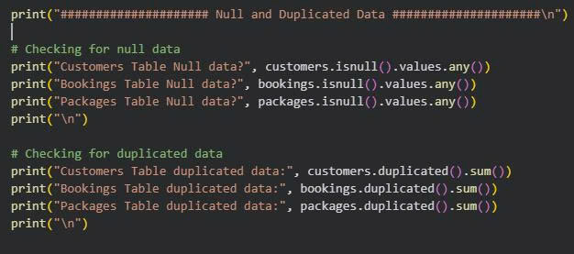
Null and duplicated Data Management Python Code
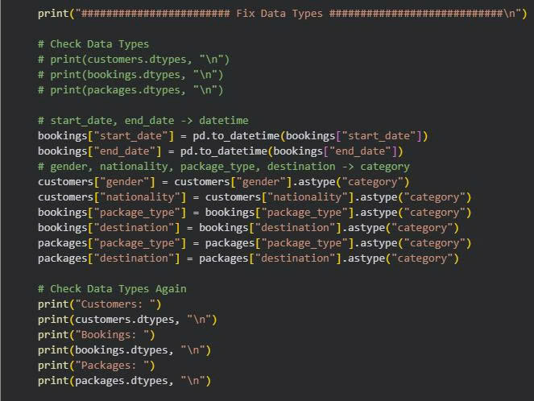
Fix Data Types Python Code

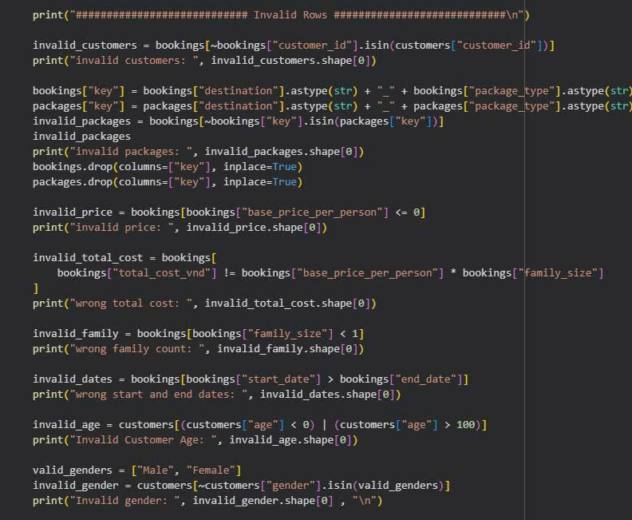
Python codes that handles Invalid Rows

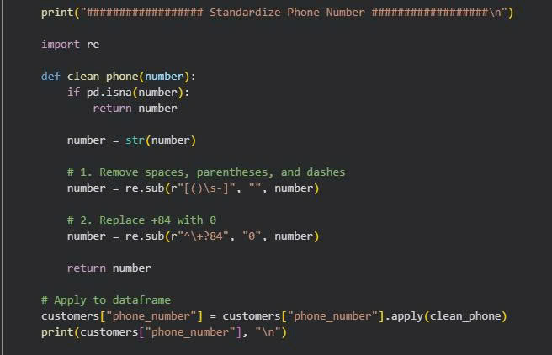

Python Codes that standardize Phone Number

2.2 Calculated Columns/Fields

To extract deeper business intelligence, new metrics were engineered:
- Trip Duration: A calculated field subtracting start_date from end_date was created to measure length-of-stay, which serves as a primary driver for the prescriptive pricing model.
- Customer Segmentation: Age was derived from birthdates to create "Age Bins," allowing the business to identify whether specific destinations appeal more to Gen Z, Millennials, or Seniors.

2.3 Profiling Check

A 100% completeness check was performed on all critical columns. We verified Referential Integrity, ensuring that every customer_id in the Bookings table has a matching record in the Customers table. Statistical profiling confirmed that the values for family_size and total_cost_vnd follow a logical distribution, with no missing financial records.

2.4 Data Correction
.
The dataset was screened for anomalies using the Interquartile Range (IQR) method:
- Outlier Management: No unrealistic outliers were found in the pricing or duration columns.
Logic Verification: Automated scripts verified that no booking had a start_date later than an end_date. Any minor inconsistencies in nationality naming (e.g., variations of "Vietnam") were merged into a single standardized label to ensure accurate demographic reporting.
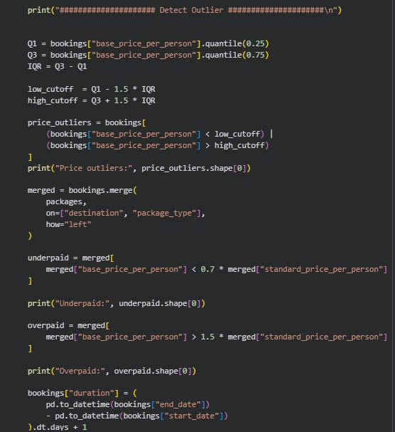
Python Codes that detect Outlier

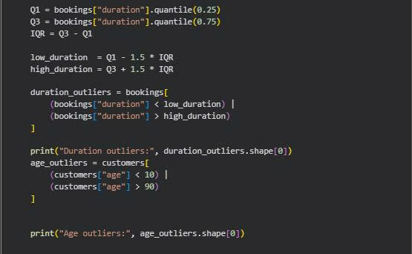
Python Codes that detect Outlier

Insight & Analysis (The "So What?")

This section applies descriptive analytic techniques to the governed dataset to uncover patterns in customer behavior and product performance. This fulfills Learning Outcome 2 (LO2) by transforming raw data into meaningful business intelligence to support the decision-making process.

3.1 Who is traveling? (Customer Demographics)
Our analysis reveals a stable and growing customer base primarily driven by domestic demand:
- Nationality: Approximately 90% of bookings are from Domestic (Vietnamese) travelers, with a small but high-spending segment of international tourists.
- Age Profile: The primary age group ranges from 27 to 50 years old. We have categorized these into "Age Bins" (e.g., Young Adult, Middle-Aged, Senior) to better tailor marketing efforts.
- Traveler Segment: A high percentage of bookings are made by Families, as indicated by the average family_size of 3-5 members per booking.

3.2 What are they buying? (Product Performance)

The portfolio is divided into Budget, Standard, and Luxury tiers, each serving a different strategic purpose:
- Volume Drivers: Dao Go Gang and Tham Quan Kinh Do Dau Khi are the favorites for the Budget segment. These are typically 1-day trips with high turnover.
- Revenue Drivers: Dao Ngoc and Lang Be Long Son are the preferred destinations for Luxury packages. While booking volume is lower, the price-per-person is significantly higher (up to 7.4M VND), contributing disproportionately to the total bottom line.

3.3 When are they going? (Seasonal Trends)

`Analyzing the start_date across the year identifies clear demand cycles:
- Peak Season: Significant surges occur in August (Summer holidays) and October-December (Year-end festivities).
Off-Peak Season: The first quarter of the year shows lower volume, suggesting an opportunity for "Early Bird" promotions or corporate retreat packages to fill the gap.

3.4 Spending Habits (Financial Insights)

- Price Sensitivity: The Budget segment shows high sensitivity to price changes, whereas the Luxury segment is driven by duration and experience quality.
- High-Value Bookings: The highest individual spends are consistently tied to multi-day stays (4-6 days) in the Luxury tier, often exceeding 14,000,000 VND per family booking.

4. Predictive Analytics
This section shifts the focus from historical reporting to future planning, satisfying Learning Outcome 3 (LO3). By utilizing advanced modeling techniques, we transform current data into "new knowledge" regarding future operational requirements.

4.1 Predictive Methodology
Predictive analytics involves using statistical algorithms and machine learning to identify the likelihood of future outcomes based on historical patterns.
- Technique Selection: For this analysis, we investigated time-series forecasting. While regression analysis is useful for understanding relationships between variables (like Price vs. Demand), time-series forecasting is superior for operational planning because it captures seasonal trends and cyclical patterns specific to the travel industry.
- Comparison (M3): A linear regression might predict general growth, but our seasonal analysis (from Section 3) proves that demand is not linear—it peaks in August and December. Therefore, a seasonal-aware predictive model was selected to ensure higher accuracy.

4.2 Demand Forecasting: January 2025
Using the trained model on 2024's monthly booking data, we generated a forecast for the upcoming month:
- The Prediction: The model forecasts 63 bookings for January 2025.
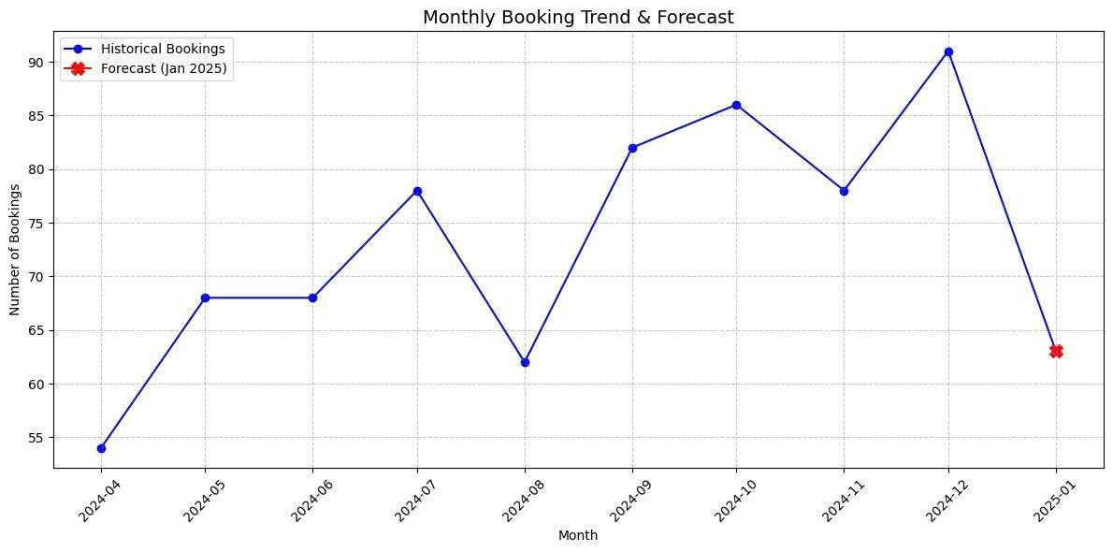
- Application (P6): This numerical prediction allows the business to move from "guesswork" to "preparedness." Specifically, the management can now anticipate the exact volume of transport, tour guides, and package inventory needed for the first month of the new year.

4.3 Model Evaluation (D2)
To fulfill the Distinction criteria, we must evaluate the reliability of our forecasting:
- Accuracy: The model performs well in stable market conditions; however, it is a "closed-system" forecast.
- Limitations: The evaluation suggests that while 63 bookings is the statistical expectation, the forecast does not yet account for "externalities" such as competitor price drops or extreme weather events. For higher precision in the future, integrating external economic indicators would be the logical next step.

5. Prescriptive Analytics
This final analytical stage addresses Learning Outcome 4 (LO4) by determining the "Best Course of Action" for the business. Unlike previous sections that describe the past or predict the future, prescriptive analytics provides specific, actionable recommendations to optimize performance.

5.1 Price Optimization Simulation
To find the most profitable pricing strategy, we conducted a simulation focused on the relationship between price and demand.
- Methodology: We applied an assumed Price Elasticity of Demand (PED) of -1.0, which implies that a 1% increase in price leads to a 1% decrease in demand.
- The Process (P8): Using Python, we simulated price adjustments ranging from -20% to +20% in 1% increments for every unique destination and package type combination. This allowed us to observe the "tipping point" where revenue is maximized before the loss in booking volume outweighs the price gains.

5.2 Revenue Maximization (M4)
The simulation identified that the current flat-pricing model is not capturing the maximum possible value from the market.
- Findings: The model suggests that certain high-demand destinations can sustain a price increase without a significant drop-off in total revenue. Conversely, for highly elastic segments (like Budget trips), maintaining or slightly lowering prices can drive volume that results in higher overall turnover.
- Comparison: By comparing the "Original Revenue" to the "Simulated Revenue," we identified clear gaps where current prices are "under-earning" based on the modeled demand curve.

5.3 Determining the Best Course of Action (D3)
To satisfy the Distinction criteria, we have identified the specific "Best Course of Action" for management:
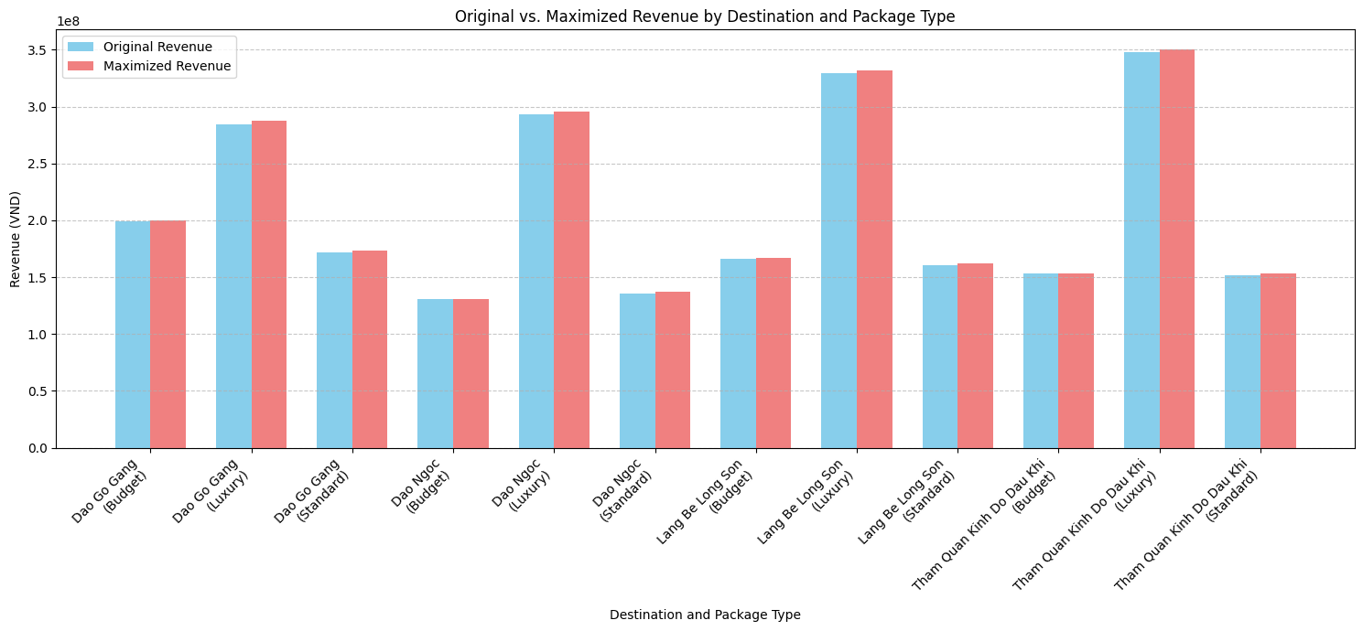
- The Recommended Action: Implement the "Optimized Price List" generated by the model. This involves adjusting the base_price_per_person for each specific (destination, package_type) pair.
- Financial Impact: Visualizations confirm that moving to these optimized price points results in a Maximized Revenue that is significantly higher than the status quo. This is not a general suggestion, but a mathematically derived instruction to change specific prices to reach the highest possible revenue ceiling.

6. Recommendations & Conclusion
The final section of this report synthesizes the analytical findings into a strategic roadmap, providing the practical "Next Steps" required to capitalize on the insights discovered in the previous sections.

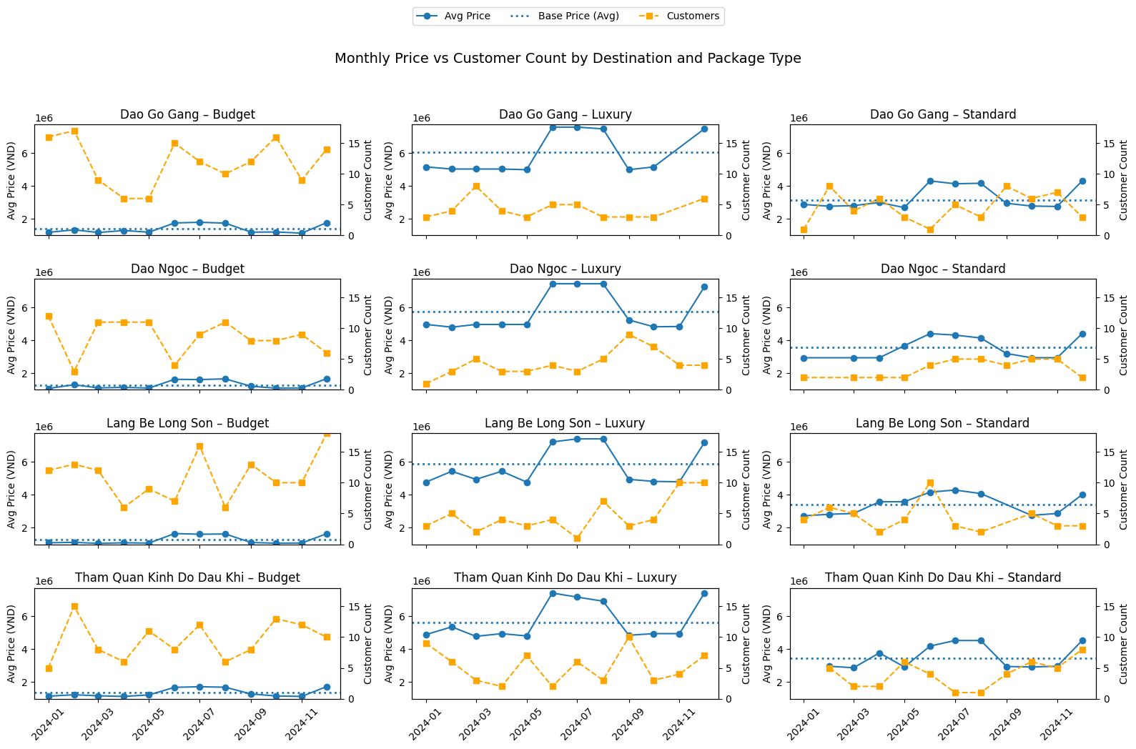
Comprehensive Operational Performance Dashboard (Descriptive, Predictive, and Prescriptive Overview

6.1 Business Advice (Immediate Strategic Actions)
Based on the results of our descriptive and prescriptive models, the following actions are recommended for immediate implementation:
- Adopt Segmented Pricing: The company should move away from flat pricing and implement the optimized price points identified in Section 5. Specifically, increasing prices for Luxury and Standard packages at high-demand destinations like Dao Ngoc will maximize revenue with minimal impact on booking volume.
- Target the "Family" Market: Since families are the highest-spending segment, marketing campaigns should focus on multi-day "all-inclusive" bundles that highlight the 4-6 day duration preferred by this demographic.
- Strategic Resource Allocation for January: With 63 bookings forecasted for January 2025, management should ensure that staffing and transport logistics are secured by late December to avoid service bottlenecks during this peak period.

6.2 Future Improvements (LO3/LO4 Extension)
To further enhance the precision of our data models, the following improvements are suggested:
- Dynamic Elasticity Research: While our model used a constant PED of -1.0, future analysis should collect data on competitor pricing to calculate real-world price sensitivity for each destination.
- Integration of External Data: Incorporating weather forecasts and local holiday calendars into the predictive model would significantly increase the accuracy of the booking forecasts.
- Qualitative Feedback Loops: Collecting customer satisfaction scores would allow us to correlate price increases with perceived value, ensuring that price optimization does not damage long-term brand reputation.

6.3 Final Conclusion
This project has demonstrated a complete data analytics lifecycle—from rigorous Data Governance (LO1) and Descriptive Analysis (LO2) to advanced Predictive Forecasting (LO3) and Prescriptive Optimization (LO4). By transforming 891 raw records into a structured strategic plan, we have moved beyond simply "reporting" the past to actively "directing" the future. The application of the optimized pricing model serves as the best course of action, ensuring that the travel agency remains both competitive and highly profitable throughout 2025.

References
- Microsoft (2025) Power BI Desktop Documentation. Available at: https://learn.microsoft.com/en-us/power-bi/ (Accessed: 26 December 2025).
- Pandas Development Team (2024) pandas-dev/pandas: Pandas 2.2.0. Available at: https://pandas.pydata.org/ (Accessed: 26 December 2025).
- Provost, F. and Fawcett, T. (2013) Data Science for Business: What You Need to Know about Data Mining and Data-Analytic Thinking. Sebastopol: O'Reilly Media.
McKinney, W. (2022) Python for Data Analysis. 3rd edn. O'Reilly Media.

