

**FPT ACADEMY INTERNATIONAL**

**FPT – APTECH COMPUTER EDUCATION**

Travel Booking App

e-Project Report Semester 4

|  |  |  |
| --- | --- | --- |
| **Supervisor** | Ngo Phuoc Nguyen | |
| **Batch** | T1.1908.E0 | |
| **Group** | 3 | |
| **Serial No.** | **Student Name** | **Enrollment No** |
| 1. | Pham Xuan Bach | Student |
| 2. | Luu Trong Phat | Student |
| 3. | Le Nguyen Minh Ngoc | Student |
| 4. | Nguyen Vu Hoang Hoa | Student |

**August 2021**

**This is to certify that**

**Mr./Ms.:**

PHAM XUAN BACH

LUU TRONG PHAT

LE NGUYEN MINH NGOC

NGUYEN VU HOANG HOA

**Has successful design & developed:**

e-Project: TRAVEL BOOKING APP

**Submitted by:** PHAM XUAN BACH

**Date of issue:** AUGUST 2021

**Authorized Signature:**

**_______________________________________**

TABLE OF CONTENTS:

**ACKNOWLEDGEMENT** 6

**REVIEW 1** 7

**INTRODUCTION** 8

**PROBLEM DEFINITION** 9

**CUSTOMER REQUIREMENT SPECIFICATION** 10

**SCOPE OF WORK** 12

**SYSTEM REQUIREMENT SPECIFICATION** 13

**Hardware** 13

Web Server 13

Client 13

**Software:** 13

Web Server 13

Client 13

**TASK SHEET REVIEW 1** 15

**REVIEW 2** 16

**DATA FLOW DIAGRAM** 17

Architecture and Design of the System: 17

I. Context Level Diagram: 17

II. First Level DFD: 18

III. DFD for Booking Cycle: 20

**Flowchart** 21

I. Login Function: (Users) 21

II. Signup Function for customers: (Users) 22

III. Searching data function: 23

IV. View data function: 24

V. Insert data function: (Admin) 25

VI. Login Function: (Admin) 26

**ENTITY RELATIONSHIP DIAGRAM** 27

**TABLE DESIGN** 28

I. Table Users: 28

II. Table Roles: 28

III. Table Tours: 29

IV. Table TourTypes: 29

V. Table TourLocations: 30

VI. Table TourImages: 30

VII. Table ReviewTours: 30

VIII. Table ReviewGuides: 31

IX. Table Locations: 31

X. Table Guides: 32

XI. Table Bookings: 32

XII. Table AuthenticationProviders: 32

**TASK SHEET REVIEW 2** 33

**REVIEW 3** 34

**GUI DESIGN** 35

**I.** **Admin:** 35

1. Login: 35

2. ToolBar: 35

3. Sidebar: 36

4. Locations Content: 37

5. Modal Add (Location): 39

6 Modal Update (Location): 40

7. Tours Content: 42

6 Modal Add (Tour) 43

7 Update Modal (Tour): 49

8 Deactive/Active Modal (Tour): 54

9 Tour Locations Content: 55

10 Modal Add (Tour Location) 56

11 Modal Update (Tour Location) 57

12 Delete Modal (Tour Location) 58

13 Tour Images Content: 59

14. Add Modal (Tour Images) 60

15 Update Modal (Tour Image): 61

16. Delete Modal (Tour Image) 62

**2** **Client:** 62

1. HomePage. 62

2. Tour 68

3. Tour Detail 73

4. Login User 80

**TASK SHEET REVIEW 3** 87

# **ACKNOWLEDGEMENT**

Our group would like to devote this chapter to express our appreciation to all those who always offered us valuable assistance during in carrying out this e-Project.

First and foremost, we owe a debt of gratitude to our dedicated instructor, Mr. Ngo Phuoc Nguyen, whose suggestions and encouragement helped us to overcome not only technological challenges but also psychological tension. Without him, our work could not have been completed successfully.

Secondly, we highly appreciate the e-Project Team at the Head Office which has provided us a golden opportunity to apply what we learned into practice. We are certain that the experiences we gained from this project will facilitate our future career greatly. Besides, we would also like to express my gratitude to all the staff members of my center for not only providing me with the opportunity to work with them on this project, but also for their support and encouragement throughout the process.

Finally, we wish to say a personal thank you to all our dear classmates and team members who are always willing to support us openly and enthusiastically.

# **REVIEW 1**

# **INTRODUCTION**

During the period of information technology and computer development people can search and find anything at home vie internet connection and use online services. Therefore, we are developing a service “Book any flight, any hotel online with more conveniences” named Travel Booking App.

Travel Booking App is a group of people who wants to develop an online site where the users who are too busy to think of how they can purchase ticket online for traveling and this is also a marketing channel for hotels and airlines who will supply products for sale. It will provide users and suppliers the following features.

**For Travel Booking App’s customers:**

* Provide an interactive GUI, on the World Wide Web for the user.
* User can sign up, login, logout, change password, reset password on the website.
* User can search any flight, any hotel and the web will show them the flight time available and the hotel room available they refer before they book.
* User can review the flight and hotel room that they booked and used.
* User can purchasing online vie payment online method as Pay-pal, stripe…
* User receive ticket with QR Scan code.
* User can see booking history.
* User can send feedback to admin or any question they have about Website or about their booking.
* User can see recommendation information.

**For Travel Booking App’s suppliers:**

* Airlines Suppliers can create, update, remove flights.
* Hotel Suppliers can create, update, remove rooms.
* Supplies can sign up, login, logout, change password, reset password on the website.
* Suppliers can send mail to any feedback or question from customers.
* Suppliers reply review on website.
* Suppliers can check total booking, total purchased money from customers.

# **PROBLEM DEFINITION**

After reading the project specifications of Travel Booking App, our team had discussed about what should to be done to fulfil their requirements properly and we came to conclusion that in order to achieve the best result, we should deal with following queries:

**From the view point of users**

1. How can customer book the flight?
2. How can customer book the hotel’s room?
3. How can customer find the flight and room they want?
4. How does customer keep track their history booking that they booked?
5. How can customers review the flight and room they used?
6. How can customers use login, signup, and logout?
7. How can customers make a payment and receive ticket?
8. How can customers send feedback to our website?

**From the view point of the Supplier**

1. How can airline suppliers create, update, delete flight?
2. How can hotel suppliers create, update, delete room?
3. How can suppliers see bookings history? And total payments?
4. How can suppliers use login, signup, and logout?
5. How can suppliers send e-mail directly to customers in order to answer questions and send ticket confirmation?
6. How can suppliers receive payment?

**From the view point of the Administrator**

1. Will the systems be able to check the validity of users’ information before saving into the database?
2. How can system generate QR Scan code for ticket?
3. How can Admin build recommendation system as if customers choose flight’s destination, it will suggest hotels at that destination?
4. How can Admin receive payment from customer and send % payment to suppliers?
5. How can Admin check feedback and reply feedback to customers?
6. How can Admin reply review from customers?
7. How can Admin check total bookings made from customers?

**CUSTOMER REQUIREMENT SPECIFICATION**

**Client:** Travel Booking App

**Business/Project Objective:** The project is to design a service online for booking flights/hotels and recommend hotels/flights on same destination.

**Input to the system:**

**Travel Booking App’s admin need to provide:**

* Information required in order to create account to access to the admin system.

**Travel Booking App’s website suppliers need to provide:**

* Company information to create supplier account.
* Information about hotel or flight going to be shown on website.

**Travel Booking App’s website customers need to provide:**

* Personal information to create an account.

**Output from the system:**

**Travel Booking App’s admin will be able to:**

* Login/Logout to the admin system.
* Manage (view, search, update, and delete) hotel’s rooms.
* Manage (view, search, update, and delete) flights.
* Manage (view, search, active/deactive) registered customers.
* Manage (view, search, active/deactive) suppliers.
* Manage (view, search, update, delete) booking tickets.
* Manage (view, search, reply, delete) reviews.
* Manage (view, search, reply, delete) feedbacks.

**Travel Booking App’s suppliers will be able to:**

* Login, Logout, Change password, Reset password.
* View, edit their information, flight/room’s images.
* For hotels: Manage (view, search, update, and delete) hotel’s rooms.
* For airlines: Manage (view, search, update, and delete) flights.
* Manage (view, reply) about flight/hotel’s room reviews.
* View their rating.
* View total bookings from customers.
* Manage (view, send email) reply feedback from customer.

**Travel Booking App’s customers will be able to:**

* If customers are guests:
  + Search flight/hotel, destination or date they want to book.
  + View flight or hotel information.
  + View review, rating about airline and hotel.
  + Can sign up to become member.
* If customers are registered members:
* Login, Logout, Change password, Reset password.
* Book hotel, book flight.
* View booking history.
* Search hotel/flight by date, destination.
* Review hotel/flight and make rating.
* Change personal information.
* Make a payment online.
* Receive booking confirmation and QR Scan code ticket.
* View Recommendation product that system suggest base on destination, date available or high rating.

# **SCOPE OF WORK**

The application should perform the following functions:

**Login:**

* There are 3 types of account in the application (“admin”, “supplier” and “user”). Admin will login as “admin”, Supplier will login as “supplier” and Customer will login as “user”.
* Three accounts must be registered and login for using the functionality of the application.
* For “admin”: can view/update customer profile, supplier information.
* For “supplier”: can update their information, update images, change their password, reset password.
* For “user”: can update profile, change password, reset password, register new account.

**Booking flight/hotel’s room:**

* When users choose a flight/hotel’s room available, website process them to payment checkout view for purchasing.

**Review flight or hotel:**

* When user search for a flight or hotel, they can see reviews and rating about that flight or hotel.
* Users can only review when they joined a flight from a airline before or stay at the hotel before, too.

**Database**

* The information about flights, hotels, bookings, reviews will be stored in the database, and users can view on the Web.

**Security:**

* The user password will be encrypted and stored in the database.

# **SYSTEM REQUIREMENT SPECIFICATION**

## **Hardware**

### Web Server

|  |  |
| --- | --- |
| Processor | Intel Core i5 or higher. |
| Memory | 4 GB RAM or greater. |
| Modem/ADSL | Connecting to internet 24/24 |

### Client

|  |  |
| --- | --- |
| Processor | Intel Core i3 or higher. |
| Memory | 2 GB RAM or greater. |
| Monitor | Super VGA (1024x768) or higher resolution |
| Modem/ADSL | Connecting to internet |

## **Software:**

### Web Server

|  |  |
| --- | --- |
| Operation System | Windows 7 or higher |
| Browser | Chrome version 35 or Microsoft Edge. |
| Database | SQL Server |
| Software | Internet Information Service |
| JAVA |
| Spring |
|  |

### Client

|  |  |
| --- | --- |
| Operation System | Windows 7 or higher |
| Browser | Chrome version 35 or Microsoft Edge. |

**2.1 Development software**

* + Microsoft Windows 10
  + SQL Server
  + Google Chrome or Microsoft Edge
  + Heroku
  + Git
  + Visual Studio Code
  + Eclipse
  + Postman

**2.2 Technology**

* JavaEE
* React
* Javascript
* jQuery
* Ajax
* Bootstrap
* Java Springboot, SpringWeb, Thymeleaf.

# **TASK SHEET REVIEW 1**

|  |  |  |  |  |  |  |  |
| --- | --- | --- | --- | --- | --- | --- | --- |
| **Project Ref. No.:**  **TRAVEL ToVN** | | **Project Title:** | **Activity Plan Prepared By:** | **Date of Preparation of Activity Plan:** | | | |
| **Sr.No.** | **Task** | **Actual Start Date** | **Actual Days** | **Team Mate Names** | **Status** |
| 1 | Introduction and Problem Definition | Travel Booking App | Pham Xuan Bach | 01/08/2021 | 1 | - Pham Xuan Bach  - Luu Trong Phat  - Le Nguyen Minh Ngoc  - Nguyen Vu Hoang Hoa | 100% |
| 2 | Customer Requirement Specification (CRS) | 01/08/2021 | 1 | 100% |
| 3 | Functional Requirement | 01/08/2021 | 1 | 100% |
| 4 | System Requirement Specification |

# **REVIEW 2**

# **DATA FLOW DIAGRAM**

## Architecture and Design of the System:

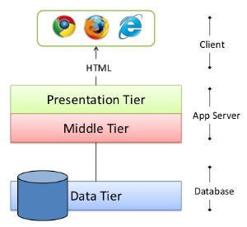

## Context Level Diagram:

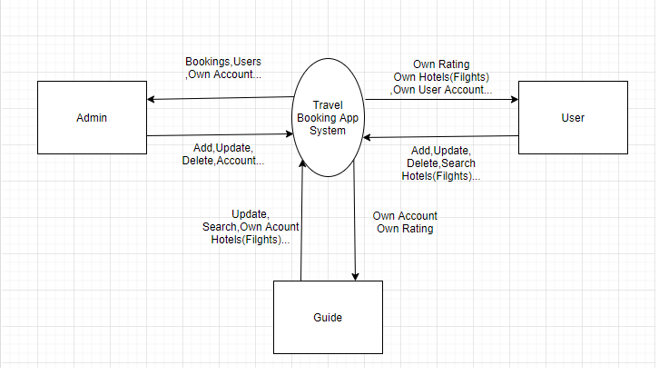

## First Level DFD:

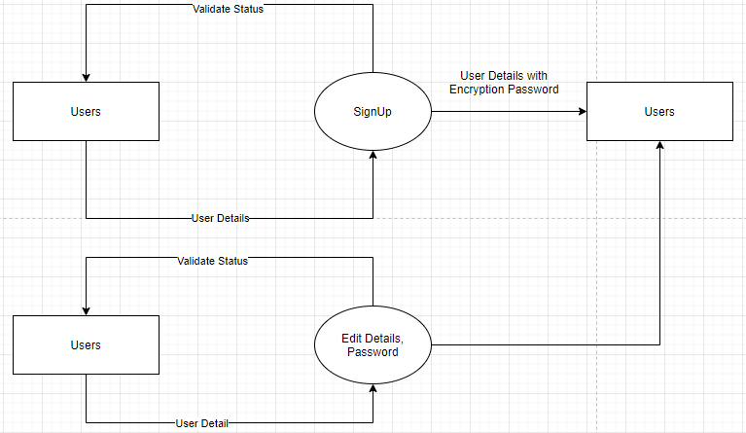

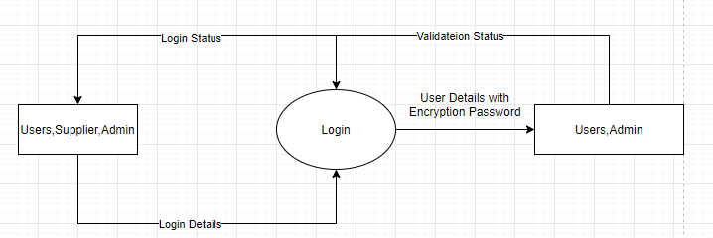

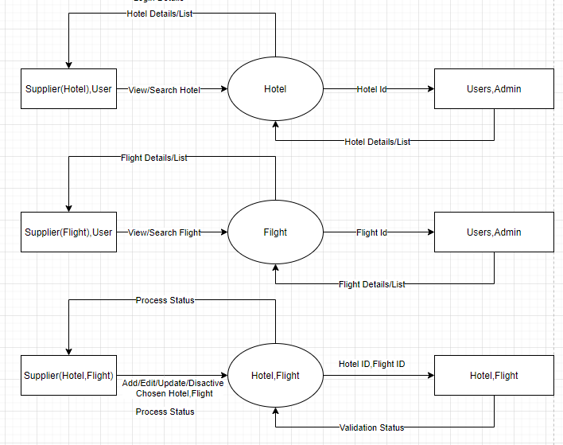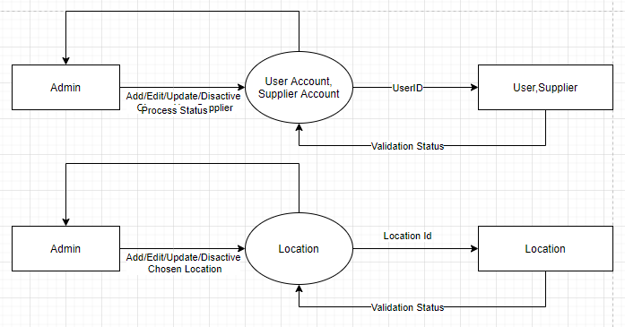

## DFD for Booking Cycle:

# **Flowchart**

## Login Function: (Users,Supplier)

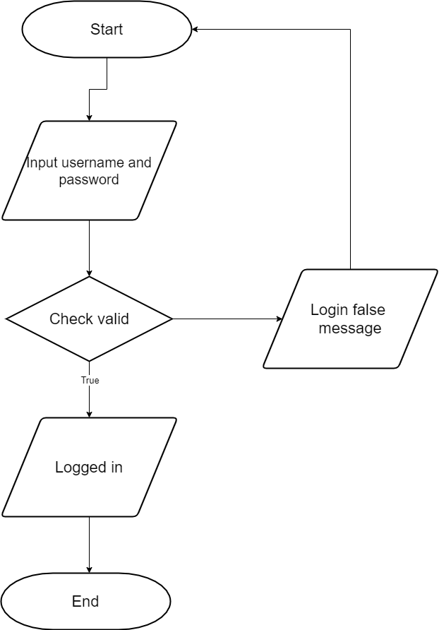

## Signup Function for customers: (Users,Supplier)

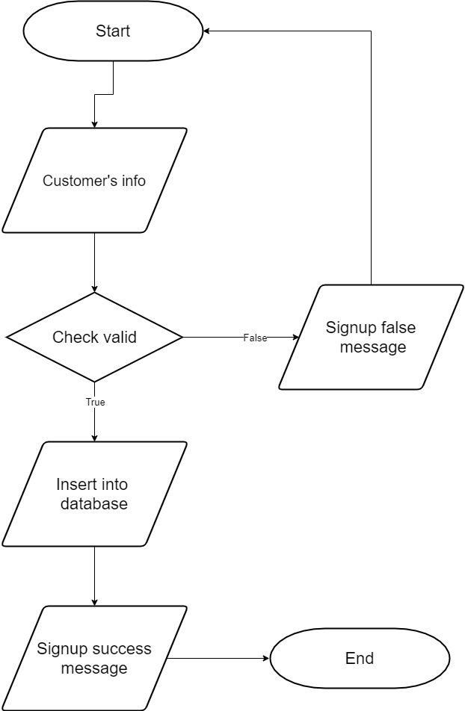

### Searching data function:

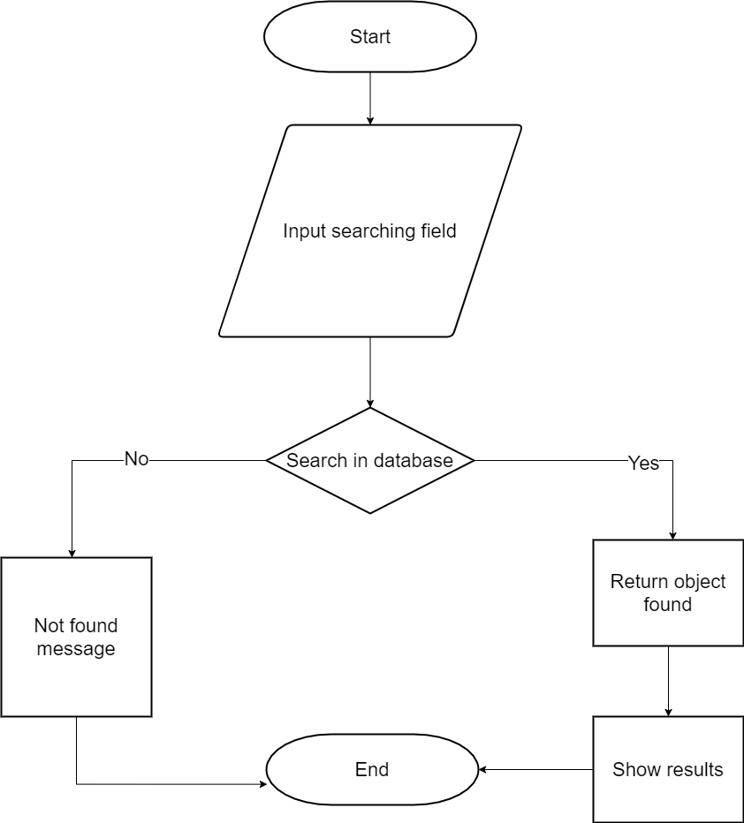

## View data function:

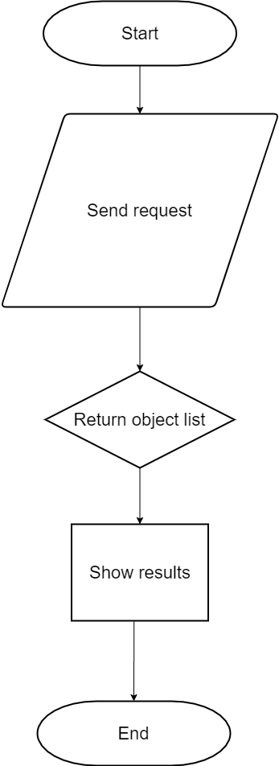

## Insert data function: (Supplier,User,Admin)

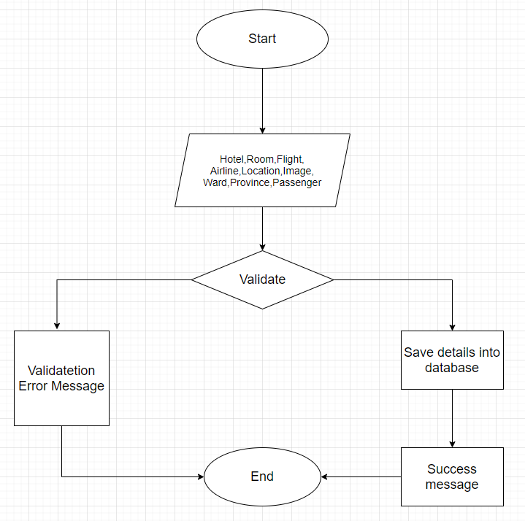

## Login Function: (Admin)

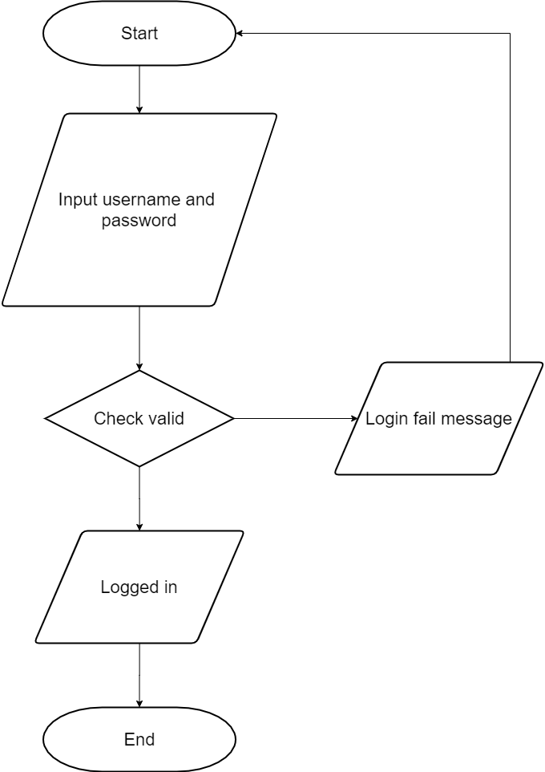

# **ENTITY RELATIONSHIP DIAGRAM**

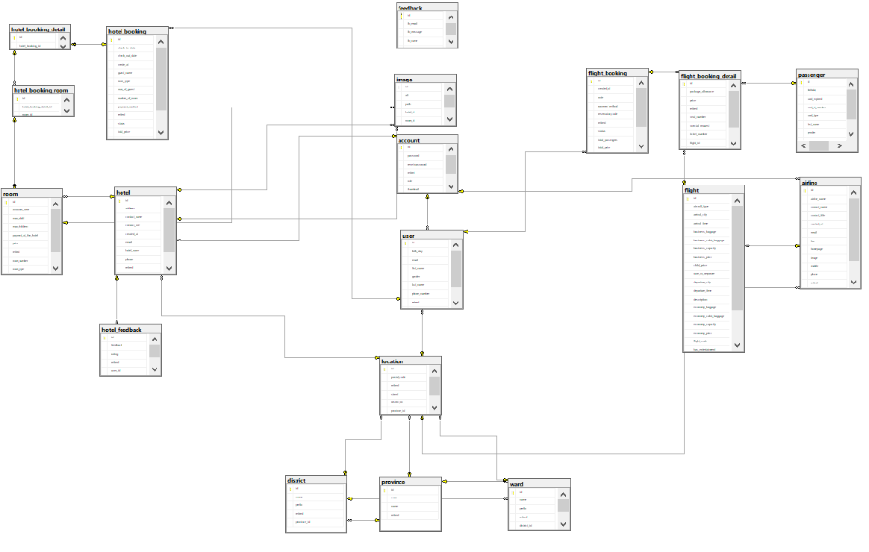

# **TABLE DESIGN**

## Table Users:

|  |  |  |  |  |  |  |
| --- | --- | --- | --- | --- | --- | --- |
| **Users** | | | | | | |
| **Field Name** | **Data Type** | **Null** | **Default Value** | **Key** | **Table-Field-Ref** | **Description** |
| ID | bigint | No |  | PK | Identity | Stores user id |
| First Name | Character varying (100) | No |  |  |  | Stores user first name |
| Last Name | Character varying (100) | No |  |  |  | Stores last name |
| Gender | Character varying (255) | No |  |  |  | Stores user gender |
| Phone | Character varying (255) | No |  |  |  | Stores user phone number |
| Retired | boolean | No | false |  |  | Remove check |
| Birth Day | Date | No |  |  |  | Stores birth day information of user |
| User Image | bigint | No |  | FK |  | Stores user image |
| Location | bigint | No |  | FK |  | Stores location of user |
| Account | bigint | No |  | FK |  | Stores Account of user |
| Ratting | bigint | No |  | FK |  | Stores user feed back |

## Table Account:

|  |  |  |  |  |  |  |
| --- | --- | --- | --- | --- | --- | --- |
| **Roles** | | | | | | |
| **Field Name** | **Data Type** | **Null** | **Default Value** | **Key** | **Table-Field-Ref** | **Description** |
| ID | bigint | No |  | PK | Identity | Stores role id |
| User name | Character varying (50) | No |  |  |  | Stores username of account |
| Password | Character varying (255) | No |  |  |  | Stores password of account |
| Role | Character varying (20) | No |  |  |  | Stores role of account(Hotel,Flight,User) |
| Retired | Boolean | Yes |  |  |  | Remove check |
| Reset Password | Character varying (255) | No |  |  |  | Stores number of updates |
| Thumbnail | Character varying (100) | No |  |  |  | Stores thumbnail of account |

## Table Airline:

|  |  |  |  |  |  |  |  |
| --- | --- | --- | --- | --- | --- | --- | --- |
| **Airline** | | | | | | | |
| **Field Name** | **Data Type** | **Null** | **Default Value** | **Key** | **Table-Field-Ref** | **Description** |
| ID | bigint | No |  | PK | Identity | Stores tour id |
| Airline Name | Character varying (100) | No |  |  |  | Stores name of airline |
| Contact Name | Character varying (100) | No |  |  |  | Stores contact name of airline |
| Contact Title | Character varying (100) | No |  |  |  | Stores contact type of airline |
| Phone | Character varying (25) | No |  |  |  | Stores phone of airline supplier |
| Mobile | Character varying (25) | No |  |  |  | Stores mobile of airline supplier |
| Fax | Character varying (255) | Yes |  |  |  | Stores fax of airline |
| Home page | Character varying (255) | No |  |  |  | Stores home page url of airline |
| Email | Character varying (100) | No |  |  |  | Stores email of airline |
| Create At | Date | No |  |  |  | Stores date airline insert |
| Status | Boolean | True |  |  |  | Stores status off airline |
| Location | bigint | No |  | FK |  | Stores location of airline |
| Account | bigint | No |  | FK |  | Stores account of airline |
| Flight | bigint | No |  | FK |  | Stores Flight of airline |
| Retired | bigint | Yes |  | FK |  | Remove check |
| Image | bigint | Yes |  | FK |  | Stores image of airline |

## Table Flight:

|  |  |  |  |  |  |  |  |  |
| --- | --- | --- | --- | --- | --- | --- | --- | --- |
|  | **Flight** | | | | | | | |
| **Field Name** | | **Data Type** | **Null** | **Default Value** | **Key** | **Table-Field-Ref** | | **Description** |
| ID | | bigint | No |  | PK | | Identity | Stores tour type id |
| Departure City | | Character varying (255) | No |  |  | |  | Stores departure city of flight |
| Arrival City | | Character varying (255) | No |  |  | |  | Stores arrival city of flight |
| Departure Time | | Date | No |  |  | |  | Stores departure time of flight |
| Arrival time | | Date | No |  |  | |  | Stores arrival time of flight |
| Description | | Character varying (255) | No |  |  | |  | Stores description of flight |
| Economy capacity | | integer | No |  |  | |  | Stores economy capacity of flight |
| Economy price | | Float | No |  |  | |  | Stores economy price of flight |
| Infant Price | | Float | No |  |  | |  | Stores infant price of flight |
| Child price | | Float | No |  |  | |  | Stores child price of flight |
| Business price | | Float | No |  |  | |  | Stores business price of flight |
| Business capacity | | Float | No |  |  | |  | Stores business capacity of flight |
| Status | | Character varying (100) | No |  |  | |  | Stores status of flight |
| Date of departure | | Date | Yes |  |  | |  | Stores date of departure of flight |
| Retired | | Boolean | Yes |  |  | |  | Remove check |
| Economy baggage | | Float | True |  |  | |  | Stores economy baggage of flight |
| Business baggage | | Float | True |  |  | |  | Stores business baggage of flight |
| Has entertainment | | Boolean | True |  |  | |  | Stores has entertainment of flight |
| Aircraft type | | Character varying (50) | True |  |  | |  | Stores aircraft type of flight |
| Airline | | bigint | No |  | FK | |  | Stores airline of flight |
| Flight code | | bigint | No |  | FK | |  | Stores flight code of flight |

## Table District:

|  |  |  |  |  |  |  |
| --- | --- | --- | --- | --- | --- | --- |
| **District** | | | | | | |
| **Field Name** | **Data Type** | **Null** | **Default Value** | **Key** | **Table-Field-Ref** | **Description** |
| ID | bigint | No |  | PK | Identity | Stores tour location id |
| Name | Character varying (255) | No |  |  |  | Stores name of district |
| Prefix | Character varying (20) | No |  |  |  | Stores Prefix of district |
| Retired | Boolean | Yes |  |  |  | Remove check |
| Province | bigint | No |  | FK |  | Stores province of district |
| Wards | bigint | No |  | FK |  | Stores ward of district |

## Table Feed Back:

|  |  |  |  |  |  |  |
| --- | --- | --- | --- | --- | --- | --- |
| **Feed Back** | | | | | | |
| **Field Name** | **Data Type** | **Null** | **Default Value** | **Key** | **Table-Field-Ref** | **Description** |
| ID | bigint | No |  | PK | Identity | Stores tour image id |
| Name | Character varying (100) | No |  |  |  | Stores title of feedback |
| Email | Character varying (100) | No |  |  |  | Stores email of user who send feedback |
| Sub title | Character varying (100) |  |  |  |  | Stores sub title of feedback |
| Message | Character varying (255) |  |  |  |  | Stores description of feedback |

## Table Image:

|  |  |  |  |  |  |  |
| --- | --- | --- | --- | --- | --- | --- |
| **Flight Booking** | | | | | | |
| **Field Name** | **Data Type** | **Null** | **Default Value** | **Key** | **Table-Field-Ref** | **Description** |
| ID | bigint | No |  | PK | Identity | Stores review id |
| Image path | Character varying (100) | No |  |  |  | Stores image path of Image |
| Image alt | Character varying (100) | No |  |  |  | Stores image alt of image |
| Hotel | bigint | No |  | FK |  | Stores hotel of image |
| Room | bigint | No |  | FK |  | Stores room of image |

## Table Flight Booking:

|  |  |  |  |  |  |  |
| --- | --- | --- | --- | --- | --- | --- |
| **Flight Booking** | | | | | | |
| **Field Name** | **Data Type** | **Null** | **Default Value** | **Key** | **Table-Field-Ref** | **Description** |
| ID | bigint | No |  | PK | Identity | Stores review id |
| Reservation code | Character varying  (255) | No |  |  |  | Stores reservation code of flight booking |
| Total price | Float | No |  |  |  | Stores total price of flight booking |
| rating | integer | No |  |  |  | Stores rating point |
| Total passengers | integer | Yes |  |  |  | Stores total passengers of flight booking |
| Status | integer | Yes |  |  |  | Stores status of flight booking |
| Note | Character varying  (255) | No |  |  |  | Stores note of flight booking |
| Create At | Date | No |  |  |  | Stores create at of flight booking |
| Update At | Date | No |  |  |  | Stores update at of flight booking |
| Flight Booking Details | bigint | No |  | FK |  | Stores flight booking details of flight booking |
| Payment method | Character varying  (100) | No |  |  |  | Stores payment method of flight booking |
| Retired | Boolean | Yes |  |  |  | Remove check |
| User | bigint | No |  | FK |  | Stores user who created booking |

## Table Flight Booking Details:

|  |  |  |  |  |  |  |
| --- | --- | --- | --- | --- | --- | --- |
| **Locations** | | | | | | |
| **Field Name** | **Data Type** | **Null** | **Default Value** | **Key** | **Table-Field-Ref** | **Description** |
| ID | bigint | No |  | PK | Identity | Stores location id |
| Ticket number | Character varying  (255) | No |  |  |  | Stores ticket number of flight booking details |
| Seat number | Character varying  (255) | No |  |  |  | Stores seat number of flight booking details |
| Price | Float | No |  |  |  | Stores price of flight booking details |
| Package allowance | Int | No |  |  |  | Stores package allowance of flight booking details |
| Special request | Character varying  (255) | Yes |  |  |  | Stores special request of flight booking details |
| Retired | Boolean | Yes |  |  |  | Remove check |
| Flight | bigint | No |  | FK |  | Stores flight of flight booking details |
| Flight booking | bigint | No |  | FK |  | Stores flight booking of flight booking details |
| Passenger | bigint | No |  | FK |  | Stores passenger of flight booking details |

## Table Hotel:

|  |  |  |  |  |  |  |
| --- | --- | --- | --- | --- | --- | --- |
| **Guides** | | | | | | |
| **Field Name** | **Data Type** | **Null** | **Default Value** | **Key** | **Table-Field-Ref** | **Description** |
| ID | bigint | No |  | PK | Identity | Stores guide id |
| Hotel name | Character varying  (150) | No |  |  |  | Stores hotel name of hotel |
| Email | Character varying  (150) | No |  |  |  | Stores email of hotel |
| Phone | Int | No |  |  |  | Stores rating average |
| Contact name | Character varying  (150) | No |  |  |  | Stores contact name |
| Contact title | Character varying  (255) | No |  |  |  | Stores contact title of hotel |
| Address | Character varying  (255) | No |  |  |  | Stores address of hotel |
| Create at | timestamp | No |  |  |  | Stores create at of hotel |
| Retired | Boolean | Yes |  |  |  | Remove check |
| Location | bigint | No |  | FK |  | Stores location of hotel |
| Account | bigint | No |  | FK |  | Stores account of hotel |

## Table Room:

|  |  |  |  |  |  |  |
| --- | --- | --- | --- | --- | --- | --- |
| **Bookings** | | | | | | |
| **Field Name** | **Data Type** | **Null** | **Default Value** | **Key** | **Table-Field-Ref** | **Description** |
| ID | bigint | No |  | PK | Identity | Stores guide id |
| Room number | Int | No |  |  |  | Stores room number of room |
| Payment at the hotels | Boolean | No |  |  |  | Allow payment at the hotel |
| Available time | Date | Yes |  |  |  | Stores payment status |
| Room type | Character  varying (150) | No |  |  |  | Stores room type of room |
| Price | Double | No |  |  |  | Stores price of room |
| Max adult | Int | No |  |  |  | Stores max adult of room |
| Max children | Int | No |  |  |  | Stores max children of room |
| Retired | Boolean | No |  |  |  | Remove check |
| Hotel | bigint | No |  | FK |  | Stores hotel of room |
| Hotel booking room | bigint | No |  | FK |  | Stores hotel booking room of room |

## Table Hotel Booking:

|  |  |  |  |  |  |  |  |  |  |  |  |
| --- | --- | --- | --- | --- | --- | --- | --- | --- | --- | --- | --- |
| **AuthenticationProviders** | | | | | | | | | | | |
| **Field Name** | **Data Type** | | **Null** | | **Default Value** | **Key** | | | **Table-Field-Ref** | **Description** | |
| ID | bigint | No | |  | | | PK | Identity | | | Stores guide id |
| Hotel type | Character  varying (150) | No | |  | | |  |  | | | Stores hotel type of hotel booking |
| Guest name | Character  varying (150) | No | |  | | |  |  | | | Stores guest name of hotel booking |
| Num of guest | Int | No | |  | | |  |  | | | Stores num of guest of hotel booking |
| Status | Boolean | No | |  | | |  |  | | | Approval type |
| Check in date | Date | No | |  | | |  |  | | | Stores check in date of hotel booking |
| Check out date | Date | No | |  | | |  |  | | | Stores check out date of hotel booking |
| Total price | Int | No | |  | | |  |  | | | Stores total price of hotel booking |
| Number of room | Int | No | |  | | |  |  | | | Stores number room of hotel booking |
| Create at | Timestamp | No | |  | | |  |  | | | Stores create at of hotel booking |
| Update at | Date | No | |  | | |  |  | | | Stores update at of hotel booking |
| Payment method | Character  varying (150) | No | |  | | |  |  | | | Stores payment method of hotel booking |
| Retired | Boolean | No | |  | | |  |  | | | Stores retired of hotel booking |
| Hotel booking detail | bigint | No | |  | | | FK |  | | | Stores hotel booking detail of booking |
| User | bigint | No | |  | | | FK |  | | | Stores user of booking |

## XIII. Table Hotel Booking Detail:

|  |  |  |  |  |  |  |  |
| --- | --- | --- | --- | --- | --- | --- | --- |
| **Hotel Booking Detail** | | | | | | | |
| **Field Name** | **Data Type** | **Null** | **Default Value** | **Key** | **Table-Field-Ref** | **Description** | |
| ID | bigint | No |  | PK | Identity | | Stores guide id |
| Hotel Booking | bigint | No |  | FK |  | | Stores hotel booking type of hotel booking detail |

## XIV. Table Hotel Booking Room:

|  |  |  |  |  |  |  |  |
| --- | --- | --- | --- | --- | --- | --- | --- |
| **Hotel Booking Room** | | | | | | | |
| **Field Name** | **Data Type** | **Null** | **Default Value** | **Key** | **Table-Field-Ref** | **Description** | |
| ID | bigint | No |  | PK | Identity | | Stores guide id |
| Hotel Booking Detail | bigint | No |  | FK |  | | Stores hotel booking detail of hotel booking room |
| Room | bigint | No |  | FK |  | | Stores room of hotel booking room |

## XV. Table Hotel Feedback:

|  |  |  |  |  |  |  |  |
| --- | --- | --- | --- | --- | --- | --- | --- |
| **Hotel Feedback** | | | | | | | |
| **Field Name** | **Data Type** | **Null** | **Default Value** | **Key** | **Table-Field-Ref** | **Description** | |
| ID | bigint | No |  | PK | Identity | | Stores guide id |
| Rating | Double | No |  |  |  | | Stores rating of hotel feed back |
| Feedback | Character  varying (255) | No |  |  |  | | Stores description of hotel feed back |
| User Id | bigint | No |  | FK |  | | Id of user feed back |
| Hotel | bigint | No |  | FK |  | | Stores hotel of hotel feedback |

## XVI. Table Location:

|  |  |  |  |  |  |  |  |
| --- | --- | --- | --- | --- | --- | --- | --- |
| **Location** | | | | | | | |
| **Field Name** | **Data Type** | **Null** | **Default Value** | **Key** | **Table-Field-Ref** | **Description** | |
| ID | bigint | No |  | PK | Identity | | Stores guide id |
| Street | Character  varying (255) | No |  |  |  | | Stores street of location |
| Postal code | Character  varying (50) | No |  |  |  | | Stores postal code of location |
| Province | bigint | No |  | FK |  | | Stores province of location |
| District | bigint | No |  | FK |  | | Stores district of location |
| Ward | bigint | No |  | FK |  | | Stores ward of location |
| Retired | Boolean | Yes |  |  |  | | Remove check |

## XVII. Table Passenger:

|  |  |  |  |  |  |  |  |
| --- | --- | --- | --- | --- | --- | --- | --- |
| **Passenger** | | | | | | | |
| **Field Name** | **Data Type** | **Null** | **Default Value** | **Key** | **Table-Field-Ref** | **Description** | |
| ID | bigint | No |  | PK | Identity | | Stores guide id |
| Firstname | Character  varying (200) | No |  |  |  | | Stores firstname of user |
| Lastname | Character  varying (200) | No |  |  |  | | Stores lastname of user |
| Brithday | Date | No |  |  |  | | Stores birthday of user |
| Gender | Boolean | No |  |  |  | | Stores bender of user |
| Card id number | Character  varying (200) | No |  |  |  | | Stores card id number of passenger |
| Card type | Int | No |  |  |  | | Stores card type of passenger |
| Card expired | Date | No |  |  |  | | Stores card expired of passenger |
| Retired | Boolean | Yes |  |  |  | | Remove check |

## XVII. Table Province:

|  |  |  |  |  |  |  |  |
| --- | --- | --- | --- | --- | --- | --- | --- |
| **Province** | | | | | | | |
| **Field Name** | **Data Type** | **Null** | **Default Value** | **Key** | **Table-Field-Ref** | **Description** | |
| ID | bigint | No |  | PK | Identity | | Stores guide id |
| Name | Character  varying (50) | No |  |  |  | | Stores name of province |
| Code | Character  varying (50) | No |  |  |  | | Stores code of province |
| Retired | Boolean | Yes |  |  |  | | Remove check |

## XVII. Table Ward:

|  |  |  |  |  |  |  |  |
| --- | --- | --- | --- | --- | --- | --- | --- |
| **Ward** | | | | | | | |
| **Field Name** | **Data Type** | **Null** | **Default Value** | **Key** | **Table-Field-Ref** | **Description** | |
| ID | bigint | No |  | PK | Identity | | Stores guide id |
| Name | Character  varying (50) | No |  |  |  | | Stores name of ward |
| Prefix | Character  varying (20) | No |  |  |  | | Stores code of prefix |
| Province | bigint | No |  |  |  | | Stores province of ward |
| District | bigint | No |  |  |  | | Stores district of ward |
| Retired | Boolean | Yes |  |  |  | | Remove check |

# **TASK SHEET REVIEW 2**

|  |  |  |  |  |  |  |  |
| --- | --- | --- | --- | --- | --- | --- | --- |
| **Project Ref. No.:**  **TRAVEL ToVN** | | **Project Title:** | **Activity Plan Prepared By:** | **Date of Preparation of Activity Plan:** | | | |
| **Sr.No.** | **Task** | **Actual Start Date** | **Actual Days** | **Team Mate Names** | **Status** |
| 1 | DFD (Data Flow Diagram) | **Travel Booking App** | Luu Trong Phat | 13/07/2021 | 1 | Nguyen Vu Hoang Hoa | 100% |
| 2 | Flowcharts | 13/07/2021 | 1 | Pham Xuan Bach | 100% |
| 3 | ERD (Entity Relationship Diagram) | 13/07/2021 | 1 | Le Nguyen Minh Ngoc | 100% |
| 4 | Table Design | 13/07/2021 | 1 | Luu Trong Phat | 100% |

|  |  |
| --- | --- |
| **Date: 25/7/2021** | |
| Signature of Instructor:  **MR. NGO PHUOC NGUYEN** | Signature of Team Leader:  **Luu Trong Phat** |

# **REVIEW 3**

# **GUI DESIGN**

## **Admin:**

### Login:

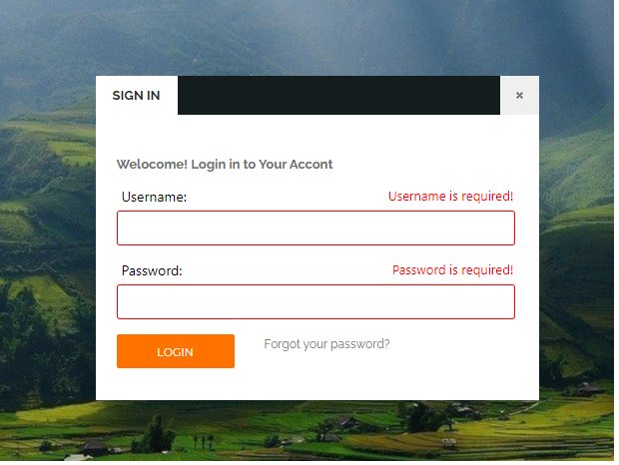

|  |  |  |  |  |  |  |
| --- | --- | --- | --- | --- | --- | --- |
| No | Name | Type | Validation | Event | Description | Status |
| 1 | UserName | Textbox | Input not blank | No | Click link to go equivalent page | Enable |
| 2 | Password | Textbox | password | Click | Choose the search filter | Enable |
| 3 | Login | Button |  | Click | Click to login | Enable |
| 4 | Forgot your password | Button |  | Click | Click to go page Forgotpassword | Enable |
|  |  |  |  |  |  |  |

### SearchBar:

|  |  |  |  |  |  |  |
| --- | --- | --- | --- | --- | --- | --- |
| No | Name | Type | Validation | Event | Description | Status |
| 1 | Hotel | Button |  | Click | Click to call search hotels | Enable |
| 2 | Filghts | Button |  | No | Click to call search flight | Enable |
| 3 | Search | Button |  | Click | Click to search and go to Flight list or Hotel list | Enable |

### Sidebar:



|  |  |  |  |  |  |  |  |
| --- | --- | --- | --- | --- | --- | --- | --- |
| No | Name |  | Type | Validation | Event | Description | Status |
| 1 | Logo |  | Link |  | Click | Click go to home page | Enable |
| 2 | Hotels |  | Link |  | Click | Click go to list hotel | Enable |
| 3 | Flights |  | Link |  | Click | Click to to list flight | Enable |
| 4 | Page |  | Link |  | Click | Show list page can go | Enable |

### Home Page:

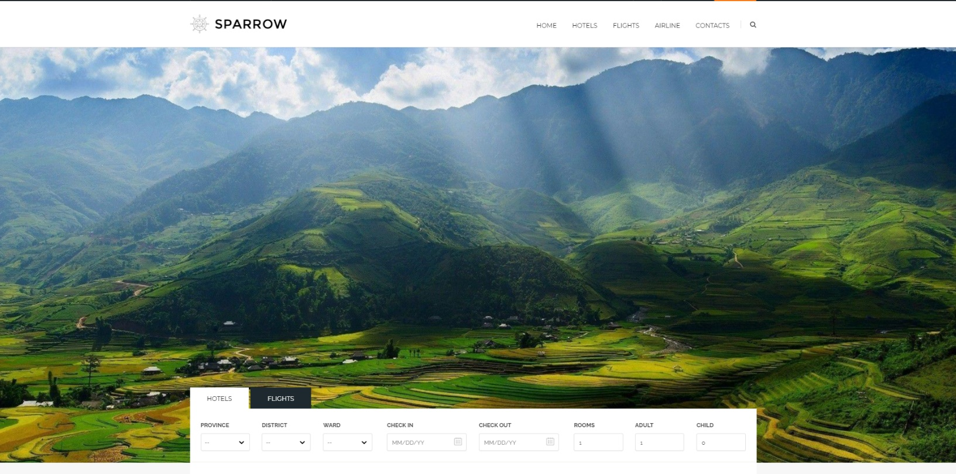

### UserProfile :

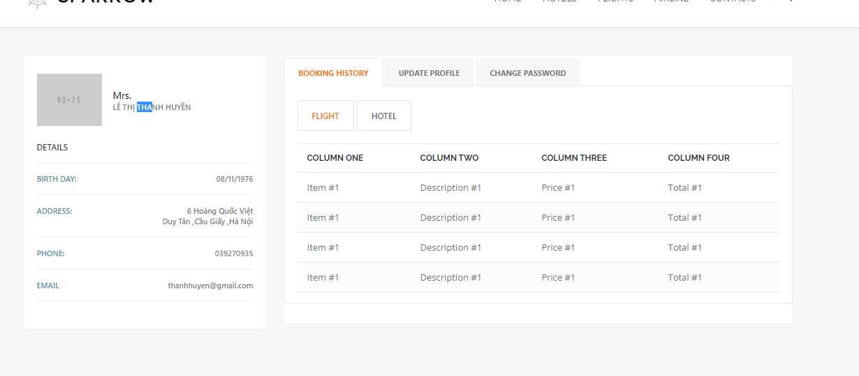

|  |  |  |  |  |  |  |
| --- | --- | --- | --- | --- | --- | --- |
| No | Name | Type | Validation | Event | Description | Status |
|  | Booking history | Tab |  | Keyup | Show list booking of user | Enable |
|  | Update Profile | Tab |  | No event | Show user information | Enable |
|  | Change Password | Tab |  | No event | Change password of user | Disable |

### Register Page:

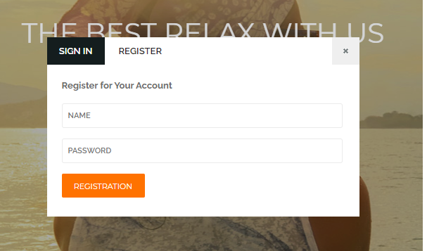

|  |  |  |  |  |  |  |
| --- | --- | --- | --- | --- | --- | --- |
| No | Name | Type | Validation | Event | Description | Status |
|  | Name | Textbox | Not null, format String | Keyup | Input name of user | Enable |
|  | Password | Textbox | Not null, format String | No event | Input password | Enable |
|  | Registration | button |  | Click | Register and close popup | Enable |

### Hotel List Page:

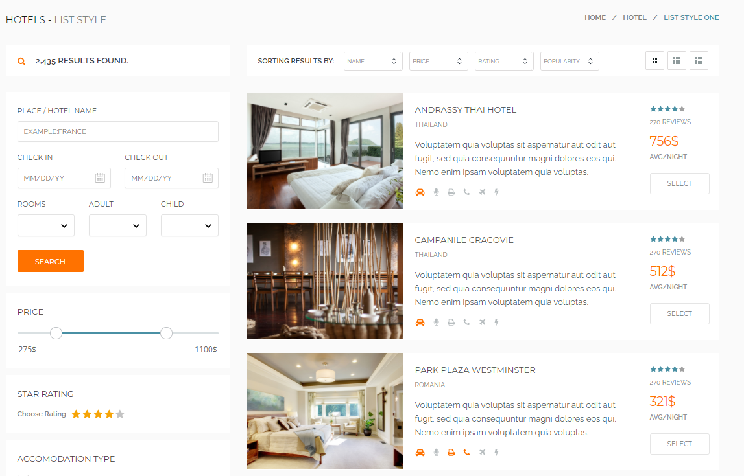

### Hotel Item page

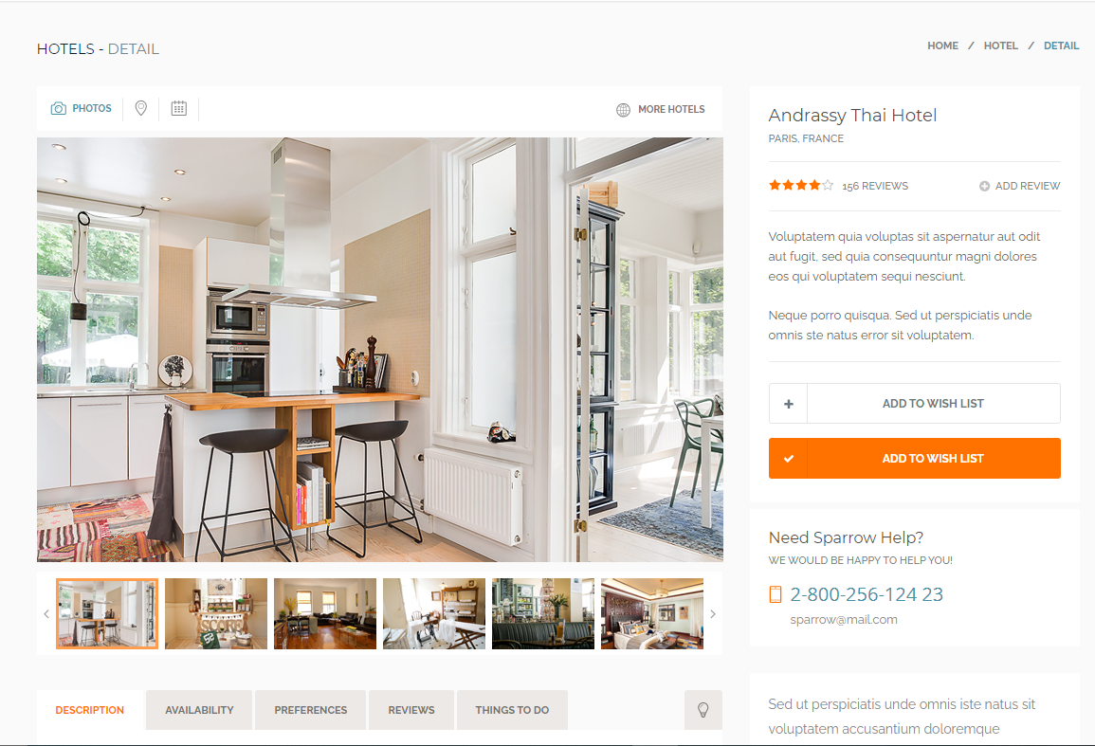

### About Us :

### Contact Page:

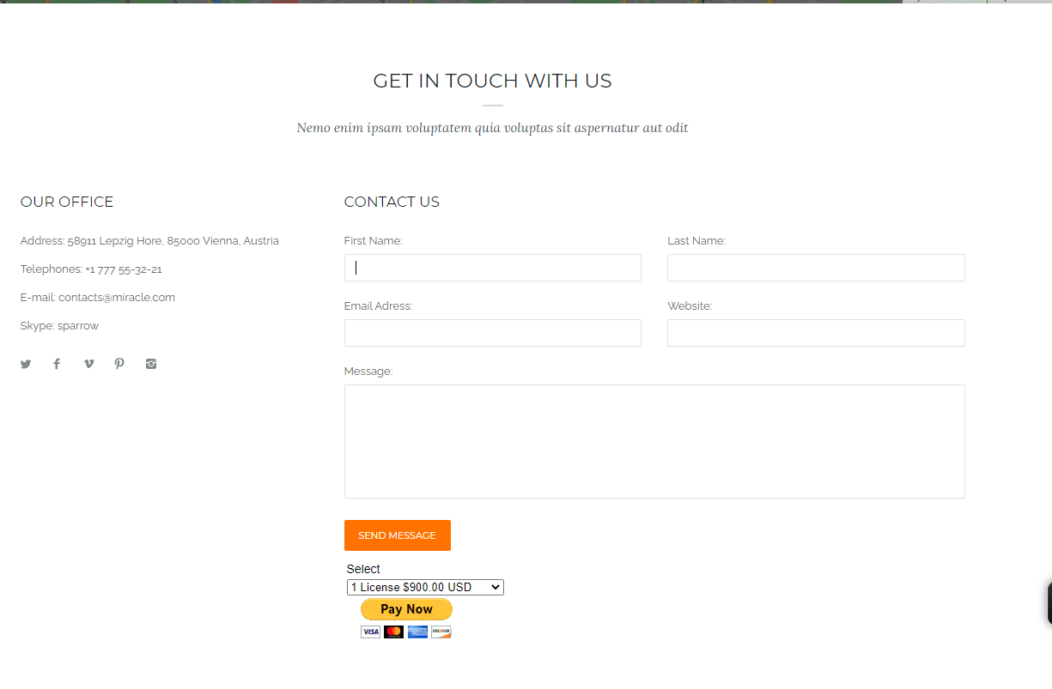

# **TASK SHEET REVIEW 3**

|  |  |  |  |  |  |  |  |
| --- | --- | --- | --- | --- | --- | --- | --- |
| **Project Ref. No.:**  **TRAVEL ToVN** | | **Project Title:** | **Activity Plan Prepared By:** | **Date of Preparation of Activity Plan:** | | | |
| **Sr.No.** | **Task** | **Actual Start Date** | **Actual Days** | **Team Mate Names** | **Status** |
| 1 | Hotel Modul | **Travel Booking App** | Luu Trong Phat | 25/07/2021 | 1 | Nguyen Vu Hoang Hoa | 100% |
| 2 | Account , User Modul | 25/07/2021 | 1 | Pham Xuan Bach | 100% |
| 3 | Flight Modul | 25/07/2021 | 1 | Le Nguyen Minh Ngoc | 100% |
| 4 | Booking Modul | 25/07/2021 | 1 | Luu Trong Phat | 100% |

|  |  |
| --- | --- |
| **Date: 2/8/2021** | |
| Signature of Instructor:  **MR. NGO PHUOC NGUYEN** | Signature of Team Leader:  **Luu Trong Phat** |