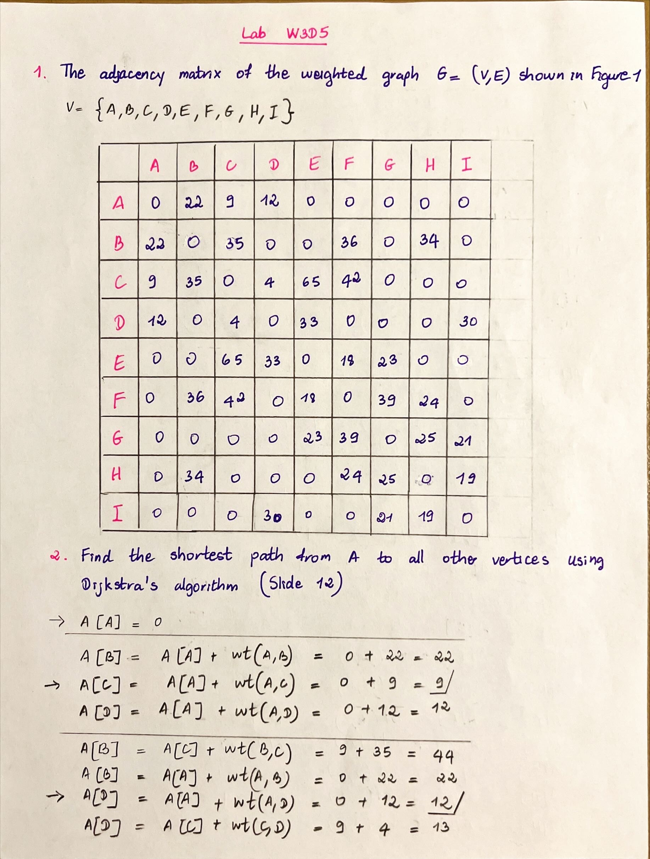

The shortest path from A to all other vertices is

A[A] = 0,

A[C] = 9,

A[D] =12,

A[B] = 22,

A[I] = 42,

A[E] = 45,

A[F] = 51,

A[H] = 56,

A[G] = 63

3. The time complexity for Dijkstra’s Algorithm is O(mn).

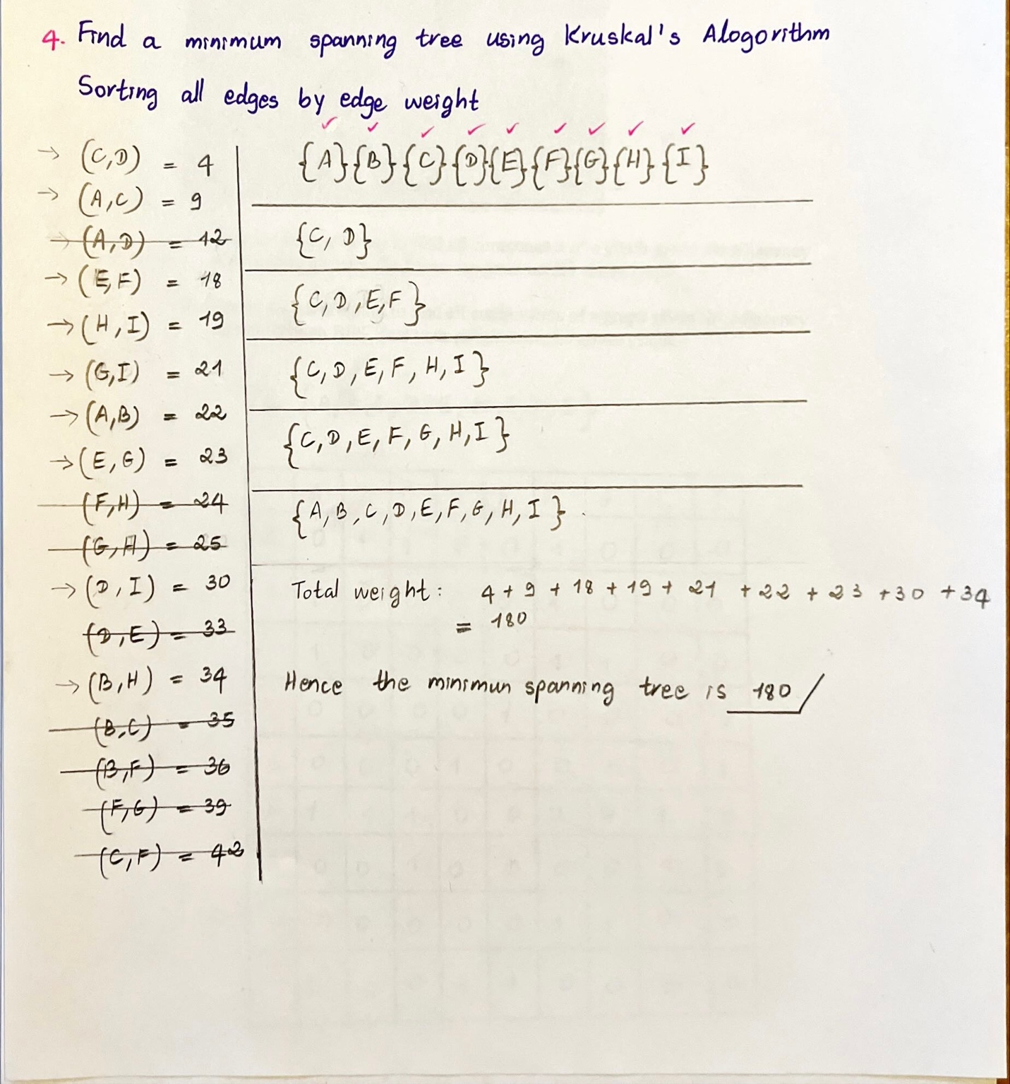

5. The time complexity for Kruskal’s Algorithm is O(mlogn)

m is edge

n is vertice

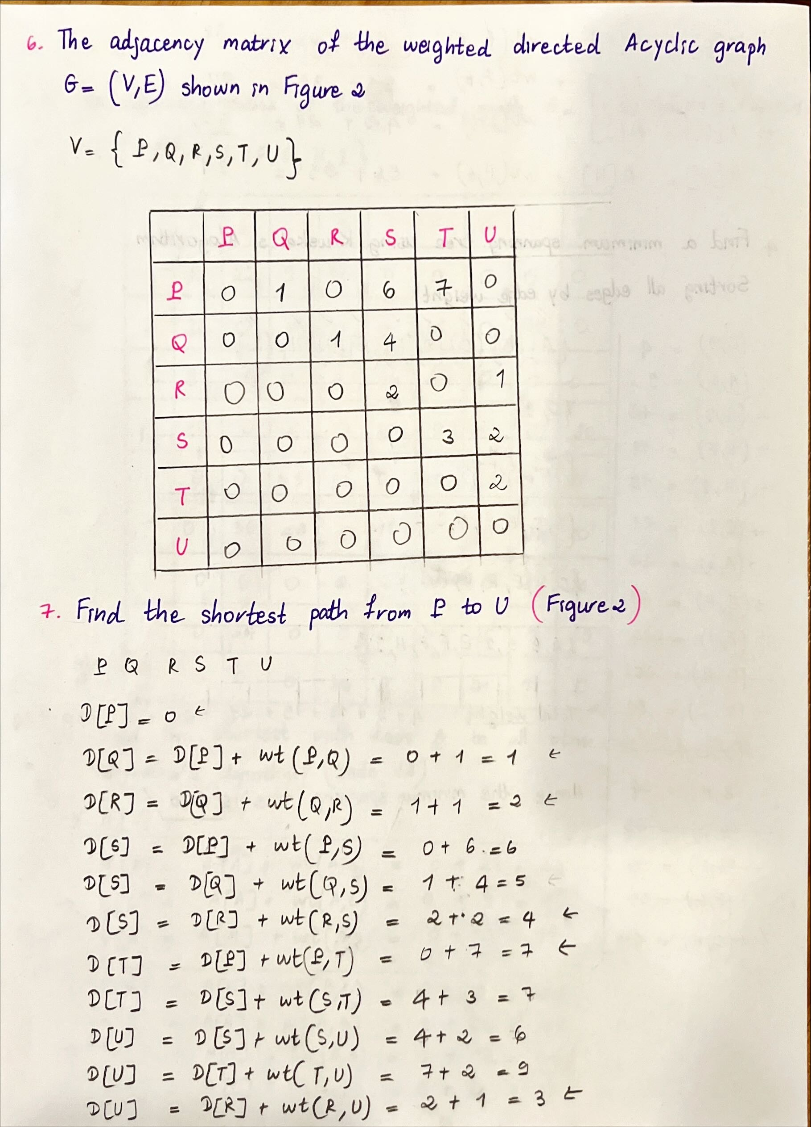

8. The time complexity for Dynamic Programming is O(n+m).

9. We cannot use Dijkstra’s Algorithm to find the shortest path from P to U because the given graph is a directed graph.

10. The answer is “No”