MONTHLY COST PROPOSAL
Email Hosting Platform
with AI Integration
itbsstudio.com · 10,000 Users · AWS Manila Local Zone (ap-southeast-1-mnl-1)
LEAN  Pilot / soft launch  ≈ $6,200/mo  ≈ ₱353,000 | RECOMMENDED (HA)  Production baseline  ≈ $9,084/mo  ≈ ₱517,800 | SAVINGS PLAN OPTION  1-year compute commitment  ≈ $8,035/mo  ≈ ₱458,000

★ Best recommendation: Use the Recommended (HA) tier as the production baseline. It balances availability, performance, and cost for 10,000 mailboxes while keeping room for storage and AI usage growth.

Prepared for | itbsstudio.com / ITBS
Platform | ITBS Mail — Docker Mailserver + Roundcube + AI Assistant
Region | AWS Asia Pacific (Singapore), Manila Local Zone ap-southeast-1-mnl-1
Scale | 10,000 mailboxes
Document date | June 2026
Currency basis | USD; indicative PHP conversion at ₱57/USD
Document purpose | Budget approval, client discussion, and DevOps implementation planning
Confidential planning document — not a final vendor quote

Contents
- 1. Executive Summary for Boss and Client
- 2. Plain-English Setup Overview
- 3. Recommended High-Availability Architecture
- 4. Detailed Monthly Cost
- 5. Tier Comparison and Storage Scenarios
- 6. Cost Optimization Levers
- 7. DevOps Deployment Plan
- 8. Ownership, Decisions, Risks, and Assumptions
- 9. Appendix: Visual Infographics
i How to use this document: Boss/client reviewers can focus on Sections 1, 4, 5, and 8. DevOps can focus on Sections 2, 3, 7, and the appendix diagrams.

1. Executive Summary for Boss and Client
This proposal sizes and prices the ITBS Mail platform for 10,000 mailboxes in the AWS Manila Local Zone. It includes mail hosting, webmail, mailbox administration, database services, outbound delivery, backups, monitoring, and an AI assistant integration.
Tier | Best use | Architecture | Monthly USD | Indicative PHP
Lean | Pilot / soft launch | Single app + single mail/DB node; no HA | ≈ $6,200 | ≈ ₱353,000
Recommended (HA) | Production baseline | Redundant app, mail, and DB nodes | ≈ $9,084 on-demand  ≈ $8,035 with 1-year Savings Plan | ≈ ₱517,800  ≈ ₱458,000
Premium | SLA-backed high quota | Full HA + larger nodes + 5 GB/user quota | ≈ $22,000 | ≈ ₱1,255,000

Recommended decision
- Approve Recommended (HA) as the production baseline: approximately $9,084/month on-demand or $8,035/month with a 1-year Compute Savings Plan.
- Use Lean only for pilot/soft launch because a single mail/DB node can create downtime during maintenance or failure.
- Treat storage as the main budget control point. Mailbox quota policy and cold-mail archiving will determine long-term monthly cost.
- Use Amazon SES for outbound delivery to improve deliverability and avoid direct port-25 reputation problems.
₱ Budget headline: Recommended (HA) is about ₱517,800/month on-demand or about ₱458,000/month with a 1-year Savings Plan, using ₱57/USD.
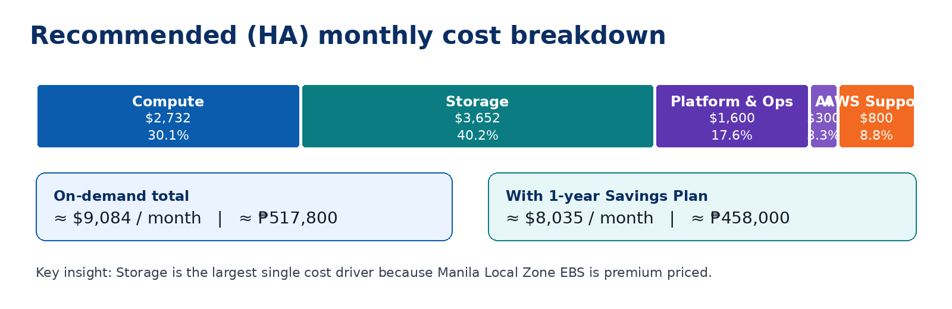
Figure 1. Cost breakdown summary for the Recommended (HA) tier.

2. Plain-English Setup Overview
The platform is a containerized email hosting stack. At small scale, all services can run on one host. For 10,000 users, the roles should be separated into dedicated AWS instances so each layer can be scaled, maintained, and protected independently.
Component | What it does | AWS placement | Who cares most
Docker Mailserver  (Postfix + Dovecot) | SMTP in/out, IMAP, mailboxes, anti-spam layer | Mail nodes: r5.2xlarge ×2 | DevOps / Client IT
Roundcube + AI Assistant plugin | Webmail interface users access in the browser | App nodes: c5.2xlarge ×2 behind ALB | Client / Users / DevOps
MariaDB 11 | Webmail metadata, sessions, address book, settings | DB nodes: m5.2xlarge ×2 | DevOps
AI API (Go) | Secure proxy between webmail plugin and OpenAI | AI nodes: t3.medium ×2 | DevOps / Product
Mail Admin  (Go + React) | Create/reset mailboxes, quotas, administration | Private/co-located, IP-allowlisted | IT/Admin
Amazon SES relay | Outbound email delivery and sender authentication support | External AWS service | Client / DevOps

What changes from the current one-host setup?
- Mail, app, database, AI, monitoring, and backups are separated into roles instead of running everything on one server.
- Public traffic uses two load balancers: NLB for mail ports and ALB for HTTPS webmail.
- Database and mail have redundancy paths so failures can be handled with less downtime.
- The same Docker images and environment-file approach can still be reused; deployment is split by role.

3. Recommended High-Availability Architecture
The recommended architecture is designed for approximately 1,000 to 2,000 peak concurrent webmail/IMAP sessions. It uses redundant mail, app, database, and AI nodes, with backup and monitoring services around them.
Traffic path | Production flow | Purpose
Webmail HTTPS | Internet → Cloudflare DNS/proxy → ALB :443 + TLS → App #1/App #2 → DB + AI API | Secure browser access for users
Mail protocol | Internet mail clients → NLB :25/:465/:587/:993 → Mail #1/Mail #2 | SMTP, submission, and IMAP access
Outbound mail | Mail nodes → Amazon SES relay → recipient mail servers | Better deliverability, DKIM/SPF/DMARC alignment
AI assistant | Roundcube plugin → AI API Go proxy → OpenAI gpt-4o-mini | Compose, reply, summarize, translate, phishing checks
Backup path | EBS snapshots + DB dumps + S3 Singapore copy | Recovery and offsite backup
Operations | Bastion + CloudWatch + log/queue alarms | Monitoring, controlled admin access, incident response

Recommended node sizing
Layer | Instance | Qty | Specs | Reason
Mail | r5.2xlarge | 2 | 8 vCPU / 64 GB | Memory helps IMAP concurrency and mail indexes. Second node supports standby/replication.
App/Webmail | c5.2xlarge | 2 | 8 vCPU / 16 GB | CPU-focused for PHP-FPM/Roundcube behind ALB.
Database | m5.2xlarge | 2 | 8 vCPU / 32 GB | Primary + replica for metadata/session workload.
AI API | t3.medium | 2 | 2 vCPU / 4 GB | Lightweight Go proxy; external model does heavy work.
Bastion/Monitoring | t3.medium | 1 | 2 vCPU / 4 GB | Admin entry point and monitoring support.
⚙ DevOps note: Managed services such as RDS or ElastiCache may not be guaranteed in the Manila Local Zone. This design self-manages MariaDB on EC2 to match the current container stack.

4. Detailed Monthly Cost — Recommended (HA) Tier
This section shows the monthly estimate in the format most useful for finance review and DevOps validation. All amounts are planning estimates and should be verified in the AWS Pricing Calculator before contract.
Cost group | On-demand | With 1-year Savings Plan
Compute | $2,731.80 | $1,780.00
Storage | $3,651.90 | $3,651.90
Platform & operations | $1,600.00 | $1,600.00
AI (OpenAI estimate) | $300.00 | $300.00
AWS Business Support | $800.00 | $703.00
TOTAL / month | ≈ $9,084 | ≈ $8,035
Indicative PHP @ ₱57/USD | ≈ ₱517,800 | ≈ ₱458,000

4.1 Compute
Role | Instance | Qty | $/mo each | Subtotal
Webmail / App | c5.2xlarge | 2 | $343.10 | $686.20
Mail (primary + standby) | r5.2xlarge | 2 | $532.90 | $1,065.80
Database (primary + replica) | m5.2xlarge | 2 | $420.48 | $840.96
AI API | t3.medium | 2 | $46.28 | $92.56
Bastion / monitoring | t3.medium | 1 | $46.28 | $46.28
Compute subtotal |  |  |  | $2,731.80
With 1-year Compute Savings Plan |  |  |  | ≈ $1,780.00

4.2 Storage
Volume | Size | Subtotal
OS / root volumes (9 instances × 50 GB) | 450 GB | $99.90
Database data (primary + replica, 2 × 500 GB) | 1,000 GB | $222.00
Mail store (single copy; standby restored from snapshot) | 15,000 GB (~15 TB) | $3,330.00
Storage subtotal |  | $3,651.90
! Storage warning: Mail storage is the largest budget risk. A full 5 GB/user quota at 10,000 users can push mail-store-only cost to around $11,100/month before backups and operations.

4.3 Platform, operations, AI, and support
Item | Basis | Monthly subtotal
Backups | EBS snapshots + S3 offsite, approximately 18 TB effective | $750.00
Data transfer out | Approximately 3 TB/month @ $0.09/GB | $300.00
Load balancers | ALB + NLB + LCUs | $80.00
Public IPv4 | Approximately 5 EIPs for mail/PTR | $20.00
CloudWatch / logs / alarms | Monitoring and operational alerts | $100.00
Amazon SES outbound relay | Approximately 3M external emails/month | $350.00
Platform subtotal |  | $1,600.00
AI estimate | ~3,000 active AI users; ~30 actions/user/month; ~2,000 in / 500 out tokens/action | ≈ $300.00
AWS Business Support | 10% of first $10k AWS spend estimate | ≈ $800.00

5. Tier Comparison and Storage Scenarios
The tier choice controls reliability and headroom. The storage policy controls the biggest long-term cost variable.
Item | Lean | Recommended (HA) | Premium
App nodes | 1 × c5.2xlarge | 2 × c5.2xlarge | 2 × c5.4xlarge
Mail nodes | 1 combined r5.4xlarge | 2 × r5.2xlarge | 2 × r5.4xlarge
Database | On mail node | 2 × m5.2xlarge | 2 × r5.2xlarge
AI nodes | Shared | 2 × t3.medium | 2 × t3.xlarge
High availability | None | App/mail/DB redundancy | Full + headroom
Mail storage | ~12 TB | ~15 TB | ~50 TB
Estimated monthly | ≈ $6,200 | ≈ $9,100  (≈ $8,000 w/ Savings Plan) | ≈ $22,000

Storage scenarios for 10,000 mailboxes
Offered quota | Provisioned / realistic | Mail store cost / month | If tiered to S3 Singapore
2 GB/user | ~15 TB (year-1 actual) | $3,330 | ~$1,200–1,800
2 GB/user | 20 TB (full quota) | $4,440 | ~$1,600–2,400
3 GB/user | 30 TB | $6,660 | ~$2,400–3,600
5 GB/user | 50 TB | $11,100 | ~$4,000–6,000
i Important: Hot/recent mail should stay on fast Local Zone EBS. Cold or archived mail can be moved to S3 Singapore to reduce cost, but this requires integration work and may add latency when users access old mail.

6. Cost Optimization Levers
Lever | Expected saving | Trade-off / note
1-year / 3-year Compute Savings Plan or Reserved Instances | Compute −35% to −55% | Requires a commitment term. No architecture change.
Tier cold mail + backups to S3 Singapore | Storage −50% to −75% on archived data | Added latency for old mail; requires archival design.
Confirm and use EBS gp3 if available in Local Zone | Storage −10% to −25% vs gp2 | Availability must be verified before final design.
Right-size mailbox quotas | Linear savings with reduced TB | Requires policy, communication, and possibly paid quota tiers.
Snapshot-based standby for mail | Avoids doubling mail storage | Slower failover because restore/promotion steps are needed.
Single DB node during non-critical phases | Approximately −$420/month | No database HA during that phase.
Amazon SES for outbound delivery | Deliverability and ops benefit | SES cost applies, but improves deliverability posture.

7. DevOps Deployment Plan
The following phased plan gives DevOps a practical path from AWS preparation through go-live. Dates can be attached later after vendor confirmation and resource assignment.
Phase | Focus | Main activities | Output / checkpoint
0 | Prerequisites | AWS account; opt in to Manila Local Zone; Cloudflare DNS plan; SES production access; DKIM/SPF/DMARC; port 25/PTR decision. | Ready to provision
1 | Network | VPC, subnets in Local Zone, security groups, NAT, EIPs, public/private access model. | Secure network baseline
2 | Compute & containers | Launch EC2 nodes; install Docker; split compose by role; configure remote.env per environment. | Running service layers
3 | Storage & data | Attach/mount EBS mail store; DB volumes; set up MariaDB primary/replica; Dovecot replication. | Persistent and replicated data
4 | TLS & DNS | ALB certificate; mail TLS; MX, SPF, DKIM, DMARC, PTR verification. | Domain validated and mail-ready
5 | HA & backups | Nightly snapshots, offsite S3 copy, DB dumps, restore tests, failover runbook. | Recoverable platform
6 | Monitoring | CPU, disk, queue depth, IMAP connections, ALB health, log/alerting rules. | Operational visibility
7 | Load test & go-live | Test webmail/IMAP concurrency, migrate users via IMAP sync where applicable, staged cutover. | Production launch

DevOps acceptance checklist
- ☐ All mail ports and HTTPS endpoints pass health checks.
- ☐ MX, SPF, DKIM, DMARC, and PTR records are published and verified.
- ☐ Backup restore test is completed before production cutover.
- ☐ Failover runbook is documented and tested at least once.
- ☐ Mailbox quota policy is confirmed with business/client stakeholders.
- ☐ Monitoring alerts reach the correct DevOps/on-call contacts.
- ☐ OpenAI API key is stored securely and usage limits are configured.
- ☐ SES sending limits are sufficient for expected outbound volume.

8. Ownership, Decisions, Risks, and Assumptions
This section clarifies what each audience needs to decide or validate before final procurement and deployment.
Audience | What they need to understand | Decision / action needed
Boss / Decision Maker | Recommended HA costs about $9,084/month on-demand or $8,035/month with Savings Plan. | Approve target tier, monthly budget, and Savings Plan direction.
Client | This setup is production-ready, redundant, and sized for 10,000 users with AI features. | Confirm quota policy, data residency expectations, and go-live window.
DevOps | Architecture separates mail, app, DB, AI, backups, and monitoring for scaling and reliability. | Validate Local Zone availability, deploy phased infrastructure, and confirm runbooks.
Finance / Procurement | AWS and OpenAI may bill separately; amounts are planning estimates. | Verify final calculator pricing, taxes, FX, support plan, and contract terms.

Assumptions
- 10,000 mailboxes with 10–20% peak concurrency assumption.
- Standard quota target of 2 GB/user, provisioned-as-you-grow for realistic year-1 storage.
- Outbound delivery through Amazon SES is recommended.
- AI adoption estimate: about 3,000 active AI users at moderate usage intensity.
- 730 hours/month; on-demand pricing unless Savings Plan is shown.
- USD pricing with indicative PHP conversion at ₱57/USD.

Excluded from monthly estimate
- One-time professional services: architecture, deployment, migration, load testing, security hardening.
- Domain registration, third-party anti-spam/AV licenses, and premium security tools.
- Taxes, VAT, withholding tax, and foreign exchange movement.
- Final AWS contractual quote and any negotiated discounts.

Key risks and controls
Risk | Why it matters | Control / mitigation
Local Zone pricing changes | The estimate uses Manila Local Zone rate assumptions. | Verify in AWS Pricing Calculator before contract.
Storage growth | Storage is the largest monthly cost driver. | Enforce quotas, monitor growth, tier cold mail.
Email deliverability | Self-hosted mail can suffer from reputation and PTR issues. | Use SES, DKIM, SPF, DMARC, PTR, and reputation monitoring.
Service availability in Local Zone | Not all AWS managed services are guaranteed locally. | Self-manage core services on EC2 or place unavailable services in Singapore with latency acceptance.
Backup/data residency policy | Backups in Singapore may need approval. | Confirm client data-residency and compliance requirements.
! Final approval gate: A firm quote requires confirming Manila Local Zone rates, final quota policy, selected Savings Plan term, taxes, and the final architecture in the AWS Pricing Calculator.

9. Appendix: Visual Infographics
These visuals summarize the architecture and the monthly cost profile. The detailed tables above are the source of truth for amounts and implementation decisions.
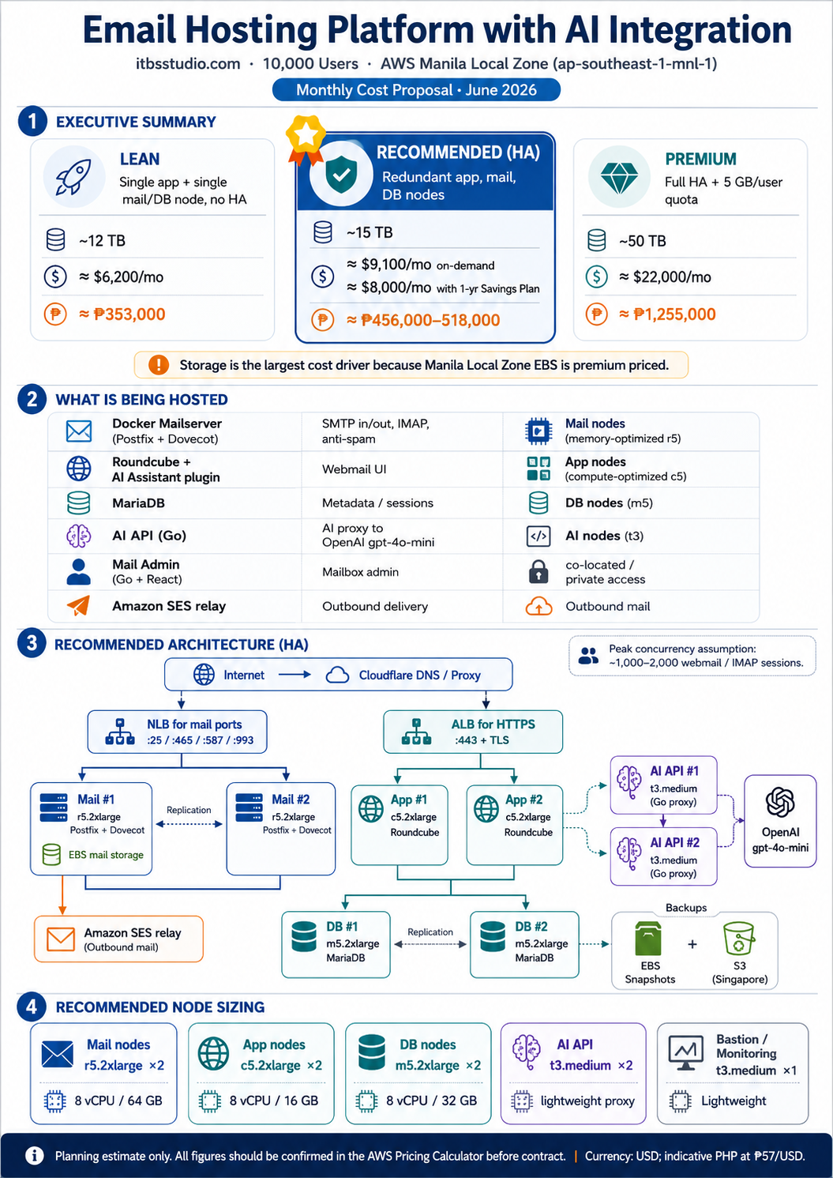
Figure 2. Architecture and setup overview infographic.

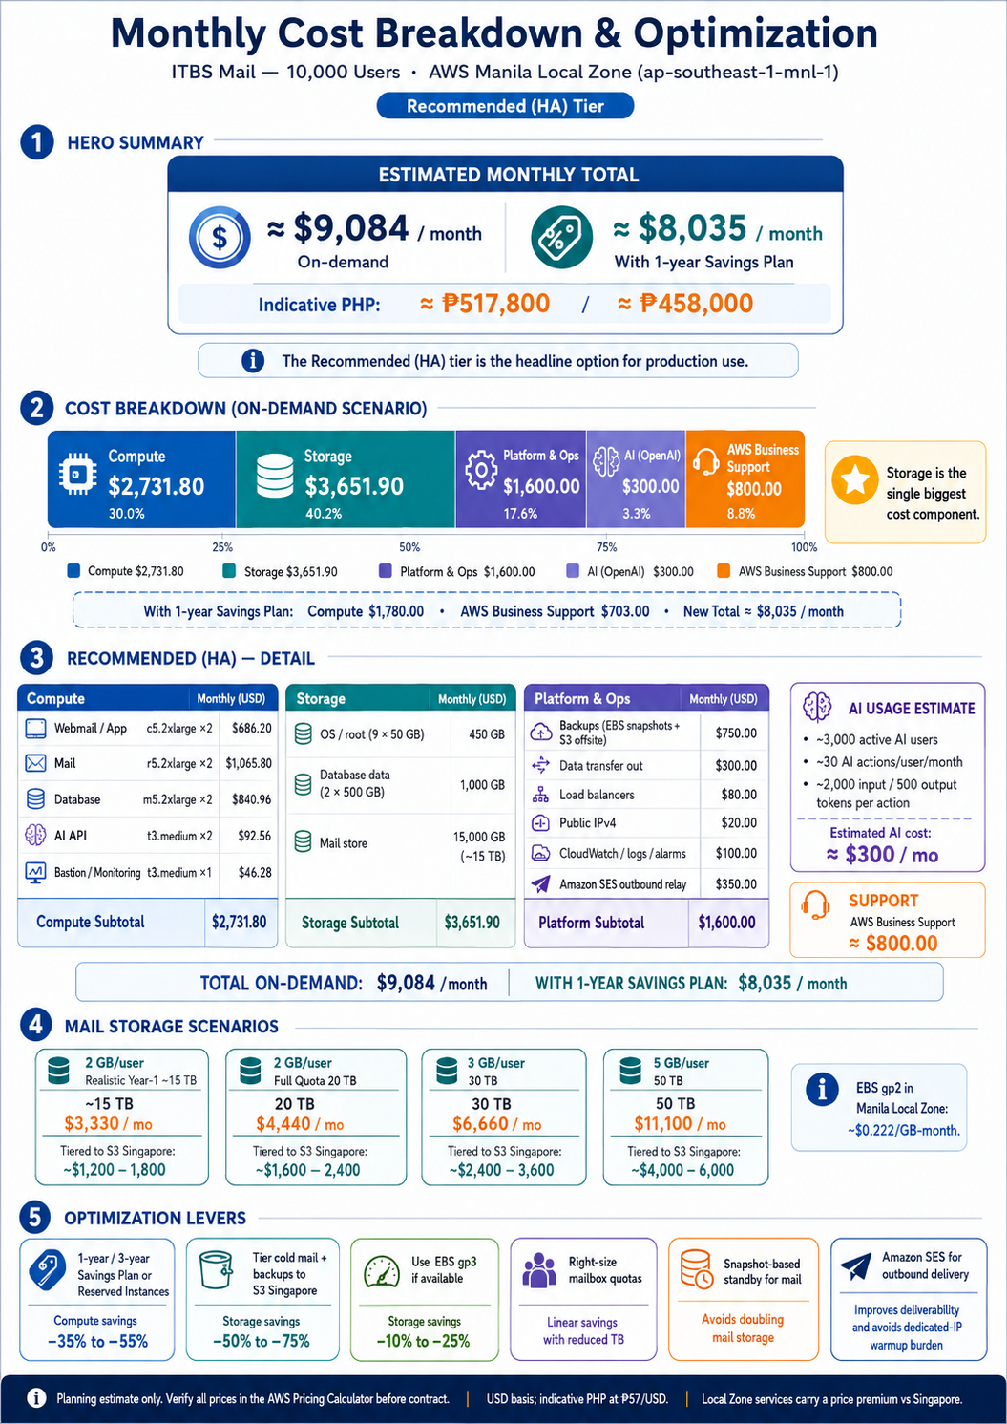
Figure 3. Monthly cost breakdown and optimization infographic.

