4. System description
4.1. Alert manager
According to the requirement of Task 1 and Task 2, every alert in SIEM system will have its own priority. This priority is ranged from low to high, and user have ability to modify the real priority of the alert.
To implement this requirement, we decide to create AlertManager class in which we use Properties File Format to store and java.util.Properties class to add and change the priority of the alert. Moreover, AlertManager class will also attach the priority to the alert object class and forward to the dashboard.
4.1.1. Properties File Format
Properties File Format is a simple text file, which contains key and value pair both as a string. The alerts’ priority are store in priorities.properties. The keys in the file are corresponding to the the alert name and the values is the corresponding priority which can be changed by user. The decision of this use is because that Properties File Format is a simple file format, and java.util.Properties is a subclass of Hashtable which easily and friendly to work with.
4.1.2. AlertManager class
This class will implement methods to read, write to priorities.properties file as also attach the priority to alert and forward to dashboard.
To read the properties file, we use FileReader Java class with load() method.

FileReader reader = new FileReader(configFile);
properties.load(reader);
reader.close();
Moreover, we restrict user from creating many object by using Singleton design pattern.
We have method getProperty() with parameter alertClass in Class type to get the value which is the priority from the file.
public String getProperty(Class alertClass){
return this.properties.getProperty(alertClass.getSimpleName());
}

To write to the properties file, we use setPriority() method with parameters are alertClass in Class type and newPriority in String type.
public void setPriority(Class alertClass, String newPriority) {
try {
FileOutputStream out = new FileOutputStream(configFile);
properties.setProperty(alertClass.getSimpleName(), newPriority);
properties.store(out, null);
out.close();
}
This method use setPriority() to set the key and value, then store to priorities.properties by using store() method.
To attach the alert with its priority and forward to dashboard, we have created acceptAlert() method.
public Alert acceptAlert(Alert alert) {
alert.setPriority(this.properties.getProperty(alert.getClass().getSimpleName()));
System.out.println(alert.getMessage());
Dashboard.acceptAlert(alert);
return alert;
}
This method use getProperty() to get the value and setPriority() to pass the value to object alert. Then Dashboard.class will call this method again to forward the object to. The return is the object alert which contains priority as also name and message of the corresponding alert.

4.2.3. Resource monitor
Each and every system will have their system resource. Those are CPU, RAM, Hard drive or Video card. When the system resource usages reach their highest bound, it may cause the system freeze or crash. This will create opportunities for attacker to attack and harm the system such as Resource exhaustion attack. In most case, the term “system resources” is used to refer CPU and RAM that are available on the system. Therefore, to prevent the system reaches its threshold, we decide to choose CPU and RAM usage as objects to monitor. When the system resource reach it threshold, an alert will be raise with the following priority. Both the threshold of the system resource and the priority can be decided by user.

4.2.3.1. Library
We use two Java library to read the CPU and RAM usage from the system: OperatingSystemMXBean which is the integrated library to monitor CPU and OSHI which is a free JNA-based (native) Operating System and Hardware Information library for Java to monitor RAM. The reason we use OSHI to monitor RAM instead of CPU is that OSHI read and return the global RAM usage more accurate while OperationSystemMXBean includes the amount of virtual memory.
The OSHI Library can be easily set up by add OSHI dependency in Maven pom.
4.2.3.2. ResourceCollector
This class will implement methods to get system resources information of the system which the SIEM System is running on. Then we convert the information to percentage and feed them to the CEP engine for raising the event.
To get the CPU usage, we use getSystemCpuLoad()method.
double cpuLoad = osBean.getSystemCpuLoad() * 100;
The return value is interval from 0 to 1. The final result should be measured in percentage, therefore we multiple the return value by 100.
To get the RAM usage, we use getMemory() method.
GlobalMemory memory = hal.getMemory();
The memory we get from is Global memory which is the total physical memory of the system.
Then we have two methods getAvailable() to get the available physical memory and getTotal() to get total of physical system memory.
long availableMemory = memory.getAvailable();
long totalMemory = memory.getTotal();
Finally, to get the current memory in use, we have algorithm
double memLoad = (1 - ((double)(availableMemory)/(double)totalMemory)) * 100;
Because the return value is interval from 0 to 1 so we multiple by 100 to get the final result in percentage.
After getting value of CPU and RAM usage, we pass these to object ResourceMonitorEvent and feed to the CEP Engine.
return new ResourceMonitorEvent(cpuLoad, memLoad);
To get the system resource and feed them to CEP Engine every second, we implement method run() in which there is a while (true) loop with Thread.sleep(1000);
4.4. Dashboard
According to Task 4, we have to create a dashboard for SIEM System in which user can monitor the recent and past alert, number of processed event for each event type and ability to customize the system such as change the real priority of the alert as well as change the configuration of SIEM System.
Dashboard is a graphical user interface of SIEM System, and we implement the dashboard using JavaFX 11. The dashboard contains 5 scenes:

Dashboard scene where alerts will be listed and showed in table.
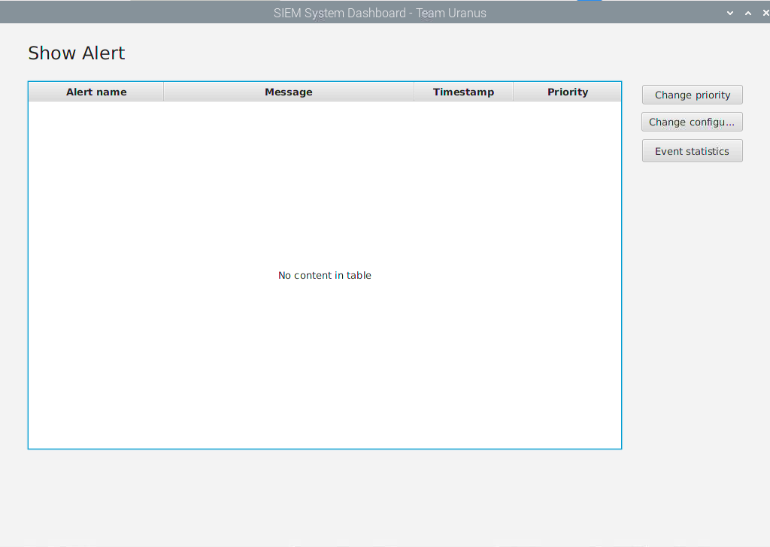
ChangePriority scene where user can change the priority of the alerts.
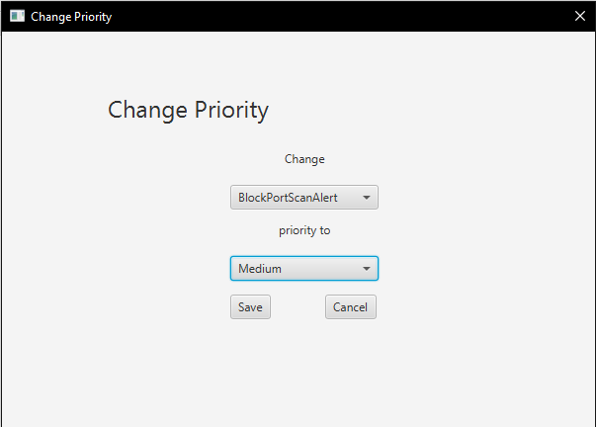

ChangeConfiguration scene where user can change the configuration of CEP Engine.
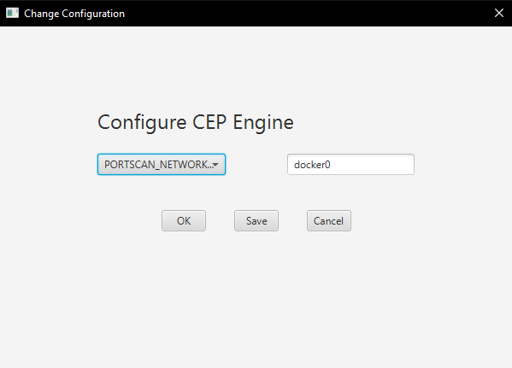

EventStatistics scene where user can see the total number of processed event for each event type.
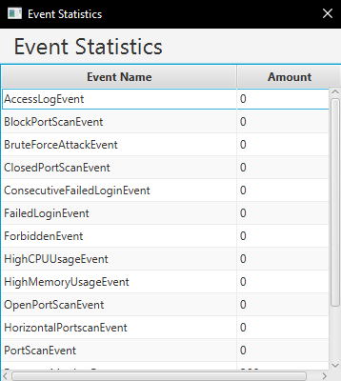

RestartNotification scene to remind user restart the application after changing the configuration.
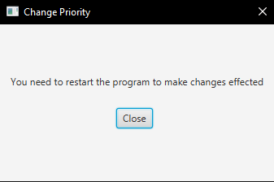
The GUI is created with Drag and Drop method by using JavaFX .fxml and SceneBuilder.
4.4.1. Dashboard scene
This is the main function of the dashboard – showing the recent and past alert. The alert will appear respectively in a real time base. Therefore, in order to make it easier to keep track with the alert, user can sort the table from A-Z or Z-A in any column by clicking on the name of its.
4.4.2. Change priority
This is one of four main features of the dashboard. According to the task requirement, user should have ability to change to real priority of the alert. Therefore we implement ChangePriority scene to make it easy for user to change and save their setting.
4.4.2.1. ChangePriority scene
In the Change Priority window, the user will have two choice boxes: one for selecting alert and one for selecting the corresponding priority.
There are 10 kinds of alert, which are BlockPortScenAlert, BruteForceAttackAlert, ConsecutiveFailedLoginAlert, ClosedPortConnectionFailureAlert, FailedLoginAlert, ForbiddenAlert, HorizontalPortScanAlert, HighCPUUsageAlert, HighMemUsageAlert, VerticalPortScanAlert, for user to choose.
The priority of each kind of alert is Low, Medium, and High. The default priority of each alert is also the current priority of that alert in priorities.properties.
The user’s change will be saved and write to the priority.properties after the user clicks the Save button.
The window will close if the user clicks the Cancel button. The user’s change will not be saved.
4.4.2.2. ChangePriority
In ChangePriority class, we have keyChoice ChoiceBox to get the input from user and return as String type. The default is BlockPortScanAlert and set by setValue() method.
keyChoice.setValue("BlockPortScanAlert");

To get the priority, we have valueChoice ChoiceBox, and the default value is equal the priority of that alert in priorities.properties which is set by using setValue() method. The priority is returned as String type.
valueChoice.setValue(alertManager.getProperty(getKey(keyChoice)));
To pass keyChoice and valueChoice value to setPriority() method, we implement two functions getKey()
public Class getKey(ChoiceBox<String> keyChoice) throws ClassNotFoundException {
return Class.forName("SIEMsystem.alert." + keyChoice.getValue());
}
and getValue() to get and return as required type.
public String getValue(ChoiceBox<String> valueChoice) {
return valueChoice.getValue();
}
Because that setPriority() method require the first parameter, which is keyChoice , as Class type, we have method getKey() to get the keyChoice as String and return as Class type.
The saveButton will execute the setPriority() method with the value from getKey() and setKey() methods.
alertManager.setPriority(getKey(keyChoice), getValue(valueChoice));

The cancelButton will close Change Priority window on click by using close() method.
cancelButton.setOnAction(e -> {
Stage stage = (Stage) cancelButton.getScene().getWindow();
stage.close();
});
4.4.3. Change configuration
This is one of four features of the dashboard. In this scene, user can change the configuration as well as review the current configuration of CEP Engine. The change will take effect after user close and open the application again.

4.4.3.1. Change Configuration scene
In the Change Configuration window, we have one Choice box to select the configuration that need to be changed. There are 19 configurations of CEP Engine that user can customize: "PORTSCAN_NETWORK_INTERFACE_NAME"
"PORTSCAN_V_TIME_OF_WINDOW_IN_SECONDS"
"PORTSCAN_V_THROW_ALERT_EACH_SECONDS"
"PORTSCAN_V_MINIMUM_NUMBER_OF_PORTS"
"PORTSCAN_H_TIME_OF_WINDOW_IN_SECONDS"
"PORTSCAN_H_THROW_ALERT_EACH_SECONDS"
"PORTSCAN_H_MINIMUM_NUMBER_OF_HOSTS"
"PORTSCAN_B_TIME_OF_WINDOW_IN_SECONDS"
"PORTSCAN_CLOSED_PORT_CONNECTION_FAILURE_TIME_WINDOW_IN_SECONDS"
"PORTSCAN_CLOSED_PORT_CONNECTION_FAILURE_ATTEMPT_THRESHOLD"
"PORTSCAN_EXCLUDE_PORTS"
"WEBSERVER_BRUTEFORCE_LOWER_THRESHOLD",
"WEBSERVER_BRUTE_FORCE_TIME_WINDOW_IN_SECONDS"
"WEBSERVER_CONSECUTIVE_FAILEDLOGIN_LOWER_THRESHOLD"
"WEBSERVER_CONSECUTIVE_FAILEDLOGIN_TIME_WINDOW_IN_SECONDS"
"WEBSERVER_LOG_FILE_PATH"
"RESOURCE_CPU_USAGE_THRESHOLD"
"RESOURCE_MEM_USAGE_THRESHOLD"
"RESOURCE_TIME_OF_WINDOW_IN_SECONDS"
Users can enter the value of that configuration in the text field. The default value of the text field is also the current value of that configuration in CEPEngine.properties.
The user’s change will be saved and write to the CEPEngine.properties after the user clicks the Save button.
To make the change effect, user have click on OK button then click on the Close button to close the program. After user open the program again, the CEP Engine will run with the new configuration.
The window will close if user click Cancel button. The user’s change will not be saved.
4.4.3.2. ChangeConfiguration
In ChangeConfiguration class, we use ChoiceBox keyChoice to get the configuration name from user and return as String type. The default value is PORTSCAN_NETWORK_INTERFACE_NAME and is set by setValue() method.
keyChoice.setValue("PORTSCAN_NETWORK_INTERFACE_NAME");
To get the configuration value from user, we have a TextField named valueTextField. The valueTextField will get the input by using setText() method. The value returns in String type.
valueTextField.setText(CEPEngine.getCreatedInstance().getProperty(getKey(keyChoice)));
The default value is set by using setText() method combine with getProperty() method to get the corresponding configuration from cepengine.properties.
To pass value from keyChoice to setProperty() method, we implement method getKey()
public String getKey(ChoiceBox<String> keyChoice) {
return keyChoice.getValue();
}

The saveButton will execute the setProperty() method with value from getKey() and getText().
CEPEngine.getCreatedInstance().setProperty(getKey(keyChoice), valueTextField.getText());
The configuration will be save only if user enter the value satisfied the constraints.
The cancelButton will close Change Configuration window on click by using close() method.
cancelButton.setOnAction(e -> {
Stage stage = (Stage) cancelButton.getScene().getWindow();
stage.close();
});

The okButton will close the Change Configuration scene and redirect user to RestartNotification scene.
4.4.4. Restart Notification
This is a small feature of our dashboard to remind user restart their application.
4.4.4.1. Restart Notification scene
This window will show after user click on OK button from the Change Configuration scene. The main function of this scene is to remind user to restart the program to take change effect. The program will be close after user click on Close button.
4.4.4.2. RestartNotification
There is a close button, which will close the JavaFX Platform and the Java Virtual Machine on click by using Platform.exit() and System.exit(0) method.
4.4.5 Event Statistic
This is one of the four features of the dashboard. In this scene, the user can see the number of each event that has been raised.
There are 15 types of event: AcessLogEvent, BlockPortScanEvent, BruteForceAttackEvent, ClosePortScantEvent, ConsecutiveFailedLoginEvent, FailedLoginEvent, ForbidenEvent, HighCPUUsageEvent, HighMemoryUsageEvent, OpenPortScanEvent, HorizontalPortScanEvent, PortScanEvent, ResourceMonitorEvent, VerticalPortScanEvent, TcpPacketEvent.
The number of these events is counted in the CEPEgine and then binds it to the ObservableList in the dashboard to make sure the dashboard will be updated on a real-time basis.

