Mobile Application Store Product API Design Document

Date: 2013-10-08
Author: David Killeffer <rayden7@gmail.com>
Reviewer(s): Catherine Bieber <catherine.bieber@gmail.com>

Introduction
This document defines the design for the Mobile Application Store Product API, which is a core component of the Mobile Application Store.

Overview
The Product API Service component of the Mobile Application Store is used to allow end-Consumers and Administrators the ability to interact with the products that are stored in the Mobile Application Store. The Product API Service is critical to the overall success of the Mobile Application Store, since the vast majority of revenue generated by the store will be through Consumer interactions with the product catalog, and the Service is the primary broker for this interaction.

Consumers are able to search for content across all categories (application, ringtone, and wallpaper) through a rich search interface. Consumer content searches may query for content across nearly every aspect of a content item, and present the full list of matching content items back to the consumer.

Administrators may likewise search for content similarly to Consumers, but they also have the ability to manage content by adding, editing, or deleting individual content items. Application developers may also manage content similarly to Administrators.

Requirements
This section defines the requirements for the Product API Service system component. Given that future sprints will incorporate authentication and authorization (Authentication Service) and that the Product API Service will need to interact with the Authentication Service, the design accounts for the notion of protecting restricted interface use cases, and will use a mock authentication token for now (for example, see requirements #1 and #4 in “Product API Requirements” from MobileApplicationStoreProductAPIRequirements.pdf).

Administrators and Application Developers that have a GUID access token should be able to add Countries, Devices, and Content to the product catalog via CSV import files loaded through the Importer. When Content items are added to the product catalog they should be validated to include all required fields. The Importer will handle allowing items to be added to the product catalog.

Consumers may search for content across several different content criteria. The SearchEngine allows consumers, administrator, and application developers to execute content searches.

More specific details on the requirements are found in the MobileApplicationStoreProductAPIRequirements.pdf document.

Use Cases
The following use case diagram shows the major functional tasks that each type of user of the Mobile Application Store can perform; the use cases surrounded with red boxes denote those that the Product API Service is responsible for. In future sprint iterations the other use cases will be built out separately from the Product API Service.

This design supports the following use cases:
- Search Content (may be performed by Consumers or Administrators)
- Manage Content (may be performed by either Administrators or Application Developers)
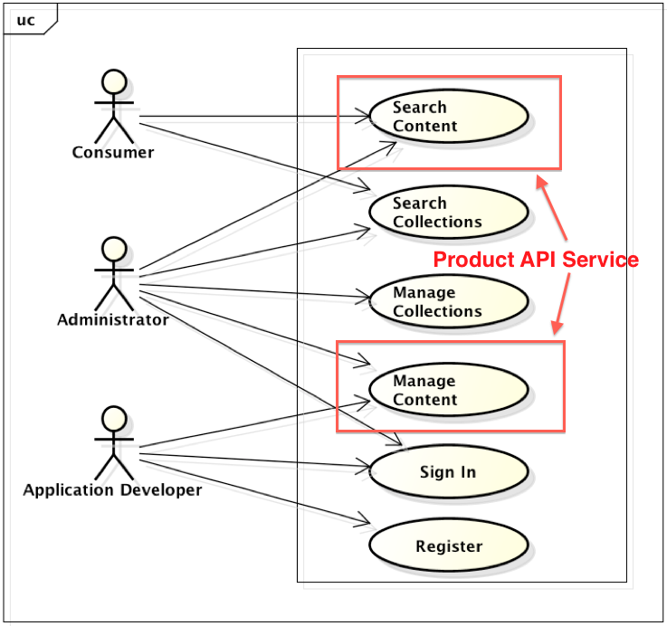

Class Diagram
The following class diagram defines the classes defined in this design.
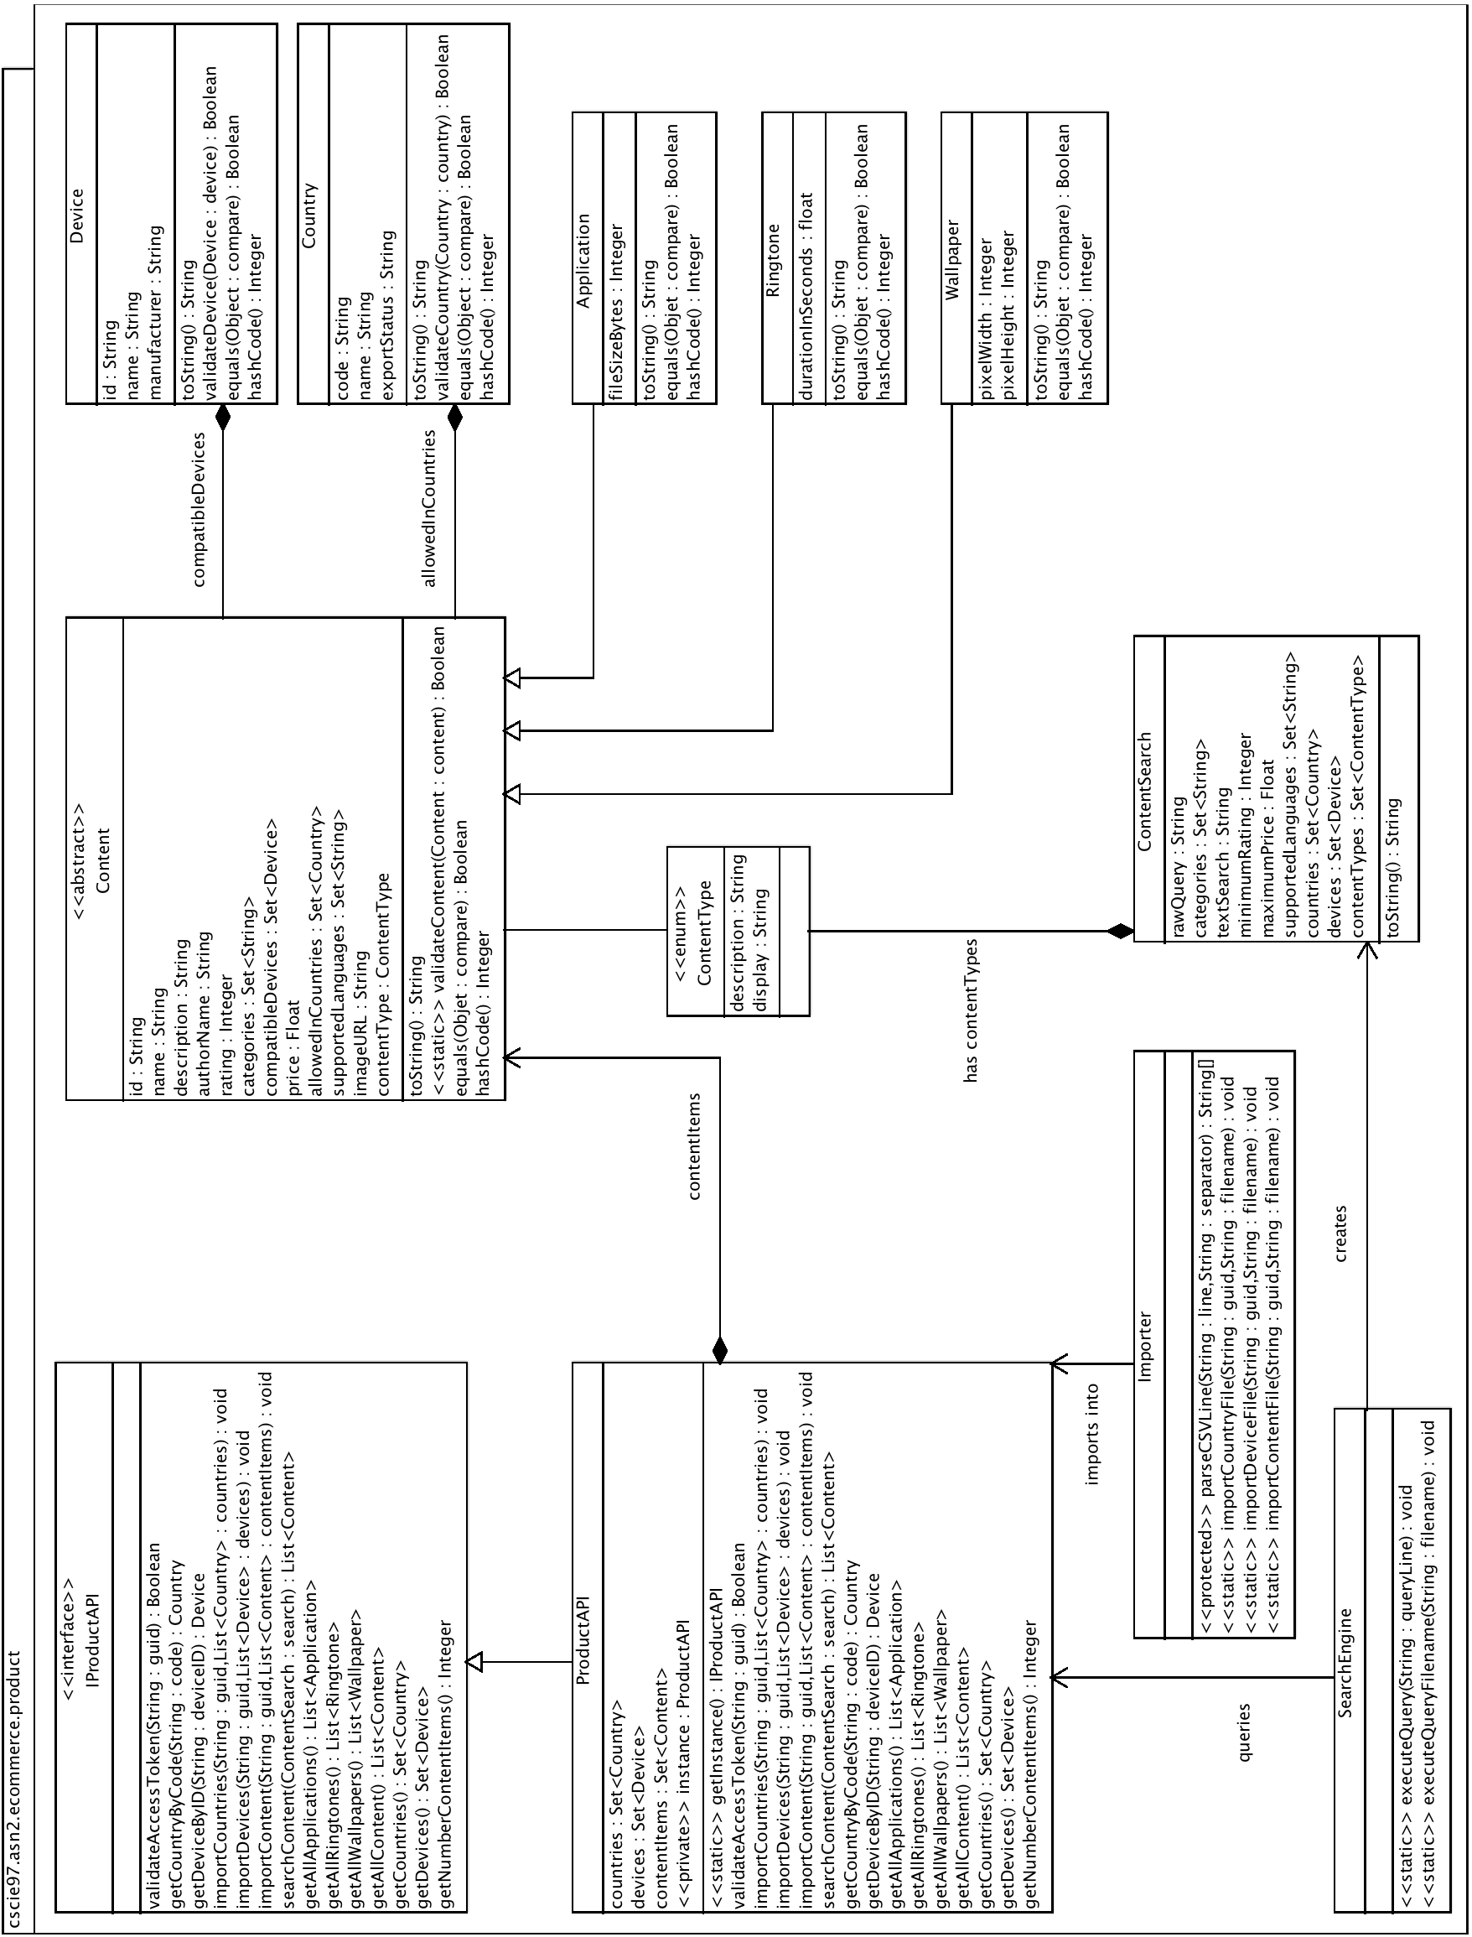
Class Dictionary
This section specifies the class dictionary for the Product API. The classes should be defined within the package “cscie97.asn2.ecommerce.product”.

ProductAPI

The ProductAPI is responsible for the public interface for interacting with the product catalog, for end-consumers, application developers, and administrations. The ProductAPI is a singleton and follows the Singleton design pattern. The contentItems property contains references to the entire product catalog of content items.

Methods
Method Name | Signature | Description
getInstance | () : ProductAPI | This method returns a reference to the single static instance of ProductAPI.
validateAccessToken | (String : guid) : bool | If the guid passed is a valid authentication token, returns true; false otherwise. Currently the guids passed to this method will be mocked and may be any value; this method will currently always return true until the Authenication API is built in a future sprint.
importCountries | (String:guid, String:filename) : void
importDevices | (String:guid, String:filename) : void
importContent | (String:guid, String:filename) : void
addCountry | (String:guid, String:code, String:name, String:exportStatus) : void
addDevice | (String:guid, String:id, String:name, String:manufacturer) : void
addContent | (String:guid, Content:item) : void
validateCountry | (Country : country) : bool
validateDevice | (Device : device) : bool
validateContent | (Content : content) : bool
parseSearchString | (String : searchString) : ContentSearch
searchContent | (String : searchString) : List<Content>
searchContent | (ContentSearch : search) : List<Content>
getAllApplications | () : List<Application>
getAllRingtones | () : List<Ringtone>
getAllWallpapers | () : List<Wallpaper>
getAllContent | () : List<Content>

Properties
Property Name | Type | Description
numberContentItems | Integer | Convenience method that gets the number of content items currently in the contentItems association.

Associations
Association Name | Type | Description
Countries | Set<Country> | Private association for maintaining the current set of Country instances.
Devices | Set<Device> | Private association for maintaining the current set of Devices.
contentItems | Set<Content> | Private association for maintaining the current set of Content items.

ContentSearch

The ContentSearch is used to capture the whole set of potential search parameters (rather than have a search method that takes a very long parameter set. Although not used yet, this object could potentially be used later to allow customers to “save searches” for later use.

Properties
Property Name | Type | Description
categories | Set<String>
textSearch | String
minimumRating | Integer
maximumPrice | float
supportedLanguages | Set<String>
country | Country
device | Device
contentTypes | Set<ContentType>

ContentType

This is a container enum type that simply holds the references to the various types of content that is supported; currently this holds APPLICATION, RINGTONE, and WALLPAPER (although in future sprints ebook and other types might be added).

Properties
Property Name | Type | Description
description | String | Contains the content type name; can be one of APPLICATION, RINGTON, WALLPAPER

Content

This abstract class is the primary superclass for all main content type classes (such as Application, Wallpaper, Rington).

Methods
Method Name | Signature | Description
toString | () : String | Returns a string representation of the content item.
getName | () : String
getDescription | () : String
getAuthorName | () : String
getRating | () : Integer
getCategories | () : Set<String>
getCompatibleDevices | () : Set<Device>
getPrice | () : float
getAllowedInCountries | () : Set<Country>
getSupportedLanguages | () : Set<String>
getImageURL | () : String
getContentType | () : ContentType

Properties
Property Name | Type | Description
name | String
description | String
authorName | String
rating | Integer
categories | Set<String>
price | float
supportedLanguages | Set<String>
imageURL | String

Associations
Association Name | Type | Description
compatibleDevices | Set<Device>
allowedInCountries | Set<Country>
contentType | ContentType

Device

Represents a device.

Methods
Method Name | Signature | Description
getID | () : String
getName | () : String
getManufacturer | () : String
toString | () : String

Properties
Property Name | Type | Description
id | String
name | String
manufacturer | String

Country

Represents a country.

Methods
Method Name | Signature | Description
getCode | () : String
getName | () : String
getExportStatus | () : String
toString | () : String

Properties
Property Name | Type | Description
code | String
name | String
exportStatus | String

Application

Inherits from Content.

Methods
Method Name | Signature | Description
getFilesizeBytes | () : Integer
toString | () : String

Properties
Property Name | Type | Description
filesizeBytes | Integer

Wallpaper

Inherits from Content.

Methods
Method Name | Signature | Description
getPixelWidth | () : Integer
getPixelHeight | () : Integer
toString | () : String

Properties
Property Name | Type | Description
pixelWidth | Integer
pixelHeight | Integer

Ringtone

Inherits from Content.

Methods
Method Name | Signature | Description
getDurationInSeconds | () : float
toString | () : String

Properties
Property Name | Type | Description
durationInSeconds | float

Content, Country, Manufacturer, and Device Instance Management
Due to the in-memory nature of this implementation, to optimize memory usage there should only be one instance for each unique Country, Manufacturer, Device, and Content item (where “Content” item is any concrete instance of an Application, Ringtone, or Wallpaper). This follows the Flyweight design pattern (see http://en.wikipedia.org/wiki/Flyweight_pattern).

Implementation Details
The Product API is implemented as a Singleton, as returned by the static getInstance() method. When loading Content, Devices, and Manufacturers into the Product Catalog, it is essential to load the data in the following order:
- Manufacturers
- Devices
- Content
Since Devices contain information on Manufacturers, the Manufacturer data must be loaded first. Likewise, since Content contains information on the Devices that the Content supports, the associated Devices must be loaded into the Product Catalog prior to the Content. Administrators may create Manufacturers, Devices, and then Content through the Product API’s public “import*” methods, each of which take a CSV file containing the appropriate data.

When Manufacturers, Devices, and Content are loaded into the Product Catalog from the “import*” methods, new objects of those types are created and maintained in-memory in the Product Catalog (in the “contentItems” property).

To simplify searches of content, the design calls for the creation of ContentSearch objects. When a client of the Product API initiates a new content search via the searchContent() method, the client passes a single string as the search criteria. The searchCriteria() method passes control to parseSearchString(), which returns a ContentSearch object back to searchContent(). Then searchContent() performs the content search over all the contentItems in the Product Catalog based on the criteria in the ContentSearch object, and finally returns a list of all matching Content items.

Changes from Original Design & Requirements
- Allows partial language code searches to match languages that have the criteria (for example, a content search for languages with code “fr” will match content items that have “fr_ca”, French Canadian, as their language code).
- To further emphasize the differences in content item types:
  - Wallpaper has added two properties:
    - pixelWidth
    - pixelHeight
  - Ringtone has added property:
    - durationInSeconds
- To emphasize the separation of concerns, Content items handle the validation of their own types.
- Since Content items are added to collections in the product catalog, to maintain that the ProductAPI only contains a single copy of each item (Device, Country, Application, Ringtone, Wallpaper), each of these types overrides “equals” and “hashCode” to ensure that the Set collections don’t contain duplicates
- This implementation makes use of two Apache Commons JARs to facilitate more easily overriding the “equals” and “hashCode” methods in the content item classes, and also to simplify content searches (the ProductAPI’s searchContent() method makes use of CollectionUtils to compare the intersection of sets).
- Content items (Application, Wallpaper, and Ringtone) and Device and Country classes override the toString() method to simplify debugging, and to more easily observe all the properties of those objects when querying

Testing
The TestDriver class will exercise both importing content into the product catalog via public methods on the ProductAPI as well as searching for specific content items. A static main() method will interactively prompt the user for Countries, Devices, and Content CSV files and call the public import methods on the ProductAPI to load them into the product catalog. Once all required content is loaded, the user will be prompted to supply a CSV query file that will query the API for matching content and output the results to standard out.

Risks
As risks are uncovered in the development process they will be documented here.

Instructions for Compiling and Running Application
Because there are two external JAR dependencies, the way to compile and run the application is slightly different from the original specifications.

To compile the code, run the following:

javac -cp ".:commons-collections4-4.0-alpha1.jar:commons-lang3-3.1.jar" cscie97/asn2/ecommerce/product/*.java cscie97/asn2/ecommerce/product/exception/*.java cscie97/asn2/test/*.java

To run the application, run the following:

java -cp ".:commons-collections4-4.0-alpha1.jar:commons-lang3-3.1.jar" cscie97.asn2.test.TestDriver countries.csv devices.csv products.csv queries.csv

