Mobile Application Store CollectionServiceAPI
Design Document

Date: 2013-10-16
Author: David Killeffer <rayden7@gmail.com>
Reviewer(s): Jonathan Nichols <jn42887@gmail.com>

Introduction
This document defines the design for the Mobile Application Store Collections Service API, which is a core component of the Mobile Application Store. This document is organized into the following sections:
- Overview: summarizes the problem that is being solved and why
- Summary of Product API Changes: explains changes that were required to the ProductAPI to accommodate refactorings based on TA feedback from Assignment 2
- Requirements: enumerates the various requirements for the CollectionServiceAPI
- Use Cases: enumerates the use cases that the CollectionServiceAPI must support
- Class Diagram: graph of the primary classes and their relationships that are in use in the CollectionServiceAPI
- Sequence Diagram: shows the primary relationship between StaticCollections/DynamicCollections and how they relate to the ProductAPI
- Class Dictionary: a catalog of the classes that collectively comprise the CollectionServiceAPI and the various methods, properties, and attributes that define each
- Implementation Details: special considerations and explanatory observations about how the classes relate to each other and work
- Changes from Original Design & Requirements: explanations of how this implementation varies slightly from the stated requirements in MobileApplicationStoreCollectionServiceRequirements.pdf
- Testing: explanation of how the classes in CollectionServiceAPI are to be tested, and how the TestDriver exercises the functionality
- Risks: identifies and enumerates any potential pitfalls or deficiencies in the current implementation and issues that might arise from this implementation
- Instructions for Compiling and Running Application: explains how to compile and run the application

Overview
The various Content items that live in the ProductAPI live as individual islands with no conceptual relationship to each other; this makes it difficult to present groups of related Content items to consumers, and also makes browsing the product catalog difficult. The Collection Service API allows the organization of Products into Collections. By organizing Products into Collections, related groups of products can be grouped by category, or organized into taxonomical structures. These new collections of content will be very useful for presenting groups of Content items to consumers so that they can easily browse related content by theme, category, price, etc.

Collections can be static lists of individual Product items, or dynamic (e.g., the Content items that comprise a dynamic collection are based on a ContentSearch criteria object that is run against the ProductAPI).

Summary of ProductAPI Changes
Several refinements and refactorings were performed to the ProductAPI for the CollectionServiceAPI, but these were mainly small functionality additions, but also some structural changes.

The first functional change was to add a method to the ProductAPI that will allow for retrieving Content items based on their contentID. The ProductAPI already had methods for retrieving countries and devices in a similar fashion (getCountryByCode(String:code) and getDeviceByID(String:deviceID)), so really this change was both for the sake of consistency (e.g., all publicly-accessible “things” that the ProductAPI is responsible for should be able to be quickly and easily retrieved by their ID), but also for the CollectionServiceAPI to be able to more easily retrieve Content items. The CollectionServiceAPI has a soft requirement to “wrap” Content items in a proxy object, and so being able to easily retrieve Content items by ID made this a requirement. The new method added to ProductAPI is:

public Content getContentByID(String:contentID);

There was some large refactorings done to the cscie97.asn3.ecommerce.exception package; all exceptions for the entire application (both ProductAPI and CollectionServiceAPI) were combined under this single umbrella. Additionally, new exception types were added. A new custom super-type exception was added called “MobileAppException”; this exception is basically the same as the old ImportException (has attributes for lineWhereFailed, lineIndexWhereFailed, filename, originalCause, etc.). Since most of the custom exceptions all shared the same properties, the new MobileAppException is declared to be the abstract exception type parent class for the ImportException, ContentNotFoundException, and CollectionNotFoundException classes. This keeps the custom exception types leaner and also limits code repetition (in keeping with D.R.Y. principles).

The last large refactoring of the ProductAPI comes in the cscie97.asn3.ecommerce.csv package. Since the CollectionServiceAPI needs to load collections via CSV files, define collection attributes and add items to collections, and also to search collections, there was some refactoring that needed to take place. Since DynamicCollections have a ContentSearch attribute, and in the old ProductAPI the only location where such items were being constructed was in the SearchEngine.executeQuery(String:query) method, the executeQuery() method was refactored to be broken out into two parts:

- first, take the CSV query line and parse it out, constructing a ContentSearch object (created a new method called getContentSearchForCSV(String:query) on the SearchEngine; now both the ProductAPI and the CollectionServiceAPI can make use of that method and benefit from the easy creation of ContentSeach objects)
- take the ContentSearch object, and pass it to the ProductAPI to run the actual content search

By breaking the method up into two smaller methods, the utility of the SearchEngine class was enhanced by adding a new client (the CollectionServiceAPI), and also the longer-term maintainability of the class enhanced since now methods have smaller, more limited sets of responsibility.

CollectionServiceAPI Requirements
This section defines the requirements for the CollectionServiceAPI system component. Given that future sprints will incorporate authentication and authorization (Authentication Service) and that the CollectionServiceAPI will need to interact with the Authentication Service, the design accounts for the notion of protecting restricted interface use cases, and will use a mock authentication token for now (for example, see requirements under “Creating Collections” and “Adding Content to Collections” in MobileApplicationStoreCollectionServiceRequirements.pdf).

Administrators and Application Developers that have a GUID access token should be able to create new Collections (whether Static or Dynamic), and both add discrete Content (via ContentProxy objects that wrap Content items) to StaticCollections and define the search criteria for DynamicCollections. Collections may be nested and contain child Collections, making a Collection an arbitrarily complex tree structure, and granting Administrators and Application Developers the ability to create organized taxonomies of Content items. For DynamicCollections, their primary children should be the result of executing a predefined ContentSearch (the same type as already built in the ProductAPI). Adding content to StaticCollections, defining the search criteria on DynamicCollections, and adding child Collections to existing Collections are similarly restricted interfaces, and all require a valid GUID access token.

Consumers, Administrators, and Application Developers should be able to search Collections and find ones that match supplied search criteria on the Collection name or description. Since Collections may contain child Collections and child Content items (in the form of ContentProxy objects), Consumers, Administrators, and Application developers must be able to iterate over all the children of Collections. More specific details on the requirements are found in the MobileApplicationStoreCollectionServiceRequirements.pdf document.

Use Cases
The following use case diagram shows the major functional tasks that each type of user of the Collection Service can perform.

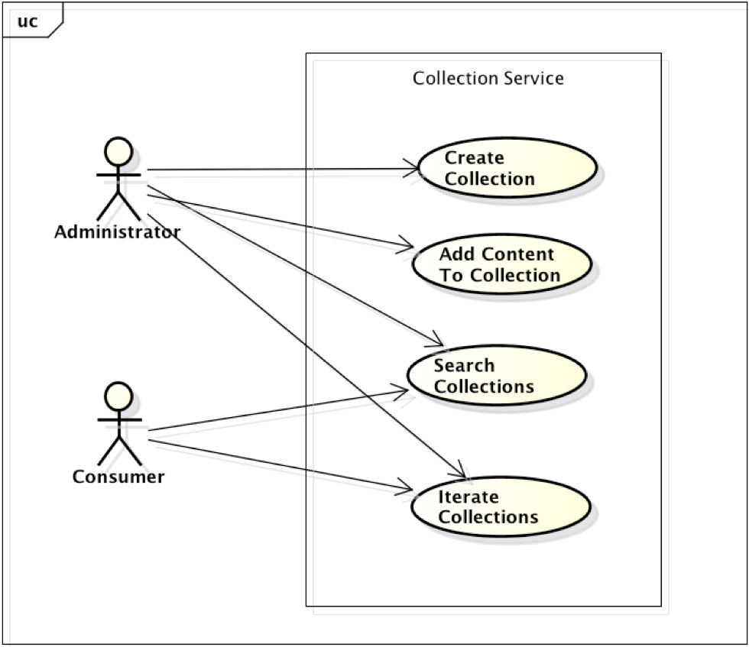

Create Collection: Administrators can create and define new Collections. These collections can be Static (e.g., consist of discrete, pre-existing Content items from the ProductAPI) or Dynamic (contain a ContentSearch property, that, when executed, returns a list of Content items). The content items in a Collection are wrapped as ContentProxy objects so that they share similar properties to the Collections themselves and can be iterated over as a common object. This is a restricted interface and requires a validated GUID token (mocked for now).

Add Content To Collection: Administrators can add content to StaticCollections and define the search criteria for DynamicCollections. This is a restricted interface and requires a validated GUID token (mocked for now). Collections may also be added to Collections, making a Collection an arbitrarily complex tree structure.

Search Collections: both Administrators and Consumers may search the Collection catalog for Collections that match the search text in either the collection’s name or description, and get a set of matching Collections. In order to search for collections that match the search criteria, this use case has an implicit dependency on the Iterate Collections use case.

Iterate Collections: both Administrators and Consumers may iterate over all the Collections in the catalog. Since both the Collections themselves and the ContentProxy items that they may contain inherit from the same abstract class, the iterator should allow for both Collections and the Content they contain to be enumerated by the iterator. This should allow for quick traversal of either a limited set of Collections or the entire catalog of Collections at once.

Class Diagram
The following class diagram defines the major classes defined in this design. A summary of the classes and their interrelationships follows the diagram.
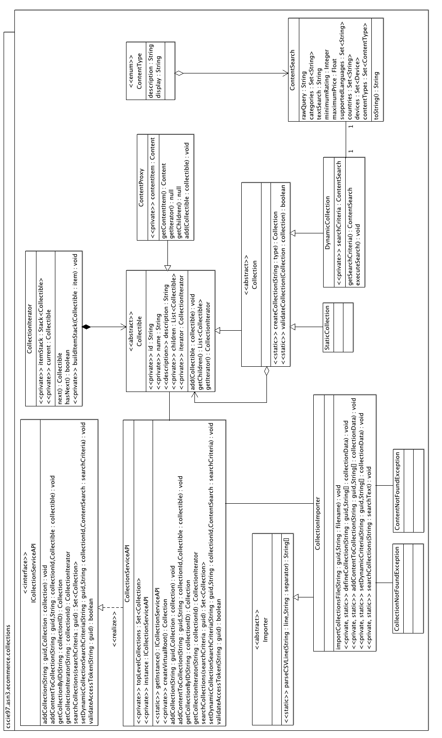

ICollectionServiceAPI / CollectionServiceAPI: The primary class for Consumers and Administrators to interact with the Collection catalog is through the CollectionServiceAPI class. ICollectionServiceAPI provides an interface to define the methods that the service must support (programming to interfaces rather than concrete classes is a good general design principle).

CollectionImporter: this is the primary mechanic by which Collections are created and imported into the catalog, content is added to Collections, content search criteria are defined on DynamicCollections, iterate over Collections, and search for matching Collections. The CollectionImporter itself only exercises the functionality of the CollectionServiceAPI. The CollectionImporter is called via the TestDriver, which loads CSV files for operation; a single CSV file called collections.csv is the primary way that all major functionality is exercised. The CollectionImporter may throw customized exceptions CollectionNotFoundException ContentNotFoundException when attempting to look up collections or content; it also uses Importer for parsing the CSV file.

Collectible: abstract parent class to Collection and ContentProxy, defining the major properties (id, name, description), as well as the children and iterator. Collectible items may be iterated over and contain many levels of child Collectibles. The Collectible uses the Composite pattern to define what “collections” are; they are groups of ContentProxy items and also StaticCollection and DynamicCollection objects; so ContentProxy, StaticCollection, and DynamicCollection objects are all instances of Collectible. Collectible objects can be iterated over by use of their CollectionIterator property.

ContentProxy: wrapper for Content items from the ProductAPI. Since Collections may contain both ContentProxy items as well as other Collections, inherits from Collectible. Together, Collectible, Collection, and ContentProxy observe the Composite design pattern to indicate that ContentProxy and Collections both inherit from Collectible and may be siblings in whole-part arbitrary hierarchies (e.g., “collections”), but that they both inherit from Collectible. This makes it easier to iterate over a Collection, because all elements in the Collection have shared attributes.

Collection: provides a Factory pattern method for creating “blank” StaticCollections or DynamicCollections based on the type passed, and also provides a static method for validating Collection objects once they have had the minimal set of required attributes defined (id, name, description). Collection is also the abstract parent class of both StaticCollection and DynamicCollection. Collection also extends Collectible, where it gets most of it’s functionality from.

StaticCollection: primarily a marker class, since the functionality of static collections is defined in it’s parent Collection and Collectible abstract classes.

DynamicCollection: allows for a Collection whose child elements are returned as a result of executing a predefined ContentSearch (exactly the same ContentSearch as is defined in the ProductAPI). Once the ContentSearch property of a DynamicCollection is defined (whether at object creation or afterwards), the search criteria is immediately executed against the ProductAPI so that the children are defined as the return result of the executed search.

CollectionIterator: used to simplify the arbitrarily complex nature of Collections, which can contain ContentProxy items, as well as StaticCollection and/or DynamicCollection objects. Since Collections are complex trees, the iterator uses a stack to add Collectibles as it traverses the Collection and then uses that stack to traverse the collection. Iteration is run in a depth-first traversal.

Sequence Diagram
This sequence diagram shows how a client might interact with the CollectionServiceAPI to iterate over the items in a specific Collection.

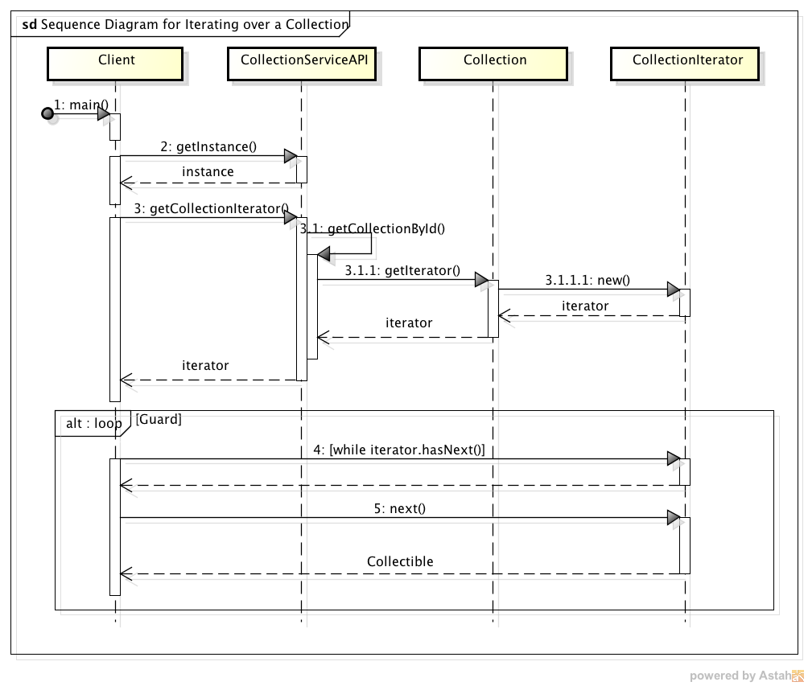
The iteration process is greatly simplified by the fact that at the time the CollectionIterator is initialized, it traverses the entire Collection tree and creates a private Stack<Collectible> objects; it then recursively performs a depth-first traversal of the tree, adding items to the stack as it goes. When the CollectionIterator is returned after being initialized, it then has access to the Stack of Collectibles, organized in depth-first order (e.g., the first item popped off the Stack is the deepest). Another design feature that aids in the CollectionIterator’s traversal of the tree is that when DynamicCollection objects are initialized with searchCriteria, that search is immediately executed against the ProductAPI; the returned items are then declared as the child items of that DynamicCollection object.

Class Dictionary
This section specifies the class dictionary for the CollectionServiceAPI. The primary classes should be defined within the package “cscie97.asn3.ecommerce.collection”. Per the changes outlined previously under the “Summary of ProductAPI Changes” section, exception classes should be defined within the package “cscie97.asn3.ecommerce.exception”, and CSV-handling classes should be defined within the package “cscie97.asn3.ecommerce.csv”. For the sake of brevity, simple accessor/mutator methods will not be documented here.

Package: cscie97.asn3.ecommerce.collection

ICollectionServiceAPI <<interface>>

This interface defines the service contract for any classes that intend to implement these methods and act as the concrete implementation of the CollectionServiceAPI. Public interface for the CollectionServiceAPI. Consumers and Administrators may search over all collections that match searchText in the Collection name or description. Administrators may also create collections, add content to collections, and for DynamicCollections, define the search criteria used.

Methods
Method Name | Signature | Description
addCollection | (String : guid, Collection : collection) : void | Restricted interface; will validate GUID token before adding content to a collection. Adds the passed collection to the CollectionService catalog at the top-level.
addContentToCollection | (String : guid, String : collectionId, Collectible : collectible) : void | Restricted interface; will validate GUID token before adding content to a collection. Looks up the Collection with matching collectionId in the catalog and then adds the passed Collectible to that Collection. Note that Collectibles may be either ContentProxy items (which wrap Content items that are returned by the IProductAPI, or Collection objects.
getCollectionByID | (String : collectionID) : Collection | Given a collection ID, search for any Collection that matches that code in the collection catalog. Constructs a private virtual "root" collection and sets all current top-level collections as it's children so that it can iterate over every collection in the catalog to find the one that matches.
getCollectionIterator | (String : collectionId) : CollectionIterator | If collectionID passed is not null and corresponds to a valid collection, simply returns the iterator for that Collection (note that the CollectionIterator can also simply be retrieved if a reference to the actual Collection instance exists). If the passed collectionId is null or empty string, constructs a virtual "root" level collection that has all the current top-level Collections as children, and returns a CollectionIterator which will be able to iterate over every item in the Collection catalog.
searchCollections | (String : searchCriteria) : Set<Collection> | Finds all Collections whose Collection name or description contains any part of the searchCriteria passed. Note that the search is case-insensitive.  To conduct the search, constructs a virtual "root" Collection that has all the top-level Collections as immediate children, and then iterates over all the Collectibles in this virtual Collection aggregate and finds matching Collections.
setDynamicCollectionSearchCriteria | (String : guid, String : collectionId, ContentSearch : searchCriteria) : void | Restricted interface; will validate GUID token before adding content to a collection. Looks up the Collection with matching collectionId in the catalog, ensures that the found collection is actually a DynamicCollection, and then sets the ContentSearch searchCriteria object on the DynamicCollection. Note that at the time the search criteria on a DynamicCollection is defined, it is immediately executed so that the child elements of the DynamicCollection are present.
validateAccessToken | (String : guid) : Boolean | Verifies that the guid access token passed is authenticated and authorized for carrying out restricted actions on the CollectionServiceAPI (such as adding new Collections, adding Content to Collection, etc.).  Note that for this version of the CollectionServiceAPI, this method is mocked and will return true for any string passed.

CollectionServiceAPI

Implements the ICollectionServiceAPI class to provide public methods for interaction with the Collection catalog. Consumers and Administrators may search over all collections that match searchText in the Collection name or description. Administrators may also create collections, add content to collections, and for DynamicCollections, define the search criteria used.

The CollectionServiceAPI is accessed as a Singleton; users must use the CollectionServiceAPI.getInstance() method to obtain a reference to the sole CollectionServiceAPI instance.

Methods
Method Name | Signature | Description
addCollection | (String : guid, Collection : collection) : void | Restricted interface; will validate GUID token before adding content to a collection. Adds the passed collection to the CollectionService catalog at the top-level.
addContentToCollection | (String : guid, String : collectionId, Collectible : collectible) : void | Restricted interface; will validate GUID token before adding content to a collection. Looks up the Collection with matching collectionId in the catalog and then adds the passed Collectible to that Collection. Note that Collectibles may be either ContentProxy items (which wrap Content items that are returned by the IProductAPI, or Collection objects.
getCollectionByID | (String : collectionID) : Collection | Given a collection ID, search for any Collection that matches that code in the collection catalog. Constructs a private virtual "root" collection and sets all current top-level collections as it's children so that it can iterate over every collection in the catalog to find the one that matches.
getCollectionIterator | (String : collectionId) : CollectionIterator | If collectionID passed is not null and corresponds to a valid collection, simply returns the iterator for that Collection (note that the CollectionIterator can also simply be retrieved if a reference to the actual Collection instance exists). If the passed collectionId is null or empty string, constructs a virtual "root" level collection that has all the current top-level Collections as children, and returns a CollectionIterator which will be able to iterate over every item in the Collection catalog.
searchCollections | (String : searchCriteria) : Set<Collection> | Finds all Collections whose Collection name or description contains any part of the searchCriteria passed. Note that the search is case-insensitive.  To conduct the search, constructs a virtual "root" Collection that has all the top-level Collections as immediate children, and then iterates over all the Collectibles in this virtual Collection aggregate and finds matching Collections.
setDynamicCollectionSearchCriteria | (String : guid, String : collectionId, ContentSearch : searchCriteria) : void | Restricted interface; will validate GUID token before adding content to a collection. Looks up the Collection with matching collectionId in the catalog, ensures that the found collection is actually a DynamicCollection, and then sets the ContentSearch searchCriteria object on the DynamicCollection. Note that at the time the search criteria on a DynamicCollection is defined, it is immediately executed so that the child elements of the DynamicCollection are present.
validateAccessToken | (String : guid) : Boolean | Verifies that the guid access token passed is authenticated and authorized for carrying out restricted actions on the CollectionServiceAPI (such as adding new Collections, adding Content to Collection, etc.).  Note that for this version of the CollectionServiceAPI, this method is mocked and will return true for any string passed.
getInstance | () : ICollectionServiceAPI | Returns a reference to the single static instance of the CollectionServiceAPI, and will construct a new instance if one does not exist already (follows Singleton pattern). In keeping with the generally accepted programming practice of coding to interfaces rather that concrete classes, the return value is declared to be an interface type.
createVirtualRoot | () : Collection | To iterate over all the collections in the CollectionServiceAPI catalog, a "virtual" root collection must be created, and all current topLevelCollections added to it. The virtual root Collection will then be able to iterate over every single Collection and Content item in the entire Collection catalog. This method will construct that virtual root Collection, add all the top-level Collections to it, and then returns the virtual root.

Properties
Property Name | Type | Description
topLevelCollections | Set<Collection> | The unique top-level collections contained in the Collection catalog; each collection may only be declared at the top-level once, but may be nested arbitrarily deeply in other collections. Required.
instance | ICollectionServiceAPI <<static>> | Singleton instance of the CollectionServiceAPI. Required.

Collectible <<abstract>>

Abstract parent class for Collection and ContentProxy objects. Collectibles can contain child Collectibles, which makes them a tree structure. Because arbitrary numbers of child Collectibles can be added, the class supports a CollectionIterator for iterating over all child elements. The object types that may be created that are children of the Collectible class are:
- StaticCollection
- DynamicCollection
- ContentProxy
All of these types will inherit their shared attributes (Collectible.id, Collectible.name, Collectible.description) from this class.

Methods
Method Name | Signature | Description
getIterator | () : CollectionIterator | Returns the iterator for the current collection. The iterator also follows the Singleton pattern; once the iterator has been declared and initialized, the already-declared one will be returned. If the iterator has not been defined when getIterator() is called, a new CollectionIterator will be created and initialized.
getChildren | () : List<Collectible> | Returns the current set of children Collectible objects that are contained by this Collectible. Note that while the children of the current Collectibles are all themselves Collectible objects, but their actual types may be one of:  - ContentProxy (used to wrap the Content objects that get returned by the IProductAPI)  - StaticCollection  - DynamicCollection  Note that if the current Collectible is actually a DynamicCollection this method will still return the found ContentProxy objects that are found by executing the search (no need to separately execute the search).
add | (Collectible : collectible) : void | Adds a child Collectible to the current Collectible. Since the children of the current Collectible will be modified as a result, a side effect of adding a new Collectible is to null out the current iterator (so that the next time a client wishes to iterate over the Collectible the new item will be included).
toString <<override>> | () : String | Overrides generic toString() method and print out all the properties of a Collectible. Useful for debugging.

Properties
Property Name | Type | Description
id | String | Unique identifier for the Collectible. Required.
name | String | Name of the Collectible. Required.
description | String | Textual description of what this Collectible is. Required.
children | List<Collectible> | All children Collectibles of the current Collectible; this makes the Collectible a tree structure.
iterator | CollectionIterator | Used for iterating over this Collectible and all children elements.

CollectionIterator

Allows for the iteration of Collectible items; implements Iterator. Collectibles follow a two-part Composite design pattern; at the lowest level, Collectibles can be instances of either StaticCollection or DynamicCollection, both of which inherit from Collection. These StaticCollection and DynamicCollection objects may be iterated over using this CollectionIterator. At a higher level, Collectibles may either be Collection instances or ContentProxy instances, and the two types share several common attributes.

However, since Collectible objects may have children of type Collection, they may have several children and at several layers of depth, making this iterator necessary to traverse a Collection. This iterator will traverse the Collectible depth-first.

Methods
Method Name | Signature | Description
getCurrent | () : Collectible | Convenience method to get the current item without moving the internal pointer of the iterator (calling CollectionIterator.next() will move the hidden internal pointer, but this method does not have that side-effect). Returns null if next() has not yet been called.
next | () : Collectible | Traverse the Collectible and return the next item.
buildItemStack <<private>> | (Collectible : item) : void | Called during class initialization. Populates the
toString <<override>> | () : String | Overrides generic toString() method and print out all the properties of a Collectible. Useful for debugging.

Properties
Property Name | Type | Description
id | String | Unique identifier for the Collectible. Required.
name | String | Name of the Collectible. Required.
description | String | Textual description of what this Collectible is. Required.
children | List<Collectible> | All children Collectibles of the current Collectible; this makes the Collectible a tree structure.
iterator | CollectionIterator | Used for iterating over this Collectible and all children elements.

ContentProxy

Wrapper class for Content objects that may be contained in Collections. Since all items that may be part of a Collection must be able to be easily iterated over and to reduce coupling with the ProductAPI, Content items must be wrapped so that they can inherit the same properties and be treated similarly by the CollectionIterator. However, since ContentProxy items are really just "wrapped" Content items, they should not able to add child items, get a CollectionIterator for, etc., so those inappropriate methods are overridden and return null or take no action.

Methods
Method Name | Signature | Description
getIterator <<override>> | () : CollectionIterator | Overrides method in Collectible; since ContentProxy objects may only contain single Content items, there is no need for an iterator.
getChildren <<override>> | () : List<Collectible> | Overrides method in Collectible; since ContentProxy items do not contain child collections, does nothing.
add <<override>> | (Collectible : collectible) : void | Overrides method in Collectible; since ContentProxy items do not contain child collections, does nothing.

Properties
Property Name | Type | Description
id | String | Unique identifier for the Collectible. Required.
name | String | Name of the Collectible. Required.
description | String | Textual description of what this Collectible is. Required.
children | List<Collectible> | All children Collectibles of the current Collectible; this makes the Collectible a tree structure.
iterator | CollectionIterator | Used for iterating over this Collectible and all children elements.

Collection <<abstract>>

Abstract class for Collections; extends Collectible. Currently supports two abstract methods: one is a factory method for the creation of either StaticCollection or DynamicCollection, and the other is for validating that the required fields for an existing Collection are valid (id, name, description).

Methods
Method Name | Signature | Description
createCollection <<static>> | (String : type) : Collection | Factory method to create an empty "shell" Collection, with no properties set. Type passed must be either “static” or “dynamic”. Only two types of Collections are currently supported: StaticCollection and DynamicCollection.
validateCollection <<static>> | (Collection : collection) : Boolean | Performs a validation check to ensure that the collection contains a minimal set of required attribute properties. Currently only requires that id, name, and description are set.
toString <<override>> | () : String | Overrides generic toString() method and print out all the properties of a Collection. Useful for debugging.

StaticCollection

Marker class for StaticCollections. StaticCollections are used to add discrete, specific Content items to a Collection. The logic for how to add content items and their properties are all contained in the parent classes Collection and its parent class, Collectible.

Methods
Method Name | Signature | Description
toString <<override>> | () : String | Overrides generic toString() method and print out all the properties of a StaticCollection. Useful for debugging.

DynamicCollection

DynamicCollections contain a ContentSearch object which is executed immediately upon defining the ContentSearch. DynamicCollections may initially be created as empty "shell" objects that have not yet defined the searchCriteria property for. Once the searchCriteria property is declared (either by calling setSearchCriteria(ContentSearch) or by passing it to the class constructor), the actual search is immediately executed by calling the IProductAPI.searchContent(ContentSearch) method and passing the search criteria object. Returned matching Content items are wrapped as ContentProxy objects because they inherit from Collectible. By executing the search criteria as soon as it is defined the DynamicCollection will have children objects available immediately after defining the search criteria, which aids in iteration (see also CollectionIterator).

Methods
Method Name | Signature | Description
setSearchCriteria | (ContentSearch : searchCriteria) : void | Defines and executes the search for Content items.
executeSearch | () : void | Executes the ContentSearch for the DynamicCollection against the IProductAPI. The returned found Content items will be wrapped as ContentProxy objects, so that all items in a Collection share the same properties and may likewise be iterated over simply, despite having different attributes and features.
toString <<override>> | () : String | Overrides generic toString() method and print out all the properties of a DynamicCollection. Useful for debugging.

Properties
Property Name | Type | Description
searchCriteria | ContentSearch | ContentSearch object used by the collection to define what criteria to use when searching for matching Content items that will first be wrapped as ContentProxy objects, and then included as children of the DynamicCollection. Required.

Package: cscie97.asn3.ecommerce.csv

CollectionImporter

Provides a single public method for handling the creation of new Collections, adding Content to StaticCollections, defining the ContentSearch criteria for DynamicCollections, and lastly, for searching over these newly created Collections. Each sub-task under loading the primary CSV is handled by private methods.

Methods
Method Name | Signature | Description
defineCollection <<private, static>> | (String : guid, String[] : collectionData) : void | Called directly by importCollectionsFile(), so GUID restriction is in place. Creates collections and adds them to the CollectionServiceAPI. The format of each element in collectionData should be:  - define_collection  - static | dynamic  - collection ID  - collection name  - collection description
addContentToCollection, throws ParseException, CollectionNotFoundException, ContentNotFoundException <<private, static>> | (String : guid, String[] : collectionData) : void | Adds ContentProxy and Collection items to Collections. The format of each element in collectionData should be:  - add_collection_content  - collection ID  - product | collection  - content ID
setDynamicCriteria, throws ParseException, CollectionNotFoundException <<private, static>> | (String : guid, String[] : collectionData) : void | Sets dynamic search criteria attribute on DynamicCollections. DynamicCollections use the ContentSearch attribute to search the IProductAPI for matching Content items. The format of each element in collectionData should be:  - set_dynamic_criteria  - collection ID  - list of content categories (pipe-separated)  - search text (will scan Content name, description, author name)  - minimum content rating (from 0-5, 5 is best)  - maximum price (as a float, in BitCoins)  - list of supported language codes (pipe-separated)  - list of country codes (pipe-separated)  - device ID  - list of content types (can be any or all of "application", "ringtone", or "wallpaper" currently)
searchCollections, throws ParseException <<private, static>> | (String : searchText) throws ParseException | Search all Collections in the ICollectionServiceAPI to find those that have full or partial matches to the searchText on either the collection's name or description. Prints found Collections to standard out.
importCollectionsFile, throws ImportException, ParseException, CollectionNotFoundException <<static>> | (String : guid, String : filename) : void | Public method for importing Collection items into the product catalog. Note that any Content items referenced in the import file must already exist in the Product catalog first, or the import of that Collection items will not work. Throws ImportException on error accessing or processing the input Collections File.

Importer <<abstract>>

Abstract parent class of all other CSV loading and query implementing child classes. Provides utility methods that are useful to all implementing classes and centralizes shared methods (such as CSV line parsing).

Methods
Method Name | Signature | Description
parseCSVLine <<static>> | (String : line, String : separator) : String[] | Splits up the line string based on the supplied separator into an array of strings and ignores any backslash-escaped separator.

Implementation Details
The CollectionServiceAPI is implemented as a Singleton, as returned by the static getInstance() method. Following good basic design principles, the CollectionServiceAPI’s public methods are enumerated in the interface that it inherits from, ICollectionServiceAPI. Anywhere in the code that a reference to the service is expected, the interface type is returned rather than a concrete implementation.

Collection, ContentProxy, and Collectible together follow the Composite design pattern.

The Collection class has a static factory method to support the creation of both StaticCollection objects and DynamicCollection objects.

Changes from Original Design & Requirements
All CSV based content loading classes were organized under a new package: cscie97.asn3.ecommerce.csv. Additionally, the Importer from Assignment 2 was refactored into a more general purpose, abstract utility class that may be used by all other classes that deal with CSVs – it’s primary shared static method parseCSVLine() is used for uniformly parsing the CSV lines, which SearchEngine, ContentImporter, and CollectionImporter all use. This logical grouping of classes with similar responsibilities under a common package separate from both cscie97.asn3.ecommerce.collection and cscie97.asn3.ecommerce.product will allow for further re-use amongst shared code logic in future sprints.

Similarly, all exception classes were broken out into a shared package as well: cscie97.asn3.ecommerce.exception. A more generic top-level exception class, MobileAppException, was created as a superclass for more specific custom exception types. ContentNotFoundException and CollectionNotFoundException classes were added as children of MobileAppException.

Testing
The TestDriver class will exercise both importing collections into the Collection catalog via public methods on the CollectionServiceAPI, defining the Content items and sub-Collections that comprise them, iterating over those Collections, and searching for Collections.

A static main() method will interactively prompt the user for Countries, Devices, Content, ContentSearches, and Collections CSV files. The Collections CSV should contain definitions of collections, instructions for content to add to StaticCollections, definitions of the dynamic search content criteria on DynamicCollections, and search criteria for Collections. The main() method should call public import methods on the CollectionServiceAPI to load collections into the collection catalog and define their properties.

In addition to the sample countries.csv, devices.csv, products.csv, queries.csv, and collections.csv files that were provided, several new devices, products, content queries, and collection data were added to further test the functionality and correctness of the implementation. To exercise the tree structure of Collections, test adding both StaticCollection and DynamicCollection objects onto Collections, test the depth-first iteration, etc., a series of collections (named “staticA”, “staticC”, and “dynamicB”) were added to the collections.csv, and easily-identifiable content items named A-K were added to products.csv. To see some of the logic on the expected results of iterating over the “staticA” collection, refer to the collections.csv file.

Risks
As risks are uncovered in the development process they will be documented here.

Instructions for Compiling and Running Application
Because there are two external JAR dependencies and the package organization has been slightly reorganized from the prior sprint, the way to compile and run the application is slightly different from the original specifications.

To compile the code, run the following:

javac -cp ".:commons-collections4-4.0-alpha1.jar:commons-lang3-3.1.jar" cscie97/asn3/ecommerce/collection/*.java cscie97/asn3/ecommerce/csv/*.java cscie97/asn3/ecommerce/exception/*.java cscie97/asn3/ecommerce/product/*.java cscie97/asn3/test/*.java

To run the application, run the following:

java -cp ".:commons-collections4-4.0-alpha1.jar:commons-lang3-3.1.jar" cscie97.asn3.test.TestDriver countries.csv devices.csv products.csv queries.csv collections.csv

