Asteroid Exploration System
Design Document

Date: 2013-12-20
Author: David Killeffer <rayden7@gmail.com>
Reviewer(s): Jonathan Nichols <jn42887@gmail.com>

Introduction
This document defines the design for the Asteroid Exploration System, which is an entire software system designed to support the robotic exploration and mining of inner solar system asteroids for minerals and other resources.

More and more scarce natural resources on Earth are being irrevocably used up. As human society advances and the need for scarce resources continues to grow, human kind must increasingly look to off-planet options for meeting its needs for resources. Recent scientific studies indicate that asteroids as close as in our solar system’s primary asteroid belt may provide a vast wealth of natural resources that may be extracted and brought back to Earth. The goal of the Asteroid Exploration System is to provide a rich, easy-to-use system to keep an inventory of all known and explored asteroids and their composition, as well as to remotely send spacecraft to explore and mine those asteroids that may contain precious resources and bring them back to Earth.

This document is organized into the following sections:
- Overview: summarizes the problem that is being solved and why
- Requirements: enumerates the various requirements for the Asteroid Exploration System as a whole, and the sub-system requirements
- Module Component Diagram: illustrates the various sub-components of the system and how their interdependencies
- Use Cases: enumerates high-level use cases that the Asteroid Exploration System must support
- Class Diagrams: graphs of the primary classes in each sub-system and their relationships
- Activity Diagrams: shows an example of the activities involved in provisioning a new Mission through the Command & Control User Interface
- Class Dictionaries: a catalog of the classes that collectively comprise the Asteroid Exploration System and the various methods, properties, and attributes that define each class within each sub-system
- Sequence Diagrams: shows an examples of how users interact with the Command and Control User Interface, and how that sub-system interacts with other sub-systems
- Command & Control User Interface Wireframes: these wireframes show at a high level what the Command & Control UI should look like for several key screens
- Implementation Details: special considerations and explanatory observations about how the classes and sub-systems relate to each other and work
- Changes from Original Design & Requirements: explanations of how this implementation varies slightly from the stated requirements in CSCIE97Assignment5AsteroidExplorationSystemRequirements.pdf
- Testing: explanation of how the classes in the Asteroid Exploration System may be tested, and explain how an example testing harness would work
- Risks: identifies and enumerates any potential pitfalls or deficiencies in the current implementation and issues that might arise from this implementation

Overview
The Asteroid Exploration System is a set of software components designed to aid mission administrators in the handling of automated robotic spacecraft that search asteroids for raw materials, water deposits, and sentient (or otherwise) living organisms. The benefits of mining asteroids for raw materials, discovery of non-Earth based water deposits, and the possibility of discovering new life are extremely tantalizing possibilities for all of humankind.

The system components of the Asteroid Exploration System are broken out into five sub-systems:
- Asteroid Inventory System
- Robotic Spacecraft Management System
- Mission Management System
- Command and Control User Interface
- Authentication Service

The Asteroid Inventory System serves as a means of cataloging all known asteroids for the purpose of archiving discoveries of minerals, water, and life. As Spacecraft make discoveries on asteroids of mineral deposits, water deposits, and organic life, the Asteroid Inventory Management system is tasked with recording and tracking these discoveries so that future mining or exploratory missions may exploit these discoveries.

The Robotic Spacecraft Management System serves as a way to provision Spacecraft for new missions to explore asteroids. Spacecraft may continually update their status to indicate fuel and communication statuses, as well as send “discovery messages” back to the Earth-based Communication Link in the Mission Management System to indicate that the Spacecraft has made a new discovery of minerals, water, or organic life.

The Mission Management System is a central control area where new missions may be defined and also started. The Mission Management System also has two important sub-components which are the Inventory Management System and the Earth-Based Communication Link. The Inventory Management System is in charge of keeping track of the overall amount of fuel available for all spacecraft not currently in the field to use, as well as the numbers of Spacecraft available (both in-field on missions as well as docked at home base), and the overall budget available to fund missions. The Earth-Based Communications Link is a software proxy that is used to receive messages sent from Spacecraft in the field; it will take these messages and relay them to the primary Mission Management System to then take action (update Spacecraft status, update Asteroid status, etc.).

The Command and Control User Interface is a web-based front-end to the above software components. In this design a series of wireframes are presented to show the vision for how this UI should work, but the actual details are left up to the person or team implementing this design. Generally the recommendation would be to follow standard industry best-practices in the implementation of this design, using the Model-View-Controller (MVC) architectural design pattern, and probably a web framework (Ruby on Rails, PHP, Swing, ASP.NET MVC, etc. are all potential options, but there are many more). The Command and Control UI makes use of all the other software components in the Model and Controller layers of an MVC architecture.

The final primary component is the re-use of the preexisting Authentication Service API. This service allows users to be defined that have administrative rights to carry out the method calls exposed via each of the primary software system’s public APIs. Currently the functional requirements only necessitate a single level of user authentication; either a user is authorized to use all of the restricted interface methods, or authorized for none. The current version of the Authentication Service API will actually allow much finer-grained access control (allows for Service definitions, Permissions to individual methods, and Roles which collect several Permissions into a defined package of Permissions). The service is used to authenticate and authorize users for all public methods – this can be seen by all restricted interface methods requiring a “guid” token be passed prior to being able to use the method, at which time the Authentication Service API is checked to ensure the user has rights.

Asteroid Exploration System Requirements
This section defines the requirements for the overall Asteroid Exploration System and it’s sub-components. The requirements include:
- Components should be loosely coupled and internally cohesive (this requirement is illustrated though the Module Component Diagram)
- Persistent data should be saved to a permanent data store (database); this requirement is satisfied though the class elements that should be persisted by implementing a “persist()” method that writes the serializable object properties to a datastore
- Asteroid Inventory Management System requirements:
  - Asteroids must support a unique identifier, which should also serve as the primary key of the object in the persistent database (the “persist()” method on the Asteroid class uses this key)
  - Other specific fields that Asteroids must support are enumerated in the CSCIE97Assignment5AsteroidExplorationSystemRequirements.pdf document (omitted here for brevity)
  - Include a method for listing all known Asteroids
  - Include a method for obtaining a specific Asteroid by its ID
  - Include a method to Create New Asteroids
  - Include a method to Update Existing Asteroids
  - Include a method to Query for Asteroids based on their properties
  - All public methods of the Asteroid component have restricted access (e.g., must supply a valid GUID access token from the Authentication Service API)
- Robotic Spacecraft Management System requirements:
  - Spacecraft must support a unique identifier, which should also serve as the primary key of the object in the persistent database (the “persist()” method on the Spacecraft class uses this key)
  - Other specific fields that Spacecraft must support are enumerated in the CSCIE97Assignment5AsteroidExplorationSystemRequirements.pdf document (omitted here for brevity)
  - Include a method for listing all Spacecraft
  - Include a method for obtaining a specific Spacecraft by its ID
  - Include a method to Create New Spacecraft
  - Include a method to Update Existing Spacecraft
  - All public methods of the Spacecraft component have restricted access (e.g., must supply a valid GUID access token from the Authentication Service API)
  - Spacecraft must also be able to send messages to the Mission Management System when they made a new discovery of minerals, water, or organic life
  - All public methods of the Robotic Spacecraft Management component have restricted access (e.g., must supply a valid GUID access token from the Authentication Service API)
- Mission Management System requirements:
  - The Mission Management System is responsible for creating new Missions and managing existing ones
  - Missions must support a unique identifier, which should also serve as the primary key of the object in the persistent database (the “persist()” method on the Mission class uses this key)
  - Other specific fields that Missions must support are enumerated in the CSCIE97Assignment5AsteroidExplorationSystemRequirements.pdf document (omitted here for brevity)
  - Must also support an Inventory Manager, which bears responsibility for tracking the available fuel resources, number of deployed/inactive Spacecraft, and total available budget for all Missions
  - As new Missions are created and launched, must inform the Inventory Manager and decrement available resources of fuel, budget money, and available Spacecraft
  - Missions must also maintain contact with Spacecraft via an Earth-Bound Communications Link; Spacecraft may send messages to the Communications Link informing it of new discoveries made on the Asteroids they are exploring, and then the Communications Link informs the Mission Management system, which should update the Asteroid (add new discovery information to it and save it) and Mission status as appropriate
  - All public methods of the Mission Management System component have restricted access (e.g., must supply a valid GUID access token from the Authentication Service API)
- Command and Control User Interface requirements:
  - Must provide a graphical user interface (GUI) for interacting with the Mission Management System, Asteroid Inventory System, Robotic Spacecraft Management System, and Authentication System
  - Users that have logged in use their credentials for interactions with the other system components for Authentication/Authorization purposes
  - Must support the following use cases:
    - Login / Logout
    - Create New Mission
    - Monitor and Update Mission Status
    - Monitor and Update Asteroid Status
    - Monitor and Update Spacecraft Status
    - Monitoring Inventory Management resources (fuel, overall budget, available/deployed Spacecraft totals)
    - Monitoring the Status of Earth-Based Communication Link
    - Monitoring incoming messages from Spacecraft
- Authentication System requirements:
  - The requirements for the Authentication System remain the same as they did for the Mobile Application Store project, since this component is simply being re-used here without any changes

Module Component Diagram
This diagram shows how the individual sub-system components within the application interact with each other.

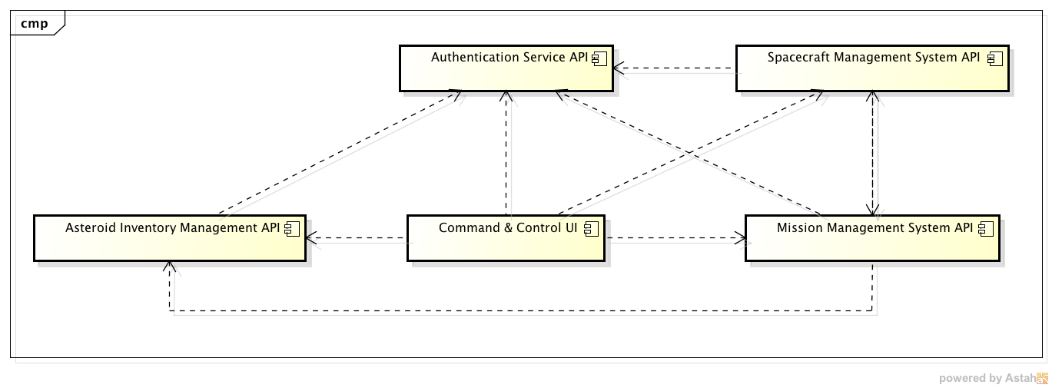
As shown, the Command & Control UI has dependencies on all other modules; this should not be surprising as it represents the user-facing front end to the entire application. The Asteroid Inventory Management system stands as the most isolated component, and can exist largely on it’s own, except for requiring authentication/authorization checks. The Spacecraft Management System API also requires checking the Authentication System for restricted interface method access, but also on the Mission Management System for communicating resource discovery messages and also Spacecraft status messages to the Mission Management System. The Mission Management System has dependencies on both the Spacecraft Management System and the Asteroid Inventory Management systems, because it needs to modify properties on the Spacecraft when missions start/end and their status changes over the course of a mission, and also it needs to update the discoveries found on the Asteroid the Spacecraft is exploring.

Use Cases
The following use case diagram shows the major functional use cases that each type of user of the Authentication Service can perform. Because there are many use cases, they will be displayed in separate diagrams for each sub-system.

Asteroid Inventory Management System
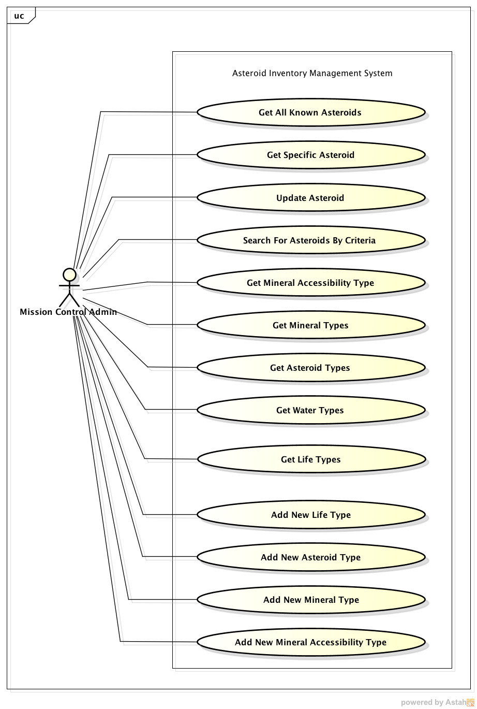
Get All Known Asteroids: list all the Asteroid objects in the system. Requires a GUID authentication token from the Authentication System.

Get Specific Asteroid: support obtaining a specific Asteroid object by it’s ID. Requires a GUID authentication token from the Authentication System.

Update Asteroid: overwrite the properties of an Asteroid with new values, and write the updates to the persistent datastore. Requires a GUID authentication token from the Authentication System.

Search For Asteroids By Criteria: allow searching for all matching Asteroids that match a given set of search criteria. Requires a GUID authentication token from the Authentication System.

Get Mineral Accessibility Types: return a list of all the enumeration objects for AccessibilityType

Get Mineral Types: return a list of all the enumeration objects for MineralType

Get Asteroid Types: return a list of all the enumeration objects for AsteroidType

Get Water Types: return a list of all the enumeration objects for WaterType

Get Life Types: return a list of all the enumeration objects for LifeType

Add New Life Type: allows adding a new type to the LifeType enumeration that is added to the persistent datastore

Add New Asteroid Type: allows adding a new type to the AsteroidType enumeration that is added to the persistent datastore

Add New Mineral Type: allows adding a new type to the MineralType enumeration that is added to the persistent datastore

Add New Mineral Accessibility Type: allows adding a new type to the AccessibilityType enumeration that is added to the persistent datastore

Robotic Spacecraft Management System
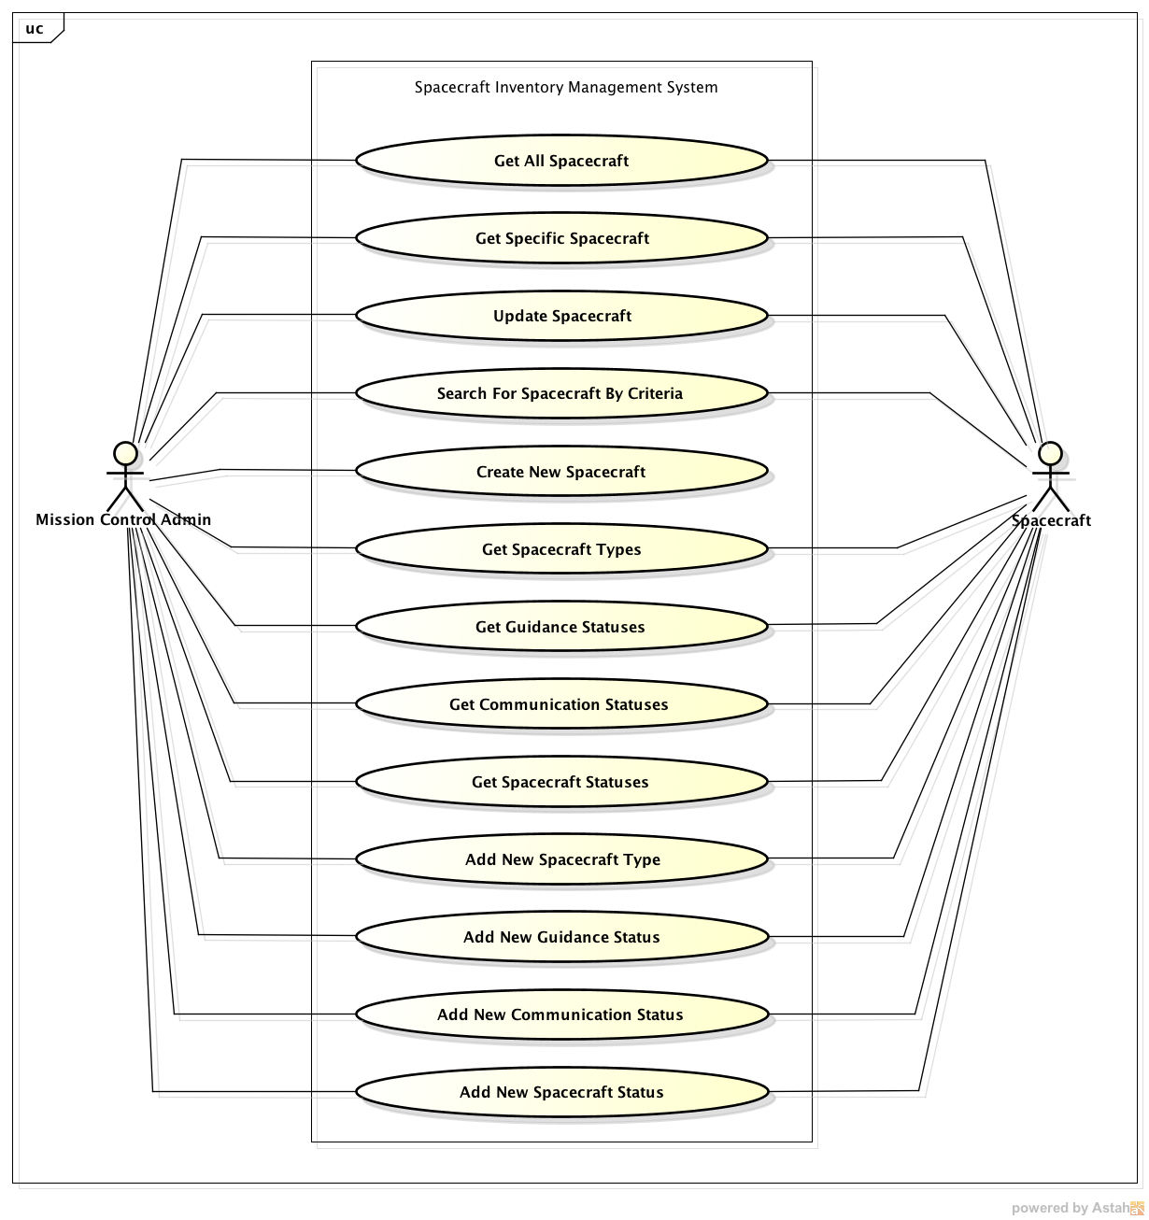
Get All Spacecraft: list all the Spacecraft objects in the system. Requires a GUID authentication token from the Authentication System.

Get Specific Spacecraft: support obtaining a specific Spacecraft object by it’s ID. Requires a GUID authentication token from the Authentication System.

Update Spacecraft: overwrite the properties of a Spacecraft with new values, and write the updates to the persistent datastore. Requires a GUID authentication token from the Authentication System.

Search For Spacecraft By Criteria: allow searching for all matching Spacecraft that match a given set of search criteria. Requires a GUID authentication token from the Authentication System.

Create New Spacecraft: allow the creation and saving to the persistent datastore of new Spacecraft objects. Requires a GUID authentication token from the Authentication System.

Get Spacecraft Types: return a list of all the enumeration objects for SpacecraftType

Get Guidance Statuses: return a list of all the enumeration objects for GuidanceStatus

Get Communication Statuses: return a list of all the enumeration objects for CommunicationStatus

Get Spacecraft Statuses: return a list of all the enumeration objects for SpacecraftStatus

Add New Spacecraft Type: allows adding a new type to the SpacecraftType enumeration that is added to the persistent datastore

Add New Guidance Status: allows adding a new type to the GuidanceStatus enumeration that is added to the persistent datastore

Add New Communication Status: allows adding a new type to the CommunicationStatus enumeration that is added to the persistent datastore

Add New Spacecraft Status: allows adding a new type to the SpacecraftStatus enumeration that is added to the persistent datastore

Mission Management System
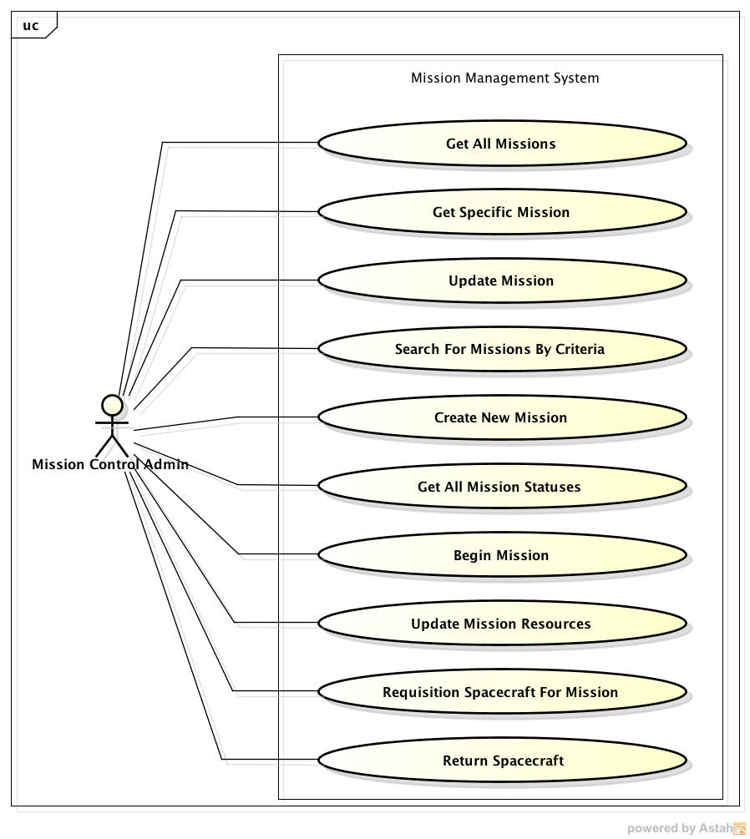
Get All Missions: list all the Mission objects in the system. Requires a GUID authentication token from the Authentication System.

Get Specific Mission: support obtaining a specific Mission object by it’s ID. Requires a GUID authentication token from the Authentication System.

Update Mission: overwrite the properties of a Mission with new values, and write the updates to the persistent datastore. Requires a GUID authentication token from the Authentication System.

Search For Missions By Criteria: allow searching for all matching Missions that match a given set of search criteria. Requires a GUID authentication token from the Authentication System.

Create New Mission: allow the creation and saving to the persistent datastore of new Mission objects. Requires a GUID authentication token from the Authentication System.

Get All Mission Statuses: return a list of all the enumeration objects for MissionStatus

Begin Mission: officially launch a Mission and all the Spacecraft connected to it; has side effect of altering resources available in Inventory Manager

Update Mission Resources: update Spacecraft and Asteroid statuses and resources based on an incoming Message from the Spacecraft

Requisition Spacecraft For Mission: makes selected Spacecraft for Mission unavailable to be selected for other Missions

Return Spacecraft: returns Spacecraft back into the available Inventory of Spacecraft that may be selected for other/future Missions

Command & Control User Interface
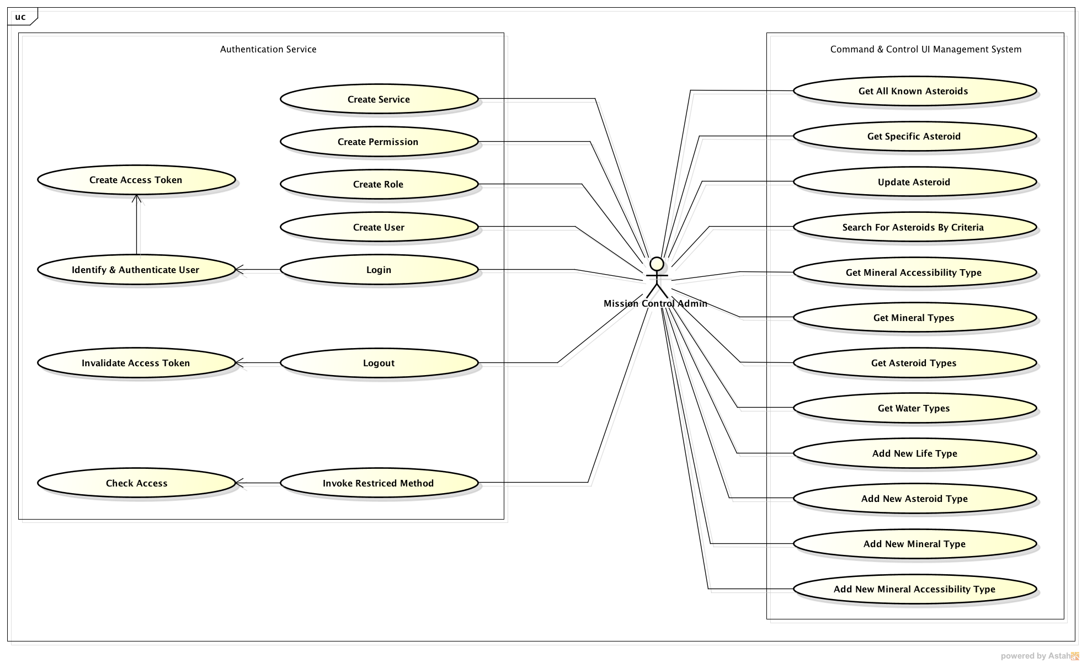
Most of these use cases will be illustrated through the wireframes of the Command & Control UI later in the document. The Create Service, Create Permission, Create Role, and Create User methods of the Authentication Service are accessible to the Misison Control Administrator through the code, but the current design requirements for the Command & Control UI do not declare that they need to be supported through the UI. Mission Control Administrators must first be “logged in” prior to being able to call any of the methods that are exposed through the Command & Control UI except for “Login” (which itself authenticates against the Authorization System).

Class Diagrams
Each sub-system will have it’s own class diagram. Note that there is not a class diagram for the Command & Control UI; the expectation is that this system will use best practices during development and use a Model-View-Controller (MVC) design pattern and supporting web framework. The selection of what supporting web framework/library is left to the discretion of the implementing team.

Exposition of each class, interface, and enumeration in each sub-system’s class diagram will be explained in the Class Dictionary in the next section.

Asteroid Inventory Management System
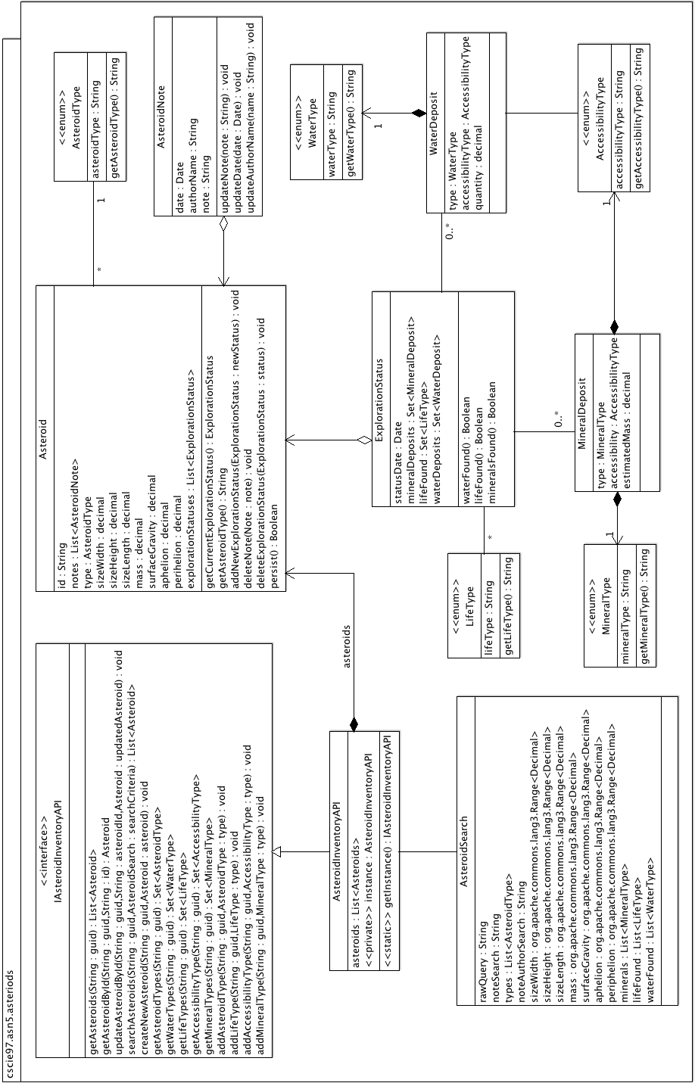

Robotic Spacecraft Management System
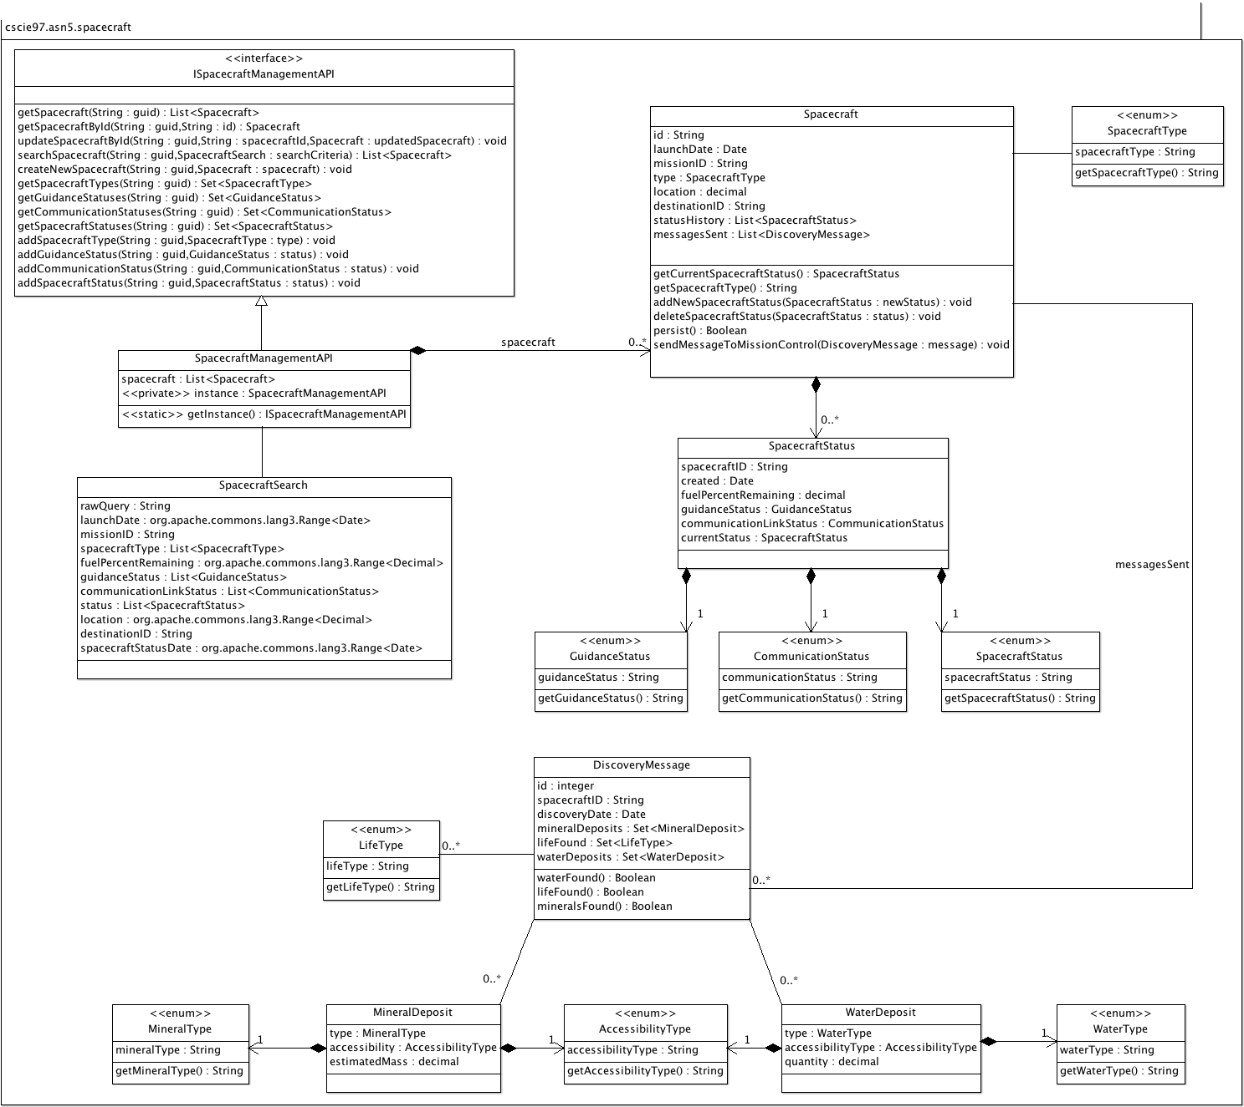

Mission Management System
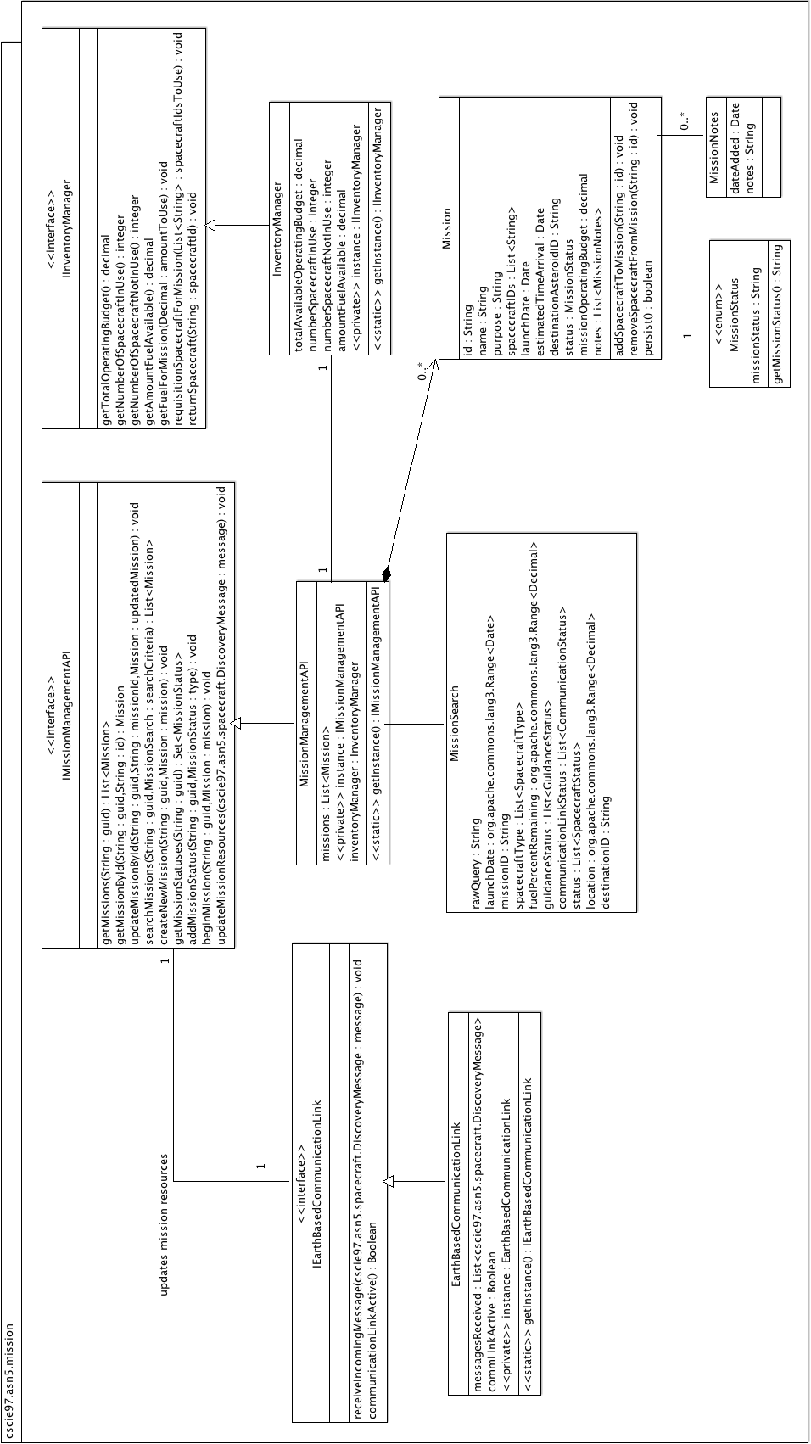

Activity Diagram
The following example activity diagram shows the logical process to provision a new Mission by users of the system.

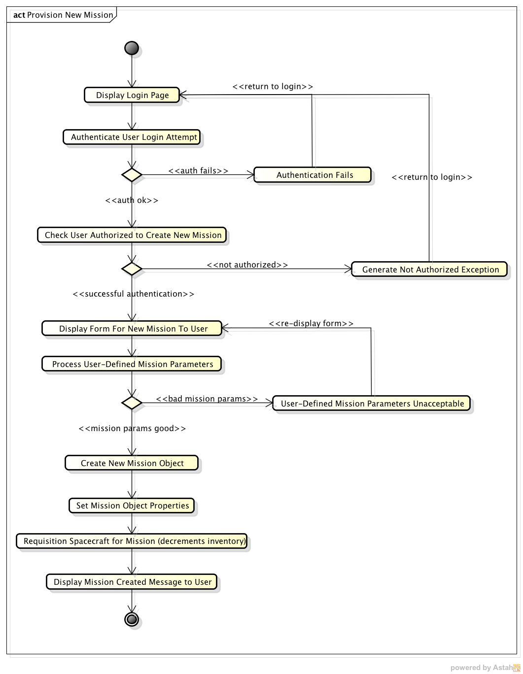

Class Dictionaries
This section specifies the class dictionaries for each sub-system in the Asteroid Exploration System. For the sake of brevity, simple accessor/mutator methods will not be documented here, nor will overridden methods in classes implementing interfaces or abstract classes.

Package: cscie97.asn5.asteroids

IAsteroidInventoryAPI <<interface>>

This interface defines the primary service contract for any classes that intend to implement these methods and act as the concrete implementation of the AsteroidInventoryAPI. All methods require authenticated access via the Authorization Service API; methods must pass a String GUID token, which is checked before continuing. Allows authenticated users access to manage all aspects of Asteroids, including creation, listing asteroids, searching, and updating Asteroids. This interface and it’s implementing class, AsteroidInventoryAPI, collectively work as a façade design pattern – only the public methods here are accessible outside the package.

Methods
Method Name | Signature | Description
getAsteroids | (String : guid) : List<Asteroid> | Returns a list of all the Asteroids under management by the API.
getAsteroidById | (String : guid, String : id) : Asteroid | Retrieves the corresponding Asteroid object from the inventory
updateAsteroidById | (String : guid, String : asteroidID, Asteroid : updatedAsteroid) : void | Finds the Asteroid in the inventory with the specified ID, and overwrites that object’s properties with those of the updatedAsteroid. Should also persist the changes to the database.
searchAsteroids | (String : guid, AsteroidSearch : searchCriteria) : List<Asteroid> | Given the supplied AsteroidSearch criteria object, find and return all Asteroids that match any of the supplied criteria in the search object.
createNewAsteroid | (String : guid, Asteroid : asteroid) : void | Clients may create new Asteroid objects independently, but this method must be called to add the Asteroid to the inventory (also persists the newly created Asteroid to the database).
getAsteroidTypes | (String : guid) : Set<AsteroidType> | Returns all the enumeration values of AsteroidType.
getWaterTypes | (String : guid) : Set<WaterType> | Returns all the enumeration values of WaterType.
getLifeTypes | (String : guid) : Set<LifeType> | Returns all the enumeration values of LifeType.
getAccessibilityTypes | (String : guid) : Set<AccessibilityType> | Returns all the enumeration values of AccessibilityType.
getMineralTypes | (String : guid) : Set<MineralType> | Returns all the enumeration values of MineralType.
addAsteroidType | (String : guid, AsteroidType : type) : void | Adds the new AsteroidType to the database; subsequent application loads will pick up this new available AsteroidType.
addLifeType | (String : guid, LifeType : type) : void | Adds the new LifeType to the database; subsequent application loads will pick up this new available LifeType.
addAccessibilityType | (String : guid, AccessibilityType : type) : void | Adds the new AccessibilityType to the database; subsequent application loads will pick up this new available AccessibilityType.
addMineralType | (String : guid, MineralType : type) : void | Adds the new MineralType to the database; subsequent application loads will pick up this new available MineralType.

AsteroidInventoryAPI, implements IAsteroidInventoryAPI

This concrete implementation of the IAsteroidInventoryAPI follows the Singleton design pattern; to obtain an instance to use, the getInstance() method will return the sole instance of the object.

Properties
Property Name | Type | Description
asteroids | List<Asteroid> | Contains all the Asteroids in the inventory. Asteroids are initially loaded from the database behind-the-scenes when the application loads and the instance is initialized.
instance <<private>> | AsteroidInventoryAPI | Singleton instance of the API; only one exists at a time

Methods
Method Name | Signature | Description
getInstance <<static, synchronized>> | () : IAsteroidInventoryAPI | Used to obtain a Singleton instance of the API for client use.

AsteroidSearch

Allows users to create a set of search criteria that richly encapsulates all the properties of an Asteroid. Since Asteroids have several numeric and date based properties, utilizes Apache Commons org.apache.commons.lang3.Range<T> class to create range-based search criteria (for example, this would allow searching for all Asteroids with a mass of between 120 and 999 tons, etc.). The search criteria properties are explicitly “OR”, to be as inclusive as possible.

Properties
Property Name | Type | Description
rawQuery | String | For text-based searches, simply contains the entire text that the user wishes to search for in String fields on the Asteroid. May optionally be logged (or saved in the database) to capture a history of searches executed.
noteSearch | String | What to search for in the “notes” fields of Asteroids
types | List<AsteroidType> | Find Asteroids that match at least 1 of these AsteroidTypes
noteAuthorSearch | String | Find Asteroids where the author name matches this property
sizeWidth | org.apache.commons.lang3.Range<Decimal> | Find all Asteroids that have a sizeWidth property in between the range supplied (inclusive)
sizeHeight | org.apache.commons.lang3.Range<Decimal> | Find all Asteroids that have a sizeHeight property in between the range supplied (inclusive)
sizeLength | org.apache.commons.lang3.Range<Decimal> | Find all Asteroids that have a sizeLength property in between the range supplied (inclusive)
mass | org.apache.commons.lang3.Range<Decimal> | Find all Asteroids that have a mass property in between the range supplied (inclusive)
surfaceGravity | org.apache.commons.lang3.Range<Decimal> | Find all Asteroids that have a surfaceGravity property in between the range supplied (inclusive)
aphelion | org.apache.commons.lang3.Range<Decimal> | Find all Asteroids that have a aphelion property in between the range supplied (inclusive)
periphelion | org.apache.commons.lang3.Range<Decimal> | Find all Asteroids that have a periphelion property in between the range supplied (inclusive)
minerals | List<MineralType> | Find all Asteroids that have at least 1 of these MineralTypes found
lifeFound | List<LifeType> | Find all Asteroids that have at least 1 of these LifeTypes found
waterFound | List<WaterType> | Find all Asteroids that have at least 1 of these WaterTypes found

Asteroid

Asteroids model the items that Spacecraft are exploring. Each Asteroid contains a history of notes that are added by Mission Control Admin staff; this will support a nice historical view of what staff have observed about the Asteroid over time. Asteroids may also have a list of ExplorationStatuses that are updated as Spacecraft make new discoveries and transmit them to the Mission Management System, which then updates these ExplorationStatuses. This too supports a rich historical view of the Asteroid, denotes what was found, and when (since discoveries take place at different times, in different quantities, etc.). Asteroids may be persisted to the database; they have a method here called “persist()” which should serialize the Asteroid and write the pertinent information to the database. All properties of the Asteroid should persist, and the database key should be the ID field.

Properties
Property Name | Type | Description
Id | String | Unique identifier for the Asteroid, and also the primary key in the database.
notes | List<AsteroidNote> | A list of notes that mission control staff write about the Asteroid. AsteroidNotes are written to a separate database table but linked to Asteroid objects by the ID.
type | AsteroidType | The particular type that this Asteroid is. Each Asteroid can only be of a single type.
sizeWidth | Decimal | The estimated width of the Asteroid in meters.
sizeHeight | Decimal | The estimated height of the Asteroid in meters.
sizeLength | Decimal | The estimated length of the Asteroid in meters.
mass | Decimal | The estimated mass of the Asteroid in tons.
surfaceGravity | Decimal | The estimated number of Earth gravities that are exerted over objects on the surface of the Asteroid.
Aphelion | Decimal | The estimated distance from the Sun in AUs
Perihelion | Decimal | The estimated distance from the Sun in AUs
explorationStatuses | List<ExplorationStatus> | History of all prior exploration discoveries made on the asteroid, including minerals found, water, and organic life found.

Methods
Method Name | Signature | Description
getCurrentExplorationStatus | () : ExplorationStatus | Returns the most recent ExplorationStatus based on the statusDate.
getAsteroidType | () : String | Returns the String type of the AsteroidType the Asteroid is
addNewExplorationStatus | (ExplorationStatus : newStatus) : void | Adds a new ExplorationStatus to the list. When added the new status should also be persisted to the database.
deleteNote | (AsteroidNote : note) : void | Deletes the supplied AsteroidNote from the object and from the database.
deleteExplorationStatus | (ExplorationStatus : status) : void | Deletes the supplied ExplorationStatus from the object and from the database.
persist | () : Boolean | Save the Asteroid and all associated objects (AsteroidNotes, ExplorationStatuses) to the database; returns true if successful, false otherwise

AsteroidNote

Contains the observation notes of a Mission Control Administrator on the Asteroid. AsteroidNotes are saved to the database in their own table, and have a many-to-one relationship with Asteroid (one Asteroid, many AsteroidNotes). Any time the parent Asteroid is saved to the database, the AteroidNotes are also updated.

Properties
Property Name | Type | Description
date | Date | When the note was last updated
authorName | String | Name of the note author
note | String | The body of the author’s observational note on the Asteroid.

Methods
Method Name | Signature | Description
updateNote | (String : note) : void | Updates the note with the new text
updateDate | (Date : date) : void | Modifies the date of the note
updateAuthorName | (String : name) : void | Modifies the name of the Author

ExplorationStatus

Represents a new discovery of either water, organic life, or minerals on the Asteroid. ExplorationStatus objects are stored in their own database table and each one may correspond to a single Asteroid (Asteroids can have many associated ExplorationStatuses). Since Asteroids may have many of these ExplorationStatuses, they may develop a rich history of when things were discovered on the Asteroid, in what quantities, etc.

Properties
Property Name | Type | Description
statusDate | Date | When the initial discovery was made
mineralDeposits | Set<MineralDeposit> | A collection of all the MineralDeposit objects that were found
lifeFound | Set<LifeType> | A collection of all the LifeTypes that were found
waterDeposits | Set<WaterDeposit> | A collection of all the WaterDeposits that were found

Methods
Method Name | Signature | Description
waterFound | () : Boolean | Convenience method to determine if there was any water found in this ExplorationStatus
lifeFound | () : Boolean | Convenience method to determine if there was any life found in this ExplorationStatus
mineralsFound | () : Boolean | Convenience method to determine if there was any minerals found in this ExplorationStatus

MineralDeposit

Represents a new mineral deposit found on the Asteroid. Each MineralDeposit is saved to it’s own database table.

Properties
Property Name | Type | Description
type | MineralType | The MineralType enum value that this discovery corresponds to
Accessibility | AccessibilityType | How easy or hard it will be to mine the Asteroid for the mineral type found
estimatedMass | Decimal | Estimated amount of the mineral found in tons

WaterDeposit

Represents a new water deposit found on the Asteroid. Each WaterDeposit is saved to it’s own database table.

Properties
Property Name | Type | Description
type | WaterType | The WaterType enum value that this discovery corresponds to
accessibility | AccessibilityType | How easy or hard it will be to obtain the water from the Asteroid (e.g., is the water underground, on top of a mountain, etc.)
quantity | Decimal | Estimated amount of the water found in the unit applicable to it’s type (e.g., for liquid water this would be gallons, for ice it might be in tons, etc.)

AsteroidType <<enum>>

An enumeration representing the types of Asteroids that are known. Each enumeration will correspond to it’s own row in a distinct database table.

Methods
Method Name | Signature | Description
getAsteroidType | () : String | Returns the String name of the enumeration property

Properties
Property Name | Type | Description
A_TYPE | String | Used by Asteroid; asteroidType is “A-Type” (see http://en.wikipedia.org/wiki/A-type_asteroid)
C_TYPE | String | Used by Asteroid; asteroidType is “C-Type” (see http://en.wikipedia.org/wiki/C-type_asteroid)
K_TYPE | String | Used by Asteroid; asteroidType is “K-Type” (see http://en.wikipedia.org/wiki/K-type_asteroid)
L_TYPE | String | Used by Asteroid; asteroidType is “L-Type” (see http://en.wikipedia.org/wiki/L-type_asteroid)
M_TYPE | String | Used by Asteroid; asteroidType is “M-Type” (see http://en.wikipedia.org/wiki/M-type_asteroid)
Q_TYPE | String | Used by Asteroid; asteroidType is “Q-Type” (see http://en.wikipedia.org/wiki/Q-type_asteroid)
R_TYPE | String | Used by Asteroid; asteroidType is “R-Type” (see http://en.wikipedia.org/wiki/R-type_asteroid)
S_TYPE | String | Used by Asteroid; asteroidType is “S-Type” (see http://en.wikipedia.org/wiki/S-type_asteroid)

WaterType <<enum>>

An enumeration representing the types of Water that are known. Each enumeration will correspond to it’s own row in a distinct database table.

Methods
Method Name | Signature | Description
getWaterType | () : String | Returns the String name of the enumeration property

Properties
Property Name | Type | Description
ICE | String | Used by WaterDeposit; waterType is “Ice”
LIQUID | String | Used by WaterDeposit; waterType is “Liquid”
VAPOR | String | Used by WaterDeposit; waterType is “Vapor”
PLASMA | String | Used by WaterDeposit; waterType is “Plasma”

AccessibilityType <<enum>>

An enumeration representing the types of Accessibility for both Minerals and Water that are found on Asteroids (e.g., minerals might be on the surface, under the surface at a particular depth, on top of a mountain, etc.). Each enumeration will correspond to it’s own row in a distinct database table.

Methods
Method Name | Signature | Description
getAccessibilityType | () : String | Returns the String name of the enumeration property

Properties
Property Name | Type | Description
SURFACE | String | Used by WaterDeposit and MineralDeposit; accessibilityType is “Surface-accessible”
UNDER_SURFACE_SHORT_DEPTH | String | Used by WaterDeposit and MineralDeposit; accessibilityType is “Under surface, short-depth”
UNDER_SURFACE_MEDIUM_DEPTH | String | Used by WaterDeposit and MineralDeposit; accessibilityType is “Under surface, medium-depth”
UNDER_SURFACE_DEEP_DEPTH | String | Used by WaterDeposit and MineralDeposit; accessibilityType is “Under surface, deep-depth”
ABOVE_SURFACE_SHORT_HEIGHT | String | Used by WaterDeposit and MineralDeposit; accessibilityType is “Above surface, short-height”
ABOVE_SURFACE_MEDIUM_HEIGHT | String | Used by WaterDeposit and MineralDeposit; accessibilityType is “Above surface, medium-height”
ABOVE_SURFACE_LARGE_HEIGHT | String | Used by WaterDeposit and MineralDeposit; accessibilityType is “Above surface, large-height”
HEAVY_EXTRACTION_REQUIRED | String | Used by WaterDeposit and MineralDeposit; accessibilityType is “Heavy extraction required; may need additional resources to extract”
UNDER_ICE | String | Used by WaterDeposit and MineralDeposit; accessibilityType is “Under ice”

MineralType <<enum>>

An enumeration representing the types of known Minerals that may be found on Asteroids and may be mined. Each enumeration will correspond to it’s own row in a distinct database table. New types may be added as they are discovered.

Methods
Method Name | Signature | Description
getMineralType | () : String | Returns the String name of the enumeration property

Properties
Property Name | Type | Description
GOLD | String | Used by MineralDeposit; mineralType is “Gold”
IRON | String | Used by MineralDeposit; mineralType is “Iron”
IRON_NICKEL | String | Used by MineralDeposit; mineralType is “Iron-Nickel Ore”
PLATINUM | String | Used by MineralDeposit; mineralType is “Platinum”
SILVER | String | Used by MineralDeposit; mineralType is “Silver”
TITANIUM | String | Used by MineralDeposit; mineralType is “Titanium”
PALADIUM | String | Used by MineralDeposit; mineralType is “Paladium”
PLUTONIUM | String | Used by MineralDeposit; mineralType is “Plutonium”
URANIUM | String | Used by MineralDeposit; mineralType is “Uranium”

LifeType <<enum>>

An enumeration representing the types of known organic Life that may be found on Asteroids. Each enumeration will correspond to it’s own row in a distinct database table. New types may be added as they are discovered.

Methods
Method Name | Signature | Description
getLifeType | () : String | Returns the String name of the enumeration property

Properties
Property Name | Type | Description
NONE | String | Used by ExplorationStatus; lifeType is “None”
SINGLE_CELL_ORGANISMS | String | Used by ExplorationStatus; lifeType is “Single-Cell Organisms”
MULTI_CELL_ORGANISMS | String | Used by ExplorationStatus; lifeType is “Multi-Cell Organisms”
INTELLIGENT | String | Used by ExplorationStatus; lifeType is “Intelligent Organisms”
FRIENDLY | String | Used by ExplorationStatus; lifeType is “Friendly Organisms”
HOSTILE | String | Used by ExplorationStatus; lifeType is “Hostile Organisms”

Package: cscie97.asn5.spacecraft

ISpacecraftManagementAPI <<interface>>

This interface defines the primary service contract for any classes that intend to implement these methods and act as the concrete implementation of the SpacrcraftManagementAPI. All methods require authenticated access via the Authorization Service API; methods must pass a String GUID token, which is checked before continuing. Allows authenticated users access to manage all aspects of Spacecraft, including creation, listing Spacecraft, searching, and updating Spacecraft. This interface and its implementing class, SpacecraftManagementAPI, collectively work as a façade design pattern – only the public methods here are accessible outside the package.

Methods
Method Name | Signature | Description
getSpacecraft | (String : guid) : List<Spacecraft> | Returns a list of all the Spacecraft under management by the API.
getSpacecraftById | (String : guid, String : id) : Spacecraft | Retrieves the corresponding Spacecraft object from the inventory
updateSpacecraftById | (String : guid, String : spacecraftID, Spacecraft : updatedSpacecraft) : void | Finds the Spacecraft in the inventory with the specified ID, and overwrites that object’s properties with those of the updatedSpacecraft. Should also persist the changes to the database.
searchSpacecraft | (String : guid, SpacecraftSearch : searchCriteria) : List<Spacecraft> | Given the supplied SpacecraftSearch criteria object, find and return all Spacecraft that match any of the supplied criteria in the search object.
createNewSpacecraft | (String : guid, Spacecraft : spacecraft) : void | Clients may create new Spacecraft objects independently, but this method must be called to add the Asteroid to the inventory (also persists the newly created Spacecraft to the database).
getSpacecraftTypes | (String : guid) : Set<SpacecraftType> | Returns all the enumeration values of SpacecraftType.
getGuidanceStatuses | (String : guid) : Set<GuidanceStatus> | Returns all the enumeration values of CommunicationStatus.
getCommunicationStatuses | (String : guid) : Set<CommunicationStatus> | Returns all the enumeration values of CommunicationStatus.
getSpacecraftStatuses | (String : guid) : Set<SpacecraftStatus> | Returns all the enumeration values of SpacecraftStatus.
addSpacecraftType | (String : guid, SpacecraftType : type) : void | Adds the new SpacecraftType to the database; subsequent application loads will pick up this new available SpacecraftType.
addGuidanceStatus | (String : guid, GuidanceStatus : type) : void | Adds the new GuidanceStatus to the database; subsequent application loads will pick up this new available GuidanceStatus.
addCommunicationStatus | (String : guid, CommunicationStatus : type) : void | Adds the new CommunicationStatus to the database; subsequent application loads will pick up this new available CommunicationStatus.

SpacecraftManagementAPI, implements ISpacecraftManagementAPI

This concrete implementation of the ISpacecraftManagementAPI follows the Singleton design pattern; to obtain an instance to use, the getInstance() method will return the sole instance of the object.

Properties
Property Name | Type | Description
spacecraft | List<Spacecraft> | Contains all the Spacecraft in the inventory. Spacecraft are initially loaded from the database behind-the-scenes when the application loads and the instance is initialized.
instance <<private>> | SpacecraftManagementAPI | Singleton instance of the API; only one exists at a time

Methods
Method Name | Signature | Description
getInstance <<static, synchronized>> | () : ISpacecraftManagementAPI | Used to obtain a Singleton instance of the API for client use.

SpacecraftSearch

Allows users to create a set of search criteria that richly encapsulates all the properties of a Spacecraft. Since Spacecraft have several numeric and date based properties, utilizes Apache Commons org.apache.commons.lang3.Range<T> class to create range-based search criteria (for example, this would allow searching for all Spacecraft with more than 10% fuel remaining but less than 25% remaining, etc.). The search criteria properties are explicitly “OR”, to be as inclusive as possible.

Properties
Property Name | Type | Description
rawQuery | String | For text-based searches, simply contains the entire text that the user wishes to search for in String fields on the Spacecraft. May optionally be logged (or saved in the database) to capture a history of searches executed.
launchDate | org.apache.commons.lang3.Range<Date> | Find Spacecraft whose launchDate is between the older and newer Date range values passed in the Range<Date> (inclusive)
missionID | String | Find Spacecraft where the ID matches this property
spacecraftType | List<SpacecraftType> | Find all Spacecraft that have a type property value that is one of the passed SpacecraftTypes
fuelPercentageRemaining | org.apache.commons.lang3.Range<Decimal> | Find all Spacecraft that have a fuelPercentageRemaining value on their most recent SpacecraftStatus property that is within the supplied percentage range (inclusive)
guidanceStatus | List<GuidanceStatus> | Find all Spacecraft that have a guidanceStatus value on their most recent SpacecraftStatus property that is one of the supplied GuidanceStatuses
communicationStatus | List<CommunicationStatus> | Find all Spacecraft that have a communicationStatus value on their most recent SpacecraftStatus property that is one of the supplied CommunicationStatuses
status | List<SpacecraftStatus> | Find all Spacecraft that have a currentStatus value on their most recent SpacecraftStatus property that is one of the supplied SpacecraftStatuses
location | org.apache.commons.lang3.Range<Decimal> | Find all Spacecraft that have a location property value that is in between the range supplied (inclusive)
destinationID | String | Find all Spacecraft that have a matching destinationID property; this is a good way to find all the Spacecraft that are heading towards the same Asteroid
spacecraftStatusDate | org.apache.commons.lang3.Range<Date> | Find all Spacecraft that have a statusDate value on any of their SpacecraftStatuses that is between the Date range values (inclusive)

Spacecraft

Spacecraft model the actual robotic spacecraft that are sent out to explore and mine asteroids. Each Spacecraft contains a history of SpacecraftStatuses that are added autonomously by the spacecraft when out on missions. The real, physical spacecraft that are actually mining asteroids may periodically send a new DiscoveryMessage to the Mission Management System, and at that time the Mission Management System will update the Asteroid where the discovery was made.

Properties
Property Name | Type | Description
Id | String | Unique identifier for the Spacecraft, and also the primary key in the database.
launchDate | Date | Date that the Spacecraft was launched on its current mission
missionID | String | The unique identifier of the Mission the Spacecraft is currently embarking on
type | SpacecraftType | The type of the Spacecraft
location | Decimal | The current location value of the Spacecraft in AUs
destinationID | String | The unique identifier of the Asteroid where the Spacecraft is headed
statusHistory | List<SpacecraftStatus> | A history of all status updates made to the Spacecraft, including fuel percentage remaining, guidance link status, communications link status, and overall Spacecraft status.
messagesSent | List<DiscoveryMessage> | A list of all DiscoveryMessages that the Spacecraft has made. When the automated robot Spacecraft makes a new discovery of water, minerals, or life, it automatically creates a new DiscoveryMessage and adds it to this list, as well as broadcasting it to the Mission Management System.

Methods
Method Name | Signature | Description
getCurrentSpacecraftStatus | () : SpacecraftStatus | Returns the most recent SpacecraftStatus based on the date on which it was created.
getSpacecraftType | () : String | Returns the string representation of the SpacecraftType enumeration value.
addNewSpacecraftStatus | (SpacecraftStatus : newStatus) : void | Adds a new SpacecraftStatus to the list. When added the new status should also be persisted to the database.
deleteSpacecraftStatus | (SpacecraftStatus : status) : void | A mechanism to delete an erroneous SpacecraftStatus that may have been added to the Spacecraft. Searches for a matching SpacecraftStatus and deletes it from the Spacecraft if found; also deletes that status record from the database.
sendMessageToMissionControl | (DiscoveryMessage : message) : void | Sends a DiscoveryMessage to the Mission Management System, which is responsible for updating Mission status and Asteroid status.
persist | () : Boolean | Save the Spacecraft and all associated objects (SpacecraftStatus items in statusHistory, and DiscoveryMessage items in messagesSent) to the database; returns true if successful, false otherwise

SpacecraftStatus

Contains a time-based record of the status of various properties of the Spacecraft at a given point in time. With these objects it is simple to construct a timeline of the overall historical (and current) status of the Spacecraft, which may be useful in investigating root cause analysis when things go wrong. Each record is saved to the database in a table different from the one where Spacecraft records are saved, and has a many-to-one relationship with Spacecraft (one Spacecraft, many SpacecraftStatus records). Any time the parent Spacecraft is saved to the database, the SpacecraftStatus objects are also updated.

Properties
Property Name | Type | Description
spacecraftID | String | The unique identifier of the associated Spacecraft this status record is for
created | Date | The date and time when this record was first created
fuelPercentageRemaining | Decimal | The amount of fuel remaining in the Spacecraft (expressed as a percentage) at the time the record was created
guidanceStatus | GuidanceStatus | The status of the guidance system of the Spacecraft
communicationLinkStatus | CommunicationStatus | The status of the Spacecraft’s communication link system with Mission Control
currentStatus | SpacecraftStatus | A status indicator of the overall health of the Spacecraft and all systems onboard

DiscoveryMessage

Represents a new discovery of either water, organic life, or minerals on the Asteroid currently being explored by the Spacecraft. This class is virtually identical to the ExplorationStatus object that is in the Asteroid package; the reason for this duplication is to attempt to isolate the various components as much as possible; the Robotic Spacecraft Management System component should not have a dependency on the Asteroid Inventory System. As the Spacecraft objects explore the Asteroids they are investigating, they will construct these DisoveryMessages, save the message to the database, and then send the message to the Mission Management System for further processing. DiscoveryMessage objects are stored in their own database table and each one may correspond to a single Spacecraft (Spacecraft can have many associated DisoveryMessages). Since Spacecraft may have many of these DiscoveryMessages, they may develop a rich history of when things were discovered on the Asteroid, in what quantities, etc.

Properties
Property Name | Type | Description
id | Integer | A unique identifier for this DiscoveryMessage
spacecraftID | String | The unique identifier of the Spacecraft making the discovery
discoveryDate | Date | When the discovery is made
mineralDeposits | Set<MineralDeposit> | The collection of all Minerals that were found in this discovery
lifeFound | Set<LifeType> | A collection of all the LifeTypes that were found
waterDeposits | Set<WaterDeposit> | A collection of all the WaterDeposits that were found

Methods
Method Name | Signature | Description
waterFound | () : Boolean | Convenience method to determine if there was any water found in this discovery
lifeFound | () : Boolean | Convenience method to determine if there was any life found in this discovery
mineralsFound | () : Boolean | Convenience method to determine if there was any minerals found in this discovery

SpacecraftType <<enum>>

An enumeration representing the types of Spacecraft currently in use. Each enumeration will correspond to it’s own row in a distinct database table.

Methods
Method Name | Signature | Description
getSpacecraftType | () : String | Returns the String name of the enumeration property

Properties
Property Name | Type | Description
EXPLORER | String | Used by Spacecraft; spacecraftType is “Explorer”
MINER | String | Used by Spacecraft; spacecraftType is “Miner”
SUPPORT_CRAFT | String | Used by Spacecraft; spacecraftType is “Support Craft”
REPAIR_CRAFT | String | Used by Spacecraft; spacecraftType is “Repair Craft”
REFUELER | String | Used by Spacecraft; spacecraftType is “Refueler”
HEAVY_EXCAVATOR | String | Used by Spacecraft; spacecraftType is “Heavy Excavator”
TOW_CRAFT | String | Used by Spacecraft; spacecraftType is “Tow Craft”

GuidanceStatus <<enum>>

An enumeration representing the status values for the Spacecraft guidance system. Each enumeration will correspond to it’s own row in a distinct database table.

Methods
Method Name | Signature | Description
getGuidanceStatus | () : String | Returns the String name of the enumeration property

Properties
Property Name | Type | Description
ALL_OK | String | Used by SpacecraftStatus; guidanceStatus is “All-OK”
SATELLITE_UPLINK_DOWN | String | Used by SpacecraftStatus; guidanceStatus is “Satellite Uplink Down”
SYSTEM_FAILURE | String | Used by SpacecraftStatus; guidanceStatus is “Guidance System Failure”
POWER_FAILURE | String | Used by SpacecraftStatus; guidanceStatus is “Guidance System Power Failure”
FUSE_BLOWN | String | Used by SpacecraftStatus; guidanceStatus is “Guidance System Fuse Blown”
SOLAR_PANEL_FAILURE | String | Used by SpacecraftStatus; guidanceStatus is “Guidance Sytstem Solar Panel Failure”

CommunicationStatus <<enum>>

An enumeration representing the status values for the Spacecraft’s communications system. Each enumeration will correspond to it’s own row in a distinct database table.

Methods
Method Name | Signature | Description
getCommunicationStatus | () : String | Returns the String name of the enumeration property

Properties
Property Name | Type | Description
ALL_OK | String | Used by SpacecraftStatus; communicationStatus is “All-OK”
COMM_TRANSMISSION_FAILURE | String | Used by SpacecraftStatus; communicationStatus is “Communication System Transmission Failure”
SIGNAL_INTERFERENCE | String | Used by SpacecraftStatus; communicationStatus is “Communication System Signal Interference”
ANTENNA_DOWN | String | Used by SpacecraftStatus; communicationStatus is “Communication System Antenna Down”
SIGNAL_RELAY_MODE | String | Used by SpacecraftStatus; communicationStatus is “Communication System Signal Relay Mode” (sends signals to other nearby Spacecraft and asks them to send message on Spacecraft’s behalf to Mission Control)

SpacecraftStatusType <<enum>>

An enumeration representing the overall mission status values for the Spacecraft. Each enumeration will correspond to it’s own row in a distinct database table.

Methods
Method Name | Signature | Description
getSpacecraftStatusType | () : String | Returns the String name of the enumeration property

Properties
Property Name | Type | Description
AWAITING_LAUNCH | String | Used by SpacecraftStatus; spacecraftStatusType is “Waiting For Launch”
EN_ROUTE_TO_ASTEROID | String | Used by SpacecraftStatus; spacecraftStatusType is “En-Route To Asteroid”
LOST | String | Used by SpacecraftStatus; spacecraftStatusType is “Lost”
CRASHED | String | Used by SpacecraftStatus; spacecraftStatusType is “Crashed”
LANDED | String | Used by SpacecraftStatus; spacecraftStatusType is “Landed”
EXPLORING | String | Used by SpacecraftStatus; spacecraftStatusType is “Exploring”
MINING | String | Used by SpacecraftStatus; spacecraftStatusType is “Mining”
REFUELING | String | Used by SpacecraftStatus; spacecraftStatusType is “REFUELING”
MALFUNCTION | String | Used by SpacecraftStatus; spacecraftStatusType is “Malfunction”
HOMEWARD_BOUND | String | Used by SpacecraftStatus; spacecraftStatusType is “Homeward Bound”

The cscie97.asn5.spacecraft package also has exact copies of several enumeration types and classes from the cscie97.asn5.asteroid package, including:

- MineralDeposit <<class>>
- WaterDeposit <<class>>
- MineralType <<enum>>
- AccessibilityType <<enum>>
- WaterType <<enum>>
- LifeType <<enum>>

For sake of brevity, the definitions of these types is not replicated here (they are exact copies of those already defined in the cscie97.asn5.asteriod package).

Package: cscie97.asn5.mission

IEarthBasedCommunicationLink <<interface>>

This interface defines the primary service contract for any classes that intend to implement these methods and act as the concrete implementation of the EarthBasedCommunicationLink. This class handles processing incoming DiscoveryMessages from Spacecraft, and also maintains a Communication Link Status property to indicate if it is functional and still able to receive messages from Spacecraft.

Methods
Method Name | Signature | Description
receiveIncomingMessage | (cscie97.asn5.spacecraft.DiscoveryMessage : message) : void | Provides a mechanism for Spacecraft to send messages when they discover new resources on an Asteroid.
communicationLinkActive | () : Boolean | Checks whether or not the current communication link is active and able to receive messages from Spacecraft

EarthBasedCommunicationLink, implements IEarthBasedCommunicationLink

This concrete implementation of the IEarthBasedCommunicationLink, follows the Singleton design pattern; to obtain an instance to use, the getInstance() method will return the sole instance of the object. All messages that are received should be stored in a persistent database table as they arrive.

Properties
Property Name | Type | Description
messagesReceived | List<cscie97.asn5.spacecraft.DiscoveryMessage> | A list of all the DiscoveryMessages that have been received from Spacecraft in the field.
commLinkActive | Boolean | Denotes if the communication link is “active” and able to receive incoming messages from Spacecraft
Instance <<private>> | EarthBasedCommunicationLink | A private Singleton instance of EarthBasedCommunicationLink, used by all clients

Methods
Method Name | Signature | Description
getInstance <<static, synchronized>> | () : ISpacecraftManagementAPI | Used to obtain a Singleton instance of the API for client use.

IInventoryManager <<interface>>

This interface defines the primary service contract for any classes that intend to implement these methods and act as the concrete implementation of the InventoryManager. This class provides getter methods for obtaining several key pieces of information about the overall program, including overall program budget, numbers of Spacecraft “in the field” and number docked on Earth, and the amount of fuel available for all Spacecraft to use.

Methods
Method Name | Signature | Description
getTotalOperatingBudget | () : Decimal | Returns the overall budget available to the entire Asteroid Exploration Program, minus the cost of currently running Missions; can be used to prohibit a new Mission from beginning if the Mission cost is more than the available budget.
getNumberOfSpacecraftInUse | () : Integer | Returns the number of Spacecraft “in the field”
getNumberOfSpacecraftNotInUse | () : Integer | Returns the number of Spacecraft that are currently docked and thus available for use in new Missions
getAmountFuelAvailable | () : decimal | Returns the amount of fuel currently available to use for any new Missions
getFuelForMission | (Decimal : amountToUse) : void | Deducts the amount of fuel requested for a Mission from the overall total amount of fuel available. Should throw a custom exception if the amount requested exceeds the amount available.
requisitionSpacecraftForMission | (List<String> : spacecraftIdsTouse) : void | Requisitions the spacecraft specified by their IDs for a new Mission. Updates the status of those spacecraft and prepares them for mission launch; updates the number of spacecraft in-use/not-in-use.
returnSpacecraft | (String : spacecraftId) : void | Returns a spacecraft back into the stable and makes it available for future missions; updates the number of spacecraft in-use/not-in-use.

InventoryManager, implements IInventoryManager

This concrete implementation of the IInventoryManager follows the Singleton design pattern; to obtain an instance to use, the getInstance() method will return the sole instance of the object. All basic properties should be stored in a persistent database table as they are created and updated.

Properties
Property Name | Type | Description
totalAvailableOperatingBudget | Decimal | The overall remaining budget figure that is to fund all future missions.
numberSpacecraftInUse | Integer | A count of the number of Spacecraft currently “in the field”
numberSpacecraftNotInUse | Integer | A count of the number of Spacecraft currently docked on Earth
amountFuelAvailable | Decimal | The amount of Spacecraft fuel ready for use on Earth, expressed in tons
instance <<private>> | IInventoryManager | A private Singleton instance of IInventoryManager, used by all clients

Methods
Method Name | Signature | Description
getInstance <<static, synchronized>> | () : IInventoryManager | Used to obtain a Singleton instance of the API for client use.

IMissionManagementAPI <<interface>>

This interface defines the primary service contract for any classes that intend to implement these methods and act as the concrete implementation of the MissionManagementAPI. The implementing class acts as the primary broker of communication from Spacecraft, as well as bears the responsibility for updating Asteroids and their ExplorationStatuses as new discoveries are made. It also administers Missions, creates them, updates them, and interacts with the InvetoryManager for overall mission control. All methods (except incoming DiscoveryMessages from Spacecraft) requires authentication, and so must pass a GUID string that the AuthenticationService will validate.

Methods
Method Name | Signature | Description
getMissions | (String : guid) : List<Mission> | Returns all the Missions in the system.
getMissionById | (String : guid, String : id) : Mission | Returns the specific Mission that matches the ID passed.
updateMissionById | (String : guid, String : missionId, Mission : updatedMission) : void | Updates the Mission whose ID matches the missionID passed, and updates all it’s values with those from the updatedMission. Writes the updated Mission to the database.
searchMissions | (String : guid, MissionSearch : searchCriteria) : List<Mission> | Searches the inventory of Missions for those that match any of the supplied criteria in the searchCriteria, and returns them as a list.
createNewMission | (String : guid, Mission : mission) : void | Creates a new Mission, and saves it to the database. If a Mission may not be created because it violates the budgetary requirements, not enough Spacecraft are available, etc., then an Exception is thrown.
getMissionStatuses | (String : guid) : Set<MissionStatus> | Returns the list of all MissionStatus enumeration types.
addMissionStatus | (String : guid, MissionStatus : type) : void | Adds a new enumeration type to the MissionStatus, and saves it to the database so that an application restart will make it available.
beginMission | (String : guid, Mission : mission) : void | Begin a Mission and update the statuses of Spacecraft.
updateMissionResources | (cscie97.asn5.spacecraft.DiscoveryMessage : message) : void | Update the Mission resources based on the DiscoveryMessage received from a Spacecraft

MissionManagementAPI, implements IMissionManagementAPI

This concrete implementation of the IMissionManagementAPI follows the Singleton design pattern; to obtain an instance to use, the getInstance() method will return the sole instance of the object. This is the central public administration interface for Missions.

Properties
Property Name | Type | Description
missions | List<Mission> | The inventory of all Missions, past and present.
inventoryManager | IInventoryManager | An instance of the InventoryManager, to update resources for all Missions as appropriate.
instance <<private>> | IMissionManagementAPI | A private Singleton instance of IInventoryManager, used by all clients

Methods
Method Name | Signature | Description
getInstance <<static, synchronized>> | () : IMissionManagementAPI | Used to obtain a Singleton instance of the API for client use.

MissionSearch

Allows users to create a set of search criteria that richly encapsulates all the properties of a Mission and use that for searching. Since Missions have several numeric and date based properties, utilizes Apache Commons org.apache.commons.lang3.Range<T> class to create range-based search criteria (for example, this would allow searching for all Missions whose Spacecraft have more than 10% fuel remaining but less than 25% remaining, etc.). The search criteria properties are explicitly “OR”, to be as inclusive as possible.

Properties
Property Name | Type | Description
rawQuery | String | For text-based searches, simply contains the entire text that the user wishes to search for in String fields on the Mission. May optionally be logged (or saved in the database) to capture a history of searches executed.
launchDate | org.apache.commons.lang3.Range<Date> | Find Missions whose launchDate is between the older and newer Date range values passed in the Range<Date> (inclusive)
missionID | String | Find Missions where the ID matches this property
spacecraftType | List<SpacecraftType> | Find all Misisons with Spacecraft that has a type property value that is one of the passed SpacecraftTypes
fuelPercentageRemaining | org.apache.commons.lang3.Range<Decimal> | Find all Missions with Spacecraft that have a fuelPercentageRemaining value on their most recent SpacecraftStatus property that is within the supplied percentage range (inclusive)
guidanceStatus | List<GuidanceStatus> | Find all Missions with Spacecraft that have a guidanceStatus value on their most recent SpacecraftStatus property that is one of the supplied GuidanceStatuses
communicationStatus | List<CommunicationStatus> | Find all Missions with Spacecraft that have a communicationStatus value on their most recent SpacecraftStatus property that is one of the supplied CommunicationStatuses
status | List<SpacecraftStatus> | Find all Missions with Spacecraft that have a currentStatus value on their most recent SpacecraftStatus property that is one of the supplied SpacecraftStatuses
location | org.apache.commons.lang3.Range<Decimal> | Find all Missions with Spacecraft that have a location property value that is in between the range supplied (inclusive)
destinationID | String | Find all Missions with Spacecraft that have a matching destinationID property; this is a good way to find all the Missions that are heading towards the same Asteroid

Mission

Missions model the exploratory efforts and Spacecraft that are sent out to Asteroids for exploration and mining of resources. Missions may be comprised of multiple Spacecraft, or just a single Spacecraft, depending on the size of the Asteroid destination. Missions should be stored in a database table and use the unique ID property as the database key; calling the “persist()” method should write the current objects to the database.

Properties
Property Name | Type | Description
Id | String | Unique identifier for the Mission, and also the primary key in the database.
name | String | The name of the Mission.
purpose | String | Explanation of the purpose for this Mission.
spacecraftIDs | List<String> | The list of Spacecraft IDs that are going on this Mission.
launchDate | Date | Date that the Mission was officially launched
estimatedTimeArrival | Date | Estimated time that the Spacecraft will reach the destination Asteroid
destinationAsteroidID | String | The ID of the Asteroid the Mission is heading to
status | MissionStatus | The current overall status of the Mission
missionOperatingBudget | Decimal | The budget for the entire Mission
notes | List<MissionNotes> | Notes that have been entered for the Mission by mission control administrators.

Methods
Method Name | Signature | Description
addSpacecraftToMission | (String : id) : void | Adds the Spacrcraft with matching ID to the list of Spacecraft that are going on this Misson.
removeSpacecraftFromMission | (String : id) : void | Removes the Spacecraft with matching ID from the list of Spacecraft participating in the Mission.
persist | () : Boolean | Save the Mission and all associated objects (MisionNotes items in notes) to the database; returns true if successful, false otherwise

MissionNotes

Contains a time-based record of notes that mission control administrators have made on the associated Mission. With these objects it is simple to construct a timeline of the overall historical notes that have been added to the Mission, which may be useful in post-mortem analysis of Mission success or failure. Each record is saved to the database in a table different from the one where Mission records are saved, and has a many-to-one relationship with Mission (one Mission, many MissionNotes records). Any time the parent Mission is saved to the database, the MissionNotes objects are also updated.

Properties
Property Name | Type | Description
dateAdded | Date | When the notes were created
notes | String | The content of the mission notes

MissionStatus <<enum>>

An enumeration representing the various MissionStatuses that a given Mission may fall under. Each enumeration will correspond to it’s own row in a distinct database table.

Methods
Method Name | Signature | Description
getMissionStatus | () : String | Returns the String name of the enumeration property

Properties
Property Name | Type | Description
IN_PROGRESS | String | Used by Mission; missionStatus is “In-Progress”
ABORTED | String | Used by Mission; missionStatus is “Aborted”
COMPLETED | String | Used by Mission; missionStatus is “Completed”
PLANNED | String | Used by Mission; missionStatus is “Planned”

Package: cscie97.asn5.authentication

The Authentication sub-system should follow the exact same design and implementation as the IAuthenticationServiceAPI used in Assignment 4. To see the design for the Authentication System, refer to the design submission for Assignment 4.

Sequence Diagrams
// TODO: make the following sequence diagrams:
- Message flow for receiving status message from a spacecraft where spacecraft has discovered water on target asteroid
- Message flow for receiving a status message where the spacecraft has completed its mission
- Message flow for provisioning a new mission

Command and Control User Interface Wireframes
In order to support mission control administrators, a web interface for the Asteroid Exploration System should be built that includes areas for allowing administrators to do the following:
- Log in and Log Out of the system
- Define new Missions
- Monitoring and updating Mission status
- Monitoring and updating Spacecraft status
- Monitoring and updating Asteroid status
- Monitoring Mission Control resources (fuel, number of available spacecraft, operating
- budget)
- Monitoring status of the ground based communication links
- Monitoring incoming DiscoveryMessages from the Spacecraft

The following series of wireframe images illustrate how the system should be visually partitioned and explains though side notes how the user interactions should work.

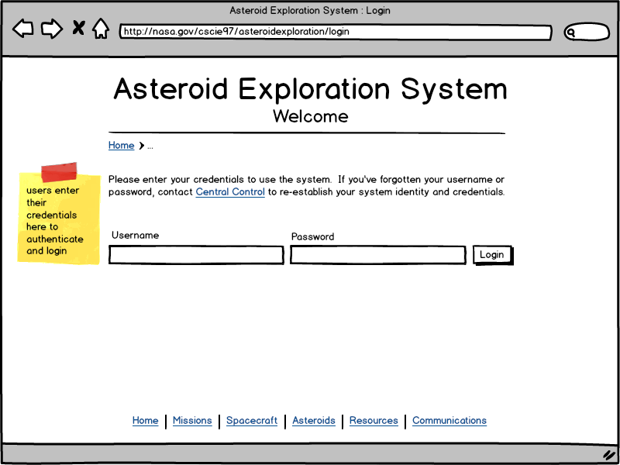

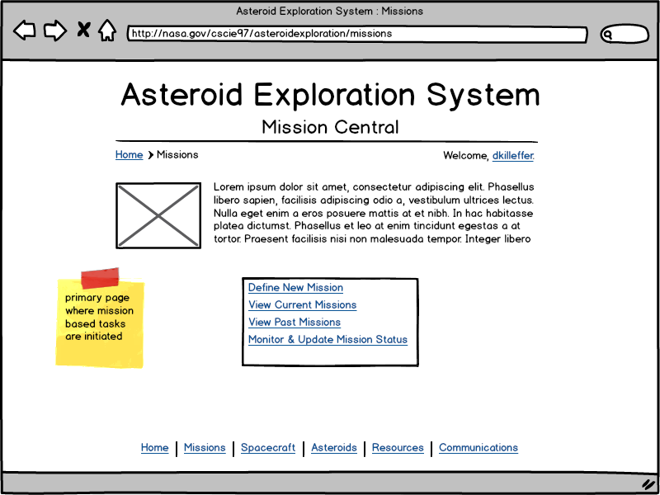

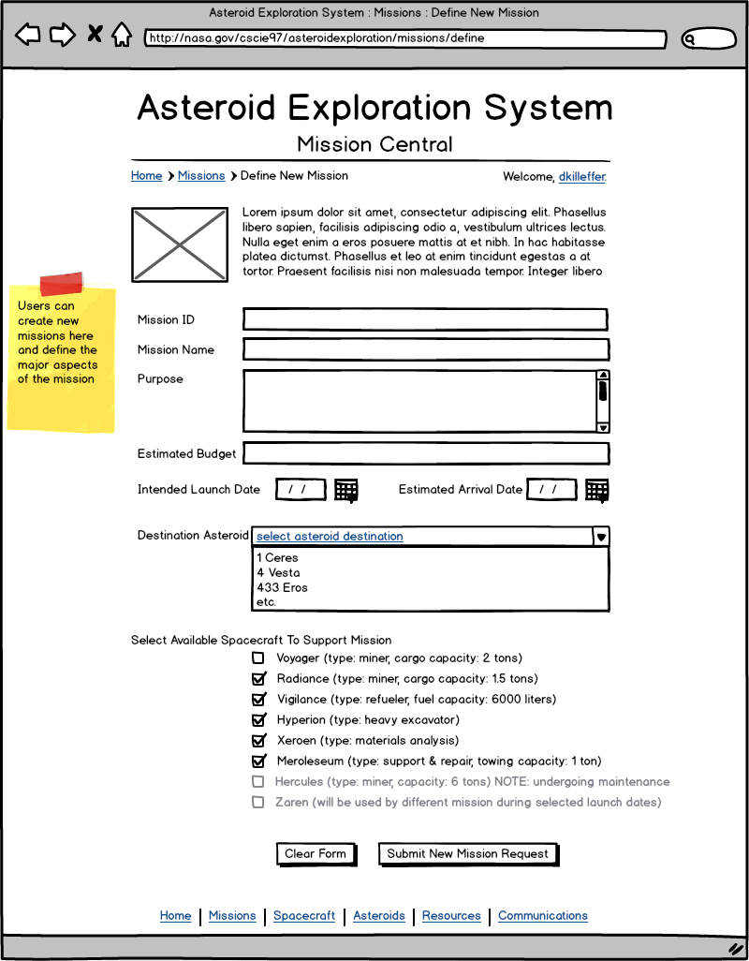

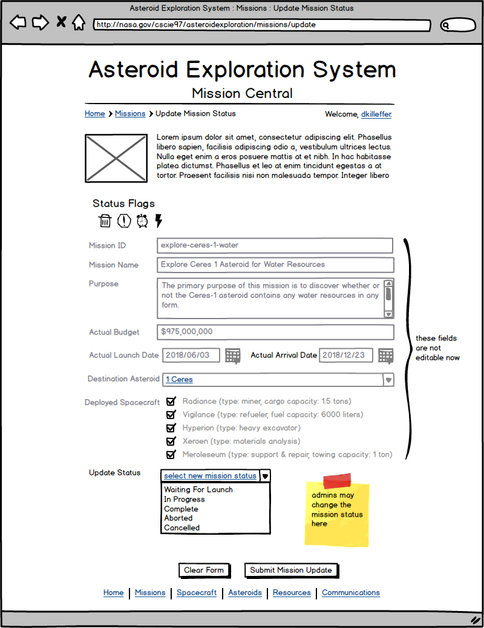
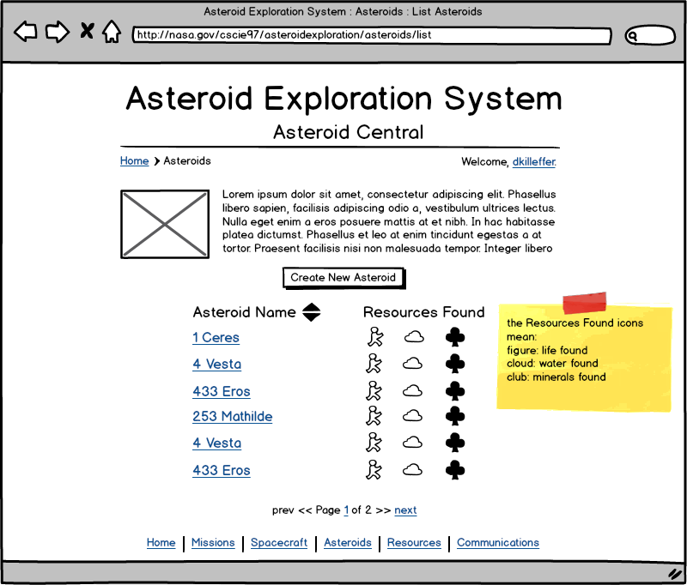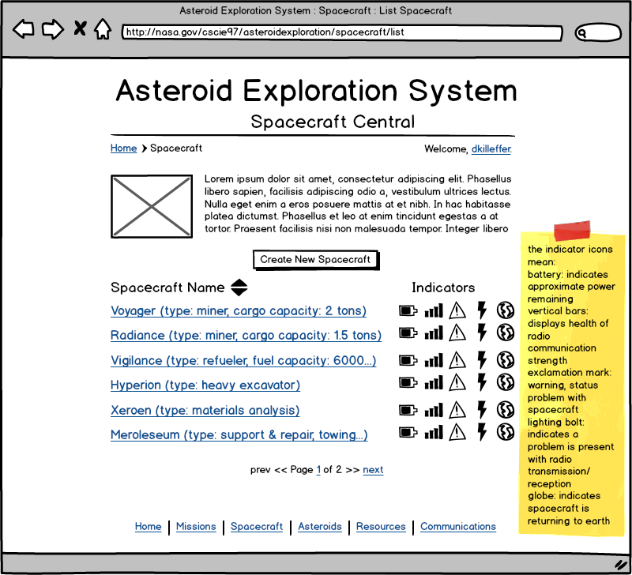

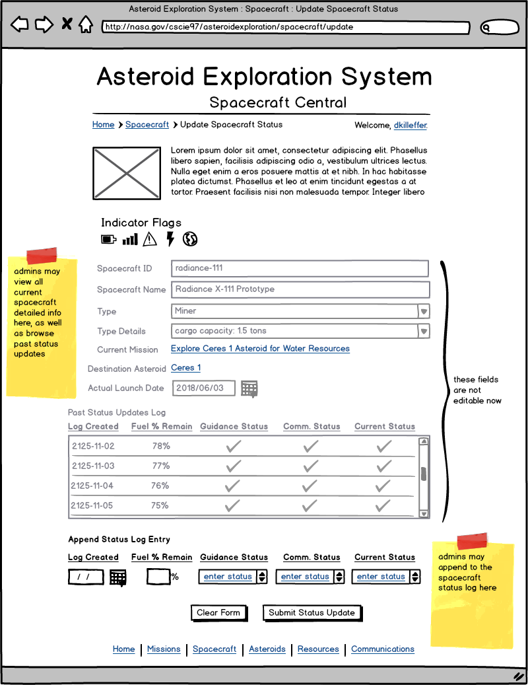
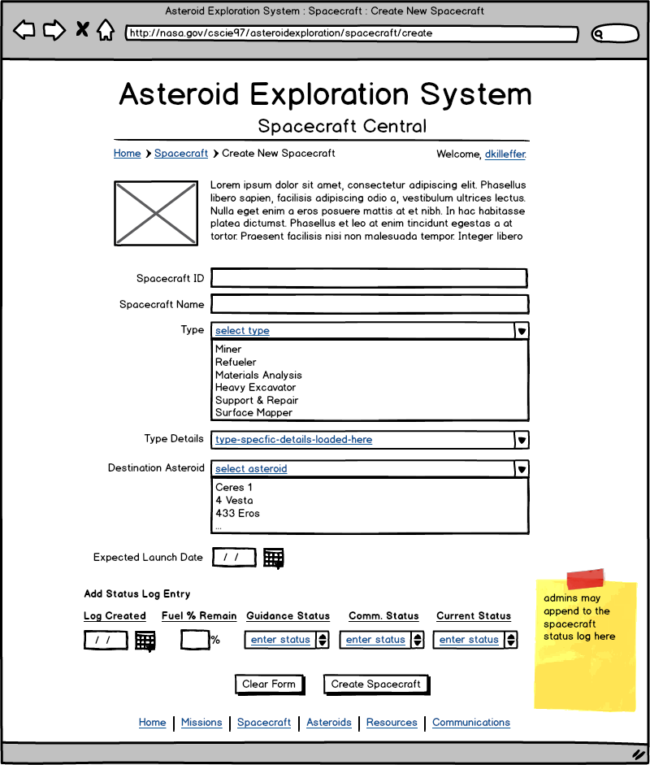

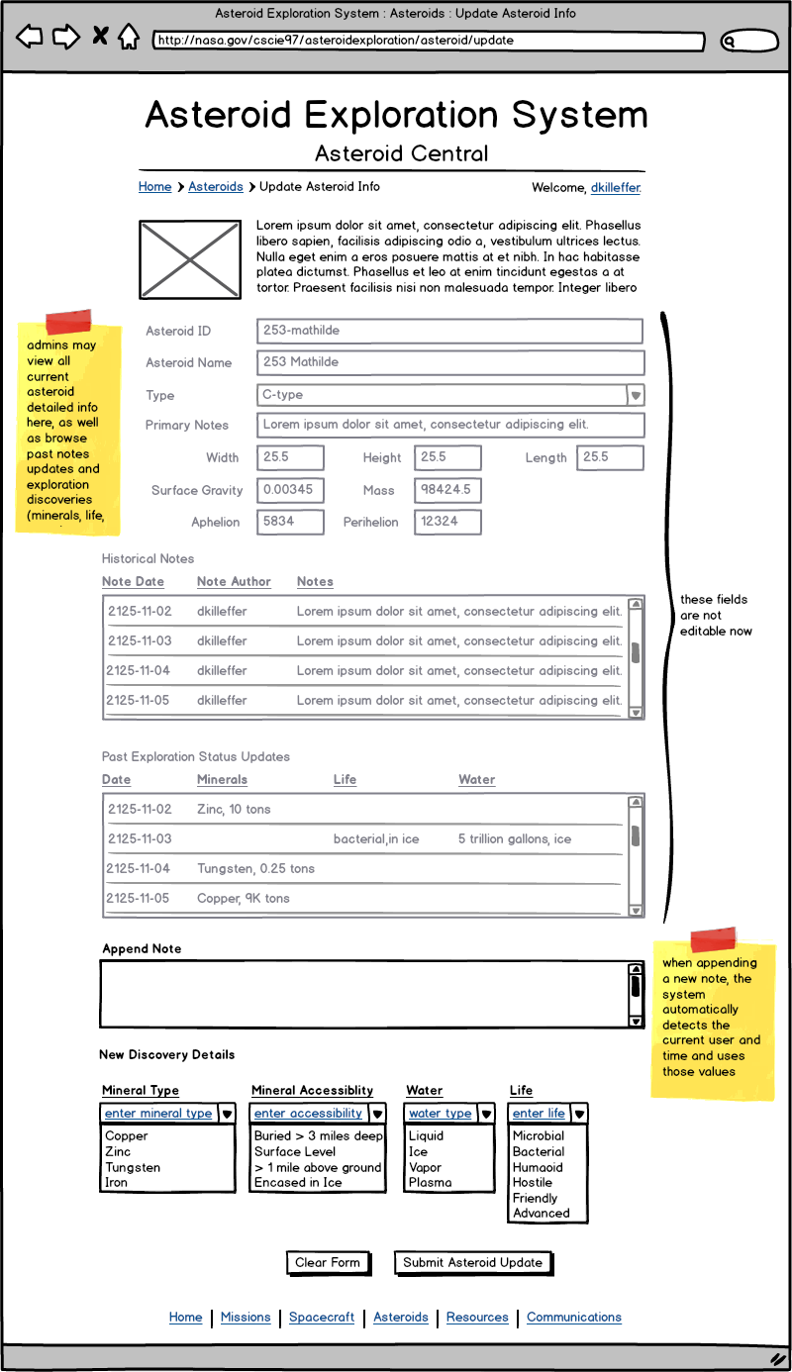
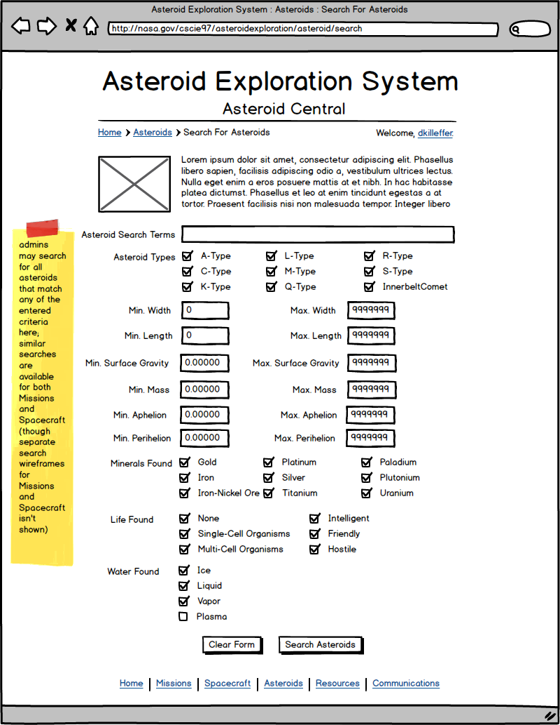
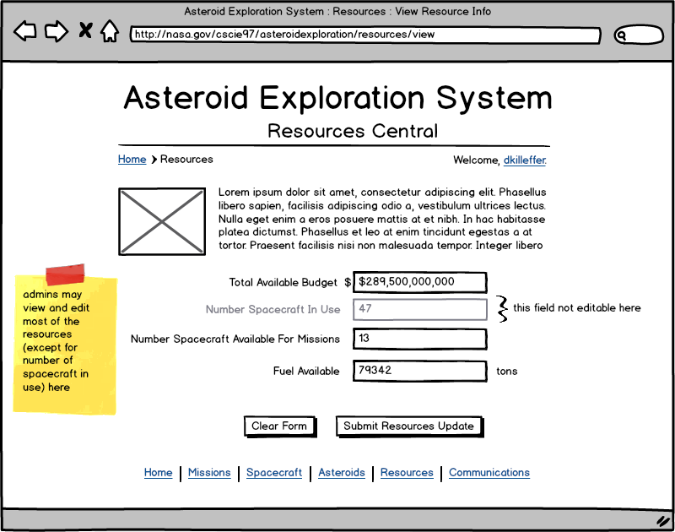

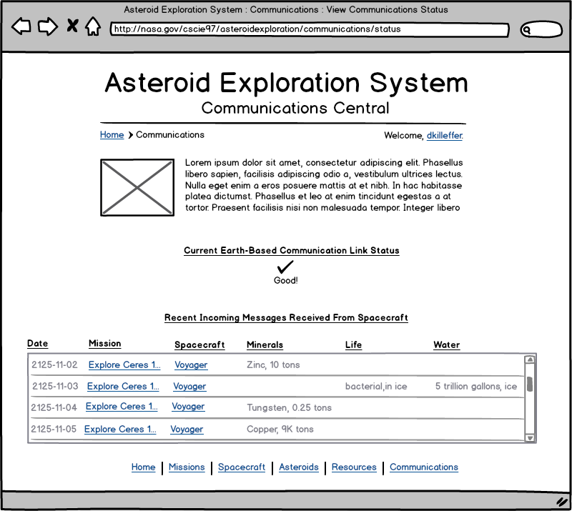

Implementation Details
Several classes in the Asteroid Exploration System are to be implemented as Singletons; examples are the AsteroidInventoryAPI, SpacecraftManagementAPI, and MissionManagementAPI. Additionally, these public APIs are also implemented as instances of their service interface definitions (IAsteroidInventoryAPI, I SpacecraftManagementAPI, and IMissionManagementAPI, respectively). This follows the Façade design pattern, and only exposes the public interface of the services to outside clients. Anywhere in the code that a reference to any of the service implementations is expected, the interface type is returned rather than a concrete implementation.

For data persistence, an Object-Relational Mapping software system should be used to directly map objects (such as Asteroid, Mission, Spacecraft, ExplorationStatus, etc.) to database tables. Depending on the implementing language, if Java is selected as the implementation language and platform, Hibernate is a good choice for an ORM layer, but there are several others to choose from. For the purposes of this sample design, the objects themselves may both be directly stored in the database as well as returned to clients when requesting objects; normally the underlying objects would not be returned to clients directly, but a Data Transfer Object (DTO) would be instead.

All Enumeration types should be stored in their own database tables, and when the application is loaded, they should be read from the database and populate the potential enumeration values. The requirements for this design did not call for an Entity-Relationship diagram of the intended database layout to be included, but in general, enumeration types should be short, small tables with one row per enumeration value. For objects that contain enumeration type values (for example, ExplorationStatus in the cscie97.asn5.asteroid package), the ExplorationStatus objects will require their own database table, but another join table will be necessary to track each enumeration type that the ExplorationStatus is meant to contain multiples of (for example, one record in the table where ExplorationStatuses are saved will correspond to N-records in another table where the ExplorationStatus’ MineralTypes are meant to be stored).

Changes from Original Design & Requirements
The original requirements for the Asteroid Exploration System only called for including one type of search functionality; the ability to search for Asteroids that match a particular text search criteria, and only searching within the Notes saved on each Asteroid. I felt that a much richer search would be expected by users of such a system in practice, and that any property of an Asteroid should be a valid search vector. As such, I designed a much richer search object (AsteroidSearch) which encapsulates nearly all of the possible properties of an Asteroid. Additionally, because there may be reporting requirements in the future to track things like Mission success rate, minerals found, etc., the AsteroidSearch allows users to specify ranges of criteria, and find all Ateroids that have properties within the specified range (see the usage of the Apache Commons org.apache.commons.lang3.Range<T> object to assist with range-based search criteria). Further, I felt that the Search capability should not only be limited to Asteroids, but also to Missions and Spacecraft as well, and so this design includes rich object-based search criteria for all types. This extends the cscie97.asn3.ecommerce.collections.ContentSearch design that I did for Assignment 3.

Another slight change is that this design calls for enumeration types in several places, in each sub-system, and these enumeration types should be stored in their own database tables. Using enumerations allows for better code re-use, and can also support expanding the list of potential enumerations by simply adding new rows to the associated database table and re-starting the application (upon application start the enumeration classes should have the possible values read in from the database).

Perhaps a somewhat larger change is that this design calls for any sort of notes, observations, discoveries, or messages to be implemented as a List or Set; the original requirements only call for single values for things such as Asteroid “ExplorationStatus”, but such a design would be overwriting old discovery values when new ones are made. Rather this design seeks to create a rich archive of all discoveries made by each Spacecraft as dated records, to note the minerals found and in what quantities and when for each Asteroid, etc. There is some additional database complexity to be considered when implementing this design over the original requirements, but the ultimate result of implementing this should be a much more usable system that provides extremely valuable historical information to users.

Another smaller change is that Missions can support N-number of Spacecraft, rather than just one Spacecraft. For Missions to larger or more distant Asteroids, it may become too risky, impractical, or even impossible to send a viable exploratory or mining mission with only a single Spacecraft.

Testing
Since the application is intended to be entirely database-backed, a testing library should consist of the following:
- A set of SQL scripts that populates all of the numeration type values, each in their own database table
- A set of SQL scripts that creates all of the base object records in the database (Asteroid, Mission, Spacecraft)
- A set of SQL scripts that creates all of the extended properties of those base object records (e.g., add ExplorationStatus for Asteroids, DiscoveryMessage records for Spacecraft, etc.)
- An object loader, that will iterate over all the tables in the database, load each record, and transform that record into an object that resides in memory

Further, following Test-Driven Development (TDD) principles, a testing library should also exercise all parts of the system that interact with the database, including creating new records, updating existing records, and deleting old records. Testing should include attempts to delete non-existent records, updating non-existent records, concurrency based testing, etc. Given the database-driven nature of the planned implementation, a CSV-file loading mechanism as was used for the prior assignments is not really appropriate here (either as a means of populating the data or as a way of testing the correctness of the overall system).

Additionally, this system has a user front-end in the Command & Control User Interface, which will require extensive testing to verify that the forms are properly sending data to the object model, and that the objects are properly persisting in the database.

Finally, as in Assignment 4, the AuthenticationServiceAPI should be tested to verify that users saved in the database are able to properly authenticate against the system, log in, log out, etc. Tests should be robust and include a variety of scenarios, including testing a logged in user attempting to access restricted interface methods with an expired accessToken, etc.

Risks
An admitted shortcoming in this design for the overall system is the message interchange between Spacecraft and the Mission Management System. The current design has Spacecraft calling a message on the IEarthBasedCommunicationLink when they make a new discovery of resources, water, or life, and then the EarthBasedCommunicationLink sending that message to the MissionManagementAPI to update the statuses of the associated Asteroid and Spacecraft. A much more robust and frankly better architecture would be to use an Enterprise Service Bus to enable message archiving, queueing, resiliency, tracking, and also two-way data interchange (for example, so that the Mission Management System could thus create and send messages to the Spacecraft). By using an ESB, Spacecraft could simply publish any new DiscoveryMessages to the service bus, and the bus would handle routing, brokering publish/subscribe relationships between objects/components, etc.

Another risk area is the database itself; as the system is designed to be database-driven, a database failure could be catastrophic for the overall system. Therefore, a system of multiple redundancies and failover plans should be in place (database replication, remote availability, etc.).

