Software Design Specification for Rub BBQ RMS

Version 2.0
12/2/2010


Prepared for:
Jared Leonard, Owner
RUB BBQ
2407 W Lunt Ave.
Chicago, IL, 60645

Prepared by:
Jerod Hodgkin
Mike Schenk
Jessie Floyd
Scott Leonard
Weber State University
Ogden, UT 84408

Responsibility Matrix
Levels | Team Member Name | Jerod | Jessie | Mike | Scott
 | Project management  (10 points) | 75% |  | 25%
 | Sec.3: Customer Statement of Requirements  (6 points) | 25% |  | 25% | 50%
 | Sec.4: Glossary of Terms  (4 points) |  | 50% | 50%
 | Sec.5: Functional Requirements Specification  (37 points) | 15% | 40% | 25% | 25%
 | Sec.6: Nonfunctional Requirements  (6 points) |  | 25% | 25% | 50%
 | Sec.7: Domain Analysis  (25points) | 30% | 10% | 30% | 30%
 | Sec.8: User Interface Design  (8 points) | 50% |  | 50%
 | Sec.9: Plan of Work  (3 points) | 25% | 25% | 25% | 25%
 | Sec.10: References  (1 point) | 50% |  | 50%

Responsibility Allocation Chart
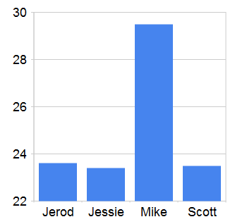

Rub BBQ RMS SDS
Summary of Changes
Change number | Date completed | Location of change | A  M  D | Brief description of change | Approved by (initials) | Date Approved
001 | 11/22/2010 |  | A | Started the document. | JTH | 11/22/2010
002 | 11/22/2010 | Use Cases | M | Added or Updated Use Cases | JLF, JTH, SWL, MS | 11/22/2010
003 | 11/29/2010 | Use Cases | A | Added and updated Use Cases | JLF, SWL,MS | 11/22/2010

*A - ADDED M - MODIFIED D - DELETED
Table of Contents
Software Design Specification for Rub BBQ RMS
Responsibility Matrix
Responsibility Allocation Chart
Summary of Changes
Table of Contents
Introduction (Customer Statement of Requirements)
Purpose
Scope
References
Audience
System Overview
System functionality
System Components
Basic Design Approach
User Interface Prototypes
Login Screen
Order Entry Screen
Cook’s Screen
Inventory Management Touch-Screen
Inventory Management
Menu Management
Employee Management
Report Selection
Running Reports
Design Considerations
Assumptions and Dependencies
General Constraints
Architectural Strategies
System Architecture
Use Cases
Menu Management
Create menu item
Inventory Management
Add Supplier
Receive an Inventory Order
Reconcile Inventory
Place an Inventory Order
Cooks interface
Complete a customer order
Customer Order Entry Subsystem
Place and save customer order without taking payment
Split a check
Take a customer order and accept payment
Accept payment for saved customer order
Recall and modify saved customer order
Take multiple payments for a customer order
Admin Functions
Managers Dashboard
Employee management
Reporting
Sales Reporting
Logical View
Development View
Process View
Order Placement and Completion
Run Report
Menu Management
Inventory Management
Employee Management Activity Diagram
Physical View
Policies and Tactics
Detailed System Design
Database
Orders and menus
Inventory
Employees
Glossary
Bibliography
History of Work**
Introduction (Customer Statement of Requirements)
Jared Leonard owns a barbecue restaurant in Chicago, IL called Rub BBQ. He has requested an application for tracking his sales. He needs to track the number of menu items that were sold, what the method of payment was, whether it was an eat-in or take-out order, how it was ordered (phone-in, walk-in) and whether it was a order for catering or a single customer. He will eventually need to use this information to generate reports. In addition, the system to be built will include the ability to manage inventory, manage employee scheduling, and support accepting payment.
Purpose
The system under development is proposed to assist in inventory management, product ordering, sales tracking, and profit/revenue projections. Jared Leonard, Ted Cowan and the development staff (Jerod Hodgkin, Mike Schenk, Jessie Floyd, and Scott Leonard) have input to this document. This document is intended to provide a basis for expectations and deliverables. It is managed by the development staff with input from the principals (Jared Leonard, Ted Cowan).
Scope
Primary development efforts shall be focused on the the following areas:
- Inventory management
- Taking customer orders
- Integration with a 3rd party payment processing system
- Managing menus to support taking orders
- Integrating a flexible reporting package
- Creating an initial set of reports
- Employee schedule management

This system will not provide:
- A payment processing system
- Support for 3rd party application integration
- Detailed accounting

This project is a new design and as such has not yet created a history of previous efforts. Operations or “sustainment” efforts are not scheduled into the project. All additional software modifications will be contracted on an “as-needed” basis and managed via the project charter.
References
The development staff will maintain revisions of additional documentation via GSC-SVN. Changes will be checked in and maintained there. The following documents will be available for review upon request:
RMS Project Charter
WBS
Project Proposal
Audience
This document is intended for both the software developers and the customer (Jared Leonard) and is intended to be a “living” document to be updated as the project requirements become more definite and aspects of the project mature.
System Overview
System functionality
The RMS system will allow the manager to create one or more menus consisting of numbered menu items with their corresponding prices. These menus and menu items will be used to dynamically create an order-entry display that employees will use to take and record customer orders. The order entry screen will be built to be used with a touch-screen device to support quick data entry. In the absence of a touch screen, the menu item numbers will allow orders to be entered quickly by keyboard primarily using the numeric keypad. The order entry screen will also allow users to enter discounts or manually adjust prices. Once the order is complete, users will be able to accept payment from the customer and record in the system what the method of payment was. If it is a credit or debit card payment, the user will key-in the card information or swipe it through an attached card reader, after which the system will send a charge request to a third-party payment processing web service. The card information will not be permanently stored.

Once an order is entered, it will appear on a separate touch-screen terminal display in the kitchen where the cook(s) will begin preparing the customer’s order. Once an order is prepared, the cook will press a button on the touch-screen to mark the order complete and dismiss it from the screen.

The RMS system will allow the owner to track restaurant inventory. Inventory tracking will occur in two parts. First, as the cooks pull ingredients from the pantry or refrigerator/freezer to be used, they will enter the amount they’re using on another touch-screen terminal. The system will track the rate of usage of each inventory item. Second, the manager will use an inventory management screen to record the purchase of additional inventory. In this way, the RMS will be able to track and report inventory levels of those items being tracked. Periodically, a physical inventory count will need to be taken and the RMS inventory levels will need to be adjusted to account for inaccuracies in earlier data-entry and also due to waste and spoilage.

Employee management allows managers to control access to the RMS system for each individual employee. It will also support recording the information necessary to compute payroll by tracking employees names, pay type, wage or salary, and time worked.

Managers will be able to access screens for modifying the menu that regular employees will not be able to access. There, they will be able to add and remove items from menus, and change their prices.

Managers will also be able to access screens where they can choose from several reports to run. These reports have yet to be defined, but will include things like daily, weekly and monthly revenue, popular menu items, comparison of walk-in versus phone-in orders, comparison of catering business versus in-store business, employee hours worked, inventory costs, etc. Reports can be printed, saved as documents, or exported to a spreadsheet file.
System Components
The RMS will be divided into the following separate components:
- RMS database
- RMS server
- RMS order entry client
- RMS cook’s display
- RMS menu management
- RMS inventory management
- RMS employee management
- RMS report interface
- RMS manager’s dashboard

These components will be divided and deployed as three separate, communicating systems. All user interfaces will be included in a single executable program which allows users to log in and then limits their access to those interfaces appropriate for them. The RMS server will run in its own executable program, and the database will be deployed in a Microsoft SQL Server instance on the same machine as the RMS server.
Basic Design Approach
The RMS will be built as a client-server, Windows®-based application. The client and server may be deployed on a single machine, or may be deployed to separate machines connected with a standard TCP/IP network. User interfaces will be built using WPF with consideration for touch-screen constraints for the order-entry and cooks display. The management functions are expected to be used by a user sitting down with a keyboard and mouse, so normal input controls with regular sizes will be used in those areas.

The server will be a fairly simple set of WCF services that provide access to a central database of order, inventory, menu, and employee information.
User Interface Prototypes
Login Screen
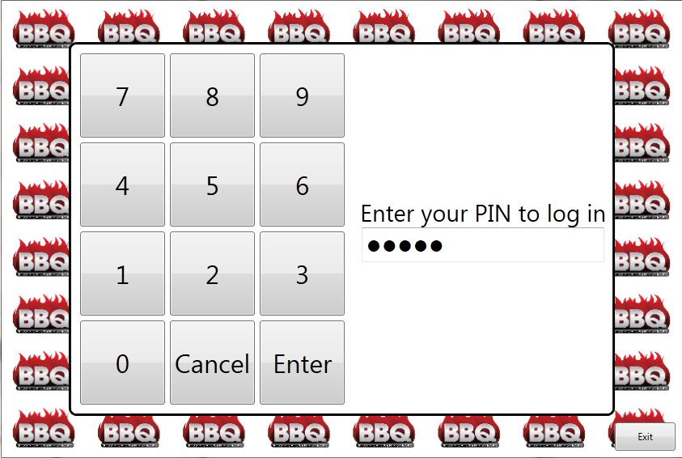

Figure 1. Login screen

To log in, users will be assigned a PIN number which they can enter through the touch-screen or keyboard.
Order Entry Screen
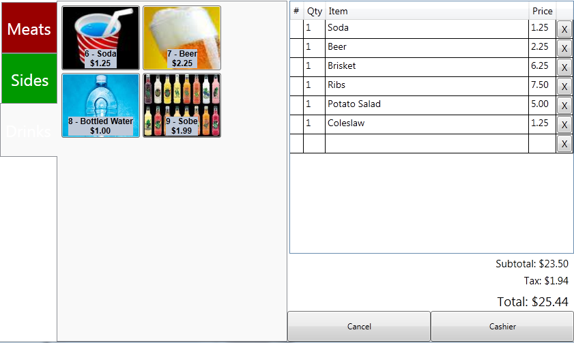

Figure 2. Order entry screen

Orders may be entered through the touch-screen by pressing the menu item buttons, or through the keyboard, by entering menu item numbers and quantities. The screen opens with the keyboard focus in the “#” column. The user can enter the item number, then quantity. Using the touch screen, each touch of a menu item adds one more to the quantity of that item in the order. Pressing the “X” button on an order item will remove the item from the order.

Since this is intended to be used with a touch-screen interface, the buttons are large and easy to press.

Figure 2 shows an order in-progress. The user has just entered “11” to add a “BBQ Burger” to the order.

Each tab on the left represents a separate “menu.” Pressing a menu button will switch the screen to show that menu’s items in the central area.

The order entry prototype screen has changed since the version in the requirements document. It has been enhanced to add keyboard data-entry support.
Cook’s Screen
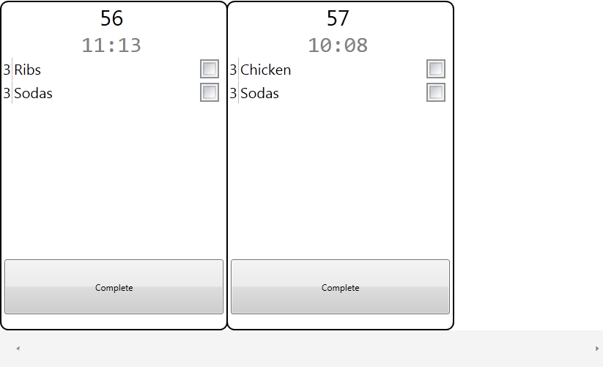

Figure 3. Cook’s screen

The cook’s screen shows the pending orders that need to be prepared. The oldest order is displayed on the left with a timer showing how long it has been since the order was placed.
Inventory Management Touch-Screen
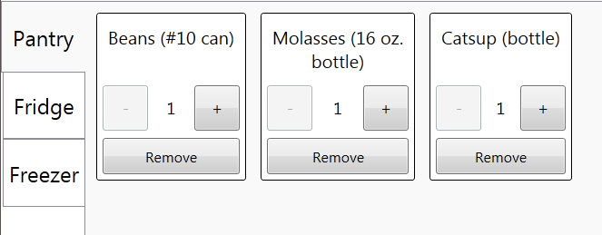

Figure 4. Inventory management touch screen

The kitchen staff uses this screen to quickly record inventory that is being used at the time they remove it. Since this is intended to be used with a touch-screen interface, the buttons are large and easy to press.
Inventory Management
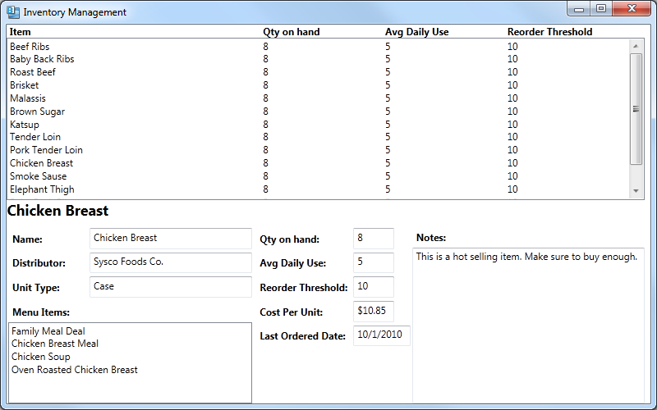
Figure 5. Inventory management

Managers use the inventory management screen to:
- Add new items to the inventory for tracking.
- Reconcile the physical inventory count with the computed count.
- Record spoilage and waste.
- Stop tracking items.
Menu Management
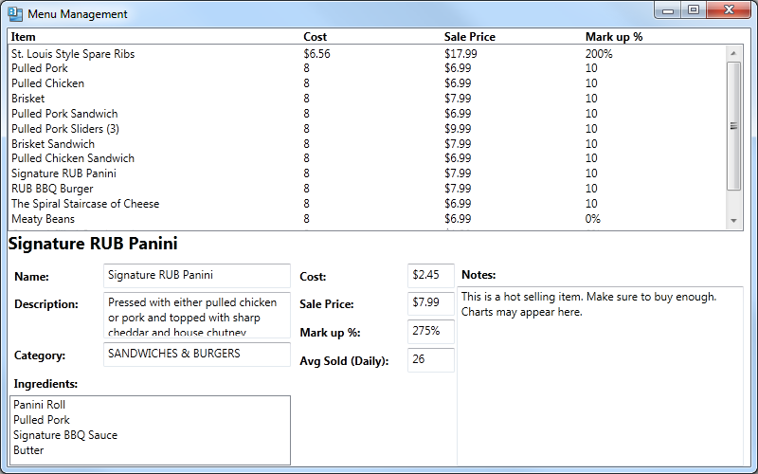
Figure 6. Menu management

Managers use the menu management screen to:
- Add a menu to or remove a menu from the ordering screen.
- Add items to or remove items from a menu, which changes the options on the ordering screen.
- Change the name or price of menu items.
- Change the inventory ingredients associated with each menu item.

Employee Management
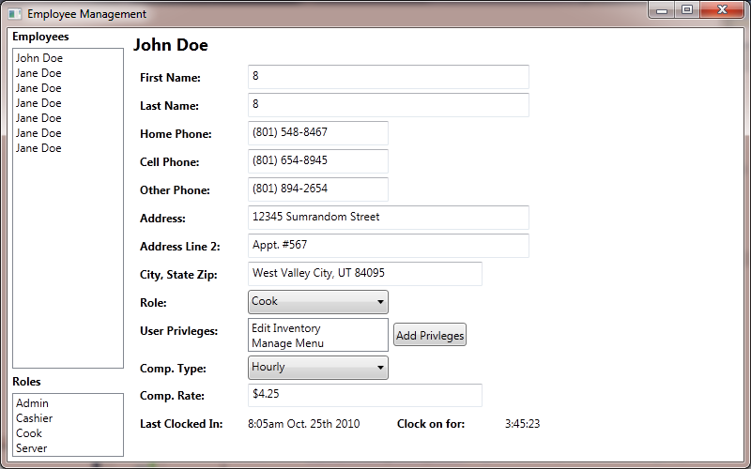
Figure 7. Employee Management

Managers will select an employee and edit the employee details.
Report Selection
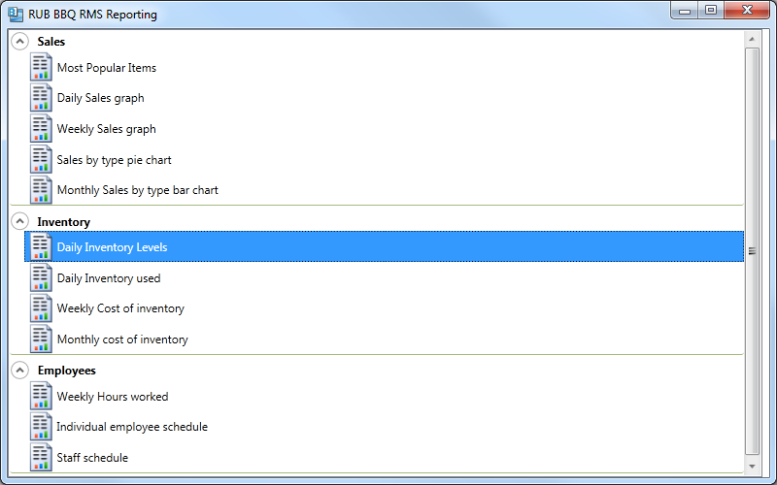
Figure 8. Report selection

Managers will select a report to run from this screen showing all the available reports organized into functional groups..
Running Reports
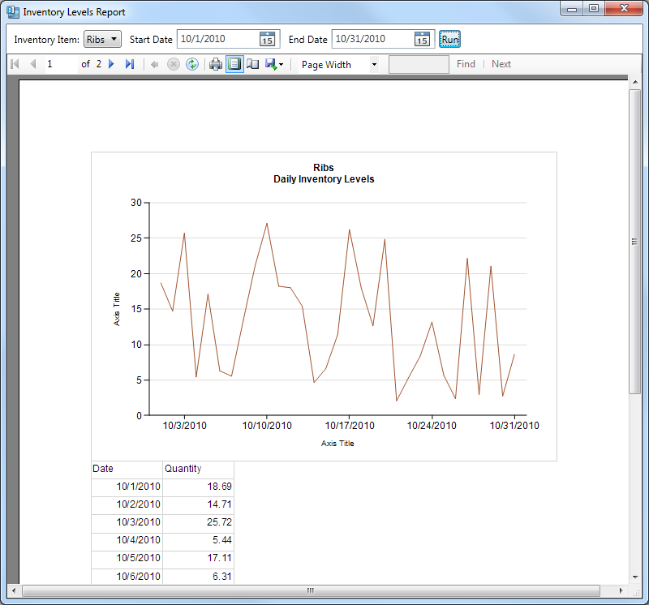
Figure 9. Running reports

Once a report has been selected, the report view screen will open and allow the user to enter the reports parameters at the top of the screen. Then after clicking “Run,” the report will be generated and displayed below. The toolbar includes options for printing and exporting the report to various formats.
Design Considerations
Assumptions and Dependencies
The software application will be deployed on a computer running a Windows® operating system with the .NET 4.0 framework and having network access. Additional software can be installed by the user as required.

Specific system functions will depend on the availability of a credit card scanner, card payment processing system, a printer, and network access.
General Constraints
All components will deploy and operate on Windows® based operating environments on commodity hardware.

Users are not expected to be computer-savvy and still should be able to operate the order entry and cooks screen after only minimal training.

The order entry and cook’s terminals are expected to be in a noisy environment probably with poor lighting conditions. Screens and keyboards are expected to get dirty. Therefore, onscreen text, icons and controls should likely be quite large with good contrast.

Orders need to be taken and recorded even while the cashier’s terminal is unable to communicate with the central server. For example, if the restaurant goes to a fair to sell food.
Architectural Strategies

- Selected a client-server, layered architecture (answer 3a from report 2 instructions)
  - The system should be able to run in a single user environment with one workstation acting as both client and server. As more users are added, the database should be moved to a server machine to allow access to clients.
- Selected Microsoft .Net 4 for the development platform.
  - Microsoft platforms give us the broadest and deepest options for data, user interface and development solutions. All development platforms used in this project will be Microsoft products. Microsoft .NET 4.0 is the latest Microsoft development platform.
- Selected WPF for the user interface platform
  - WPF is Microsoft’s solution to provided rich, advanced user interfaces.
- Selected WCF (Data services) for the communication platform
- Selected Microsoft SQL Server for the data storage
  - Microsoft SQL Server gives us the best database solution for the .NET platform.
- Selected Windows 7 for the target client operating system
  - This is the latest version of Microsoft Windows, and is the OS in use by the client on their current system.
- Intend to support touch-screen interaction
  - The client wants to maximize his customer interaction. A touch panel interface will allow him to maintain contact with the customer as orders are placed.
- Intend to support keyboard/mouse interaction
  - The keyboard and mouse will need to be used in areas where touch panels are not possible, or not cost effective.
- Intend to allow users to use or not use the inventory module
  - The system will incorporate a modular design which will allow clients to use any or all parts of the system as needed.
- Intend to allow users to use or not use an integrated cashiering module
  - The system will incorporate a modular design which will allow clients to use any or all parts of the system as needed.
- Intend to allow orders to be taken while offline (i.e. off-site at a festival or fair)
  - BBQ restaurants make a lot of money at remote sites. This option is critical to allow the clients to use the same system in the restaurant or on the road.
- Intend to integrate with an online payment card processor already in use
  - The client needs to be able to take credit card payment using his existing payment processor.
- Intend to support a flexible reporting package
  - The true value of the system is in the ability to show the client how his business is performing and show him where he can improve.
System Architecture
Use Cases
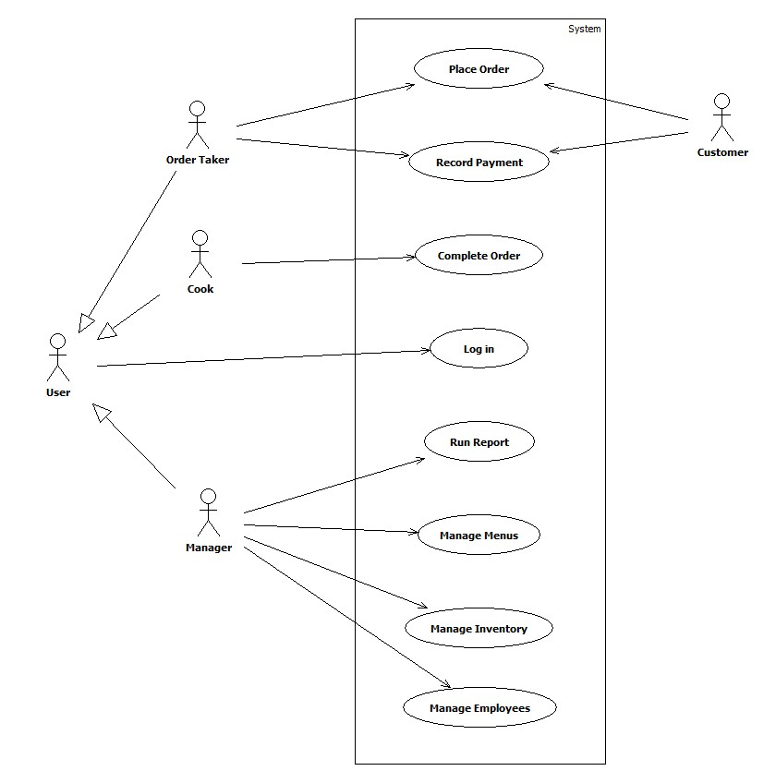
Figure 10. RMS use case diagram

Managers, Cooks and Order Takers are all users of the system so they all must log in. The other use cases are specific to the individual user’s role. It is expected that some employees will have both the Cook and Order Taker roles, and Managers will most often also have Order Taker and Cook roles.

The customer is a secondary actor who interacts with the Order Taker during the Place Order and Record Payment cases.
Menu Management
Create menu item
Related use cases:  Inventory management  Place order  Complete order | Actors:  Managers

Summary
The menu items will be the items sold to the the customers. Menu items are constructed of inventory items. The owners should be able to create new menu items from existing inventory items and change details of the current menu items including, recipe, description and sale price.

Preconditions
There exist items in the inventory database with which to construct menu items. There exist menus in the database to add menu items to.

Input/Output sequence for this feature
The inventory items shall be read from the database and be combined to create a recipe that is associated with a menu item. The manager shall select a menu to which this item is to be added.

Postconditions
There exists a menu item that can be ordered by a customer.

Design constraints of this feature
Menu management shall read the inventory to construct menu items. Menu items shall be available to be added to an order.

Performance requirements of this feature
No performance requirements have been identified.
Inventory Management
Add Supplier
Related use cases  Log in  Inventory Management | Actors  Managers

Summary
Provide a user interface to add new suppliers. These suppliers are the companies or people that sell and deliver the products that make up the inventory.

Preconditions
None

Input/Output sequence for this feature
The user shall input the supplier information. This information may include (but is not limited to) address, contact phone number, contact name, discounts. After the supplier is entered it shall be available on the inventory menu when adding a supplier to an inventory item.

Postconditions
There exists a supplier that can be associated with an inventory item.

Design constraints of this feature
This screen does not need to be designed as a touch interface, but ease of use for potential touch interface should be considered. Supplier names shall be used on other screens such as inventory management. These screens may require new constraints be added to this user story.

Performance requirements of this feature
None.

Receive an Inventory Order
Related use cases:  log in  Place an Order | Actors:  Managers

Summary
The manager should be able to receive an order from a supplier marking the order complete in the BBQ RMS removing the item from a pending receipt table.

Preconditions
Knowledge of a shipment and the supplier and item(s)

Input/Output sequence for this feature
Identify the supplier, locate pending order, mark complete

Postconditions
Inventory tables are updated to reflect current status and quantity.

Design constraints of this feature
Items to be received into inventory will be known by the system prior to receiving an order. This is accomplished by the placed an order scenario. Once an order is known, completing an inventory should be quickly accomplished using a mobile device similar in design to the touch-sensitive tablet computer used for customer order entry.

Performance requirements of this feature
Able to complete an entire order as well as a partial shipment, meaning only some of the ordered items are shipped and received into inventory leaving some items ‘outstanding’ or pending shipment.
Reconcile Inventory
Related use cases:  Inventory reporting  Complete order | Actors:  Managers

Summary:
The owners should be able to track the use of inventory through the day and make adjustments to inventory when a physical inventory count is taken

Preconditions:
We have not identified the preconditions.

Steps
We have not yet created user stories for the use cases. We need information from our client

Input/Output sequence for this feature
The client shall enter an initial inventory count when they go live on the system. The client shall reduce the inventory by an appropriate quantity as inventory items are used to make menu items. The client shall take a regular physical inventory to reconcile the difference between the system inventory count and the actual inventory count.

Postconditions
The client will have an accurate count of their inventory.

Design constraints of this feature
The inventory shall be stored in the database. The database shall exist such that the inventory items and quantities shall be available in other areas of the system. Reporting, ordering, and the menu shall access the inventory as needed.

Performance requirements of this feature
Inventory management shall be able to store up to 10,000 inventory items. The inventory screen shall take less than 10 seconds to load when all inventory items are listed.
Place an Inventory Order
Related use cases:  Log on  Add Item | Actors:  Managers

Summary
Reorder items from inventory when stock supplies drops below allowable threshold.

Preconditions
Suppliers are known and inventory items loaded into database tables.

Steps
Locate the item in the inventory management menu, identify quantity desired and click “re-order” which prints a order form to be called in to the supplier.

Input/Output sequence for this feature

Postconditions
Database tables and inventory management system records pending order and presents the manager an option to close the order marking it complete.

Design constraints of this feature
Identified Suppliers, quantity, shipment time, and cost are known to the manager prior to order.

Performance requirements of this feature
Large number of suppliers shall not inhibit the system function

Cooks interface
Complete a customer order
Related use cases:  Menu management  Place order  Receive payment | Actors:  Cooks

Summary:
After an order is placed, it will show up on the cook’s screen. An employee in the kitchen will prepare the items on the order and mark the order completed. Complete order shall allow the employees in the kitchen to receive orders that have been placed and mark the order complete once the items have been prepared.

Preconditions:
There exist orders that have not been completed or paid for.

Input/Output sequence for this feature
Cooks shall be presented with incomplete orders on a screen. The time since each order was placed shall be displayed. Once an order has been prepared, the cook shall press an on-screen button to indicate it is complete and it will disappear from the screen. The customer order will be marked complete in the database with a timestamp so it can be reported on later.

Postconditions
An order will be stored in the database in a completed status with a completed date and time.

Design constraints of this feature
More than one employee shall be able to view the active orders at once. A certain minimum number of orders needs to be visible on screen at once.

Performance requirements of this feature
This feature shall be capable of showing new orders in near real time. A large number of orders shall not impact the performance of this feature.
Customer Order Entry Subsystem
Place and save customer order without taking payment
Related use cases:  Menu management  Complete customer order  Accept payment for saved customer order  Recall and modify saved customer order | Actors:  Customers  Order Takers

Summary
Employees shall be able to add menu items to a customer order. Employees shall be able to save a customer order for later recall. Employees shall be able to send customer orders to the kitchen for customer order completion. Employees shall have the option to accept payment as the order is placed.

Preconditions
There exist menu items that can be sold on the order.

Input/Output sequence for this feature
Menu items shall be added to an order. For a catering order, additional customer information shall be recorded. The order can be passed to the cook so the food can be prepared. The order can be saved for later recall.

Postconditions
An order shall exist in the system that can be completed, cashiered or saved for recall.

Design constraints of this feature
Place order shall read menu items in the database so an order can be created. Place order shall save orders in the database. Place order shall do some simple calculations to determine order price based on menu item price and tax information. Several people shall be able to place an order simultaneously.

Performance requirements of this feature
This feature shall be in continuous use when the restaurant is open. This feature shall run without slowing down over long periods of time. As more orders are placed the performance of this feature shall not be impacted. As menu items are added to an order the performance of this feature shall not be impacted.
Split a check
Related use cases:  Take a customer order and accept payment  Complete order | Actors:  Order Takers  Customers

Summary
Order Takers shall be able to modify an existing customer order in order to divide the check to produce separate receipts and totals to be paid separately.

Preconditions
An order is saved in the database.

Input/Output sequence for this feature
An Order Taker shall retrieve an existing, un-paid customer order. The order taker shall select items from the existing order to place on a new check. Each check can then be printed separately.

Postconditions
An order will be split so that it can be paid separately.

Design constraints of this feature
If the order is split before it has been completed by the cook, splitting the check should not impact the cook’s screen and the “Complete a customer order” use case.

Performance requirements of this feature
No performance requirements have been set.

Take a customer order and accept payment
Related use cases:  Menu management  Place order  Complete order  Sales reporting | Actors:  Order Takers  Customers

Summary:
After an order is placed, it will show up on the cook screen. An employee in the kitchen will prepare the items on the order and mark the order completed. These orders will show up on the cashier screen so the employee can ring them up and receive payment for the order.

Preconditions:
There exist orders that have been completed but not paid for.

Input/Output sequence for this feature
Completed orders shall be viewed in receive payment. Orders shall be paid and go to history. Orders for which payment is not received shall be marked unpaid at the end of the day, and shall still be a part of the history.

Postconditions
A completed paid order will show up in the order history.

Design constraints of this feature
Receive payment shall read completed orders from the database and see the price of menu items so the invoice can be totalled. Receive payment shall be able to add tax and tip to the total.

Performance requirements of this feature
This feature shall be capable of showing completed orders in near real time. A large number of orders shall not impact the performance of this feature.
Accept payment for saved customer order
Related use cases:  Take multiple forms of payment | Actors:  Cashier  Customer

Summary:
The cashier shall retrieve a saved customer order. The cashier shall identify the type of payment and record the amount of the payment received.

Preconditions:
At least one unpaid order has been saved.

Input/Output sequence for this feature:
The cashier enters or selects a saved order. The cashier shall select a payment type then enter an amount paid. The cashier can take multiple forms of payment by following the respective use case. The system shall print a receipt. When accepting credit or debit card payments, the cashier shall swipe or enter the card number before entering the payment amount. The system shall communicate with a third party payment processor to process the card payment.

Postconditions:
The selected order will have payment information recorded and saved with it. A receipt will have been printed for the customer.

Design constraints of this feature
The third party payment processing system needs to be accessible from the terminal where the cashier is taking payment.

Performance requirements of this feature
This feature shall be in continuous use when the restaurant is open. This feature shall run without slowing down over long periods of time. As more payments are accepted the performance of this feature shall not be impacted.
Recall and modify saved customer order
Related use cases:  Take multiple payments for a customer order  Accept payment for saved customer order | Actors:  Cashier  Customer  Cook

Summary:
The cashier shall retrieve a saved customer order. The cashier shall make adjustments to the order and resend it to the kitchen, and either cashier the order or save it again.

Preconditions:
At least one uncompleted order has been saved. The cook has not marked the order completed.

Input/Output sequence for this feature:
The cashier shall recall a saved order that has not been marked completed by the cook. The cashier shall make changes to the order which could include adding or removing items to the order, applying discounts or payments to the order. The cashier shall save the order. If the order exists on the cook screen, the order shall be marked to show there was a change.

Postconditions:
The order that was changed will now show with the changes.

Design constraints of this feature
The cook should be notified of changes to any orders on the cook screen.

Performance requirements of this feature
None
Take multiple payments for a customer order
Related use cases:  Place a customer order | Actors:  Cashier

Summary
Provide the cashier the ability to receive multiple types of payments for a single order. Allowing the customer to provide multiple payment options. For example; some amount of cash and the difference of the balance due provided by a debit card or credit card.

Preconditions
An order is placed and received for items on the menu.

Input/Output sequence for this feature
An order is communicated by the customer to the cashier. The order is understood and items are available.

Postconditions
An order exists that has payments made on it that can be resaved or cashiered.

Design constraints for this feature
Upon completion the bill satisfied and the order is submitted to the cooks.

Performance requirements of this feature
multiple cashier actions shall be able to complete simultaniously.
Admin Functions
Managers Dashboard
Related use cases:  Log in | Actors:  Managers

Summary
A manager needs to be able to see a real-time updated, status of the performance of the business.

Preconditions
A manager is logged in.

Input/Output sequence for this feature
A manager logs in, then shall select an option to display the dashboard. The system shall periodically update the display to show certain key performance metrics.

Postconditions
A managers dashboard screen is displayed.

Design constraints for this feature
The display needs to represent several measurements in an easily understandable display.

Performance requirements of this feature
The information displayed needs to be up-to-date to within 2 seconds.

Employee management
Related use cases:  Log in | Actors:  Managers

Summary
The managers should be able to create user accounts and set or change their access roles. The managers should be able to track the employees working hours and their wage or salary. Track employees work hours and control their access to the RMS.

Preconditions
A manager is logged in.

Input/Output sequence for this feature
The user chooses an existing employee to go to an editing screen with that employees data. The user enters or changes the employee’s information, then issues a command to save their changes. The changed employee record is saved in the central database.

Postconditions
The appropriate users will be able to log in to the system. Managers will be able to export necessary information to an external payroll system.

Introduction/Purpose of this feature
The employee management feature shall allow the owners to add, remove and update records of employees. Those employees also may be users of the system so managers can use this feature to control their access.

Design constraints of this feature
The employee data shall be stored in the database. Employee data includes private, personal information which needs to be managed securely.

Performance requirements of this feature
Not yet defined.
Reporting
Sales Reporting
Related use cases:  Receive payment  Inventory reporting | Actors:  Managers

Summary:
When an order has been marked paid or not paid, it will be saved in history to be counted and reported on. Reporting will allow the owners to track their sales.

Goals:
Owners should be able to view details about sales as they happen through the day. They should be able to see a sales breakdown by hour, day, month, and year.

Preconditions:
There exist customer orders that have been paid.

Input/Output sequence for this feature
The orders that have been marked paid or not paid shall show up in sales reports. The client shall be able to view or print reports.
A manager logs in to the system.
The user opens the reporting screen.
The user selects the desired report.
The user is prompted to enter parameters needed to configure the report.
The user runs the report and views it on-screen.
The user has options to print the report or save it in various formats.

Other specific types of reports will be developed according to the customer’s needs. Running each report will follow the same steps.

Postconditions
The manager has a printed report or an electronic file.

Design constraints of this feature
Sales reporting shall read sales history from the database.

Performance requirements of this feature
No sales report shall take longer than 120 seconds to load.
Logical View
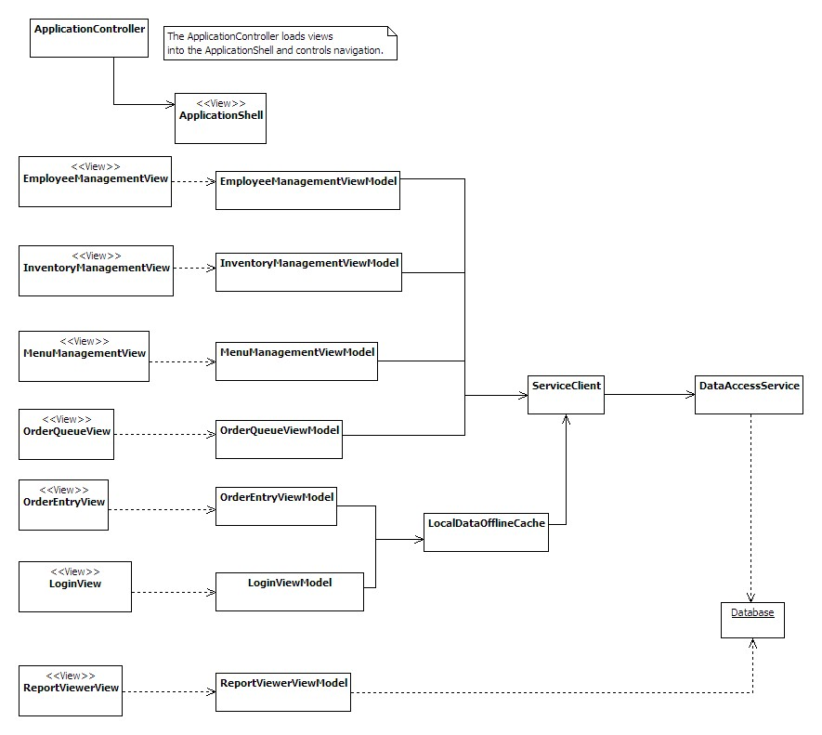
Figure 11. Logical View

Figure 11 depicts the classes that will implement the behavior of the system. The classes follow a Model-View-ViewModel design pattern. The Model classes are not shown on this diagram, but their structure will mirror the entities in the entity relationship diagrams later in this document. They will be mapped from the database using Entity Framework.
Development View
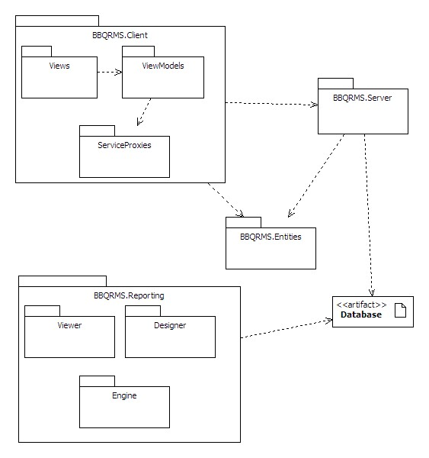
Figure 12. Package diagram

The RMS source code will be organized into packages as illustrated in Figure 12.

The BBQRMS.Client package will include all of the code running the user interfaces.

BBQRMS.Server will include WCF services exposed on the network providing access to the data stored in the central database. It will include Entity Framework classes, (the Object-Relational-Mapping system), to convert objects to database rows and vice versa.

BBQRMS.Entities will hold the data classes for the business entities that will be persisted in the central database. Instances of these entities will be transferred in serialized form from the server to the client and back.

BBQRMS.Reporting will hold the utility classes to support the integration of a pre-existing reporting package including its viewer component, rendering engine and report designer. Pre-defined report definitions will also be in the BBQRMS.Reporting package. The reporting subsystem will connect directly to the database since that is how most reporting packages expect to be used. It will not go through the same data access services and ORM layer as the other user interface components.
Process View
Order Placement and Completion
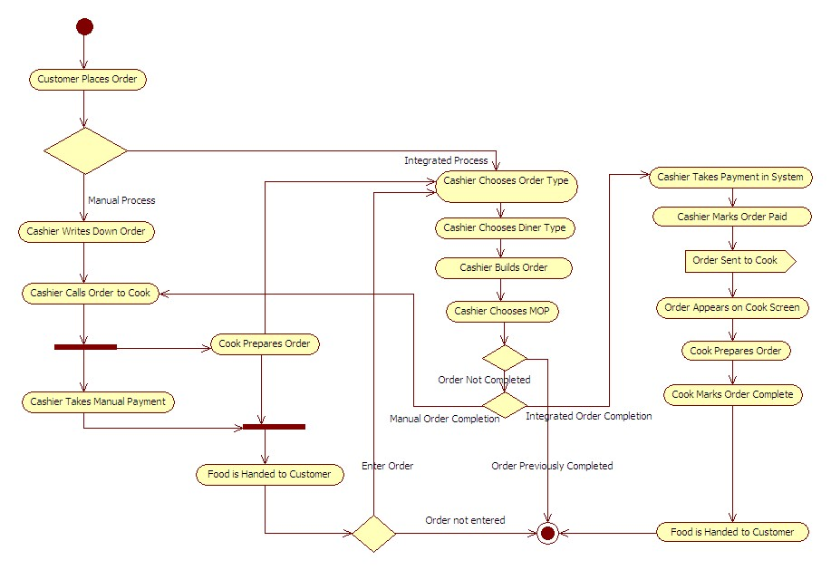
Figure 13. Order Placement and Completion Activity Diagram
Run Report
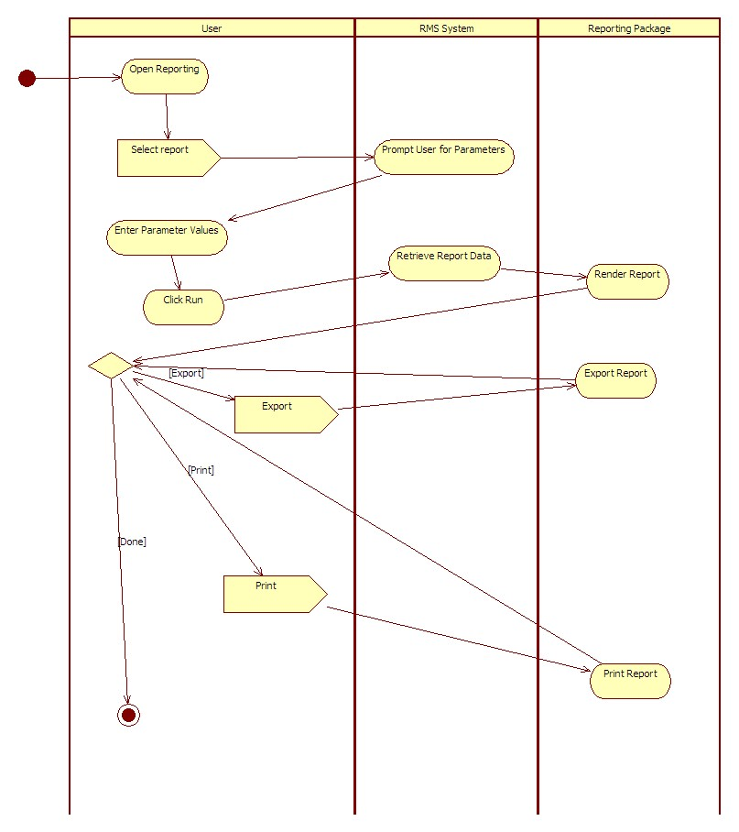
Figure 14. Run Report Activity Diagram
Menu Management
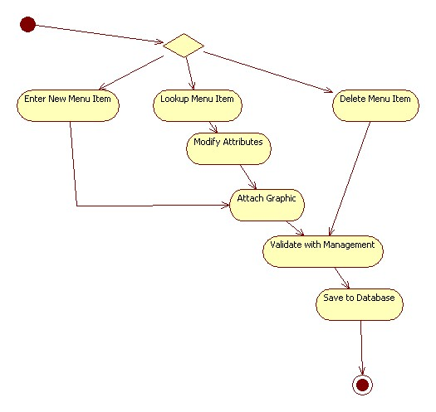
Figure 15. Menu Management Activity Diagram
Inventory Management
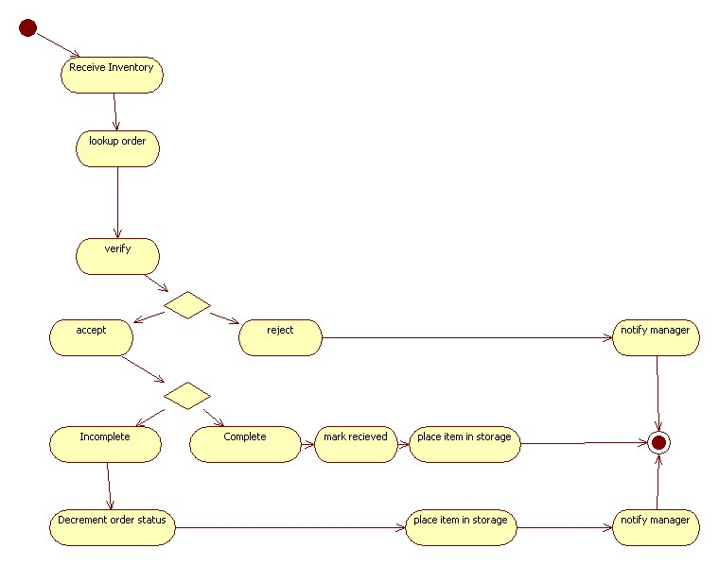
Figure 16. Inventory Management Activity Diagram
Employee Management Activity Diagram
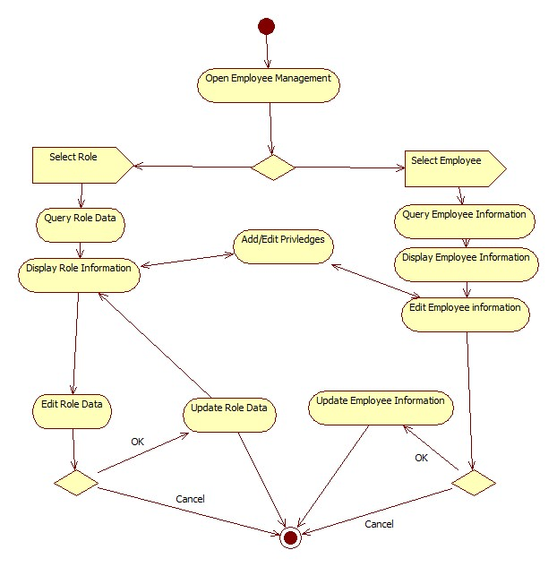
Figure 17. Employee Management Activity Diagram
Physical View
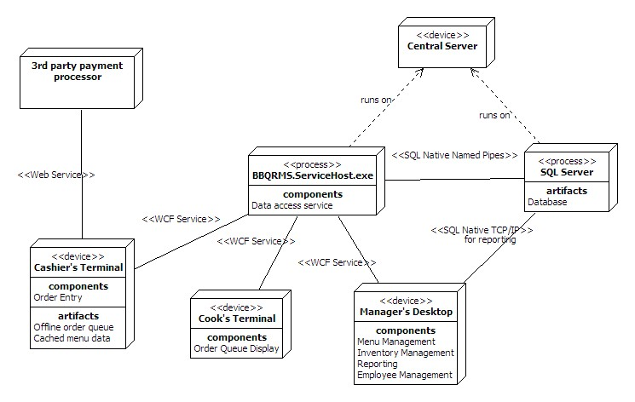
Figure 18. Deployment diagram

A full deployment of the RMS will include:
- one central server machine running the SQL Server database service and the service hosting the BBQRMS data access services
- one or more cashier’s terminals where the BBQRMS client program can be run to use the Order Entry component.
- one or more cook’s terminals where the BBQRMS client program is run to use the order queue display component.
- one or more manager’s terminals where the BBQRMS client program is run to use the management and administrative components.

The cashier’s terminal will also include local data storage to be used when a connection to the central server is unavailable.

Communication between processes, (except the connection to the database), will utilize WCF channels. This decision allows us to configure the details of the bindings later without impacting the system architecture.

A minimal deployment will also be supported where all the components and all three processes can run on a single machine.
Policies and Tactics
Using the Model-View-ViewModel design pattern for user interfaces.
Using WCF Data Services for the data access layer
Using ADO.Net Entity Framework 4 for the Object-Relational-Mapping system.

Using continuous integration
Using Subversion for source code control

Detailed System Design
Database
Orders and menus
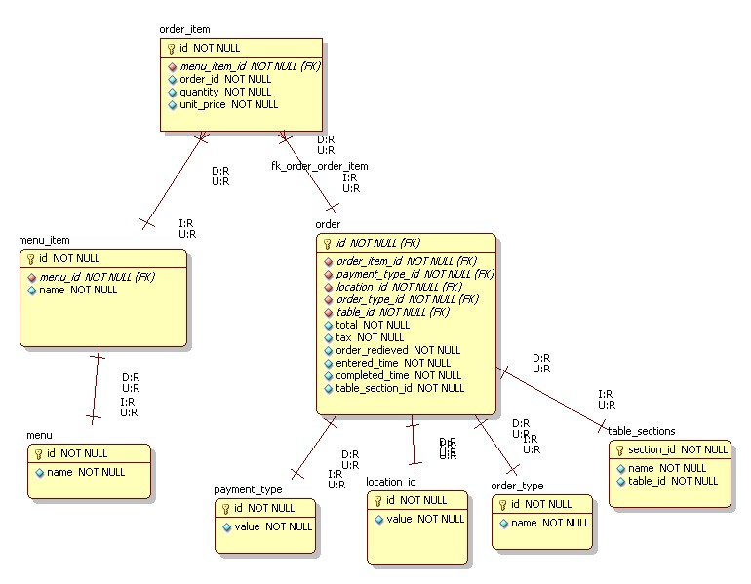
Figure 19. ERD of the order and menus module
Inventory
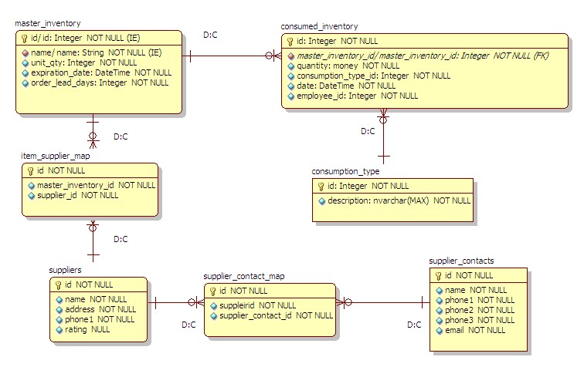
Figure 20. ERD of the inventory module
Employees
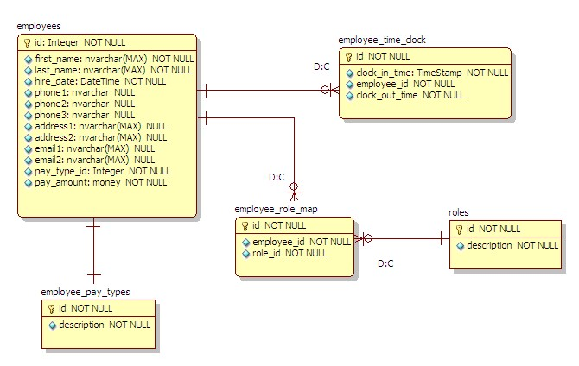
Figure 21. ERD of the employee management module
Glossary

Term or Acronym | Definition
Alpha test | Limited release(s) to selected, outside testers
Beta test | Limited release(s) to cooperating customers wanting early access to developing systems
Final test | aka, Acceptance test, release of full functionality to customer for approval
DFD | Data Flow Diagram
SDD | Software Design Document, aka SDS, Software Design Specification
SRS | Software Requirements Specification
SSRS | System and Software Requirements Specification
RMS | Restaurant Management System
POS | Point of Sale
ERD | Entity Relationship Diagram
WPF | Windows Presentation Foundation
WCF | Windows Communication Foundation
RDBMS | Relational Database Management System
GSC-SVN | Google Source Control - subversion
WBS | Work Break-down Structure (MS project file)
Use case | A diagram and description of a certain function of the system.
GUI | Graphical user interface
MOP | Method of Payment
Bibliography
Foundations of Programming Building Better Software By Karl Seguin www.codebetter.com
Model-View-ViewModel Pattern By Chistian Moser http://www.wpftutorial.net/MVVM.html
UML Design Tool: Star UML http://staruml.sourceforge.net/en/
fyiReporting RDL Project http://www.fyireporting.com
SQL Server http://www.microsoft.com/sqlserver/2008/en/us/
Window Communication Foundation (WCF) http://msdn.microsoft.com/en-us/netframework/aa663324.aspx
Entity Framework http://msdn.microsoft.com/en-us/library/aa697427%28VS.80%29.aspx
Windows Presentation Foundation (WPF) http://msdn.microsoft.com/en-us/library/ms754130.aspx

History of Work