Phần 1: Một số lệnh Docker Compose cơ bản
- docker compose version
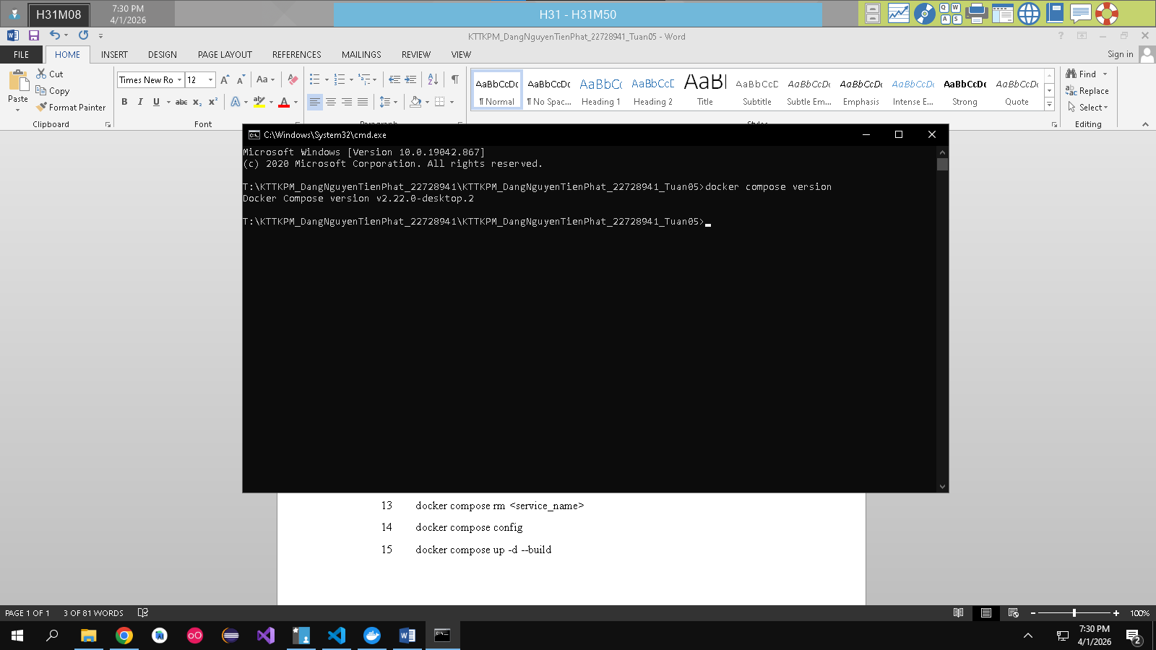
- docker compose up
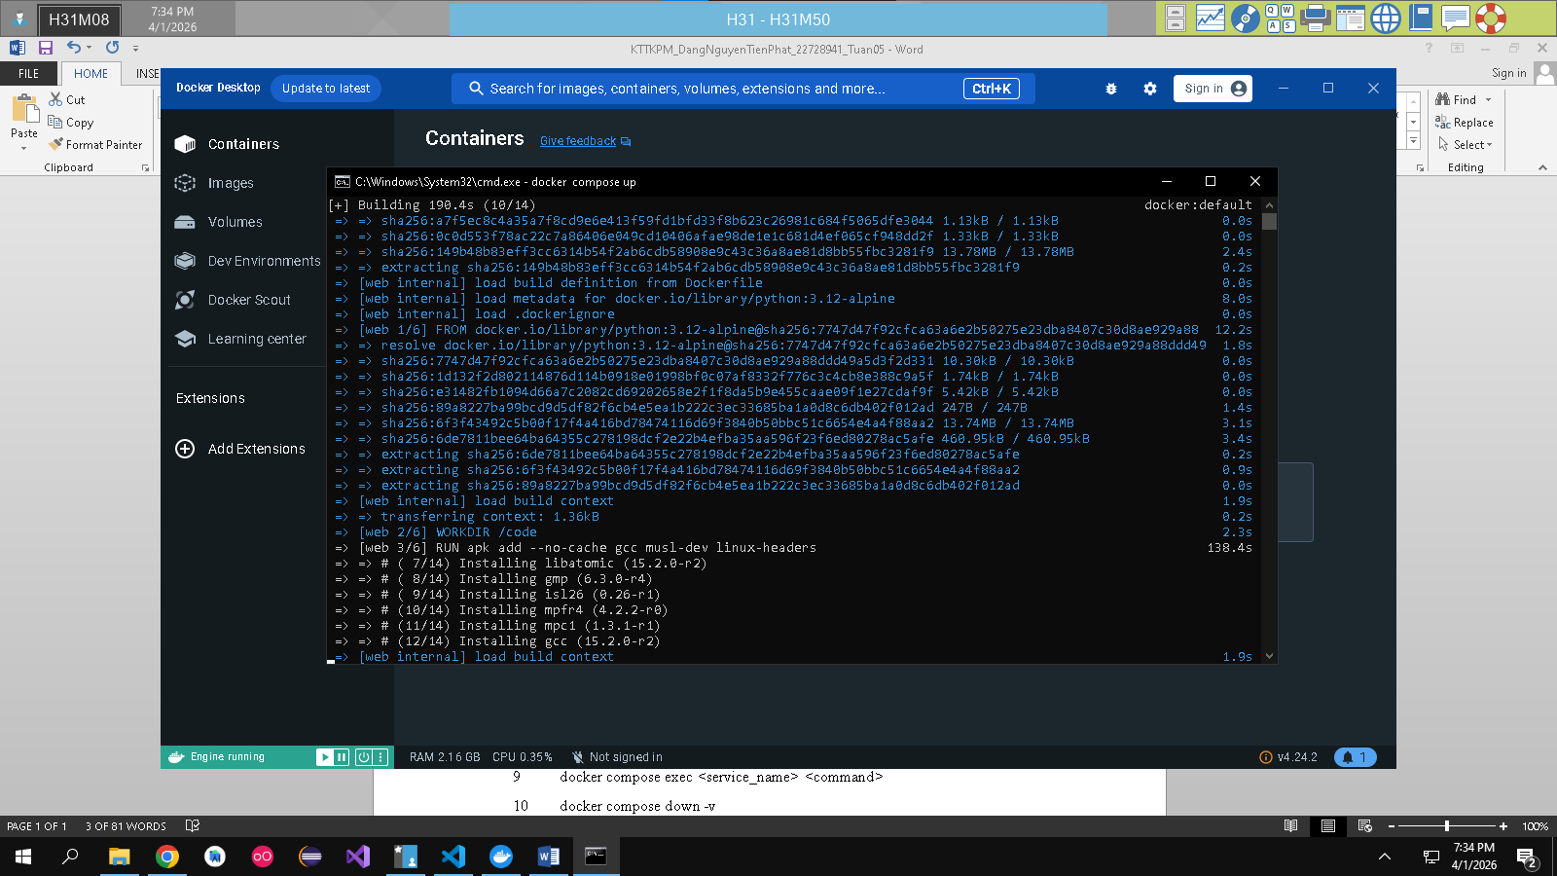
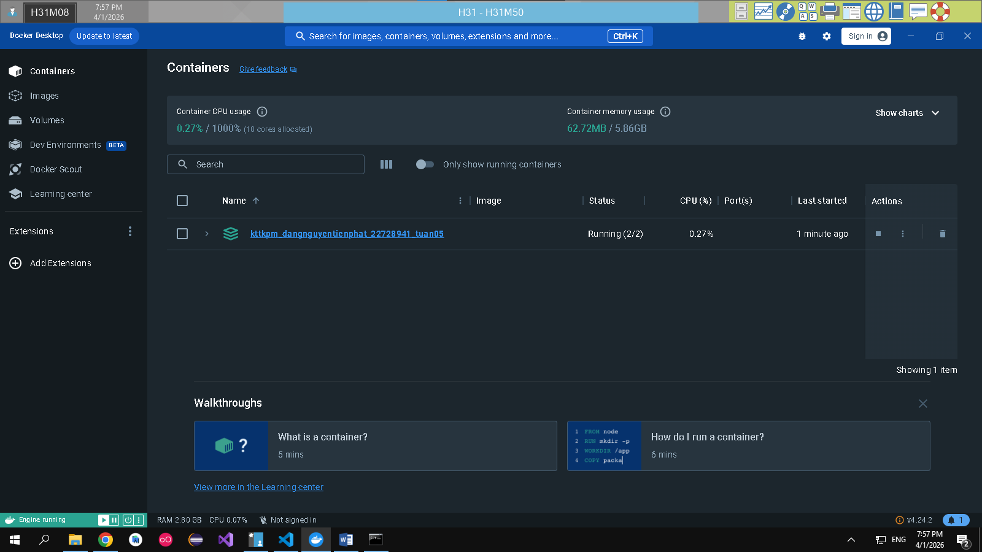
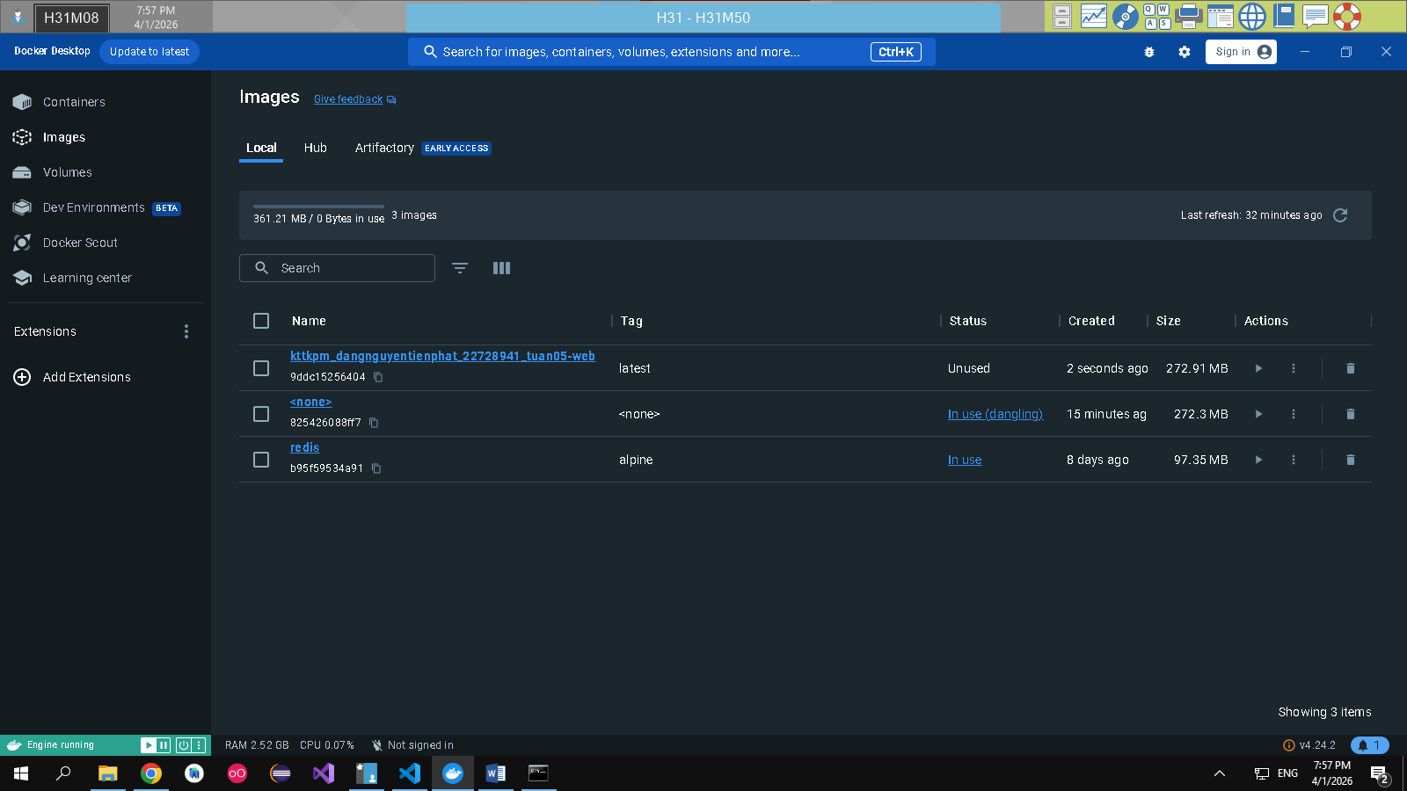
- docker compose up -d
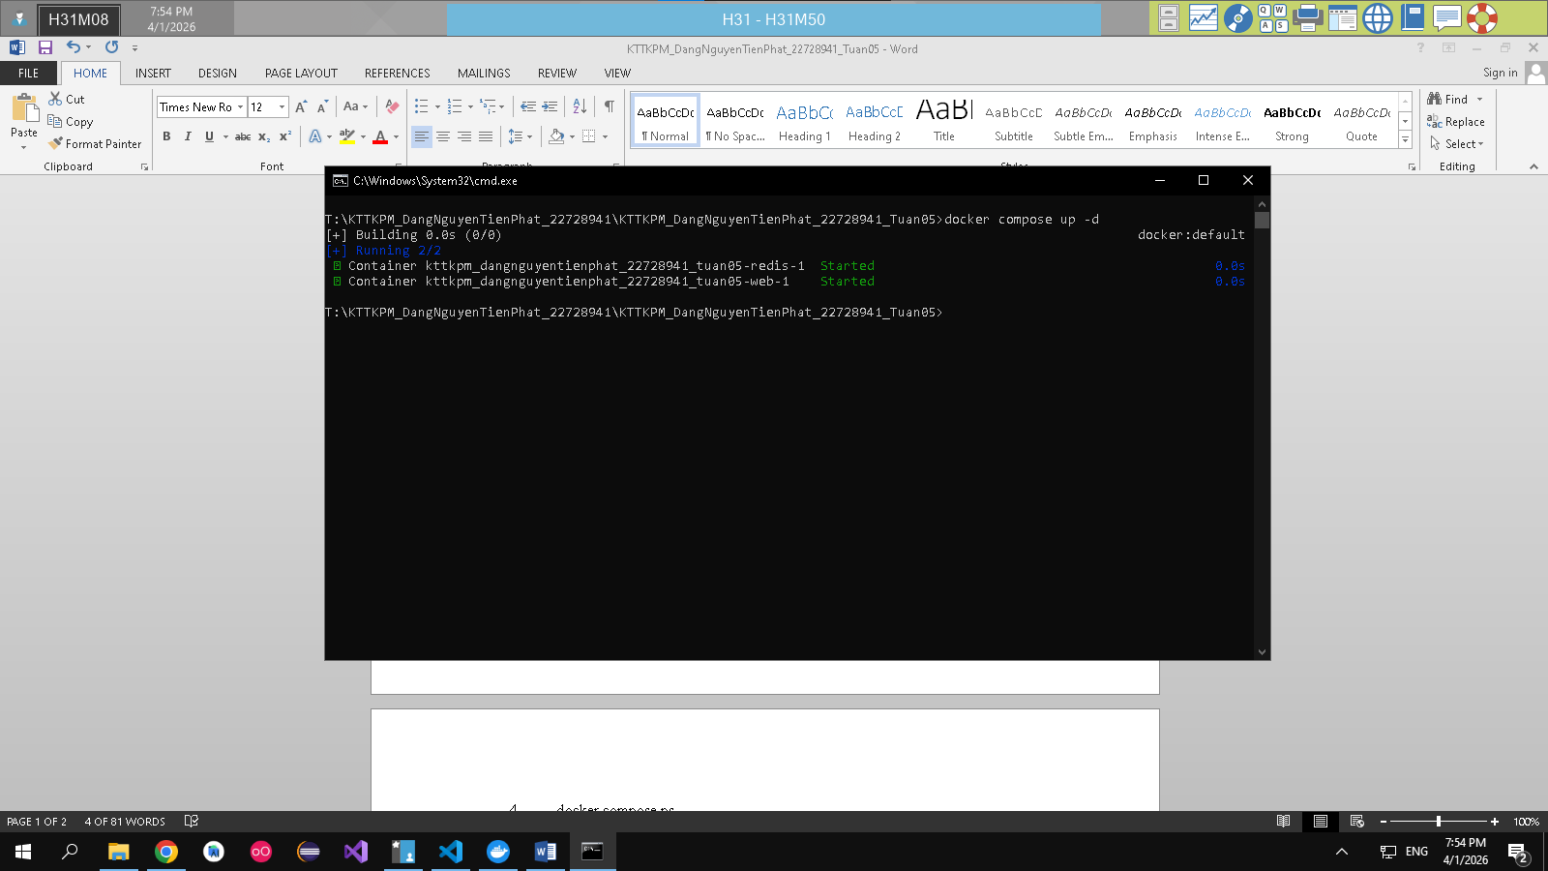
- docker compose ps
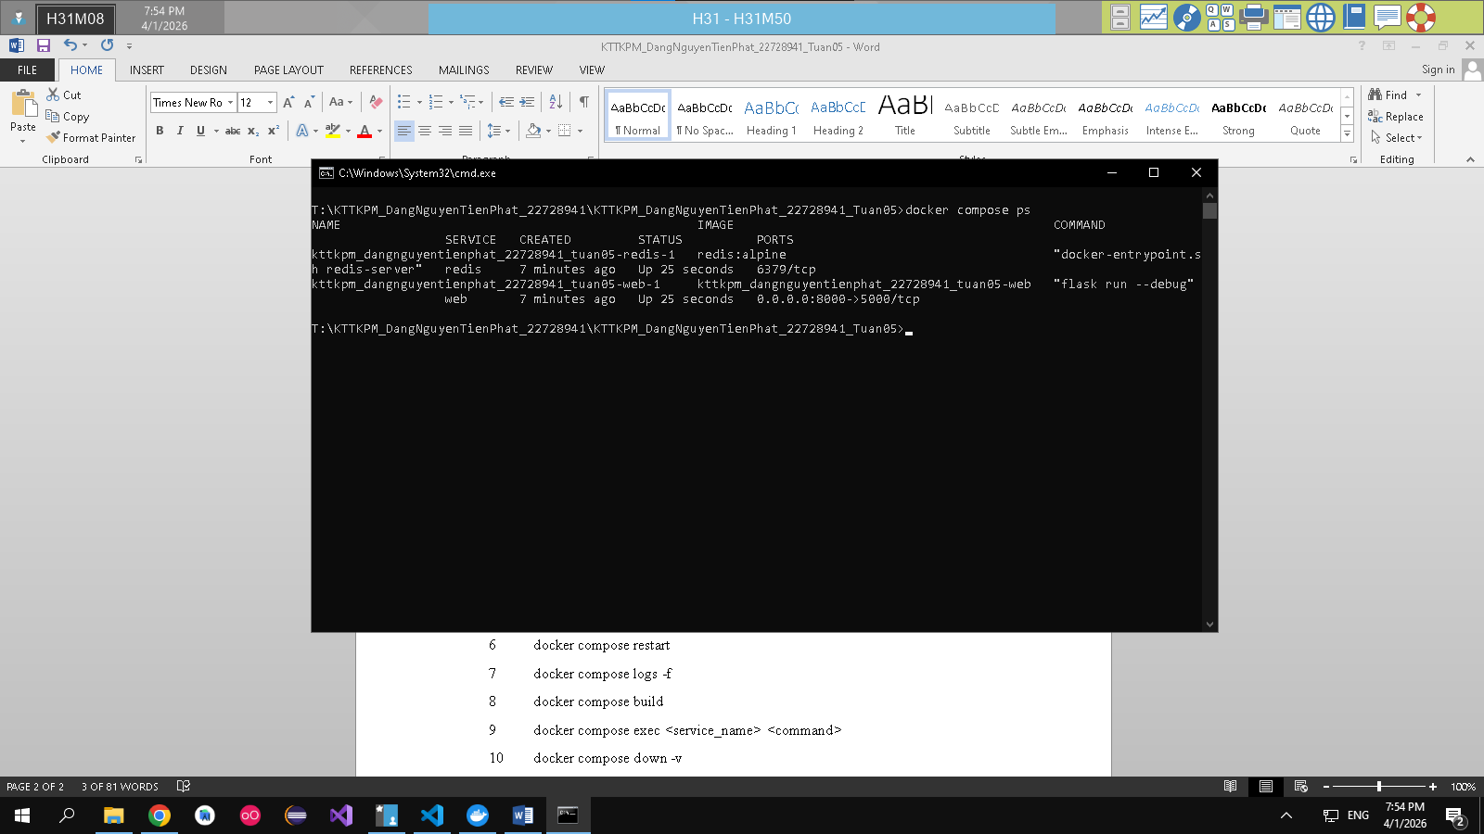
- docker compose down
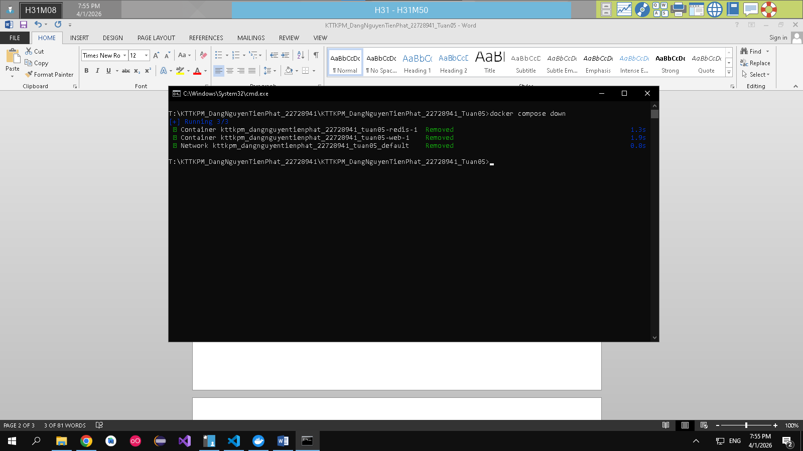
- docker compose restart
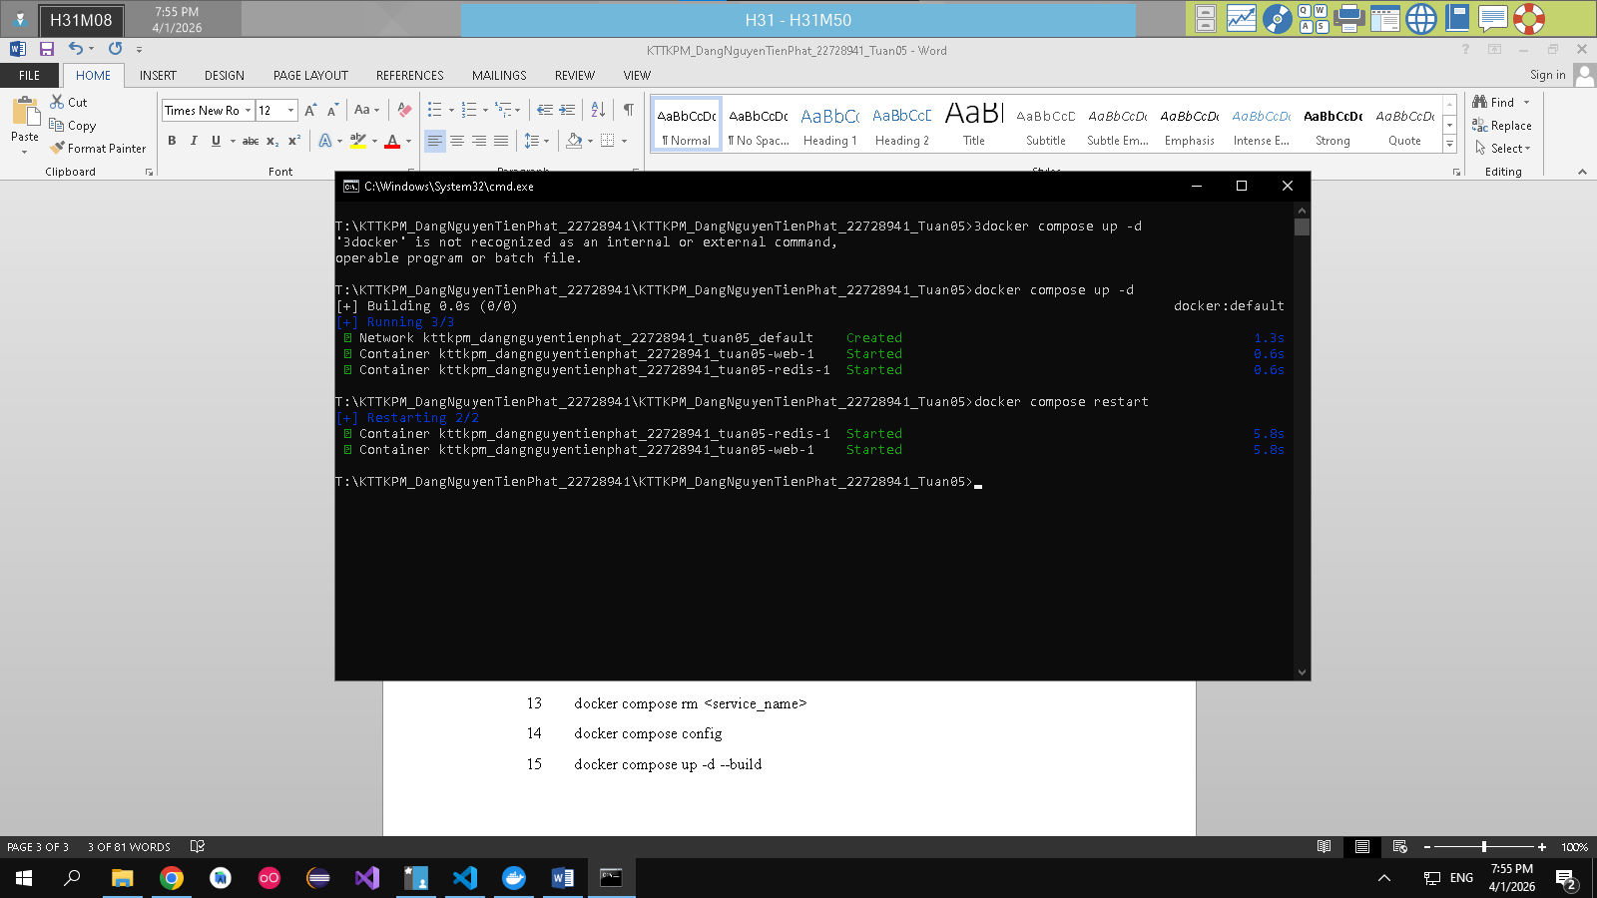
- docker compose logs -f
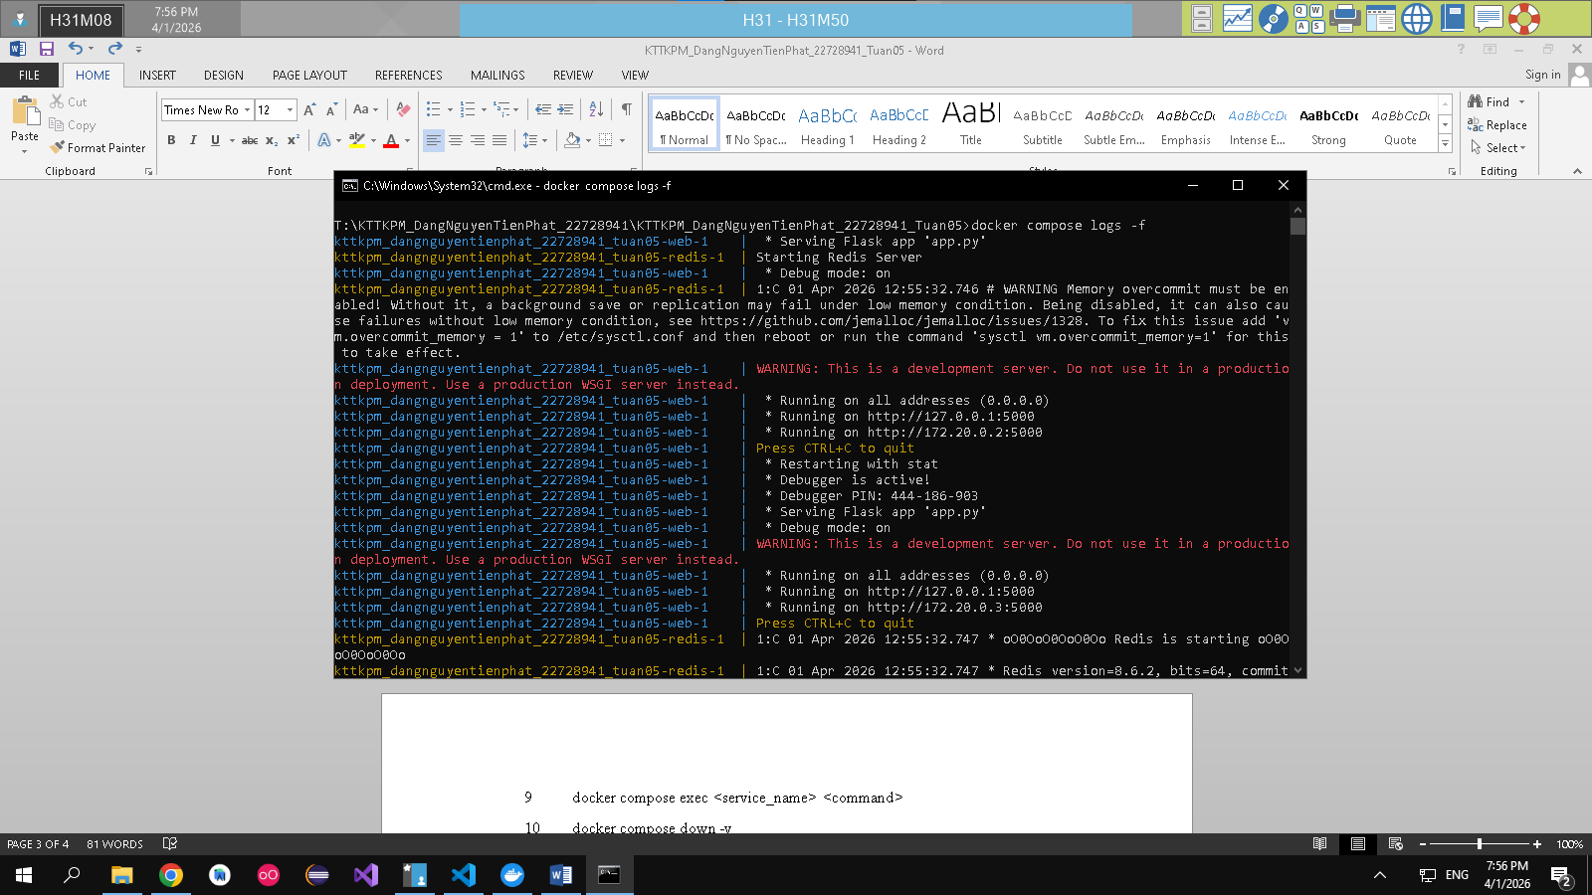
- docker compose build
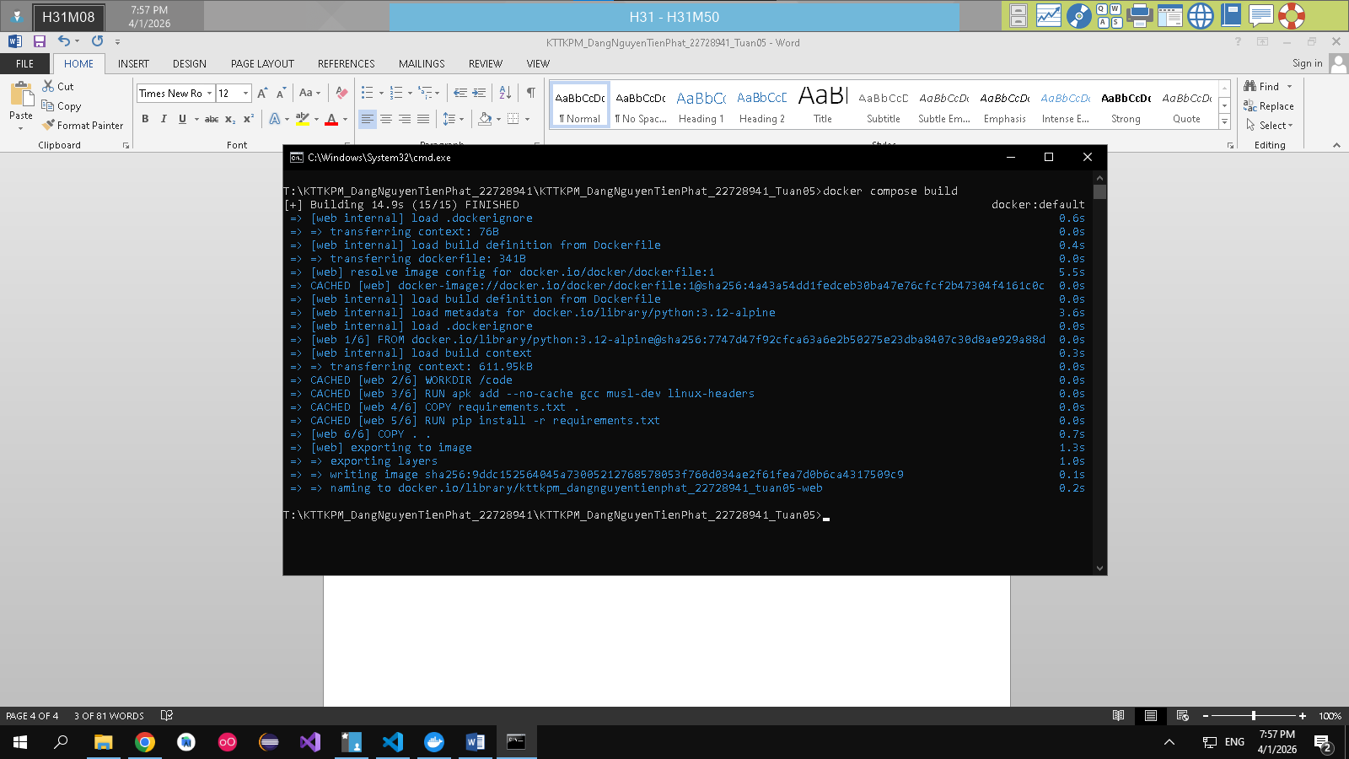
9 docker compose exec <service_name> <command>
10 docker compose down -v
11 docker compose run <service_name> <command>
12 docker compose stop <service_name>
13 docker compose rm <service_name>
14 docker compose config
15 docker compose up -d --build

