# Exploring Weather Trend Between Bangkok and Global

## Outline

### What tools did you use for each step? (Python, SQL, Excel, etc.)

* SQL query for extract data from a database to CSV file.
* Manipulate data and data visualization in Excel.

### How did you calculate the moving average?

* Use AVERAGE formula in Excel to calculate 7 year moving average like the picture below then copy the formula by drag it down to next cell.

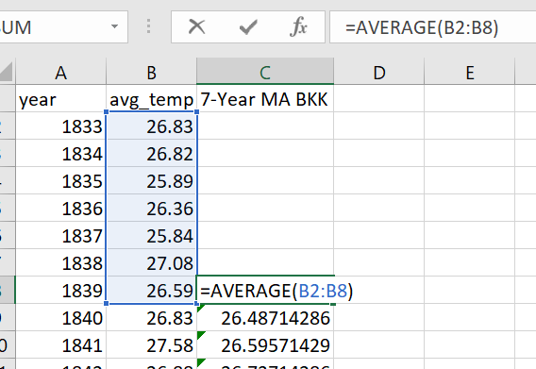

### What were your key considerations when deciding how to visualize the trends?

* To compare 7 year moving average temperature of my local city to 7 year moving average temperature of global.

## Line chart with local and global temperature trends

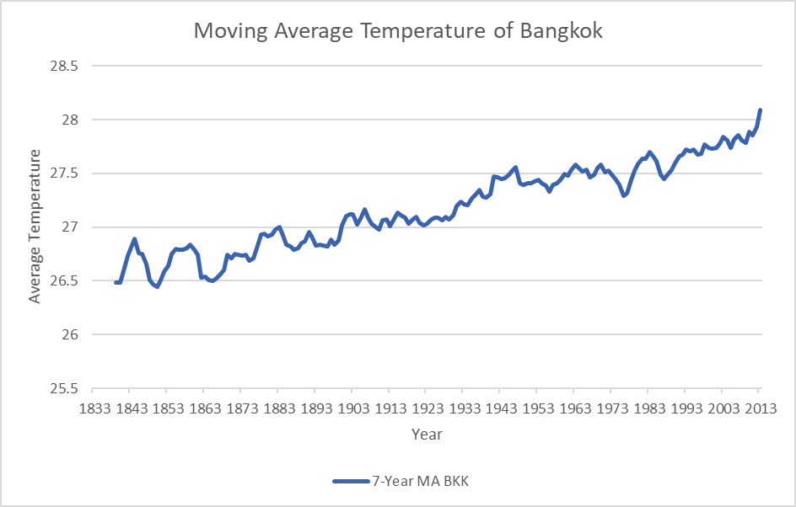

Figure 1: Moving Average Temperature of Bangkok

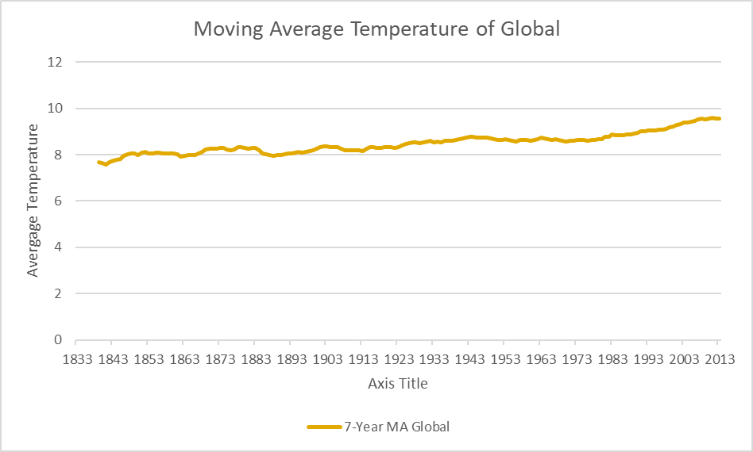

Figure 2: Moving Average Temperature of Global

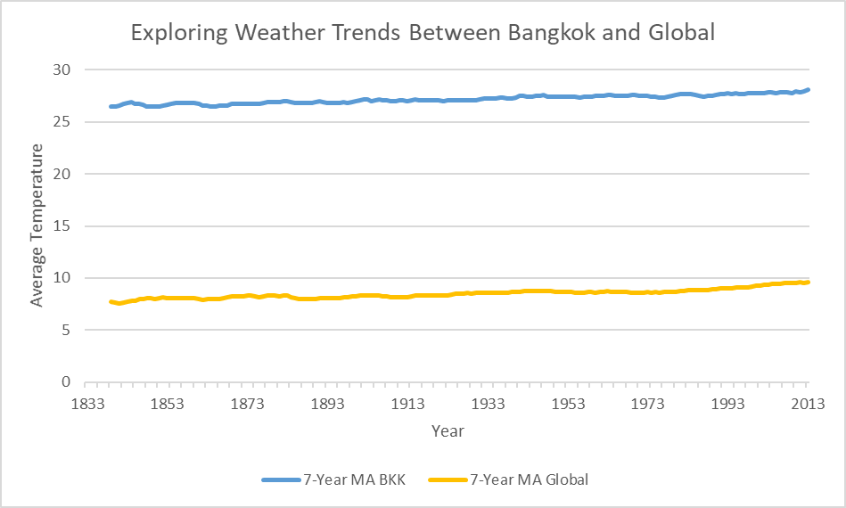

Figure 3: Exploring Weather Trends Between Bangkok and Global

## Make observations

### Is your city hotter or cooler on average compared to the global average? Has the difference been consistent over time?

* Bangkok where is my city is hotter than global average consistently over time.

### “How do the changes in your city’s temperatures over time compare to the changes in the global average?”

* Bangkok average temperature changes from 26.83 in year 1833 to 28.98 in year 2013 or 2.15 increase while global average temperature changes from 8.01 in year 1833 to 9.61 in year 2013 or 1.60 increase.

### What does the overall trend look like? Is the world getting hotter or cooler? Has the trend been consistent over the last few hundred years?

* The world is getting hotter base on data on the past hundred years.

### Is your city temperature more fluctuate than global average?

* Yes, Bangkok average temperature is more fluctuate than global average base on the fluctuation of moving average line in Figure 1 chart.