

**E-lectronix.com**

|  |  |  |
| --- | --- | --- |
| **Supervisor:** | *LÊ TUẤN XUYÊN* | |
| **Semester:** | *02* | |
| **Batch No:** | *T1.2210.E1* | |
| **Group No:** | *03* | |
| **Order:** | **Full name** | **Roll No.** |
| *1.* | *Lê Văn A* | *Student0000001* |
| *2.* | *Trần Văn Sê* | *Student0000002* |
| *3.* | *Nguyễn Thị Bê* | *Student0000003* |

***Month****: 01* ***Year****: 2002*



This is to certify that

|  |  |
| --- | --- |
| **Mr.** | **LÊ VĂN A** |
| **Mr.** | **TRẦN VĂN SÊ** |
| **Ms.** | **NGUYỄN THỊ BÊ** |

Have successfully Designed & Developed

|  |  |  |
| --- | --- | --- |
|  |  |  |
| **DOODLE NEW SEARCH TOOL** | | |

Submitted by:

|  |
| --- |
| **Mr. LE THANH NHAN** |

Date Of Issue:

|  |  |
| --- | --- |
|  |  |

Authorized Signature:

|  |  |
| --- | --- |
|  |  |

|  |
| --- |
| **Content** |

Content

Acknowledge

Synposis

Review1 (điền số trang theo thực tế)

Review2 (điền số trang theo thực tế)

Review3 (điền số trang theo thực tế)

Testting Document (điền số trang theo thực tế)

Final Checklist (điền số trang theo thực tế)

Tasksheet (điền số trang theo thực tế)

|  |
| --- |
| **Acknowledge** |

As we understand that the eProject is a step-by- step learning environment that closely simulates the class-room and Lab based learning environment into actual implementation. It is a projectimplementation at your fingertips!! An electronic, live juncture on the machine that allows you to.

* Practice step by step i.e. laddered approach.
* Build a larger more robust application.
* Usage of certain utilities in applications designed by user.
* Single program to unified code leading to a complete application.
* Learn implementation of concepts in a phased manner.
* Enhance skills and add value.
* Work on real life projects.
* Give a real life scenario and help to create applications more complicated and useful.
* Mentoring through email support.

We would like to send a great thank to our professor and others student for the addorable supports during the time in project.

Beside serveral mistakes we had made in the project, we hope to have more oppotunities to widen our knownledge in web developing world.

We also thank you so much for your infomation and the “demo” project from India APTECH to help us get more reality experience in this project. Since we have gained more experience from this project, we will not stop learning any thing as much as we can to be more successful in the future.

Your Sincerely,

Team Group xx.

|  |
| --- |
| **Synposis** |

The Objective of this program we aim is to give a sample project to work on real life projects. These applications help us build a larger more robust application.

The objective is not to teach us HTML/JavaScript but to provide us with a real life scenario and help us create basic applications using the tools.

Hence, we can revise the chapters before we start with the project.

This project is meant for students like us who have completed the module of HTML5. These programs should be done in the Lab sessions with assistance of the faculty if required.

|  |
| --- |
| The website (in this project) is a tool that brings everything in the world to you such as historic monuments information natural knowledge or skill in technology... |

It is very essential for us that will have a clear understanding of the subject. We think we should go through the project and solve the assignments as per requirements given.

And get back ***eprojects@aptech.ac.in*** as the assigned schedule.

|  |
| --- |
| **Problem Definition** |

1. Đây là nội dung theo đề của India
2. Sinh viên có thể mô tả thêm nội dung giới thiệu đề tài, nêu vấn đề của bài toán.
3. Mô tả các chức năng dành cho từng đối tượng như user/member, webmaster…

|  |  |  |  |  |  |  |  |  |  |  |  |  |  |  |  |
| --- | --- | --- | --- | --- | --- | --- | --- | --- | --- | --- | --- | --- | --- | --- | --- |
| |  | | --- | | **Customer Requirements Specifications** |   Mô tả các điểm trong chu trình xử lý dữ liệu cho từng đối tượng sử dụng.   |  |  | | --- | --- | | **User:** | | |  | **input:** | |  | * Nhập dữ liệu 01 * Nhập dữ liệu 02 * Nhập dữ liệu 03 | |  | **Process:** | |  | * Xử lý dữ liệu 01 * Xử lý dữ liệu 02 * Xử lý dữ liệu 03 | |  | **Output:** | |  | * Xuất thông tin 01 * Xuất thông tin 02 * Xuất thông tin 03 | |

|  |  |
| --- | --- |
| **Webmaster:** | |
|  | **input:** |
|  | * Nhập dữ liệu 01 * Nhập dữ liệu 02 * Nhập dữ liệu 03 |
|  | **Process:** |
|  | * Xử lý dữ liệu 01 * Xử lý dữ liệu 02 * Xử lý dữ liệu 03 |
|  | **Output:** |
|  | * Xuất thông tin 01 * Xuất thông tin 02 * Xuất thông tin 03 |

|  |  |
| --- | --- |
| **Hardware / software requirement:** | |
|  | **Software:** |
|  | * Theo đề Ấn Độ |
|  | **Hardware:** |
|  | * Theo đề Ấn Độ |

|  |
| --- |
| **Architecture and design of the project** |

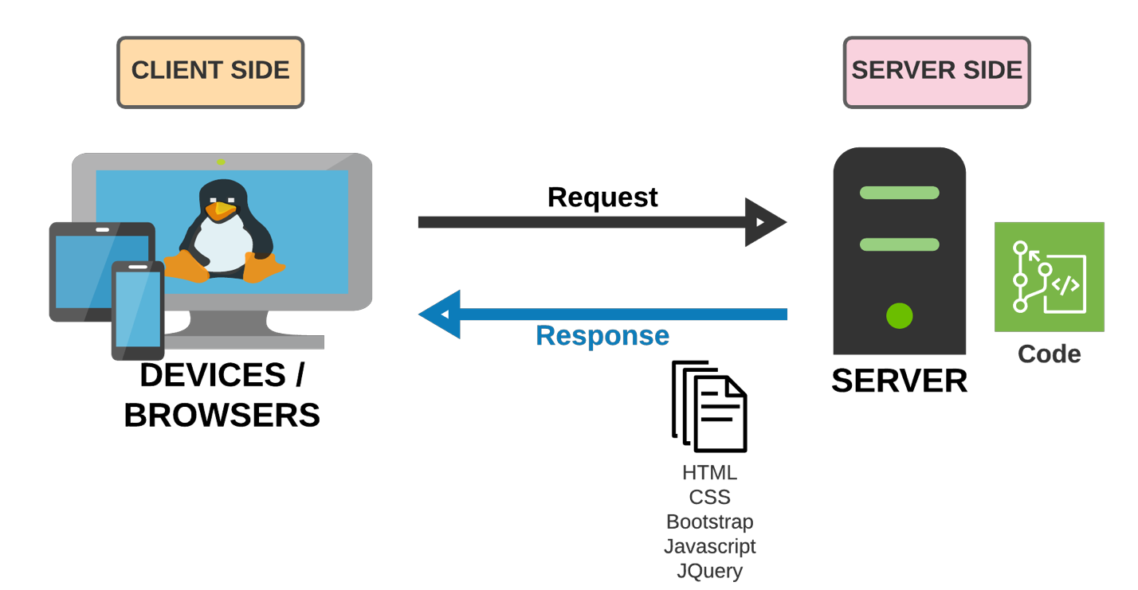

|  |
| --- |
| **SiteMap** |

1. Sơ đồ trang của project.
2. Xem Problem Statement trong đề tài của India
3. Từ Home, vẽ các menu chính thành cấp F1.
4. Bổ sung thêm cấp F2.

|  |
| --- |
| **Screen shots** |

Các layout mô tả màn hình. Sinh viên có thể vẽ layout. Nếu không thể thì code HTML cơ bản rồi chụp lại hình màn hình.

**Ví dụ cách thứ nhất:** (Khuyến cáo sử dụng)

1. **Homepage:**

|  |  |  |  |  |  |
| --- | --- | --- | --- | --- | --- |
| Logo | | | Banner size x size | | Banner size x size |
| Homepage | Categories | | Register | | About us |
| < | | Services Carousel | | > | |
| Enter text for searching:  Click for seaching | | | | | |
|  | | | | | |
| Footer | | | | | |

**Description** : Mô tả màn hình là gì? Dùng làm gì?

**From** : Được mở từ đâu? Menu nào?

**To** : Có thể tới được trang nào khác?

**Ví dụ cách thứ hai:**

1. **Homepage:**

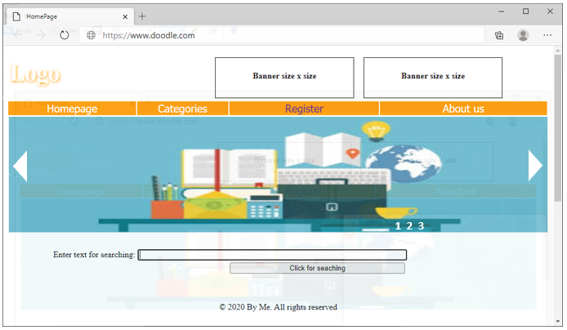

**Description** : Mô tả màn hình là gì? Dùng làm gì?

**From** : Được mở từ đâu? Menu nào?

**To** : Có thể tới được trang nào khác?

|  |
| --- |
| **Testing document** |

|  |  |  |
| --- | --- | --- |
| **Sr.No** | **Features Tested** | **Remarks** |
| 1 |  |  |
| 2 |  |  |
| 3 |  |  |
| 4 |  |  |
| 5 |  |  |
| 6 |  |  |
| 7 |  |  |
| 8 |  |  |
| 9 |  |  |
| 10 |  |  |
| 11 |  |  |
| 12 |  |  |
| 13 |  |  |
| 14 |  |  |
| 15 |  |  |

|  |
| --- |
| **Final checklist** |

|  |  |  |
| --- | --- | --- |
| **Sr.No** | **Aspected Tested** | **Suggestion/**  **Remarks** |
| 1 | Are all the users able to view the images and links? |  |
| 2 | Have all the views, modules and controllers been properly integrated and is the site function as a single page application? |  |
| 3 | Are the GUI content devoid of spelling mistakes? |  |
| 4 | Is the application user-friendly? |  |
| 5 | Is the Website launching correctly in all popular browsers? |  |
| 6 | Are all the forms validated with proper criteria? |  |
| 7 | Do all text links lead to the appropriate website? |  |
| 8 | Do all image links lead to the appropriate website? |  |
| 9 | Are all the images and links clearly visible on the page? |  |
| 10 | Does the Web page work properly in all the tested browsers? |  |
| 11 | Does the Web page take too long to be loaded fully? |  |
| 12 | Is the navigation sequences correct through all the Web pages on the site? |  |
| 13 | Is the JavaScript code working as expected in all click events? |  |
|  |  |  |
|  | (Sinh viên ghi thêm…) |  |

|  |  |  |  |  |  |  |  |
| --- | --- | --- | --- | --- | --- | --- | --- |
| **No** | **Member** | **Contents** | **Page Name** | **Activity Plan** | **Date of Preparation of Activity Plan** | | |
| **Planed Start Date** | **Actual Start Date** | **Actual Days** | **Status** |
| 1 | Lê Văn A | Hompage | Hompage.html | 01-01-2002 | 01-01-2002 | 5 | OK |
| 2 | Categories | Categories.html | 01-01-2002 | 01-01-2002 | 5 | OK |
|  | | | | | | | |
| 1 | Trần Văn Sê | Register | Register.html | 01-01-2002 | 01-01-2002 | 5 | OK |
| 2 | Abou tus | Abou tus.html | 01-01-2002 | 01-01-2002 | 5 | OK |
|  | | | | | | | |
| 1 | Nguyễn Thị Bê | Search | Search.html | 01-01-2002 | 01-01-2002 | 5 | OK |
| 2 | Geolocation | Geolocation.html | 01-01-2002 | 01-01-2002 | 5 | OK |