

**E-lectronix.com**

|  |  |  |
| --- | --- | --- |
| **Supervisor:** | *LÊ TUẤN XUYÊN* | |
| **Semester:** | *02* | |
| **Batch No:** | *T1.2210.E1* | |
| **Group No:** | *03* | |
| **Order:** | **Full name** | **Roll No.** |
| *1.* | *Trần Anh Tiến* |  |
| *2.* | *Vũ Hữu Tài* |  |
| *3.* | *Trần Vĩnh Phát* |  |
| *4.* | *Lê Viết Nguyễn Sơn* |  |
| *5.* | *Trần Ngọc Anh* |  |

***Month****: 08* ***Year****: 2023*



This is to certify that

|  |  |
| --- | --- |
| **Mr.** | **TRẦN VĨNH PHÁT** |
| **Mr.** | **VŨ HỮU TÀI** |
| **Mr.** | **TRẦN ANH TIẾN** |
| **Mr.** | **TRẦN NGỌC ANH** |
| **Mr.** | **LÊ VIẾT NGUYÊN SƠN** |

Have successfully Designed & Developed

|  |  |  |
| --- | --- | --- |
|  |  |  |
| **E-LECTRONIX.COM** | | |

Submitted by:

|  |
| --- |
| **Mr. LE TUAN XUYEN** |

Date Of Issue:

|  |  |
| --- | --- |
|  |  |

Authorized Signature:

|  |  |
| --- | --- |
|  |  |

|  |
| --- |
| Content |

Content

Acknowledge

Synopsis

Review1 (điền số trang theo thực tế)

Review2 (điền số trang theo thực tế)

Review3 (điền số trang theo thực tế)

Testing Document (điền số trang theo thực tế)

Final Checklist (điền số trang theo thực tế)

Task sheet (điền số trang theo thực tế)

|  |
| --- |
| Acknowledge |

The eProject has been an incredible step-by-step learning experience, seamlessly bringing the classroom and lab environment into practical implementation. It has truly been a project at our fingertips, enabling us to grasp concepts in a laddered approach and transform them into a comprehensive application.

The platform has allowed us to:

* Immerse ourselves in hands-on practice, embracing a gradual learning curve.
* Construct more intricate and robust applications.
* Utilize specialized utilities within our designed applications.
* Consolidate diverse code fragments into a unified program, culminating in a complete and functional application.
* Implement and comprehend complex concepts in a phased and structured manner.
* Elevate our skills, enrich our knowledge, and create tangible value.
* Engage with real-life projects, bridging the gap between theory and practice.
* Confront genuine scenarios, leading to the development of practical and valuable applications.
* Benefit from invaluable mentoring via email support.

We would also like to extend our heartfelt appreciation to our fellow students for their invaluable camaraderie and support during the project's duration. While we acknowledge the inevitable mistakes we encountered along the way, we are resolute in our desire to seize every opportunity to expand our proficiency in the realm of web development.

Furthermore, we extend our sincere gratitude to India APTECH for generously sharing their "demo" project, which provided us with a tangible taste of real-world application development. This experience has been instrumental in honing our skills, and we are committed to pursuing continuous learning to ensure our success in future endeavours.

In closing, we are deeply grateful for your guidance, the collaborative spirit of our peers, and the enlightening experience with India APTECH's project. We are inspired to continue our journey of knowledge acquisition and skill refinement, aiming for a future marked by achievement and innovation.

Yours sincerely,

Team Group 03

# REVIEW 1

# TASK SHEET REVIEW 1

|  |  |  |  |  |  |  |  |
| --- | --- | --- | --- | --- | --- | --- | --- |
| **Project Ref. No** | | **Project Title:** | **Activity Plan Prepared By:** | **Date of Preparation of Activity Plan:** | | | |
| **Sr.No** | **Task** | **Actual Start Date** | **Actual Days** | **Team Mate Names** | **Status** |
| 1 | Introduction and Problem Definition | E-lectronix.com | Trần Vĩnh Phát | 25/07/2023 | 1 | - Vũ Hữu Tài  - Trần Ngọc Anh  - Trần Anh Tiến  - Lê Viết Nguyễn Sơn | 100% |
| 2 | Customer Requirement Specification (CRS) | 25/07/2023 | 1 | 100% |
| 3 | Functional Requirement | 25/07/2023 | 1 | 100% |
| 4 | System Requirement Specification |
| 25/07/2023 | 1 | 100% |
| 5. | Scope Of Work | 12/06/2023 | 1 | 100% |

|  |
| --- |
| Synopsis |

The primary goal of this program is to furnish a practical avenue for engaging in real-life projects utilizing the Laravel framework. By embarking on these projects, we can effectively construct more intricate and robust applications.

It's important to note that the intent is not solely to instruct us in the nuances of HTML/JavaScript, but rather to immerse us in genuine scenarios that facilitate the creation of fundamental applications utilizing Laravel's tools and features.

In line with this objective, we have the opportunity to revisit and reinforce our understanding of relevant chapters prior to commencing each project. This initiative is tailored for students like us who have successfully completed the HTML5 module, ensuring a foundational knowledge base.

To optimize our learning experience, these projects will be conducted during dedicated Lab sessions, where the guidance and assistance of our faculty will be readily available if needed.

|  |
| --- |
| The online platform (within this venture) is an innovative hub that brings the entirety of the electronics realm right to your fingertips. From cutting-edge gadgets and tech-savvy devices to a plethora of accessories and high-performance equipment, we offer a comprehensive array of electronic products tailored to your needs.  Explore a treasure trove of the latest electronics, where every click unlocks a world of possibilities. Whether you're a tech enthusiast seeking the most advanced smartphones, laptops, and wearables, we've curated a curated selection that caters to your distinct desires. |

It is very essential for us that will have a clear understanding of the subject. We think we should go through the project and solve the assignments as per requirements given.

And get back ***eprojects@aptech.ac.in*** as the assigned schedule.

|  |
| --- |
| Problem Definition |

By the passionate of electrical devices such as smart phone, laptop, gaming PC, and order technology devices. We decided to create Ecommerce, during this development we found it struggling in some points.

1. Let the customer change their previous password.
2. Using ajax for comment system.
3. Often deal with bugs during coding.
4. How can manage files effectively.

**For Ecommerce’s customer.**

- User-friendly web interface.

- View product information.

- Offer numerous of newest phones or laptops at affordable prices.

- Find the product easily by searching for its keywords.

- Pay online with Momo.

- Pay online with PayPal.

- Will receive an email by paying for any product on this website.

- Customers can comment below the product information if it has poor quality condition or somethings.

- Comment system provides customer report button if any comments contain bad words or bad attitude **,** the website allows customers to register, log in changes avatar images.

**For Ecommerce system’s Admin:**

* Manage to do the CRUD for images, colors, quantities etc. of the products.
* Admin can read the reported comments to decide if it is worth deleting.
* Admin can also post new events on discount products.

|  |  |
| --- | --- |
| |  | | --- | | Customer Requirements Specifications | |

Business/Project Objective: Ecommerce is designed to order electrical devices.

**A. Functional Requirement:**

Input to the system:

Administrators need to provide:

REQ.1: Provide price, colour, type for one product.

Customers need to provide:

REQ.1: Personal information to create an account.

Output of the system:

Administrators can:

REQ.1: Have an admin account to login in admin dashboard.

REQ.2: Mange orders (CRUD).

REQ.3: Mange user’s comments.

REQ.4: Manage order’s process.

**B. Non-functional Requirement:**

REQ.1: checkout email will be sent to the user’s email if user has made an order.

**SCOPE OF WORK**

The application must perform the following functions:

**Login:**

* There are 2 types of accounts in the applications (“Admin” and “user”). The administrator will login as “Admin” on the website will be redirect to Admin’s Panel and the Customer will login as the “User”.

-> Two accounts must be logged in to use the app’s functionality:

Administrator: can manage the order process and CURD for products, brands, categories and manage Users.

User: register a new account.

**Transport:**

- When customers order online, the customer can track their order on the website and get it by delivery services.

## SYSTEM REQUIREMENT SPECIFICATION

**Hardware:**

* + - 1. **Web server:**

|  |  |
| --- | --- |
| Processor | Intel Core i5 or higher. |
| Memory | 128 Megabytes of RAM or better. |
| Modem/ADSL | Connecting to internet 24/24 |

* + - 1. **Client:**

|  |  |
| --- | --- |
| Processor | Intel Core i3 or higher. |
| Memory | 128 Megabytes of RAM or better. |
| Modem/ADSL | Connecting to internet |

**Software:**

1**. Web server:**

|  |  |
| --- | --- |
| Operation System | Windows 7 or higher |
| Browser | Chrome version 35 or better |
| Database | MySQL |
| Software | Visual Studio Code |

**2. Client:**

|  |  |
| --- | --- |
| Operation System | Windows 7 or higher |
| Browser | Chrome version 35 or better |
| Database | MySQL |
| Software | Visual Studio Code, XAMPP |

**Technology:**

|  |  |
| --- | --- |
| Frontend | HTML5, CSS, Jquery 3.7.0 |
| JavaScript |
| Bootstrap 5 |
| Backend | PHP, Laravel |

|  |
| --- |
| **Architecture and design of the project** |

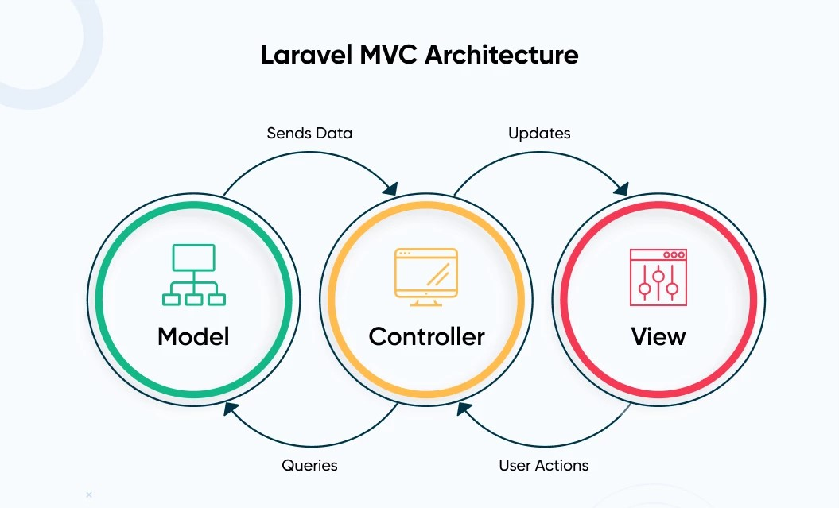

|  |
| --- |
| **SiteMap** |

|  |
| --- |
| **Screen shots** |

|  |
| --- |
| **Testing document** |

|  |  |  |
| --- | --- | --- |
| **Sr.No** | **Features Tested** | **Remarks** |
| 1 |  |  |
| 2 |  |  |
| 3 |  |  |
| 4 |  |  |
| 5 |  |  |
| 6 |  |  |
| 7 |  |  |
| 8 |  |  |
| 9 |  |  |
| 10 |  |  |
| 11 |  |  |
| 12 |  |  |
| 13 |  |  |
| 14 |  |  |
| 15 |  |  |

|  |
| --- |
| **Final checklist** |

|  |  |  |
| --- | --- | --- |
| **Sr.No** | **Aspected Tested** | **Suggestion/**  **Remarks** |
| 1 | Are all the users able to view the images and links? |  |
| 2 | Have all the views, modules and controllers been properly integrated and is the site function as a single page application? |  |
| 3 | Are the GUI content devoid of spelling mistakes? |  |
| 4 | Is the application user-friendly? |  |
| 5 | Is the Website launching correctly in all popular browsers? |  |
| 6 | Are all the forms validated with proper criteria? |  |
| 7 | Do all text links lead to the appropriate website? |  |
| 8 | Do all image links lead to the appropriate website? |  |
| 9 | Are all the images and links clearly visible on the page? |  |
| 10 | Does the Web page work properly in all the tested browsers? |  |
| 11 | Does the Web page take too long to be loaded fully? |  |
| 12 | Is the navigation sequences correct through all the Web pages on the site? |  |
| 13 | Is the JavaScript code working as expected in all click events? |  |
|  |  |  |
|  | (Sinh viên ghi thêm…) |  |

# REVIEW 2

# TASK SHEET REVIEW 2

|  |  |  |  |  |  |  |  |
| --- | --- | --- | --- | --- | --- | --- | --- |
| **Project Ref. No** | | **Project Title:** | **Activity Plan Prepared By:** | **Date of Preparation of Activity Plan:** | | | |
| **Sr.No** | **Task** | **Actual Start Date** | **Actual Days** | **Team Mate Names** | **Status** |
| 1 | DFD (Data Flow Diagram) | E-lectronix.com | Trần Vĩnh Phát | 25/07/2023 | 1 | - Vũ Hữu Tài  - Trần Ngọc Anh  - Trần Anh Tiến  - Lê Viết Nguyễn Sơn | 100% |
| 2 | Use Case Diagram and Sequence Diagram | 25/07/2023 | 1 | 100% |
| 3 | ERD (Entity Relationship Diagram) | 25/07/2023 | 1 | 100% |
| 4 | Table Design |
| 25/07/2023 | 1 | 100% |

## Architecture Project

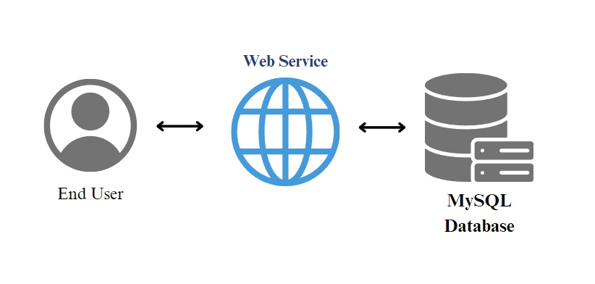

## DATA FLOW DIAGRAM

**Context level:**

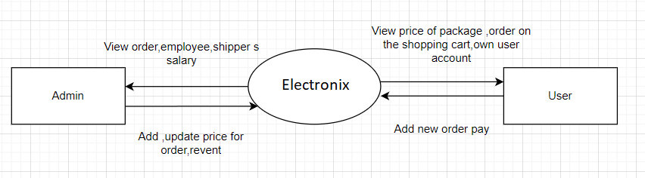

2. Admin:

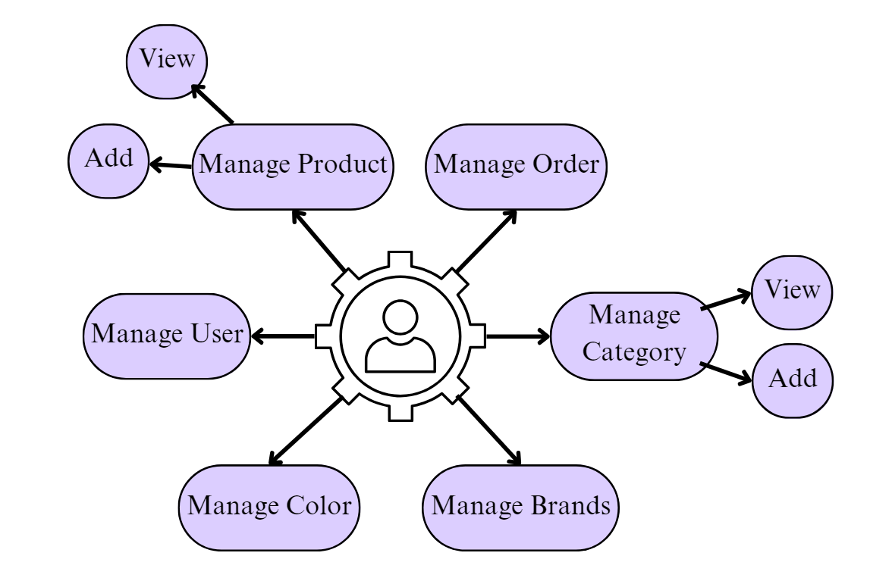

## USE CASE DIAGRAM AND SEQUENCE DIAGRAM

**1.Visitor(Customer):**

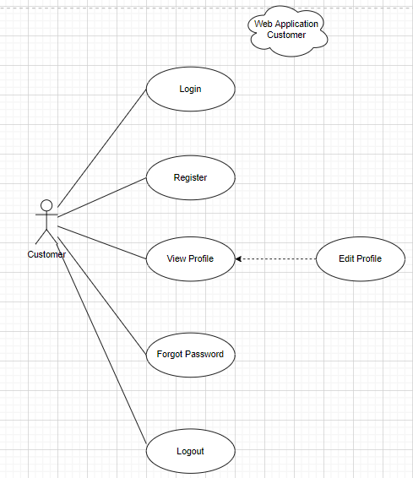

* Sign Up:

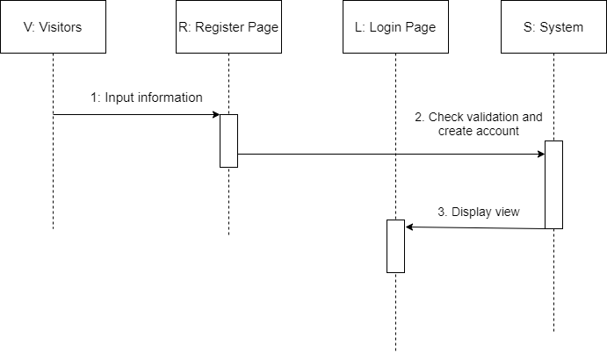

|  |  |  |
| --- | --- | --- |
| **Description** | When visitors input information and click on register button,  E-lectronix.com system will create new account | |
|  | **Action** | **System responses** |
| **Basic flow** | 1) Input information | When visitor enters the Register page, the registration form will appear to register. After the form is displayed, the visitors enter their information. |
| 2) Check validation and create account | After the visitor enters the information, the system will validate the info, if all the information is correct and the Name not contain any sensitive words, the system will create an account for the user. |
| 3) Display view | If the account is created successfully, the system will display a Login page for user to sign in. |
| **Exception** | Username field blank  Username min length  Password field blank  Password min length | Display error message  “The name contains sensitive words”  “Username cannot blank”  “Username must be larger than 3 characters”  “Password cannot blank”  “Password must be larger than 3 characters” |

* Sign Up Gmail, Twitter (x):

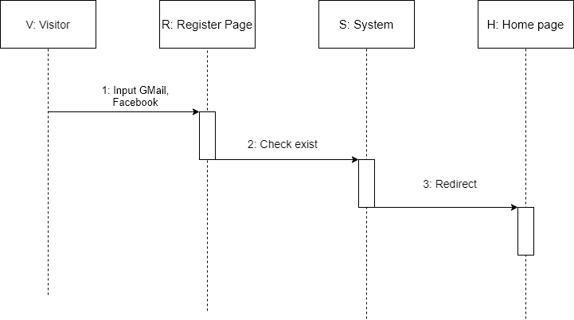

|  |  |  |
| --- | --- | --- |
| **Description** | When visitors use Twitter, Gmail. E-lectronix.com system will create new account | |
|  | **Action** | **System responses** |
| **Basic flow** | 1)Input Gmail, Facebook | When visitor enters the Register page, the Twitter, Gmail buttons will appear to register. |
| 2) Check exists | Electronix.com system will check, if the account exists, it will log in to the system, if the account doesn’t exist, it will create a new User in Users Table. |
| 3) Redirect | After create successfully, it will return to Home page. |
| **Exception** |  |  |

**Login:**

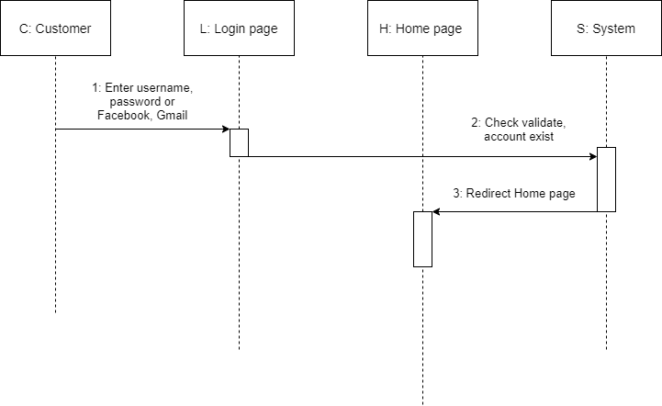

**Create an order:**

|  |  |  |  |
| --- | --- | --- | --- |
| **Description** | When the user starts ordering, if user not logged in, the system will prompt user to login to continue. If user has already logged in, then user can start to add product the **Cart**. | | |
|  | **Action** | **System responses** |
| **Basic flow** | 1) Input item (available category), Input quantity | When you want to place an order, customers only need to enter the quantity they want to, as well as select the colour of items to order. |
| 2) View information | User can go to **Profile->My Order** to view the details of the orders. |
| 3) Create order and order detail | When user purchased, the system will send an email which contains an invoice to the email of the users. |
| **Exception** |  |  |

**Payment:**

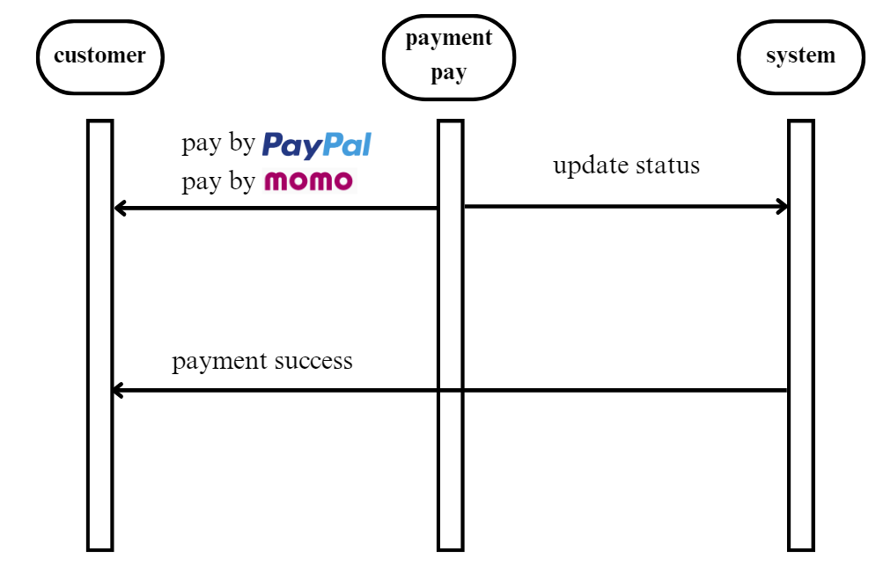

|  |  |  |
| --- | --- | --- |
| **Description** | Once the order is created, the user will receive an email for payment | |
|  | **Action** | **System responses** |
| **Basic flow** | Pay by paypal  Pay by momo | Customer pays and confirm payment. |
| Payment success | Customer will receive a successful payment notification after completing the process. |
| **Exception** |  |  |

**2.Admin:**

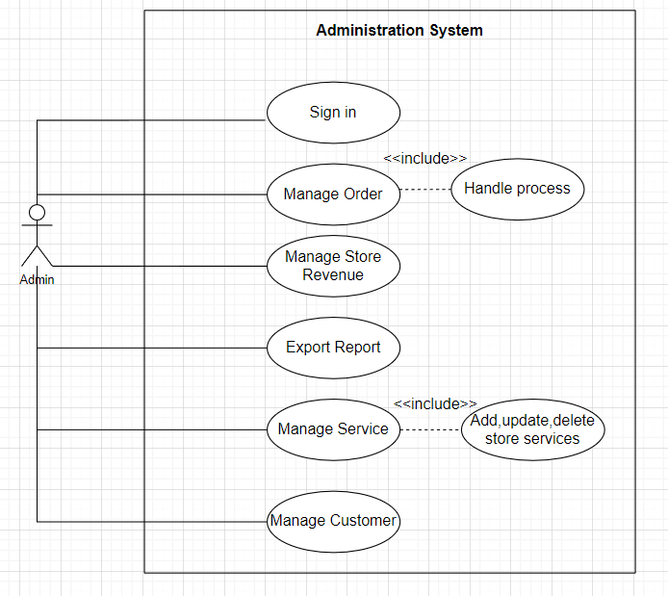

* Sign in:

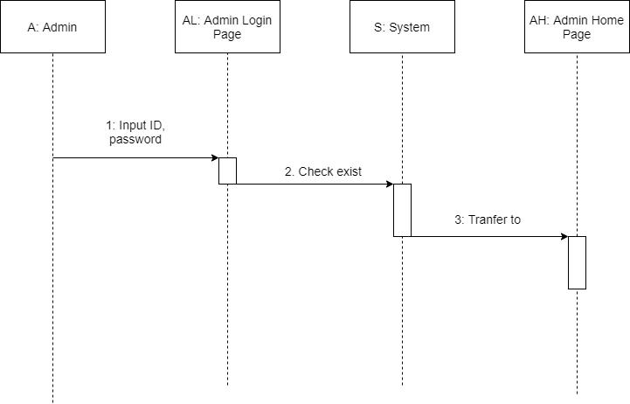

|  |  |  |
| --- | --- | --- |
| **Description** | Admin log in after the system checks, it will let you in. | |
|  | **Action** | **System responses** |
| **Basic flow** | 1) Input ID, password | Admin enters ID, password. |
| 2) Check exists | The system will check whether the ID and password are correct. |
| 3) Transfer to | If everything is correct, the System will transfer to Admin Dashboard Page. |
| **Exception** | Admin ID field blank  Password field blank  Check correct | Display error message  “ID cannot blank”  “Password cannot blank”  “Incorrect ID or Password” |

* **Manage Order:**

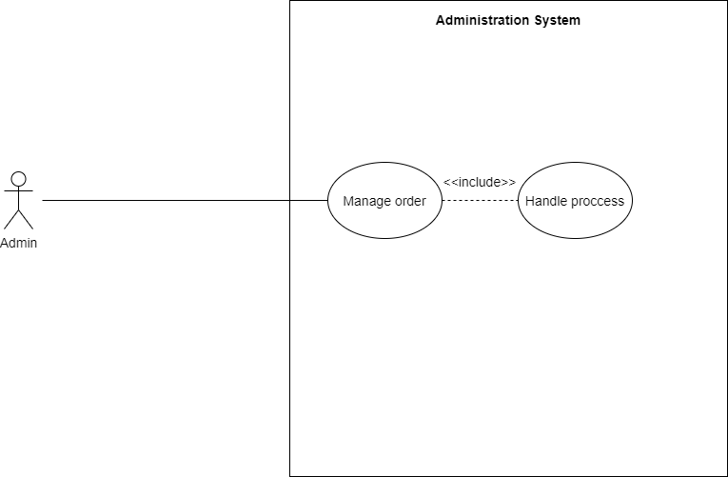

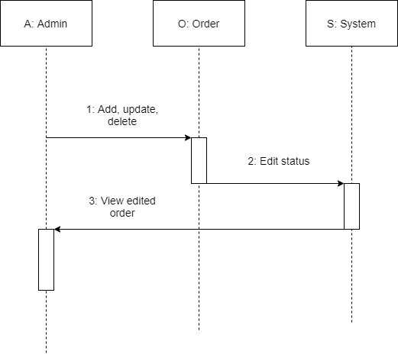

|  |  |  |
| --- | --- | --- |
| **Description** | Admin edits the status in the order then the system will update the status. | |
|  | **Action** | **System responses** |
| **Basic flow** | 1) Add, update, delete | Admin adds, updates, deletes order. |
| 2) Edit status | The system will update status. |
| 3) View edited order | If the system update is successful, it will show a notification succeed. |
| **Exception** |  |  |

* Manage revenue:

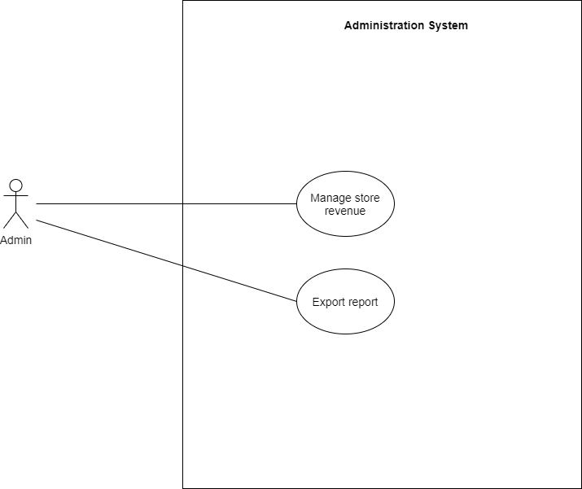

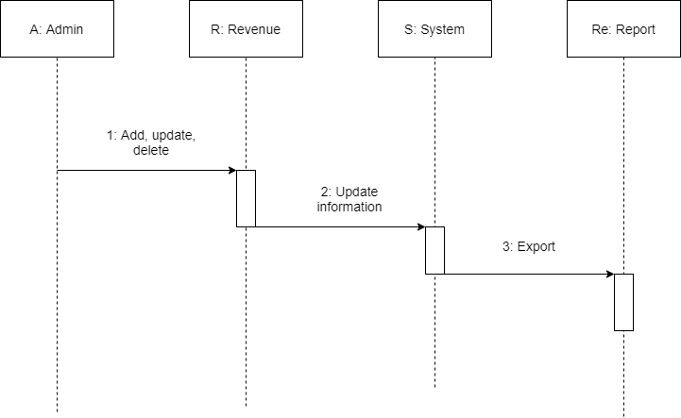

|  |  |  |
| --- | --- | --- |
| **Description** | Admin edits the status in the order then the system will update the status. | |
|  | **Action** | **System responses** |
| **Basic flow** | 1) Add, update, delete | Admin adds, updates, deletes store’s orders. |
| 2) Update information | The system will update information. |
| 3) Export | Admin can print invoice of orders. |
| **Exception** |  |  |

## ENTITY RELATIONSHIP DIAGRAM

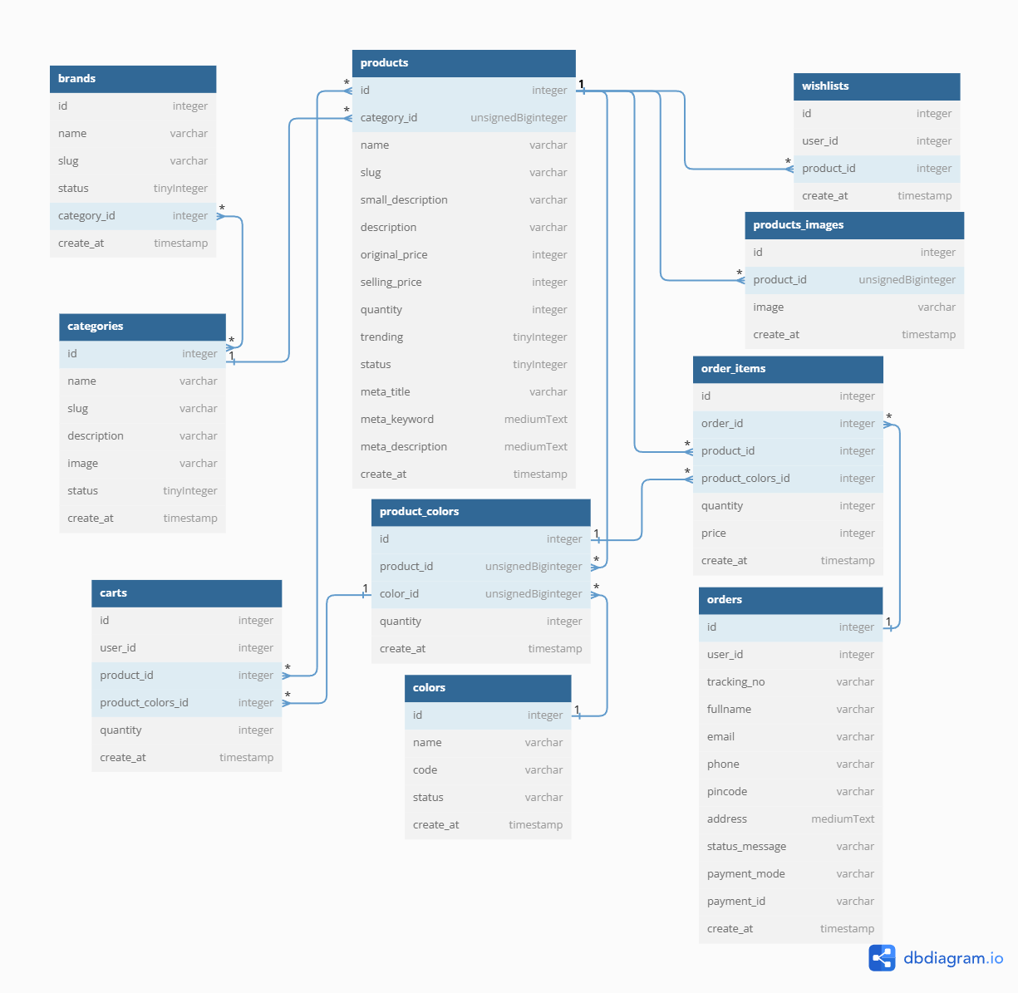

**REVIEW 3**

DESIGN

1. Admin

**1. Login**

1: email

2: password

3: Login

4: Login with Gmail

5: Login with Twitter

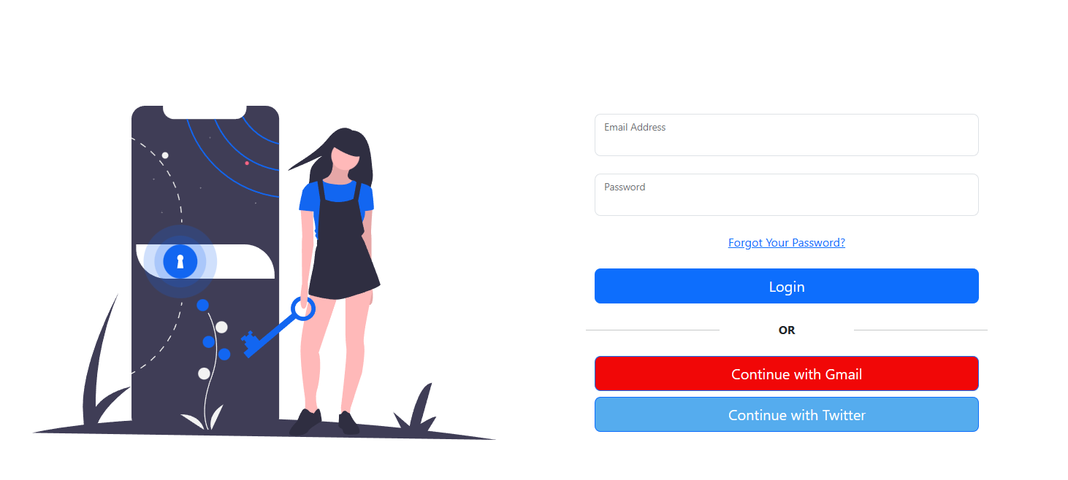

5

4

3

2

1

|  |  |  |  |  |  |
| --- | --- | --- | --- | --- | --- |
| **No** | **Name** | **Type** | **Validation** | **Description** | **Status** |
| 1 | Email | Textbox | Input not blank | Enter Admin’s ID | Enable |
| 2 | Password | Textbox | Input not blank | Enter Admin’s password | Enable |
| 3 | SignIn | Button |  | Click to login | Enable |
| 4 | Login with Gmail | Button |  | Click to login with Gmail | Enable |
| 5 | Login with Twitter | Button |  | Click to login with Twitter | Enable |

**2.NavBar**

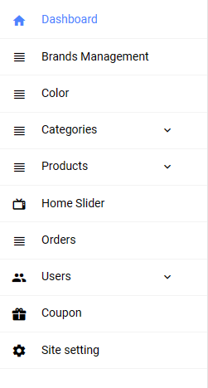

1

2

3

4

5

6

7

8

9

10

|  |  |  |  |  |  |  |  |  |  |  |  |
| --- | --- | --- | --- | --- | --- | --- | --- | --- | --- | --- | --- |
| **No** | | **Name** | | **Type** | | **Validation** | | **Description** | | **Status** | |
| 1 | | dashboard | | Link | |  | | Click on to go to Admin | | Enable | |
| 2 | | Brands Management | | Link | |  | | Click on to go to Brands | | Enable | |
| 3 | | Color | | Link | |  | | Click on to go to Color | | Enable | |
| 4 | | Categories | | Link | |  | | Click on to go to Categories | | Enable | |
| 5 | | Products | | Link | |  | | Click on to go to Product | | Enable | |
| 6 | | Home Slider | | Link | |  | | Click on to go Home Slider | | Enable | |
| 7 | | Order | | Link | |  | | Click on to go order | | Enable | |
| 8 | | User | | Link | |  | | Click on to go User | | Enable | |
| 9 | | Coupon | | Link | |  | | Click on to go Coupon | | Enable | |
| 10 | | Site Setting | | Link | |  | | Click on to go Site Setting | | Enable | |

**3.Admin Page**

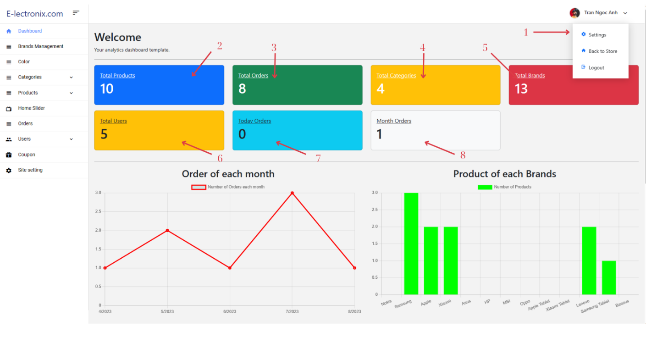

|  |  |  |  |  |  |  |  |  |  |  |  |
| --- | --- | --- | --- | --- | --- | --- | --- | --- | --- | --- | --- |
| **No** | | **Name** | | **Type** | | **Validation** | | **Description** | | **Status** | |
| 1 | | user | | Button | |  | | Click to back to store or logout | | Enable | |
| 2 | | See all products | | Link | |  | | Show all products | | Enable | |
| 3 | | See all orders | | Link | |  | | Show all orders | | Enable | |
| 4 | | See all Categories | | Link | |  | | Show all Categories | | Enable | |
| 5 | | See all Brands | | Link | |  | | Show all Brands | | Enable | |
| 6 | | See all Users | | Link | |  | | Show all Users | | Enable | |
| 7 | | See all Today Oders | | Link | |  | | Show all Today Oders | | Enable | |
| 8 | | See all Month Oders | | Link | |  | | Show all Month Oders | | Enable | |

**4.Manage Brands**

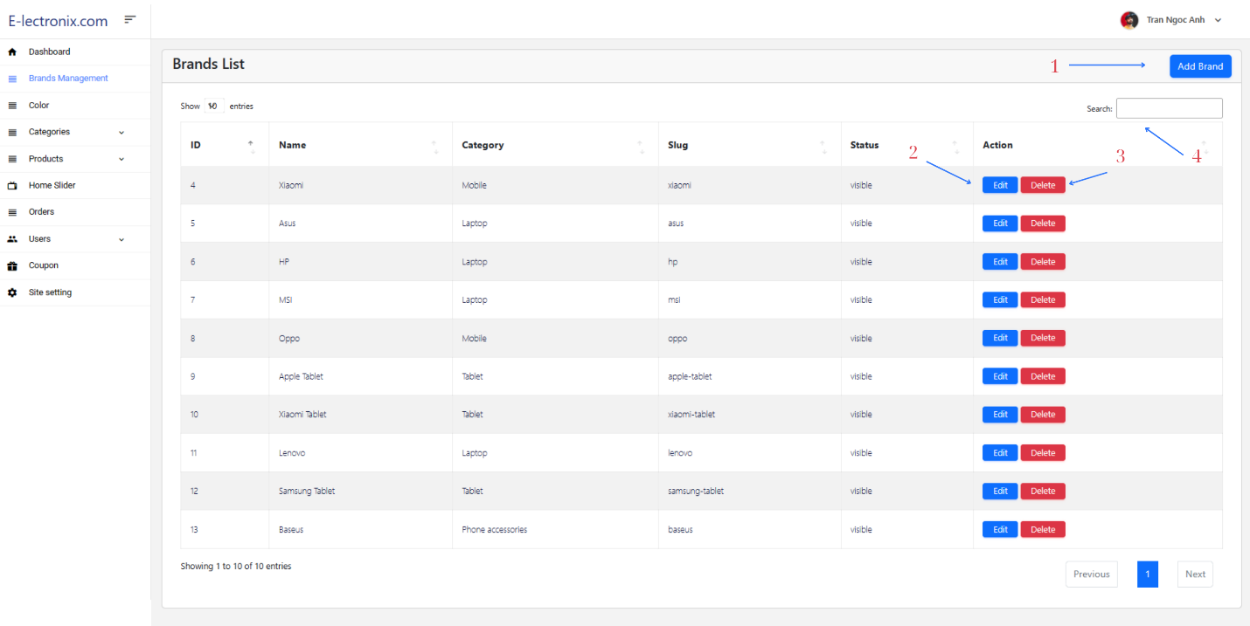

|  |  |  |  |  |  |
| --- | --- | --- | --- | --- | --- |
| **No** | **Name** | **Type** | **Validation** | **Description** | **Status** |
| 1 | Add | Button |  | Click on to go to Create New Brands page | Enable |
| 2 | Edit | Link |  | Click on go to Edit Brands | Enable |
| 3 | Delete | Button |  | Click on to go to delete Brands | Enable |
| 4 | Search | Textbox |  | Search brands | Enable |

**5.Manage Color**

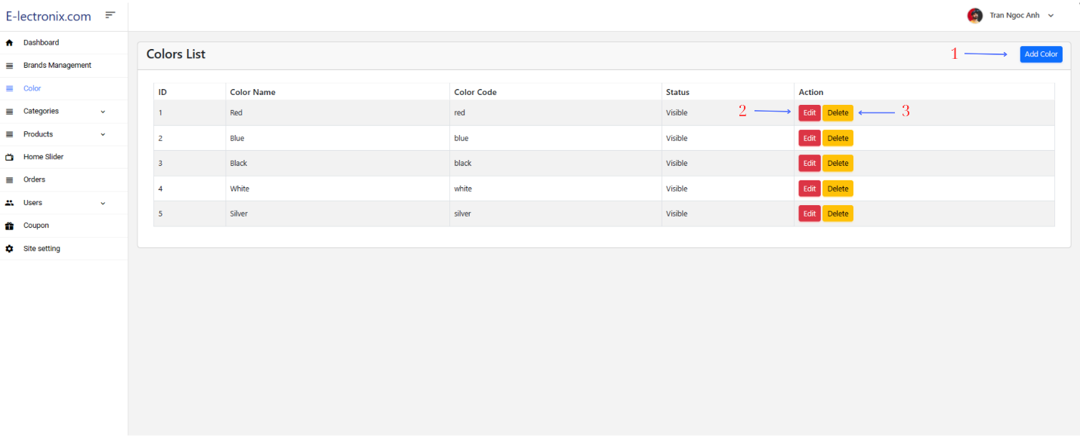

2

3

|  |  |  |  |  |  |
| --- | --- | --- | --- | --- | --- |
| **No** | **Name** | **Type** | **Validation** | **Description** | **Status** |
| 1 | Add Color | Button |  | Click on to go to “Create New Color” page | Enable |
| 3 | Edit | Link |  | Click on to go to “Update ” page | Enable |
| 4 | Delete | Button |  | Click to remove color | Enable |

**6.Manage Categories**

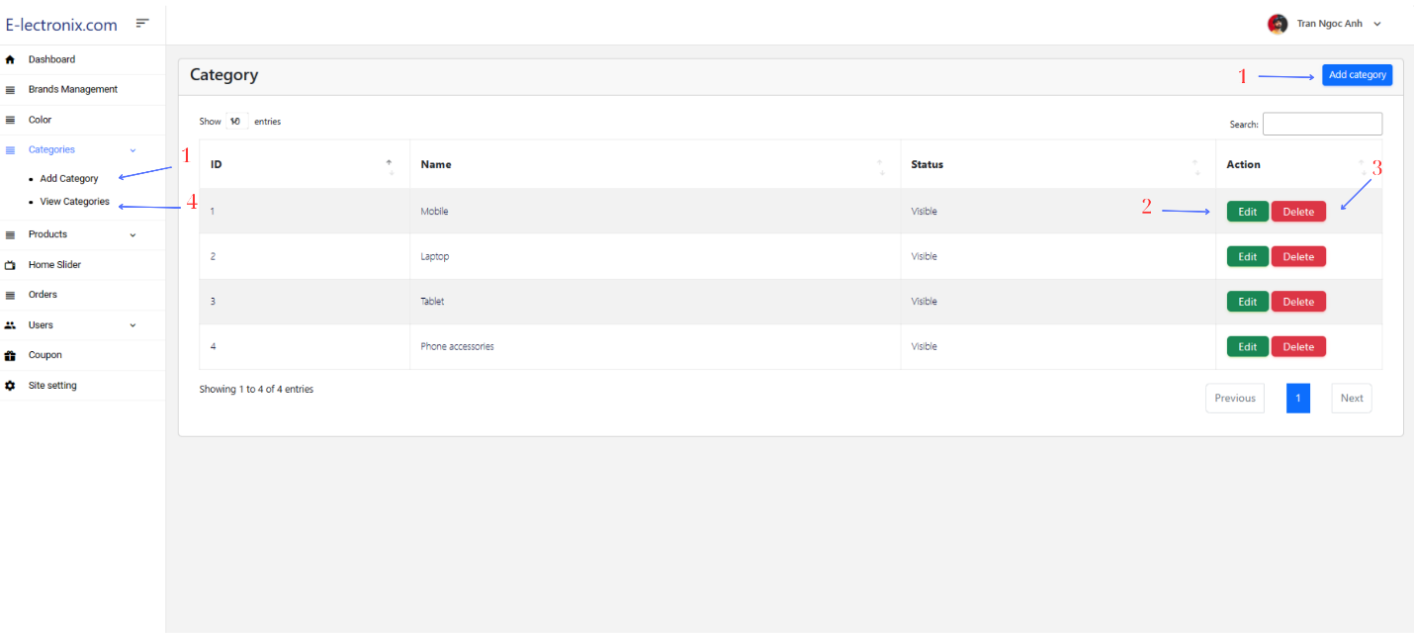

|  |  |  |  |  |  |
| --- | --- | --- | --- | --- | --- |
| **No** | **Name** | **Type** | **Validation** | **Description** | **Status** |
| 1 | Add categories | Button |  | Click on to go to “Create New Categories” page | Enable |
| 2 | Edit | Link |  | Click on to go to “Update ” page | Enable |
| 3 | Delete | Button |  | Click to remove categories | Enable |
| 4 | View Categories | Link |  | Show all Categories | Enable |

**7.Manage Product**

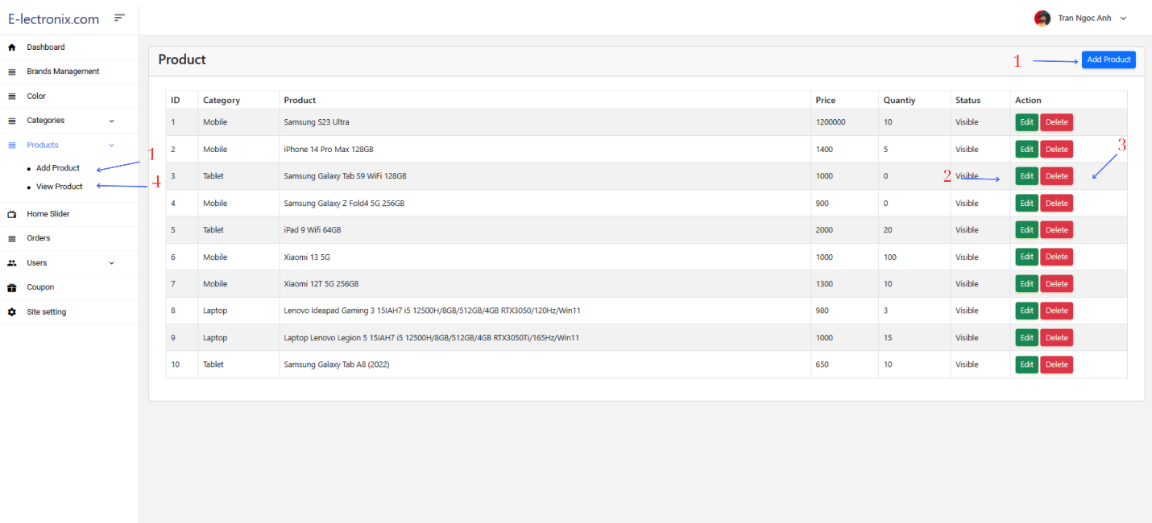

1

2

3

|  |  |  |  |  |  |
| --- | --- | --- | --- | --- | --- |
| **No** | **Name** | **Type** | **Validation** | **Description** | **Status** |
| 1 | Add Products | Button |  | Click on to go to “Create New Products” page | Enable |
| 2 | Edit | Link |  | Click on to go to “Update ” page | Enable |
| 3 | Delete | Button |  | Click to remove products | Enable |
| 4 | View Products | Link |  | Show all Products | Enable |

**8.Manage Slider**

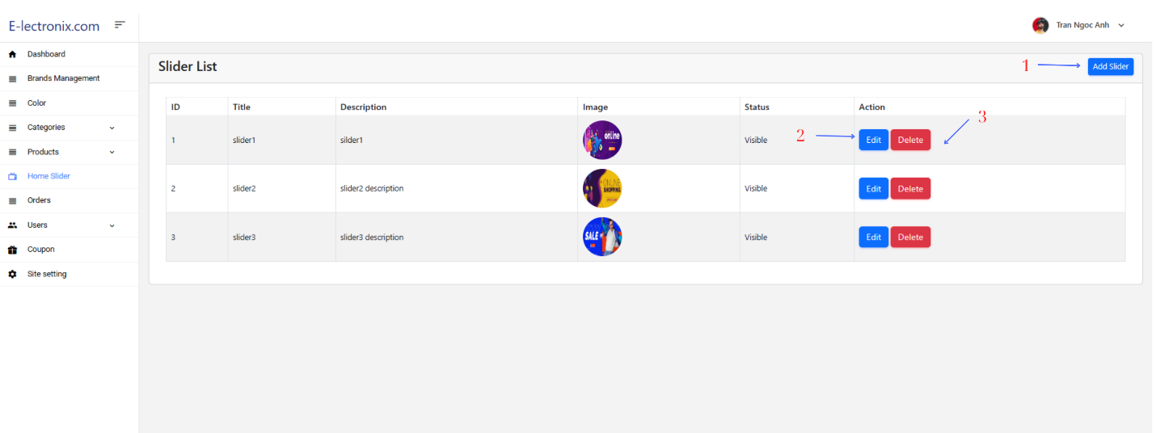

|  |  |  |  |  |  |
| --- | --- | --- | --- | --- | --- |
| **No** | **Name** | **Type** | **Validation** | **Description** | **Status** |
| 1 | Add Slider | Button |  | Click on to go to “Create New slider” page | Enable |
| 2 | Edit | Link |  | Click on to go to “Update ” page | Enable |
| 3 | Delete | Button |  | Click to remove slider | Enable |
| 4 | View Products | Link |  | Show all Products | Enable |

**9.Manage Orders**

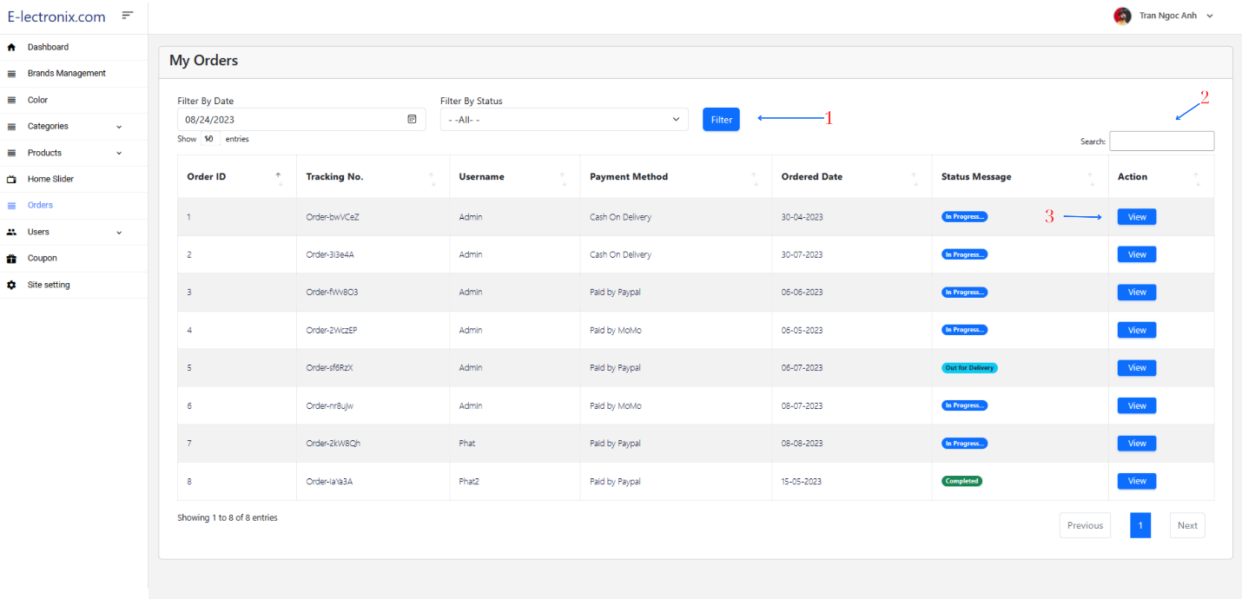

|  |  |  |  |  |  |
| --- | --- | --- | --- | --- | --- |
| **No** | **Name** | **Type** | **Validation** | **Description** | **Status** |
| 1 | Filter | Button |  | Click on to go to filter orders | Enable |
| 2 | Search | Textbox |  | Search Orders | Enable |
| 3 | View | Button |  | Click on to go to order details | Enable |

**9.Order details**

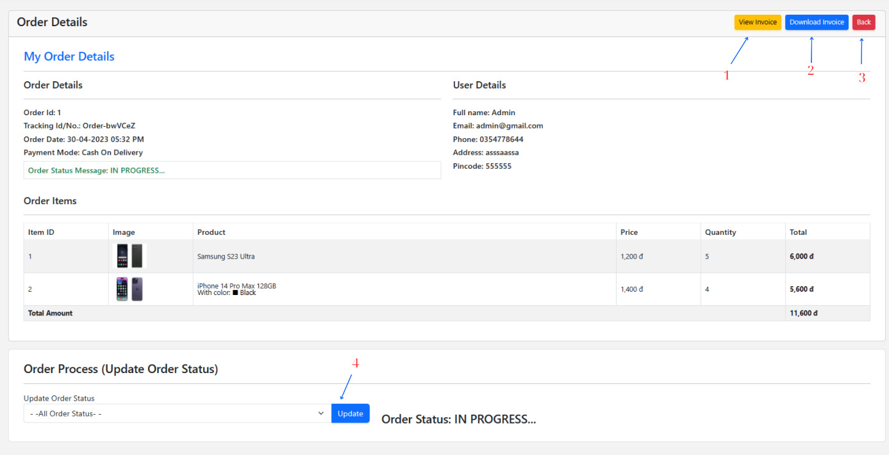

|  |  |  |  |  |  |
| --- | --- | --- | --- | --- | --- |
| **No** | **Name** | **Type** | **Validation** | **Description** | **Status** |
| 1 | View Invoice | Button |  | Show invoice customer | Enable |
| 2 | Download invoice | Button |  | Download invoice | Enable |
| 3 | Back | Button |  | Click on to go to order | Enable |
| 4 | Update | Button |  | Update Order Status | Enable |

**Invoice**

