Ho Chi Minh University of Education

**Department of Information Technology**

|  |
| --- |
|  |
|  |  |

**Report No.1 – 16/01/2020**

**CodEbot-AITeacher**

**Main Supervisor: Professor Hung Nguyen**

**Students: Nguyen Vuong, Tam Luong**

Copyright © 2020 by Nguyen Vuong, Tam Luong

# CONTENTS

CONTENTS 3

Chapter 1. Scope & Limitations 4

1.1. Supported Languages in Questioning and Answering 4

1.2. Supported Programming Languages 4

1.3. Key Features 4

Chapter 2. Future Plan 5

2.1. Overall 5

2.2. Detaill 5

References 6

# FIGURES

Figure 1. Overall timeline 5

# Scope & Limitations

## Supported Languages in Questioning and Answering

* Vietnamese (mixed with programming terms in English)

## Supported Programming Languages

* C/CPP
* Pascal
* Python

## Key Features

* Get some key topics for the conversation after a set of fixed questions so as to get an overall idea of how to effectively help questioners with their own problems.
* Answer basic theorical and practical questions that students often make when they just start learning programming.
* Troubleshoot common syntactic problems (compilation errors) in many programming languages.
* Describe in natural language the flow of simple programs (with a few functions) written in supported programming languages.
* Recommend tips and fixes for common problems and bugs in programming as well as how to be more fluent at programming.

# Research Plan

## Overall

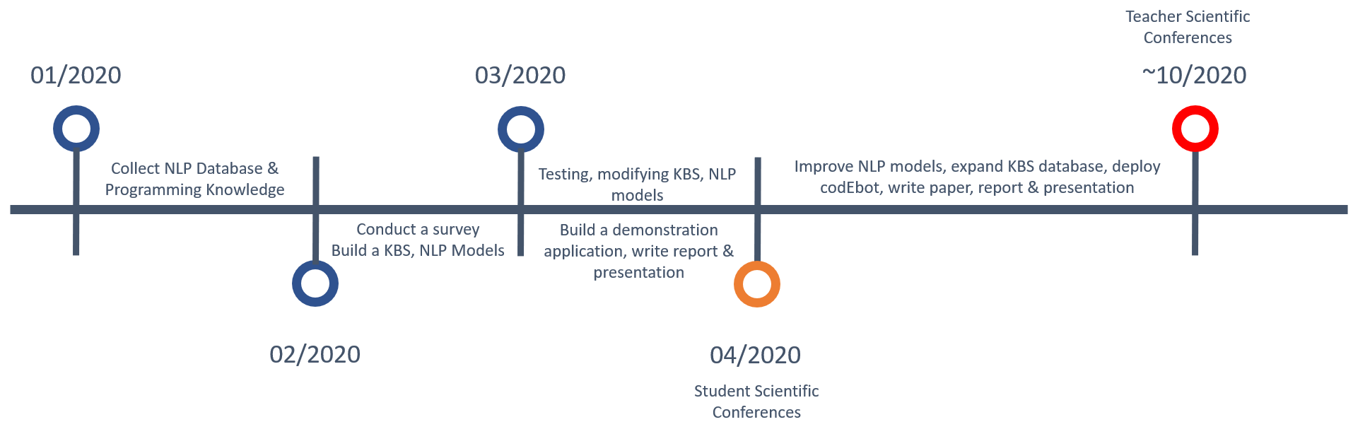

Figure . Overall timeline

## Detail

### HCMUE Student Scientific Conference

**Jan 17 – Feb 01:** Collect dataset for Natural Language Processing system, collect programing knowledge (theory, exercises, tips…) for Knowledge based System. Prepare survey question.

**Feb 01 – March 01:** Conduct a Survey for HCMUE-FIT students and some high schools in the region.

**Feb 01 – Feb 15:** Build, train & test Natural Language Processing models

**Feb 15 – March 01:** Build a Knowledge based System

**March 01 – March 25:** Test, modify NLP models, KBS. Build a demonstration chatbot.

**March 25 – April:** Write final report, presentation.

### HCMUE Teacher Scientific Conference

Not planned

# References

1. D. A. Ferrucci, "Introduction to “This is Watson”," in IBM Journal of Research and Development, vol. 56, no. 3.4, pp. 1:1-1:15, May-June 2012.
2. A. Lally et al., "Question analysis: How Watson reads a clue," in IBM Journal of Research and Development, vol. 56, no. 3.4, pp. 2:1-2:14, May-June 2012.
3. M. C. McCord, J. W. Murdock and B. K. Boguraev, "Deep parsing in Watson," in IBM Journal of Research and Development, vol. 56, no. 3.4, pp. 3:1-3:15, May-June 2012.
4. J. Chu-Carroll, J. Fan, N. Schlaefer and W. Zadrozny, "Textual resource acquisition and engineering," in IBM Journal of Research and Development, vol. 56, no. .4, pp. 4:1-4:11, May-June 2012.
5. J. Fan, A. Kalyanpur, D. C. Gondek and D. A. Ferrucci, "Automatic knowledge extraction from documents," in IBM Journal of Research and Development, vol. 56, no. 3.4, pp. 5:1-5:10, May-June 2012.
6. J. Chu-Carroll, J. Fan, B. K. Boguraev, D. Carmel, D. Sheinwald and C. Welty, "Finding needles in the haystack: Search and candidate generation," in IBM Journal of Research and Development, vol. 56, no. 3.4, pp. 6:1-6:12, May-June 2012.
7. J. W. Murdock et al., "Typing candidate answers using type coercion," in IBM Journal of Research and Development, vol. 56, no. 3.4, pp. 7:1-7:13, May-June 2012.
8. J. W. Murdock, J. Fan, A. Lally, H. Shima and B. K. Boguraev, "Textual evidence gathering and analysis," in IBM Journal of Research and Development, vol. 56, no. 3.4, pp. 8:1-8:14, May-June 2012.
9. C. Wang, A. Kalyanpur, J. Fan, B. K. Boguraev and D. C. Gondek, "Relation extraction and scoring in DeepQA," in IBM Journal of Research and Development, vol. 6, no. 3.4, pp. 9:1-9:12, May-June 2012.
10. A. Kalyanpur et al., "Structured data and inference in DeepQA," in IBM Journal of Research and Development, vol. 56, no. 3.4, pp. 10:1-10:14, May-June 2012.
11. J. M. Prager, E. W. Brown and J. Chu-Carroll, "Special Questions and techniques," in IBM Journal of Research and Development, vol. 56, no. 3.4, pp. 11:1-1:13, May-June 2012.
12. J. Chu-Carroll, E. W. Brown, A. Lally and J. W. Murdock, "Identifying implicit relationships," in IBM Journal of Research and Development, vol. 56, no. 3.4, pp. 12:1-12:10, May-June 2012.
13. A. Kalyanpur, S. Patwardhan, B. K. Boguraev, A. Lally and J. Chu-Carroll, "Fact-based question decomposition in DeepQA," in IBM Journal of Research and Development, vol. 56, no. 3.4, pp. 13:1-13:11, May-June 2012.
14. D. C. Gondek et al., "A framework for merging and ranking of answers in DeepQA," in IBM Journal of Research and Development, vol. 56, no. 3.4, pp. 14:1-14:12, May-June 2012.
15. E. A. Epstein, M. I. Schor, B. S. Iyer, A. Lally, E. W. Brown and J. Cwiklik, "Making Watson fast," in IBM Journal of Research and Development, vol. 56, no. 3.4, pp. 15:1-15:12, May-June 2012.
16. G. Tesauro, D. C. Gondek, J. Lenchner, J. Fan and J. M. Prager, "Simulation, learning, and optimization techniques in Watson's game strategies," in IBM Journal of Research and Development, vol. 56, no. 3.4, pp. 16:1-16:11, May-June 2012.
17. B. L. Lewis, "In the game: The interface between Watson and Jeopardy!" in IBM Journal of Research and Development, vol. 56, no. 3.4, pp. 17:1-17:6, May-June 2012.