## Cách tạo

1. Tạo menu

1. Xử lý Fragment

Tạo các fragment Tương tự, Layout tương tự

1. Xử lý MainMenu
2. XML(Đang dùng Ralative Layout)

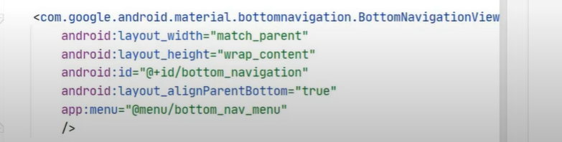



1. JavaCode



