**Spinner**

XML:

Layout:

JavaCode:

Data:

**Date and Time**

XML:

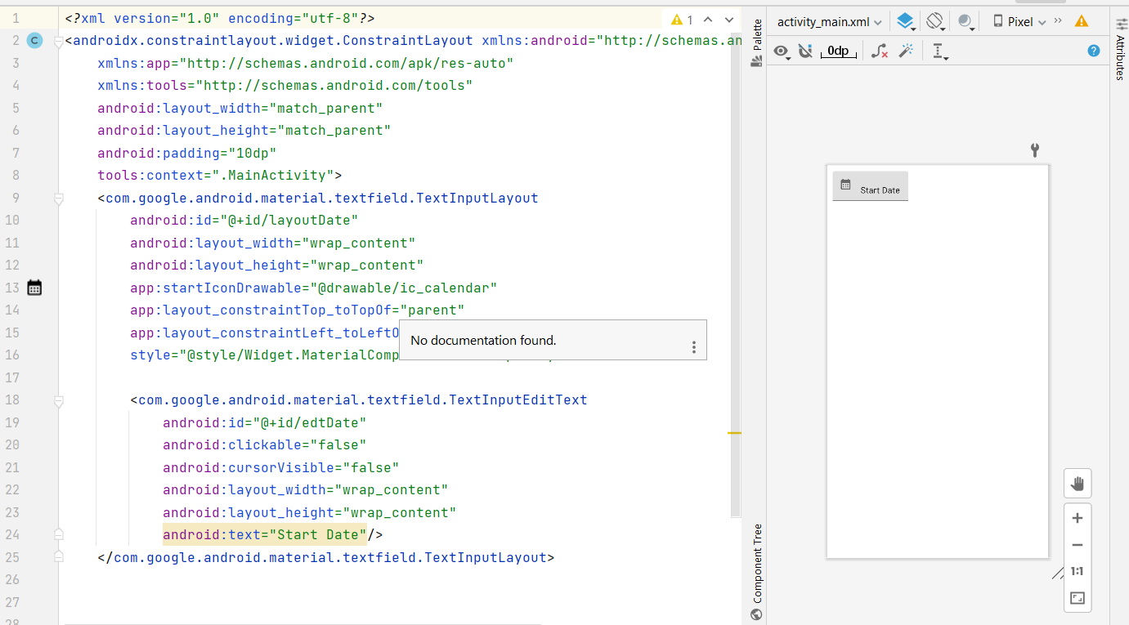

Javacode:

