**Snipper**

Code.xml

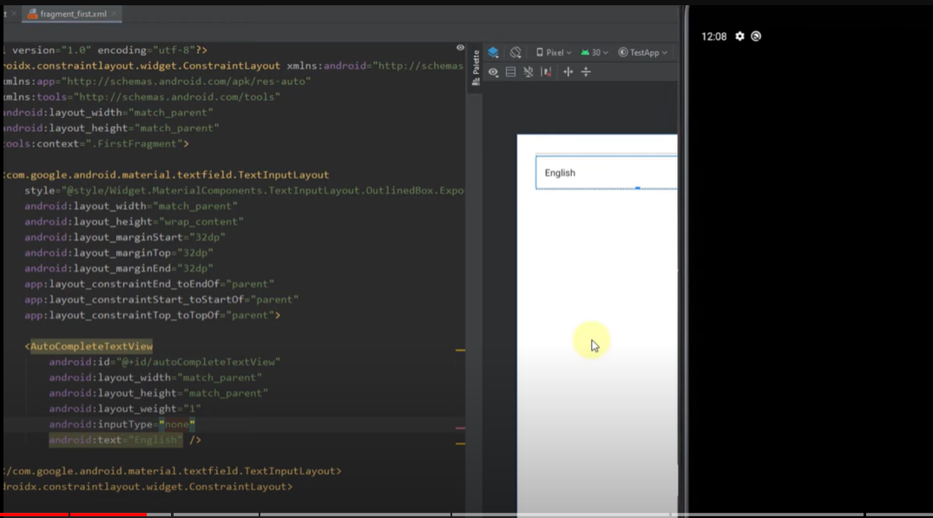



layout

Code.java

