

Presented to

Scout’s Name

for participation in the

**2014 ANZAC Day March**

**DATE GROUP Kingsford Smith**

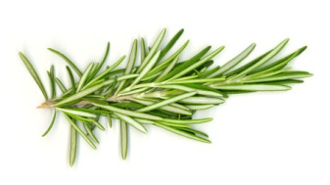

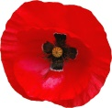

**LEADER ____________________**