Climate Modelling in-class worksheet 7 (week 8)

Group members:

1. _

2. _

3. _

4. _

The reading has been focusing on atmospheric and ocean dynamics, as well as natural variability. We’ve also talked a little about ‘large ensembles’ – multiple simulations using the same climate model, which are used to understand how trends over relatively short time periods (e.g. 10-50 years) could be different simply because of the internal dynamics of the climate system. This worksheet will start helping you explore the CESM Large ENSemble simulations (CESM LENS and CESM LENS2).

Within your group, explore these two resources:

CESM LENS: <https://www.cesm.ucar.edu/community-projects/lens>

CESM LENS2: <https://www.cesm.ucar.edu/community-projects/lens2>

1. How many ensemble members are there in the CESM LENS? How many in the CESM LENS2?
2. List some other key differences between the CESM LENS and the CESM LENS2
3. In CESM2 LENS, ensemble members are initialized from four different states of the AMOC (Atlantic Meridional Overturning Circulation), as in the figure below. The AMOC circulation brings warm saline water from the tropics northward in the Gulf stream in the Atlantic. When it reaches high latitudes, the water cools, and, because of its increased salinity relative to water below it, sinks downwards, helping create the ‘conveyor belt’ of the AMOC. AMOC strength can be measured in Sverdrups (Sv), a measurement of volumetric flow of water – a stronger AMOC is associated with more flow (both warm water northwards in the upper ocean, and the ‘return flow’ of cooler water southwards at depth). Often the AMOC index is calculated at a particular latitude. In the figure below the strength of the AMOC is measured as the volumetric flow at 45N.
   1. What is the maximum difference in AMOC strength between the 4 discrete AMOC states that the CESM LENS2 is initialized with?
   2. Which AMOC state (1231,1251,1281,1301) is initialized with the weakest AMOC?

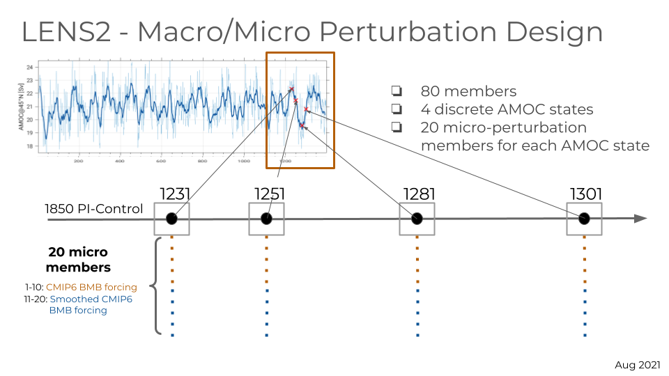

*Fig. 1. The AMOC strength in the control simulation (blue line; thick line is a running mean over time), and the 4 discrete (macro-perturbation) initial conditions from which 20-member micro-perturbations were initialized in the CESM LENS2*

The following figure is taken from Liu et al. 2020 (<https://www.science.org/doi/10.1126/sciadv.aaz4876>). It shows the different in surface temperature (left) and precipitation (right) between a simulation with an AMOC index of around 18Sv, and a simulation with an AMOC index of around 25Sv. Use Figs and 2, together with the information about the AMOC states from Q3 to answer the following questions.

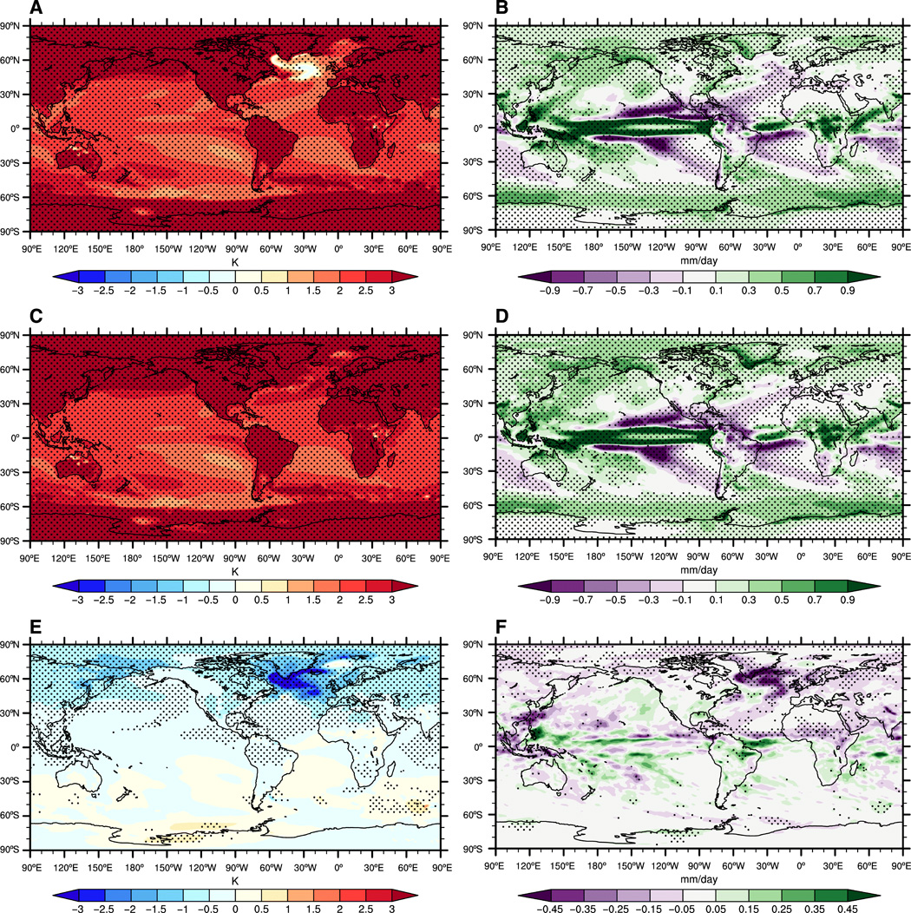

*Fig. 2. In all the panels, stippling indicates that the response is statistically significant at the 95% confidence level of Student’s t test. The impacts of a reduced AMOC on surface temperature and precipitation are revealed in (E) and (F).*

1. What is the main temperature effect of reducing the strength of the AMOC? Is this consistent with what you know about the AMOC and its transport of water? Why/why not?
2. Which of the initial AMOC states (1231,1251,1281,1301) do you think would likely have the lowest temperatures in the North Atlantic for the first ~20 years of the simulation?
3. Assume that the AMOC strength evolves in each of the ensemble simulations exactly as it did in the control simulation in Fig. 1 (this likely isn’t quite true due to internal variability of the ocean system). Think about the trend of temperature averaged over the Northern hemisphere for the first 50 years of each simulation (temperature trends would be a combination of anthropogenic forced trend, and trends due to natural variability, including the AMOC).
   1. Which initial condition do you think is most likely to have the largest increasing trend during the first 50 years? Why?
   2. Which initial condition would have the smallest increasing trend (or maybe even a decreasing trend)? Why?