



**Guideline**



|  |  |
| --- | --- |
| **Project Acronym:** | **PEPPOL** |
| **Grant Agreement number:** | **224974** |
| **Project Title:** | **Pan-European Public Procurement Online** |
| **Transport Infrastructure ICT**  **Services-Components**  **PEPPOL-Silicone**  **Java Development Setup**  **Version: 1.3**  **Status: In Use**  **Editors:**  **Philip Helger, PEPPOL.AT** | |

|  |  |  |
| --- | --- | --- |
| **Project co-funded by the European Commission within the ICT Policy Support Programme** | | |
| **Dissemination Level** | | |
| **P** | **Public** | **X** |
| **C** | **Confidential, only for members of the consortium and the Commission Services** |  |

**Revision History**

|  |  |  |  |  |
| --- | --- | --- | --- | --- |
| **Version** | **Date** | **Editor** | **Org** | **Description** |
| 0.1 | 2011-01-12 | PH | BRZ | Initial version |
| 0.2 | 2011-01-14 | PH | BRZ | Added input from IBX (Ana) and BRZ (Jakob) |
| 0.3 | 2011-01-19 | PH | BRZ | Added workaround for m2eclipse problem – thanx to Joan |
| 0.4 | 2011-02-09 | PH | BRZ | Updated several items based on recent finding |
| 1.0 | 2011-02-25 | PH | BRZ | Added chapter on what to do if a project does not compiler after import  Added specific note to use Metro 2.0.1 instead of 2.1 |
| 1.1 | 2011-04-20 | PH | BRZ | Added recommendation on the usage of Metro 2.1  Specified details on the usage of 64bit software  Fixed project paths |
| 1.2 | 2012-02-19 | PH | BRZ | Updated to the latest version of the components  Added notes on Eclipse 3.7 and Subversion 1.7  Requiring Maven 3.x  Updated to paths for Google Code repository  Updated to new layout |
| 1.3 | 2012-03-21 | PH | BRZ | Updated to new template  Minor adjustments for Java 7 |
|  |  |  |  |  |
|  |  |  |  |  |

**Contributors**

**Statement of copyright**



This deliverable is released under the terms of the **Creative Commons Licence** accessed through the following link: http://creativecommons.org/licenses/by/3.0/.

In short, it is free to

**Share** — to copy, distribute and transmit the work  
**Remix** — to adapt the work

Under the following conditions

**Attribution** — You must attribute the work in the manner specified by the author or licensor (but not in any way that suggests that they endorse you or your use of the work).

**Statement of originality**

This deliverable contains original unpublished work except where clearly indicated otherwise. Acknowledgement of previously published material and of the work of others has been made through appropriate citation, quotation or both.

**Organisations**

PEPPOL.AT/BRZ (Bundesrechenzentrum)[1], Austria, http://www.brz.gv.at/

IBX/Cap Gemini

alfa1lab

**Persons**

Philip Helger, BRZ

Ana Chiritescu (IBX/Cap Gemini)

Jakob Frohnwieser (BRZ)

Joan Farfan (alfa1lab)

**Table of Contents**

1 Introduction 5

1.1 Objective and Scope 5

1.2 Audience 5

1.3 [Document dependent sections] 5

2 ?? 6

# Introduction

## Objective and Scope

This document is the introduction document on how to develop for the Java version of the PEPPOL Reference Implementation (PEPPOL RI). This document does not contain information that is specific to BusDox or PEPPOL components (SML, SMP and AP).

All elements listed here where tested under Windows XP, Vista and 7. Theoretically everything is platform independent and can be built on any platform that supports the required software components.

## Audience

The audience for this document is organizations in need for a short introduction to the PEPPOL Silicone development process. These may include the following PEPPOL Stakeholders:

* PEPPOL Community Governance
* Contracting Authorities
* Economic Operators
* ICT Providers
* Service Providers

More specific it is the following roles:

* ICT Architects
* ICT Developers
* ICT Governing participants

# Software components

Prerequisites to developing and running the Java PEPPOL components:

* It is assume that you have checked out the OSOR SVN components.
* Internet access

The following software components are required for development

* Latest Sun JDK 1.6.x with Metro 2.1.1 (it works also with 2.0.1 but 2.1.1 is recommended)
* Eclipse 3.6/3.7 JEE
  + M2eclipse plugin
  + Subclipse plugin
* Apache Maven 3.0x

Optional software components but strongly recommended:

* Subversion client (either command line or TortoiseSVN or both)
* Subclipse (Eclipse Subversion plugin)

For running some of the applications:

* Apache Tomcat 6.x/.x or Jetty 7.x
* MySQL 5.x (or another relation database)

## Prerequisites

Check out the PEPPOL Java RI from the OSOR Subversion (SVN) directory. Use [**https**://peppol-silicone.googlecode.com/svn/trunk/](https://peppol-silicone.googlecode.com/svn/trunk/) as the SVN base directory if you are a developer or use [**http**://peppol-silicone.googlecode.com/svn/trunk/](http://peppol-silicone.googlecode.com/svn/trunk/) for read-only access. Either use the command line client (svn co [**https**://peppol-silicone.googlecode.com/svn/trunk/](https://peppol-silicone.googlecode.com/svn/trunk/)) or use TortoiseSVN (Checkout… and enter [**https**://peppol-silicone.googlecode.com/svn/trunk/](https://peppol-silicone.googlecode.com/svn/trunk/) into the field “URL of repository”).

It is strongly recommended to avoid blanks in the path where you check out, as this may result in severe and hard to track problems when building!

## Sun JDK

The latest Sun JDK (1.6.0_31 at the time of writing) can be downloaded from the following website <http://www.oracle.com/technetwork/java/javase/downloads/index.html>

Because of updates of components that are part of the runtime library (rt.jar), a few parts of the Metro framework must be present in the JDK directory:

1. Download version 2.1.1 of the Metro framework from <http://metro.java.net/2.1.1/>
2. Unzip the Metro download and copy the file “webservices-api.jar” into your JDK endorsed directory (e.g. C:\Program Files\Java\jdk1.6.0_31\jre\lib\endorsed)

Ensure that the “JAVA_HOME” environment variable points to this Java installation – see chapter 5.1 for details.

You may also choose to use Java 7 for development and deployment, but it hasn’t been tested extensively.

## Eclipse 3.6/3.7

Because of potential incompatibilities with other Eclipse plugins it is strongly recommended to setup a new Eclipse instance (separate installation directory) and separate workspace for PEPPOL development.

Download the latest Eclipse 3.6 JEE edition from <http://www.eclipse.org/downloads/packages/eclipse-ide-java-ee-developers/heliossr2> or Eclipse 3.7 JEE edition from <http://www.eclipse.org/downloads/packages/eclipse-ide-java-ee-developers/indigosr1>. Choose your platform on the right side.

After downloading and unzipping, run eclipse.exe for the first time and select a new workspace directory. Then install the following Eclipse plugins (via Help | Install new Software...):

* M2eclipse (Update site <http://download.eclipse.org/technology/m2e/releases>)
* Subclipse (Update site <http://subclipse.tigris.org/update_1.6.x> for Subversion 1.6.x or [http://subclipse.tigris.org/update_1.8.x](http://subclipse.tigris.org/update_1.6.x) for Subversion 1.7.x)  
  When using 64 bit Java you may be presented with an obscure error message. This can be resolved by locally installing a native 64 Bit SVN command client like SlikSVN: <http://www.sliksvn.com/en/download>

Afterwards restart Eclipse. Modify the Eclipse preferences (Window | Preferences) as follows:

* Java
  + Code style
    - Formatter: Import the formatter from the SVN file “java/00config/eclipse-formatter-peppol.xml”
  + Installed JREs: ensure that the previously installed JDK is contained and selected in this list. If it is contained, press “Edit...” and select “Restore Default” to ensure that the endorsed libraries (Metro) are correctly contained. If it is not contained, use “Search...” and locate the Java directory; afterwards select the JDK instance.  
    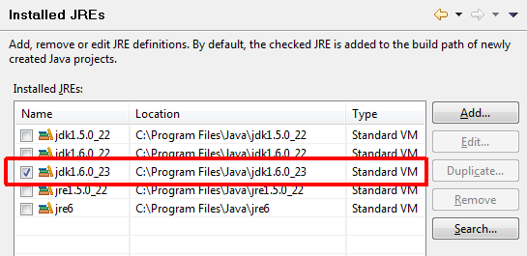
    - Execution Environments: Ensure that the execution environment “JavaSE-1.6” is mapped to the JDK you previously setup.  
      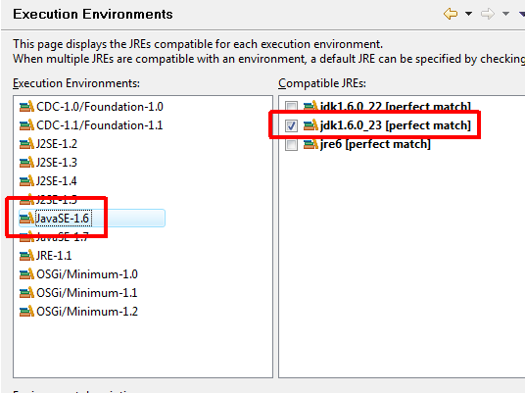

Now import the following projects – that are required by all projects - from the SVN directory:

* java/commons-busdox
* java/commons-peppol

### Running Eclipse with a JDK

By default Eclipse uses the public JRE for executing itself. Maven sometimes expects Eclipse to run with a JDK. Therefore you need to modify the eclipse.ini file that resides in your Eclipse installation directory. For Windows you may simple add the following lines to eclipse.ini (of course the path to the JDK must be adopted):

-vm

C:/Programme/Java/jdk1.6.0_31/bin/javaw.exe

Since the format of the eclipse.ini file is very specific, it is strongly recommended to read the following web pages before performing the modifications to ensure the Eclipse will start up correctly:

<http://wiki.eclipse.org/FAQ_How_do_I_run_Eclipse%3F#eclipse.ini>

<http://wiki.eclipse.org/Eclipse.ini>

This modification requires a restart of Eclipse in case you did it while running Eclipse.

### Issues with the m2eclipse plugin

Installing the m2eclipse plugin may fail because of the following problem:

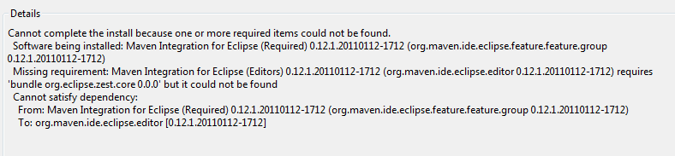

In that case you need to add the following update site:

<http://download.eclipse.org/tools/gef/updates/releases/>

And from that update site you need to install the “zest visualization toolkit” library.

### Projects not compiling after initial import

If you have the issue that projects are not compiling after import (especially “commons-busdox” is a candidate), try calling “Run as” “Maven generate-sources” to create all generated source files. This seems to be necessary due to a bug in m2eclipse that won’t execute these actions automatically upon project import.

## Apache Maven 3.x

Download the latest Apache Maven 3.x from <http://maven.apache.org> and unzip the file to a common directory. Set the environment variable “M2_HOME” to the unzipped directory (the directory that includes the “bin” directory). Extend the environment variable “PATH” to contain “%M2_HOME%/bin”. Use the correct separator to append this item to the existing PATH (“;” on Windows and “:” on Unix).

After setting up Maven open a command line and type “mvn –v”. The output should look similar to the following screen:

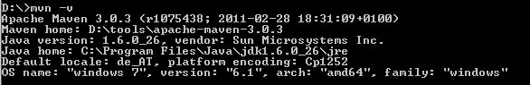

Maven provides central support for repository managers (mirrors), proxy servers etc. Please see the documentation on the Maven website for details.

### Maven repository manages

If you are using a Maven repository manager (like Sonatype Nexus, Apache Archiva or JFrog Artifactory) you may need to add the following repositories to the proxied ones (Please contact your Maven administrator for the details):

* <http://repo.phloc.com/maven2/> (for releases and snapshots; Maven 2 layout

In case you cannot modify your repository manager you can work around this issue by temporarily commenting the element “<mirrorOf>” in your local Maven 2 settings.xml (*userHome*/.m2/settings.xml).

## Subversion

TortoiseSVN is a Windows explorer integration that lets you perform SVN command via the GUI. Download it at <http://tortoisesvn.net/downloads.html> and select either 32 bit or 64 bit version as you need it.

A Win32 command line SVN client can be acquired from SlikSVN: <http://www.sliksvn.com/en/download>. Also choose correctly between 32 bit and 64 bit version.

As Subversion 1.7.x is a major update, it must be ensured that all Subversion components (command line client, TortoiseSVN and the Eclipse plugin) use the same version. So either all versions are on 1.6.x or on 1.7.x - mixing will result in weird errors!

# Special cases

## Proxy server

If you’re behind a proxy server you may face issues when using Subversion or Maven.

### Maven

For Maven update both your personal settings.xml (see <http://maven.apache.org/settings.html> for details) and - if this does not solve all issues (e.g. for the “busdox-types” project using the wsimport plugin) - pass the required parameters on the command line like this:

mvn install -Dhttp.proxyHost=10.0.0.1 -Dhttp.proxyPort=8080

See <http://download.oracle.com/javase/6/docs/technotes/guides/net/proxies.html> for a list of all proxy related command line parameters.

### Subversion

Please see <http://subversion.apache.org/faq.html#proxy> for details on how to configure a proxy server for the usage of Subversion.

# Default components

## Logging

Source level logging is done via SLF4J (<http://www.slf4j.org/>) only. SLF4J is a logging façade comparable to Apache commons-logging but has less known issues and offers binding to Log4J and other logging frameworks. Don’t use commons-logging or java.util.logging in PEPPOL Silicone code. The preferred way to create a logger is as follows:

**private** **static** **final** Logger *log* = LoggerFactory.*getLogger* (*MyClass*.**class**);

“MyClass” has to be replaced with the actual class name. Logger is org.slf4j.Logger and LoggerFactory corresponds to org.slf4j.LoggerFactory. The field name “log” should be used.

All messages with lower priority than “info” have to be prefixed with a query for performance reasons[2]:

If (log.isDebugEnabled ())

log.debug (“Doing this and that”)

Log messages with a log level >= “info” should also be prefixed, but there is no necessity.

# Appendix

## Setting environment variables in Windows

Setting environment variables in Windows is a hard to find if you want set values system wide.

On Windows XP press <Windows key>+<Pause>. On Windows Vista you can execute the application “SystemPropertiesAdvanced.exe” or press <Windows key>+<Pause> followed by selecting the “advanced properties” text in the left task pane. You should end up with a window like this:

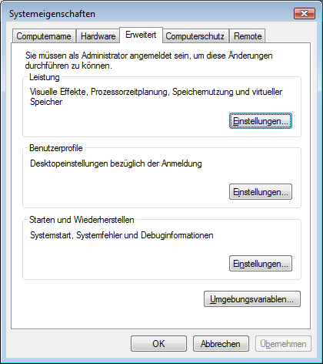

Go to the “Advanced” tab (already selected in the screenshot above) and select the “Environment variables…” button (in the above screenshot it is the button directly above “OK” and “Cancel”).

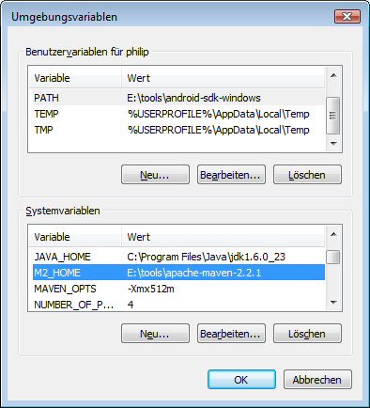

The top list shows environment variables that are user specific. This means only your account has access to them. I prefer to set the variables system wide but there are also good reasons to set it in the personal section. After you changed the values here, you need to close and re-open existing command windows, as changes only take effect after a restart.

1. English: Austrian Federal Computing Centre
2. If you e.g. have log.debug(„My value is „ + sValue“) the preceding „isDebugEnabled“ check may spare you the string concatenation operation.