**Release Notes for v1.0.1.110 Released 31 JAN 2023**

**Contents**

Introduction................................................ 1

Description ................................................ 1

Initial release ............................................. 1

Device Compatibility .................................. 1

Release Notes........................................... 1

Components .............................................. 2

Installation ................................................. 2

Notes ......................................................... 2

Application usage and Screens brief ......... 2

**Introduction**

This release notes are for the Zebra RFID Xamarin Demo Application v1.0.1.110

**Description**

The Zebra RFID Xamarin Demo application demonstrates the use case of using the

Xamarin to work with rfid readers.

**v1.0.1.110 updates**

* Integrate latest SDK version release

**v1.0.1.100 updates**

* New Keymapping support for RFD40/RFD90

**Initial release**

* Inventory – Do inventory using Trigger
* Access – Perform read/write and lock operation on selected tag
* Locate – Search particular tag using Locate API
* Relative Distance – Based RSSI show heatmap for all the tags
* Reader List – access available readers
* Firmware update
* Scan barcode data

**Device Compatibility**

* MC33xR
* RFD40
* RFD40 Premium and RFD40 Premium plus
* RFD8500
* RFD90

**Release Notes**

• ZebraRFIDXamarinDemo

**Components**

The zip file contains the following components:

* Zebra RFID Xamarin Demo APK file
* Zebra RFID Xamarin Demo Visual Studio project source code

**Installation**

Supported operating systems: Visual Studio 2019

Developer system requirements:

• Developer Computers: Windows 10 64-bit

• Xamarin

**Notes**

1. Exit the RFID Demo application or other user application which can be using reader

2. Reader region is already set as per regulatory requirements

**Application usage and Screens brief**

1. From home screen using application icon launch the application, home screen is shown on next page

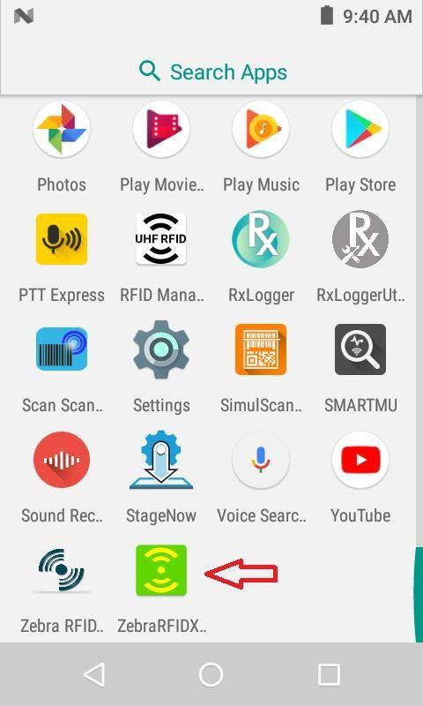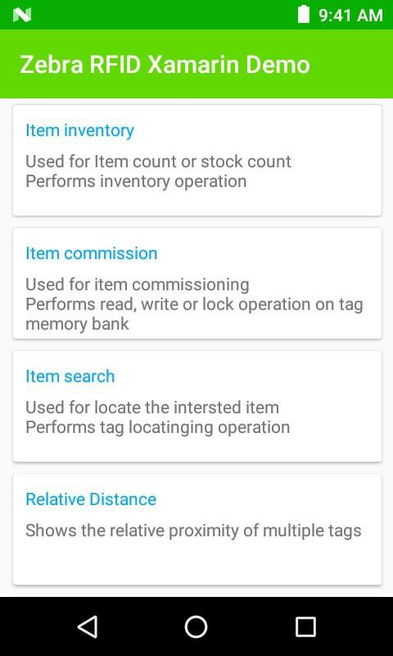

2. Tap on Item Inventory to open inventory screen. It shows reader connection status and press gun trigger to start the inventory. When reader reads the tags tag list get populated with tags EPC ID, RSSI and count values Tag Any tag ID to select it. Selected tag ID will be shown on commissioning and search screen.

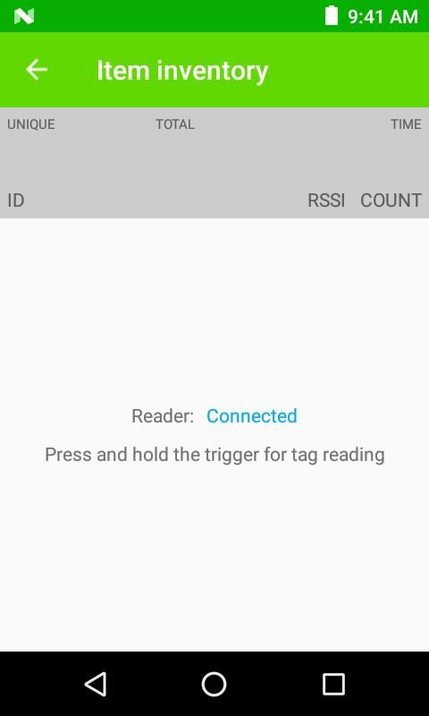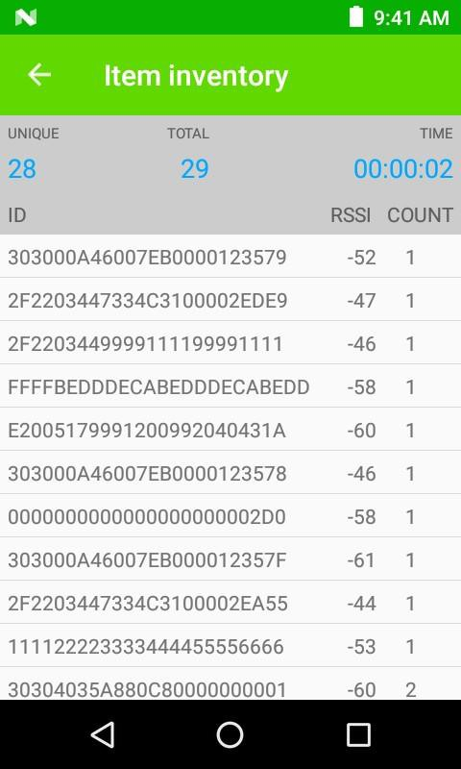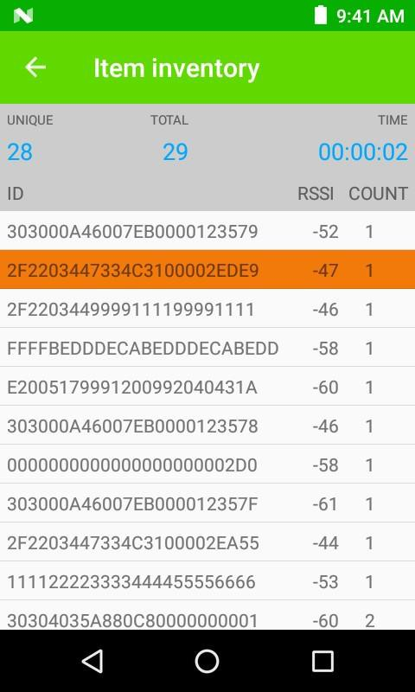

3. Tap on Item commission from Home screen to perform access operations like read/write and lock on selected tag ID in inventory screen.

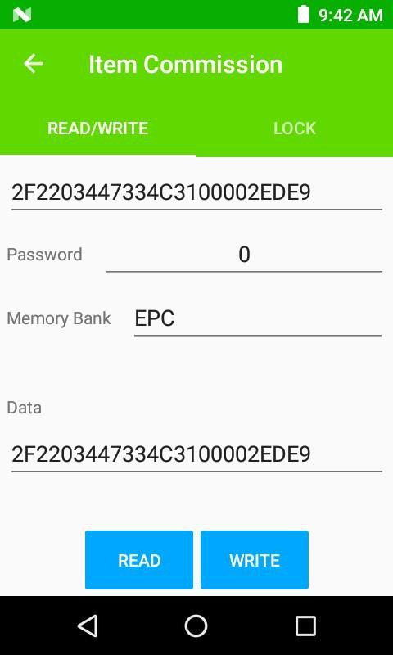

4. Tap on Item search from Home screen to perform item search/locate operation on selected tag id. Press gun trigger to start locate operation for particular tag, release to stop.

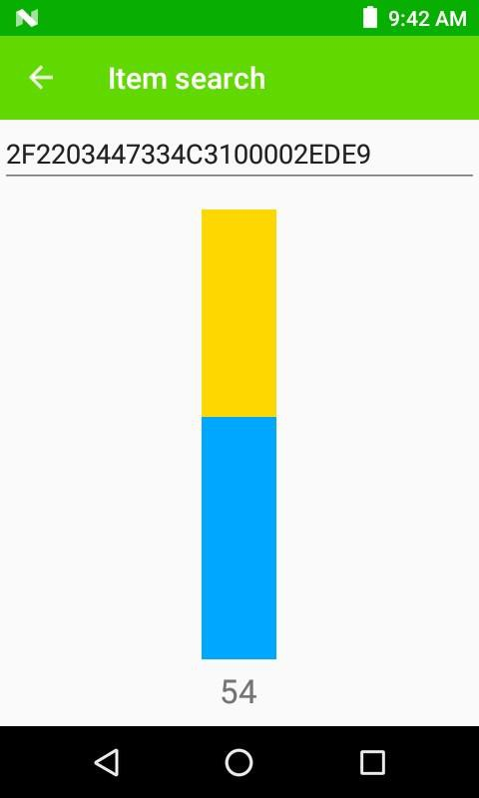

5. Tap on Relative distance to see varying relative distance of tags in field of view based on their RSSI as detected by reader. It is based on color heat map where blue (cold) to red (hot) for far to near tag respectively.

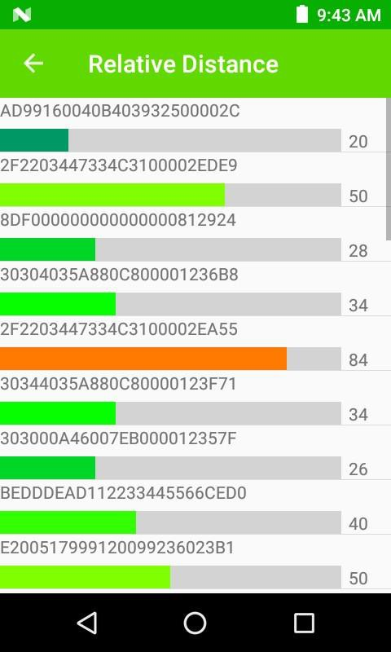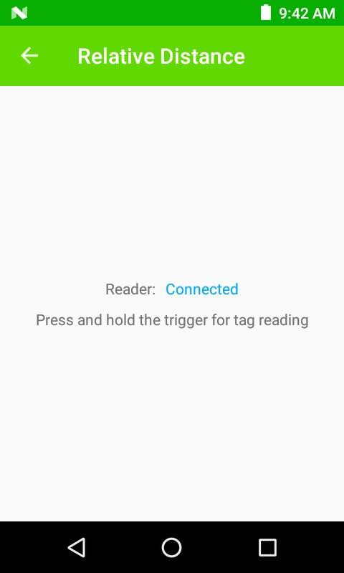

6. Tap on Reader List on Home screen to see available and connected reader

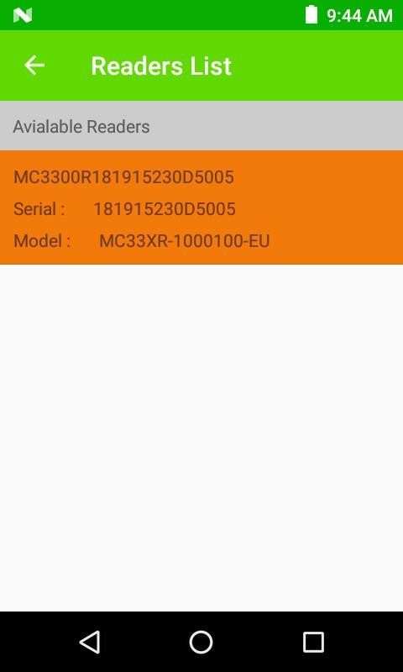

6. Select Firmware Update for firmware update

Copy file to /sdcard/Download/ZebraFirmware to list the firmware file

Note: Make sure app has been provided with Allow management of all files permission

6. Select Barcode scanner to scan barcode data

7. New Key Remapping support

