Extended Geospatial Tagging Pipeline Report
Generated on: 2025-12-09 09:45:24

1. Methodology

1.1 Data Collection & Preprocessing
Data was collected for 12 cities (Islamabad, Lahore, Karachi, Rawalpindi, Kohat, Peshawar, Attock, Chitral, Skardu, Quetta, Sialkot, Muzaffarabad) using the Overpass API. The preprocessing pipeline included Roman Urdu normalization and POS tagging.
Total Preprocessed Records: 54246

1.2 Pattern Mining (Guided FP-Growth)
We employed Guided FP-Growth to mine frequent itemsets. A total of 517 relevant patterns were identified.

1.3 Feature Selection (Bayesian Elastic Net)
Bayesian Elastic Net (BEN) regularization selected 252 high-utility features from the mined patterns.

2. Mathematical Methodology: Bayesian Elastic Net

2.1 Objective Function
The objective function minimized is (Negative Log-Likelihood + Elastic Net Prior):
L(w) = -(1/N) * Σ [y_i * log(p_i) + (1 - y_i) * log(1 - p_i)] + λ [ α ||w||_1 + (1 - α)/2 ||w||_2^2 ]
Where:
- p_i is the predicted probability.
- λ (alpha in code) controls regularization strength.
- α (l1_ratio) balances L1 (Lasso) and L2 (Ridge) penalties.

2.2 Bayesian Interpretation
1. L2 (Ridge): Corresponds to a Gaussian Prior P(w) ~ Normal(0, σ²).
2. L1 (Lasso): Corresponds to a Laplace Prior P(w) ~ Laplace(0, b).
The Elastic Net combines both, encouraging sparsity and grouping.

3. Hybrid Classification
The final classification model is a Hybrid Architecture fusing:
- - Semantic Embeddings: DistilBERT (Contextual understanding)
- - Linguistic Features: Selected via BEN (Domain-specific signals)
These inputs are concatenated and passed through a Multi-Layer Perceptron (MLP) for final tag prediction.

2. Results & Benchmarking
Metric | Value
Baseline Accuracy (Word2Vec) | 0.9752
Hybrid Model Accuracy (DistilBERT+BEN) | 0.9985
Improvement | +0.0233
Total Classes | 97

The Hybrid model achieved an accuracy of 99.85%, outperforming the baseline by 2.33%.

3. Explainable AI (SHAP)
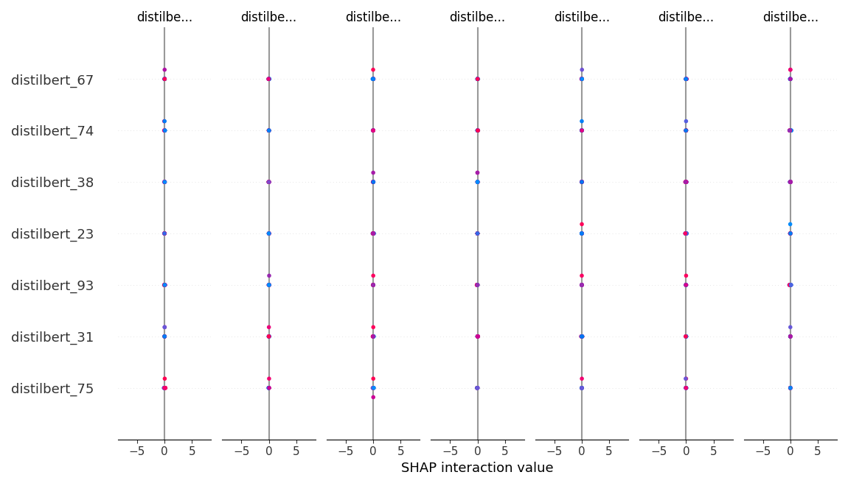
Figure 1: SHAP Summary Plot showing top features influencing the model predictions.

