EX1. Write a C program that prints the following text on the screen:
Hello World!
EX2.: Write a C program to print your name, date of birth. and Address.
EX3.: VIết 1 chương trình hiển thị tổng, hiệu, tích, thương của 2 số 446 và 223 trên màn hình.
Yêu cầu: mỗi biểu thức hiển thị trên một dòng.
Output:
446 + 223 = 669
446 - 223 = 223
446 * 223 = 99458
446 / 223 = 2
EX4.: Write a C program to print a block F using hash (#), where the F has a height of six characters and width of five and four characters.
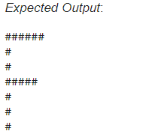

EX5. Write a program to create 2 integer variables a and b, assign value 125 to a and 600to b then display the following result as output.
Output:
a+b =725
Write a program to declare 2 variable a and b which are real numbers, assign value 10.5 to a, 7.3 to b and display the following line as output,
Output:
a/b=1.44
EX6. Give a rectangle with the length of 7.8 and the width of 3.6. Write a program to print the area of this rectangle on the screen as below:
Area= 28.0800
EX7. Write a program to display character ‘d’ on the screen.
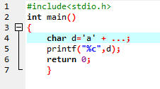

EX8. Explore memory structure of programs
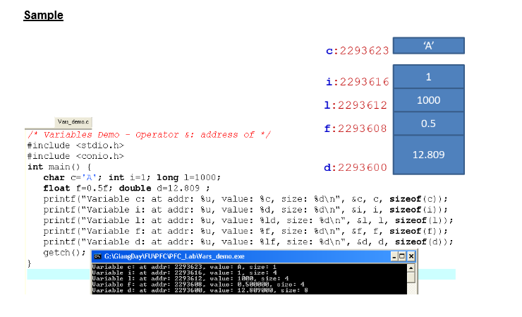

Complete the code of following program then draw it’s memory structure

