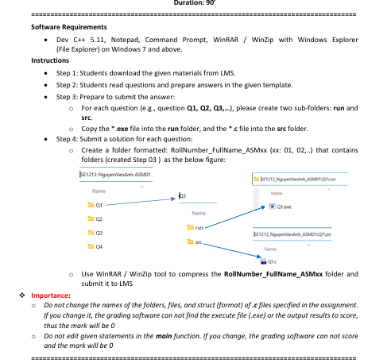

Question 1 (2 marks)
The given file Q1.c already contains statements to input data for 3 sides of a triangle. You should write statements so that print out the area of that triangle.
Notes:
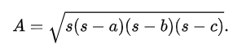
Heron's formula for three side lengths a, b, c:
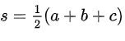

- Do not edit given statements in the main function.
- You can create new function(s) if you see it is necessary.
- The output result is formatted in two decimal places
Sample input and output:
Input: Side1 = 3, Side2 = 3, Side3 = 4
After processing: result = 4.47
Output for marking:
OUTPUT:
4.47

Question 2:
(3 marks)
The given file Q2.c already contains statements to input the integer variable named n. You should write statements to calculate expression value:
$S=1+\frac{1}{3}+\frac{1}{3^{2}}+\frac{1}{3^{3}}+…+\frac{1}{3^{n}}$
Notes:
- You can create new function(s) if you see it is necessary.
- Do not edit given statements in the main function.

Sample input and output:
Input: n =3
After processing: result = 1.481
Output for marking:
OUTPUT:
1.481

Question 3:
(2 marks)
The given file Q3.c already contains statements to input data for the integer 1-D array and the integer variable named 'x'. You should write statements to print out the count of how many times 'x' appears in the array.
Notes:
- You can create new function(s) if you see it is necessary.
- Do not edit given statements in the main function.

Sample input and output:
Input: n = 5
Array: 1 8 8 4 8
x=8
After processing: 3
Output for marking:
OUTPUT:
3

