Theoretical views on social cohesion, group characteristics, and social interactions

The study of social cohesion
The question of what holds societies together or makes them cohesive has long been a sociological inquiry.
Ya Durkheim conceptualizo y describrio la formas elementales de la solidaridad en su forma mecánica - característica de las sociedades tradicionales con fuerte importancia en los lazos de parentesco, en contraste con su forma orgánica característica de las sociedades modernas altamente diferenciadas caracterizadas por una division del trabajo social.

Social cohesion is a contested and multidimensional concept in the social sciences, having differences in operationalization which has led to conflated conceptualization (Chan, To, & Chan, 2006; Schiefer & Noll, 2017). Despite this ambiguity, recent theoretical syntheses and empirical efforts have sought to reinforce the concept, leading to a significant convergence around its measurable core (Dickes, Valentova, and Borsenberger 2010; 2013;Delhey and colleagues, 2023). This renewed focus stems from the need to distinguish the constituent elements of cohesion from its causes, correlates, and consequences (Chan, To, & Chan, 2006; Schiefer & Noll, 2017; Fonseca, Lukosch, & Brazier, 2019). Critiques note that expansive definitions often conflate these elements (Chan, To, & Chan, 2006; Friedkin, 2004). For instance, scholars widely agree that structural factors like economic inequality and poverty are antecedents that erode trust and participation but are not constitutive components of social cohesion (Schiefer & Noll, 2017; Dickes & Valentova, 2013). This analytical maneuver restores clarity by defining cohesion as an emergent phenomenon—either as a state of affairs characterized by trust, identity, and cooperation (Chan, To, & Chan, 2006), or as an ongoing process that enables well-being, belonging, and voluntary participation (Fonseca, Lukosch, & Brazier, 2019).
Conceptually, social cohesion is universally regarded as a collective attribute or macro-level property of a society, such as a country or region (Chan, To, & Chan, 2006; Delhey et al., 2023). However, its empirical measurement is achieved through the aggregation of micro-level data—specifically individual attitudes and behaviors—to describe these societal characteristics (Dickes, Valentova, & Borsenberger, 2010; Schiefer & Noll, 2017). This necessitates frameworks that address micro–macro linkages and reciprocal causation, acknowledging that group-level conditions shape individual attitudes, while individuals’ interactions maintain or transform those conditions (Friedkin, 2004). Measurement designs have converged on a core triad of constituent dimensions: social relations (networks, trust, and acceptance of diversity), identification with the social entity (belonging and attachment), and orientation toward the common good (solidarity and cooperation) (Schiefer & Noll, 2017; Delhey et al., 2023). These dimensions are analyzed across horizontal linkages (interpersonal and intergroup relations) and vertical linkages (state–citizen relations, including institutional trust and legitimacy) (Chan, To, & Chan, 2006). Broader measurement schemes often locate these elements within three major domains of social life: the socioeconomic sphere, the sociocultural/diversity domains, and the politico-value domains, encompassing everything from income distribution to generalized trust and civic participation (Delhey et al., 2023; Dickes, Valentova, & Borsenberger, 2010). Although these structural domains are often included in the overall conceptual scope, empirical validation has confirmed a clear distinction between attitudinal/formal dimensions (e.g., trust) and behavioral/substantial dimensions (e.g., participation) (Dickes & Valentova, 2013).
This study focuses on the subjective-horizontal dimension of social cohesion, operationalized as cross-group solidarity—the expectation that individuals from different social positions (defined by status, religion, nationality, ideology, or values) will act cooperatively and with mutual regard. This concept draws on the Durkheimian tradition of organic solidarity and Blau's (1977) emphasis on social associations across groups as the foundation of macrosocial integration.

Social structure, inhibitors or promoters of social cohesion
In the scholarly discussion of social cohesion, the attention on the factors that affect, either positive or negative, has been mainly on the macro factors that affect the different constituent elements of the above defined horizontal and vertical dimensions of social cohesion [Cites]. As mentioned above, these macro factors can be organized in the socioeconomic, sociocultural diversity and socio-political values domains.
Economic Prosperity
Economic inequality is identified as antecedent that exerts a corrosive impact on cohesion, primarily by undermining interpersonal trust, and by impeding participation (Schiefer & Noll, 2017; Portes & Vickstrom, 2011). Research suggests that while moderate income inequality may be compatible with cohesion, extreme inequality triggers domain-specific erosion (Delhey et al., 2023).
Furthermore, the effect of ethno-racial heterogeneity on cohesion is highly relevant (Delhey et al., 2023; Portes & Vickstrom, 2011). The most significant risk comes from unequal diversity—where heterogeneity is coupled with high segregation and inequality—rather than diversity alone (Portes & Vickstrom, 2011). This evidence underscores the primacy of strong, fair, and inclusive institutions and effective governance, which function as crucial moderators by undergirding the systemic integration and organic solidarity necessary for complex modern societies, thereby neutralizing or reversing negative correlations between diversity and trust (Portes & Vickstrom, 2011; Delhey et al., 2023).
Political: polarizations
https://www.methaodos.org/revista-methaodos/index.php/methaodos/article/view/889/1375
Values: consensus
Against this background, another part of the scholarly discussion has focused on the micro aspect of social cohesion

Las sociedades pueden entenderse como la estructura de relaciones sociales entre individuos. Estas relaciones sociales son las que pueden cohesionar estructuralmente a las sociedades en términos de sus parámetros nominales y graduales, vinculados a la noción de desigualdad de recursos de estatus y heterogeneidad composicional (Blau).
Dicha diferenciación se ve reflejada en la estructuración de los vínculos sociales entre personas de similares características – influenciado por la homofilia (McPherson), como también por las chances de formación de puentes entre miembros de grupos diferentes o la permeabilidad de las relaciones sociales (Wright y Cho).
A este respecto, la atención de la literatura ha estado tanto en características macrosociales como individuales como fuerzas inhibidoras o promotora de la cohesión social.
Las fuerzas inhibidoras son aquellas características que merman o debilitan la cohesión social, mientras que las fuerzas promotoras son aquellas características que incrementan o fortalecen la cohesión social.
En relación con las características macrosociales, parte importante de la literatura ha estado prestado atención tanto a la desigualdad como a la heterogeneidad como factores clave para la cohesión social.
Por ejemplo, se ha argumentado que tanto la heterogeneidad étnica como la desigualdad económica pueden mermar la cohesión social (Lancee).
Adicionalmente, en sociedades más prosperas con estados de bienestar más generosos promueven comportamientos orientados al bien común (Lancee, Delhey et al).
También se ha argumentado que los valores en la sociedad conforman una dimensión normativa que puede operar como un promotor de la cohesión social, especialmente cuando estos valores son compartidos por los miembros de la sociedad.
Estas diferencias observadas en el vínculo entre condiciones macrosociales y cohesión social poseen un correlato a nivel individual en lo que refiere a las relaciones intergrupales.

"How do heterogeneity and inequality affect intergroup and interstratum relations?" (Blau)
[Revisar conceptualizacion de Blau sobre discriminación]
Across all the conceptualization , trust – particularly in its interpersonal form, is considered one of the, if not the most important, constituent of social cohesion.
“multiplexity of social relations” (Small, Mario)
The study of social cohesion and its constitutive dimensions have suggested different paths through which it can be explained. I refer to the characteristics linked to associated to the constituent elements of social cohesion at the individual level. When I refer to these, I consider the attitudinal and behavioral expression of interpersonal and intergroup relationships (horizontal dimension), as well as their links with political institutions (vertical dimension). This study will be focused on the horizontal dimension. When it comes to this dimension I can trace three groups of factors.
“Apart from considering only societal-level approaches I apply Moody and White’s (2003) useful distinction between the ideational and relational dimension of social cohesion to broadly frame these approaches. The ideational dimension refers to shared norms, values and identities as the affective side of social cohesion. The relational dimension refers to the observed relationships between members within a collectivity.” (Janmaat, 2011, p. 63)
“out-group trust to build social relations across different groups, such as social classes, religions, ethnicities, or nationalities, makes it a powerful phenomenon both in civil society and in the political sphere (OECD, 2017; Putnam, 1993; Yamagishi and Yamagishi, 1994).” (Uttenthal, 2024, p. 402)
A common constituent element of social cohesion across literature is interpersonal trust.
“the degree to which parameters intersect, or alternatively consolidate differences in social positions through their strong correlations, reflects the most important structural conditions in a society, which have crucial consequences for conflict (Coleman 1957) and for social integration.” (Blau, 1977, p. 32) incluir esto 'acording to Blau...'
“Both inequality and heterogeneity, the two forms of differentiation, are barriers to social intercourse, on the assumption that proximate status and common group membership promote social associations” (Blau, 1977, p. 32)

 | Nominal | Graduated
person-to-person | group-based (commonality) | status-based (proximity)
person-to-institutions
Integration is “resting on the actual social associations between persons in different segments, not on functional interdependence or common values, though these may contribute to integration by promoting social interaction between persons in different groups and strata” (Blau, 1977, p. 33) “assumption is that social associations are less extensive between persons in different social positions than among those in the same ones, high rates of associations among different groups and hierarchical strata are the criterion of macrosocial integratio” (Blau, 1977, p. 33) macrosocial integration como la cantidad de lazos entre personas de distintos grupos sociales
“Dense networks of ingroup relations integrate individuals in their groups, but they threaten to fragment society, the integration of which depends on extensive intergroup relations.” (Blau, 1977, p. 33)
“The social experience of associating with persons with different backgrounds undoubtedly affects attitudes and conduc” (Blau, 1977, p. 36) It may well broaden people's horizons, promote tolerance, and stimulate intellectual endeavors (Simmel 1908, pp. 685-87; Laumann 1973, pp. 98-105, 126-28). T” (Blau, 1977, p. 36)

Socio-economic domain
How is socioeconomic status related to social cohesion? How is socioeconomic status related to perceived cohesion (trustworthiness) of others?
One is the socioeconomic differences between and within groups. This includes occupational class divides, relative income positions and educational credentials. All these have been studied in different ways by social scientists.
“The obvious interpretation is that health and social problems whose frequency is affected by social status are made worse by increased status differentiation.” (https://www.louischauvel.org/Wilkinson12.pdf)
“When resources are distributed inequitably, people at the top and the bottom will not see each other as facing a shared fate.” (Uslaner and Brown, 2005, p. 869)

[Paragraph about the general question about socioeconomic status and cohesion]
How is individual socioeconomic status (income, education or occupational class) related to social cohesion? What is/are the mechanisms involved in this relationship?
[Paragraph about the empirical findings that link socioeconomic status with social trust]
How is the socioeconomic status of others (income, education or occupational class) related to how they are perceived in terms of trustworthiness? What is/are the mechanisms involved in this relationship?

H1: Persons show higher cohesive attitudes towards high socioeconomic status individuals

Does Chile follow a pyramidal shape? Or is it a diamond?
In that context, the social association of high status is higher with all lower status (higher diversity) This is basically the lower stratas are more numerous in size. By consequence, those in intermediate status should have more social associations with those below them, than above them. But still have more social associations to the high status than those held by the low status groups.
However, blausian idea is:
“Reductions in inequality diminish the impact of status on social associations (T-8).” (Blau, 1977, p. 43)“status distance discourages social associations (A-1.2) and the definition of inequality in terms of average status distanc” (Blau, 1977, p. 43)

Socio-cultural diversity
How are migration and religion related to social cohesion? How are migration and religious background related to perceived cohesion (trustworthiness) of others?
[Paragraph about the general question about socio-cultural diversity and cohesion]
[Paragraph about the theories that link religion with social trust]
[Paragraph about the theories that link migration with social trust]
[Paragraph about the empirical findings that link religion and migration with social trust]
The relationship between religion and interpersonal trust is a multidimensional phenomenon rooted in both the internal logic of faith and the external structures of religious communities. Theoretically, social trust is anchored in the existence of a "moral community" or a "web of commonsense expectations" where shared fundamental norms make the behavior of strangers predictable (Dingemans & Van Ingen, 2015; Salgado et al., 2021). Scholars distinguish between religious integration, which fosters prosociality through communal networks, and individual faith intensity, which may narrow one’s moral circle by creating symbolic boundaries against those perceived as different (Dingemans & Van Ingen, 2015; Welch et al., 2004). Contextually, the "spill-over" mechanism suggests that religious environmentsinstitutionalize values of honesty that affect even non-religious citizens, while fractionalization theories debate whether religious diversity challenges or strengthens the "social glue" of a community (Dingemans & Van Ingen, 2015). Empirically, regular attendance at religious services consistently increases generalized trust by providing functional social networks (Dingemans & Van Ingen, 2015; Welch et al., 2004). In contrast, a high individual "importance of God" (RELIMP) often correlates negatively with trust in strangers, as intense belief can foster suspicion toward outgroups (Berggren & Bjørnskov, 2011; Dingemans & Van Ingen, 2015). Denominational variations are also stark; for instance, in Canada, Mennonites are the most trusting group, while Pentecostals often report the lowest trust, though this can be mitigated by high congregational involvement (Dilmaghani, 2017; Welch et al., 2004). Furthermore, macro-level studies show that religious diversity can actually foster trust, provided it is not accompanied by residential segregation (Dingemans & Van Ingen, 2015).

H2a: Persons show lower cohesive attitudes towards individuals with migration background

Individuals evaluate and trust different religious groups based on social heuristics and ingroup biases. Theoretically, religious people are perceived as more trustworthy because they are associated with a "slow life-history strategy," signaled by traits such as low impulsivity and high family investment (Moon et al., 2018). The perception of being monitored by "Big Gods" who punish immoral behavior is a common theoretical explanation for this attributed trust, though direct behavioral information often overrides religious cues (Moon et al., 2018). Empirically, a strong ingroup bias exists in the United States, where Christians trust other Christians significantly more than they trust Muslims or nonbelievers (Thunström et al., 2021). This evaluation is moderated by religiosity levels: religious individuals trust highly religious others only if they share the same faith, while nonbelievers place less trust in people with high religious commitment (Thunström et al., 2021). Despite these disparities in perception, experimental evidence reveals a gap between perceived trust and actual trustworthiness. For example, while Christians in the US may distrust Muslims, reciprocity tests show that Muslims and Christians are equally trustworthy in economic interactions (Thunström et al., 2021). In contrast, nonbelievers are often the most distrusted group due to prejudices that link morality exclusively to belief in God (Moon et al., 2018; Thunström et al., 2021). Finally, in highly unequal contexts like Chile, socioeconomic status can supersede religion as a signal of trustworthiness, as lower-status individuals tend to distrust those with higher incomes (Salgado et al., 2021).
H2b: Persons show higher cohesive attitudes towards individuals with a religious denomination

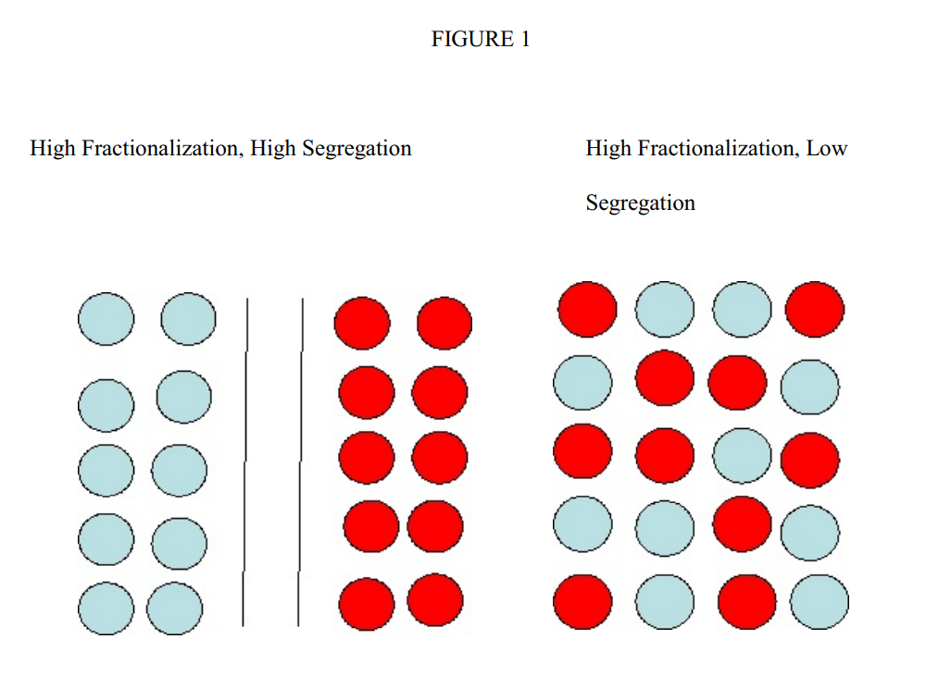
https://papers.ssrn.com/sol3/Delivery.cfm?abstractid=1523709
Another debated aspect is the sociocultural diversity that incorporates ethnic and religious differences between individuals and groups. According to this dimension,

Socio-political values
How are basic human values and political identity (left-right) related to social cohesion? How are basic human values and political identity (left-right) related to perceived cohesion (trustworthiness) of others?
Certain views can be promoters of social cohesion, such as self-transcendence and openness values. This can correlate with ideological positions among progressive/liberal leftist (CITE?)
Lastly, I find that the socio-political value dimension is a distinguishable aspect present in the literature. Here, a usual claim is that similarity can promote social cohesion.
“We conceptualize a socio-political value dimension that integrates individual value priorities (e.g., self-transcendence vs. conservation) with ideological orientations (left–right), reflecting the interplay between cultural values and political positioning.”

Basic human values
The theoretical integration of human values and political identities within social cohesion research necessitates a rigorous distinction between the phenomenon’s constitutive core and its facilitating antecedents (Schiefer and Noll 2017). Prosocial values, such as universalism and benevolence, function as psychological facilitators that smooth interpersonal interactions and foster a predisposition toward cooperation; however, they remain analytically distinct from the state of cohesion itself (Schiefer and Noll 2017). Similarly, political identities—spanning the spectrum from left to right or liberal to conservative—represent the diverse "projects" and "communities of interpretation" inherent in pluralistic societies (Bernard 1999).
H3a: Persons show higher cohesive attitudes towards individuals with self-transcendence values compared to those with self-enhancement values.

Political positioning
Despite being addressed in the social cohesion literature as a relevant factor, is yet unclear whether divide related to political positioning can affect social cohesion.
The role of political positioning on social cohesion has been discussed in related evidence with mixed conclusions.
Theories in social psychology have argued that system-justification ideologies argue that individuals who consider the social system to be fair are also less likely to engage in prosocial activities.
H3b: Persons show higher cohesive attitudes towards politically moderate individuals

“Politics is inherently polarizing. It is about choosing sides and, ideally, also about selecting one ideology over another (Schattschneider 1960).” (Uslaner, 2002, p. 8)
“(…) la confianza generalizada tiende a ser menor en los extremos de la escala ideológica, en particular en el extremo derecho. Esta tendencia resulta consistentecon la hipótesis que vincula la polarización ideológica con una erosión de la confianza interpersonal, y se manifiesta con claridad en los tres periodos analizados (https://www.methaodos.org/revista-methaodos/index.php/methaodos/article/view/889/1375)

Thus, besides socio-economic factors, also political factors appear to cause political distrust. Whereas right-wing individuals are more likely to express political distrust when the Left is in power, left-wing ones are prone to trust less when the Right governs. If the government is relatively centrist, both the radical left and right individuals are likely to become less trustful (Miller, 1974). https://jspp.psychopen.eu/index.php/jspp/article/download/5025/5025.html?inline=1#:~:text=Indeed%2C%20a%20recent%20large%2Dscale,ills%20than%20a%20trusting%20one%E2%80%9D.
Balliet D, Tybur JM, Wu J, Antonellis C, Van Lange PAM. Political Ideology, Trust, and Cooperation: In-group Favoritism among Republicans and Democrats during a US National Election. J Conflict Resolut. 2018 Apr;62(4):797-818. doi: 10.1177/0022002716658694. Epub 2016 Jul 21. PMID: 29593363; PMCID: PMC5858642.

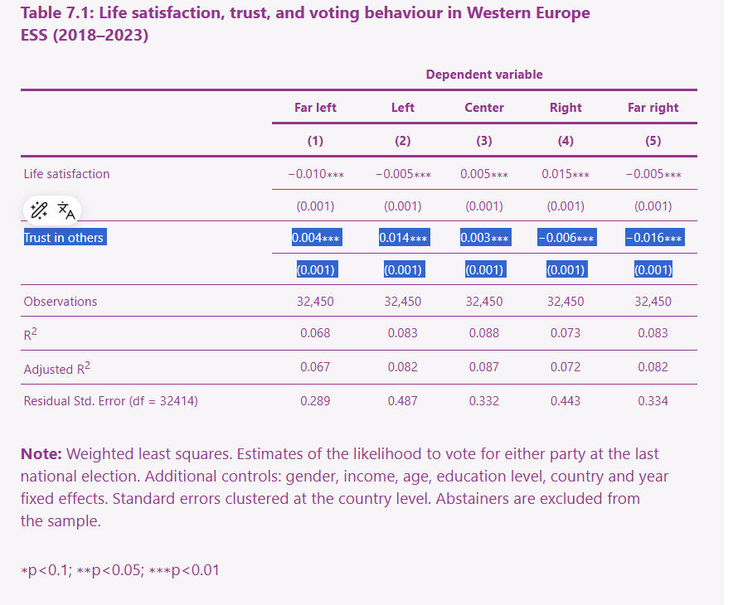
https://www.worldhappiness.report/ed/2025/trusting-others-how-unhappiness-and-social-distrust-explain-populism/#:~:text=anti%2Dimmigration%20foundations.-,Far%2Dleft%20voters%20have%20a%20higher%20level%20of%20social%20trust,to%20support%20income%20redistribution%20policies.

Does similarity affect social cohesion?
There are different manner in which literature has understood same-group interactions and its consequences on attitudes.
The role of homophily, here I have all the revised network literature on attitudes.
Homans’ attitudinal similarity breeds attraction but can operate as echo chambers of political opinion and possibly even reduce social cohesion. For example, social cohesion ca be low in highly segregated societies with lower cross-group exposure.
Value similarity breeds cohesion, but not necessarily at the individual level. The argument is that value similarity “strengthens” the social bond among “different” and promote shared goals in a collectivity.
The literature on intergroup-contact says: positive cross-group (ethnic, migrant, etc) encounters reduce prejudges and promote empathy.

The present study

H1 (socioeconomic)
Higher socioeconomic status people are more trustworthy
H2: (sociocultural diversity)
H2a: Religious people are more trustworthy than those without declared religious beliefs.
H2b: Migrants are less trustworthy than nationals
H3: (socio-political values)
Politically moderate people are more trustworthy than those people on the left and the right sides of the ideological spectrum.
People with self-transcendence values will be more trustworthy in contrast with those with self-enhancement values

H4: Same-group interactions are more trustworthy than cross-group interactions

Theoretical views on social positions, social interactions and social cohesion

Concept of Social Cohesion
Social cohesion is a contested and multidimensional concept in the social sciences, with differences in operationalization that have led to conflated conceptualizations (Chan, To, & Chan, 2006; Schiefer & Noll, 2017). Despite this ambiguity, recent theoretical syntheses and empirical efforts have sought to reinforce the concept, leading to a significant convergence around its measurable core (Dickes, Valentova, & Borsenberger, 2010; Delhey et al., 2023). This renewed focus stems from the need to distinguish the constituent elements of cohesion from its causes, correlates, and consequences (Chan, To, & Chan, 2006; Schiefer & Noll, 2017; Fonseca, Lukosch, & Brazier, 2019). Conceptually, social cohesion is universally regarded as a collective attribute or macro-level property of a society, such as a country or region (Chan, To, & Chan, 2006; Delhey et al., 2023). However, its empirical measurement is achieved through the aggregation of micro-level data—specifically individual attitudes and behaviors—to describe these societal characteristics (Dickes, Valentova, & Borsenberger, 2010; Schiefer & Noll, 2017).
Measurement designs have converged on a core triad of constituent dimensions: (1) social relations (networks, trust, and acceptance of diversity), (2) identification with the social entity (belonging and attachment), and (3) orientation toward the common good (solidarity and cooperation) (Schiefer & Noll, 2017; Delhey et al., 2023). These dimensions are analyzed across two fundamental axes. First, the horizontal axis refers to linkages between individuals and groups within society—interpersonal relations, intergroup trust, and social networks. Second, the vertical axis refers to linkages between individuals and societal institutions—trust in political systems, legitimacy of authorities, and civic engagement (Chan, To, & Chan, 2006). Additionally, a crucial analytical distinction is made between the subjective dimension of cohesion (attitudes, perceptions, feelings of belonging) and the objective dimension (observable behaviors, such as participation in associations, intermarriage rates, or civic engagement) (Dickes & Valentova, 2013).
Across all conceptualizations, trust—particularly in its interpersonal form—is considered one of the most important constituent elements of social cohesion. As Uttenthal (2024, p. 402) notes, "out-group trust to build social relations across different groups, such as social classes, religions, ethnicities, or nationalities, makes it a powerful phenomenon both in civil society and in the political sphere."
In this study, I focus on the subjective aspect of the horizontal dimension of social cohesion. Specifically, I examine interpersonal out-group trust as the dependent variable—the attitudinal disposition to trust individuals from different social groups.

Antecedents of social cohesion – ‘the causes’
Among the factors that affect social cohesion—either positively or negatively—scholarly attention has primarily focused on macro-level conditions that influence the constituent elements of the horizontal and vertical dimensions. These macro factors can be organized into three substantive domains (Delhey et al., 2023; Schiefer & Noll, 2017).
First, the socioeconomic domain encompasses economic prosperity and inequality. Economic inequality is identified as an antecedent that exerts a corrosive impact on cohesion, primarily by undermining interpersonal trust and impeding participation (Schiefer & Noll, 2017; Portes & Vickstrom, 2011). Research suggests that while moderate income inequality may be compatible with cohesion, extreme inequality triggers domain-specific erosion (Delhey et al., 2023). The theoretical mechanism linking inequality to cohesion operates through status differentiation: when resources are distributed inequitably, individuals at different ends of the hierarchy do not perceive themselves as sharing a common fate (Uslaner & Brown, 2005).
Second, the sociocultural domain concerns migration, ethnic heterogeneity, and religious diversity. The effect of ethno-racial heterogeneity on cohesion is highly relevant (Delhey et al., 2023; Portes & Vickstrom, 2011). The most significant risk comes from unequal diversity—where heterogeneity is coupled with high segregation and inequality—rather than diversity alone (Portes & Vickstrom, 2011). Theoretical accounts suggest that diversity can erode trust by reducing shared social networks and increasing perceived threat, though strong institutions can moderate these effects.
Third, the political domain encompasses democracy, institutional quality, and corruption. Strong, fair, and inclusive institutions function as crucial moderators by undergirding the systemic integration necessary for complex modern societies, thereby neutralizing or reversing negative correlations between diversity and trust (Portes & Vickstrom, 2011; Delhey et al., 2023). Conversely, corruption and weak governance undermine both vertical trust (in institutions) and horizontal trust (among citizens).

This study focuses on the subjective-horizontal dimension of social cohesion, operationalized as cross-group solidarity—the expectation that individuals from different social positions (defined by status, religion, nationality, ideology, or values) will act cooperatively and with mutual regard. This concept draws on the Durkheimian tradition of organic solidarity and Blau's (1977) emphasis on social associations across groups as the foundation of macrosocial integration.

Objective social positions
To understand how these macro-level conditions translate into individual-level dispositions toward out-group trust, it is useful to turn to Peter Blau's (1977) macrosociological theory of social structure. For Blau, societies can be understood as the structure of social relations between individuals. These relations are what can structurally integrate societies, and their configuration depends on the distribution of populations across two fundamental types of parameters.
Blau distinguishes between graduated parameters (e.g., income, education) and nominal parameters (e.g., religion, ethnicity, nationality). Graduated parameters generate inequality—the distribution of populations along hierarchical dimensions of status and resources. Nominal parameters generate heterogeneity—the distribution of populations across categorical groups without inherent hierarchy. As Blau (1977, p. 32) states: "Both inequality and heterogeneity, the two forms of differentiation, are barriers to social intercourse, on the assumption that proximate status and common group membership promote social associations."
The central question guiding this approach is: "How do heterogeneity and inequality affect intergroup and interstratum relations?" (Blau, 1977). The answer lies in the intersection or consolidation of parameters: "the degree to which parameters intersect, or alternatively consolidate differences in social positions through their strong correlations, reflects the most important structural conditions in a society, which have crucial consequences for conflict and for social integration" (Blau, 1977, p. 32). For Blau, these are objective demographic parameters—measurable characteristics of populations that shape the opportunities for social associations, independent of individuals' attitudes or values.

Subjective (Ideational) social positions
While Blau's theory provides a powerful framework for understanding how objective population parameters structure social associations, it explicitly downplays the role of normative and value dimensions. Blau (1977, p. 33) states that integration rests on "actual social associations between persons in different segments, not on functional interdependence or common values." However, the social cohesion literature—and related work on social milieus and cultural stratification—suggests that subjective or ideational characteristics can operate analogously to objective parameters in shaping social associations.
Expanding on this point, both status-based and group-based characteristics can also be understood in subjective terms. For instance, Groh-Samberg and colleagues (2014) discuss the cultural dimension in the formation of social milieus in Germany, arguing that shared lifestyles, values, and worldviews create patterns of social closure and affiliation that are not reducible to objective class positions. Similarly, the social psychology literature on homophily (McPherson, Smith-Lovin, & Cook, 2001) demonstrates that individuals tend to form associations with others who share their attitudes, values, and beliefs—often regardless of whether these are tied to objective social positions.
Arguably, there are different subjective characteristics that have been studied in the social sciences as explanatory factors of social associations. In this study, I distinguish between two such characteristics:
- Political ideology (e.g., left, right, or undefined)—a subjective orientation that signals affiliation with broader political projects and communities of interpretation. Political ideology can function as a nominal parameter: individuals categorize others as "like me" or "not like me" based on perceived ideological proximity, even in the absence of objective group markers.
- Human values (e.g., self-transcendence vs. self-enhancement, following Schwartz, 1992)—deep-seated motivational orientations that shape how individuals evaluate others and prioritize different forms of social engagement. Value similarity has been shown to foster trust and cooperation, while value dissimilarity can generate social distance and distrust.
In this study, I aim to understand how different types of "social positions"—both objective (graduated and nominal parameters) and subjective (ideology and values)—are associated with the subjective horizontal dimension of social cohesion, specifically interpersonal out-group trust.

Social Positions and interpersonal expectations
Paragraph: the microlevel gap, why should this have to be studied?
Theories of social cohesion typically treat it as a macro-level phenomenon—an emergent property of societies, regions, or communities. Empirically, however, these theories rely on aggregated survey data to capture individual attitudes and behaviors. What remains underexplored is the micro-level process: how do individuals, situated in particular social positions, develop dispositions to trust—or distrust—others from different groups? This question is particularly relevant for my theoretical framework, which draws on Blau's (1977) insight that social structure is fundamentally about the associations between persons in different social positions. Understanding how structural parameters translate into individual-level associative dispositions requires engaging with theories and empirical evidence from across the social sciences.
In what follows, I organize the micro-level mechanisms according to the typology introduced above. Specifically, I examine how each type of social position—objective-graduated, objective-nominal, subjective-nominal (ideology), and subjective-value-based—shapes individuals' dispositions toward out-group trust. For each, I review relevant theories and empirical findings that illuminate the mechanisms linking position to disposition.

Objective-Graduated Parameters (Socioeconomic Status)
Mechanisms: Status Distance, Resource Signaling, and Homophily
The relationship between socioeconomic status and out-group trust operates through multiple mechanisms. First, status distance discourages social intercourse. Blau (1977, p. 43) proposes that "status distance discourages social associations," and that "reductions in inequality diminish the impact of status on social associations." The implication is that individuals are more likely to form trusting relationships with those who are proximate in status; large status gaps create barriers to mutual understanding and shared experience.
Second, resource signaling suggests that individuals use socioeconomic cues to infer trustworthiness. Higher-status individuals may be perceived as more trustworthy because they are seen as having more to lose from opportunistic behavior, or because they embody cultural capital and competence (Salgado et al., 2021). Conversely, lower-status individuals may face stigmatization and distrust due to negative stereotypes associating poverty with moral failure or unpredictability.
Third, homophily—the tendency to associate with similar others—operates along status lines (McPherson, Smith-Lovin, & Cook, 2001). Individuals prefer to interact with others who share their educational background, income level, or occupational prestige. This preference is not merely a matter of opportunity; it reflects deeper psychological tendencies toward similarity-attraction and the reinforcement of status identities.
Empirical evidence: Experimental studies show that individuals display higher trust toward higher-status others in economic games (Balliet et al., 2018). Survey research consistently finds positive associations between own socioeconomic status and generalized trust, though the causal direction remains debated (Uslaner & Brown, 2005). In the Chilean context, Salgado et al. (2021) find that lower-status individuals tend to distrust those with higher incomes, suggesting that status hierarchies generate asymmetric trust patterns.

Objective-Nominal Parameters (Group Membership)
Mechanisms: Ingroup Bias, Stereotyping, and Intergroup Contact
Nominal parameters—such as religion, ethnicity, or migratory status—structure social associations primarily through ingroup bias and outgroup stereotyping. Social identity theory (Tajfel & Turner, 1979) posits that individuals derive part of their self-concept from group memberships, leading to favoritism toward ingroups and discrimination against outgroups. These biases operate even in the absence of objective conflict, and they are often activated automatically and unconsciously.
Mechanisms of bias: Three mechanisms are particularly relevant. First, categorization simplifies the social world by grouping individuals into "us" and "them." Second, social learning transmits stereotypes and prejudices through family, peers, and media. Third, perceived threat—whether realistic (competition for resources) or symbolic (threat to cultural values)—amplifies outgroup distrust (Stephan & Stephan, 2000).
However, intergroup contact theory (Allport, 1954; Pettigrew & Tropp, 2006) offers a countervailing mechanism: positive contact with outgroup members, under appropriate conditions (equal status, common goals, institutional support), reduces prejudice and increases trust. The effects of nominal parameters on trust are therefore not deterministic; they depend on opportunities for contact and the structural conditions (segregation vs. integration) in which groups interact.
Empirical evidence: Regarding religion, Dingemans and Van Ingen (2015) find that regular religious attendance increases generalized trust by providing functional social networks, while high individual religiosity can reduce trust in outgroups. Thunström et al. (2021) document strong ingroup bias in the United States: Christians trust other Christians more than Muslims or nonbelievers. Regarding migration, Portes and Vickstrom (2011) show that the corrosive effects of ethnic heterogeneity on trust are contingent on inequality and segregation; in contexts of unequal diversity, distrust is higher.

Subjective-Nominal Parameters (Political Ideology)
Mechanisms: Value Signaling, Moral Boundaries, and Partisan Identity
Political ideology—the self-placement along a left-right or liberal-conservative spectrum—functions as a subjective-nominal parameter. Unlike objective nominal parameters (religion, ethnicity), ideology is not visibly marked; it is communicated through language, symbols, and expressed opinions. Yet it can generate powerful ingroup-outgroup dynamics.
Mechanisms: Three mechanisms explain how ideology shapes out-group trust. First, value signaling: ideology communicates moral commitments and worldviews. Individuals use ideological cues to infer whether others share their fundamental values, which serves as a heuristic for trustworthiness (Feldman, 2003). Second, moral boundaries: ideological identities are often tied to moral foundations (Graham, Haidt, & Nosek, 2009). Individuals who perceive others as violating their moral foundations (e.g., care, fairness, loyalty, authority, purity) are less likely to trust them. Third, partisan identity functions similarly to ethnic identity: in contexts of polarization, partisans develop affective attachments to their own political group and animosity toward the opposing group (Iyengar & Westwood, 2015). This "affective polarization" can reduce trust across party lines even when policy disagreements are modest.
Empirical evidence: Balliet et al. (2018) show that during a US national election, Republicans and Democrats displayed strong ingroup favoritism in trust and cooperation. Research from Spain finds that generalized trust tends to be lower at the ideological extremes, particularly on the right (Methaodos, 2024). Uslaner (2002, p. 8) notes that "politics is inherently polarizing," suggesting that ideological divisions may be particularly corrosive to trust. Importantly, ideology operates independently of objective social position: individuals can share ideological affiliations across class, educational, or religious lines, creating cross-cutting ties that may either bridge or deepen social divisions.

Subjective-Nominal-Parameter (Human Values)
Mechanisms: Value Congruence, Motivational Orientations, and Social Distance
Human values—defined as trans-situational motivational goals that guide behavior (Schwartz, 1992)—represent a deeper layer of subjective orientation. Unlike political ideology, which is explicitly political, values encompass broader conceptions of what is good, important, and desirable. The value approach is particularly useful for understanding out-group trust because values are theorized to structure attitudes toward others in systematic ways.
Mechanisms: First, value congruence: individuals trust others who share their value priorities because shared values signal predictability and mutual understanding. Research shows that perceived value similarity increases trust and cooperation, even controlling for demographic similarity (Edgell, Gerteis, & Hartmann, 2006). Second, motivational orientations: Schwartz's (1992) circumplex model distinguishes between values that promote self-transcendence (universalism, benevolence: concern for the welfare of others) and self-enhancement (power, achievement: pursuit of self-interest). Self-transcendence values are positively associated with out-group trust and prosocial behavior, while self-enhancement values are associated with social dominance orientation and reduced empathy (Schiefer & Noll, 2017). Third, social distance: value dissimilarity generates psychological distance. Individuals who prioritize security and conformity may view those who prioritize self-direction and hedonism as threatening or untrustworthy.
Empirical evidence: Schiefer and Noll (2017) argue that prosocial values function as facilitators of social cohesion, smoothing interactions and fostering cooperation. However, they emphasize that values remain analytically distinct from cohesion itself: they are antecedents, not constitutive elements. Dingemans and Van Ingen (2015) find that value orientations moderate the effects of religious participation on trust. In experimental settings, value-based interventions that emphasize universalism can reduce prejudice and increase trust across group boundaries.
Concluding ideas of the theory section
The review above demonstrates that each type of social position—objective-graduated, objective-nominal, subjective-nominal, and subjective-value-based—operates through distinct mechanisms to shape dispositions toward out-group trust. While Blau's original framework focused on objective parameters and the opportunities for association they create, the micro-level evidence suggests that subjective parameters (ideology and values) exert independent effects through cognitive and affective processes such as value signaling, moral boundary formation, and ingroup bias. These findings support the extension of the Blauian framework proposed in this study.
In the following section, I specify the hypotheses derived from this review and describe the empirical strategy for testing them.

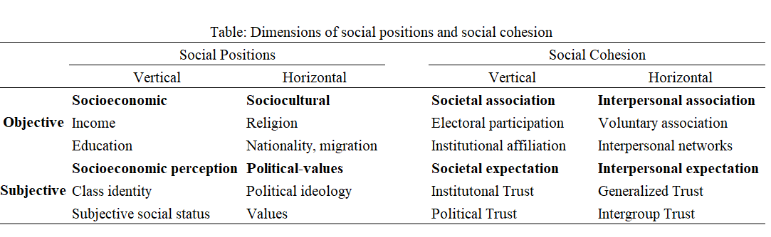

Notes
Think in a three-paragraph structure in American English including the references in APA.
Topic sentence about social cohesion: multidimensional, contested concept in the social science but with recent empirical and theoretical convergency. Also mention that recently there has been research that seek to reinforce the concept with empirical efforts on this, just mention them, because they will be developed in the next paragraph.
Brief review of the theoretical views on “what social cohesion is and what is not” This refers to the commonalities in the theoretical views. Also refers to the differences between them. I think one of the main distinctions is the conflation between causes, consequences and constituent elements of it. Also, mentioning the empirical efforts regarding conceptualization and measurement are key.
An important thing is that social cohesion is usually understood as a macro-level attribute (country, regions, etc) but empirical comes from micro-level data usually. Mention this briefly.
I want to highlight that there are at least three dimensions: socioeconomic, sociocultural diversity and, politico-value domains. These will be reviewed later on in the antecedents.
A final paragraph on what are the factors involved affecting social cohesion.
Please avoid over use of adjective, common in IA text. Keep an academic sociological language.

