Results

How are different social positions linked to positive interactional expectations?
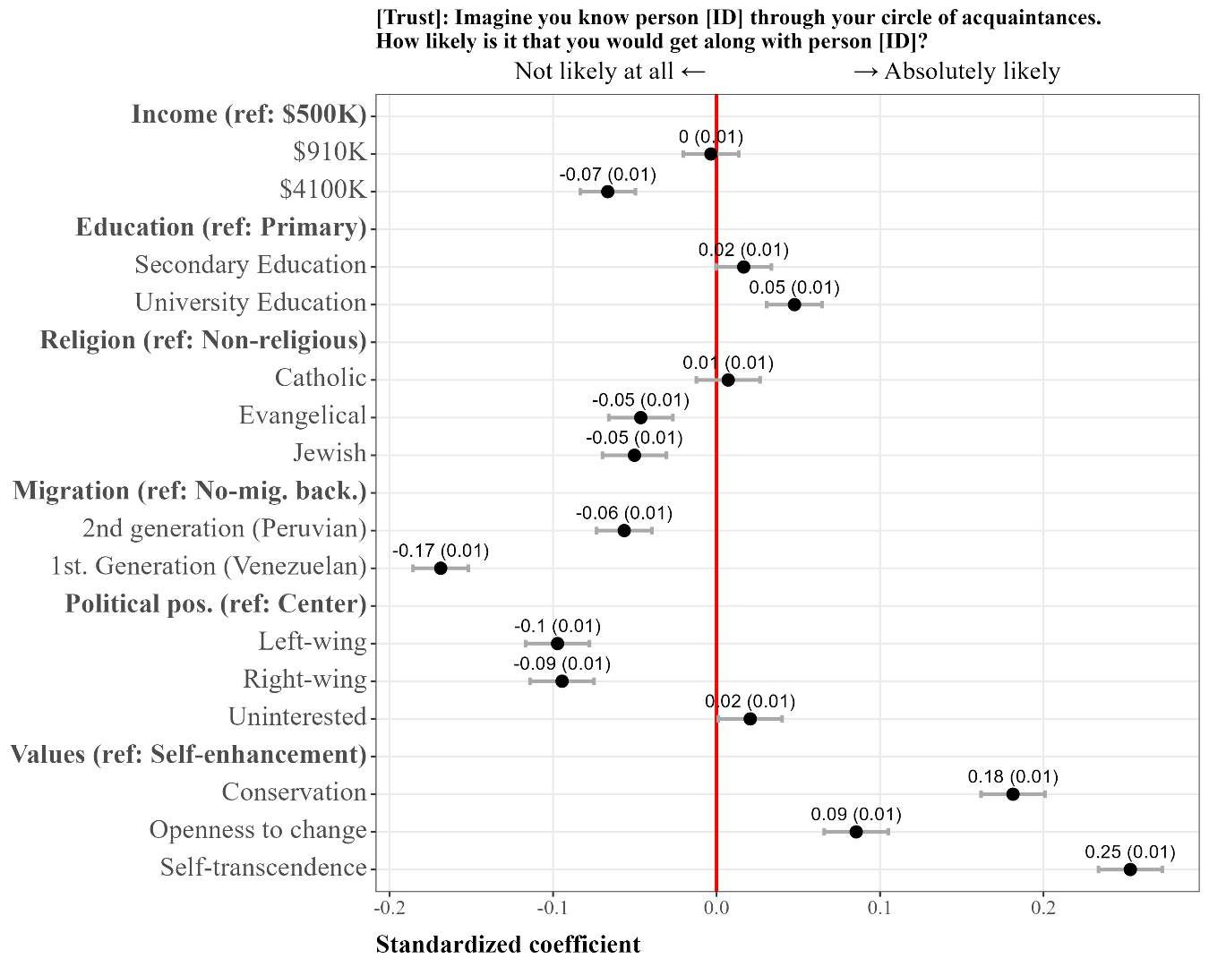
Figure 2: Relationship between social positions and social cohesion
Figure 2 presents the standardized coefficients from the multilevel model estimating the effects of vignette characteristics on positive interactional expectations (full estimates in Table S1). Results are discussed in three thematic groups corresponding to the theoretical framework: socioeconomic position (income and education), sociocultural position (migration background and religious affiliation), and value and ideological position (human values and political orientation).
Regarding income, the coefficient for the middle income category ($910K) is negligible in magnitude (β = 0.00, SE = 0.01) and statistically insignificant. The high income category ($4.1M) is associated with a statistically significant reduction in positive interactional expectations relative to the low-income reference (β = −0.07, SE = 0.01). While statistically significant, this effect is modest in substantive terms: it represents less than a third of the smallest effect observed in the values block. Overall, income differences between vignette persons produce at most marginal effects on anticipated social compatibility.
Regarding education, both secondary (β = 0.02, SE = 0.01) and university education (β = 0.05, SE = 0.01) are associated with statistically significant increases in positive interactional expectations relative to the primary education reference. As with income, however, the substantive magnitude of these effects is small. University education produces the larger of the two effects, suggesting a modest positive gradient, but the overall explanatory contribution of socioeconomic characteristics remains limited compared to the other attribute categories.
Migration background produces the most pronounced negative effects in the model. Relative to vignette persons with no migration background, second-generation Peruvian migrants are associated with a statistically significant and substantively meaningful reduction in positive interactional expectations (β = −0.06, SE = 0.01). First-generation Venezuelan migrants show an even larger statistically significant negative effect (β = −0.17, SE = 0.01), the single largest negative coefficient among all vignette-level predictors. The contrast between these two coefficients is notable: first-generation status and Venezuelan national origin together appear to accumulate into a substantially stronger social distance effect than Peruvian-origin second-generation status alone.
Regarding religious affiliation, Catholic identity produces a statistically insignificant effect relative to the non-religious reference (β = 0.01, SE = 0.01). Evangelical and Jewish affiliations are each associated with statistically significant negative effects of equal magnitude (β = −0.05, SE = 0.01 for both). While the absolute size of these effects remains modest, they indicate that minority religious identities — unlike majority Catholic affiliation — are associated with reduced anticipated social compatibility relative to non-religiosity.
Human values yield the largest effects in the model across all vignette dimensions. Relative to the self-enhancement reference, self-transcendence is associated with the strongest positive effect (β = 0.25, SE = 0.01), followed by conservation (β = 0.18, SE = 0.01) and openness to change (β = 0.09, SE = 0.01), all statistically significant. The magnitude of the self-transcendence effect is notably large — approximately 1.5 times that of the next-largest positive predictor — and substantially exceeds all effects observed in the socioeconomic and sociocultural blocks. This pattern indicates that value orientations emphasizing prosociality, solidarity, and collective orientation are evaluated most favorably, while self-oriented value profiles serve as the least preferred reference point.
Political orientation shows a broadly symmetrical negative pattern for both ideological extremes relative to the center reference. Left-wing affiliation (β = −0.10, SE = 0.01) and right-wing affiliation (β = −0.09, SE = 0.01) are each associated with statistically significant reductions in positive interactional expectations of comparable magnitude. Political disinterest produces a small but statistically significant positive effect (β = 0.02, SE = 0.01). Taken together, these results suggest that perceived ideological distance — regardless of direction — moderately reduces anticipated social compatibility, while the absence of a declared political identity carries a slight positive signal.

To what extent does similarity in social position affect interaction expectations?

Figure 3 presents the cross-level interaction results for socioeconomic position, Figure 4 for sociocultural position, and Figure 5 for value and ideological position. All three figures test whether respondents evaluate vignette persons more favorably when they share the same social characteristics — the homophily hypothesis.
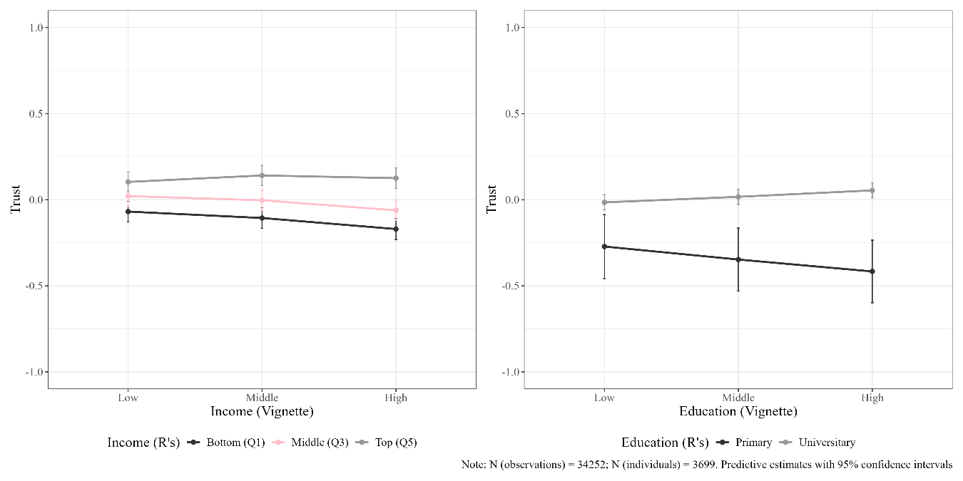
Figure 3: Interaction between vignette and respondent socioeconomic positions
For income (Figure 3, left panel), the three respondent groups — bottom, middle, and top income quintile — follow broadly parallel trajectories across vignette income levels. None of the lines cross in the pattern expected under homophily, and confidence intervals overlap substantially across groups. Bottom-quintile respondents evaluate all vignette income levels somewhat more negatively than top-quintile respondents, but this reflects a main effect of respondent income rather than an interaction. There is no visual evidence of in-group preference: bottom-quintile respondents do not rate low-income vignette persons relatively more favorably, nor do top-quintile respondents show a specific advantage for high-income vignettes. The homophily hypothesis finds no support for income.
For education (Figure 3, right panel), the pattern is more pronounced but does not follow a straightforward homophily logic either. University-educated respondents maintain near-zero and flat predicted values across all vignette education levels, suggesting they evaluate vignette persons similarly regardless of educational attainment. Primary-educated respondents, by contrast, show an increasingly negative gradient as vignette education rises, rating high-education vignette persons substantially more negatively than low-education ones. The two lines diverge rather than crossing at the expected in-group point, suggesting that evaluation asymmetry — rather than mutual in-group preference — characterizes this dimension.
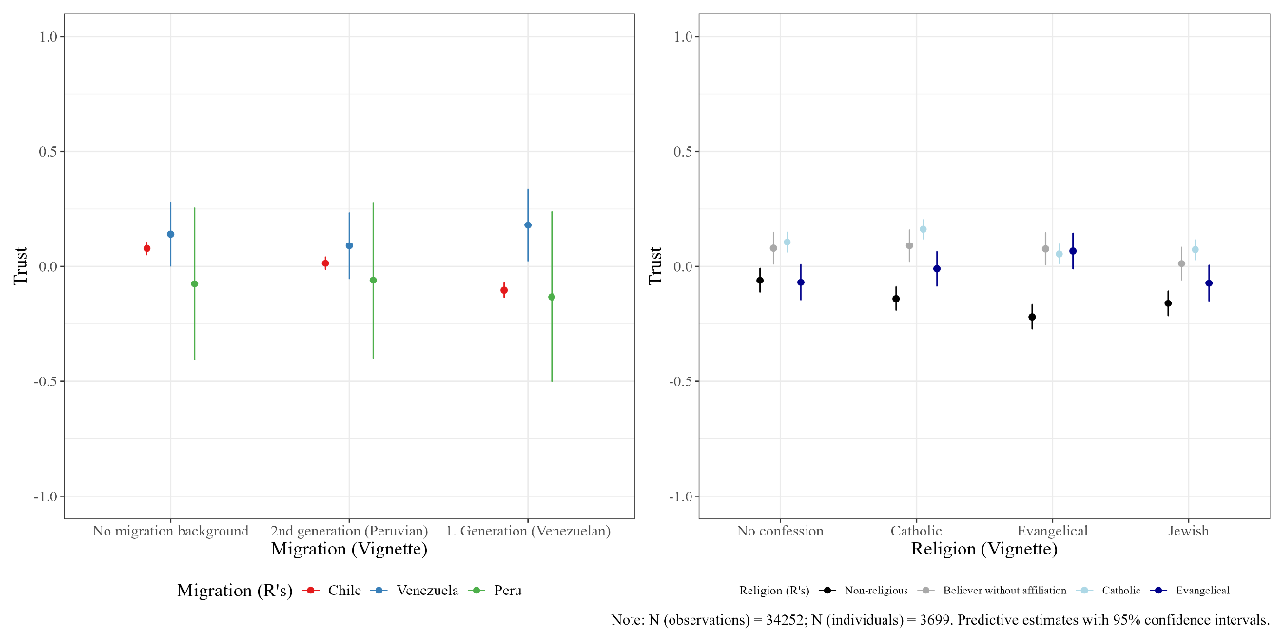
Figure 4: Interaction between vignette and respondent sociocultural positions
Migration background (Figure 4, left panel) produces the most differentiated interaction pattern in the sociocultural block. Chilean-origin respondents show a downward gradient, rating vignette persons progressively more negatively as migration distance increases, with first-generation Venezuelan vignettes receiving the lowest evaluations. Venezuelan-origin respondents display the opposite pattern: they rate first-generation Venezuelan vignette persons clearly more positively than either Chilean or Peruvian respondents do, consistent with in-group preference. Peruvian-origin respondents show no discernible advantage for second-generation Peruvian vignettes and rate first-generation Venezuelan vignettes most negatively of all three groups — a pattern inconsistent with simple homophily but suggestive of stronger out-group devaluation toward Venezuelans among Peruvian respondents specifically. The lines cross between the no-migration and Venezuelan vignette categories, indicating a meaningful interaction, though its form varies substantially across respondent groups.
For religious affiliation (Figure 4, right panel), the interaction patterns are more modest in magnitude and less systematic. Catholic respondents show a slightly elevated evaluation of Catholic vignette persons relative to other religious categories, offering tentative support for in-group preference. Evangelical respondents do not show a corresponding advantage for Evangelical vignette persons, a pattern inconsistent with homophily. Non-religious and believer-without-affiliation respondents maintain relatively stable and near-zero predicted values across vignette religious categories. Overall, confidence intervals overlap considerably across groups, and no clear or consistent homophily pattern emerges for religion.
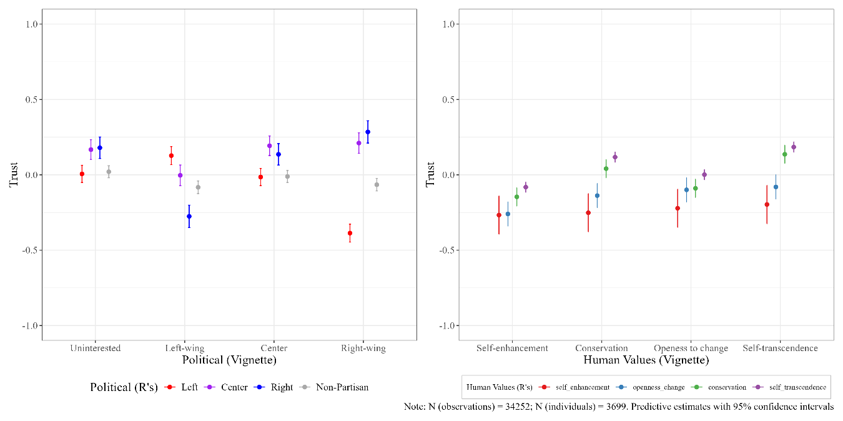
Figure 5: Interaction between vignette and respondent value and ideological positions
Political orientation (Figure 5, left panel) displays the most pronounced and visually clear homophily pattern in the entire analysis. Left-wing respondents rate left-wing vignette persons most favorably and right-wing vignette persons most negatively, with a steep negative gradient from left to right across the vignette axis. Right-wing respondents show the mirror image. Lowest ratings for left-wing vignettes and highest ratings for right-wing vignettes, with the two lines crossing sharply. Center respondents show moderately positive evaluations for center vignettes and attenuate toward both extremes. Non-partisan respondents display a comparatively flat profile with slightly negative values throughout. The crossing of the left and right respondent lines is substantively large, indicating a strong and directionally consistent homophily effect for political orientation.
For human values (Figure 5, right panel), a homophily pattern is also visible, though less pronounced than for political orientation. Self-transcendence respondents show a clear upward gradient from self-enhancement to self-transcendence vignettes, rating value-congruent vignette persons most favorably. Conservation and openness-to-change respondents show more muted gradients, with slight increases at their respective in-group vignette categories. Self-enhancement respondents maintain a relatively flat and negative profile across all vignette value types, showing little differentiation. The overall pattern suggests that value similarity is positively associated with interactional expectations, with self-transcendence respondents displaying the clearest and most consistent in-group preference.

