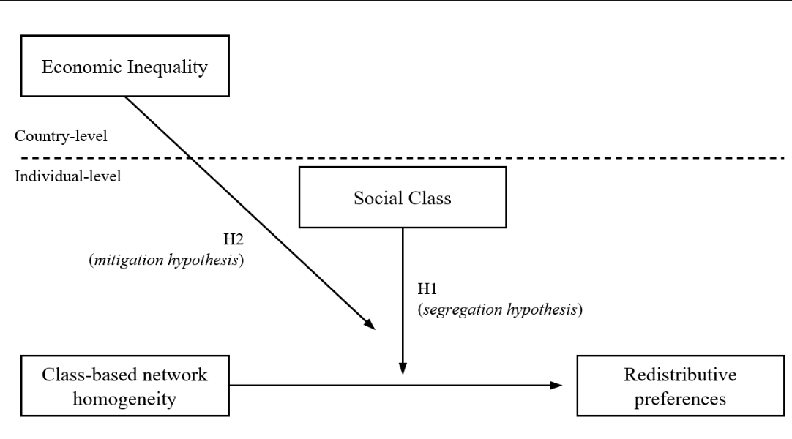

Figure 1: Hypotheses at individual and country levels

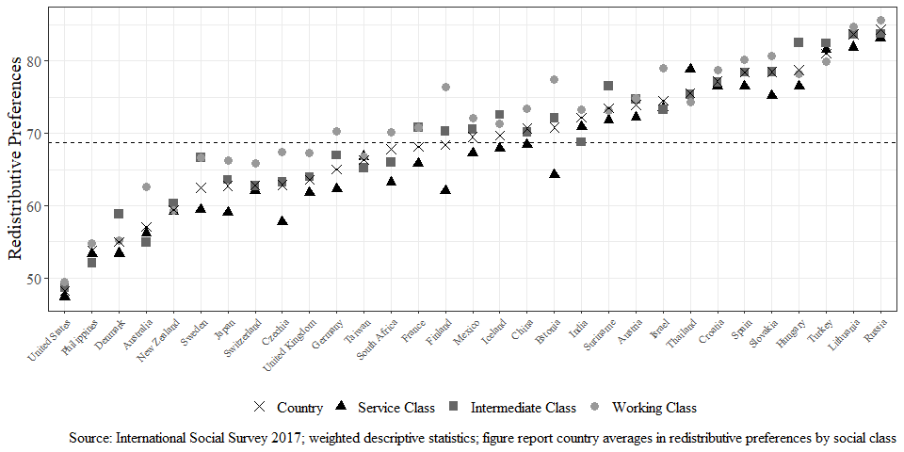

Figure 2: Cross-country differences in redistributive preferences by social class

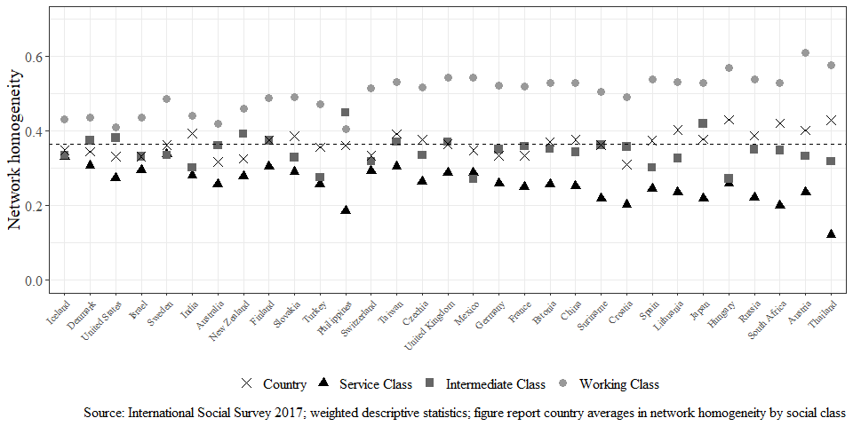

Figure 3: Cross-country differences in network homogeneity by social class

Figure 4: Relationship between income Inequality, network homogeneity and redistributive preferences

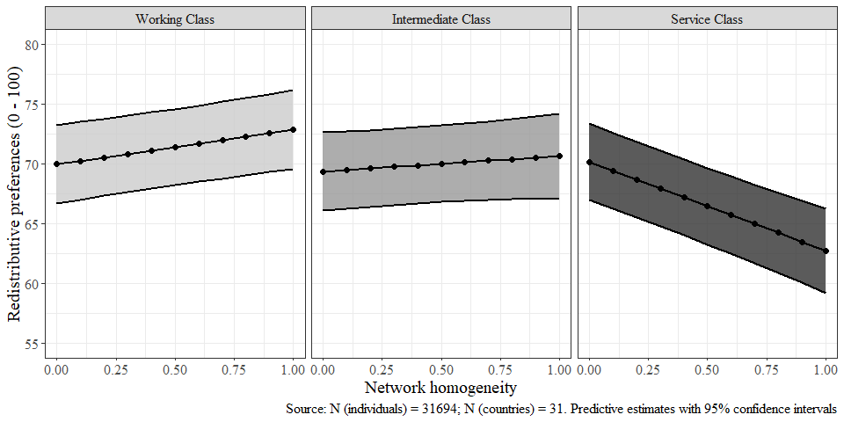

Figure 5: Interaction of network homogeneity and social class on redistributive preferences

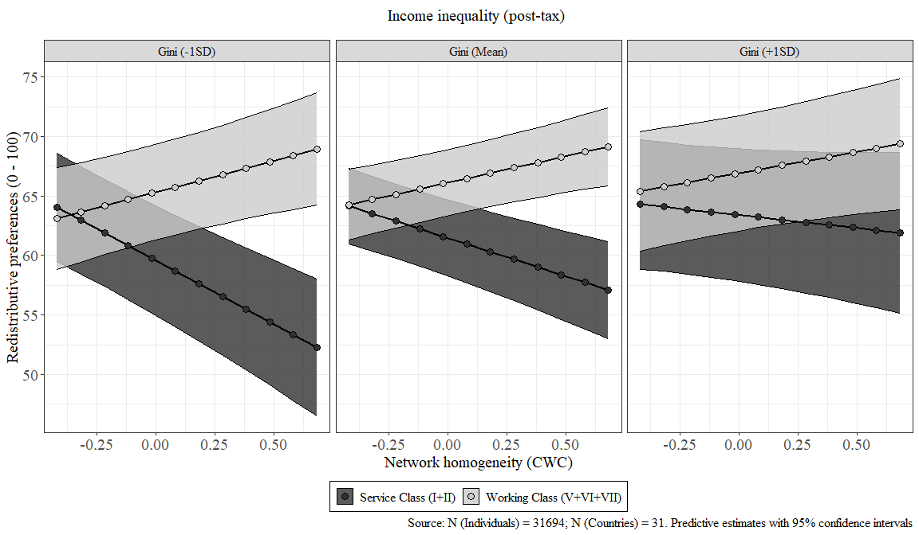

Figure 6: Three-way interaction of network homogeneity, social class, and income inequality on redistributive preferences