# 1 Introduction

The study of redistributive preferences and social class has been mainly focused on the individual and household situation. Despite this, less attention has been paid to the role of social networks as socialization agents of attitudes toward redistribution. It has been stated that friendship and partnership ties tend to be homogeneous in their characteristics, expressing the tendency to form and consolidate homophilous social networks (Lazarsfeld & Merton, 1954; McPherson et al., 2001). Thus, the scope of class analysis in attitude formation urges to be extended to stress the role of social ties and segregation as they involve social processes, such as class identity formation, internalization of shared norms, conflict, and cooperation between classes (Svallfors, 2006). In this respect, recent research has argued that the degree of segregation in the composition of social ties can influence opinions about economic inequality as they function as a window for learning about the lifestyles, economic conditions, and worldviews of other social classes (Mijs, 2018; Otero & Mendoza, 2023). However, there is still a knowledge gap to disentangle the network mechanisms involved in political attitude formation about the role of government in enacting redistributive policies to strive against economic inequality (McCall & Kenworthy, 2009).

The class composition of network ties can influence opinions on redistributive policies, but also the degree of segregation from other social classes in more homogeneous social networks can strengthen the class divide in redistributive preferences (Lee, 2023; Lindh et al., 2021; Paskov & Weisstanner, 2022). While prior research has predominantly focused on examining the impact of social class through an individualistic lens, it is noteworthy that more attention should be devoted to understanding the role of social environments in class relations. This omission is particularly surprising given that class positions are fundamentally rooted in production relations that make them inherently relational, not only in their economic underpinnings but also in the power dynamics entwined within class conflicts (Wright, 1989). In addition, the normative basis of class relations introduces the relevance of the dimensions of solidarity and reciprocity, which have been argued to provide the moral basis for legitimacy and popular support for welfare schemes (Mau, 2003).

Besides the micro-level dynamics, little is known about how contextual factors affect the association between class relations and redistributive preferences. Studies on the class-attitude link posit that economic inequality is crucial for understanding how class relations are mirrored in redistributive demands as it represents the current state of the distributive class struggle in contemporary capitalist societies (Curtis & Andersen, 2015; Edlund & Lindh, 2015). In this matter, a central consistent finding is that the upper classes tend to hold more egalitarian attitudes in contexts of high inequality, while the already high redistributive demands of the working class remain stable regardless of inequality levels. In this discussion, the moral economy approach in sociology argues that the upper classes are more concerned about the integrity of resource allocation procedures as a matter of distributive justice (Sachweh & Sthamer, 2019). Conversely, political economists suggest that the upper classes are more likely to support redistribution policies due to the negative consequences of inequality (Dimick et al., 2017). Nevertheless, when focusing on how inequality can intervene in social relations, previous studies have shown that wider economic gaps lead to segregated forms of social participation and status composition of social networks (Otero, Volker, & Rozer, 2022; Pichler & Wallace, 2007). Indeed, economic inequality reinforces the stratified access to social activities and the social distance between social classes, resulting in an increasing marginalization of the lower classes and consolidating the privileged positions of the upper classes that held better opportunities for diversifying their social activities and interpersonal ties (Lancee & Van de Werfhorst, 2012; Letki & Mieriņa, 2015; Otero et al., 2023).

In this context, no research has comparatively stressed the role of economic inequality in the relationship between network segregation and redistributive preferences. Therefore, the present study aims to answer two research questions. First, at the micro-level, what is the role of class-based network segregation on redistributive preferences? Secondly, to what extent does economic inequality condition the relationship between class-based network segregation and redistributive preferences? To address these questions, we have analyzed data from the International Social Survey Program (ISSP) 2017, which includes a sample of 32,529 individuals across 31 societies. In this regard, the ISSP presents a nonprecedence opportunity as it provides comprehensive information on interpersonal networks, social class, and attitudes toward redistribution.

# 2 Theoretical views on class, social networks, and redistributive preferences

## 2.1 Class divide in redistributive preferences

Over the past decades, the study of redistributive preferences in industrialized societies has consistently demonstrated the importance of social class as a key explanatory factor (Lindh & McCall, 2020, p. 421). Specifically, the relevance of class position has been persistently demonstrated in individual opinions on the government’s role in various aspects of the economic sphere, such as reducing income disparities or enhancing opportunities for those in economic distress (McCall & Kenworthy, 2009).

However, class-based explanations of redistributive preferences have mainly been, but not exclusively, focused on the individual or household situation. It has been claimed that redistributive preferences can be explained through the labor market situation, which comprises access to economic resources and risk exposure (Meltzer & Richard, 1981; Rehm, 2009). Moreover, as material interests might prevail in scarcity, value-driven motivations are a relevant explanatory factor of redistributive preferences (Feldman & Steenbergen, 2001; Kulin & Svallfors, 2013), becoming salient under greater certainty and weaker under material precariousness (Maldonado et al., 2019). Other approaches have suggested that given the substantial time workers spend performing their jobs, social relations in the workspace can also imprint normative views that ultimately shape political opinions (Oesch, 2006). It is argued that continuous interaction with diverse people that characterize interpersonal services can reinforce egalitarian values (Kitschelt & Rehm, 2014). In contrast, the vertical monitoring in managerial occupations and the relevance of autonomy in the case of self-employed can contribute to self-interested and conservative political views (Langsæther & Evans, 2020; Oesch & Rennwald, 2018).

Empirically, the current understanding of the class divides on attitudes regarding the market distribution of resources, and government income redistribution is extensive (Andersen & Yaish, 2018; Brooks & Svallfors, 2010; Curtis & Andersen, 2015; Langsæther & Evans, 2020; Lindh, 2015; Svallfors, 2006). Nevertheless, besides the market situation of individuals and their households, including class-based social ties raises the relevance of how social relations can be understood through the *class situation* because it comprises both economic interests and life chances that motivate communal action beyond the individualistic lens (Weber, 2011, pp. 57–59). Therefore, the role of social relations on redistributive preferences from a network perspective is still urged to be understood beyond mere resource interchanges but as part of the sociability practices that structure class relations.

## 2.2 Class relations and social networks

It is possible to argue that class relations represent not only resource-based distinctions but also patterns of sociability and exchange observed in the differentiation of social ties. Class relations can also be understood as the degree of cross-class relationship as a structural characteristic of a society, representing a network of social ties between different class positions (Blau, 1977). Empirically, homophily in social relations is a consistent finding in the social network literature (McPherson et al., 2001, p. 416). Here, friendship and family tend to be homogeneous in terms of their demographic characteristics that simultaneously intersect with socioeconomic status and class (Bargsted et al., 2020; Lazarsfeld & Merton, 1954; Plaza et al., 2022). Acknowledging that socialization preferences indeed play a role in the formation of segregated networks (Homans, 1951; Visser & Mirabile, 2004), we argue that attitudinal similarity is the result of segregated social relations, which in turn are strongly linked to structural processes of differentiation that ultimately demarcate the opportunities in the formation of diverse social ties (Feld, 1981).

In the discussion on the class composition of social networks, it is possible to find two approaches. On the one hand, one approach has emphasized the role of diversity as the degree of connectedness to dissimilar occupations as social positions that vertically represent access to resources embedded in social networks (Lin, 2007). However, diversity is defined as the rate of dissimilar ties or the total ties to certain groups that do not necessarily count with a reference position to describe the network composition. On the other hand, a second approach has underscored the role of network segregation, which has been described as lacking cross-class network ties and is conceptually more proximate to the homophily principle because it is anchored in individual class positions (Otero et al., 2021).

Empirically, studies on network diversity have shown that higher civic engagement in formal organizations increases the chances of bridging with diverse people among the upper class, in contrast to the more homogeneous participation of the working class (Pichler & Wallace, 2009). Similar patterns have been found in terms of the composition of social ties, where the upper and intermediate classes hold increasingly diverse and prestigious social environments than the working classes (Carrascosa, 2023; Cepić & Tonković, 2020). Also, this segregation pattern holds during the life course, where the upper classes hold increasingly diverse social contacts in contrast to the stable networks of the working classes (Volker, 2020). In contrast, studies that have focused on segregation suggest that the property dimension is much less permeable than authority-based boundaries, given that class interests increase the social distance between proprietors and workers, while the intermediate class position of supervisors and contact frequency with workers make friendship tie formation more likely (Wright & Cho, 1992) Similar studies have shown that the intermediate classes’ higher permeability contrasts with the working class’s more homogeneous networks, suggesting that their limited resources and lower capacity to be socially engaged ultimately result in a lack of social resources that lead to social segregation. In contrast, the upper class is less permeable and homogeneous because it tends to self-select as a practice that ultimately seeks to reproduce its privileged positions (Otero et al., 2021).

## 2.3 Network segregation and attitudes toward redistribution

In addition to individual-based explanations, it is argued that people form opinions in the economic domain based on their social relations. Despite limited research on the link between social networks and redistributive preferences, I identify two broad theoretical approaches that have discussed the role of the social environment in attitude formation.

It has been stated that perceptions about economic inequality rooted in social comparison processes can explain the formation of redistributive preferences (Condon & Wichowsky, 2020). This hypothesis can be traced to the studies on class images and perceived class conflicts (M. D. R. Evans et al., 1992; Kelley & Evans, 1995). Here, the argument posits that people form their beliefs through the individual, family, friends, and coworkers’ experiences instead of the whole society, which is described as an availability heuristic that systematically biases inferences about inequality based on the homophily of reference groups (M. D. R. Evans et al., 1992, p. 467). From this perspective, how people infer the social world is linked to the degree of segregation in their immediate social environment, which influences the intensity and character of the information that ultimately shapes their perceptions of inequality (Mijs & Roe, 2021). Accordingly, experience sharing in conversations with socioeconomically diverse networks has been proven to contribute to the accuracy of the images of income and wealth inequalities compared with people in more segregated networks (Summers et al., 2022). Despite this, I argue that this research field has been mainly focused on the cognitive dimension of preference formation through inequality perceptions, either relying on surveys (Cansunar, 2021; García-Castro et al., 2022) or experimental manipulations (Becker, 2021; Cruces et al., 2013) rather than empirically addressing the role of class segregation in social networks and the claimed influence on attitudes in the economic domain.

In contrast, attitudes towards redistribution may be influenced by the class situation of both the individual and network ties, where social influence processes can either allineate or divide attitudes according to the characteristics of groups and the level of segregation that allows factual contact opportunities. In this context, the lens of a network approach provides a better picture of class relations that nurture social norms and group identity (Kalmijn & Kraaykamp, 2007, p. 550). This claim resembles the fact that classes are characterized as collectivities with differences in their degrees of cohesion and solidarity, encompassing unequal status-based social interactions that are linked to individual or household material well-being, cultural perspectives, and political preferences that structure broader social experiences (Morris & Scott, 1996, p. 48). Furthermore, social integration can be affected in societies with lower contact opportunities between different social classes, where social distance among them widened by extreme inequality can create an “empathy gulf” that comprises barriers to imagining others’ lifestyles (Sachweh, 2012). In this matter, spatially segregated interactions may nurture doubts about worthiness when the lower classes contrast themselves with the lifestyles of the upper classes, which might undermine feelings of social inclusion and cohesion (Sachweh, 2012). Consequently, segregation drives the lives of others to become more distant and might have consequences for empathy and solidarity toward others, potentially leading to the perception of fellow citizens as strangers (Otero, Volker, Rözer, et al., 2022, p. 758).

The attention has increased in recent years to how social ties are connected to attitudes toward inequality, and it has been shown that frequent interactions between classes can lead to different attitudinal changes depending on the individuals’ social class. For instance, contact with the upper classes drives higher justification of economic inequality among the lower classes, whereas interactions with lower classes may prompt the different social classes to question the fairness of income distribution (Vargas Salfate & Stern, 2023). Further evidence suggests that class-based contact diversity shortens the social distance between social classes, providing broader images of the living conditions of others, which can trigger greater concerns about inequality (Otero & Mendoza, 2023) and undermine support for the market distribution of social services (Beck, 2019).

The class position of surrounding family members, friends, and acquaintances influences redistributive preferences as their function as socialization agents, which can be bolstered in segregated social networks. In principle, political attitudes are connected to class interests and norms as they are nurtured in the family of origin during childhood and early adulthood. For instance, it has been shown that individuals with network ties to the upper class through parental connections support redistribution and progressive taxation less than those from working-class family backgrounds (Lee, 2023). Also, as households share risk according to the class position of their members, redistributive preferences are not only affected by their family background but also by partners’ class positions. For example, Paskov & Weisstanner (2022) found that working-class ties bolster redistributive preferences but decrease with upper-class ties, becoming much more intense when the class positions of individuals, partners, and parents form a more homogeneous network. Besides, Lindh et al. (2021) found that when friends and acquaintances are included as network ties, individuals with higher managerial class social ties have lower redistributive preferences than those with higher sociocultural and working-class occupational ties, suggesting that people tend to consider and adjust their attitudes according to the class position of their contacts (Lindh et al., 2021, p. 698).

In summary, the tendency to form homogenous social ties regarding social class is expected to reinforce attitudes and consolidate opinion similarity. Empirically, a weak direct association between homogeneity and redistributive preferences is expected because class segregation does not distinguish between classes as it provides only the *overall* degree of segregation. In contrast, the focus will be on how class-based network homogeneity is conditional to social class. In simpler terms, this is possible by examining the interaction between network homogeneity and social class. Precisely, this will indicate if being segregated into lower (upper) classes leads to stronger (weaker) redistributive preferences ($H_{1}$).

## 2.4 Economic Inequality as context for Class relations and Redistributive Preferences

Studies that have stressed the role of economic inequality on the relationship between social class and redistributive preferences indicate that the lower and the upper classes react differently to rising economic inequality. Theoretically, political economy studies have suggested that high-income individuals are far from monolithic in their redistributive preferences, arguing that their concerns about the harmful *consequences* of economic inequality (e.g., crime) ultimately motivate altruistic support for redistribution (Dimick et al., 2017, 2018; Rueda, 2018; Rueda & Stegmueller, 2016). Conversely, the moral economy literature has suggested that the differences among the affluent can be explained as a matter of justice distributive evaluations about the *procedures* for resource allocation (Atria et al., 2020; Liebig & Sauer, 2016). Hence, affluent groups are more sensitive because they perceive that increasing inequality undermines opportunities for social mobility (Sachweh, 2017). Likewise, lower perceived inequality of opportunity among the upper classes can motivate support for redistribution as a matter of justice in the conditions for getting ahead (Kim & Lee, 2018). In contrast, low-income individuals perceive ascribed characteristics as more important in constraining the opportunity structure, regardless of current income inequality. (Sachweh & Sthamer, 2019, p. 656).

Regarding social networks, prior studies have argued that social relations are directly linked to resource access and how these are distributed in society. For instance, Neckerman & Torche (2007, p. 344) suggest that experiencing marginalization is deeply associated with the life chances to participate openly in social life, which can be exacerbated in contexts of greater material inequality. Also, economic inequality can lead to greater perceived status competition (García-Sánchez et al., 2024; Wilkinson & Pickett, 2010), which in turn hampers the establishment of trustworthy social ties among those facing economic distress (Salgado et al., 2021). In contrast, it has also been argued that societies with robust welfare institutions and lower economic inequality foster social engagement in civic and social activities, thereby enhancing social trust between citizens and bolstering social solidarity (Kragten & Rözer, 2017; Lynch et al., 2004; Uslaner & Brown, 2005).

Empirically, comparative evidence shows that already-stratified access to social activities and diverse networks is strengthened in unequal societies (Lancee, 2017). In this regard, Pichler & Wallace (2009) show that class differences in participation in civic (formal) and family (informal) networks are deepened in more unequal societies. Similarly, Lancee & Van de Werfhorst (2012) have found that the stratified civic participation by income level is strengthened as inequality rises. Other studies have shown that low-income individuals hold more extensive close networks and rely on family ties to seek support in unequal societies but rely more on external ties to pursue resources (Letki & Mieriņa, 2015). Likewise, economic inequality enhances stratified access to contact network diversity due to greater interdependence between cultural, economic, and social capital (Otero et al., 2023). Thus, the upper classes can navigate diverse social settings while remaining segregated, whereas the lower classes may experience greater marginalization and segregation because of the choices of others (Otero et al., 2021, p. 24).

It has been argued that state-organized redistribution reflects political class conflict in a modern industrialized capitalist society, and social classes should not be undervalued as vehicles of antagonism and social tension (Edlund & Lindh, 2015, p. 323). In this line, economic inequality is crucial in moderating conflicts as it can impact the political consensus for supporting redistribution between classes. One potential implication is that the decline in social trust, civic participation, and prosocial attitudes could undermine the normative basis for collective solidarity (Uslaner & Brown, 2005). As a result, less cohesive societies can nurture stronger class polarization that undermines egalitarian attitudes (Andersen & Yaish, 2018), making the middle classes less prone to support policies favoring the working classes. However, in contexts of rising economic inequality, the middle classes tend to have greater political awareness about the causes and incentives of economic inequality (Svallfors, 2006, pp. 66–67), as well as its consequences for class conflict and cohesion (Kelley & Evans, 1995). Additionally, it has been suggested that perceived social conflict decreases in societies with lower material inequality and a predominant middle-class imaginery (Hertel & Schöneck, 2022). Therefore, in more unequal societies, those who are better-off are more likely to support redistribution than their counterparts in more egalitarian contexts, where their attitudes gradually converge with the interests of the working class (Curtis & Andersen, 2015).

To summarise, it has been shown that economic inequality increases the dependency of network segregation with class positions, leading the working classes to be equally segregated regardless of income inequality compared to the increasingly diverse networks of the upper classes (Otero et al., 2023; Pichler & Wallace, 2009). Consequently, it is expected that class-based network segregation in unequal societies might have a weaker association with redistributive preferences. Thus, economic inequality is expected to *mitigate* the association of class-based network segregation with redistributive preferences ($H_{2}$).

# 3 Data, variables and method

## 3.1 Data

Individual data from the International Social Survey Programme (ISSP) 2017, titled “Social Networks and Social Resources,” is utilized (ISSP Research Group, 2019). Established in 1984, the ISSP is a collaborative research project that conducts cross-national surveys on various topics related to social issues, attitudes, and values. Specifically, the ISSP 2017 survey includes questions on social ties and activities, evaluated through a position generator, as well as inquiries on social resources derived from network members. Additionally, respondents express their views on topics such as social trust and attitudes toward economic inequality. Initially, the dataset comprised 47,027 individual observations across 32 countries. However, Slovenia (SVN) was excluded from the analysis because the key dependent variable was not present in the questionnaire. Consequently, the present study comprises complete information on 32,529 individuals from 31 countries, representing a group of diverse societies in terms of socio-economic and institutional arrangements.

## 3.2 Variables

### *Individual level*

Two indicators available in the questionnaire were used to measure redistributive preferences. First, support for government redistribution (1) is measured by the item ‘It is the responsibility of the government to reduce the differences in income between people with high incomes and those with low incomes.’ and the egalitarian preferences represented by the item (2) ‘For a society to be fair, differences in people’s standard of living should be small.’ indicators are five-point Likert scales with the categories ‘Strongly agree’ (1), ‘Agree’ (2), ‘Neither agree nor disagree’ (3), ‘Disagree’ (4) and ‘Strongly disagree’ (5). Second, due to the correlation between the indicators (r = 0.7) and following previous research, the indicators were reverse-coded to compute the average values. They were then rescaled to create an indicator that ranges from 0 to 100, where higher values reflect stronger redistributive preferences (Svallfors, 2013).

For measuring social class, the Erikson-Goldthorpe-Portocarrero (EGP) class Scheme is employed (Erikson & Goldthorpe, 1992; Erikson et al., 1979). The EGP is one of the most consistent and validated measures for social class positions in comparative research (G. Evans & Graaf, 2013) and has demonstrated its validity in regions of the industrialized world, as well as in countries of late industrialization (Barozet et al., 2021; Ishida & Miwa, 2008; Solís et al., 2019; Torche, 2005; Wang & Olivos, 2024). Therefore, using the recently developed DIGCLASS algorithm (Cimentada et al., 2023), information regarding (i) occupational codes, (ii) self-employment status, and (iii) the number of workers was used to classify respondents into class positions. In line with previous research on political attitudes, this study utilizes a collapsed version of three classes (Edlund, 2003; Sosnaud et al., 2013). Accordingly, the class scheme contemplates the (i) Service Class (Higher and Lower managerial and professionals), (ii) Intermediate Class (Routine nonmanual and Self-employed), and (iii) Working Class (Manual supervisors, skilled manual and unskilled manual).

The position generator is employed to create our measure of network homogeneity based on social class. This instrument has been widely employed in social capital studies, relying on the assumption that access to social resources is based on ties to different positions in the social structure following an ego-centered network approach (Lin & Dumin, 1986; van der Gaag et al., 2008). In this case, the position generator displays a list of ten occupations where the respondent declares four possible options through which this tie is classified: “Family or relative”, “Close friend”, “Someone else I know”, and “No one”. In the case of the indicator used here, the first three categories are classified as “Knows” = 1 and “Does not know” = 0. Based on this, it is possible to obtain the total number of a person’s social ties. Subsequently, the occupations are classified into three groups resembling social class positions (Otero et al., 2021; Sapin et al., 2020). First, the (i) lawyer, (ii) executive of a large firm, and (iii) human resource manager are classified as high-status. Second, the (iv) school teacher, (v) police officer, and (vi) nurse are considered intermediate-status. Third, (vii) car mechanic, (viii) bus driver, (iv) hairdresser, and (v) home or office cleaner are low-status occupations.

As the network status groups are employed as proxies of social class positions, the number of similar or ingroup social ties is calculated according to the respondents’ class position and provides the absolute number of similar ties. Subsequently, the number of ingroup ties is divided by the total number of contacts to provide a measure of network homogeneity that seeks to represent the share of similar social ties within the personal network (Otero, Volker, Rözer, et al., 2022; Völker, 2022). Here, zero represents that all social ties are *different* (heterogeneity), while one means that all social contacts are *similar* (homogeneity). In substantial terms, higher values represent higher social distance from other social classes in society.

Regarding control variables, the number of social ties is included to guarantee that the observed influence of network homogeneity is independent of network size. Second, socioeconomic characteristics are sequentially incorporated in the models as they represent the current social status in terms of income, educational skills, and labor market risk (Häusermann et al., 2015; Kitschelt & Rehm, 2014; Meltzer & Richard, 1981). In addition, gender, age, and marital status are included in all models as a sociodemographic characteristic to control for the potential influence of gender norms and life course events on attitudes (Alesina & La Ferrara, 2005; VanHeuvelen & Copas, 2018; Waitkus & Minkus, 2021).

### *Macro level*

The primary societal characteristic under examination is the current levels of economic inequality, for which we have utilized the Gini Index (post-taxes and transfers) sourced from the World Income Inequality Dataset (WID) (Alvaredo et al., 2022). Additionally, two contextual variables are incorporated as controls in the multilevel models. Firstly, employing the Gross Domestic Product (GDP) available in the WID ensures consistency in the economic inequality estimates independently of economic property (Finseraas, 2009; Schmidt-Catran, 2016). Secondly, to account for heterogeneity in institutional arrangements stemming from welfare schemes, a measure of the size of the welfare state is included (see Edlund & Lindh, 2015). The measure is a standardized and rescaled indicator from 0 to 100 that combines (i) tax revenue as a percentage of GDP (ILO, 2022), (ii) welfare generosity as total governmental spending as a share of GDP (ILO, 2022), and (iii) the current level of redistribution (Solt, 2020).

## 3.3 Method

Multilevel linear models account for the hierarchical structure of the data, where individuals are nested within countries. Therefore, the analysis begins with estimating the null model by declaring the nested structure using random intercept. This initial model assesses the intraclass correlation, revealing that 13.5% of the variance in redistributive preferences can be attributed to belonging to higher-level units (countries). Subsequently, the micro-level models are estimated to determine the association between network homogeneity and the interaction with social class to test the *segregation* hypothesis ($H_{1}$). Following this, macro-level models are estimated by incorporating random intercepts alongside random slopes for network homogeneity and social class to determine whether economic inequality moderates the effect of the micro-level interaction ($H_{2}$). Therefore, a three-way cross-level interaction is estimated to determine if income inequality moderates the interaction between network homogeneity and social class [1]. In the macro-level models, all the individual-level factors are group-mean centered (CWC) to mitigate possible collinearity problems (Hox, 2010). Additionally, all the country-level factors have been standardized (z-scores) to ease comparability in the estimations (Hox, 2010).

# 4 Results

## 4.1 Descriptive

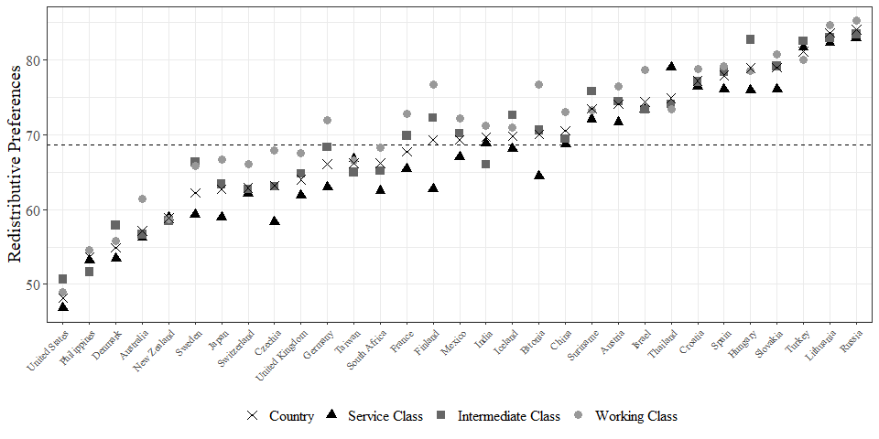

Figure 4.1: Cross-country comparison of Redistributive preferences and Social Class

Figure 4.1 depicts the distribution of redistributive preferences across countries and social classes. First, it is possible to notice that the United States has lower redistributive preferences, whereas Russia is a society where redistributive preferences are stronger among all social classes. As was expected, in most societies, the working class holds stronger redistributive preferences in contrast to the intermediate and services classes, with four exceptions where the differences are close to zero between both classes. However, it is also notable that there are some differences between the two extreme cases. For example, in the U.S., the working class held lower redistributive preferences (49.1) than the intermediate class (50.6), but still above the service class (46.8). In contrast, in Russia, the general pattern of higher preferences among the working class is maintained, with an escalated decrease in the working (85.5), intermediate (83.5), and service class (83.0).

Another interesting fact is related to class differences in redistributive preferences. For example, the differences between the service and the working class are close to 2.3 points in the United States. At the same time, Finland represents the average case in the distribution but is also one of societies with the greater class divide in redistributive preferences, showing a gap of 14.1 points between the upper and the lower classes. Interestingly, Russian society depicts class differences similar to the U.S., with an average difference of 2.4 points.

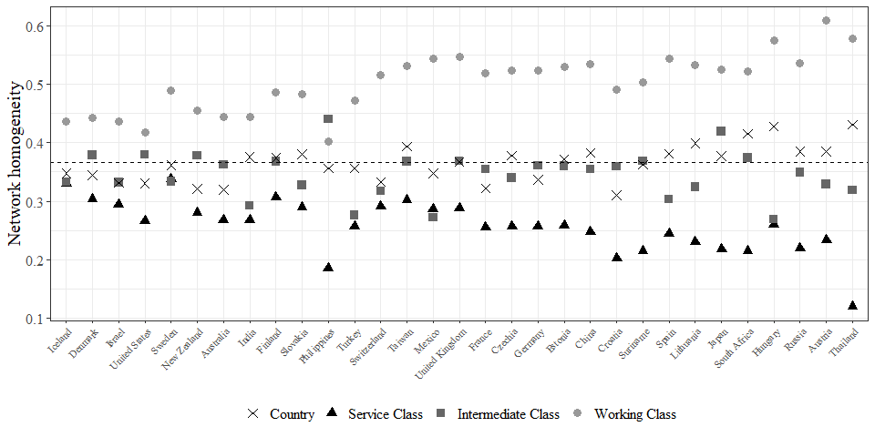

Figure 4.2: Cross-country comparison of Network homogeneity and Social Class

Regarding network segregation, Figure 4.2 depicts the distribution of network homogeneity and social class across countries. In contrast to redistributive preferences, the distribution of network homogeneity is more scattered between countries and social classes. However, it is worth to mention at least two interesting findings. First, looking at the sample average (M = 0.36), we can notice that the variation between countries is low (SD = 0.08), with Thailand being the society with higher levels of network segregation (M = 0.43), and Iceland among lowest (M = 0.31). Second, it is depicted that the working class network homogeneity drives the pattern of homogeneity. In addition, the general pattern is that the service class is less segregated than the intermediate and working class. Besides, an interesting fact is that in some cases (e.g., Mexico), although the working class remains highly segregated (above 0.5), the intermediate and service classes are similar in their network homogeneity. As noticed, in most cases observed, the general pattern is that the working class is highly homogeneous in their networks, except in the Philippines, where the intermediate class shows a slightly higher average homogeneity. Overall, one of the most substantial findings is that the working class is more segregated than the services class.

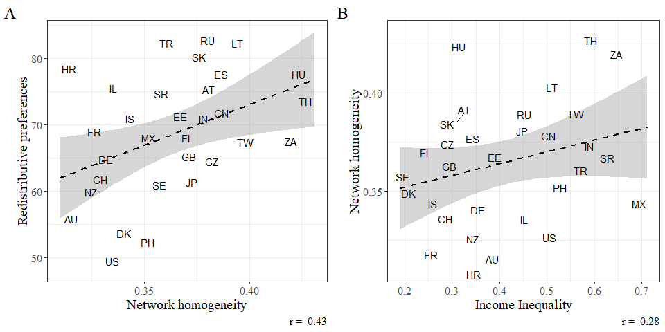

Figure 4.3: Bivariate relationships between Income Inequality, Network homogeneity and Redistributive preferences

Moving to the bivariate macro relationships, Figure 4.3 depicts the correlation between network homogeneity, redistributive preferences, and income inequality, our main societal characteristic of interest. First, according to Cohen (1988), for effect size criteria, we observe a medium positive and significant association between network homogeneity and redistributive preferences in Panel A (*r* = 0.43, *p* <.001). In concordance with the previously depicted distribution, we know that higher levels of network homogeneity are driven by the highly segregated networks of the working classes; what makes it logical that in countries where network homogeneity is high, this might also reflect greater social segregation among the working classes and consequently drive higher redistributive preferences. Second, Panel B depicts a positive but relatively weak and non significant association between income inequality and network homogeneity (*r* = 0.28, *p*<.01). In other words, average homogeneity also tends to increase in societies with greater income gaps. However, the macro association only shows the general pattern between countries but does not allow us to look deeper into class differences according to the levels of inequality.

Interestingly, certain countries with higher levels of inequality and network homogeneity are societies that present class differences between the working class and the services class (e.g., Thailand or Mexico). By contrast, more egalitarian countries tend to be less homogeneous and have smaller class differences (e.g., Denmark or Sweden). As an additional exploratory analysis (see Fig. 6.1), we have found that the association between income inequality and the gap in network homogeneity between the upper and lower classes tends to be moderate and statistically significant (*r* = 0.3, *p*<.01). In other words, income inequality not only increase homogeneity overall but higher social distance between social classes as well.

## 4.2 Multivariate results

The multilevel analysis results are shown in Table ??. Regarding the first hypothesis, the central argument is that class segregation has differential consequences on redistributive preferences. In other words, the association between network homogeneity and redistributive preferences is conditional on class position.

Model 1 integrates our measure of network homogeneity. Initially, as previously noted in the macro associations, individuals with more homogeneous networks tend to exhibit stronger redistributive preferences. This association persists in Model 2, where we control for network size. However, after including social class in Model 3, the relationship between homogeneity and redistributive preferences appears to reverse, with a reduction in statistical significance (*p*<0.10). Subsequently, Model 4 incorporates income, education in years and employment status. As expected, socioeconomic status is negatively associated with redistributive preferences regarding household economic resources and educational credentials. In addition, we find that people outside the labor market do not differ significantly from those who are economically active in their preferences. Finally, in Model 5, we see that by incorporating the interaction term between network homogeneity and social class, we observe that the working and intermediate class interaction terms are positive and statistically significant. Based on Model 5, Figure 4.4 shows increased redistributive preferences in homogeneous working-class networks and the intermediate class. For the service class, the relationship is reversed, where more homogeneous networks for this social class decrease redistributive preferences. Altogether, these results provide evidence in favor of hypothesis 1, where the class divide in redistributive preferences becomes stronger for individuals with more homogeneous social networks.

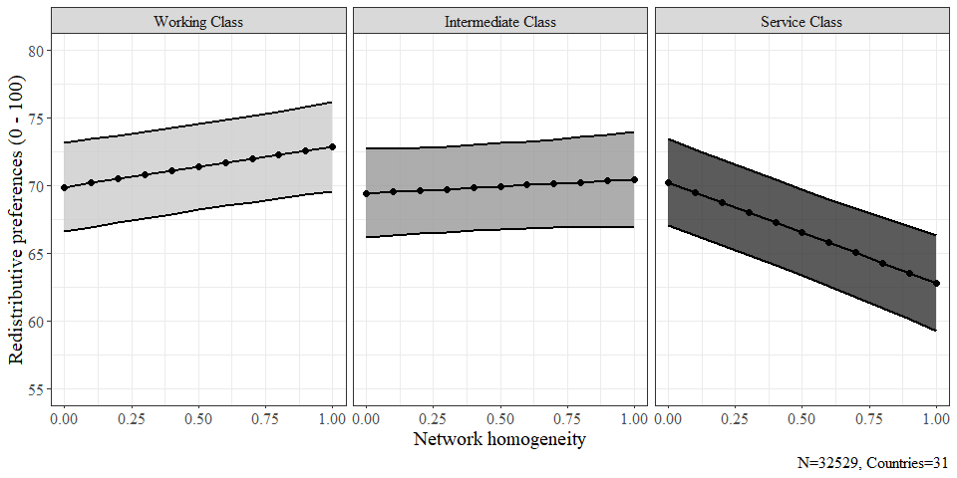

Figure 4.4: Interaction of network homogeneity and social class on redistributive preferences

Table ?? presents the results of the multilevel models for income inequality. In Model 1, income inequality demonstrates a positive association, as expected, yet it fails to reach significance. Subsequently, Model 2 incorporates economic prosperity through GDP per capita, revealing a negative and significant relationship (*p* > .05). Furthermore, Model 3 indicates that including the size of the welfare state establishes a positive and significant relationship (*p* > .05). In contrast, GDP per capita maintains its negative association with redistributive preferences (*p* > .01). In other words, in Model 3, economic prosperity appears to depress redistributive preferences. Nevertheless, higher redistributive preferences are observed in countries with more generous welfare states.

Finally, Model 4 incorporates the three-way interaction to determine whether the interaction of network homogeneity and social class on redistributive preferences is moderated by income inequality. First, the relationship observed at the micro level retains its original meaning, indicating that segregation in terms of network homogeneity strengthens the class divide in redistributive preferences. Second, the three-way interaction suggests that higher economic inequality weakens the interaction of network homogeneity and social class. To better illustrate this result, Figure 4.5 depicts how the relationship between network homogeneity and social class is more pronounced in societies of lower income inequality and gradually diminishes as inequality increases. In other words, the results provide evidence in favor of Hypothesis 2, suggesting that the greater class divide in redistributive preferences observed in more segregated class-based social networks weakens as income inequality increases.

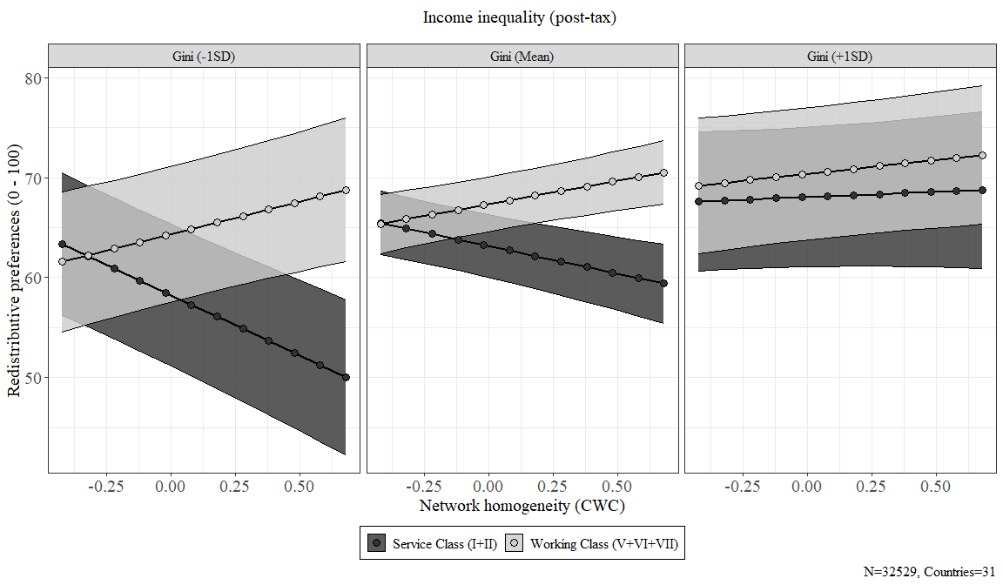

Figure 4.5: Three-way interaction of network homogeneity, social class and income inequality on redistributive preferences

# 5 Discussion and conclusion

In this research, we ask how class-based network segregation is related to preferences for redistribution and to what extent economic inequality conditions this relationship. In this context, the literature on interpersonal networks has shed light on how network structure harbors not only social resources (Lin & Dumin, 1986; Otero et al., 2021) but also carries the capacity to establish niches that contribute to the formation of political opinions through social influence, as well as the degree of network segregation (Lindh et al., 2021; Paskov & Weisstanner, 2022). In this case, the micro-level relationship under scrutiny was that class-based network segregation does play a role in redistributive preferences. In contrast to evidence on the undermining role of network homogeneity on social cohesion (Otero, Volker, Rözer, et al., 2022), redistributive preferences are not the case. Indeed, we found that greater homogeneity in terms of social class has a polarizing effect on redistributive preferences because it has differentiated attitudinal consequences according to class position. In other words, for working-class members, homogeneity strengthens their redistributive preferences, while in the service class, homogeneity translates into even lower redistributive preferences.

Our theoretical approach has established that social classes should be understood beyond labor market relationships but as relational networks that can provide an explanatory framework for attitude formation. Theoretically, what the literature has established as processes of social influence (Lindh et al., 2021) or political socialization (Lee, 2023) has echoed in how social closure in interpersonal networks generates distance between different social classes in terms of their redistributive preferences. Here, the extent to which social classes distance themselves in terms of network segregation indeed creates an “empathy gulf” (Sachweh, 2012) that can be observed in how the service class is less willing to take action to strive with inequality as a matter of collective commitment when they are highly segregated in homogeneous upper-class environments (Otero & Mendoza, 2023), in contrast to the increasing redistributive pressures of the marginalized working class. Besides, as network homogeneity represents low cross-class ties, it can be argued that lower social integration (Blau, 1977) can undermine social solidarity as it consolidates weaker chances of contact between social classes and the lack of knowledge about the lives of others (Vargas Salfate & Stern, 2023).

While the results are substantially consistent at the micro level, our theoretical framework established alternative scenarios regarding the role of economic inequality. In short, our competing hypothesis suggested that income inequality, which represents greater gaps in economic and social resources, should be related to class relations and redistributive preferences. In line with the social cohesion argument, it is suggested that social relations are undermined by economic inequality as it represents the distribution of available resources and, consequently, might *amplify* the relationship between segregation and redistributive preferences given the increase in social distance between social classes. However, the evidence indicates the opposite as it shows that inequality *mitigates* the micro-level relationship, which translates into a narrower class gap, mainly through changes in redistributive preferences in the service class. These results resonate with two key pieces of evidence on the role of inequality on (i) class relations and (ii) redistributive preferences. It has been argued that in unequal societies, the better-off class position tends to become more egalitarian in their stances on economic inequality (Edlund & Lindh, 2015; Sachweh & Sthamer, 2019). Additionally, recent cross-national studies suggest that upper classes can consolidate their distinctive position while their advantages allow them to navigate diverse networks at the expense of the marginalization of the poor in contexts of greater inequality (Otero et al., 2023).

This research is a contribution to the field of study on social class and redistributive preferences, but it also contributes to previous studies that have emphasized the role of social ties in redistributive preferences (Edlund, 2003; Langsæther & Evans, 2020; Newman, 2014). In addition to the micro-level contribution, the cross-national component of this research dialogue with previous studies on the role of income inequality on social networks (Letki & Mieriņa, 2015; Otero et al., 2023; Pichler & Wallace, 2009) and class-based research on redistributive preferences (Curtis & Andersen, 2015; Edlund & Lindh, 2015). Besides, this research broadly contributes to the ongoing research on social cohesion beyond Western industrialized countries, as our analyses include a heterogeneous group of societies.

In the end, our research has been reached with limitations. On the side of our dependent variable, a two-item index is a rough proxy of what we conceptually claim as redistributive preferences. It is well established in the literature that the popular responses to economic inequality are diverse regarding how the government strives with economic inequality (García-Sánchez et al., 2022; McCall & Kenworthy, 2009). In addition, the position generator included in the ISSP is limited in terms of the capability to reflect the class structure more precisely, mainly regarding the self-employed and the intermediate-class occupations. In this regard, we are aware of the limitations of the instrument, and therefore, we present these results with prudence. Finally, it has been established that network formation is structured by contact opportunities (Feld, 1981), but values-based interaction also play a role in consolidating networks (Visser & Mirabile, 2004). Thus, the cross-sectional nature of our data does not allow us to make causal claims because there could be problems of endogeneity between class position, the composition of social ties, and attitudes.

To summarize, future survey research should consider better measurement strategies for attitudes in the economic domain, such as market-based social services, willingness to pay taxes as redistributive measures, or direct focalized transfers. In addition, the network dimension can be better approached with a more detailed measurement strategy incorporating other aspects of the occupational structure, such as authority or autonomy in the labor market. Finally, the causality-related issues can be addressed by employing longitudinal designs.

# 6 References

Alesina, A., & La Ferrara, E. (2005). Preferences for redistribution in the land of opportunities. *Journal of Public Economics*, *89*(5-6), 897–931. <https://doi.org/10.1016/j.jpubeco.2004.05.009>

Alvaredo, F., Atkinson, A. B., Piketty, T., & Saez, E. (2022). World inequality database. WID.world.

Andersen, R., & Yaish, M. (2018). Preferences for the Distribution of Incomes in Modern Societies: The Enduring Influence of Social Class and Economic Context. *Canadian Public Policy / Analyse de Politiques*, *44*(2), 190–205. Retrieved from <https://www.jstor.org/stable/90022701>

Atria, J., Castillo, J., Maldonado, L., & Ramirez, S. (2020). Economic Elites’ Attitudes Toward Meritocracy in Chile: A Moral Economy Perspective. *American Behavioral Scientist*, *64*(9), 1219–1241. <https://doi.org/10.1177/0002764220941214>

Bargsted, M., Espinoza, V., & Plaza, A. (2020). Pautas de homofilia en Chile. *Papers. Revista de Sociologia*, *105*(4), 583. <https://doi.org/10.5565/rev/papers.2617>

Barozet, E., Boado, M., & Marqués-Perales, I. (2021). The Measurement of Social Stratification: Comparative Perspectives Between Europe and Latin America. In P. López-Roldán & S. Fachelli (Eds.), *Towards a Comparative Analysis of Social Inequalities between Europe and Latin America* (pp. 171–202). Cham: Springer International Publishing. <https://doi.org/10.1007/978-3-030-48442-2_6>

Beck, G. (2019). *Explorando la asociación entre redes de contacto ocupacionales y la justificación de la desigualdad social en Chile* (Master’s thesis). Pontificia Universidad Católica de Chile, Santiago de Chile.

Becker, B. (2021). Significant others? Social groups, income expectations, and redistributive preferences. *Social Science Research*, *100*, 102612. <https://doi.org/10.1016/j.ssresearch.2021.102612>

Blau, P. (1977). A Macrosociological Theory of Social Structure. *American Journal of Sociology*, *83*(1), 26–54. Retrieved from <https://www.jstor.org/stable/2777762>

Brooks, C., & Svallfors, S. (2010). Why does class matter? Policy attitudes, mechanisms, and the case of the Nordic countries. *Research in Social Stratification and Mobility*, *28*(2), 199–213. <https://doi.org/10.1016/j.rssm.2010.01.003>

Cansunar, A. (2021). Who Is High Income, Anyway? Social Comparison, Subjective Group Identification, and Preferences over Progressive Taxation. *The Journal of Politics*, 000–000. <https://doi.org/10.1086/711627>

Carrascosa, J. (2023). Class inequalities in access to social capital in the metropolitan area of Buenos Aires. *Social Networks*, *72*, 59–69. <https://doi.org/10.1016/j.socnet.2022.09.003>

Cepić, D., & Tonković, Ž. (2020). How social ties transcend class boundaries? Network variability as tool for exploring occupational homophily. *Social Networks*, *62*, 33–42. <https://doi.org/10.1016/j.socnet.2020.02.003>

Cimentada, J., Vidal-Lorda, G., Gil-Hernández, C., & Smallenbroek, O. (2023). DIGCLASS: A package to translate between occupational classes in R. R package version 0.0.1.

Cohen, J. (1988). *Statistical power analysis for the behavioral sciences* (2nd ed). Hillsdale, N.J: L. Erlbaum Associates.

Condon, M., & Wichowsky, A. (2020). *The Economic Other: Inequality in the American Political Imagination*. University of Chicago Press. <https://doi.org/10.7208/chicago/9780226691909.001.0001>

Cruces, G., Pérez Truglia, R., & Tetaz, M. (2013). Biased perceptions of income distribution and preferences for redistribution: Evidence from a survey experiment. *Journal of Public Economics*, *98*(5699), 100–112. <https://doi.org/10.1016/j.jpubeco.2012.10.009>

Curtis, J., & Andersen, R. (2015). How Social Class Shapes Attitudes on Economic Inequality: The Competing Forces of Self-Interest and Legitimation. *International Review of Social Research*, *5*(1), 4–19. <https://doi.org/10.1515/irsr-2015-0002>

Dimick, M., Rueda, D., & Stegmueller, D. (2017). The Altruistic Rich? Inequality and Other-Regarding Preferences for Redistribution. *Quarterly Journal of Political Science*, *11*(4), 385–439. <https://doi.org/10.1561/100.00015099>

Dimick, M., Rueda, D., & Stegmueller, D. (2018). Models of Other-Regarding Preferences , Inequality , and Redistribution, (December 2013), 1–20. <https://doi.org/10.1146/annurev-polisci-091515-030034>

Edlund, J. (2003). The Influence of the Class Situations of Husbands and Wives on Class Identity, Party Preference and Attitudes Towards Redistribution: Sweden, Germany and the United States. *Acta Sociologica*, *46*(3), 195–214. Retrieved from <https://www.jstor.org/stable/4194983>

Edlund, J., & Lindh, A. (2015). The democratic class struggle revisited: The welfare state, social cohesion and political conflict. *Acta Sociologica*, *58*(4), 311–328. <https://doi.org/10.1177/0001699315610176>

Erikson, R., & Goldthorpe, J. H. (1992). *The constant flux: A study of class mobility in industrial societies*. Oxford, UK: Oxford University Press.

Erikson, R., Goldthorpe, J. H., & Portocarero, L. (1979). Intergenerational Class Mobility in Three Western European Societies: England, France and Sweden. *The British Journal of Sociology*, *30*(4), 415. <https://doi.org/10.2307/589632>

Evans, G., & Graaf, N. D. de (Eds.). (2013). *Political choice matters: Explaining the strength of class and religious cleavages in cross-national perspective* (1st ed). Oxford: Oxford University Press.

Evans, M. D. R., Kelley, J., & Kolosi, T. (1992). Images of Class: Public Perceptions in Hungary and Australia. *American Sociological Review*, *57*(4), 461. <https://doi.org/10.2307/2096095>

Feld, S. L. (1981). The Focused Organization of Social Ties. *American Journal of Sociology*, *86*(5), 1015–1035. Retrieved from <https://www.jstor.org/stable/2778746>

Feldman, S., & Steenbergen, M. R. (2001). The Humanitarian Foundation of Public Support for Social Welfare. *American Journal of Political Science*, *45*(3), 658. <https://doi.org/10.2307/2669244>

Finseraas, H. (2009). Income inequality and demand for redistribution: A multilevel analysis of european public opinion. *Scandinavian Political Studies*, *32*(1), 94–119. <https://doi.org/10.1111/j.1467-9477.2008.00211.x>

Ganzeboom, H. B. (2010). A new international socio-economic index (ISEI) of occupational status for the international standard classification of occupation 2008 (ISCO-08) constructed with data from the ISSP 2002–2007. In *Annual Conference of International Social Survey Programm* (Vol. 1). Lisbon.

García-Castro, J. D., García-Sánchez, E., Willis, G. B., Castillo, J. C., & Rodríguez-Bailón, R. (2022). Perceived Economic Inequality Measures and Their Association With Objective Inequality and Redistributive Preferences. *Social Psychology*, *53*(5), 277–291. <https://doi.org/10.1027/1864-9335/a000498>

García-Sánchez, E., Castillo, J. C., Rodríguez-Bailón, R., & Willis, G. B. (2022). The Two Faces of Support for Redistribution in Colombia: Taxing the Wealthy or Assisting People in Need. *Frontiers in Sociology*, *7*, 773378. <https://doi.org/10.3389/fsoc.2022.773378>

García-Sánchez, E., Matamoros-Lima, J., Moreno-Bella, E., Melita, D., Sánchez-Rodríguez, Á., García-Castro, J. D., … Willis, G. B. (2024). Perceived Economic Inequality Is Negatively Associated with Subjective Well-being through Status Anxiety and Social Trust. *Social Indicators Research*. <https://doi.org/10.1007/s11205-024-03306-x>

Häusermann, S., Kurer, T., & Schwander, H. (2015). High-skilled outsiders? Labor market vulnerability, education and welfare state preferences. *Socio-Economic Review*, *13*(2), 235–258. <https://doi.org/10.1093/ser/mwu026>

Hertel, F. R., & Schöneck, N. M. (2022). Conflict perceptions across 27 OECD countries: The roles of socioeconomic inequality and collective stratification beliefs. *Acta Sociologica*, *65*(3), 231–249. <https://doi.org/10.1177/0001699319847515>

Homans, G. C. (1951). *The human group.* (pp. xxxiv, 484). Piscataway, NJ, US: Transaction Publishers.

Hox, J. J. (2010). *Multilevel analysis: Techniques and applications* (2. ed). New York: Routledge, Taylor & Francis.

ILO. (2022). *World Economic Outlook Database*.

Ishida, H., & Miwa, S. (2008). Trends in intergenerational class mobility and education in japan. In *Social Stratification and Social Mobility in Late-Industrializing Countries* (pp. 1–48).

ISSP Research Group. (2019). International Social Survey Programme: Social Networks and Social Resources - ISSP 2017. GESIS Data Archive. <https://doi.org/10.4232/1.13322>

Kalmijn, M., & Kraaykamp, G. (2007). Social stratification and attitudes: A comparative analysis of the effects of class and education in Europe1. *The British Journal of Sociology*, *58*(4), 547–576. <https://doi.org/10.1111/j.1468-4446.2007.00166.x>

Kelley, J., & Evans, M. D. R. (1995). Class and class conflict in six western nations. *American Sociological Review*, *60*(2), 157–178. Retrieved from <https://www.jstor.org/stable/2096382>

Kim, H., & Lee, Y. (2018). Socioeconomic status, perceived inequality of opportunity, and attitudes toward redistribution. *The Social Science Journal*, *55*(3), 300–312. <https://doi.org/10.1016/j.soscij.2018.01.008>

Kitschelt, H., & Rehm, P. (2014). Occupations as a Site of Political Preference Formation. *Comparative Political Studies*, *47*(12), 1670–1706. <https://doi.org/10.1177/0010414013516066>

Kragten, N., & Rözer, J. (2017). The Income Inequality Hypothesis Revisited: Assessing the Hypothesis Using Four Methodological Approaches. *Social Indicators Research*, *131*(3), 1015–1033. <https://doi.org/10.1007/s11205-016-1283-8>

Kulin, J., & Svallfors, S. (2013). Class, values, and attitudes towards redistribution: A European comparison. *European Sociological Review*, *29*(2), 155–167. <https://doi.org/10.1093/esr/jcr046>

Lancee, B. (2017). Diversity, trust and social cohesion. In *Trust at Risk: Implications for EU Policies and Institutions* (pp. rust in Justice In: Heiko Prange–Gstöhl 152).

Lancee, B., & Van de Werfhorst, H. G. (2012). Income inequality and participation: A comparison of 24 European countries. *Social Science Research*, *41*(5), 1166–1178. <https://doi.org/10.1016/j.ssresearch.2012.04.005>

Langsæther, P. E., & Evans, G. (2020). More than self-interest: Why different classes have different attitudes to income inequality. *The British Journal of Sociology*, *71*(4), 594–607. <https://doi.org/10.1111/1468-4446.12747>

Lazarsfeld, P. F., & Merton, R. K. (1954). Friendship as a social process: A substantive and methodological analysis. In T. Morroe & C. H. Page (Eds.), *Freedom and control in modern society* (Vol. 18, pp. 18–66). New York: Van Nostrand.

Lee, J. (2023). Consider your origins: Parental social class and preferences for redistribution in the United States from 1977 to 2018. *Social Science Research*, *110*, 102840. <https://doi.org/10.1016/j.ssresearch.2022.102840>

Letki, N., & Mieriņa, I. (2015). Getting support in polarized societies: Income, social networks, and socioeconomic context. *Social Science Research*, *49*, 217–233. <https://doi.org/10.1016/j.ssresearch.2014.08.002>

Liebig, S., & Sauer, C. (2016). Sociology of Justice. In C. Sabbagh & M. Schmitt (Eds.), *Handbook of Social Justice Theory and Research* (pp. 37–59). New York, NY: Springer New York.

Lin, N. (2007). *Social capital: A theory of social structure and action* (Repr). Cambridge: Cambridge Univ. Pr.

Lin, N., & Dumin, M. (1986). Access to occupations through social ties. *Social Networks*, *8*(4), 365–385. <https://doi.org/10.1016/0378-8733(86)90003-1>

Lindh, A. (2015). Public Opinion against Markets? Attitudes towards Market Distribution of Social Services – A Comparison of 17 Countries. *Social Policy & Administration*, *49*(7), 887–910. <https://doi.org/10.1111/spol.12105>

Lindh, A., Andersson, A. B., & Volker, B. (2021). The Missing Link: Network Influences on Class Divides in Political Attitudes. *European Sociological Review*, *37*(5), 695–712. <https://doi.org/10.1093/esr/jcab010>

Lindh, A., & McCall, L. (2020). Class Position and Political Opinion in Rich Democracies. *Annual Review of Sociology*, *46*(1), 419–441. <https://doi.org/10.1146/annurev-soc-121919-054609>

Lynch, J., Smith, G. D., Harper, S., Hillemeier, M., Ross, N., Kaplan, G. A., & Wolfson, M. (2004). Is income inequality a determinant of population health? Part 1. A systematic review. *The Milbank Quarterly*, *82*(1), 5–99. <https://doi.org/10.1111/j.0887-378x.2004.00302.x>

Maldonado, L., Olivos, F., Castillo, J. C., Atria, J., & Azar, A. (2019). Risk Exposure, Humanitarianism and Willingness to Pay for Universal Healthcare: A Cross-National Analysis of 28 Countries. *Social Justice Research*. <https://doi.org/10.1007/s11211-019-00336-6>

Mau, S. (2003). *The moral economy of welfare states: Britain and Germany compared*. London ; New York: Routledge.

McCall, L., & Kenworthy, L. (2009). Americans’ Social Policy Preferences in the Era of Rising Inequality. *Perspectives on Politics*, *7*(3), 459–484. <https://doi.org/10.1017/S1537592709990818>

McPherson, M., Smith-Lovin, L., & Cook, J. M. (2001). Birds of a Feather: Homophily in Social Networks. *Annual Review of Sociology*, *27*, 415–444. Retrieved from <https://www.jstor.org/stable/2678628>

Meltzer, A. H., & Richard, S. F. (1981). A Rational Theory of the Size of Government. *Journal of Political Economy*, *89*(5), 914–927. <https://doi.org/10.1086/261013>

Mijs, J. (2018). Inequality Is a Problem of Inference: How People Solve the Social Puzzle of Unequal Outcomes. *Societies*, *8*(3), 64. <https://doi.org/10.3390/soc8030064>

Mijs, J., & Roe, E. L. (2021). Is America coming apart? Socioeconomic segregation in neighborhoods, schools, workplaces, and social networks, 1970–2020. *Sociology Compass*, *15*(6). <https://doi.org/10.1111/soc4.12884>

Morris, L., & Scott, J. (1996). The Attenuation of Class Analysis: Some Comments on G. Marshall, S. Roberts and C. Burgoyne, ’Social Class and the Underclass in Britain in the USA’. *The British Journal of Sociology*, *47*(1), 45. <https://doi.org/10.2307/591115>

Neckerman, K. M., & Torche, F. (2007). Inequality: Causes and Consequences. *Annual Review of Sociology*, *33*(1), 335–357. <https://doi.org/10.1146/annurev.soc.33.040406.131755>

Newman, B. J. (2014). My Poor Friend: Financial Distress in One’s Social Network, the Perceived Power of the Rich, and Support for Redistribution. *The Journal of Politics*, *76*(1), 126–138. <https://doi.org/10.1017/S0022381613001138>

Oesch, D. (2006). *Redrawing the Class Map*. London: Palgrave Macmillan UK. <https://doi.org/10.1057/9780230504592>

Oesch, D., & Rennwald, L. (2018). Electoral competition in Europe’s new tripolar political space: Class voting for the left, centre-right and radical right. *European Journal of Political Research*, *57*(4), 783–807. <https://doi.org/10.1111/1475-6765.12259>

Otero, G., & Mendoza, M. (2023). The Power of Diversity: Class, Networks and Attitudes Towards Inequality. *Sociology*, 00380385231217625. <https://doi.org/10.1177/00380385231217625>

Otero, G., Volker, B., & Rozer, J. (2021). Open But Segregated? Class Divisions And the Network Structure of Social Capital in Chile. *Social Forces*, *100*(2), 649–679. <https://doi.org/10.1093/sf/soab005>

Otero, G., Volker, B., & Rozer, J. (2022). Space and social capital: Social contacts in a segregated city. *Urban Geography*, *43*(10), 1638–1661. <https://doi.org/10.1080/02723638.2021.1950982>

Otero, G., Volker, B., Rözer, J., & Mollenhorst, G. (2022). The lives of others: Class divisions, network segregation, and attachment to society in Chile. *The British Journal of Sociology*, *73*(4), 754–785. <https://doi.org/10.1111/1468-4446.12966>

Otero, G., Völker, B., Rözer, J., & Mollenhorst, G. (2023). Differences in access to social capital across societies. *European Sociological Review*, jcad035. <https://doi.org/10.1093/esr/jcad035>

Paskov, M., & Weisstanner, D. (2022). Cross-Class Embeddedness through Family Ties and Support for Income Redistribution. *European Sociological Review*, *38*(2), 286–303. <https://doi.org/10.1093/esr/jcab040>

Pichler, F., & Wallace, C. (2007). Patterns of Formal and Informal Social Capital in Europe. *European Sociological Review*, *23*(4), 423–435. Retrieved from <https://www.jstor.org/stable/4621236>

Pichler, F., & Wallace, C. (2009). Social Capital and Social Class in Europe: The Role of Social Networks in Social Stratification. *European Sociological Review*, *25*(3), 319–332. <https://doi.org/10.1093/esr/jcn050>

Plaza, A., Cantillan, R., Beck, G., & Espinoza, V. (2022). Juntos, pero no revueltos: Homofilia en relaciones intergrupales mapuche y no-mapuche. *Revista de Sociología*, *37*(1). <https://doi.org/10.5354/0719-529X.2022.68147>

Rehm, P. (2009). Risks and Redistribution: An Individual-Level Analysis. *Comparative Political Studies*, *42*(7), 855–881. <https://doi.org/10.1177/0010414008330595>

Rueda, D. (2018). Food Comes First, Then Morals: Redistribution Preferences, Parochial Altruism, and Immigration in Western Europe. *The Journal of Politics*, *80*(1), 225–239. <https://doi.org/10.1086/694201>

Rueda, D., & Stegmueller, D. (2016). The Externalities of Inequality: Fear of Crime and Preferences for Redistribution in Western Europe. *American Journal of Political Science*, *60*(2), 472–489. <https://doi.org/10.1111/ajps.12212>

Sachweh, P. (2012). The moral economy of inequality: Popular views on income differentiation, poverty and wealth. *Socio-Economic Review*, *10*(3), 419–445. <https://doi.org/10.1093/ser/mwr023>

Sachweh, P. (2017). Criticizing Inequality? How Ideals of Equality Do – and Do Not – Contribute to the De-Legitimation of Inequality in Contemporary Germany. *Historical Social Research*, *42*, 6278. <https://doi.org/10.12759/HSR.42.2017.3.62-78>

Sachweh, P., & Sthamer, E. (2019). Why Do the Affluent Find Inequality Increasingly Unjust? Changing Inequality and Justice Perceptions in Germany, 1994–2014. *European Sociological Review*, *35*(5), 651–668. <https://doi.org/10.1093/esr/jcz024>

Salgado, M., Núñez, J., & Mackenna, B. (2021). Expectations of trustworthiness in cross-status interactions. *Social Science Research*, *99*, 102596. <https://doi.org/10.1016/j.ssresearch.2021.102596>

Sapin, M., Joye, D., & Wolf, C. (2020). The ISSP 2017 social networks and social resources module. *International Journal of Sociology*, *50*(1), 1–25. <https://doi.org/10.1080/00207659.2020.1712157>

Schmidt-Catran, A. W. (2016). Economic inequality and public demand for redistribution: Combining cross-sectional and longitudinal evidence. *Socio-Economic Review*, *14*(1), 119–140. <https://doi.org/10.1093/ser/mwu030>

Solís, P., Molina, E. C., & Cobos, D. (2019). Class Structure, Labor Market Heterogeneity, and Living Conditions in Latin America. *Latin American Research Review*, *54*(4), 854–876. <https://doi.org/10.25222/larr.442>

Solt, F. (2020). Measuring Income Inequality Across Countries and Over Time: The Standardized World Income Inequality Database. *Social Science Quarterly*, *101*(3), 1183–1199. <https://doi.org/10.1111/ssqu.12795>

Sosnaud, B., Brady, D., & Frenk, S. M. (2013). Class in Name Only: Subjective Class Identity, Objective Class Position, and Vote Choice in American Presidential Elections. *Social Problems*, *60*(1), 81–99. <https://doi.org/10.1525/sp.2013.10258.This>

Summers, K., Accominotti, F., Burchardt, T., Hecht, K., Mann, E., & Mijs, J. (2022). Deliberating Inequality: A Blueprint for Studying the Social Formation of Beliefs about Economic Inequality. *Social Justice Research*, *35*(4), 379–400. <https://doi.org/10.1007/s11211-022-00389-0>

Svallfors, S. (2006). *The moral economy of class: Class and attitudes in comparative perspective*. Stanford University Press. <https://doi.org/10.1515/9781503625624>

Svallfors, S. (2013). Government quality, egalitarianism, and attitudes to taxes and social spending: A European comparison. *European Political Science Review*, *5*(3), 363–380. <https://doi.org/10.1017/S175577391200015X>

Torche, F. (2005). Unequal But Fluid: Social Mobility in Chile in Comparative Perspective. *American Sociological Review*, *70*(June), 422–450. <https://doi.org/10.1177/000312240507000304>

Uslaner, E. M., & Brown, M. (2005). Inequality, Trust, and Civic Engagement. *American Politics Research*, *33*(6), 868–894. <https://doi.org/10.1177/1532673X04271903>

van der Gaag, M., Snijders, T. A. B., & Flap, H. (2008). Position Generator Measures and Their Relationship to Other Social Capital Measures. In N. Lin & B. Erickson (Eds.), *Social Capital: An International Research Program* (p. 0). Oxford University Press.

VanHeuvelen, T., & Copas, K. (2018). The Intercohort Dynamics of Support for Redistribution in 54 Countries, 1985–2017. *Societies*, *8*(3), 69. <https://doi.org/10.3390/soc8030069>

Vargas Salfate, S., & Stern, C. (2023). Is contact among social class groups associated with legitimation of inequality? An examination across 28 countries. *The British Journal of Social Psychology*. <https://doi.org/10.1111/bjso.12692>

Visser, P. S., & Mirabile, R. R. (2004). Attitudes in the Social Context: The Impact of Social Network Composition on Individual-Level Attitude Strength. *Journal of Personality and Social Psychology*, *87*(6), 779–795. <https://doi.org/10.1037/0022-3514.87.6.779>

Volker, B. (2020). Social capital across the life course: Accumulation, diminution, or segregation? *Network Science*, *8*(3), 313–332. <https://doi.org/10.1017/nws.2020.26>

Völker, B. (2022). ’Birds of a feather’ - forever? Homogeneity in adult friendship networks through the life course. *Advances in Life Course Research*, *53*, 100498. <https://doi.org/10.1016/j.alcr.2022.100498>

Waitkus, N., & Minkus, L. (2021). Investigating the Gender Wealth Gap Across Occupational Classes. *Feminist Economics*, *27*(4), 114–147. <https://doi.org/10.1080/13545701.2021.1973059>

Wang, P., & Olivos, F. (2024). Where do opportunity beliefs come from? Implications of intergenerational social mobility for beliefs about the distribution system in China. *Research in Social Stratification and Mobility*, *89*, 100888. <https://doi.org/10.1016/j.rssm.2024.100888>

Weber, M. (2011). Class, Status, Party. In *The Inequality Reader* (2nd ed.). Routledge.

Wilkinson, R. G., & Pickett, K. (2010). *The spirit level: Why equality is better for everyone; [with a new chapter responding to their critics]* (Publ. with a new postscript). London: Penguin Books.

Wright, E. O. (1989). The Comparative Project on Class Structure and Class Consciousness: An Overview. *Acta Sociologica*, *32*(1), 3–22. <https://doi.org/10.1177/000169938903200101>

Wright, E. O., & Cho, D. (1992). The Relative Permeability of Class Boundaries to Cross-Class Friendships: A Comparative Study of the United States, Canada, Sweden, and Norway. *American Sociological Review*, *57*(1), 85–102. <https://doi.org/10.2307/2096146>

(#tab:status-ocup)ISEI scores assigned to occupations included in the position generator instrument

Occupation

ISEI08

Higher-status positions

Lawyer

85

Executive of large firm

70

Human resource manager

68

Middle-status positions

School teacher

63

Police officer

54

Nurse

48

Lower-status positions

Car mechanic

38

Bus/lory driver

36

Hairdresser/barber

32

Home or office cleaner

17

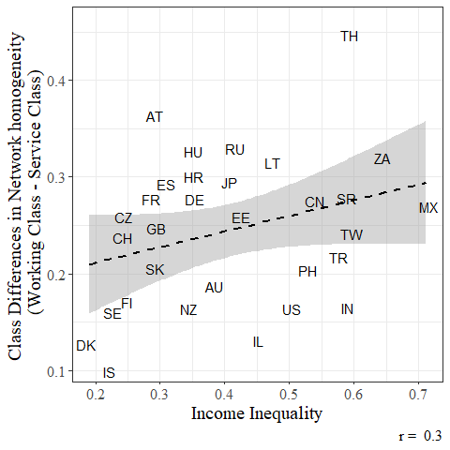

Figure 6.1: Bivariate relationships between Income Inequality and Class differences in network homogeneity

1. Supplementary analyses employing alternative income inequality measures show that the results are robust when using the Inter-decile ratio (D9/D1) and the Top 10/Bottom 50 ratio. Additionally, countries were classified into low, middle-low, middle, middle-high, and high-income inequality groups based on quintiles according to the Gini index. Hence, country-fixed effects regressions are used to control for the cross-country differences and observed and unobserved societal characteristics. The results are consistent with the multilevel estimations.