# Introduction

Over the past few decades, cross-national studies on social class and redistributive preferences have predominantly focused on individual class positions (Lindh and McCall, 2020). Recently, however, a growing body of research has begun to focus on how the class composition of social networks influences redistributive preferences (Lee, 2023; Lindh et al., 2021; Paskov and Weisstanner, 2022). Additionally, social classes tend to form segregated networks according to the homophily principle, whereby individuals have higher chances of forming social ties with others with similar characteristics (McPherson et al., 2001; Otero et al., 2021). Cross-national comparisons indicate that class differences in social participation and access to social resources increase in countries with high economic inequality, which in turn is related to wider social distance between classes (Otero et al., 2024; Pichler and Wallace, 2009). Although prior evidence has shown that class-based network *segregation* — as the proportion of the same (or similar) class network contacts relative to individual class position — can undermine attachment to society in contexts with high income inequality (Otero et al., 2022), our understanding of how being embedded in a homogeneous class-based network impacts attitudes toward redistribution is scarce (Paskov and Weisstanner, 2022). Additionally, most of the studies on networks and redistributive preferences have focused on particular countries (Lee, 2023; Lindh et al., 2021; Otero and Mendoza, 2023), and despite recent cross-country evidence on the role of relative redistribution (Lindh and Andersson, 2024), little is known about how income inequality can moderate the relationship between class-based network segregation and redistributive preferences.

While class-based network segregation may deepen existing class divisions in redistributive preferences (Paskov and Weisstanner, 2022), the knowledge regarding how differences in income inequality between countries can moderate this relationship is narrow. To address the gap in the literature, I discuss the role of income inequality in how differences in economic resources can moderate the relationship between class-based networks and attitudes toward inequality. On the one hand, research on the class-attitude link suggests that income inequality is crucial for understanding how class-based inequalities — i.e., the socioeconomic and political distance between classes— translate into redistributive demands, as it reflects the current state of distributive affairs in contemporary capitalist societies (Curtis and Andersen, 2015; Edlund and Lindh, 2015). A consistent finding is that those in more advantaged socioeconomic positions tend to be more supportive of redistribution in contexts of high inequality, whereas the stronger redistributive demands of the socioeconomically disadvantaged remain relatively stable, regardless of inequality levels (Dimick et al., 2017; Sachweh and Sthamer, 2019). On the other hand, it is well-documented that income inequality affects social relations, reinforcing stratified access to social activities and widening the social distance between classes. In such conditions, the upper classes tend to be more socially active and maintain more diverse networks, while the lower classes become increasingly inactive and segregated in contexts with higher levels of economic inequality (Lancee and Van de Werfhorst, 2012; Otero et al., 2024; Pichler and Wallace, 2009). Nevertheless, current research has primarily examined how income inequality moderates the impact of social class on either social networks or redistributive preferences. Against this background, this study aims to address two key questions:

1. How does class-based network segregation influence redistributive preferences?
2. To what extent does economic inequality moderate the relationship between class-based network segregation and redistributive preferences?

In this paper, I use a sample of 31,694 individuals from 31 countries, drawn from the 2017 International Social Survey Program (ISSP). This dataset offers unprecedented cross-national comparative data on social networks, social class, and attitudes toward redistribution.

# Theoretical framework: Class, social networks, and redistributive preferences

## Class divides in redistributive preferences

Over the past few decades, research on political attitudes in industrialized societies has consistently highlighted the significance of social class as a key driver of public opinion (Lindh and McCall, 2020). Social class, in this context, not only reflects individuals’ labor market relations but also their economic interests and moral perspectives regarding the role of the market and the state in the distribution and redistribution of resources (Svallfors, 2006). Redistributive preferences refer to individuals’ support for policies and mechanisms aimed at reducing economic inequality (McCall and Kenworthy, 2009). These preferences encompass views on taxation, welfare programs, public services, and other government interventions designed to transfer resources from wealthier individuals or groups to those with fewer resources (García-Sánchez et al., 2022).

Empirically, the class divide in redistributive preferences is well documented (Brooks and Svallfors, 2010; Curtis and Andersen, 2015; Langsæther and Evans, 2020; Lindh, 2015). Class-based explanations of redistributive preferences have predominantly focused on individuals’ socioeconomic position. According to self-interest-driven theories, economic resources or risk exposure explain why working classes with fewer resources and greater job insecurity tend to support redistribution more than the upper classes (Meltzer and Richard, 1981; Rehm, 2009). Furthermore, while material interests often dominate in conditions of scarcity, value-based motivations, such as egalitarianism, may drive stronger support for redistribution under conditions of greater security and weaken under material hardship (Kulin and Svallfors, 2013; Maldonado et al., 2019).

Other approaches emphasize the role of social relations in the workplace, which can imprint normative views that ultimately shape political opinions due to the significant time people spend at work (Oesch, 2006). For instance, continuous and diverse social interactions in interpersonal service roles can foster empathy and reinforce egalitarian values (Kitschelt and Rehm, 2014). Conversely, vertical oversight in managerial positions and the emphasis on autonomy in self-employed roles often bolster self-interested and conservative political views (Oesch and Rennwald, 2018).

Given the individual focus of current approaches on class and redistributive preferences, a network perspective offers a more comprehensive way to understand redistributive preferences beyond the individual level. By focusing on class differences in network ties, the interpersonal dimension of between-class relations is brought to the forefront, emphasizing that social ties encompass both social and economic resources (Lin and Dumin, 1986) embedded in class positions (Weber, 2011, pp. 57–59).

## Class relations and social networks

Theoretically, class relations can be understood as the structure of social ties between different classes within the broader social system, represented by networks spanning various social strata (Blau, 1977). Social network research consistently demonstrates that homophily—the tendency for individuals to associate with others who are similar—is a structured and persistent feature of social relations (McPherson et al., 2001). For instance, friendships and family ties often display homogeneity in terms of social status or demographic characteristics, while more distant ties tend to connect individuals to different social groups, thereby contributing to network diversity (Diprete et al., 2011; Lazarsfeld and Merton, 1954). Moreover, it is well established that sociability preferences play a role in forming segregated networks (Homans, 1951; Visser and Mirabile, 2004). However, this research aligns with the prevailing view that attitudinal similarity within networks arises primarily from structural contact opportunities shaped by the class composition of social ties, rather than from homophilic preferences for socializing with like-minded individuals (Feld, 1981). Thus, to investigate the implications of networks for redistributive preferences, I propose distinguishing between two closely related—but distinct—perspectives on how class-based networks are structured.

First, network *diversity* refers to the degree of an individual’s connectedness to dissimilar ties (e.g., different occupations or activities), representing access to diverse resources within social networks (Lin and Dumin, 1986). Thus, network diversity refers to the dispersion of an attribute tie (alteri) within the network, independently of the characteristic that an individual (ego) has (Otero and Mendoza, 2023). Studies by Pichler and Wallace (2009) and Lancee and Van de Werfhorst (2012) have argued that participation in a wider range of formal organizations increases the chances of the upper classes forming more diverse social connections. In contrast, the working classes show a more homogeneous participation repertoire. Similar patterns emerge in the socioeconomic composition of networks, where the upper middle classes maintain more prestigious and diverse networks than the working classes (Carrascosa, 2023; Cepić and Tonković, 2020). However, I argue that although diversity accounts for the dispersion of an attribute within the network, by not referring to a specific social group or class, diversity falls short when talking about the segregation of a social class concerning other class positions.

By contrast, the perspective adopted in this study is network *segregation,* defined as the pattern of contact an individual has with people who share similar (or the same) characteristics. Here, the focus is on the similarity between the class position of individuals (ego) and their network ties (alteri). Therefore, it is conceptually closer to homophily and has been empirically examined through network homogeneity (Otero et al., 2021). Some studies have suggested that property-based boundaries are far less permeable than authority-based ones in the formation of cross-class ties. For example, Wright and Cho (1992) suggest that class interests tend to widen the social distance between proprietors and manual workers, while the intermediate position of supervisors and their more frequent contact with manual workers make cross-class friendships more likely. Similarly, Otero et al. (2021) identified a U-shaped pattern of acquaintance network segregation in Chile, where the middle classes (e.g., lower managerial professionals, clerks, and manual supervisors) exhibit lower network homogeneity than the upper and lower classes. Thus, segregation is most prevalent on both ends of the class structure, particularly among the lower classes. Otero et al. (2021) argue that segregation in the lower classes is often driven by limited life chances and reduced social participation, while upper-class segregation is largely explained by self-selection—a practice that reinforces privileged positions, which can coexist with a broader range of social connections (Otero et al., 2021).

One theoretical implication is that experiencing segregated class-based networks may be related to class differences in redistributive preferences. But how are the two linked?

## Network segregation and redistributive preferences

The argument that social ties have implications for attitude formation is not entirely new. Two approaches have discussed the role of social relations in the formation of redistributive preferences: reference groups and class-based networks.

Processes of social comparison with similar reference groups are one potential mechanism that can explain the formation of redistributive preferences (Condon and Wichowsky, 2020). The key argument posits that people form their perceptions through family, friends, and coworkers’ experiences instead of the whole society, which is described as an availability heuristic that systematically biases inferences about inequality based on the homophily of reference groups (M. D. R. Evans et al., 1992, p. 467). Therefore, inferences about inequality are linked to network segregation which influences information that ultimately shapes inequality perceptions (Mijs and Roe, 2021). Yet, this research has mainly focused on the cognitive dimension of preference formation through inequality perceptions rather than straightforwardly addressing the influence of network segregation on redistributive preferences (Cansunar, 2021; García-Castro et al., 2022).

Therefore, this paper adopts the second approach, which suggests that social networks provide a comprehensive picture of the class relations that contribute to group identity formation and internalization of social norms (Kalmijn and Kraaykamp, 2007). Specifically, it has been argued that redistributive preferences are influenced not only by individuals’ social class but also by the class positions of their network ties (Paskov and Weisstanner, 2022). Thus, opinions can either align or divide through social influence processes depending on the class positions of contacts and the level of network segregation (Lindh et al., 2021). These arguments reflect the notion that classes are characterized as collectivities with varying degrees of cohesion and solidarity, comprising asymmetric status-based interactions related to material resources, cultural practices, and political preferences (Morris and Scott, 1996). Resembling the reference group argument, Sachweh (2012) suggests social integration can be impeded in societies with few opportunities for contact between different social classes, creating an “empathy gulf” that hinders individuals from understanding others’ lifestyles amid rising inequality. Consequently, segregated interactions may lead individuals to perceive the lives of different classes as more distant (Sachweh, 2012). Thus, segregation can potentially exacerbate perceptions of others as strangers which in turn reduces empathy and solidarity (Otero et al., 2022). Although both approaches share the assumption that social networks shape information (*availability heuristic*) and affect attitudes (*social influence*), I argue that an advantage of the network perspective is that it has been more effective in defining the structural position of network ties and has more directly addressed the relationship with redistributive preferences.

How do network ties affect redistributive preferences? The class position of surrounding family members, friends, and acquaintances not only provides information about inequality, but they are also a source of social influence whose impact on redistributive preferences can be amplified in segregated social networks. In principle, political attitudes are connected to class interests and norms as they are primarily - but not exclusively - socialized in the family of origin during childhood and early adulthood. For instance, Lee (2023) shows that individuals with network ties to the upper class through parental connections tend to support redistribution and progressive taxation less than those from working-class family backgrounds. Moreover, since households share risk based on the class position of their members, redistributive preferences are shaped not only by family background but also by the class positions of partners. For example, Paskov and Weisstanner (2022) indicate that working-class ties bolster redistributive preferences, whereas ties with the upper class decrease them, with the effects becoming more pronounced when the class positions of individuals, partners, and parents form a more class-based homogeneous network. Beyond family ties, Lindh et al. (2021) found that friendship and acquaintanceship ties to the managerial class are associated with lower redistributive preferences compared to ties with the sociocultural and working classes. Hence, this suggests that individuals tend to adjust their attitudes based on the class position of their contacts (Lindh et al., 2021).

In summary, I expect a mild direct association between network segregation and redistributive preferences. This is mainly because network homogeneity - as the proportion of similar class network ties - does not distinguish between ego’s class position and refers to the overall degree of segregation. Conversely, I hypothesize that the association of network homogeneity with redistributive preferences is conditional on social class as homogeneous social networks should reinforce attitude similarity (*segregation hypothesis*). Specifically, I propose that greater network segregation in the lower classes is associated with higher redistributive preferences, whereas greater segregation in the upper classes is related to lower redistributive preferences. Therefore, the first hypothesis is as follows:

H1: *The greater the network segregation in the lower (upper) classes, the higher (lower) the redistributive preferences.*

## Economic inequality as context for class-based network segregation and redistributive preferences

There are several arguments on why income inequality can play a moderating role in the relationship between class-based networks and redistributive preferences that can be summarized in three key theoretical implications. First, income inequality likely leads to greater segregation due to reduced participation and lower social trust (Lancee and Van de Werfhorst; Kragten and Rözer, 2017); however, while resource interdependency exacerbates social exclusion for lower classes, the upper classes may hold higher opportunities and openness to participate in social life, potentially maintaining or even reducing segregation in more unequal countries. Empirically, previous studies have shown that high levels of inequality erode trust and social participation particularly among marginalized groups, thereby exacerbating social exclusion (Neckerman and Torche, 2007). In contrast, egalitarian societies foster higher levels of civic engagement and cross-class interactions, which strengthen solidarity and promote more egalitarian attitudes (Uslaner and Brown, 2005; Yamamura, 2012). Otero et al., 2024

Second, the relationship between class and attitudes weakens in highly unequal contexts, where upper classes tend to show higher support for redistribution, contrasting with the relatively stable preferences of lower classes. In egalitarian societies with comprehensive welfare states, class-based distributive struggles have become more institutionalized, allowing class positions to be closely tied to political conflict (Curtis and Andersen, 2015; Edlund and Lindh, 2015). Political economists have suggested that affluent individuals are not monolithic in their attitudes, with some supporting redistribution out of concern for the broader societal effects of inequality, such as crime and instability (Dimick et al., 2017, 2018). From a sociological moral economy approach, it has been argued that these differences can be explained through diverging views on distributive justice perceptions in resource allocation (Liebig and Sauer, 2016). Empirically, affluent individuals are more likely to perceive inequality as a threat to social mobility and opportunity structures, motivating support for redistribution as a form of procedural justice (Kim and Lee, 2018; Sachweh and Sthamer, 2019). By contrast, low-income individuals focus more on structural barriers that limit opportunities, regardless of inequality (Sachweh and Sthamer, 2019). Also, it has been shown that in contexts with higher income inequality the support for redistribution might stem from a heightened awareness of mismatches between the consequences and incentives of income inequality (Svallfors, 2006).

Third and last, I argue that as inequality rises and the class divide in redistributive preferences narrows, the influence of class-based segregation on these preferences may diminish, with homogeneous class networks losing significance as class positions become less relevant in shaping attitudes. A recent study by Lindh and Andersson (2024) has argued that in countries with higher redistribution rates the class-based network profiles – defined as connections to specific classes – follow a similar pattern as individual class positions, showing that the higher (lower) egalitarian preferences associated with being connected to lower (upper) class positions are stronger in countries with higher levels of income redistribution.

Against this backdrop, I expect *disposable* income inequality to weaken network homogeneity and social class interaction. Specifically, I hypothesize that the conditional relationship between network homogeneity and social class is less pronounced in the context of higher income inequality (*mitigation hypothesis*). Given these considerations, the second hypothesis reads as follows:

H2: *The greater the level of income inequality in a country, the weaker the conditional association of network segregation by social class with redistributive preferences.*

A simplified framework of the hypotheses is shown in Figure 1.

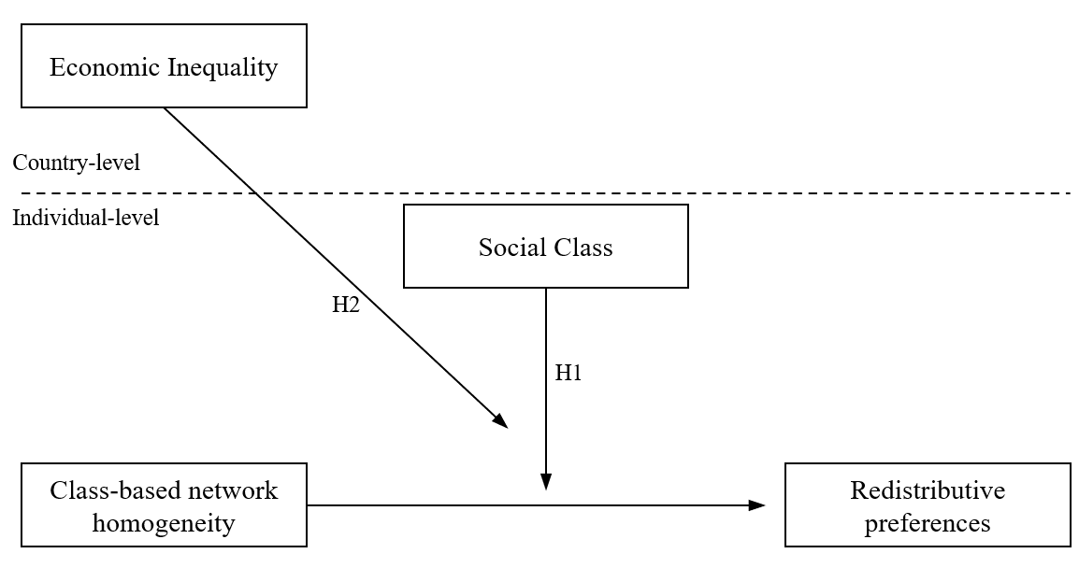

Figure 1: Hypotheses at country and respondent levels

# Methodology

## Data

The primary data source for this study is the “Social Networks and Social Resources” module of the International Social Survey Program (ISSP) (ISSP Research Group, 2019). The ISSP provides a nationally representative probability sample of the adult population in each participating country. Each country administers a carefully adapted questionnaire to ensure cross-cultural validity of the data and enable meaningful comparisons between countries. The questionnaire includes sections on social networks, attitudes toward economic inequality, and demographic and socioeconomic background characteristics. The complete sample comprises 47,027 observations across 32 countries. However, after reviewing the required information and applying listwise case deletion, the final sample used in the analyses consists of 31,694 observations from 31 countries[1].

## Variables

### Dependent variable

I use two indicators to measure redistributive preferences. The first indicator is support for government redistribution, as measured by the following item: “It is the responsibility of the government to reduce the differences in income between people with high incomes and those with low incomes.” The second indicator is egalitarian preferences measured by the item: “For a society to be fair, differences in people’s standard of living should be small.” Both indicators use a five-point Likert scale with the following categories: ‘Strongly agree’ (1), ‘Agree’ (2), ‘Neither agree nor disagree’(3), ‘Disagree’ (4), and ‘Strongly disagree’(5) (*r* = 0.62). Following Svallfors (2013), I reverse-coded, averaged, and normalized the indicators in a 0 to 100 index, where higher values reflect stronger redistributive preferences.

### Independent variables - individual level

I employ the Erikson-Goldthorpe-Portocarrero (EGP) class scheme to measure social class (Erikson and Goldthorpe, 1992). The EGP scheme is the most consistent and validated measure for class positions in comparative research and has demonstrated its validity in both industrialized and late-industrialized societies (Barozet et al., 2021; G. Evans and Graaf, 2013). Information about occupations, self-employment status, and the number of employees is used to classify respondents into six class positions. Following previous research, a simplified version of the EGP class scheme that collapses three classes is employed (Edlund, 2003; Sosnaud et al., 2013). Specifically, this version distinguishes among the Service Class (higher and lower managerial and professionals), Intermediate Class (routine nonmanual workers and self-employed), and Working Class (manual supervisors, skilled and unskilled manual workers) [2] (see Table A2 in the Appendix).

I employed the position generator as the basis for the class-based network homogeneity measure. This instrument has been widely used in social capital studies and follows an ego-centered approach where it is assumed that social ties to different hierarchical positions in the social structure provide access to social resources (van der Gaag et al., 2008). The position generator employed included a list of ten occupations. Here, occupations are presented to the respondent in a grid that allows them to declare whether they know (or not) a person who performs that occupation. The tie can be classified into four groups, defining tie to this person as a “Family or relative,” “Close friend,” “Someone else I know,” or “No one.” With this information, the first three categories are coded as 1 to represent the presence of a tie (“Knows”) and 0 as the absence of a connection to a person with that occupation (“Does not know”). Subsequently, all declared ties were summed to represent the total number of occupations known by the respondent.

Subsequently, following previous cross-national studies I classify occupations into three status positions that resemble class positions (Lindh and Andersson, 2024; Otero et al., 2024). The classification is as follows: lawyer, executive of a large firm, and human resource manager are categorized as *higher* positions; schoolteacher, police officer, and nurse are classified as *medium* positions; and car mechanic, bus driver, hairdresser, and home or office cleaner are considered *lower* positions.

Given the above, I adopt established procedures in the literature for measuring homogeneity in ego-centered networks (Völker, 2022). Regarding class segregation, Otero et al. (2022) classified occupations from the position generator into three class positions to compute the proportion of similar ties based on social class, thereby measuring class-based network homogeneity.

I calculate the number of ingroup ties according to the respondents’ class position and divide it by the total number of known occupations. This measure represents the proportion of similar social ties within the personal network, where a value of zero indicates complete *heterogeneity* (i.e., all ties are different), and a value of one indicates complete *homogeneity* (i.e., all ties are similar). Substantively, higher values reflect a greater social distance from other social classes in society.

A set of control variables are considered in the estimations. First, the number of social ties is included to ensure that the association between network homogeneity and redistributive preferences is independent of network size. Second, socioeconomic characteristics are incorporated into the models, as they represent the current social status through income, education, and labor market status (Häusermann et al., 2015; Kitschelt and Rehm, 2014). Third, given the gender-based class inequality in economic resources (Waitkus and Minkus, 2021), age differences in terms of values and socioeconomic vulnerability (VanHeuvelen and Copas, 2018), and the role of family support provided by partners (Edlund, 2003), gender, age, and marital status were included as control variables in all models.

### Independent variables - country level

To measure economic inequality comparatively, I use the Gini index (post-taxes and transfers) from the World Income Inequality Dataset (WID) (Alvaredo et al., 2022). Additionally, I incorporate two contextual variables as controls in the multilevel regression. First, employing Gross Domestic Product (GDP) in constant 2017 USD (PPP) ensures that economic inequality estimates remain consistent regardless of economic conditions (UNU-WIDER, 2023). Second, following Edlund and Lindh (2015), I include a measure of the welfare state that conceptually captures both its overall size and redistributive capacity based on taxation and spending levels. This approach provides a more accurate representation of the welfare state’s impact by incorporating a broader range of services and reflecting the actual outcomes of welfare policies. Empirically, I compute a normalized indicator on a scale from 0 to 100, which combines (i) tax revenue as a percentage of GDP (ILO, 2022), (ii) welfare generosity as total governmental spending as a share of GDP (ILO, 2022), and (iii) the current level of redistribution (Solt, 2020).

## Methods

I employ multilevel linear regression models to account for the hierarchical structure of the data(individuals nested within countries). The analysis begins by estimating a null model with a random intercept to reflect this nested structure. This initial model assesses the intraclass correlation, revealing that 13.5% of the variance in redistributive preferences can be attributed to differences between countries. Subsequently, models including the individual level factors are estimated to examine the association between network homogeneity and social class to test hypothesis 1 [3]. Following this, country-level variables are included in the estimations by incorporating random intercepts and random slopes for network homogeneity and social class. This model tests hypothesis 2 by estimating a three-way cross-level interaction to determine whether income inequality moderates the interaction between network homogeneity and social class. In the latter models, individual-level variables are group-mean centered (CWC) to mitigate collinearity issues between lower- and higher-level predictors and to avoid spurious cross-level interaction coefficients (Aguinis et al., 2013). Additionally, all country-level factors are standardized (z-scores) to facilitate comparability in the estimations (Hox, 2010). All the models are estimated employing the lme4 package in R (Bates et al., 2015). [4]

# Results

## Descriptive cross-country comparison on class, network segregation, and redistributive preferences

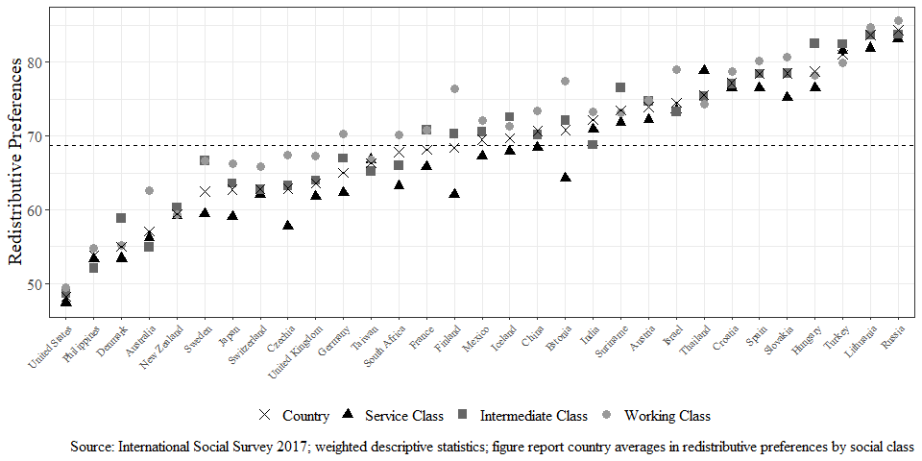

Figure 2: Cross-country differences in redistributive preferences by social class

Figure 2 depicts the differences in redistributive preferences across countries and social classes. As expected, the working class shows higher redistributive preferences compared to the intermediate and service classes in most societies. Notably, there are also some differences between the two extreme cases. For instance, the working class exhibits similar redistributive preferences compared to the intermediate class in the United States, although both classes have higher preferences than the service class. Conversely, the general trend of stronger preferences among the working class persists in Russia, but the preferences of the intermediate class are much closer to the service class.

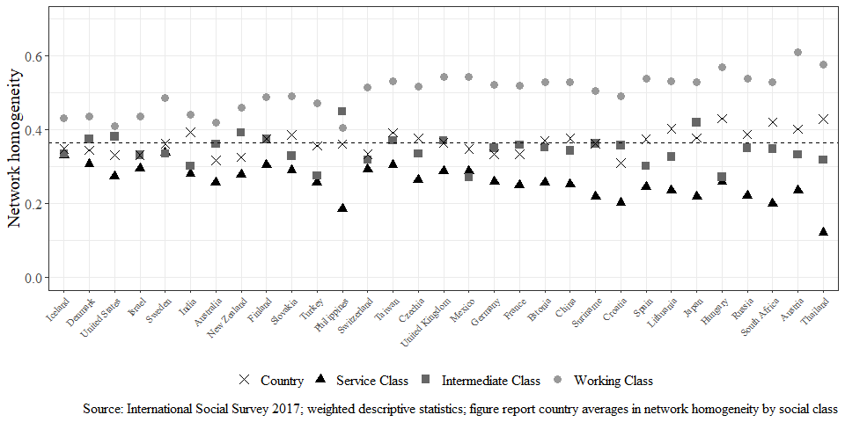

Figure 3: Cross-country differences in network homogeneity by social class

Regarding network segregation, Figure 3 shows that between-country variation in network homogeneity is relatively low, whereas class differences are quite distinguishable. On the one hand, a general pattern is that the working class demonstrates high network homogeneity in most countries. On the other hand, the service class generally exhibits less segregation compared to the intermediate and working classes. In addition, homogeneity in the intermediate class tends to be close to the average of each country. Despite that, some countries show a divergent distribution of network homogeneity by social class (e.g. Philippines), the general pattern of a segregated working class and an upper class with lower segregation holds.

Figure 4: Relationship between income Inequality, network homogeneity and redistributive preferences

Regarding the country-level relationships, Figure 4 depicts the correlation between network homogeneity and income inequality (Panel A), and network homogeneity and redistributive preferences (Panel B). Complementary, I included the correlation between income inequality and the class differences between the working and service classes on network homogeneity (Panel C), and class differences in homogeneity and redistributive preferences (Panel D). Panel A illustrates a positive but relatively weak association between income inequality and network homogeneity (*r* = 0.28), suggesting that in more unequal countries, class-based network homogeneity is also higher. Panel B shows a medium positive association between network homogeneity and redistributive preferences (*r* = 0.44). Furthermore, Panel C depicts the differences in network homogeneity between the working class and the service class is higher in countries with higher income inequality (*r* = 0.31), showing that in countries with higher income inequality, the working class tends to be segregated than the services class. Therefore, income inequality not only is associated with greater overall network homogeneity but also goes along with a wider social distance between social classes. Additionally, Panel D shows that higher national levels of class differences between the working and service classes are also associated with redistributive preferences (*r* = 0.46). This means that in countries where the working class holds more segregated networks than the service class, redistributive preferences tend to be higher as well.

## The segregation hypothesis on redistributive preferences

| Table 1: Multilevel models for network homogeneity and redistributive preferences | | | |
| --- | --- | --- | --- |
|  | **Model 1** | **Model 2** | **Model 3** |
| Class-based network homogeneity | 2.82 (0.54)*** | 1.43 (0.55)** | -7.45 (1.11)*** |
| Network size |  | -0.32 (0.05)*** | -0.25 (0.05)*** |
| Social Class (Ref.= Service Class) |  |  |  |
| Intermediate Class |  |  | -0.82 (0.60) |
| Working Class |  |  | -0.21 (0.63) |
| Homogeneity x Social Class |  |  |  |
| Homogeneity*Intermediate Class |  |  | 8.74 (1.64)*** |
| Homogeneity*Working Class |  |  | 10.35 (1.45)*** |
| Controls | No | Yes | Yes |
| BIC | 289891.64 | 289409.95 | 289319.54 |
| Num. obs. | 31694 | 31694 | 31694 |
| Num. groups | 31 | 31 | 31 |
| Var: Country (Intercept) | 77.98 | 80.39 | 77.07 |
| Var: Residual | 493.00 | 483.94 | 482.07 |
| Note: Standard errors are in parentheses. ***p < 0.001; **p < 0.01; *p < 0.05; .p < 0.1 | | | |

The results regarding the relationship between class-based network homogeneity and redistributive preferences using multilevel models are shown in Table 1. Model 1 shows that individuals embedded in homogeneous social networks are more likely to support redistribution. In Model 2, the introduction of control variables and network size slightly reduces the effect of homogeneity. These results contrast with previous findings, where being more segregated is associated with less attachment to society (Otero et al., 2022) and stronger support for redistribution in more cohesive communities (Yamamura, 2012). [5]

Moving to hypothesis 1, the interaction terms of network homogeneity and social class in Model 3 test for the conditional effect of network homogeneity on individuals’ social class. The results show that the association of class-based network homogeneity is conditional to the ego’s class position. For the working (β=8.74, *p* < 0.001) and the intermediate classes (β=10.35, *p* < 0.001), network homogeneity has a positive association with redistributive preferences, in contrast to the negative association in the service class (β=-7.45, *p* < 0.001). To illustrate this result further, according to Model 3, Figure 5 depicts that the changes in redistributive preferences from lower to higher levels of class-based network homogeneity are quite mild, where the differences in the predicted average estimates in redistributive preferences – on a scale of 0 to 100 – go from 69.8 to 72.8 in the working class and from 69.4 to 70.47 in the intermediate class. In contrast, the changes in the predicted average estimates of redistributive preferences in homogeneous services class networks are more pronounced, changing from 70 when homogeneity is at its lowest point to 62.8 in fully homogeneous networks.

These results confirm previous findings on how social influence processes through class-based network ties affect attitudes in the economic domain (Lindh et al., 2021; Otero and Mendoza, 2023). Additionally, they echo previous arguments on how sharing similar class positions with partner or family ties tends to intensify redistributive preferences depending on individual class positions (Lee, 2023; Paskov and Weisstanner, 2022). Altogether, these results support the *segregation hypothesis* (H1), where the class differences in redistributive preferences become wider as network homogeneity increases.

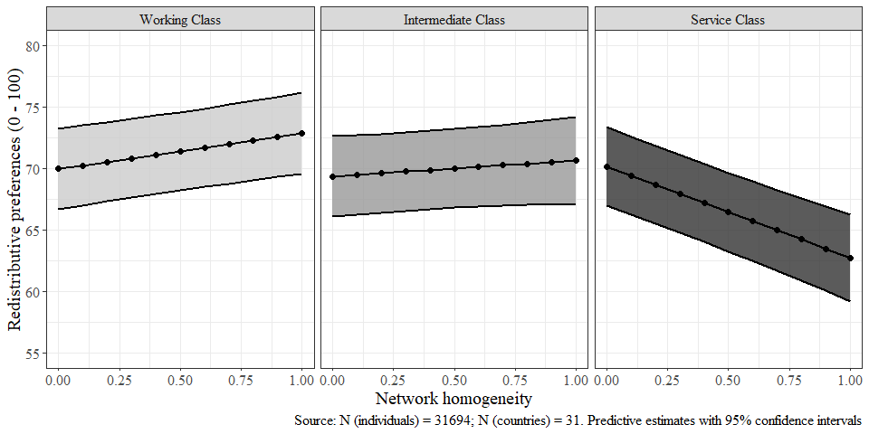

Figure 5: Interaction of network homogeneity and social class on redistributive preferences

## The mitigation hypothesis on network segregation and redistributive preferences

Table 2 presents the results of the multilevel models for the moderating role of income inequality on the interaction between social class and network homogeneity. Looking at the impact of country-level indicators, we see that redistributive preferences are unrelated to national levels of income inequality (Model 1), are lower in economically prosperous countries (Model 2), and higher in more generous welfare states (Model 3).

| Table 2: Multilevel models for income inequality, network homogeneity and redistributive preferences | | | | |
| --- | --- | --- | --- | --- |
|  | **Model 1** | **Model 2** | **Model 3** | **Model 4** |
| Class-based network homogeneity (CWC) | -0.79 (1.05) | -0.79 (1.05) | -0.82 (1.05) | -7.60 (1.43)*** |
| Social Class (Ref.= Service Class) |  |  |  |  |
| Intermediate Class | 1.53 (0.51)** | 1.52 (0.51)** | 1.52 (0.51)** | 2.27 (0.53)*** |
| Working Class | 3.26 (0.76)*** | 3.24 (0.76)*** | 3.22 (0.77)*** | 3.44 (0.73)*** |
| **Country-level factors** |  |  |  |  |
| Income inequality (Gini index) | 0.09 (1.74) | -0.69 (1.76) | 0.84 (1.74) | 1.91 (2.02) |
| GDP/capita |  | -2.82 (1.55). | -5.58 (1.72)** | -5.26 (1.75)** |
| Size of the welfare state |  |  | 5.74 (1.76)** | 4.38 (1.79)* |
| **Homogeneity x Social Class** |  |  |  |  |
| Homogeneity*Intermediate Class |  |  |  | 8.99 (1.65)*** |
| Homogeneity*Working Class |  |  |  | 10.88 (1.51)*** |
| Homogeneity x Income Inequality |  |  |  | 4.26 (1.49)** |
| **Homogeneity x Social Class x Income Inequality** |  |  |  |  |
| Homogeneity*Intermediate Class*Income Inequality |  |  |  | -6.58 (1.58)*** |
| Homogeneity*Working Class*Income Inequality |  |  |  | -5.11 (1.35)*** |
| Controls | Yes | Yes | Yes | Yes |
| BIC | 289374.24 | 289378.87 | 289381.23 | 289369.56 |
| Num. obs. | 31694 | 31694 | 31694 | 31694 |
| Num. groups | 31 | 31 | 31 | 31 |
| Var: Country (Intercept) | 87.85 | 77.49 | 89.37 | 78.07 |
| Var: Country Homogeneity | 20.28 | 20.35 | 20.67 | 21.75 |
| Var: Country Intermediate Class | 4.48 | 4.53 | 4.42 | 4.34 |
| Var: Country Working Class | 13.40 | 13.35 | 13.46 | 11.43 |
| Cov: Country (Intercept), Homogeneity | 12.94 | 9.88 | 16.63 | 10.70 |
| Cov: Country (Intercept), Intermediate Class | -4.59 | -3.62 | -12.76 | -7.45 |
| Cov: Country (Intercept), Working Class | -14.79 | -12.05 | -21.86 | -16.07 |
| Cov: Country Homogeneity, Intermediate Class | -5.65 | -5.55 | -5.61 | -5.28 |
| Cov: Country Homogeneity, Working Class | -7.84 | -7.74 | -7.87 | -6.71 |
| Cov: Country Intermediate Class, Working Class | 7.23 | 7.24 | 7.21 | 6.06 |
| Var: Residual | 480.42 | 480.41 | 480.42 | 479.39 |
| Note: Models include individual-level controls centered within cluster (group mean). Standard errors in parentheses. ***p < 0.001; **p < 0.01; *p < 0.05; .p < 0.1 | | | | |

Model 4 tests the *mitigation hypothesis* that posits that the greater the level of income inequality in a country, the weaker the conditional association of network segregation by social class with redistributive preferences. The results suggest that in societies with higher levels of economic inequality, the interaction of network homogeneity and social class – especially in the service class – becomes less prominent than in societies with lower levels of economic inequality. To illustrate this result, Figure 6 depicts how the interaction of network homogeneity and social class is gradually mitigated as income inequality increases. The left panel in Figure 6 illustrates that when inequality is low, the conditional association of network homogeneity and social class on redistributive preferences is more pronounced than in contexts of middle and high inequality.

Taking a closer look, differences in redistributive preferences between the working and service classes are smaller when network homogeneity is low, regardless of income inequality. Greater network homogeneity is associated with wider class differences in redistributive preferences, especially in countries with low levels of inequality. These differences, however, gradually become smaller in contexts with higher inequality. These results resonate with previous studies that have argued that the upper classes are more sensitive to income inequality, whereas the working class shows relatively stable attitudes regardless of the contextual levels of income inequality (Curtis and Andersen, 2015; Dimick et al., 2017; Edlund and Lindh, 2015). This also contrasts with previous research that has argued that individuals in unequal societies support a stronger meritocratic distribution of resources and become less concerned about income differences than those of more egalitarian societies (Mijs, 2021).

Also, these results echo the findings of Lindh and Andersson (2024) who showed that primarily working (upper-middle) class positions with predominantly working (upper-middle) class ties support more (less) income inequality reduction in countries where redistribution is high. Additionally, their results on the role of market income inequality (pre-tax and transfer) show a null moderating effect when including the cross-level interaction of redistribution simultaneously. Instead, I provide evidence that disposable income (post-tax and transfers) entails robust results, even holding the size of the welfare state and economic prosperity constant. Even though the inclusion of both interactions follows a theoretical rationale, employing a small number of clusters without a restricted maximum likelihood estimation (see Lindh and Andersson (2024, p. 12)) can lead to uncertainty in the estimation of the coefficients, as well as problems with the size of the variances and standard errors (Bryan and Jenkins, 2016).

In sum, my results jointly suggest that network segregation matters in contexts of low and middle economic inequality but loses relevance when inequality is high. Overall, the results presented above support the claims of the *mitigation* hypothesis (H2), where the wider class divide in redistributive preferences in homogeneous class-based networks weakens as income inequality increases.

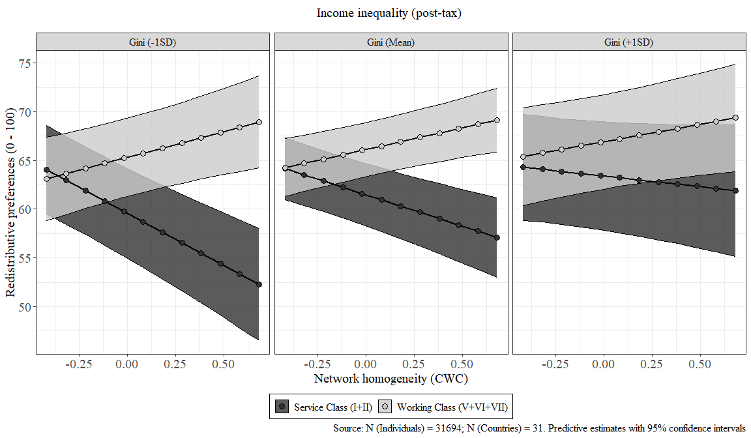

Figure 6: Three-way interaction of network homogeneity, social class and income inequality on redistributive preferences

# Discussion and conclusion

This paper has examined how class-based network segregation is associated with redistributive preferences and how income inequality mitigates this relationship from a cross-national perspective. My first expectation was that class differences in redistributive preferences should not only consider individual class positions, but the structure of social networks as sources of preference formation. Therefore, my first hypothesis was that class-based segregated networks in the lower (upper) classes are associated with higher (lower) redistributive preferences. In this regard, my finding supports the claims that social influence and particularly segregation in interpersonal networks strengthen class differences in redistributive preferences (Lindh et al., 2021; Paskov and Weisstanner, 2022). Additionally, these results support the idea that low cross-class embeddedness can reduce collective solidarity as they limit awareness about the living conditions of other classes (Blau, 1977; Otero et al., 2022). Furthermore, the claimed ‘empathy gulf’ is more evident in how the service class is less willing to act against inequality as a collective commitment when they are highly segregated in homogeneous upper-class environments, in contrast to the increasing redistributive demands of the marginalized working class (Otero and Mendoza, 2023; Sachweh, 2012). Thus, my first finding supports the expectation that the relation between class-based network segregation and redistributive preferences is conditional on social class. Higher network homogeneity in the working class is associated with higher redistributive preferences, while homogeneous networks in the service class are associated with lower support for redistribution. Overall, higher network homogeneity thus is associated with a wider divide in redistributive preferences between the working and the service classes.

My second hypothesis was that economic inequality mitigates the conditional association of network homogeneity by social class on redistributive preferences. Theoretically, I understand economic inequality as the context where class-based inequalities in the economic domain are crystallized in attitudes toward redistribution (Edlund and Lindh, 2015). I argued that social influence is linked to redistributive preferences as it explains how class positions intensify their attitudes as network segregation increases (Lindh et al., 2021). Likewise, recent evidence shows that the association between network class profiles with redistributive preferences follows a similar pattern as individual class positions and this relationship is strengthened as redistribution rates increase at the country level (Lindh and Andersson, 2024). In this regard, my findings indicate that income inequality indeed *mitigates* the conditional association of class-based network homogeneity and social class on redistributive preferences, independently of the size of the welfare state and economic prosperity. In other words, the role of network segregation observed in the interaction of homogeneity and class is less pronounced in countries with higher income inequality. Particularly, the most notable differences in redistributive preferences are observed in homogeneous service class networks. In contrast, preferences in homogeneous working-class networks are relatively unaffected by inequality. Also, the conditional association of class-based network homogeneity by social class prevails mostly in countries with low and middle levels of income inequality. These findings are in line with previous cross-national studies that have pointed out that the upper classes are more reactive to the levels of contextual economic inequality which is associated with a reduced class divide in redistributive preferences (Curtis and Andersen, 2015; Dimick et al., 2017; Edlund and Lindh, 2015).

I interpret the role of income inequality on the conditional association of network homogeneity to social class on redistributive preferences in two ways. First, an important related fact is that unequal societies have smaller class differences mainly because of the higher redistributive preferences in the upper classes. Thus, the consequences of segregated class relations on redistributive preferences become mild as the class divide in political attitudes also loses strength in unequal societies. In this line, it could also be that class segregation reinforces the class divide in contexts where social classes have a stronger political meaning reflected in wider class differences in redistributive preferences (Lindh and Andersson, 2024). Second, another possible explanation – still open to empirical scrutiny – is that social networks are more stratified in more unequal contexts, increasing cross-class contacts and lowering segregation mainly in the upper class (Otero et al., 2024). Here, it could be possible that higher cross-class ties in the upper class toward the intermediate or lower-class positions are associated with greater empathy that motivates solidarity toward others in more relatively disadvantaged socioeconomic conditions.

The contributions of this study can be summarized as follows. First, I demonstrated that class-based network segregation can reinforce the previously documented class divide in redistributive preferences. Unlike previous studies focusing on class profiles (Lindh et al., 2021; Paskov and Weisstanner, 2022; Lindh and Andersson, 2024), the attention to how network segregation is conditional to individual class location allowed me to empirically address how the different social classes change their redistributive preferences according to the degree of class-based network homogeneity. Second, the relevance of the cross-national comparison provided the opportunity to scrutinize the role of income inequality as a moderator of the conditional association of class-based network homogeneity to social class on redistributive preferences. Particularly, using a three-way interaction I demonstrated that the conditional association of network homogeneity to social class is more salient in contexts of low and middle inequality but loses strength in societies with higher levels of inequality.

However, this study also has limitations. On the side of the dependent variable, a two-item index comprises a rough proxy for redistributive preferences compared to more detailed questions on willingness to pay taxes or specific welfare policies. Additionally, the position generator employed is limited in accurately representing a class scheme, particularly in the self-employment and authority dimensions. Thus, recognizing these measurement limitations, the results should be interpreted cautiously. Finally, causality is also a limitation when employing cross-sectional data. Theoretically, contact opportunities between classes and sociability preferences jointly drive network composition. Therefore, I recognize that the endogenous nature of class positions, network structure, and attitudes imply difficulties regarding causal claims.

Future research should include more fine-grained distinctions in measuring attitudes by including established questions on attitudes toward specific welfare policies or willingness to pay taxes as redistributive measures. Additionally, class-based social networks can be better assessed by incorporating other aspects of the market situation of network ties, such as self-employment status or workplace authority. Finally, longitudinal analyses can contribute to disentangling the temporal relationship between class, networks, and political attitudes.

# References

Aguinis, H., Gottfredson, R. K., and Culpepper, S. A. (2013). [Best-Practice Recommendations for Estimating Cross-Level Interaction Effects Using Multilevel Modeling](https://doi.org/10.1177/0149206313478188). *Journal of Management*, *39*, 1490–1528.

Alvaredo, F., Atkinson, A. B., Piketty, T., and Saez, E. (2022). *World inequality database*. WID.world.

Barozet, E., Boado, M., and Marqués-Perales, I. (2021). [The Measurement of Social Stratification: Comparative Perspectives Between Europe and Latin America](https://doi.org/10.1007/978-3-030-48442-2_6). In P. López-Roldán and S. Fachelli (Eds.), *Towards a Comparative Analysis of Social Inequalities between Europe and Latin America* (pp. 171–202). Cham: Springer International Publishing.

Bates, D., Mächler, M., Bolker, B., and Walker, S. (2015). [Fitting linear mixed-effects models using Lme4](https://doi.org/10.18637/jss.v067.i01). *Journal of Statistical Software*, *67*, 1–48.

Blau, P. (1977). [A Macrosociological Theory of Social Structure](https://www.jstor.org/stable/2777762). *American Journal of Sociology*, *83*, 26–54.

Brooks, C., and Svallfors, S. (2010). [Why does class matter? Policy attitudes, mechanisms, and the case of the Nordic countries](https://doi.org/10.1016/j.rssm.2010.01.003). *Research in Social Stratification and Mobility*, *28*, 199–213.

Bryan, M. L., and Jenkins, S. P. (2016). [Multilevel Modelling of Country Effects: A Cautionary Tale](https://doi.org/10.1093/esr/jcv059). *European Sociological Review*, *32*, 3–22.

Cansunar, A. (2021). [Who Is High Income, Anyway? Social Comparison, Subjective Group Identification, and Preferences over Progressive Taxation](https://doi.org/10.1086/711627). *The Journal of Politics*, 000–000.

Carrascosa, J. (2023). [Class inequalities in access to social capital in the metropolitan area of Buenos Aires](https://doi.org/10.1016/j.socnet.2022.09.003). *Social Networks*, *72*, 59–69.

Cepić, D., and Tonković, Ž. (2020). [How social ties transcend class boundaries? Network variability as tool for exploring occupational homophily](https://doi.org/10.1016/j.socnet.2020.02.003). *Social Networks*, *62*, 33–42.

Condon, M., and Wichowsky, A. (2020). [*The Economic Other: Inequality in the American Political Imagination*](https://doi.org/10.7208/chicago/9780226691909.001.0001). University of Chicago Press.

Curtis, J., and Andersen, R. (2015). [How Social Class Shapes Attitudes on Economic Inequality: The Competing Forces of Self-Interest and Legitimation](https://doi.org/10.1515/irsr-2015-0002). *International Review of Social Research*, *5*, 4–19.

Dimick, M., Rueda, D., and Stegmueller, D. (2017). [The Altruistic Rich? Inequality and Other-Regarding Preferences for Redistribution](https://doi.org/10.1561/100.00015099). *Quarterly Journal of Political Science*, *11*, 385–439.

Dimick, M., Rueda, D., and Stegmueller, D. (2018). [Models of Other-Regarding Preferences , Inequality , and Redistribution](https://doi.org/10.1146/annurev-polisci-091515-030034). *Annual Review of Political Science*, *21*, 441–460.

Diprete, T. A., Gelman, A., Mccormick, T., Teitler, J., and Zheng, T. (2011). [Segregation in Social Networks Based on Acquaintanceship and Trust](https://doi.org/10.1086/659100). *Source: American Journal of Sociology AJS*, *116*, 1234–1283.

Edlund, J. (2003). [The Influence of the Class Situations of Husbands and Wives on Class Identity, Party Preference and Attitudes Towards Redistribution: Sweden, Germany and the United States](https://www.jstor.org/stable/4194983). *Acta Sociologica*, *46*, 195–214.

Edlund, J., and Lindh, A. (2015). [The democratic class struggle revisited: The welfare state, social cohesion and political conflict](https://doi.org/10.1177/0001699315610176). *Acta Sociologica*, *58*, 311–328.

Erikson, R., and Goldthorpe, J. H. (1992). *The constant flux: A study of class mobility in industrial societies*. Oxford, UK: Oxford University Press.

Evans, G., and Graaf, N. D. de (Eds.). (2013). *Political choice matters: Explaining the strength of class and religious cleavages in cross-national perspective* (1st ed). Oxford: Oxford University Press.

Evans, M. D. R., Kelley, J., and Kolosi, T. (1992). [Images of Class: Public Perceptions in Hungary and Australia](https://doi.org/10.2307/2096095). *American Sociological Review*, *57*, 461.

Feld, S. L. (1981). [The Focused Organization of Social Ties](https://www.jstor.org/stable/2778746). *American Journal of Sociology*, *86*, 1015–1035.

García-Castro, J. D., García-Sánchez, E., Willis, G. B., Castillo, J. C., and Rodríguez-Bailón, R. (2022). [Perceived Economic Inequality Measures and Their Association With Objective Inequality and Redistributive Preferences](https://doi.org/10.1027/1864-9335/a000498). *Social Psychology*, *53*, 277–291.

García-Sánchez, E., Castillo, J. C., Rodríguez-Bailón, R., and Willis, G. B. (2022). [The Two Faces of Support for Redistribution in Colombia: Taxing the Wealthy or Assisting People in Need](https://doi.org/10.3389/fsoc.2022.773378). *Frontiers in Sociology*, *7*, 773378.

Häusermann, S., Kurer, T., and Schwander, H. (2015). [High-skilled outsiders? Labor market vulnerability, education and welfare state preferences](https://doi.org/10.1093/ser/mwu026). *Socio-Economic Review*, *13*, 235–258.

Homans, G. C. (1951). *The human group.* Piscataway, NJ, US: Transaction Publishers.

Hox, J. J. (2010). *Multilevel analysis: Techniques and applications* (2. ed). New York: Routledge, Taylor & Francis.

ILO. (2022). *World Economic Outlook Database*.

ISSP Research Group. (2019). [*International Social Survey Programme: Social Networks and Social Resources - ISSP 2017*](https://doi.org/10.4232/1.13322). GESIS Data Archive.

Kalmijn, M., and Kraaykamp, G. (2007). [Social stratification and attitudes: A comparative analysis of the effects of class and education in Europe1](https://doi.org/10.1111/j.1468-4446.2007.00166.x). *The British Journal of Sociology*, *58*, 547–576.

Kim, H., and Lee, Y. (2018). [Socioeconomic status, perceived inequality of opportunity, and attitudes toward redistribution](https://doi.org/10.1016/j.soscij.2018.01.008). *The Social Science Journal*, *55*, 300–312.

Kitschelt, H., and Rehm, P. (2014). [Occupations as a Site of Political Preference Formation](https://doi.org/10.1177/0010414013516066). *Comparative Political Studies*, *47*, 1670–1706.

Kragten, N., and Rözer, J. (2017). [The Income Inequality Hypothesis Revisited: Assessing the Hypothesis Using Four Methodological Approaches](https://doi.org/10.1007/s11205-016-1283-8). *Social Indicators Research*, *131*, 1015–1033.

Kulin, J., and Svallfors, S. (2013). [Class, values, and attitudes towards redistribution: A European comparison](https://doi.org/10.1093/esr/jcr046). *European Sociological Review*, *29*, 155–167.

Lancee, B., and Van de Werfhorst, H. G. (2012). [Income inequality and participation: A comparison of 24 European countries](https://doi.org/10.1016/j.ssresearch.2012.04.005). *Social Science Research*, *41*, 1166–1178.

Langsæther, P. E., and Evans, G. (2020). [More than self-interest: Why different classes have different attitudes to income inequality](https://doi.org/10.1111/1468-4446.12747). *The British Journal of Sociology*, *71*, 594–607.

Lazarsfeld, P. F., and Merton, R. K. (1954). Friendship as a social process: A substantive and methodological analysis. In T. Morroe and C. H. Page (Eds.), *Freedom and control in modern society* (Vol. 18, pp. 18–66). New York: Van Nostrand.

Lee, J. (2023). [Consider your origins: Parental social class and preferences for redistribution in the United States from 1977 to 2018](https://doi.org/10.1016/j.ssresearch.2022.102840). *Social Science Research*, *110*, 102840.

Liebig, S., and Sauer, C. (2016). Sociology of Justice. In C. Sabbagh and M. Schmitt (Eds.), *Handbook of Social Justice Theory and Research* (pp. 37–59). New York, NY: Springer New York.

Lin, N., and Dumin, M. (1986). [Access to occupations through social ties](https://doi.org/10.1016/0378-8733(86)90003-1). *Social Networks*, *8*, 365–385.

Lindh, A. (2015). [Public Opinion against Markets? Attitudes towards Market Distribution of Social Services – A Comparison of 17 Countries](https://doi.org/10.1111/spol.12105). *Social Policy & Administration*, *49*, 887–910.

Lindh, A., Andersson, A. B., and Völker, B. (2021). [The Missing Link: Network Influences on Class Divides in Political Attitudes](https://doi.org/10.1093/esr/jcab010). *European Sociological Review*, *37*, 695–712.

Lindh, A., and Andersson, A. B. (2024). Social networks and distributive conflict: The class divide in social ties and attitudes to income inequality across 29 countries. *European Sociological Review*, jcae039.

Lindh, A., and McCall, L. (2020). [Class Position and Political Opinion in Rich Democracies](https://doi.org/10.1146/annurev-soc-121919-054609). *Annual Review of Sociology*, *46*, 419–441.

Maldonado, L., Olivos, F., Castillo, J. C., Atria, J., and Azar, A. (2019). [Risk Exposure, Humanitarianism and Willingness to Pay for Universal Healthcare: A Cross-National Analysis of 28 Countries](https://doi.org/10.1007/s11211-019-00336-6). *Social Justice Research*, *32*, 349 283.

McCall, L., and Kenworthy, L. (2009). [Americans’ Social Policy Preferences in the Era of Rising Inequality](https://doi.org/10.1017/S1537592709990818). *Perspectives on Politics*, *7*, 459–484.

McPherson, M., Smith-Lovin, L., and Cook, J. M. (2001). [Birds of a Feather: Homophily in Social Networks](https://www.jstor.org/stable/2678628). *Annual Review of Sociology*, *27*, 415–444.

Meltzer, A. H., and Richard, S. F. (1981). [A Rational Theory of the Size of Government](https://doi.org/10.1086/261013). *Journal of Political Economy*, *89*, 914–927.

Mijs, J., and Roe, E. L. (2021). [Is America coming apart? Socioeconomic segregation in neighborhoods, schools, workplaces, and social networks, 1970–2020](https://doi.org/10.1111/soc4.12884). *Sociology Compass*, *15*, e12884.

Mijs, J. (2021). ‘The Paradox of Inequality: Income Inequality and Belief in Meritocracy Go Hand in Hand’. *Socio-Economic Review* 19(1):7–35.

Morris, L., and Scott, J. (1996). [The Attenuation of Class Analysis: Some Comments on G. Marshall, S. Roberts and C. Burgoyne, ’Social Class and the Underclass in Britain in the USA’](https://doi.org/10.2307/591115). *The British Journal of Sociology*, *47*, 45.

Neckerman, K. M., and Torche, F. (2007). [Inequality: Causes and Consequences](https://doi.org/10.1146/annurev.soc.33.040406.131755). *Annual Review of Sociology*, *33*, 335–357.

Oesch, D. (2006). [*Redrawing the Class Map*](https://doi.org/10.1057/9780230504592). London: Palgrave Macmillan UK.

Oesch, D., and Rennwald, L. (2018). [Electoral competition in Europe’s new tripolar political space: Class voting for the left, centre-right and radical right](https://doi.org/10.1111/1475-6765.12259). *European Journal of Political Research*, *57*, 783–807.

Otero, G., and Mendoza, M. (2023). [The Power of Diversity: Class, Networks and Attitudes Towards Inequality](https://doi.org/10.1177/00380385231217625). *Sociology*, 00380385231217625.

Otero, G., Völker, B., and Rözer, J. (2021). [Open But Segregated? Class Divisions And the Network Structure of Social Capital in Chile](https://doi.org/10.1093/sf/soab005). *Social Forces*, *100*, 649–679.

Otero, G., Völker, B., Rözer, J., and Mollenhorst, G. (2022). [The lives of others: Class divisions, network segregation, and attachment to society in Chile](https://doi.org/10.1111/1468-4446.12966). *The British Journal of Sociology*, *73*, 754–785.

Otero, G., Völker, B., Rözer, J., and Mollenhorst, G. (2024). [Differences in access to social capital across societies](https://doi.org/10.1093/esr/jcad035). *European Sociological Review*, jcad035.

Palme, J. (2006). Welfare states and inequality: Institutional designs and distributive outcome. *Research in Social Stratification and Mobility*, 24, 387–403.

Paskov, M., and Weisstanner, D. (2022). [Cross-Class Embeddedness through Family Ties and Support for Income Redistribution](https://doi.org/10.1093/esr/jcab040). *European Sociological Review*, *38*, 286–303.

Pichler, F., and Wallace, C. (2009). [Social Capital and Social Class in Europe: The Role of Social Networks in Social Stratification](https://doi.org/10.1093/esr/jcn050). *European Sociological Review*, *25*, 319–332.

Rehm, P. (2009). [Risks and Redistribution: An Individual-Level Analysis](https://doi.org/10.1177/0010414008330595). *Comparative Political Studies*, *42*, 855–881.

Sachweh, P. (2012). [The moral economy of inequality: Popular views on income differentiation, poverty and wealth](https://doi.org/10.1093/ser/mwr023). *Socio-Economic Review*, *10*, 419–445.

Sachweh, P., and Sthamer, E. (2019). [Why Do the Affluent Find Inequality Increasingly Unjust? Changing Inequality and Justice Perceptions in Germany, 1994–2014](https://doi.org/10.1093/esr/jcz024). *European Sociological Review*, *35*, 651–668.

Solt, F. (2020). [Measuring Income Inequality Across Countries and Over Time: The Standardized World Income Inequality Database](https://doi.org/10.1111/ssqu.12795). *Social Science Quarterly*, *101*, 1183–1199.

Sosnaud, B., Brady, D., and Frenk, S. M. (2013). [Class in Name Only: Subjective Class Identity, Objective Class Position, and Vote Choice in American Presidential Elections](https://doi.org/10.1525/sp.2013.10258.This). *Social Problems*, *60*, 81–99.

Summers, K., Accominotti, F., Burchardt, T., Hecht, K., Mann, E., and Mijs, J. (2022). [Deliberating Inequality: A Blueprint for Studying the Social Formation of Beliefs about Economic Inequality](https://doi.org/10.1007/s11211-022-00389-0). *Social Justice Research*, *35*, 379–400.

Svallfors, S. (2006). [*The moral economy of class: Class and attitudes in comparative perspective*](https://doi.org/10.1515/9781503625624). Stanford University Press.

Svallfors, S. (2013). [Government quality, egalitarianism, and attitudes to taxes and social spending: A European comparison](https://doi.org/10.1017/S175577391200015X). *European Political Science Review*, *5*, 363–380.

UNU-WIDER. (2023). [*World Income Inequality Database (WIID) – Version 28 November 2023*](https://doi.org/10.35188/UNU-WIDER/WIID-281123). United Nations University World Institute for Development Economics Research.

Uslaner, E. M., and Brown, M. (2005). [Inequality, Trust, and Civic Engagement](https://doi.org/10.1177/1532673X04271903). *American Politics Research*, *33*, 868–894.

van der Gaag, M., Snijders, T. A. B., and Flap, H. (2008). Position Generator Measures and Their Relationship to Other Social Capital Measures. In N. Lin and B. Erickson (Eds.), *Social Capital: An International Research Program* (pp. 27–48). Oxford University Press.

VanHeuvelen, T., and Copas, K. (2018). [The Intercohort Dynamics of Support for Redistribution in 54 Countries, 1985–2017](https://doi.org/10.3390/soc8030069). *Societies*, *8*, 69.

Visser, P. S., and Mirabile, R. R. (2004). [Attitudes in the Social Context: The Impact of Social Network Composition on Individual-Level Attitude Strength.](https://doi.org/10.1037/0022-3514.87.6.779) *Journal of Personality and Social Psychology*, *87*, 779–795.

Völker, B. (2022). [’Birds of a feather’ - forever? Homogeneity in adult friendship networks through the life course](https://doi.org/10.1016/j.alcr.2022.100498). *Advances in Life Course Research*, *53*, 100498.

Waitkus, N., and Minkus, L. (2021). [Investigating the Gender Wealth Gap Across Occupational Classes](https://doi.org/10.1080/13545701.2021.1973059). *Feminist Economics*, *27*, 114–147.

Weber, M. (2011). Class, Status, Party. In *The Inequality Reader* (2nd ed.). Routledge.

Wright, E. O., and Cho, D. (1992). [The Relative Permeability of Class Boundaries to Cross-Class Friendships: A Comparative Study of the United States, Canada, Sweden, and Norway](https://doi.org/10.2307/2096146). *American Sociological Review*, *57*, 85–102.

Yamamura, E. (2012). [Social capital, household income, and preferences for income redistribution](https://doi.org/10.1016/j.ejpoleco.2012.05.010). *European Journal of Political Economy*, *28*, 498–511.

# Appendix

| Table A1: Multilevel models for network homogeneity and redistributive preferences | | | | |
| --- | --- | --- | --- | --- |
|  | **Model 1** | **Model 2** | **Model 3** | **Model 4** |
| Class-based network homogeneity | 2.82 (0.54)*** | 1.43 (0.55)** | -0.66 (0.60) | -7.45 (1.11)*** |
| Network size |  | -0.32 (0.05)*** | -0.30 (0.05)*** | -0.25 (0.05)*** |
| Female (Ref. = Male) |  | 1.94 (0.25)*** | 2.23 (0.26)*** | 2.18 (0.26)*** |
| Age |  | 0.07 (0.01)*** | 0.08 (0.01)*** | 0.08 (0.01)*** |
| Year of Education |  | -0.23 (0.03)*** | -0.12 (0.04)*** | -0.09 (0.04)** |
| Household Income (Ref.= Tertile I) |  |  |  |  |
| Income (T2) |  | -2.29 (0.36)*** | -2.11 (0.36)*** | -2.06 (0.36)*** |
| Income (T3) |  | -4.95 (0.36)*** | -4.51 (0.37)*** | -4.30 (0.37)*** |
| Income (No information) |  | -4.11 (0.39)*** | -3.88 (0.39)*** | -3.76 (0.39)*** |
| Not in paid work (Ref. = In paid work) |  | -0.13 (0.31) | -0.21 (0.31) | -0.21 (0.31) |
| Has partner (Ref.= No partner) |  | -1.15 (0.26)*** | -1.06 (0.26)*** | -1.04 (0.26)*** |
| Social Class (Ref.= Service Class) |  |  |  |  |
| Intermediate Class |  |  | 1.54 (0.33)*** | -0.82 (0.60) |
| Working Class |  |  | 3.18 (0.37)*** | -0.21 (0.63) |
| Homogeneity x Social Class |  |  |  |  |
| Homogeneity*Intermediate Class |  |  |  | 8.74 (1.64)*** |
| Homogeneity*Working Class |  |  |  | 10.35 (1.45)*** |
| Controls | No | Yes | Yes | Yes |
| BIC | 289891.64 | 289409.95 | 289358.32 | 289319.54 |
| Num. obs. | 31694 | 31694 | 31694 | 31694 |
| Num. groups | 31 | 31 | 31 | 31 |
| Var: Country (Intercept) | 77.98 | 80.39 | 78.27 | 77.07 |
| Var: Residual | 493.00 | 483.94 | 482.86 | 482.07 |
| *Note*: Models include sampling weights. Standard errors in parentheses. ***p < 0.001; **p < 0.01; *p < 0.05; .p < 0.1 | | | | |

|  |  |  |
| --- | --- | --- |
| Table A2 occupations included in the position generator instrument | | |
| Occupation | ISCO08 | % |
| **Higher-status positions** |  |  |
| Lawyer | 2611 | 45.9 |
| Executive of large firm | 1100 | 46.8 |
| Human resource manager | 1212 | 50.6 |
| **Medium-status positions** |  |  |
| School teacher | 2300 | 73.0 |
| Police officer | 5412 | 57.0 |
| Nurse | 2220 | 70.7 |
| **Lower-status positions** |  |  |
| Car mechanic | 7231 | 58.3 |
| Bus/lory driver | 8331 | 71.3 |
| Hairdresser/barber | 5140 | 56.1 |
| Home or office cleaner | 9111 | 66.7 |
| Note: N = 31,694 |  |  |



|  |  |  |  |  |  |
| --- | --- | --- | --- | --- | --- |
| Table A3: Level of aggregation of social class | | | | | |
| EGP-6 | N | % | EGP-3 | N | % |
| Upper Service | 4,832 | 15.2 | Service | 13,365 | 42.2 |
| Lower Service | 8,533 | 26.9 |  |  |  |
| Routine nonmanual | 5,89 | 18.6 | Intermediate | 8,041 | 25.4 |
| Self-employed | 2,151 | 6.8 |  |  |  |
| Skilled working | 8,799 | 27.8 | Working | 10,288 | 32.5 |
| Unskilled working | 1,489 | 4.7 |  |  |  |
| Note: N = 31,694 |  |  |  |  |  |

|  |  |  |  |  |  |
| --- | --- | --- | --- | --- | --- |
| Table A4: Values per country for the macro-social variables | | | | | |
| Country | N | Network Homogeneity | Income Inequality (Gini Index) | GDP/capita in $1000 | Size of the Welfare State |
| Croatia (HR) | 859 | 0.310 | 0.37 | 27.15 | 75.38 |
| France (FR) | 996 | 0.320 | 0.27 | 44.58 | 98.10 |
| Australia (AU) | 940 | 0.320 | 0.37 | 48.40 | 53.51 |
| New Zealand (NZ) | 768 | 0.321 | 0.36 | 42.29 | 53.62 |
| United States (US) | 1,051 | 0.331 | 0.49 | 60.11 | 46.38 |
| Israel (IL) | 1,018 | 0.332 | 0.47 | 39.12 | 52.37 |
| Switzerland (CH) | 960 | 0.333 | 0.26 | 69.10 | 42.97 |
| Germany (DE) | 1,362 | 0.336 | 0.34 | 53.07 | 78.61 |
| Denmark (DK) | 722 | 0.345 | 0.19 | 55.36 | 93.82 |
| Iceland (IS) | 1,012 | 0.348 | 0.24 | 55.64 | 84.19 |
| Mexico (MX) | 676 | 0.348 | 0.71 | 19.72 | 19.20 |
| Philippines (PH) | 1,019 | 0.356 | 0.55 | 8.12 | 4.70 |
| Turkey (TR) | 827 | 0.357 | 0.55 | 27.91 | 37.40 |
| Suriname (SR) | 519 | 0.358 | 0.61 | 18.28 | 10.97 |
| Sweden (SE) | 903 | 0.362 | 0.22 | 51.95 | 85.22 |
| United Kingdom (GB) | 1,338 | 0.363 | 0.28 | 46.37 | 62.65 |
| Estonia (EE) | 814 | 0.372 | 0.41 | 33.82 | 58.39 |
| Finland (FI) | 827 | 0.373 | 0.26 | 47.57 | 100.00 |
| India (IN) | 840 | 0.374 | 0.61 | 6.18 | 15.84 |
| Czechia (CZ) | 1,149 | 0.377 | 0.27 | 38.82 | 65.07 |
| Spain (ES) | 1,381 | 0.378 | 0.33 | 39.53 | 64.31 |
| Japan (JP) | 902 | 0.378 | 0.43 | 41.51 | 52.75 |
| Slovakia (SK) | 1,053 | 0.380 | 0.27 | 30.06 | 64.10 |
| China (CN) | 2,385 | 0.382 | 0.52 | 14.24 | 33.92 |
| Russia (RU) | 1,174 | 0.385 | 0.43 | 25.93 | 46.15 |
| Austria (AT) | 1,083 | 0.385 | 0.31 | 54.17 | 86.83 |
| Taiwan (TW) | 1,610 | 0.394 | 0.58 | 47.57 | 0.00 |
| Lithuania (LT) | 721 | 0.400 | 0.49 | 33.76 | 47.43 |
| South Africa (ZA) | 1,426 | 0.414 | 0.63 | 13.86 | 29.68 |
| Hungary (HU) | 844 | 0.427 | 0.33 | 29.50 | 80.67 |
| Thailand (TH) | 515 | 0.429 | 0.61 | 17.42 | 10.14 |
| *Note:*N = 31,694; Source: ISSP 2017, WID, WIID and ILO. Variables in original scale | | | | | |

|  |  |  |  |  |  |
| --- | --- | --- | --- | --- | --- |
| Table A5: Descriptive Statistics for Study Variables |  |  |  |  |  |
| **Variable** | **N** | **Mean** | **SD** | **Min** | **Max** |
| Redistributive preferences | 31694 | 69 | 24 | 0 | 100 |
| Class-based network homogeneity | 31694 | 0.37 | 0.23 | 0 | 1 |
| Network size | 31694 | 5.8 | 2.6 | 1 | 10 |
| Social class | 31694 |  |  |  |  |
| ... Service Class (I+II) |  | 42% |  |  |  |
| ... Intermediate class (III+IV) |  | 25% |  |  |  |
| ... Working Class (V+VI+VII) |  | 32% |  |  |  |
| Household Income | 31694 |  |  |  |  |
| ... T01 |  | 23% |  |  |  |
| ... T02 |  | 27% |  |  |  |
| ... T03 |  | 29% |  |  |  |
| ... Missing |  | 21% |  |  |  |
| Education in years | 31694 | 13 | 4.3 | 0 | 72 |
| Labor market status | 31694 |  |  |  |  |
| ... In paid work |  | 66% |  |  |  |
| ... Not in paid work |  | 34% |  |  |  |
| Gender | 31694 |  |  |  |  |
| ... Male |  | 49% |  |  |  |
| ... Female |  | 51% |  |  |  |
| Age in years | 31694 | 49 | 16 | 15 | 99 |
| Has partner | 31694 |  |  |  |  |
| ... No partner |  | 43% |  |  |  |
| ... Has a partner |  | 57% |  |  |  |
| Income Inequality - Gini Index | 31694 | 0.41 | 0.14 | 0.19 | 0.71 |
| GDP/capita | 31694 | 37 | 16 | 6.2 | 69 |
| Size of the welfare state | 31694 | 53 | 27 | 0 | 100 |

1. Slovenia is excluded from the study because the measure of support for government redistribution, specifically “It is the responsibility of the government to reduce the differences in income between people with high incomes and those with low incomes,” was not available in the dataset.
2. Self-employed farmers (IVc) are included in the self-employed class, while agricultural labor (VIIb) is in the working class.
3. Supplementary analyses employing alternative income inequality measures show that the results are robust when using the Inter-decile (D9/D1) (see Table S1) and the Top 10/Bottom 50 ratios (see Table S2). Additionally, I classified countries into low, middle-low, middle, middle-high, and high-income inequality groups based on quintiles according to the Gini index. Hence, I used country-fixed effects regressions to control for the cross-country differences and observed and unobserved societal characteristics (see Table S3). The results are consistent with the multilevel estimations.
4. I employed the Restricted Maximum Likelihood (REML) method because it adjusts the estimation of standard errors for small sample sizes and provides better estimates of variance components in the context of cross-national data (Bryan and Jenkins, 2016).
5. After including individual social class, the association between homogeneity and redistributive preferences loses strength and significance (see Appendix Table A1).