I need and automation script for this task:

I need to scrap information from this site <https://www.rockauto.com/> to excel

I need to search some code for example

K8795T

I need information all information about codes, Code number, Category, from info button: Alternate/OEM Part Number(s)

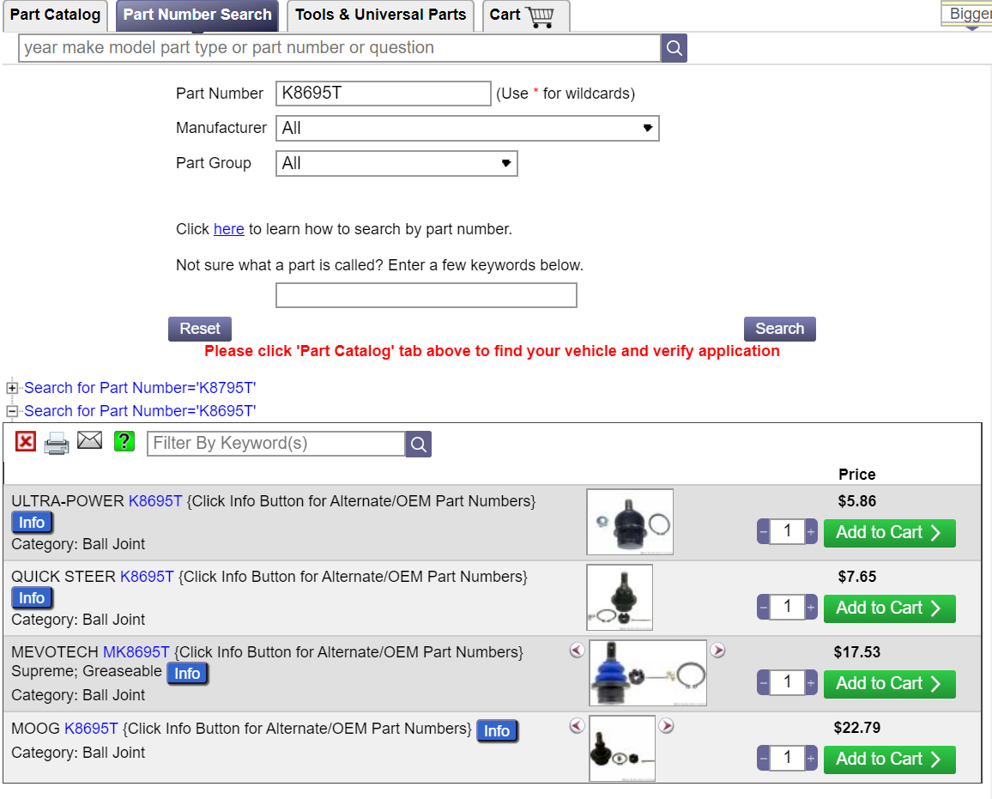

I need information from the code link mark in red

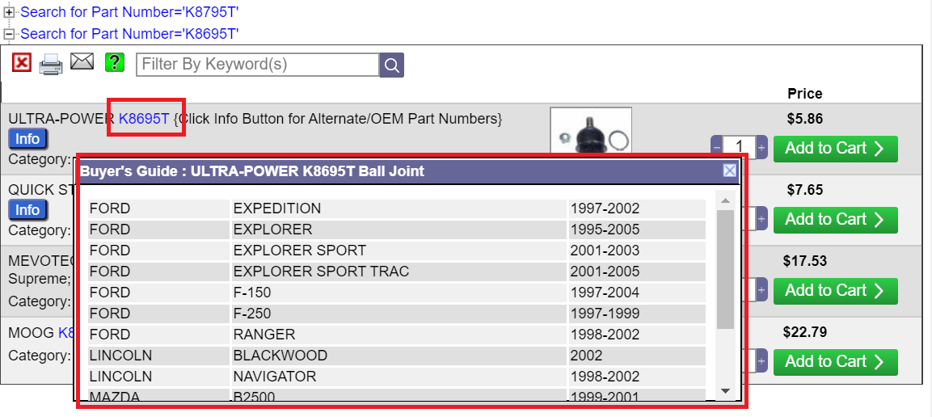

And information about code K8695T FRONT LOWER

<https://www.rockauto.com/en/catalog/ford,2002,explorer,4.0l+v6,1377660,suspension,ball+joint,10070>

