Power Analysis for Confirmatory Factor Analysis: A Practical Tutorial
  - Analytical and Simulation-Based Approaches
Pablo Rogers
2026-09-24
Abstract
This tutorial presents a pedagogical introduction to statistical power analysis in Confirmatory Factor Analysis (CFA). Proper sample size planning requires assessing the probability of detecting overall model misfit, either through analytical methods or simulation-based approaches. Standard analytical tools rely on asymptotic normal theory, which can break down under non-normality or missing data. This tutorial demonstrates both strategies — analytical (using semPower with lavaan syntax) and Monte Carlo simulation (using simsem) — side by side, using the WHOQOL-BREF four-factor model as a unifying case study. We illustrate how simulation complements analytical calculations by enabling researchers to evaluate parameter-level power, coverage, and relative bias under realistic scenarios involving model misspecification, missing data, and non-normal continuous indicators. We argue that analytical methods provide a fast and theoretically grounded starting point for sample size planning, while simulation-based approaches allow those conclusions to be stress-tested against the specific population structure, misspecification form, and data conditions of the study at hand.

1 Introduction
Statistical power in CFA is the probability of correctly rejecting a misspecified model — or of detecting a parameter of interest when it is truly non-zero in the population (MacCallum et al., 1996). Despite its importance, power is rarely reported in applied CFA work: researchers frequently fall back on arbitrary rules of thumb linking required sample size to the number of observed variables or estimated parameters, rather than conducting formal prospective calculations (Aguirre-Urreta et al., 2024; Wolf et al., 2013).
Two main paradigms address power analysis in CFA:
- Analytical methods: Rely on the non-central $χ^{2}$ distribution to determine the sample size required for detecting global or local model misfit, typically quantified through the RMSEA (Jak et al., 2021; MacCallum et al., 1996).
- Simulation-based methods: Use Monte Carlo data generation to estimate power, bias, and coverage for specific parameters or overall fit indices across varying sample sizes, without relying on the asymptotic assumptions that constrain analytical solutions (Muthén & Muthén, 2002; Pornprasertmanit et al., 2021).
This document provides a comprehensive tutorial covering both paradigms: analytical power analysis using the semPower package, and Monte Carlo simulation using the simsem package (Moshagen & Bader, 2024; Pornprasertmanit et al., 2021).
 Reproducibility Note
For local development and computational convenience, simulations in this tutorial use 1,500 replications. Production-quality applied research should increase this to 5,000 or more. Results throughout this tutorial therefore carry more sampling variability than would be expected in a final study. All analytical and simulation parameters are centrally defined in helpers.R and models.R in Scripts/DataAppendixScripts.

2 The Running Example: WHOQOL-BREF Population CFA Model
All power analyses in this tutorial are anchored in the World Health Organization Quality of Life-BREF (WHOQOL-BREF) four-factor measurement model (Lin & Yao, 2022; Mosqueira Taipe et al., 2026). Meaningful power analysis requires an explicit population model — a formal representation of the “true” covariance structure from which data are presumed to be generated (Feng & Hancock, 2023). By grounding this model in meta-analytic evidence rather than in arbitrary parameter choices, we ensure that sample size targets reflect realistic measurement conditions (Lin & Yao, 2022; Mosqueira Taipe et al., 2026).
We specify four population variants to support sensitivity analyses:
- Meta-analytic (popmodel): Loadings and residual variances matching the pooled estimates from Lin & Yao (2022).
- Naive (naivemodel): A pessimistic baseline derived from the lowest reported reliability values per domain (Mosqueira Taipe et al., 2026).
- Optimistic (optmodel): A best-case scenario derived from the highest reported reliability values per domain (Mosqueira Taipe et al., 2026).
- Misspecification (h1model): A cross-loading model representing the alternative hypothesis $H_{1}$, with three additional cross-loadings based on the meta-EFA results of Lin & Yao (2022).

2.1 Population model
The primary population model (popmodel) operationalizes a meta-analytic scenario based on Lin & Yao (2022), whose pooled EFA estimates across 16 international studies provide the factor loadings ($λ$). Key features of this model are:
- Interfactor correlations ($ϕ$): Fixed at $0.20$, a conservative midpoint of the reported range $0.08$–$0.31$ (Lin & Yao, 2022).
- Residual covariance: Items $Q3$ and $Q4$ share a residual covariance ($r_{Q3,Q4∣\text{physical}}=0.30$), preserving the subfactor signal identified in the five-factor EFA solution (Lin & Yao, 2022).
- Factor structure: Item $Q8$ is retained in the Environmental domain despite loading more strongly on the Psychological domain in the meta-EFA. This constitutes the null hypothesis ($H_{0}$) version of the population, strictly maintaining the original four-factor structure without cross-loadings.
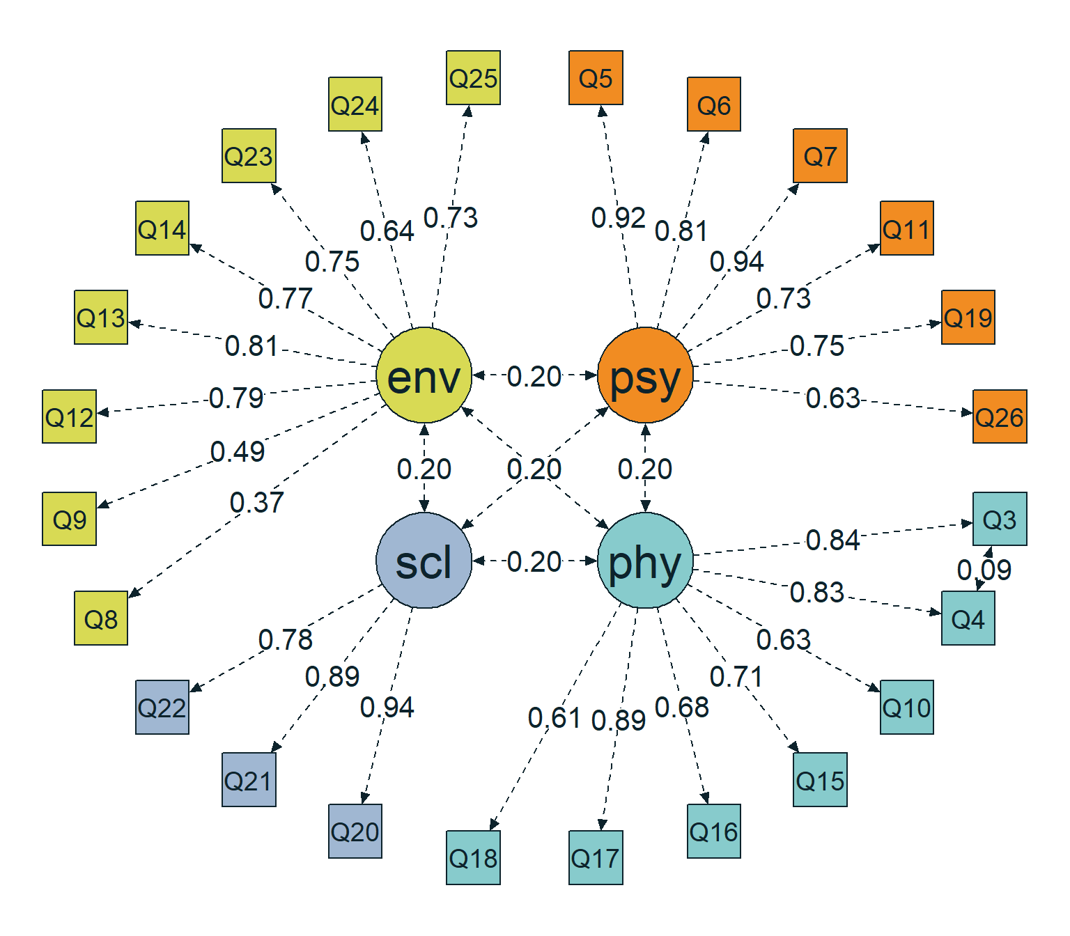
Figure 1: Path diagram of the popmodel
_{Source: Population Models}

2.2 Naive model
The naive model provides an empirically grounded pessimistic scenario. Factor loadings are derived via the Spearman-Brown prediction formula from the lowest Cronbach’s $α$ values identified in the literature (Mosqueira Taipe et al., 2026), yielding conservative parameter estimates that push sample size requirements upward:
- Approach: Assuming equal loadings within each domain, $λ=\sqrt{α/(k−α(k−1))}$ and $θ=1−λ^{2}$.
- Alpha sources: Lowest domain alphas from a single study identified in the systematic review by Mosqueira Taipe et al. (2026) (Physical $α=0.672$; Psychological $α=0.704$; Social $α=0.630$; Environmental $α=0.709$), all within the $M−1SD$ range reported by Lin & Yao (2022).
- Interfactor correlations ($ϕ$): Fixed at $0.30$ (the upper bound from Lin & Yao (2022)), making factors harder to distinguish and yielding a deliberately conservative power estimate.
- Derived parameters: Physical ($λ=0.4758$, $θ=0.7736$); Psychological ($λ=0.5328$, $θ=0.7161$); Social ($λ=0.6017$, $θ=0.6379$); Environmental ($λ=0.4832$, $θ=0.7665$). The residual covariance between $Q3$ and $Q4$ is adjusted to $0.2321$.
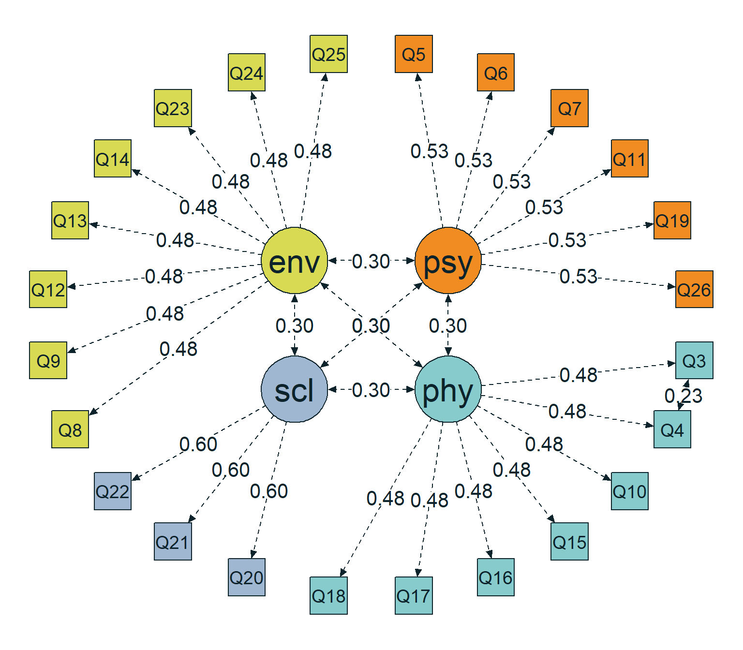
Figure 2: Path diagram of the naivemodel
_{Source: Population Models}

2.3 Optimistic model
The optimistic model applies the same Spearman-Brown derivation but draws on the highest observed Cronbach’s $α$ values per domain, producing stronger loadings and lower residual variances relative to the naive model (Mosqueira Taipe et al., 2026):
- Alpha sources: Maximum domain alphas from the literature (Mosqueira Taipe et al., 2026) (Physical $α=0.860$; Psychological $α=0.860$; Social $α=0.810$; Environmental $α=0.849$), all confirmed within the $M+1SD$ range from Lin & Yao (2022).
- Interfactor correlations ($ϕ$): Fixed at $0.08$ (the lower bound from Lin & Yao (2022)), so that factors are well distinguished and sample size requirements are reduced.
- Derived parameters: Physical ($λ=0.6837$, $θ=0.5326$); Psychological ($λ=0.7113$, $θ=0.4941$); Social ($λ=0.7661$, $θ=0.4130$); Environmental ($λ=0.6424$, $θ=0.5873$). The residual covariance between $Q3$ and $Q4$ is adjusted to $0.1598$.
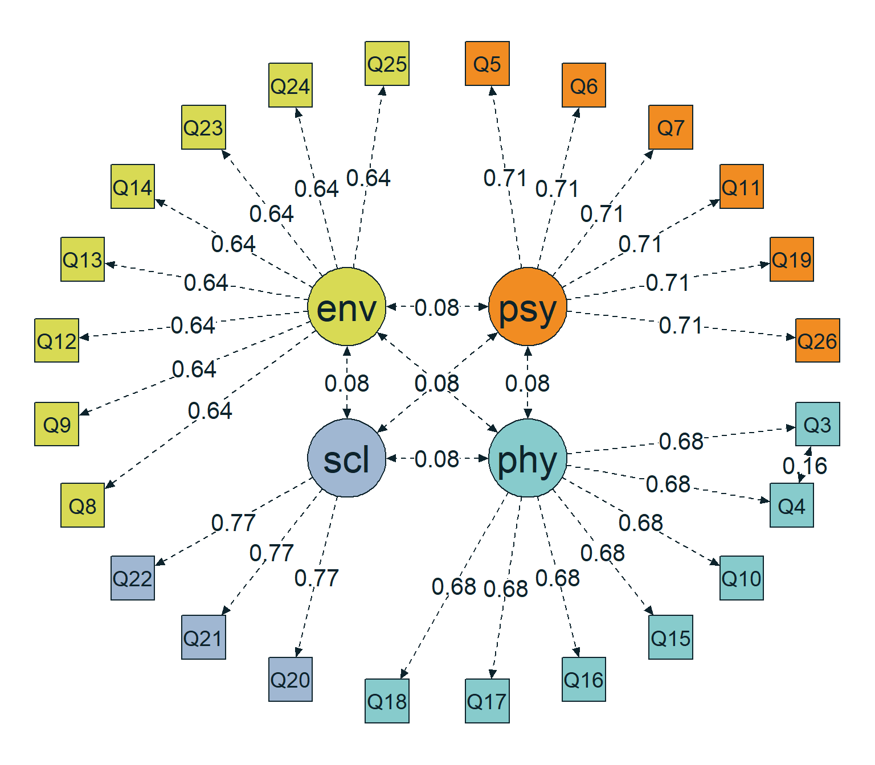
Figure 3: Path diagram of the optmodel
_{Source: Population Models}

2.4 Misspecification model
This model defines the alternative hypothesis ($H_{1}$): a cross-loading variant of the four-factor structure in which three empirically motivated cross-loadings are added based on the meta-EFA results of Lin & Yao (2022) and the systematic review evidence in Mosqueira Taipe et al. (2026):
- Cross-loading 1: Item $Q8$ on the Psychological factor ($λ=0.55$). This item showed the highest betweenness centrality ($40.50$) and was assigned to the Psychological factor in 9 of 16 studies (Lin & Yao, 2022).
- Cross-loading 2: Item $Q9$ on the Psychological factor ($λ=0.21$), identified as a secondary loading in the five-factor EFA solution.
- Cross-loading 3: Item $Q15$ on the Environmental factor ($λ=0.24$). “Mobility” conceptually bridges physical ability and environmental access, and this item showed the second-highest betweenness centrality ($36.50$) (Lin & Yao, 2022).
Residual variances for cross-loaded items were recalculated to preserve total item variance: $θ=1−λ_{\text{primary}}^{2}−λ_{\text{secondary}}^{2}−2λ_{\text{primary}}λ_{\text{secondary}}ϕ$, where $ϕ=0.20$.
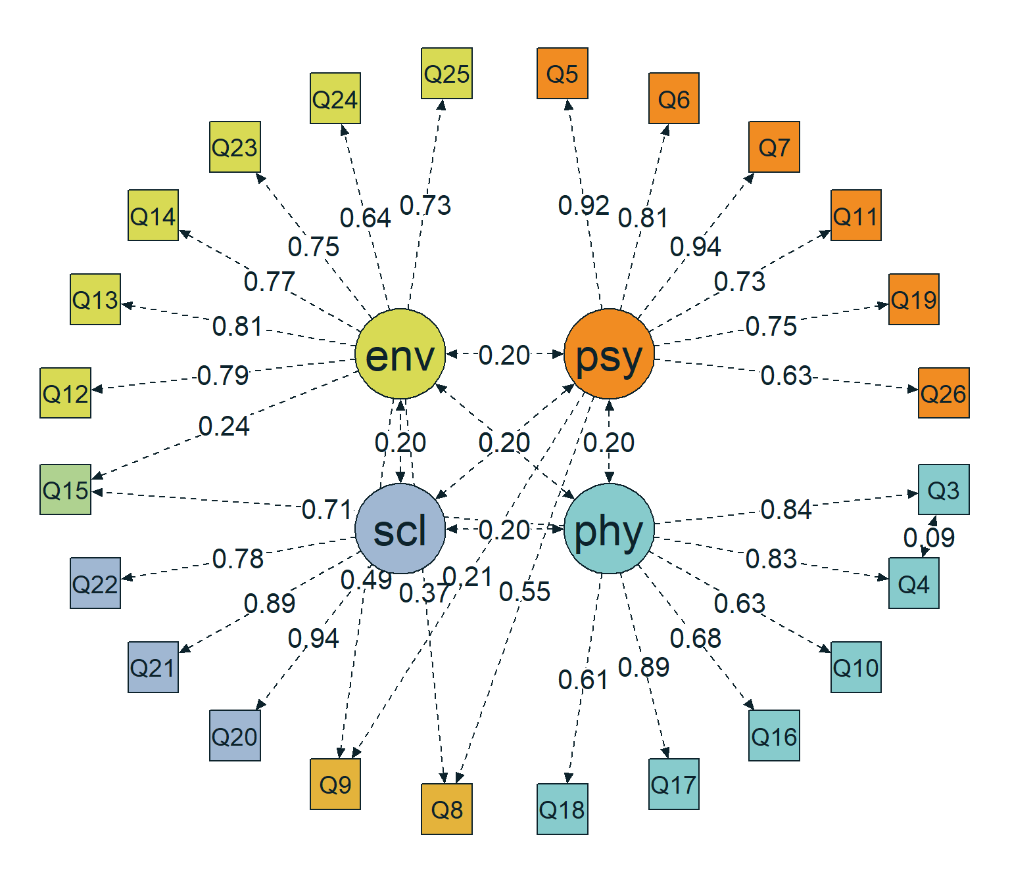
Figure 4: Path diagram of the h1model
_{Source: Population Models}

2.5 Summary of population models
Table 1 presents all parameters of the four population models. Table 2 summarizes key features across models — minimum and maximum factor loadings, mean loading, modal interfactor correlation, minimum and maximum residual variances, and the residual correlation between $Q3$ and $Q4$ — to facilitate direct comparison.
Table 1: Summary of population models used for sensitivity analysis
parameters | popmodel | naivemodel | optmodel | h1model
psycho=~Q5 | 0.9200 | 0.5328 | 0.7113 | 0.9200
psycho=~Q6 | 0.8100 | 0.5328 | 0.7113 | 0.8100
psycho=~Q7 | 0.9400 | 0.5328 | 0.7113 | 0.9400
psycho=~Q11 | 0.7300 | 0.5328 | 0.7113 | 0.7300
psycho=~Q19 | 0.7500 | 0.5328 | 0.7113 | 0.7500
psycho=~Q26 | 0.6300 | 0.5328 | 0.7113 | 0.6300
physical=~Q3 | 0.8400 | 0.4758 | 0.6837 | 0.8400
physical=~Q4 | 0.8300 | 0.4758 | 0.6837 | 0.8300
physical=~Q10 | 0.6300 | 0.4758 | 0.6837 | 0.6300
physical=~Q15 | 0.7100 | 0.4758 | 0.6837 | 0.7100
physical=~Q16 | 0.6800 | 0.4758 | 0.6837 | 0.6800
physical=~Q17 | 0.8900 | 0.4758 | 0.6837 | 0.8900
physical=~Q18 | 0.6100 | 0.4758 | 0.6837 | 0.6100
social=~Q20 | 0.9400 | 0.6017 | 0.7661 | 0.9400
social=~Q21 | 0.8900 | 0.6017 | 0.7661 | 0.8900
social=~Q22 | 0.7800 | 0.6017 | 0.7661 | 0.7800
environment=~Q8 | 0.3700 | 0.4832 | 0.6424 | 0.3700
environment=~Q9 | 0.4900 | 0.4832 | 0.6424 | 0.4900
environment=~Q12 | 0.7900 | 0.4832 | 0.6424 | 0.7900
environment=~Q13 | 0.8100 | 0.4832 | 0.6424 | 0.8100
environment=~Q14 | 0.7700 | 0.4832 | 0.6424 | 0.7700
environment=~Q23 | 0.7500 | 0.4832 | 0.6424 | 0.7500
environment=~Q24 | 0.6400 | 0.4832 | 0.6424 | 0.6400
environment=~Q25 | 0.7300 | 0.4832 | 0.6424 | 0.7300
Q3~~Q4 | 0.0908 | 0.2321 | 0.1598 | 0.0908
psycho~~psycho | 1.0000 | 1.0000 | 1.0000 | 1.0000
psycho~~physical | 0.2000 | 0.3000 | 0.0800 | 0.2000
psycho~~social | 0.2000 | 0.3000 | 0.0800 | 0.2000
psycho~~environment | 0.2000 | 0.3000 | 0.0800 | 0.2000
physical~~physical | 1.0000 | 1.0000 | 1.0000 | 1.0000
physical~~social | 0.2000 | 0.3000 | 0.0800 | 0.2000
physical~~environment | 0.2000 | 0.3000 | 0.0800 | 0.2000
social~~social | 1.0000 | 1.0000 | 1.0000 | 1.0000
social~~environment | 0.2000 | 0.3000 | 0.0800 | 0.2000
environment~~environment | 1.0000 | 1.0000 | 1.0000 | 1.0000
Q5~~Q5 | 0.1536 | 0.7161 | 0.4941 | 0.1536
Q6~~Q6 | 0.3439 | 0.7161 | 0.4941 | 0.3439
Q7~~Q7 | 0.1164 | 0.7161 | 0.4941 | 0.1164
Q11~~Q11 | 0.4671 | 0.7161 | 0.4941 | 0.4671
Q19~~Q19 | 0.4375 | 0.7161 | 0.4941 | 0.4375
Q26~~Q26 | 0.6031 | 0.7161 | 0.4941 | 0.6031
Q3~~Q3 | 0.2944 | 0.7736 | 0.5326 | 0.2944
Q4~~Q4 | 0.3111 | 0.7736 | 0.5326 | 0.3111
Q10~~Q10 | 0.6031 | 0.7736 | 0.5326 | 0.6031
Q15~~Q15 | 0.4959 | 0.7736 | 0.5326 | 0.3701
Q16~~Q16 | 0.5376 | 0.7736 | 0.5326 | 0.5376
Q17~~Q17 | 0.2079 | 0.7736 | 0.5326 | 0.2079
Q18~~Q18 | 0.6279 | 0.7736 | 0.5326 | 0.6279
Q20~~Q20 | 0.1164 | 0.6379 | 0.4130 | 0.1164
Q21~~Q21 | 0.2079 | 0.6379 | 0.4130 | 0.2079
Q22~~Q22 | 0.3916 | 0.6379 | 0.4130 | 0.3916
Q8~~Q8 | 0.8631 | 0.7665 | 0.5873 | 0.4792
Q9~~Q9 | 0.7599 | 0.7665 | 0.5873 | 0.6746
Q12~~Q12 | 0.3759 | 0.7665 | 0.5873 | 0.3759
Q13~~Q13 | 0.3439 | 0.7665 | 0.5873 | 0.3439
Q14~~Q14 | 0.4071 | 0.7665 | 0.5873 | 0.4071
Q23~~Q23 | 0.4375 | 0.7665 | 0.5873 | 0.4375
Q24~~Q24 | 0.5904 | 0.7665 | 0.5873 | 0.5904
Q25~~Q25 | 0.4671 | 0.7665 | 0.5873 | 0.4671
psycho=~Q8 | NA | NA | NA | 0.5500
psycho=~Q9 | NA | NA | NA | 0.2100
environment=~Q15 | NA | NA | NA | 0.2400

_{Source: Population Models}
Table 2: Comparison of model variants used for sensitivity analysis
Metric | Meta-analytic (popmodel) | Naive (naivemodel) | Optimistic (optmodel) | H1 (h1model)
Loading Min | 0.37 | 0.48 | 0.64 | 0.21
Loading Max | 0.94 | 0.60 | 0.77 | 0.94
Mean Loading | 0.75 | 0.51 | 0.69 | 0.70
Factor Correlations | 0.20 | 0.30 | 0.08 | 0.20
Residual Min | 0.12 | 0.64 | 0.41 | 0.12
Residual Max | 0.86 | 0.77 | 0.59 | 0.67
Q3–Q4 Correlation | 0.09 | 0.23 | 0.16 | 0.09

_{Source: Population Models}

2.6 Analysis model
The analysis model (analyzemodel) serves dual purposes depending on the simulation paradigm:
- Misspecification detection: When data are generated from the misspecification model (h1model), the analysis model acts as the null hypothesis ($H_{0}$) by omitting the three cross-loadings. Power is then the probability of correctly rejecting this under-parameterized model.
- Parameter recovery: When data are generated from the meta-analytic, naive, or optimistic population models, the same structure is used to estimate the four-factor model with the $Q3$–$Q4$ residual covariance, and power reflects the ability to recover individual parameters.
Key specification choices:
- Identification: Factor variances fixed to $1$ (marker-free scaling), allowing all first-indicator loadings to be freely estimated.
- Residual covariance: The $Q3$–$Q4$ covariance is freely estimated, which is both theoretically justified and empirically supported (Lin & Yao, 2022; Mosqueira Taipe et al., 2026).
- Omitted cross-loadings: The deliberate exclusion of cross-loadings for $Q8$, $Q9$, and $Q15$ defines the misspecification that this tutorial’s main analysis is designed to detect.
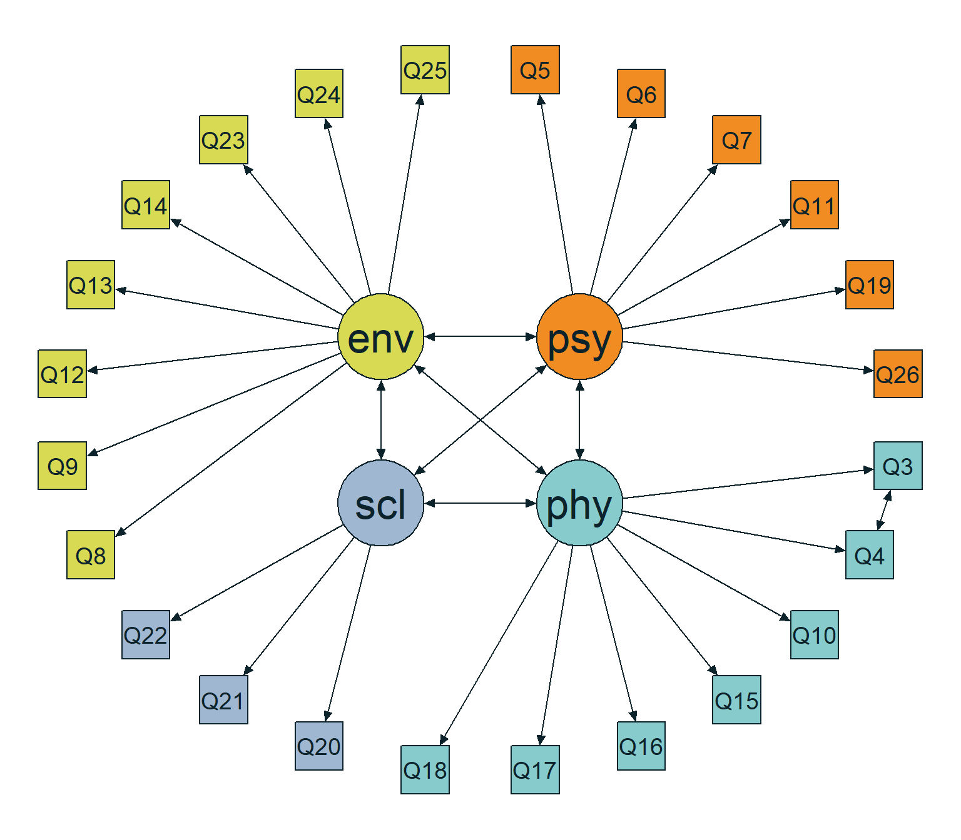
Figure 5: Path diagram of the analyzemodel
_{Source: Population Models}

3 Analytical Power Analysis
Before running any data collection, analytical power analysis answers a fundamental planning question: how large must $N$ be so that, if the model is wrong by at least a specified amount, we will reject it with acceptable probability? In SEM, the dominant analytical framework links misspecification to the non-central $χ^{2}$ distribution through the noncentrality parameter $λ$, which scales with both $N$ and the magnitude of model discrepancy (Jak et al., 2021; MacCallum et al., 1996).

3.1 Model Degrees of Freedom
All analytical calculations in this section depend on the model degrees of freedom ($df$) — the difference between the number of unique variances and covariances in the observed data and the number of freely estimated parameters. This quantity enters the non-central $χ^{2}$ distribution directly and is therefore required before any a priori or post hoc power calculation can proceed (Jak et al., 2021; Moshagen & Bader, 2024). For the hypothesized four-factor WHOQOL-BREF CFA model analyzed here (comprising 24 observed indicators, yielding $p(p+1)/2=300$ non-redundant sample moments and 55 freely estimated parameters under standardized latent variables), this yields $df=245$.

3.2 A Priori: How Many Observations?

3.2.1 Model-free approach (RMSEA-based)
The simplest analytical strategy sets the target effect through the RMSEA, a noncentrality-based index that expresses misfit per degree of freedom and is therefore comparable across models of different complexity (MacCallum et al., 1996). Because RMSEA is directly linked to the population minimum of the fitting function through $F_{0}={\text{RMSEA}}^{2}×df$, specifying a target RMSEA is sufficient to define the entire noncentrality-based framework needed for the power calculation. The approach is “model-free” in the sense that no explicit population model needs to be specified: the required sample size depends only on $\text{RMSEA}$, $α$, desired power, and $df$ (Jak et al., 2021; Jobst et al., 2023).
This strategy is most appropriate when the objective is to plan sample size for detecting overall model misspecification in a global chi-square test of fit, rather than for testing an individual parameter restriction (Moshagen & Bader, 2024; Wang, 2023).
Table 3: Analytical a priori power parameters for RMSEA = 0.05
Metric | Symbol | Value
Population discrepancy | $F_{0}$ | 0.613
Root mean square error of approximation | $\text{RMSEA}$ | 0.050
McDonald centrality index | $Mc$ | 0.736
Goodness-of-fit index | $\text{GFI}$ | 0.951
Adjusted goodness-of-fit index | $\text{AGFI}$ | 0.941
Degrees of freedom | $df$ | 245
Required sample size | $N$ | 100
Critical chi-square | $χ_{\text{crit}}^{2}$ | 282.511
Noncentrality parameter | $λ$ | 60.638
Significance level (alpha) | $α$ | 0.050
Type II error rate (beta) | $β$ | 0.1984
Statistical power | $1−β$ | 0.8016

Source: Analytical Power Analysis
The analytical solution reported in Table 3 indicates the minimum $N$ required to detect misfit of $\text{RMSEA}=0.05$ with power $≈0.80$ at $α=0.05$. Note that $0.05$ refers to the misspecification level to be detected under the alternative hypothesis, not to a tolerated misfit level under the null (Jak et al., 2021; MacCallum et al., 1996).
The table presents several equivalent representations of the same target effect. The value $F_{0}$ = 0.613 is the population minimum of the fitting function, obtained from $F_{0}=df⋅{\text{RMSEA}}^{2}$ = 245 $⋅$ ${0.05}^{2}$. Alongside it, the summary also reports $Mc$ = 0.736, $GFI$ = 0.951, and $AGFI$ = 0.941. These are not distinct effect sizes but alternative summaries of the same degree of model misfit, expressed in the metrics used by semPower (Moshagen & Bader, 2024).
The key conversion is:
$$λ=(N−1)F_{0}=(N−1) df {\text{RMSEA}}^{2}$$
which translates the chosen misfit into the noncentrality parameter used to locate the alternative $χ^{2}$ distribution (Jak et al., 2021; MacCallum et al., 1996).
With $df$ = 245, the a priori solution is $N$ = 100. At that $N$, the noncentrality parameter is $λ$ = 60.638 and the critical value is $χ_{c}^{2}$ = 282.511. The implied $β$ $≈$ 0.198 corresponds to power $1−β$ $≈$ 0.802, confirming that $N$ = 100 is the minimum sample size at which the target operating characteristics are met (Jobst et al., 2023).
In Figure 6, the solid red curve is the central $χ^{2}$ under exact fit, the dashed blue curve is the noncentral $χ^{2}$ under the target misspecification, and the vertical dotted line at $χ^{2}$ = 282.511 is the decision threshold (Jak et al., 2021; Moshagen & Bader, 2024).
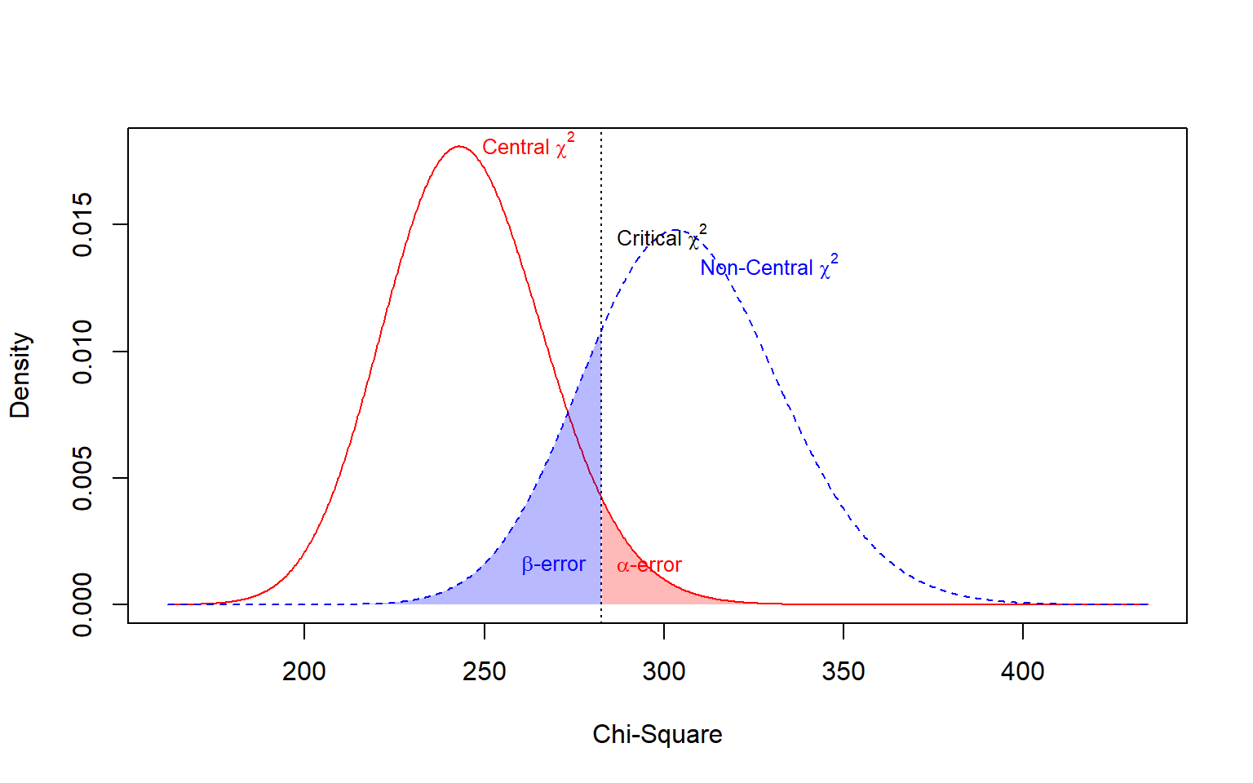
Figure 6: A priori power analysis for exact fit with RMSEA-based effect size
Source: Analytical Power Analysis

3.2.2 Model-based approach
When substantive theory specifies the population structure, a model-based power analysis is more informative: rather than setting misfit to a generic RMSEA value, the effect is implied by the discrepancy between an explicitly defined population model and the restricted analysis model (Feng & Hancock, 2023; Wang, 2023). This makes the sample size estimate dependent on the hypothesized parameter configuration rather than on a conventional threshold.
semPower.powerLav() implements this by fitting the null model to the population-implied covariance matrix and translating the resulting discrepancy into $F_{0}$ and then into $λ=(N−1)F_{0}$. When modelH1 is omitted, the null model is evaluated against the saturated model, making the analysis a global test of fit rather than a test of any single restriction (Jobst et al., 2023; Moshagen & Bader, 2024). Because the effect is generated from the full model specification, any change to loadings, factor correlations, or residual variances will alter the required $N$ — an important point when conducting sensitivity analyses (Buchberger et al., 2024).
Table 4: Analytical a priori power parameters for model-based approach (h1model vs analyzemodel)
Metric | Symbol | Value
Population discrepancy | $F_{0}$ | 0.579
Root mean square error of approximation | $\text{RMSEA}$ | 0.049
McDonald centrality index | $Mc$ | 0.749
Standardized root mean square residual | $\text{SRMR}$ | 0.067
Comparative fit index | $\text{CFI}$ | 0.960
Degrees of freedom | $df$ | 245
Required sample size | $N$ | 106
Critical chi-square | $χ_{\text{crit}}^{2}$ | 282.511
Noncentrality parameter | $λ$ | 60.793
Significance level (alpha) | $α$ | 0.050
Type II error rate (beta) | $β$ | 0.1968
Statistical power | $1−β$ | 0.8032

Source: Analytical Power Analysis
The model-based analytical solution in Table 4 reports a population discrepancy of $F_{0}$ = 0.579, equivalently expressed as $\text{RMSEA}$ = 0.049 and $Mc$ = 0.749. With $df$ = 245, the required sample size is $N$ = 106, and the corresponding critical chi-square is 282.511. The noncentrality parameter is $λ$ = 60.793, consistent with $(N−1)F_{0}$ at the obtained solution. The error rates are $α$ = 0.05, $β$ = 0.197, and power = 0.803, confirming that the design conditions are met at $N$ = 106. The corresponding distribution curves are displayed in Figure 7:
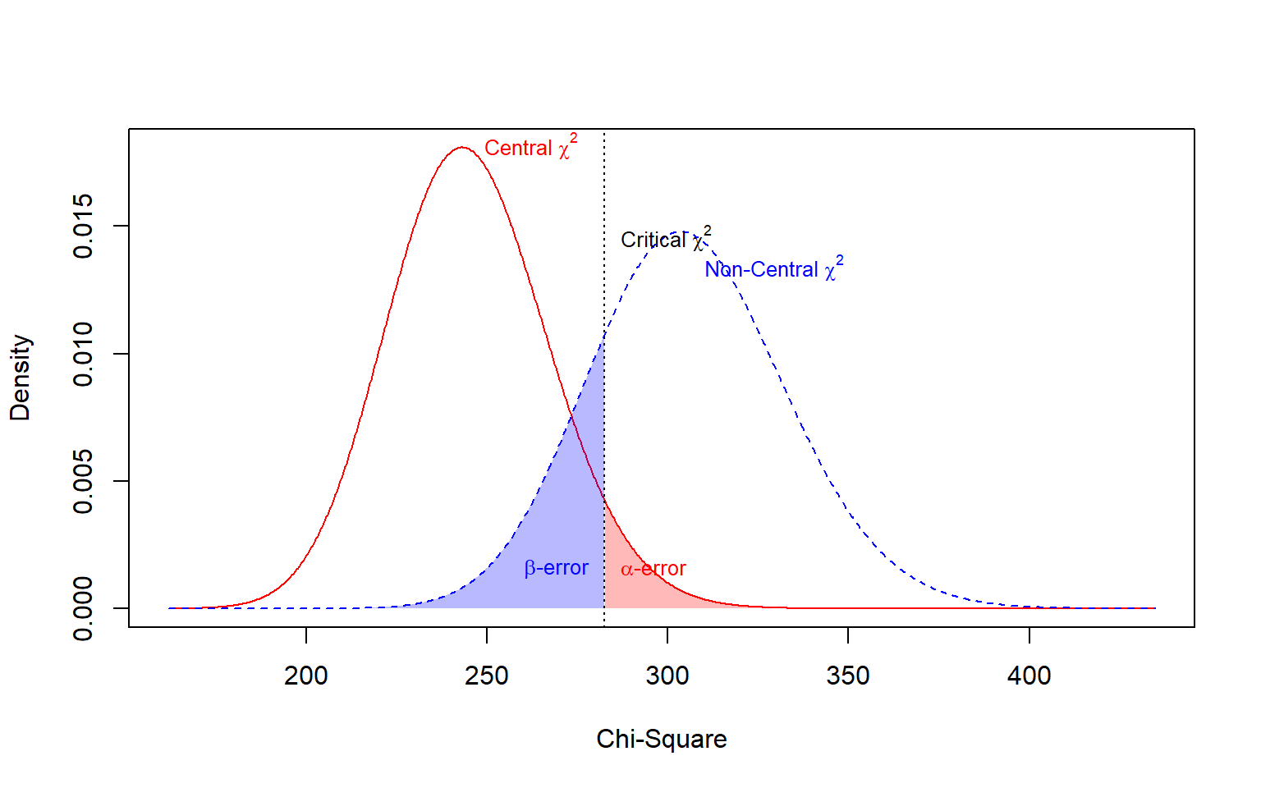
Figure 7: A priori power analysis Model-based approach (h1model vs analyzemodel)
Source: Analytical Power Analysis

3.3 Power Curves
Power curves visualize the relationship between sample size and the probability of detecting a prespecified degree of model misspecification, holding $α$ and $df$ constant. They serve as a planning aid by showing at a glance which $N$ values are underpowered and where additional observations yield diminishing returns (Moshagen & Bader, 2024).

3.3.1 Model-free approach (RMSEA-based)
In the model-free setup, the power function depends entirely on $\text{RMSEA}$, $df$, and $α$ — not on any substantive model parameters. Representing this function graphically answers a direct planning question: for a model with fixed $df$, how large must $N$ be to achieve a sufficiently high probability of detecting misfit of at least the target magnitude (Jak et al., 2021; Jobst et al., 2023)? This visualization is especially useful when the research objective concerns global fit rather than individual parameter restrictions, and it also makes it easy to communicate design justification to reviewers or funding agencies (Moshagen & Bader, 2024; Wang, 2023).
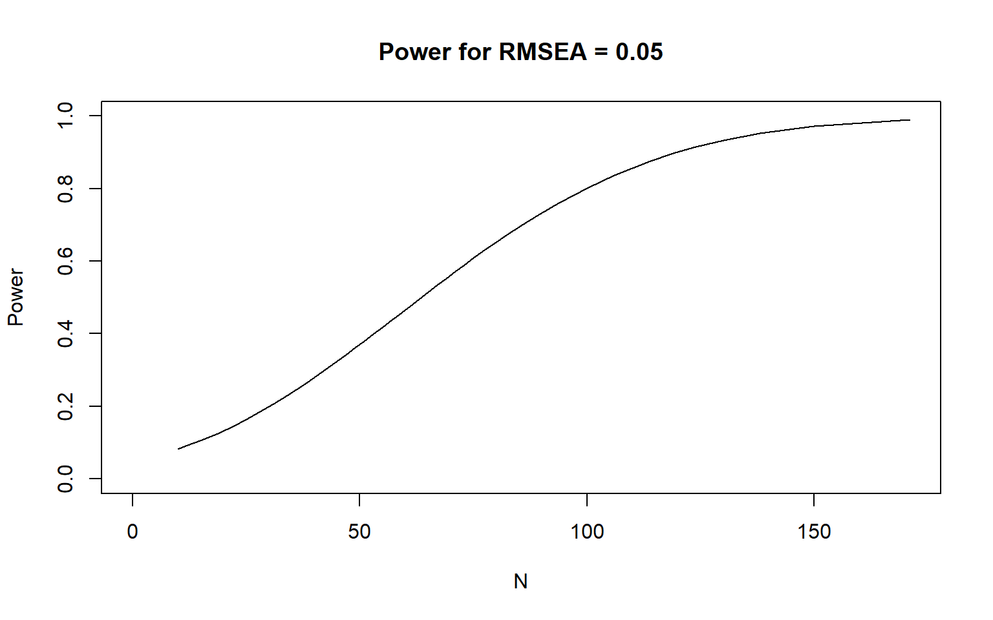
Figure 8: Power as a function of sample size for RMSEA = 0.05
Source: Analytical Power Analysis
Power increases monotonically with $N$. At the lower end of the range, the curve is well below the target threshold, indicating insufficient sensitivity to detect the prespecified misspecification; at higher $N$, it approaches the ceiling. The crossing point between the curve and the target power level identifies the minimum adequate sample size, and the shape of the curve shows how quickly additional observations convert into detection probability in this particular setting.

3.3.2 Model-based approach
When the effect is grounded in an explicitly specified population model, the power curve traces the same monotonic pattern but now reflects the particular covariance structure implied by the substantive hypotheses (Buchberger et al., 2024; Feng & Hancock, 2023). semPower.powerPlot() evaluates the previously specified model-based effect at each $N$ in the grid, so the curve is a design-oriented summary of how sensitivity changes as sample size grows — without re-estimating any parameters (Moshagen & Bader, 2024).
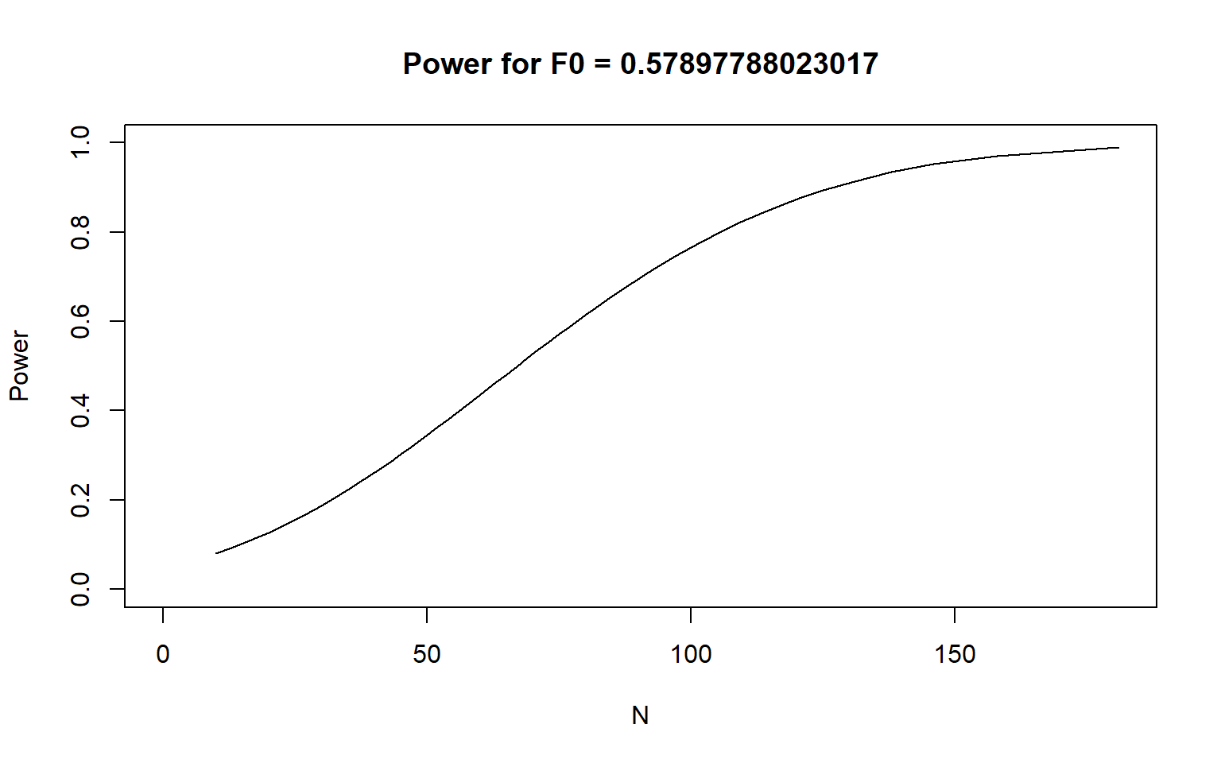
Figure 9: Power as a function of sample size for the population model (popModel)
Source: Analytical Power Analysis
The plot titled Power for $F_{0}$ = 0.579 shows a clear monotonic increase. At the lower end, power hovers near $0.07$–$0.10$, indicating inadequate sensitivity for small samples. A period of rapid growth occurs between roughly $N=60$ and $N=120$, where each additional observation translates into a substantial gain. The conventional $0.80$ threshold is crossed at approximately $N≈106$, and power approaches $0.95$ around $N≈140$, with further gains becoming marginal above that.

3.4 Summary table
Table 5 compares the analytical power solutions. The model-based global fit test requires $N=106$, closely matching the model-free RMSEA-based target ($N=100$). This convergence occurs because the misspecification introduced by the three cross-loadings translates into an implied $\text{RMSEA}=0.0486$, almost identical to the generic $0.05$ threshold.
Table 5: Summary of analytical power analysis results
Method | N Required | Power | Implied RMSEA | df
Model-free a priori (RMSEA = .05) | 100 | 0.8016 | 0.0500 | 245
Model-based global fit (h1model vs. saturated) | 106 | 0.8032 | 0.0486 | 245

Source: Analytical Power Analysis
 Limitations of the Analytical Approach
The RMSEA/$χ^{2}$-based analytical method assumes continuous, multivariate normal data and Maximum Likelihood estimation. It can yield biased sample size estimates when distributions are non-normal, data are ordinal, or missing data reduce estimation efficiency. Furthermore, because power is framed around global misfit, the analytical approach provides no information about whether $N$ is sufficient to detect specific weak loadings, factor correlations, or structural paths. These limitations motivate the simulation-based extensions developed in subsequent sections.

4 Monte Carlo Simulation: Ideal Conditions
Simulation-based power analysis in SEM operates on a different logic from its analytical counterpart. Rather than deriving power from the non-central $χ^{2}$ distribution, the approach repeatedly generates data from an assumed population model, fits the analysis model to each replicate, and summarizes rejection rates empirically. This makes the framework far more flexible: it can accommodate complex data conditions, evaluate multiple fit criteria simultaneously, and quantify estimation quality — bias, standard error accuracy, and coverage — alongside power (Muthén & Muthén, 2002; Pornprasertmanit et al., 2021).
The central distinction in the design is between the data-generating model and the analysis model (Feng & Hancock, 2023). The former defines the population from which replicated samples are drawn; the latter defines the structure that is repeatedly fit to each sample. Statistical power in SEM depends not only on $N$, but on the discrepancy between these two models, so this separation is essential (Feng & Hancock, 2023; Jobst et al., 2023).
In the main analysis, the reference condition uses data generated from popmodel, while the alternative condition uses data generated from h1model — a structurally equivalent model with three additional cross-loadings. The analysis model (analyzemodel) omits those cross-loadings, so power reflects the probability that global fit indices flag this deliberate misspecification. Varying $N$ across a predefined sequence turns the simulation into a sample size planning exercise: as $N$ grows, the sampling distributions under the reference and alternative conditions separate, and the probability of correctly flagging the misspecified condition increases (Feng & Hancock, 2023; Jobst et al., 2023).
Power based on fit indices is therefore interpreted as the probability that a rejection rule — calibrated from the reference distribution at $α$ — classifies data generated under the alternative as showing worse fit than expected under the well-fitting model. Practically, this shifts the inferential focus from testing a single parameter to evaluating whether global fit criteria are sensitive enough to detect a substantively meaningful form of misspecification across plausible sample sizes (Liang & Sterba, 2024; Wang, 2023).

4.1 Main analysis under ideal conditions
The Figure 11 and Figure 10 present the main results for the comparison between popmodel and h1model under ideal conditions (multivariate normality, no missing data).
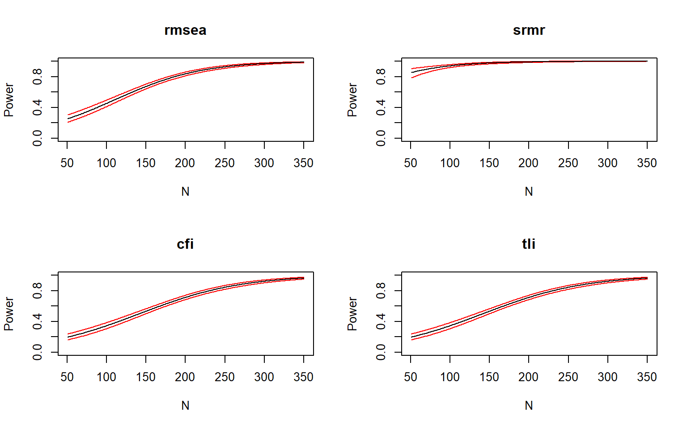
Figure 10: Power curves for fit indices under ideal conditions.
Source: Simulation — Ideal Conditions
Power increases monotonically with $N$ for all four indices. At the lower end of the sample-size sequence, every index falls below the target threshold, indicating insufficient sensitivity. As $N$ grows, the curves diverge: some indices reach the $0.80$ target earlier than others, reflecting different degrees of sensitivity to the imposed cross-loading misspecification. The most conservative planning decision is therefore anchored in the last index to cross the target — the index whose detection requires the largest $N$.
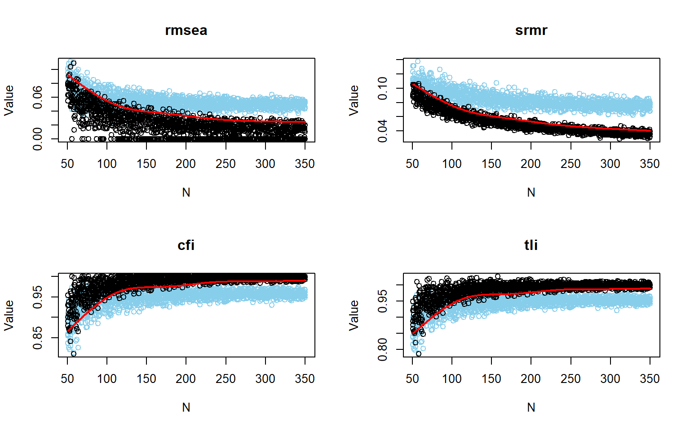
Figure 11: Power curves for fit indices under ideal conditions without logistic smoothing.
Source: Simulation — Ideal Conditions
The Figure 11 makes the discrimination mechanism visible. At small $N$, the sampling distributions of each fit index under the reference and alternative conditions overlap substantially, so the indices cannot reliably distinguish the two scenarios. As $N$ increases, the alternative-condition distribution shifts toward worse fit while the reference distribution remains stable, widening the gap between them. This growing separation is the empirical basis for the power gains shown in the Figure 10, and it provides an intuitive picture of how fit indices work as decision variables rather than mere descriptive summaries (McNeish & Wolf, 2021; Pornprasertmanit et al., 2021).
Table 6: Power and fit index cutoff values under ideal conditions at N = 231.
 | RMSEA | SRMR | CFI | TLI
Power | 0.900 | 0.995 | 0.801 | 0.801
Cutoff | 0.039 | 0.058 | 0.965 | 0.961

Source: Simulation — Ideal Conditions
At $N=231$, power was 0.9 for RMSEA, 0.995 for SRMR, and 0.801 for both CFI and TLI. The ordering SRMR > RMSEA > CFI $≈$ TLI is consistent across the power curves. The empirical cutoffs were 0.039 for RMSEA, 0.058 for SRMR, 0.965 for CFI, and 0.961 for TLI, defining the data-driven rejection boundaries at this $N$. Taken together, the results confirm that $N=231$ is sufficient for all four indices to achieve at least $0.80$ power in the ideal scenario, with SRMR and RMSEA providing a comfortable margin and CFI/TLI operating near the minimum threshold (Jobst et al., 2023; McNeish & Wolf, 2021).

4.2 Traditional cutoff values for fit indices
When traditional thresholds are applied — $\text{RMSEA}≤.06$, $\text{CFI}≥.95$, $\text{TLI}≥.95$, $\text{SRMR}≤.06$ — power is defined as the proportion of replications in which the misspecified model crosses those fixed boundaries in the direction of worse fit. This mirrors common applied practice, but a key limitation is that these thresholds were derived under specific simulation conditions and may not be universally valid across different model structures and sample sizes (Kyriazos, 2018; McNeish & Wolf, 2021).
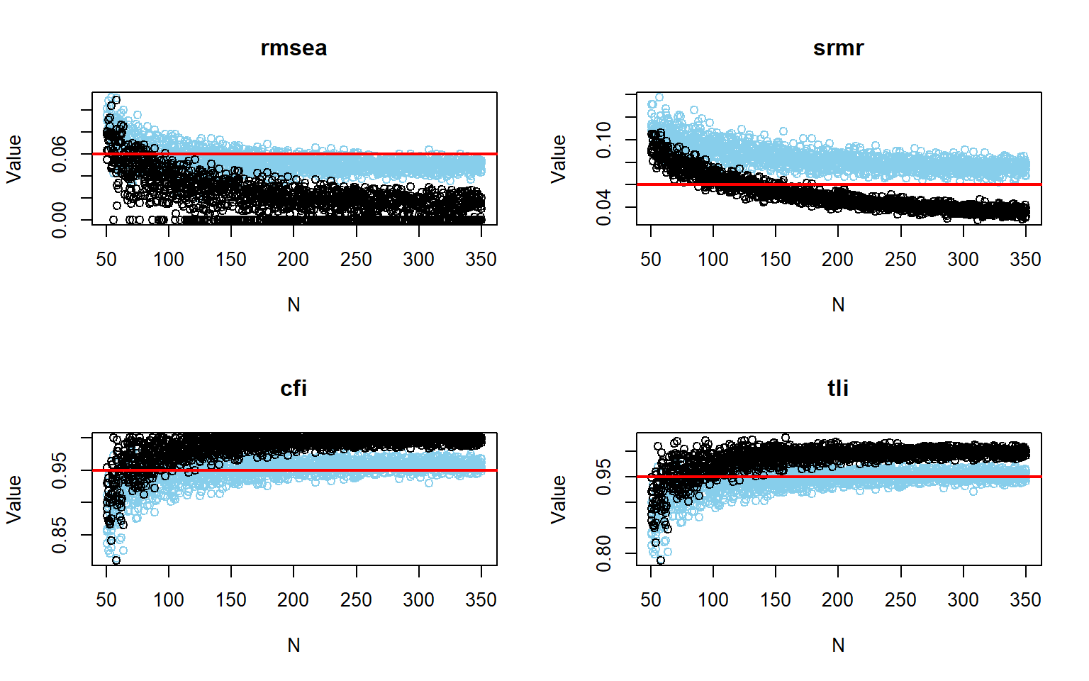
Figure 12: Power curves using traditional fit index cutoffs under ideal conditions.
Source: Simulation — Ideal Conditions
The contrast with the empirical-cutoff results is instructive. SRMR is the only index that achieves clear visual discrimination under the traditional threshold, and only at $N≈200$ or larger. RMSEA shows some separation but would require a cutoff near $0.04$ rather than $0.06$ to make a meaningful distinction in this figure. CFI and TLI show essentially no discrimination at the $0.95$ threshold because both the reference and alternative point clouds cluster in the same region throughout the sample-size range (Figure 12). The Table 7 summarizes the power for each fit index under the traditional cutoff values.
Table 7: Power for traditional fit index cutoffs under ideal conditions at N = 231.
 | CFI | TLI | RMSEA | SRMR
Power | 0.381 | 0.579 | 0.153 | > 0.98

Source: Simulation — Ideal Conditions

4.3 Targeting specific parameters
The previous analyses focused on global fit. However, power is always tied to a specific hypothesis, and different parameters within the same model can require markedly different $N$ to reach the same target (Moshagen & Bader, 2024; Wang, 2023). This section evaluates power at the parameter level to identify which parts of the model are hardest to recover and should therefore anchor the sample size decision.
In simsem, parameter-level summaries include relative bias, standard-error bias, CI coverage, and detection power. These four indicators are not redundant: a parameter may show high power while still being poorly estimated, and estimation quality should always be verified alongside detection rates (Pornprasertmanit et al., 2021; Wang & Rhemtulla, 2021).
Table 8: Summary of parameter estimates under ideal conditions.
Parameter | Rel Bias | Rel SE Bias | Coverage | Power (Not equal 0)
psycho=~Q5 | -0.003 | -0.043 | 0.947 | 1.000
psycho=~Q6 | -0.005 | -0.084 | 0.937 | 1.000
psycho=~Q7 | -0.004 | -0.066 | 0.940 | 1.000
psycho=~Q11 | -0.005 | -0.050 | 0.945 | 1.000
psycho=~Q19 | -0.003 | 0.000 | 0.953 | 1.000
psycho=~Q26 | -0.006 | -0.079 | 0.938 | 1.000
physical=~Q3 | -0.011 | -0.063 | 0.947 | 1.000
physical=~Q4 | -0.006 | -0.066 | 0.945 | 1.000
physical=~Q10 | -0.010 | -0.062 | 0.947 | 1.000
physical=~Q15 | 0.068 | -0.106 | 0.871 | 1.000
physical=~Q16 | -0.011 | -0.061 | 0.941 | 1.000
physical=~Q17 | -0.010 | -0.090 | 0.931 | 1.000
physical=~Q18 | -0.011 | -0.077 | 0.938 | 1.000
social=~Q20 | -0.004 | -0.050 | 0.941 | 1.000
social=~Q21 | -0.003 | -0.025 | 0.952 | 1.000
social=~Q22 | 0.002 | -0.048 | 0.943 | 1.000
environment=~Q8 | 0.360 | -0.090 | 0.520 | 0.997
environment=~Q9 | 0.105 | -0.051 | 0.879 | 0.999
environment=~Q12 | -0.012 | -0.065 | 0.939 | 1.000
environment=~Q13 | -0.010 | -0.080 | 0.942 | 1.000
environment=~Q14 | -0.009 | -0.045 | 0.940 | 1.000
environment=~Q23 | -0.010 | -0.075 | 0.939 | 1.000
environment=~Q24 | -0.006 | -0.047 | 0.947 | 1.000
environment=~Q25 | -0.011 | -0.059 | 0.940 | 1.000
psycho~~physical | 0.039 | -0.069 | 0.941 | 0.751
psycho~~social | -0.002 | -0.069 | 0.935 | 0.727
psycho~~environment | 0.286 | -0.122 | 0.831 | 0.857
physical~~social | 0.046 | -0.047 | 0.944 | 0.760
physical~~environment | 0.239 | -0.091 | 0.875 | 0.839
social~~environment | 0.038 | -0.070 | 0.931 | 0.736
Q3~~Q4 | 0.007 | -0.050 | 0.944 | 0.775
Q5~~Q5 | -0.012 | -0.043 | 0.944 | 0.999
Q6~~Q6 | -0.017 | -0.039 | 0.934 | 1.000
Q7~~Q7 | -0.020 | -0.071 | 0.929 | 0.993
Q11~~Q11 | -0.014 | -0.073 | 0.926 | 1.000
Q19~~Q19 | -0.014 | -0.050 | 0.933 | 1.000
Q26~~Q26 | -0.018 | -0.038 | 0.933 | 1.000
Q3~~Q3 | -0.012 | -0.059 | 0.935 | 1.000
Q4~~Q4 | -0.015 | -0.040 | 0.944 | 1.000
Q10~~Q10 | -0.008 | -0.044 | 0.934 | 1.000
Q15~~Q15 | 0.105 | -0.068 | 0.896 | 1.000
Q16~~Q16 | -0.011 | -0.055 | 0.934 | 1.000
Q17~~Q17 | -0.008 | -0.084 | 0.934 | 0.999
Q18~~Q18 | -0.008 | -0.010 | 0.949 | 1.000
Q20~~Q20 | -0.004 | -0.091 | 0.943 | 0.848
Q21~~Q21 | -0.015 | -0.042 | 0.946 | 0.991
Q22~~Q22 | -0.018 | -0.050 | 0.933 | 1.000
Q8~~Q8 | 0.536 | -0.058 | 0.136 | 1.000
Q9~~Q9 | 0.028 | -0.059 | 0.944 | 1.000
Q12~~Q12 | -0.001 | -0.036 | 0.943 | 1.000
Q13~~Q13 | 0.004 | -0.042 | 0.936 | 1.000
Q14~~Q14 | -0.002 | -0.085 | 0.937 | 1.000
Q23~~Q23 | -0.001 | -0.029 | 0.945 | 1.000
Q24~~Q24 | -0.013 | -0.055 | 0.937 | 1.000
Q25~~Q25 | -0.007 | -0.058 | 0.942 | 1.000

Source: Simulation — Ideal Conditions
Primary factor loadings for psycho, physical, and social recover very well: high power, minimal bias, modest SE distortion, and coverage close to nominal. Two exceptions stand out. The loading of $Q8$ on environment and its residual variance are easily detected but not well recovered — the model would flag this parameter as non-zero while still estimating it with noticeable distortion. Item $Q15$ shows a secondary warning on the same dimensions. Among the latent parameters, interfactor covariances — particularly those involving social and environment — are harder to recover than loadings, with lower power and weaker coverage. The residual covariance $Q3∼∼Q4$ stands out as the most demanding residual parameter, behaving more like a latent covariance than a measurement parameter in terms of inferential difficulty.
The required $N$ for each parameter follows directly from these patterns (Jobst et al., 2023; Moshagen & Bader, 2024), as shown in Table 9.
Table 9: Sample size needed for 80% power under ideal conditions.
Parameter | N
environment=~Q8 | 51
environment=~Q9 | 51
psycho~~physical | 200
psycho~~social | 212
psycho~~environment | 138
physical~~social | 198
physical~~environment | 148
social~~environment | 208
Q3~~Q4 | 181
Q5~~Q5 | 51
Q7~~Q7 | 51
Q17~~Q17 | 51
Q20~~Q20 | 143
Q21~~Q21 | 51

Source: Simulation — Ideal Conditions
Many primary loadings and residual variances reach the target power at the low end of the simulated range. Latent covariances and the residual covariance $Q3∼∼Q4$ require substantially larger samples. In practice, the sample size decision should be driven by the hardest-to-detect parameters, not by the easiest ones — a principle that pushes the practical reference toward $N≈200$ rather than $N≈50$ (Pornprasertmanit et al., 2021; Wang & Rhemtulla, 2021). Specifically, the psycho~~social covariance requires $N$ = 212, which sets the effective ceiling for parameter-level planning in this model.

4.4 Recovering population parameters

4.4.1 Parameter-level power under the naive model
Examining parameter recovery under the naive model serves as a conservative benchmark for the measurement structure: because this population assumes the weakest factor loadings ($λ≈0.40$), indicator communalities are low, which increases estimation uncertainty for the measurement parameters (Mosqueira Taipe et al., 2026). Concurrently, its interfactor correlations are moderate ($ϕ=0.30$). For detecting latent covariances, a larger effect size ($ϕ=0.30$) requires a substantially smaller sample size than a near-zero correlation, allowing all six factor correlations to reach $80\%$ power within $N≤90$ (Pornprasertmanit et al., 2021; Wang & Rhemtulla, 2021).
Table 10: Parameter estimates and required sample size for 80% power under naive conditions.
Parameter | Rel Bias | Rel SE Bias | Coverage | Power (Not equal 0) | Required N
psycho~~physical | 0.140 | -0.944 | 0.913 | 0.793 | 180
psycho~~social | -0.009 | -0.137 | 0.922 | 0.780 | 186
psycho~~environment | -0.003 | -0.089 | 0.931 | 0.817 | 164
physical~~social | 0.331 | -0.971 | 0.924 | 0.775 | 192
physical~~environment | 0.141 | -0.932 | 0.929 | 0.793 | 178
social~~environment | -0.014 | -0.123 | 0.928 | 0.780 | 184
Q3~~Q4 | -0.013 | -0.130 | 0.932 | 0.845 | 143

Source: Simulation — Ideal Conditions
Most factor loadings reach the $0.80$ target with $N<60$, confirming that the loading structure is not the binding constraint. The binding constraint is the set of latent covariances. Their required sample sizes are: $\text{psycho}∼∼\text{physical}$ = 180, $\text{psycho}∼∼\text{social}$ = 186, $\text{psycho}∼∼\text{environment}$ = 164, $\text{physical}∼∼\text{social}$ = 192, $\text{physical}∼∼\text{environment}$ = 178, and $\text{social}∼∼\text{environment}$ = 184. The residual covariance $Q3∼∼Q4$ requires $N$ = 143, placing it between the loadings and the latent covariances in difficulty. The largest required $N$ is $\text{physical}∼∼\text{social}$ = 192, which therefore governs the minimum sample size for the naive scenario.

4.4.2 Parameter-level power under the optimistic model
Under the optimistic model, stronger loadings ($λ≈0.80$) and lower interfactor correlations ($ϕ=0.08$) yield two sharply contrasting patterns (Mosqueira Taipe et al., 2026). Because the measurement structure is exceptionally strong, all primary factor loadings and residual variances reach $0.80$ power at the lowest simulated sample size ($N≤51$) with negligible bias. Conversely, because the true interfactor correlations are very weak ($ϕ=0.08$), detecting them as statistically different from zero requires substantially larger samples: analytical power calculations indicate that reaching $80\%$ power for $ϕ=0.08$ requires $N>1,200$. Within the simulated sample-size range ($N∈[51,350]$), power for these correlations never crosses $0.80$, leading findPower to return NA.
Table 11: Parameter estimates and required sample size for 80% power under optimal conditions.
Parameter | Rel Bias | Rel SE Bias | Coverage | Power (Not equal 0) | Required N
Q3~~Q4 | -0.008 | -0.082 | 0.934 | 0.85 | 139

Source: Simulation — Ideal Conditions
Among parameters with finite required $N$ above 60, only the residual covariance $Q3∼∼Q4$ appears in Table 11, requiring $N$ = 139. Rather than implying that the entire model is powered at $N=51$, this analysis reveals that weak latent correlations represent an acute bottleneck for parameter-level hypothesis testing, even when measurement quality is optimal (Buchberger et al., 2024; Pornprasertmanit et al., 2021). The contrast between the naive and optimistic results demonstrates how sensitive $N$ recommendations are to the assumed population: the same model structure implies very different requirements depending on which parameter set is used, reinforcing the importance of sensitivity analyses across population variants (Buchberger et al., 2024; Irmer et al., 2024).

5 Monte Carlo Simulation: Realistic Scenarios
The ideal-condition analyses establish a theoretical baseline, but actual data collection rarely conforms to multivariate normality with complete observations. When non-normality or missing data are anticipated, analytical power estimates may be optimistic, and the required $N$ should be reassessed under more realistic assumptions (Feng & Hancock, 2023; Wang, 2023). Monte Carlo simulation is especially valuable here because it can encode precisely the data conditions expected in practice — including the missing-data mechanism, the distributional shape, and the estimator — and propagate them through to the power estimate (Irmer et al., 2024; Schoemann et al., 2014).
The goal of this section is not to replace the ideal-condition results but to probe how sensitive they are to two common violations: missing data and non-normality. Both analyses follow the same design logic as before — reference data from popmodel, alternative data from h1model, analysis model analyzemodel — so the results remain directly comparable (Jobst et al., 2023; Moshagen & Bader, 2024).

5.1 Missing Data (MCAR)
Missing data reduce the amount of usable information per participant and therefore generally lower estimation efficiency and statistical power, even when data are missing completely at random (MCAR) and the analysis model handles missingness correctly via full information maximum likelihood (Jak et al., 2021; Wolf et al., 2013). The relevant design question is not only how many cases are planned but how much information survives the anticipated missing-data process (Feng & Hancock, 2023).
In this simulation, 10% of observations are set missing at random prior to each analysis. All other aspects of the design are unchanged from the ideal-condition analysis.
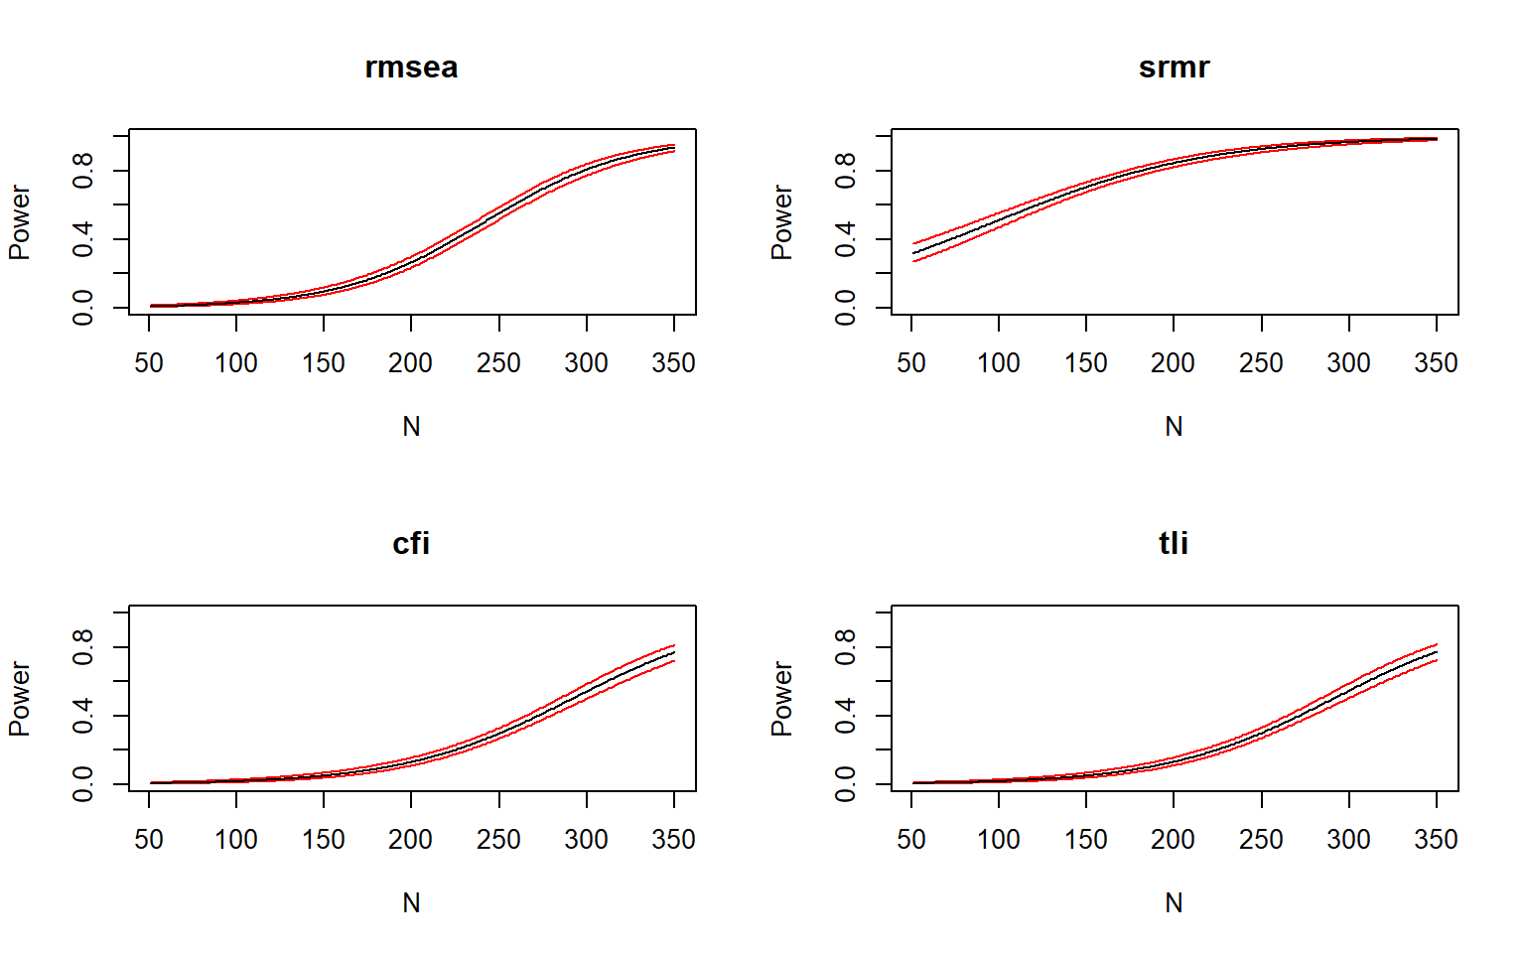
Figure 13: Power curves for fit indices under missing data conditions.
Source: Simulation — Realistic Scenarios
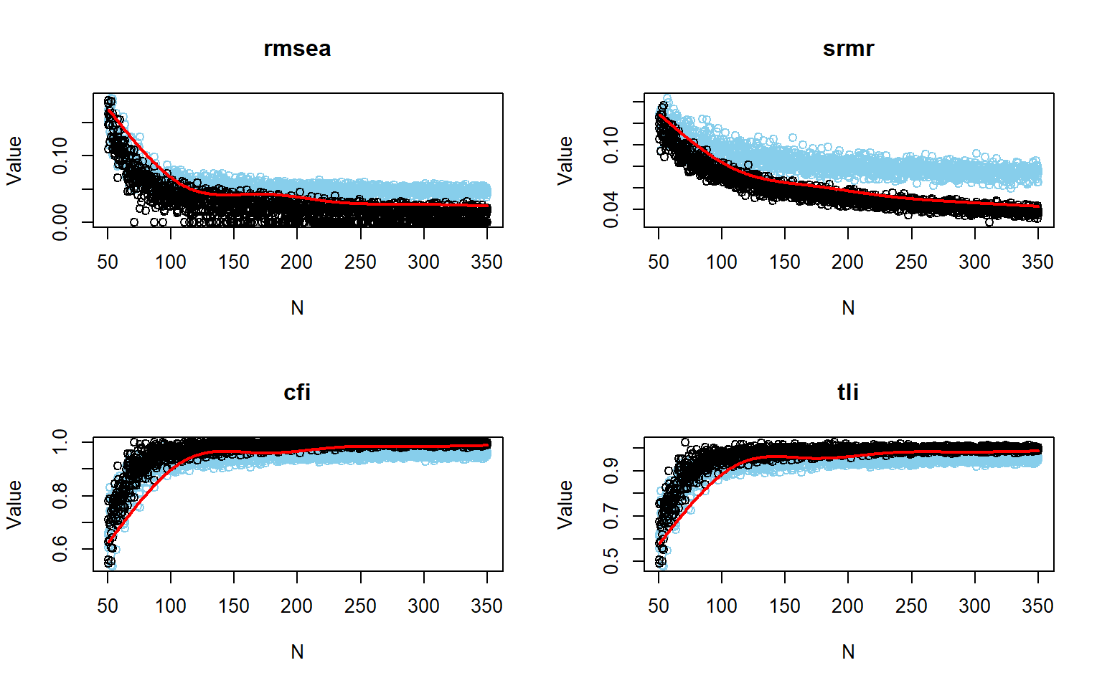
Figure 14: Power curves for fit indices under missing data conditions without logistic smoothing.
Source: Simulation — Realistic Scenarios
Both figures show the expected pattern: power curves shift rightward relative to the ideal condition, requiring larger $N$ to reach the same thresholds. The separation between distributions in the raw fit-index plots is less pronounced, especially for CFI and TLI, which show more overlap at small and intermediate sample sizes.
Table 12: Power and fit index cutoff values under missing data conditions at N = 359.
 | RMSEA | SRMR | CFI | TLI
Power | 0.947 | 0.987 | 0.802 | 0.806
Cutoff | 0.011 | 0.035 | 1.008 | 1.010

Source: Simulation — Realistic Scenarios
At $N=359$, power was 0.947 for RMSEA, 0.987 for SRMR, 0.802 for CFI, and 0.806 for TLI. SRMR remains the strongest index and RMSEA is close behind; CFI and TLI are adequate but marginally so. The empirical cutoffs were 0.011 for RMSEA, 0.035 for SRMR, 1.008 for CFI, and 1.01 for TLI. The values above $1.00$ for CFI and TLI indicate that the classification boundary from the simulation falls at the upper edge of the index scale, which explains why their power is only marginally above $0.80$ at this $N$ (McNeish & Wolf, 2021). Comparing $N=231$ (ideal) with $N=359$ (10% MCAR) makes the information cost of missing data concrete: approximately 128 additional participants are needed to restore the same level of detection performance.

5.2 Non-Normality
Mild departures from normality — skewness in the range $[−1,+1]$ and excess kurtosis in the range $[1,2]$ — are common in applied social science measurement and can affect the behavior of fit indices even when robust estimators are used (Irmer et al., 2024; Kyriazos, 2018). This analysis evaluates how such departures alter the power conclusions relative to the ideal condition.
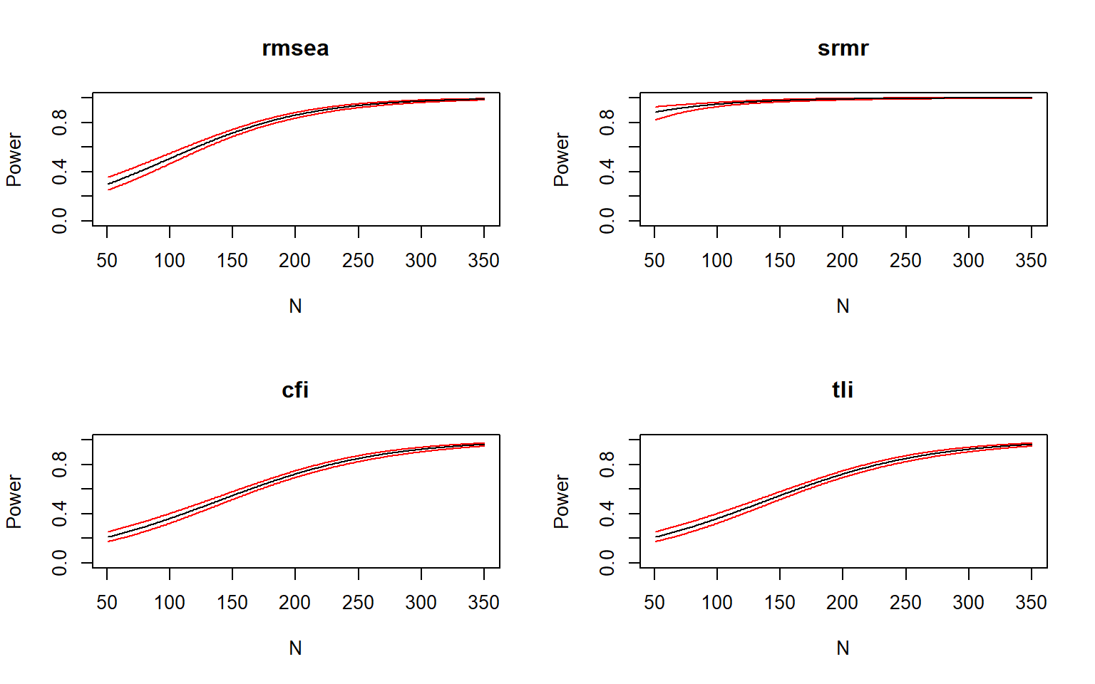
Figure 15: Power curves for fit indices under non-normal conditions.
Source: Simulation — Realistic Scenarios
The ordering of sensitivity is stable: SRMR $>$ RMSEA $>$ CFI $≈$ TLI. SRMR reaches near-ceiling power early in the sample-size range; RMSEA follows steadily; CFI and TLI rise more slowly and remain below the other two across most of the evaluated range.
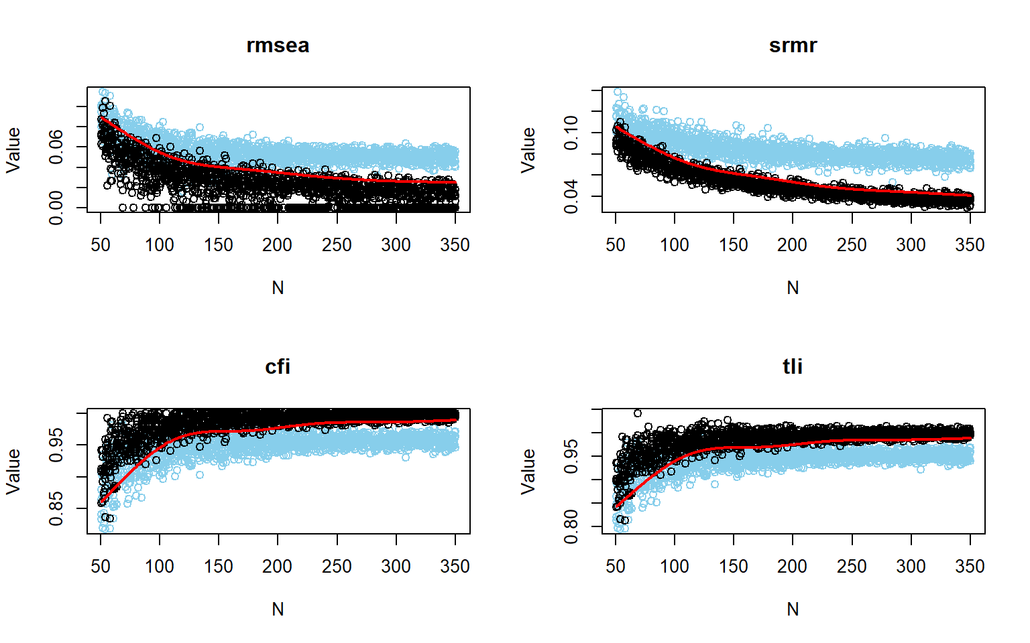
Figure 16: Power curves for fit indices under non-normal conditions without logistic smoothing.
Source: Simulation — Realistic Scenarios
The raw fit-index plots confirm the ordering. For RMSEA and SRMR, the two point clouds are increasingly distinct as $N$ grows; for CFI and TLI, overlap is more visible at lower and intermediate sample sizes and clears only at larger $N$.
Table 13: Power and fit index cutoff values under non-normal conditions at N = 228.
 | RMSEA | SRMR | CFI | TLI
Power | 0.91 | 0.994 | 0.800 | 0.80
Cutoff | 0.04 | 0.059 | 0.964 | 0.96

Source: Simulation — Realistic Scenarios
At $N=228$, power was 0.91 for RMSEA, 0.994 for SRMR, 0.8 for CFI, and 0.8 for TLI. Notably, this result is almost identical to the ideal-condition estimate of $N=231$, suggesting that mild non-normality introduces negligible additional cost under the current design and model structure (Irmer et al., 2024). The empirical cutoffs at $N=228$ were 0.04 (RMSEA), 0.059 (SRMR), 0.964 (CFI), and 0.96 (TLI), consistent with the discrimination patterns in the figures.

5.3 Simulation with fixed N
Having established minimum sample size thresholds across individual analytical and simulation conditions — where requirements largely converged between $N=100$ and $N=231$ — the planning focus naturally shifts from searching for the smallest sufficient $N$ to evaluating a candidate recruitment target. In applied research, sample sizes are frequently shaped by budgetary, temporal, and logistical feasibility.
Fixing $N=250$ represents a realistic, well-powered target sample size that comfortably exceeds both the ideal ($N=231$) and non-normal ($N=228$) benchmarks. This section subjects this planned sample size to a rigorous Monte Carlo stress test: evaluating 1,000 independent replications under compound realistic disturbances simultaneously (10% MCAR missing data and mild non-normality with robust MLR estimation). The goal is to determine whether a planned study with $N=250$ reliably discriminates the true from the misspecified model under combined real-world imperfections.
This step also highlights the practical difference between empirical and traditional fit criteria. Empirical cutoffs are calibrated to the actual sampling distribution of the fitted model; traditional cutoffs are generic conventions. The two approaches can lead to very different conclusions about adequacy (McNeish & Wolf, 2021; Pornprasertmanit et al., 2021).
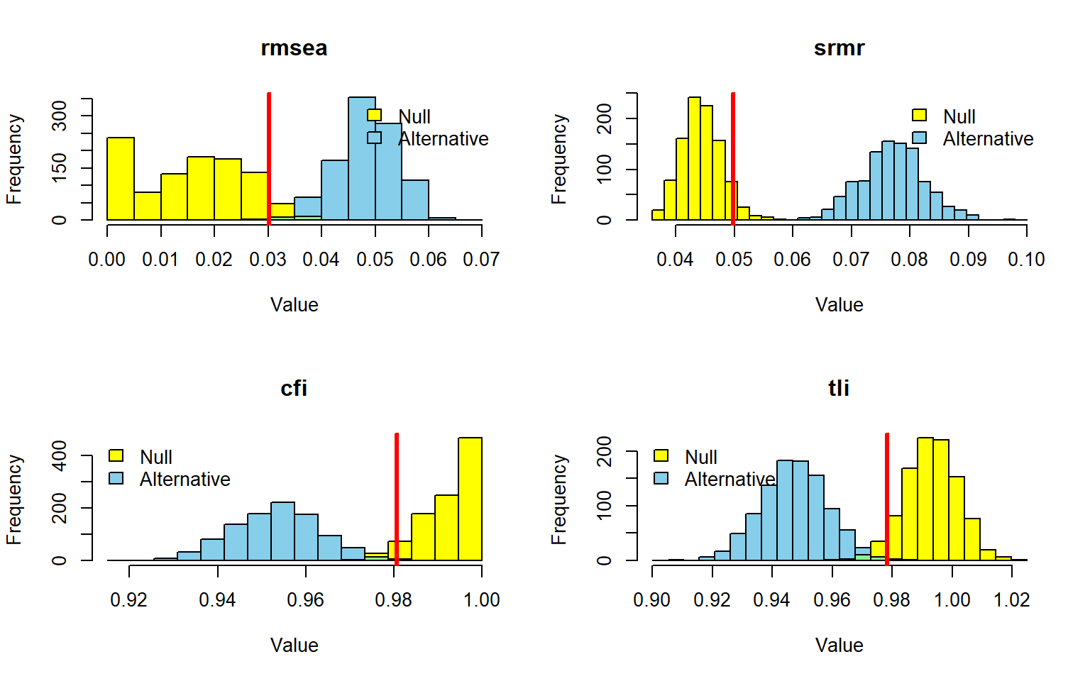
Figure 17: Power curves for fit indices with fixed sample size.
_{Source: Simulation — Fixed N}
With $N=250$, the main analysis achieves power = 1.000 for all four fit indices using empirical cutoffs. The distributions of the reference and alternative conditions are completely separated in every panel, confirming that this sample size provides essentially perfect discrimination under the target design (Liang & Sterba, 2024; Moshagen & Bader, 2024). The empirical cutoffs at $N=250$ serve as data-driven benchmarks for this specific population-analysis model combination, and their values (Table 14) differ noticeably from conventional thresholds — which underscores the value of deriving rejection rules from the simulation rather than from generic recommendations.
Table 14: Power and fit index cutoff values with fixed sample size.
 | RMSEA | SRMR | CFI | TLI
Power | 0.998 | 1.00 | 0.997 | 0.997
Cutoff | 0.030 | 0.05 | 0.981 | 0.978

_{Source: Simulation — Fixed N}

5.3.1 Power analysis with traditional cutoffs
Applying traditional rule-of-thumb thresholds to the same fixed-$N$ simulation produces a strikingly different picture. Power remains high for SRMR, falls substantially for CFI and TLI, and drops to zero for RMSEA — not because the sample is inadequate, but because the conventional $\text{RMSEA}≤0.05$ threshold is misaligned with the empirical distribution of this specific model (Kyriazos, 2018; McNeish & Wolf, 2021). This contrast is one of the clearest illustrations in this tutorial of why power conclusions depend on how the rejection criterion is defined, not only on $N$.
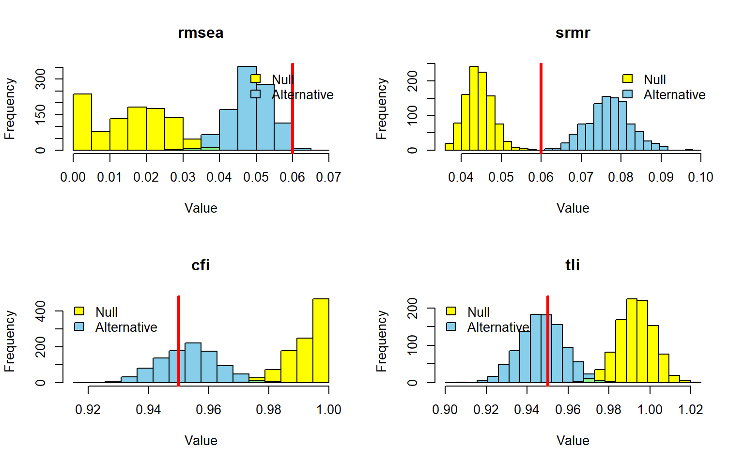
Figure 18: Power curves using traditional fit index cutoffs with fixed sample size.
_{Source: Simulation — Fixed N}
Table 15: Power for traditional fit index cutoffs with fixed sample size.
 | CFI | TLI | RMSEA | SRMR
Power | 0.354 | 0.587 | 0.007 | 0.999

_{Source: Simulation — Fixed N}
Taken together, the fixed-$N$ results support $N=250$ as a conservative, stable design choice for the main comparison: it delivers perfect discrimination when empirical cutoffs are used, and its failures under traditional cutoffs reveal a limitation of those cutoffs rather than of the design itself (Liang & Sterba, 2024; Pornprasertmanit et al., 2021).

6 Post Hoc Power Analysis
Post hoc power analysis evaluates the detection capacity of a study design after the data have been collected, using the observed $N$, the fitted model, and a specified reference structure. In SEM, this is meaningful only with respect to a clearly defined comparison: power is always the probability of rejecting a specific model under a specific alternative, not a general property of a dataset or a software routine (Jobst et al., 2023; Moshagen & Bader, 2024). In this section, we evaluate post hoc power against an empirical dataset from Mendeley (Rogers, 2022), fitting analyzemodel to real WHOQOL-BREF data and assessing how reliably the collected $N$ would have rejected meaningful misspecification.

6.1 With Simulation
The simulation-based strategy first fits the analysis model to the real data to obtain an empirically grounded reference structure. It then generates data from both the null model and the alternative model at the observed $N$ and quantifies how well the fit indices separate the two conditions. This approach is particularly informative when the effect of interest is defined in model terms, because the full parameterization — loadings, residual structure, latent correlations — shapes the discrepancy and therefore the power estimate (Feng & Hancock, 2023; Wang & Rhemtulla, 2021).
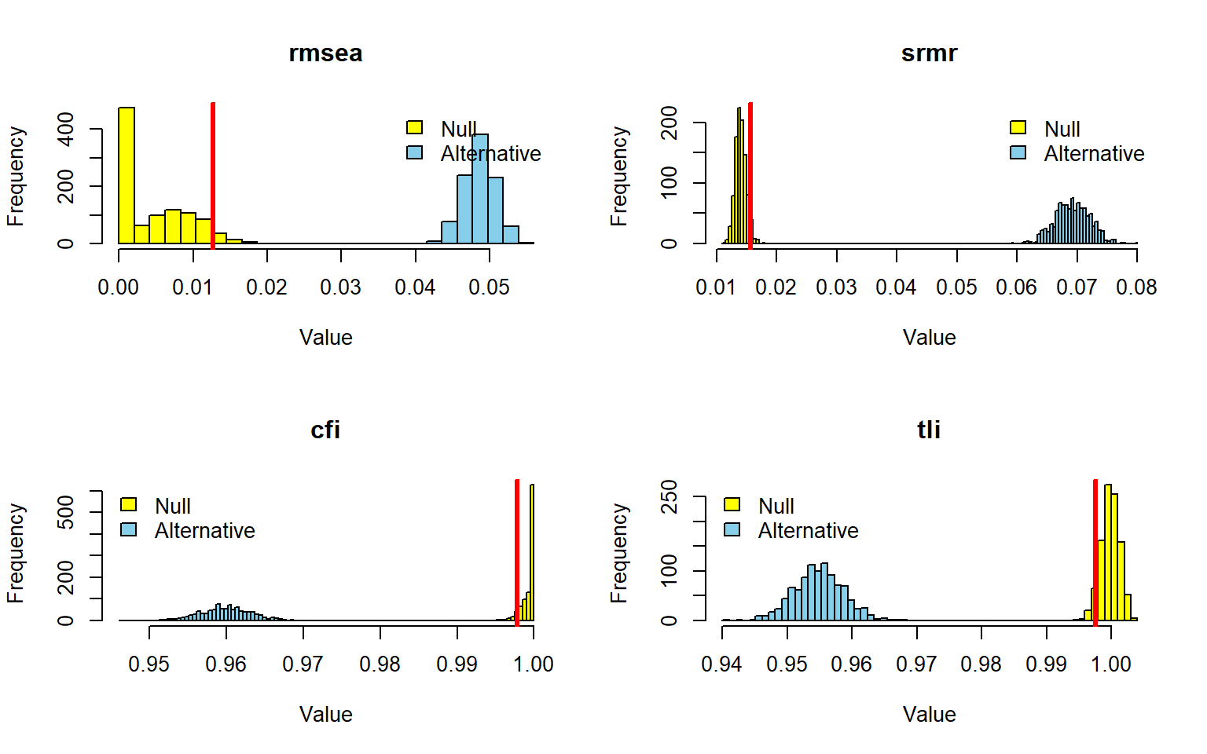
Figure 19: Power curve for post hoc analysis based on simulation.
Source: Post Hoc Power Analysis
Table 16: Power for post hoc analysis based on simulation.
RMSEA | SRMR | CFI | TLI
1 | 1 | 1 | 1

Source: Post Hoc Power Analysis
All four fit indices reached power equal to $1.00$. In the figure, every panel shows complete separation between the null and alternative distributions, with the red cutoff line falling cleanly between them and no visible overlap. For RMSEA, the null distribution concentrates near zero while the alternative is centered around $0.05$. For SRMR, the null clusters near $0.01$–$0.02$ and the alternative near $0.06$–$0.08$. For CFI and TLI, the null is close to $1.00$ and the alternative centers around $0.95$–$0.97$. The complete discrimination in every panel confirms that the observed $N$ would have been fully adequate to detect the target misspecification (Pornprasertmanit et al., 2021). Note that some indices are operating below their conventional thresholds, which is a consequence of the empirical cutoffs derived from the null distribution in this specific setting — not an indication that model fit is poor.

6.2 With Analytical Solutions
Analytical post hoc power expresses the effect through $F_{0}$ or RMSEA and links it to the noncentrality-based framework of the likelihood-ratio test. This is computationally immediate and free from Monte Carlo sampling error, making it the preferred first-pass approach when the asymptotic assumptions underlying the chi-square test are credible (Jak et al., 2021; Moshagen & Bader, 2024). Two specifications are compared here, illustrating a spectrum from the most generic to the most substantively specific formulation.

6.2.1 Model-free specification
The first specification supplies $\text{RMSEA}=0.05$ directly, treating misspecification as a generic level of global misfit per degree of freedom. This makes the analysis comparable across SEM families sharing the same $df$, but it abstracts away from the particular covariance structure of the WHOQOL-BREF model (Jak et al., 2021; MacCallum et al., 1996).
Table 17: Analytical post hoc power parameters for RMSEA = 0.05
Metric | Symbol | Value
Population discrepancy | $F_{0}$ | 0.613
Root mean square error of approximation | $\text{RMSEA}$ | 0.050
McDonald centrality index | $Mc$ | 0.736
Goodness-of-fit index | $\text{GFI}$ | 0.951
Adjusted goodness-of-fit index | $\text{AGFI}$ | 0.941
Degrees of freedom | $df$ | 245
Observed sample size | $N$ | 1047
Critical chi-square | $χ_{\text{crit}}^{2}$ | 282.511
Noncentrality parameter | $λ$ | 640.675
Significance level (alpha) | $α$ | 0.050
Type II error rate (beta) | $β$ | 3.07e-47
Statistical power | $1−β$ | > 0.9999

Source: Post Hoc Power Analysis
The post hoc power parameters in Table 17 demonstrate that with $F_{0}$ = 0.613, $\text{RMSEA}$ = 0.05, $df$ = 245, and $N$ = 1047, the noncentrality parameter reached $\text{NCP}$ = 640.675, far exceeding the critical value $χ_{\text{crit}}^{2}$ = 282.511. Power was effectively 1. As illustrated in Figure 20, the noncentral $χ^{2}$ curve lies far to the right of the critical value, and the shaded $β$ region is negligible (Jobst et al., 2023; MacCallum et al., 1996).
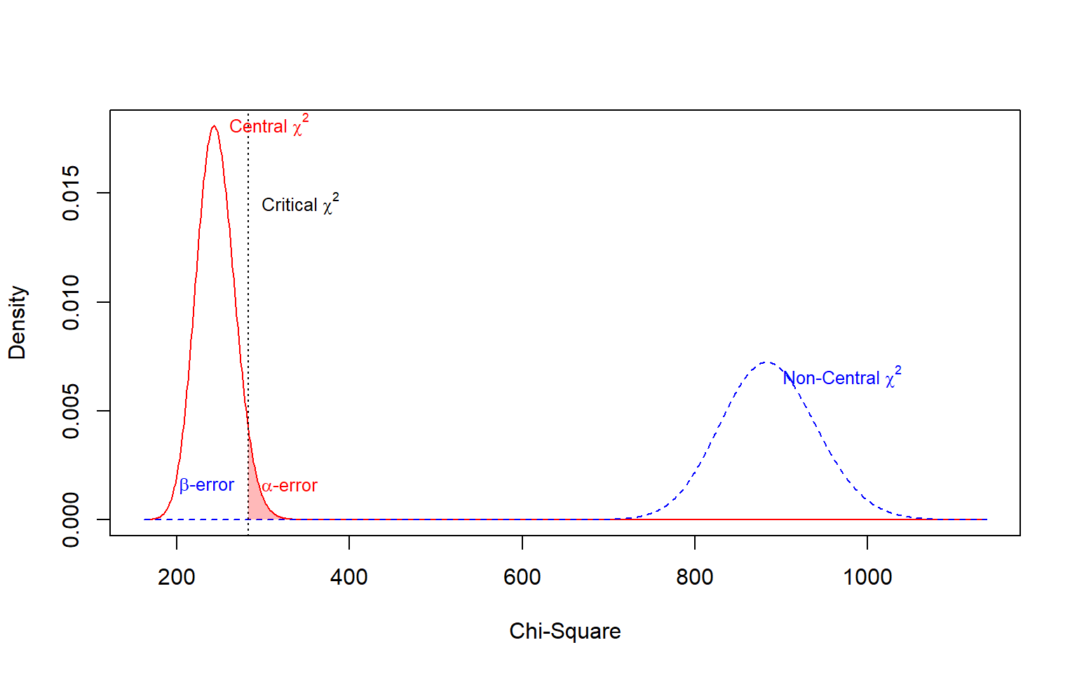
Figure 20: Post hoc power analysis for RMSEA = 0.05.
Source: Post Hoc Power Analysis

6.2.2 Model-based specification: global fit
The second specification derives the effect from the discrepancy between h1model (incorporating the cross-loadings) and the fitted analysis model, evaluating the null model against the saturated model. This tests global fit rather than an isolated restriction, so it is sensitive to any source of misspecification in the analysis model, not only the cross-loadings (Moshagen & Bader, 2024; Wang, 2023).
Table 18: Analytical post hoc power parameters for empirical fitted model
Metric | Symbol | Value
Population discrepancy | $F_{0}$ | 0.579
Root mean square error of approximation | $\text{RMSEA}$ | 0.049
McDonald centrality index | $Mc$ | 0.749
Goodness-of-fit index | $\text{GFI}$ | 0.954
Adjusted goodness-of-fit index | $\text{AGFI}$ | 0.944
Standardized root mean square residual | $\text{SRMR}$ | 0.067
Comparative fit index | $\text{CFI}$ | 0.960
Degrees of freedom | $df$ | 245
Observed sample size | $N$ | 1047
Critical chi-square | $χ_{\text{crit}}^{2}$ | 282.511
Noncentrality parameter | $λ$ | 605.611
Significance level (alpha) | $α$ | 0.050
Type II error rate (beta) | $β$ | 1.87e-43
Statistical power | $1−β$ | > 0.9999

Source: Post Hoc Power Analysis
With $F_{0}$ = 0.579, $\text{RMSEA}$ = 0.049, $df$ = 245, and $N$ = 1047, the noncentrality reached $\text{NCP}$ = 605.611 against a critical value of $χ_{\text{crit}}^{2}$ = 282.511. Power was 1, confirming that the observed sample size provides complete statistical power to detect the misspecification (Table 18; Figure 21).
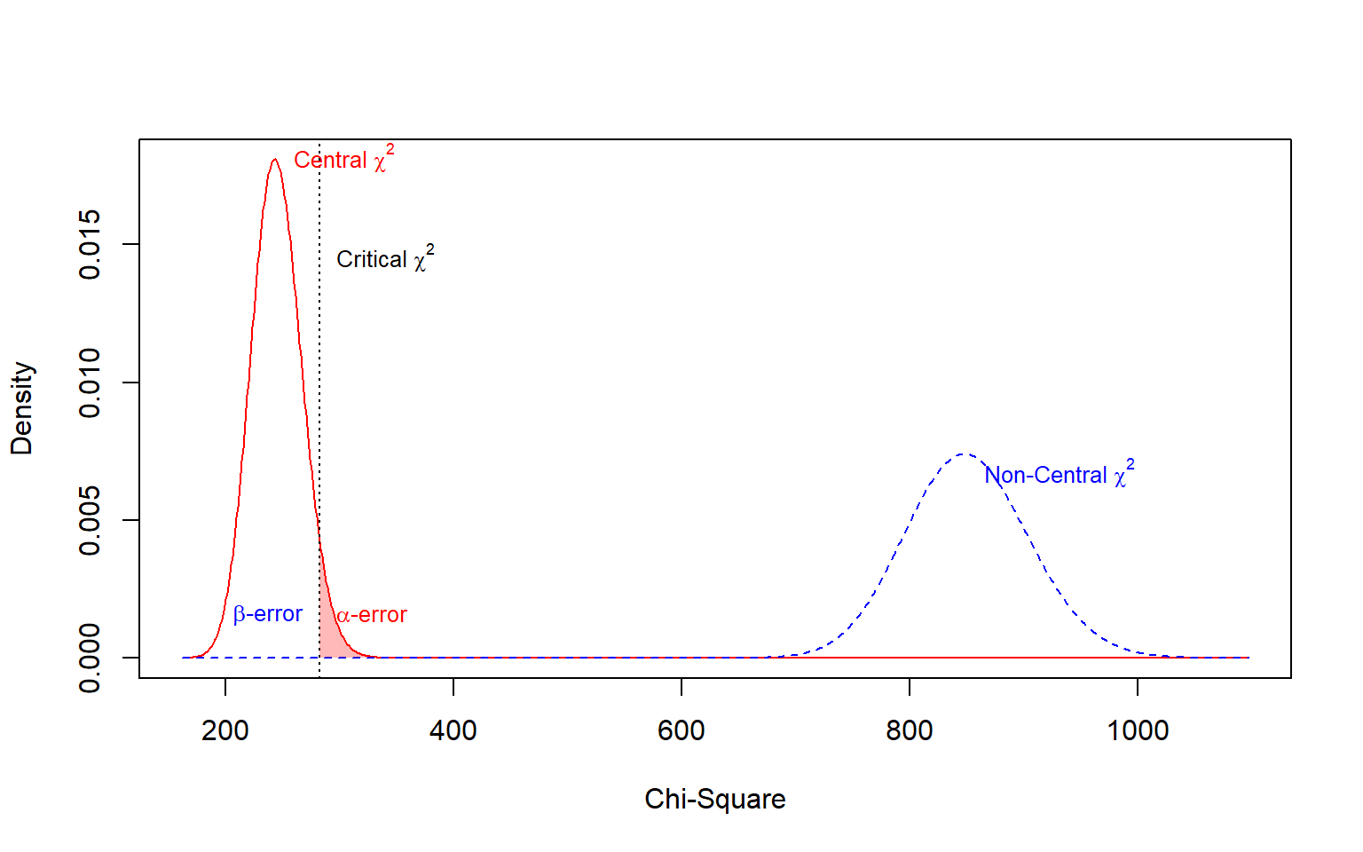
Figure 21: Post hoc power analysis for the real model.
Source: Post Hoc Power Analysis
However, post hoc power must always be interpreted with methodological caution. Calculating power retrospectively from observed sample statistics after finding a non-significant result constitutes the well-known “observed power fallacy” (Jobst et al., 2023; MacCallum et al., 1996; Zhang & Yuan, 2018), where low power is simply a tautological re-expression of an unremarkable $p$-value. Post hoc power analysis remains legitimate only when framed prospective-retrospectively: asking whether the collected $N$ possessed adequate sensitivity to reject a pre-specified, theoretically grounded alternative ($H_{1}$) that was determined prior to inspecting data-derived effects (Moshagen & Bader, 2024; Wang, 2023).

References
Aguirre-Urreta, M. I., Rönkkö, M., & McIntosh, C. N. (2024). Too Small to Succeed: Small Samples and the p-Value Problem. SIGMIS Database, 55(3), 12–49. https://doi.org/10.1145/3685235.3685238
Buchberger, E. S., Ngo, C. T., Peikert, A., Brandmaier, A. M., & Werkle-Bergner, M. (2024). Estimating statistical power for structural equation models in developmental cognitive science: A tutorial in R. Behavior Research Methods, 56(7), 1–18. https://doi.org/10.3758/s13428-024-02396-2
Feng, Y., & Hancock, G. R. (2023). Power Analysis within a Structural Equation Modeling Framework. In R. H. Hoyle (Ed.), Handbook of Structural Equation Modeling. The Guilford Press.
Irmer, J. P., Klein, A. G., & Schermelleh-Engel, K. (2024). Model-implied simulation-based power estimation for correctly specified and distributionally misspecified models: Applications to nonlinear and linear structural equation models. Behavior Research Methods, 56(8), 8955–8991. https://doi.org/10.3758/s13428-024-02507-z
Jak, S., Jorgensen, T. D., Verdam, M. G. E., Oort, F. J., & Elffers, L. (2021). Analytical power calculations for structural equation modeling: A tutorial and Shiny app. Behavior Research Mehods, 53, 1385–1406. https://doi.org/10.3758/s13428-020-01479-0/Published
Jobst, L. J., Bader, M., & Moshagen, M. (2023). A tutorial on assessing statistical power and determining sample size for structural equation models. Psychological Methods, 28(1), 207–221. https://doi.org/10.1037/met0000423
Kyriazos, T. A. (2018). Applied Psychometrics: Sample Size and Sample Power Considerations in Factor Analysis (EFA, CFA) and SEM in General. Psychology, 09(08), 2207–2230. https://doi.org/10.4236/psych.2018.98126
Liang, A., & Sterba, S. K. (2024). Power analysis to detect misfit in SEMs with many items: Resolving unrecognized problems, relating old and new approaches, and “matching” power analysis approach to data analysis approach. Psychological Methods. https://doi.org/10.1037/met0000684
Lin, L.-C., & Yao, G. (2022). Validation of the factor structure of the WHOQOL-BREF using meta-analysis of exploratory factor analysis and social network analysis. Psychological Assessment, 34(7), 660–670. https://doi.org/10.1037/pas0001122
MacCallum, R. C., Browne, M. W., & Sugawara, H. M. (1996). Power analysis and determination of sample size for covariance structure modeling. Psychological Methods, 1(2), 130–149. https://doi.org/10.1037/1082-989X.1.2.130
McNeish, D., & Wolf, M. G. (2021). Dynamic fit index cutoffs for confirmatory factor analysis models. Psychological Methods, 28(1), 61–88. https://doi.org/10.1037/met0000425
Moshagen, M., & Bader, M. (2024). semPower: General power analysis for structural equation models. Behavior Research Methods, 56(4), 2901–2922. https://doi.org/10.3758/s13428-023-02254-7
Mosqueira Taipe, C. M., Amador Campos, J. A., Krieger, V., Miasso, A. I., Molina, N. P. F. M., & dos Santos, P. L. (2026). Systematic review of the factor structure of WHOQOL-bref in adult population. Quality of Life Research, 35(17), 1–18. https://doi.org/10.1007/s11136-025-04115-6
Muthén, L. K., & Muthén, B. O. (2002). How to Use a Monte Carlo Study to Decide on Sample Size and Determine Power. Structural Equation Modeling: A Multidisciplinary Journal, 9(4), 599–620. https://doi.org/10.1207/S15328007SEM0904_8
Pornprasertmanit, S., Miller, P., Schoemann, A., & Jorgensen, T. D. (2021). Simsem: SIMulated Structural Equation Modeling. https://CRAN.R-project.org/package=simsem
Rogers, P. (2022). Best Practices for Your Exploratory Factor Analysis: A Factor Tutorial. Revista de Administração Contemporânea, 26(6). https://doi.org/10.1590/1982-7849rac2022210085.en
Schoemann, A. M., Miller, P., Pornprasertmanit, S., & Wu, W. (2014). Using Monte Carlo simulations to determine power and sample size for planned missing designs. International Journal of Behavioral Development, 38(5), 471–479. https://doi.org/10.1177/0165025413515169
Wang, Y. A. (2023). How to Conduct Power Analysis for Structural Equation Models: A Practical Primer [Preprint]. PsyArXiv. https://doi.org/10.31234/osf.io/4n3uk
Wang, Y. A., & Rhemtulla, M. (2021). Power Analysis for Parameter Estimation in Structural Equation Modeling: A Discussion and Tutorial. Advances in Methods and Practices in Psychological Science, 4(1), 1–17. https://doi.org/10.1177/2515245920918253
Wolf, E. J., Harrington, K. M., Clark, S. L., & Miller, M. W. (2013). Sample Size Requirements for Structural Equation Models: An Evaluation of Power, Bias, and Solution Propriety. Educational and Psychological Measurement, 76(6), 913–934. https://doi.org/10.1177/0013164413495237
Zhang, Z., & Yuan, K.-H. (2018). Practical statistical power analysis using Webpower and R. ISDSA Press.

