Power Analysis for Confirmatory Factor Analysis: A Practical Tutorial
  - Analytical and Simulation-Based Approaches
Pablo Rogers
2026-04-21
Abstract
This notebook presents a pedagogical tutorial on statistical power analysis in Confirmatory Factor Analysis (CFA). Proper planning of sample sizes requires assessing the power to detect overall model misfit by analytical approach or simulation-based approach. Standard analytical tools typically rely on asymptotic normal theory, which may break down when confronted with non-normality or missing data. This tutorial demonstrates both analytical strategies (using semPower and semTools) and Monte Carlo simulations (using simsem) side-by-side using the WHOQOL-BREF 4-factor model as a unifying case study. We illustrate how simulation can complement analytical calculations, allowing researchers to evaluate parameter-level power, coverage, and relative bias under realistic scenarios involving varying degrees of model misspecification, missing data, and continuous non-normal indicators. Ultimately, we argue that analytical methods are ideal for initial planning, while simulations constitute the gold standard for robust confirmation.

1 Introduction
Statistical power in Confirmatory Factor Analysis (CFA) reflects the probability of correctly rejecting an incorrectly specified model, or detecting a parameter of interest when it is truly non-zero in the population (MacCallum et al., 1996). Power analysis is critical when planning a CFA study; however, researchers often rely on arbitrary rules of thumb mapping required sample sizes to the number of measured variables or parameters, rather than formal prospective calculations.
There are two main paradigms to power analysis in CFA:
- Analytical methods: Rely on asymptotic statistical theory (e.g., the non-central $χ^{2}$ distribution) to calculate the required sample size for detecting global/local model misfit based on established fit indices like the RMSEA (Moshagen & Bader, 2024).
- Simulation-based methods: Use Monte Carlo data generation to repeatedly establish how the model behaves under assumed population models, allowing the estimation of power, bias, and coverage for specific parameters or overall fit indices across varying sample sizes (Pornprasertmanit et al., 2021).
This document provides a comprehensive tutorial covering analytical methods using the semPower package, and Monte Carlo methods using the simsem package.
 Reproducibility Note
For local development and computational convenience across this pedagogical document, simulations use 1,500 replications. For production-quality applied research, you must increase this to 5,000 or more replications. The results throughout this tutorial will thus show more sampling variability than you would expect in a final study. All analytical and simulation parameters are centrally defined in helpers.R and models.R in Scripts/DataAppendixScripts.

2 The Running Example: WHOQOL-BREF Population CFA Model
To anchor our power analyses, we use the World Health Organization Quality of Life-BREF (WHOQOL-BREF) 4-factor measurement instrument. Meaningful power analysis requires the definition of a population model—the “true” state of the world from which we believe our data are generated. By simulating from a meta-analytically derived population model rather than a purely arbitrary one, researchers can ensure that tests reflect realistic boundaries (Lin & Yao, 2022; Mosqueira Taipe et al., 2026).
We specify four population variations to perform sensitivity analyses:
- Meta-analytic: Loadings and residual variances closely matching Lin & Yao (2022).
- Naive: A pessimistic baseline where factor loadings are based on the lowest reported reliability values per domain (Mosqueira Taipe et al., 2026).
- Optimistic: A best-case scenario where factor loadings are based on the highest reported reliability values per domain (Mosqueira Taipe et al., 2026).
- H1: A misspecified model with three cross-loadings based on the meta-EFA results from Lin & Yao (2022).

2.1 Population model
The primary population model represents a meta-analytic scenario based on Lin & Yao (2022). Factor loadings ($λ$) match the pooled empirical Exploratory Factor Analysis (EFA) estimates across 16 international studies. Characteristics:
- Interfactor correlations ($ϕ$): Set to $0.20$ (conservative midpoint of the reported range $0.08$–$0.31$).
- Residual covariance: $Q3$ and $Q4$ share a residual covariance ($\text{r}(Q3,Q4|\text{physical})=0.30$), maintaining the subfactor signal observed in the EFA 5-factor solution (Lin & Yao, 2022).
- Factor structure: Item $Q8$ is maintained in the environment domain despite having a higher cross-loading on the psychological domain in the meta-EFA ($λ_{\text{psy}}>λ_{\text{env}}$). This represents the null hypothesis ($H_{0}$) version of the population, strictly maintaining the original 4-factor structure without cross-loadings.
The lavaan syntax for this population model is shown below, and Figure 1 provides a visual representation of the model structure.
# ── Factor loadings: empirical estimates from Lin & Yao (2022) ────────────
psycho =~ 0.92*Q5 + 0.81*Q6 + 0.94*Q7 +
0.73*Q11 + 0.75*Q19 + 0.63*Q26
physical =~ 0.84*Q3 + 0.83*Q4 + 0.63*Q10 +
0.71*Q15 + 0.68*Q16 + 0.89*Q17 + 0.61*Q18
social =~ 0.94*Q20 + 0.89*Q21 + 0.78*Q22
environment =~ 0.37*Q8 + 0.49*Q9 + 0.79*Q12 + 0.81*Q13 +
0.77*Q14 + 0.75*Q23 + 0.64*Q24 + 0.73*Q25
# ── Residual covariance Q3~~Q4 ────────────────────────────────────────────
# r(Q3,Q4|physical) = 0.30 (method bias / conceptual proximity)
# cov = 0.30 × sqrt(1-0.84²) × sqrt(1-0.83²) = 0.0908
Q4 ~~ 0.0908*Q3
# ── Factor variances (=1) and interfactor correlations ────────────────────
# Range reported in Lin & Yao (2022): 0.08 to 0.31
# Conservative midpoint = 0.20 for all pairs
psycho ~~ 1*psycho + 0.2*physical + 0.2*social + 0.2*environment
physical ~~ 1*physical + 0.2*social + 0.2*environment
social ~~ 1*social + 0.2*environment
environment ~~ 1*environment
# ── Residual variances: θ = 1 − λ² (standardised indicators) ─────────────
Q5 ~~ 0.1536*Q5 # 1 − 0.92²
Q6 ~~ 0.3439*Q6 # 1 − 0.81²
Q7 ~~ 0.1164*Q7 # 1 − 0.94²
Q11 ~~ 0.4671*Q11 # 1 − 0.73²
Q19 ~~ 0.4375*Q19 # 1 − 0.75²
Q26 ~~ 0.6031*Q26 # 1 − 0.63²
Q3 ~~ 0.2944*Q3 # 1 − 0.84²
Q4 ~~ 0.3111*Q4 # 1 − 0.83²
Q10 ~~ 0.6031*Q10 # 1 − 0.63²
Q15 ~~ 0.4959*Q15 # 1 − 0.71²
Q16 ~~ 0.5376*Q16 # 1 − 0.68²
Q17 ~~ 0.2079*Q17 # 1 − 0.89²
Q18 ~~ 0.6279*Q18 # 1 − 0.61²
Q20 ~~ 0.1164*Q20 # 1 − 0.94²
Q21 ~~ 0.2079*Q21 # 1 − 0.89²
Q22 ~~ 0.3916*Q22 # 1 − 0.78²
Q8 ~~ 0.8631*Q8 # 1 − 0.37² — lowest loading; bridge item (betweenness=40.5)
Q9 ~~ 0.7599*Q9 # 1 − 0.49²
Q12 ~~ 0.3759*Q12 # 1 − 0.79²
Q13 ~~ 0.3439*Q13 # 1 − 0.81²
Q14 ~~ 0.4071*Q14 # 1 − 0.77²
Q23 ~~ 0.4375*Q23 # 1 − 0.75²
Q24 ~~ 0.5904*Q24 # 1 − 0.64²
Q25 ~~ 0.4671*Q25 # 1 − 0.73²
_{Source: Population Models}
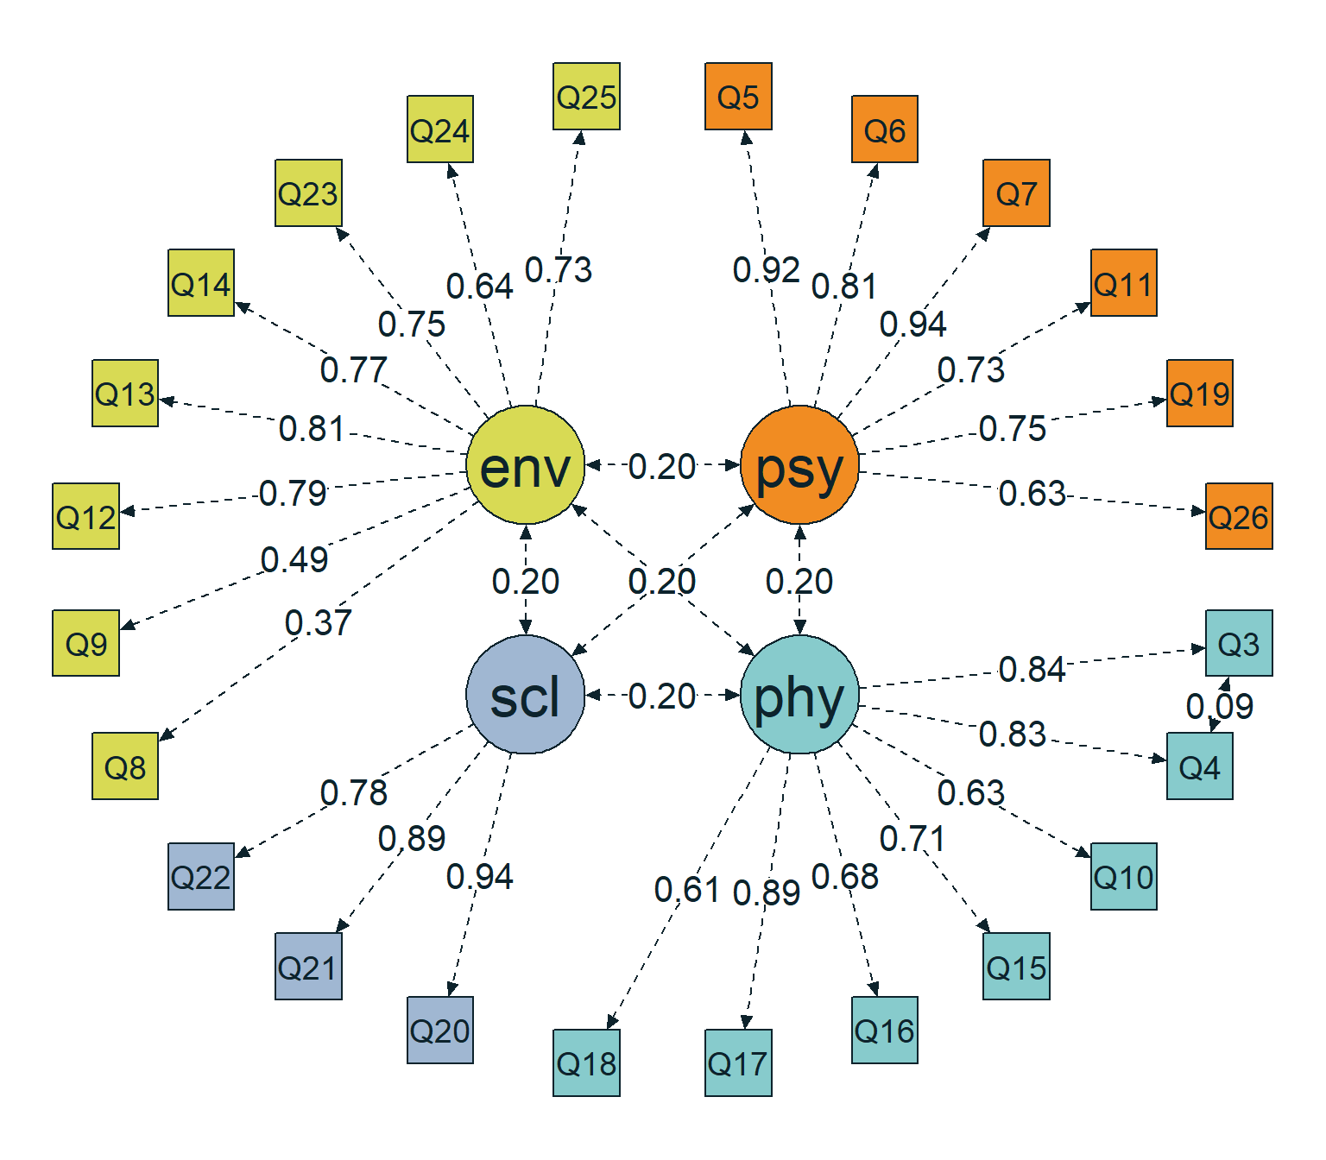
Figure 1: Path diagram of the popmodel
_{Source: Population Models}

2.2 Naive model
This model defines a pessimistic, empirically grounded scenario. We apply the Spearman-Brown prediction formula to derive tau-equivalent factor loadings based on the lowest reported Cronbach’s alpha ($α$) values.
- Approach: Assuming equal loadings within each domain, we estimate the loadings as $λ=\sqrt{α/(k−α(k−1))}$ and residual variances as $θ=1−λ^{2}$.
- Alpha sources: Based on the lowest alphas for the original 4-factor structure reported by a single study identified in the systematic review by Mosqueira Taipe et al. (2026) (Physical $α=0.672$; Psychological $α=0.704$; Social $α=0.630$; Environmental $α=0.709$). All values reside within the $M−1SD$ range reported by Lin & Yao (2022).
- Interfactor correlations ($ϕ$): Fixed at $0.30$ (the upper bound from Lin & Yao (2022)), which makes factors harder to distinguish and yields a conservative power estimate.
- Derived parameters: E.g., Physical ($λ=0.4758,θ=0.7736$), Psychological ($λ=0.5328,θ=0.7161$), Social ($λ=0.6017,θ=0.6379$), Environmental ($λ=0.4832,θ=0.7665$). The residual covariance between $Q3$ and $Q4$ is adjusted to $0.2321$.
The lavaan syntax for this population model is shown below, and Figure 2 provides a visual representation of the model structure.
# ── Factor loadings: tau-equivalent (uniform λ per domain) ───────────────
psycho =~ 0.5328*Q5 + 0.5328*Q6 + 0.5328*Q7 +
0.5328*Q11 + 0.5328*Q19 + 0.5328*Q26
physical =~ 0.4758*Q3 + 0.4758*Q4 + 0.4758*Q10 +
0.4758*Q15 + 0.4758*Q16 + 0.4758*Q17 + 0.4758*Q18
social =~ 0.6017*Q20 + 0.6017*Q21 + 0.6017*Q22
environment =~ 0.4832*Q8 + 0.4832*Q9 + 0.4832*Q12 + 0.4832*Q13 +
0.4832*Q14 + 0.4832*Q23 + 0.4832*Q24 + 0.4832*Q25
# ── Residual covariance Q3~~Q4 ────────────────────────────────────────────
# r(Q3,Q4|physical) = 0.30; cov = 0.30 × (1 − 0.4758²) = 0.2321
Q4 ~~ 0.2321*Q3
# ── Factor variances (=1) and interfactor correlations ────────────────────
# φ = 0.30: upper bound of Lin & Yao (2022) range — pessimistic scenario
psycho ~~ 1*psycho + 0.3*physical + 0.3*social + 0.3*environment
physical ~~ 1*physical + 0.3*social + 0.3*environment
social ~~ 1*social + 0.3*environment
environment ~~ 1*environment
# ── Residual variances: θ = 1 − λ² per domain ────────────────────────────
Q5 ~~ 0.7161*Q5 # Psychological: θ = 1 − 0.5328² = 0.7161
Q6 ~~ 0.7161*Q6
Q7 ~~ 0.7161*Q7
Q11 ~~ 0.7161*Q11
Q19 ~~ 0.7161*Q19
Q26 ~~ 0.7161*Q26
Q3 ~~ 0.7736*Q3 # Physical: θ = 1 − 0.4758² = 0.7736
Q4 ~~ 0.7736*Q4
Q10 ~~ 0.7736*Q10
Q15 ~~ 0.7736*Q15
Q16 ~~ 0.7736*Q16
Q17 ~~ 0.7736*Q17
Q18 ~~ 0.7736*Q18
Q20 ~~ 0.6379*Q20 # Social: θ = 1 − 0.6017² = 0.6379
Q21 ~~ 0.6379*Q21
Q22 ~~ 0.6379*Q22
Q8 ~~ 0.7665*Q8 # Environmental: θ = 1 − 0.4832² = 0.7665
Q9 ~~ 0.7665*Q9
Q12 ~~ 0.7665*Q12
Q13 ~~ 0.7665*Q13
Q14 ~~ 0.7665*Q14
Q23 ~~ 0.7665*Q23
Q24 ~~ 0.7665*Q24
Q25 ~~ 0.7665*Q25
_{Source: Population Models}
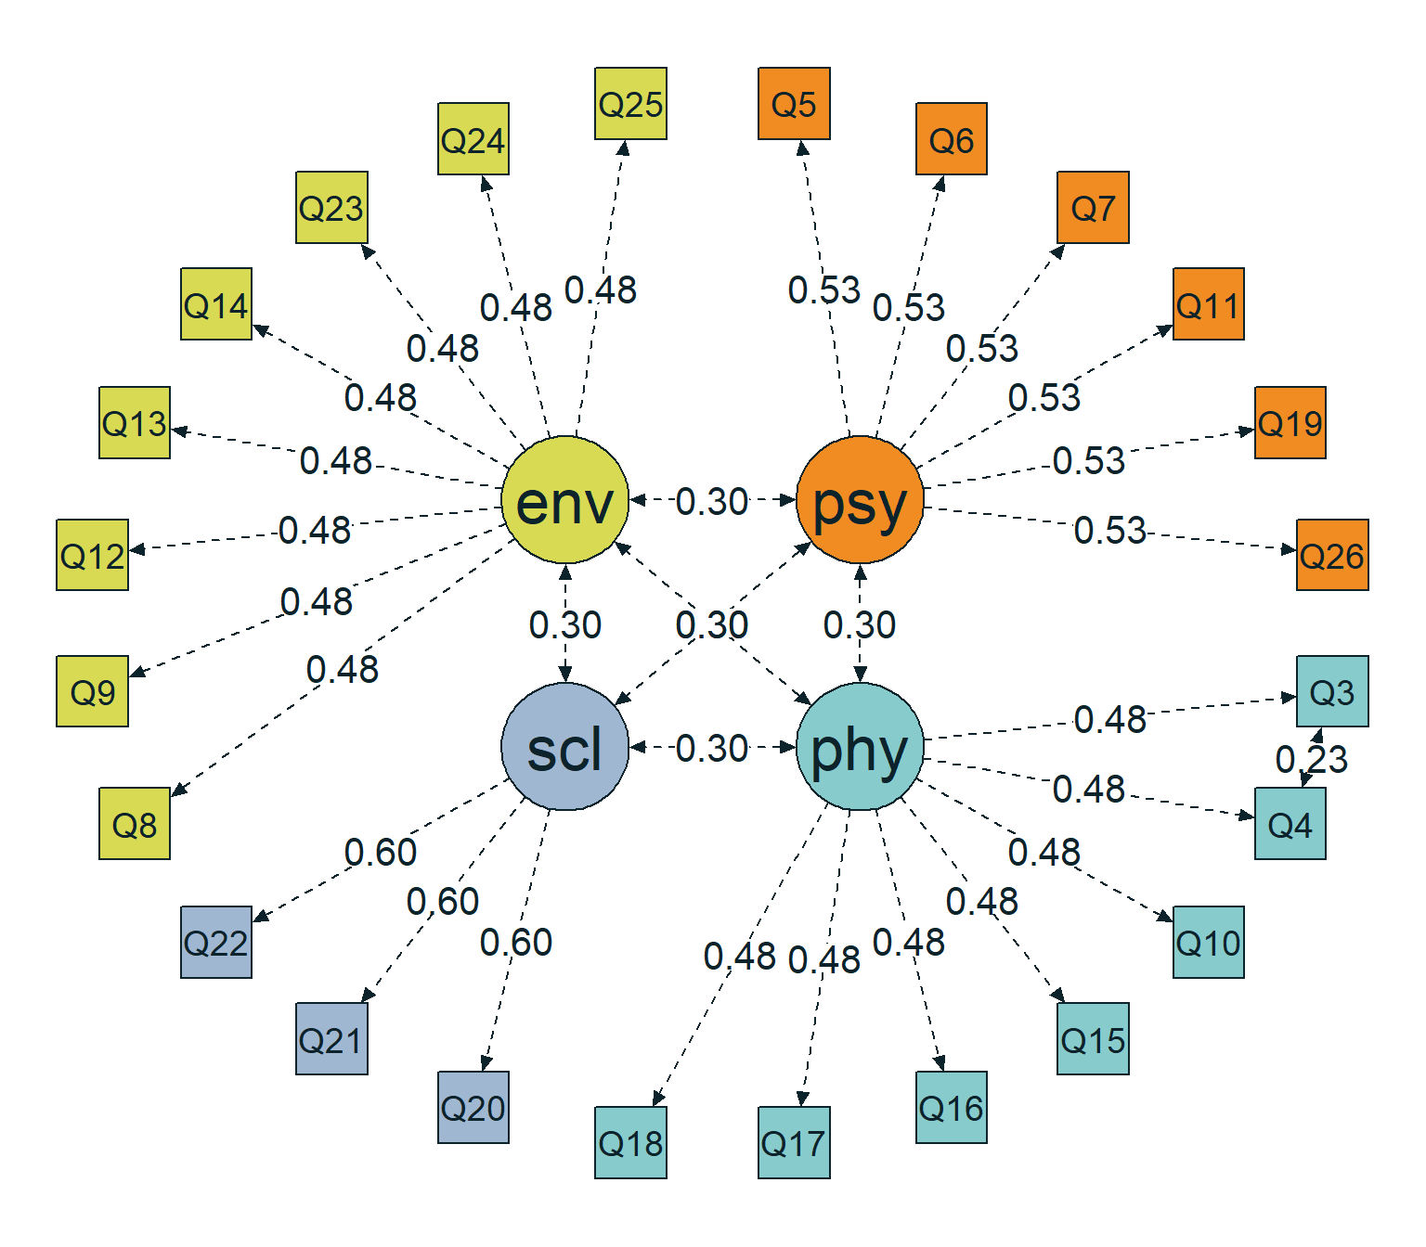
Figure 2: Path diagram of the naivemodel
_{Source: Population Models}

2.3 Optimistic model
This model defines an optimistic, empirically grounded scenario using the same Spearman-Brown derivation approach but leveraging the highest observed Cronbach’s alpha ($α$) values per domain.
- Alpha sources: Based on maximum alphas reported in the literature (Mosqueira Taipe et al., 2026) (Physical $α=0.860$; Psychological $α=0.860$; Social $α=0.810$; Environmental $α=0.849$). All values are confirmed within the $M+1SD$ range from Lin & Yao (2022).
- Interfactor correlations ($ϕ$): Fixed at $0.08$ (the lower bound from Lin & Yao (2022)), resulting in factors that are well-distinguished and providing an optimistic power estimate.
- Derived parameters: E.g., Physical ($λ=0.6837,θ=0.5326$), Psychological ($λ=0.7113,θ=0.4941$), Social ($λ=0.7661,θ=0.4130$), Environmental ($λ=0.6424,θ=0.5873$). The residual covariance between $Q3$ and $Q4$ is adjusted to $0.1598$.
The lavaan syntax for this population model is shown below, and Figure 3 provides a visual representation of the model structure.
# ── Factor loadings: tau-equivalent (uniform λ per domain) ───────────────
psycho =~ 0.7113*Q5 + 0.7113*Q6 + 0.7113*Q7 +
0.7113*Q11 + 0.7113*Q19 + 0.7113*Q26
physical =~ 0.6837*Q3 + 0.6837*Q4 + 0.6837*Q10 +
0.6837*Q15 + 0.6837*Q16 + 0.6837*Q17 + 0.6837*Q18
social =~ 0.7661*Q20 + 0.7661*Q21 + 0.7661*Q22
environment =~ 0.6424*Q8 + 0.6424*Q9 + 0.6424*Q12 + 0.6424*Q13 +
0.6424*Q14 + 0.6424*Q23 + 0.6424*Q24 + 0.6424*Q25
# ── Residual covariance Q3~~Q4 ────────────────────────────────────────────
# r(Q3,Q4|physical) = 0.30; cov = 0.30 × (1 − 0.6837²) = 0.1598
Q4 ~~ 0.1598*Q3
# ── Factor variances (=1) and interfactor correlations ────────────────────
# φ = 0.08: lower bound of Lin & Yao (2022) range — optimistic scenario
psycho ~~ 1*psycho + 0.08*physical + 0.08*social + 0.08*environment
physical ~~ 1*physical + 0.08*social + 0.08*environment
social ~~ 1*social + 0.08*environment
environment ~~ 1*environment
# ── Residual variances: θ = 1 − λ² per domain ────────────────────────────
Q5 ~~ 0.4941*Q5 # Psychological: θ = 1 − 0.7113² = 0.4941
Q6 ~~ 0.4941*Q6
Q7 ~~ 0.4941*Q7
Q11 ~~ 0.4941*Q11
Q19 ~~ 0.4941*Q19
Q26 ~~ 0.4941*Q26
Q3 ~~ 0.5326*Q3 # Physical: θ = 1 − 0.6837² = 0.5326
Q4 ~~ 0.5326*Q4
Q10 ~~ 0.5326*Q10
Q15 ~~ 0.5326*Q15
Q16 ~~ 0.5326*Q16
Q17 ~~ 0.5326*Q17
Q18 ~~ 0.5326*Q18
Q20 ~~ 0.4130*Q20 # Social: θ = 1 − 0.7661² = 0.4130
Q21 ~~ 0.4130*Q21
Q22 ~~ 0.4130*Q22
Q8 ~~ 0.5873*Q8 # Environmental: θ = 1 − 0.6424² = 0.5873
Q9 ~~ 0.5873*Q9
Q12 ~~ 0.5873*Q12
Q13 ~~ 0.5873*Q13
Q14 ~~ 0.5873*Q14
Q23 ~~ 0.5873*Q23
Q24 ~~ 0.5873*Q24
Q25 ~~ 0.5873*Q25
_{Source: Population Models}
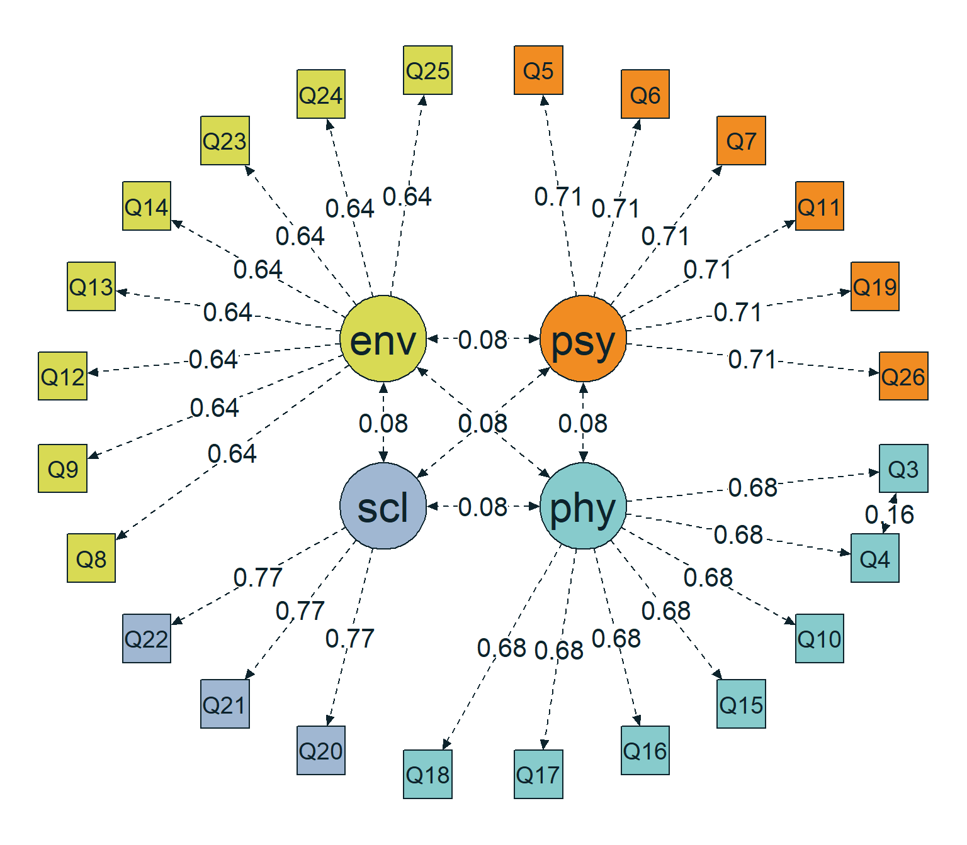
Figure 3: Path diagram of the optmodel
_{Source: Population Models}

2.4 Misspecification model
This represents the alternative hypothesis ($H_{1}$), defining a cross-loading population model. Three empirical cross-loadings are added to the baseline 4-factor structure based on Lin & Yao (2022) and supported by recent literature (Mosqueira Taipe et al., 2026):
- Cross-loading 1: item $Q8$ loading on the Psychological factor ($λ=0.55$). This item showed the highest betweenness ($40.50$) and explicitly grouped with the psychological factor in 9/16 studies (Lin & Yao, 2022).
- Cross-loading 2: item $Q9$ loading on the Psychological factor ($λ=0.21$). Identified as a secondary loading in the 5-factor solution.
- Cross-loading 3: item $Q15$ loading on the Environmental factor ($λ=0.24$). “Mobility” conceptually bridges physical ability and environmental access, showing the second-highest betweenness ($36.50$) (Lin & Yao, 2022).
Residual variances ($θ$) for cross-loaded items were recalculated to preserve total item variance using the formula $θ=1−λ_{\text{primary}}^{2}−λ_{\text{secondary}}^{2}−2λ_{\text{primary}}λ_{\text{secondary}}ϕ$, where the interfactor correlation ($ϕ$) is $0.20$.
The lavaan syntax for this population model is shown below, and Figure 4 provides a visual representation of the model structure.
# ── Factor loadings (with three cross-loadings) ───────────────────────────
psycho =~ 0.92*Q5 + 0.81*Q6 + 0.94*Q7 +
0.73*Q11 + 0.75*Q19 + 0.63*Q26 +
0.55*Q8 + # cross-load (1)
0.21*Q9 # cross-load (2)
physical =~ 0.84*Q3 + 0.83*Q4 + 0.63*Q10 +
0.71*Q15 + 0.68*Q16 + 0.89*Q17 + 0.61*Q18
social =~ 0.94*Q20 + 0.89*Q21 + 0.78*Q22
environment =~ 0.37*Q8 + 0.49*Q9 + 0.79*Q12 + 0.81*Q13 +
0.77*Q14 + 0.75*Q23 + 0.64*Q24 + 0.73*Q25 +
0.24*Q15 # cross-load (3)
# ── Residual covariance Q3~~Q4 (fixed in both P2 and analyzeModel) ────────
Q4 ~~ 0.0908*Q3
# ── Factor variances (=1) and interfactor correlations ────────────────────
psycho ~~ 1*psycho + 0.2*physical + 0.2*social + 0.2*environment
physical ~~ 1*physical + 0.2*social + 0.2*environment
social ~~ 1*social + 0.2*environment
environment ~~ 1*environment
# ── Residual variances ────────────────────────────────────────────────────
Q5 ~~ 0.1536*Q5
Q6 ~~ 0.3439*Q6
Q7 ~~ 0.1164*Q7
Q11 ~~ 0.4671*Q11
Q19 ~~ 0.4375*Q19
Q26 ~~ 0.6031*Q26
Q3 ~~ 0.2944*Q3
Q4 ~~ 0.3111*Q4
Q10 ~~ 0.6031*Q10
Q15 ~~ 0.3701*Q15 # UPDATED: was 0.4959 — cross-load on environment
Q16 ~~ 0.5376*Q16
Q17 ~~ 0.2079*Q17
Q18 ~~ 0.6279*Q18
Q20 ~~ 0.1164*Q20
Q21 ~~ 0.2079*Q21
Q22 ~~ 0.3916*Q22
Q8 ~~ 0.4792*Q8 # UPDATED: was 0.8631 — cross-load on psycho
Q9 ~~ 0.6746*Q9 # UPDATED: was 0.7599 — cross-load on psycho
Q12 ~~ 0.3759*Q12
Q13 ~~ 0.3439*Q13
Q14 ~~ 0.4071*Q14
Q23 ~~ 0.4375*Q23
Q24 ~~ 0.5904*Q24
Q25 ~~ 0.4671*Q25
_{Source: Population Models}
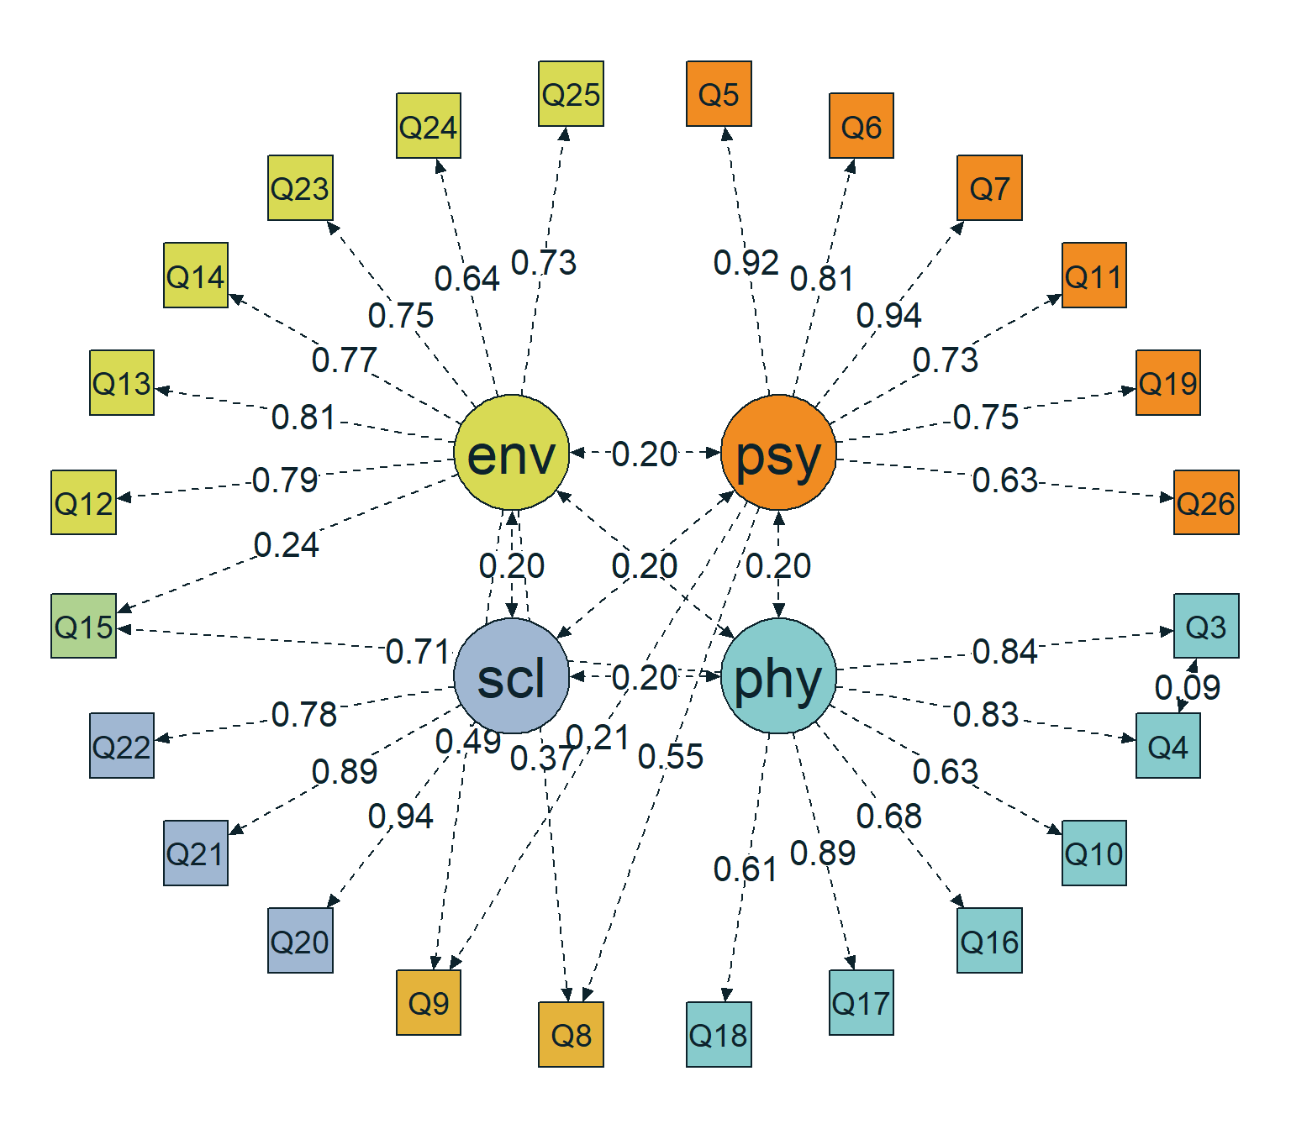
Figure 4: Path diagram of the h1model
_{Source: Population Models}

2.5 Summary of population (alternative) models
In Table 1, we show all parameters of the four population models. To facilitate comparison, Table 2 summarizes key parameters across models, including the minimum and maximum factor loadings, mean loading, mode of the factor correlations, minimum and maximum residual variances, and the residual correlation between $Q3$ and $Q4$.
Table 1: Summary of population models used for sensitivity analysis
CFA Population Models Parameter
parameters | popmodel | naivemodel | optmodel | h1model
psycho=~Q5 | 0.9200 | 0.5328 | 0.7113 | 0.9200
psycho=~Q6 | 0.8100 | 0.5328 | 0.7113 | 0.8100
psycho=~Q7 | 0.9400 | 0.5328 | 0.7113 | 0.9400
psycho=~Q11 | 0.7300 | 0.5328 | 0.7113 | 0.7300
psycho=~Q19 | 0.7500 | 0.5328 | 0.7113 | 0.7500
psycho=~Q26 | 0.6300 | 0.5328 | 0.7113 | 0.6300
physical=~Q3 | 0.8400 | 0.4758 | 0.6837 | 0.8400
physical=~Q4 | 0.8300 | 0.4758 | 0.6837 | 0.8300
physical=~Q10 | 0.6300 | 0.4758 | 0.6837 | 0.6300
physical=~Q15 | 0.7100 | 0.4758 | 0.6837 | 0.7100
physical=~Q16 | 0.6800 | 0.4758 | 0.6837 | 0.6800
physical=~Q17 | 0.8900 | 0.4758 | 0.6837 | 0.8900
physical=~Q18 | 0.6100 | 0.4758 | 0.6837 | 0.6100
social=~Q20 | 0.9400 | 0.6017 | 0.7661 | 0.9400
social=~Q21 | 0.8900 | 0.6017 | 0.7661 | 0.8900
social=~Q22 | 0.7800 | 0.6017 | 0.7661 | 0.7800
environment=~Q8 | 0.3700 | 0.4832 | 0.6424 | 0.3700
environment=~Q9 | 0.4900 | 0.4832 | 0.6424 | 0.4900
environment=~Q12 | 0.7900 | 0.4832 | 0.6424 | 0.7900
environment=~Q13 | 0.8100 | 0.4832 | 0.6424 | 0.8100
environment=~Q14 | 0.7700 | 0.4832 | 0.6424 | 0.7700
environment=~Q23 | 0.7500 | 0.4832 | 0.6424 | 0.7500
environment=~Q24 | 0.6400 | 0.4832 | 0.6424 | 0.6400
environment=~Q25 | 0.7300 | 0.4832 | 0.6424 | 0.7300
Q3~~Q4 | 0.0908 | 0.2321 | 0.1598 | 0.0908
psycho~~psycho | 1.0000 | 1.0000 | 1.0000 | 1.0000
psycho~~physical | 0.2000 | 0.3000 | 0.0800 | 0.2000
psycho~~social | 0.2000 | 0.3000 | 0.0800 | 0.2000
psycho~~environment | 0.2000 | 0.3000 | 0.0800 | 0.2000
physical~~physical | 1.0000 | 1.0000 | 1.0000 | 1.0000
physical~~social | 0.2000 | 0.3000 | 0.0800 | 0.2000
physical~~environment | 0.2000 | 0.3000 | 0.0800 | 0.2000
social~~social | 1.0000 | 1.0000 | 1.0000 | 1.0000
social~~environment | 0.2000 | 0.3000 | 0.0800 | 0.2000
environment~~environment | 1.0000 | 1.0000 | 1.0000 | 1.0000
Q5~~Q5 | 0.1536 | 0.7161 | 0.4941 | 0.1536
Q6~~Q6 | 0.3439 | 0.7161 | 0.4941 | 0.3439
Q7~~Q7 | 0.1164 | 0.7161 | 0.4941 | 0.1164
Q11~~Q11 | 0.4671 | 0.7161 | 0.4941 | 0.4671
Q19~~Q19 | 0.4375 | 0.7161 | 0.4941 | 0.4375
Q26~~Q26 | 0.6031 | 0.7161 | 0.4941 | 0.6031
Q3~~Q3 | 0.2944 | 0.7736 | 0.5326 | 0.2944
Q4~~Q4 | 0.3111 | 0.7736 | 0.5326 | 0.3111
Q10~~Q10 | 0.6031 | 0.7736 | 0.5326 | 0.6031
Q15~~Q15 | 0.4959 | 0.7736 | 0.5326 | 0.3701
Q16~~Q16 | 0.5376 | 0.7736 | 0.5326 | 0.5376
Q17~~Q17 | 0.2079 | 0.7736 | 0.5326 | 0.2079
Q18~~Q18 | 0.6279 | 0.7736 | 0.5326 | 0.6279
Q20~~Q20 | 0.1164 | 0.6379 | 0.4130 | 0.1164
Q21~~Q21 | 0.2079 | 0.6379 | 0.4130 | 0.2079
Q22~~Q22 | 0.3916 | 0.6379 | 0.4130 | 0.3916
Q8~~Q8 | 0.8631 | 0.7665 | 0.5873 | 0.4792
Q9~~Q9 | 0.7599 | 0.7665 | 0.5873 | 0.6746
Q12~~Q12 | 0.3759 | 0.7665 | 0.5873 | 0.3759
Q13~~Q13 | 0.3439 | 0.7665 | 0.5873 | 0.3439
Q14~~Q14 | 0.4071 | 0.7665 | 0.5873 | 0.4071
Q23~~Q23 | 0.4375 | 0.7665 | 0.5873 | 0.4375
Q24~~Q24 | 0.5904 | 0.7665 | 0.5873 | 0.5904
Q25~~Q25 | 0.4671 | 0.7665 | 0.5873 | 0.4671
psycho=~Q8 | NA | NA | NA | 0.5500
psycho=~Q9 | NA | NA | NA | 0.2100
environment=~Q15 | NA | NA | NA | 0.2400

_{Source: Population Models}
Table 2: Comparison of model variants used for sensitivity analysis
Metric | Meta-analytic (popmodel) | Naive (naivemodel) | Optimistic (optmodel) | H1 (h1model)
Loading Min | 0.37 | 0.48 | 0.64 | 0.21
Loading Max | 0.94 | 0.60 | 0.77 | 0.94
Mean Loading | 0.75 | 0.51 | 0.69 | 0.70
Factor Correlations | 0.20 | 0.30 | 0.08 | 0.20
Residual Min | 0.12 | 0.64 | 0.41 | 0.12
Residual Max | 0.86 | 0.77 | 0.59 | 0.67
Q3–Q4 Correlation | 0.09 | 0.23 | 0.16 | 0.09

_{Source: Population Models}

2.6 Analysis model
The analysis model serves dual purposes depending on the simulation paradigm:
- Misspecification detection: Acts as the null hypothesis ($H_{0}$), meaning it omits the cross-loadings, when fitting data generated from the misspecification model ($H_{1}$). Here, power is the probability of correctly rejecting the model given that cross-loadings exist in the population.
- Recovery power: Estimates the 4-factor structure plus the $Q3$ and $Q4$ residual covariance given data from the meta-analytic, naive, or optimistic population models.
Key constraints and features:
- Identification: Factor variances are fixed to $1$ (marker-free scaling) allowing the first indicator to be freely estimated.
- Residual covariance: $Q3$ and $Q4$ correlation is freely estimated, which is theoretically justified and empirically supported (Lin & Yao, 2022; Mosqueira Taipe et al., 2026).
- Cross-loadings: The omission of cross-loadings for items $Q8$, $Q9$, and $Q15$ deliberately defines the misspecification tested in misspecification detection.
The lavaan syntax for this analysis model is shown below, and Figure 5 provides a visual representation of the model structure.
# ── Factor loadings: freely estimated ─────────────────────────────────────
psycho =~ Q5 + Q6 + Q7 + Q11 + Q19 + Q26
physical =~ Q3 + Q4 + Q10 + Q15 + Q16 + Q17 + Q18
social =~ Q20 + Q21 + Q22
environment =~ Q8 + Q9 + Q12 + Q13 + Q14 + Q23 + Q24 + Q25
# ── Factor variances (=1) and free interfactor correlations ───────────────
psycho ~~ 1*psycho + physical + social + environment
physical ~~ 1*physical + social + environment
social ~~ 1*social + environment
environment ~~ 1*environment
# ── Residual covariance Q3~~Q4: freely estimated ──────────────────────────
Q4 ~~ Q3
# ── Residual variances: freely estimated ──────────────────────────────────
Q5 ~~ Q5; Q6 ~~ Q6; Q7 ~~ Q7
Q11 ~~ Q11; Q19 ~~ Q19; Q26 ~~ Q26
Q3 ~~ Q3; Q4 ~~ Q4; Q10 ~~ Q10
Q15 ~~ Q15; Q16 ~~ Q16; Q17 ~~ Q17; Q18 ~~ Q18
Q20 ~~ Q20; Q21 ~~ Q21; Q22 ~~ Q22
Q8 ~~ Q8; Q9 ~~ Q9; Q12 ~~ Q12; Q13 ~~ Q13
Q14 ~~ Q14; Q23 ~~ Q23; Q24 ~~ Q24; Q25 ~~ Q25
_{Source: Population Models}
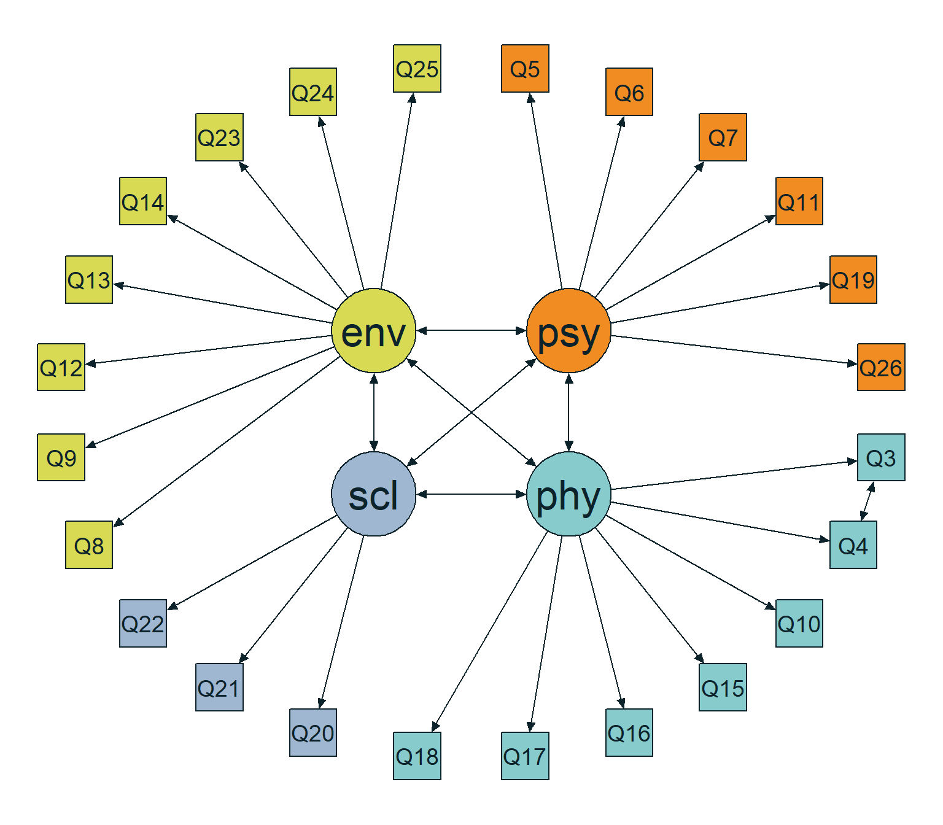
Figure 5: Path diagram of the analyzemodel
_{Source: Population Models}

3 Analytical Power Analysis
Analytical power usually asks: “How large must $N$ be to reject the hypothesis that the model fits perfectly (or adequately) when the true misfit in the population is of a certain magnitude?” A common formulation sets the alternative hypothesis to RMSEA = 0.05 (MacCallum et al., 1996).

3.1 Model Degrees of Freedom
Analytical calculations depend crucially on model degrees of freedom ($df$), the difference between the number of available pieces of information (unique variances/covariances) and the number of freely estimated parameters. Knowing this allows tools to parameterize the non-central $χ^{2}$ distribution. This calculation is necessary for both a priori and post hoc power analyses in analytical methods for global fit:
Model degrees of freedom (via semPower): 249
Source: Analytical Power Analysis

3.2 A Priori: How Many Observations?

3.2.1 Model-free approach (RMSEA-based)
An a priori power analysis is conducted before data collection to determine the sample size required to detect a target effect with a prespecified significance level, desired power, and model degrees of freedom (Jobst et al., 2023; Moshagen & Bader, 2024).
In this setup, the effect is defined through the RMSEA, which expresses model misfit on a per-degree-of-freedom basis and therefore serves as a noncentrality-based measure of discrepancy between the null model and the comparison model (Jobst et al., 2023; Moshagen & Bader, 2024).
Because RMSEA is directly linked to the population minimum of the fitting function through $F_{0}={\text{RMSEA}}^{2}×df$, the target misfit can be translated into the noncentrality parameter used in the analytical power calculation, $λ=(N−1)F_{0}$ (Moshagen & Bader, 2024).
This corresponds to an analytical, model-free power analysis, meaning that the required sample size is determined by the chosen effect magnitude, $α$, desired power, and $df$, rather than by the interpretation of any single model parameter (Moshagen & Bader, 2024).
Accordingly, an RMSEA-based a priori analysis is most appropriate when the objective is to plan sample size for detecting overall model misspecification in a global chi-square test of model fit (Jobst et al., 2023; Moshagen & Bader, 2024).
semPower: A priori power analysis
F0 0.622500
RMSEA 0.050000
Mc 0.732531
GFI 0.950683
AGFI 0.940582
df 249
Required Num Observations 99
Critical Chi-Square 286.8077
NCP 61.00500
Alpha 0.050000
Beta 0.199217
Power (1 - Beta) 0.800783
Implied Alpha/Beta Ratio 0.250983
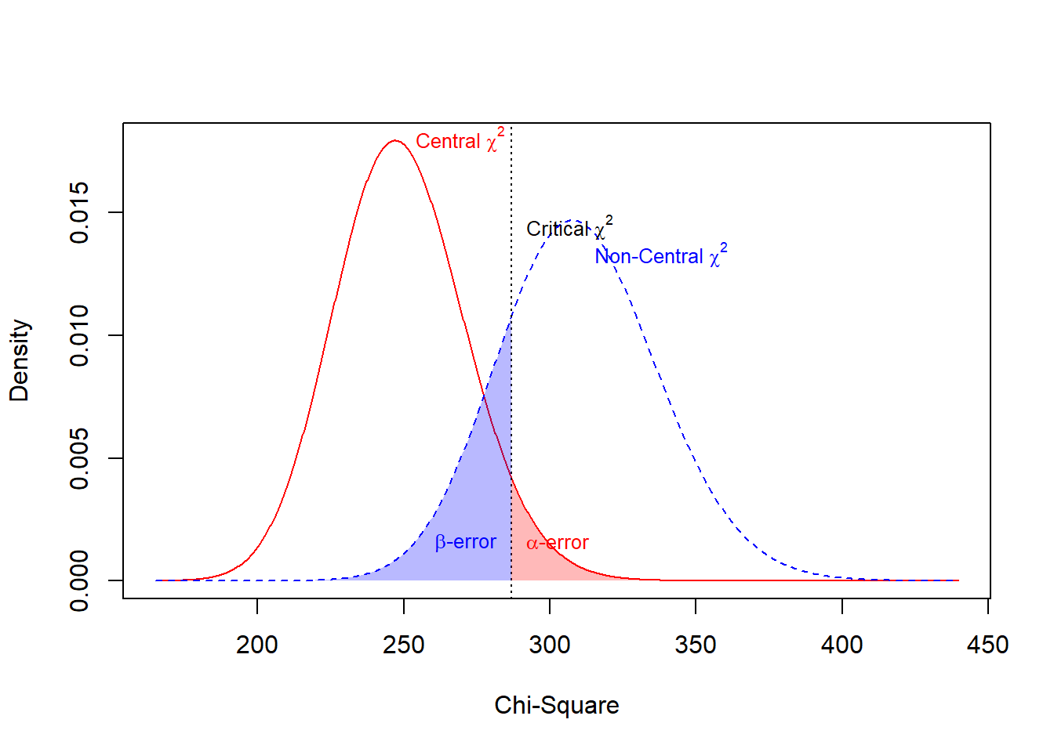
Source: Analytical Power Analysis
This output shows the minimum sample size required to detect a degree of model misfit equal to $\text{RMSEA}=0.05$ with target power $0.80$ at $α=0.05$. In this setup, the null hypothesis is exact fit, so the reported effect refers to the level of misspecification to be detected under the alternative hypothesis, not to a misfit level assumed under the null (Jobst et al., 2023; Moshagen & Bader, 2024).
The output reports several equivalent representations of the same target effect. The value $F_{0}$ = 0.623 is the population minimum of the fitting function, obtained from $F_{0}=df⋅{\text{RMSEA}}^{2}$ = 249 $⋅$ ${0.05}^{2}$, so it is simply the RMSEA target expressed on the scale used by the chi-square power calculation (Jobst et al., 2023; Moshagen & Bader, 2024).
The same discrepancy is also shown as $\text{RMSEA}=0.050$, $Mc$ = 0.733, $GFI$ = 0.951, and $AGFI$ = 0.941. These are not different effects; they are alternative summaries of the same amount of model misfit, reported in the format used by semPower (Moshagen & Bader, 2024).
The key conversion behind the output is
$$λ=(N−1)F_{0}=(N−1) df {\text{RMSEA}}^{2}$$
which translates the chosen effect size into the noncentrality parameter used to define the alternative chi-square distribution (Jobst et al., 2023; Moshagen & Bader, 2024).
The model has $df$ = 249, and these degrees of freedom determine the reference central chi-square distribution used in the test. Given the requested operating conditions, the a priori solution is $N$ = 99, meaning that 99 observations are the minimum sample size needed to achieve power of about 0.80 in this exact specification (Jak et al., 2021; Jobst et al., 2023).
At that sample size, the noncentrality parameter is $λ$ = 61.005, obtained from (99 $−$ 1) $⋅$ 0.623. This value determines how far the alternative chi-square distribution is shifted to the right relative to the null distribution (Jak et al., 2021; Moshagen & Bader, 2024).
The critical value is $χ_{c}^{2}$ = 286.808. In practical terms, this is the cutoff used to decide whether the observed test statistic is large enough to reject exact fit at the $α=0.05$ level (Jak et al., 2021; Jobst et al., 2023).
The reported $α=0.05$ is the probability of rejecting the model when exact fit is actually true. The reported $β$ $≈$ 0.199 is the probability of failing to reject the model even though the population misfit is $\text{RMSEA}=0.05$ (Jak et al., 2021; Jobst et al., 2023).
Accordingly, the reported power is $1−β$ $≈$ 0.801. This means that, with $N$ = 99, the analysis has about an 80% chance of detecting this level of misspecification if it is truly present in the population (Jobst et al., 2023; Moshagen & Bader, 2024).
In the figure, the solid red curve represents the central $χ^{2}$ distribution under exact fit, and the dashed blue curve represents the noncentral $χ^{2}$ distribution under the target misspecification $\text{RMSEA}=0.05$. The vertical dotted line at $χ^{2}$ = 286.808 is the decision threshold, so the two shaded tail areas visualize the reported $α$, $β$, and power values (Jak et al., 2021; Moshagen & Bader, 2024).
Because the achieved power is 0.801, the solution is essentially right at the requested threshold rather than comfortably above it. The output therefore supports the interpretation that $N$ = 99 is the minimum adequate sample size for this particular a priori specification (Jobst et al., 2023).

3.2.2 Model-based approach
By contrast, when the substantive hypothesis concerns a specific loading, regression coefficient, factor correlation, or cross-group constraint, a model-based power analysis is typically more appropriate than a global RMSEA-based specification (Moshagen & Bader, 2024).
In this framework, power is defined for a specific hypothesis, so the relevant sample size depends on the discrepancy between the null model and the comparison model rather than on a universal rule of thumb for SEM sample sizes (Jobst et al., 2023; Moshagen & Bader, 2024).
Using semPower.powerLav(), the population model represents the data-generating structure, whereas modelH0 represents the null analysis model to be challenged. When modelH1 is omitted, the null model is evaluated against the saturated model, which makes the analysis a test of global model misfit rather than a test of a single isolated parameter restriction (Jobst et al., 2023; Moshagen & Bader, 2024).
Conceptually, the analytical procedure fits the null model to the population-implied covariance structure and converts the resulting discrepancy into a noncentrality-based effect size. The key quantity is the population minimum of the fitting function, $F_{0}$, which is linked to the noncentrality parameter by $λ=(N−1)F_{0}$ and therefore connects substantive model misspecification to statistical power (Jobst et al., 2023; Moshagen & Bader, 2024).
Because the effect is generated by the full model specification, the required sample size is inherently model-dependent and may change when loadings, factor correlations, residual variances, or other population parameters are modified (Jobst et al., 2023; Moshagen & Bader, 2024).
This type of analysis is especially useful when the goal is to justify sample size planning from a theoretically specified SEM rather than from a generic fit index threshold. At the same time, its interpretation relies on the assumptions underlying analytical chi-square-based power analysis, so simulation-based approaches become preferable when nonnormality, missing data, or convergence issues are central concerns (Jobst et al., 2023; Moshagen & Bader, 2024).
semPower: A priori power analysis
F0 0.303870
RMSEA 0.034934
SRMR 0.175600
Mc 0.859044
GFI 0.975303
AGFI 0.970244
CFI 0.977582
df 249
Required Num Observations 202
Critical Chi-Square 286.8077
NCP 61.07791
Alpha 0.050000
Beta 0.198481
Power (1 - Beta) 0.801519
Implied Alpha/Beta Ratio 0.251914
Source: Analytical Power Analysis
The output indicates a population discrepancy of $F_{0}$ = 0.304, which is also expressed as $\text{RMSEA}$ = 0.035 and $Mc$ = 0.859 in the summary table.
The null model has $df$ = 249, and the a priori analysis shows that the required sample size is $N$ = 202 to attain the requested design conditions. The corresponding critical chi-square is 286.808, which is the cutoff used by the test at the specified significance level.
The output also reports a noncentrality parameter of 61.078, consistent with the relationship $λ=(N−1)F_{0}$ for the obtained solution.
Regarding the error rates, the summary shows $α$ = 0.05, $β$ = 0.198, and $\text{Power}=1−β$ = 0.802, indicating that the result reaches the intended power of approximately 80%.

3.3 Power Curves
This figures are used to frame power analysis as a relationship between sample size and the probability of detecting a prespecified degree of model misspecification, holding the significance level and model degrees of freedom constant (Jobst et al., 2023; Moshagen & Bader, 2024).

3.3.1 Model-free approach (RMSEA-based)
In setting below, power is evaluated analytically and model-free, which means the calculation depends on the chosen effect size metric, $α$, and $df$, rather than on a fully parameterized substantive SEM (Jobst et al., 2023; Moshagen & Bader, 2024).
Using RMSEA as the effect definition is convenient because it is a noncentrality-based fit measure with a direct connection to the discrepancy underlying the chi-square test, typically expressed as $F_{0}={\text{RMSEA}}^{2}×df$ (Jobst et al., 2023; Moshagen & Bader, 2024).
Conceptually, the plot answers a planning question: for a model with fixed $df$, how large must $N$ be so that the test has a sufficiently high probability of detecting misspecification of at least the target magnitude (Jobst et al., 2023; Moshagen & Bader, 2024).
This type of visualization is especially useful when the research objective concerns global model fit rather than a single parameter restriction, because it summarizes the sensitivity of the chi-square-based test across a continuum of sample sizes (Jobst et al., 2023; Moshagen & Bader, 2024). It therefore supports design justification by linking substantive tolerance for model misfit to sample size requirements in a transparent and reproducible way (Jobst et al., 2023; Moshagen & Bader, 2024).
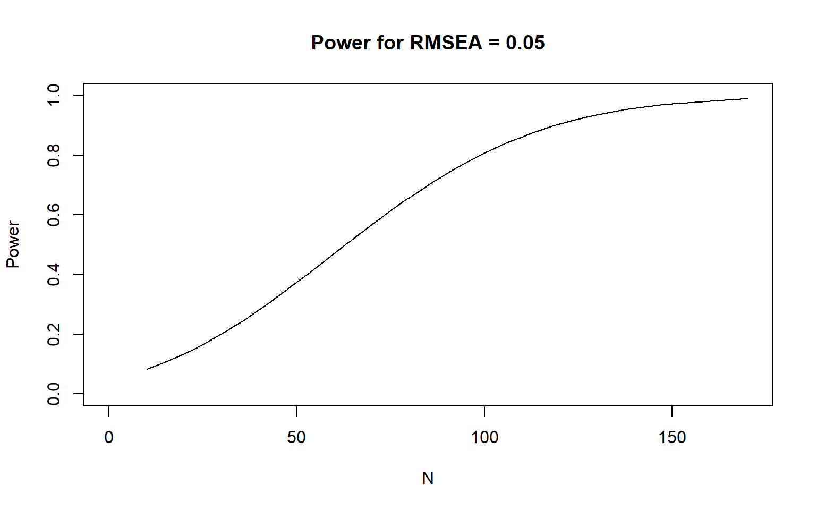
Figure 6: Power as a function of sample size for RMSEA = 0.05
Source: Analytical Power Analysis
The figure shows that statistical power increases monotonically as sample size $N$ becomes larger. At the lower end of the $N$ range, the curve indicates insufficient sensitivity to detect the prespecified level of misspecification, whereas at higher $N$ values the curve approaches very high power.
The most important empirical result in this plot is the point where the curve reaches the target power threshold used in the analysis. That crossing identifies the minimum sample size in the displayed range that is consistent with the desired level of power, while values below that point remain underpowered and values above it provide progressively greater detection probability.
In practical terms, the graph supports a direct reading of sample-size adequacy from the plotted trajectory. The relevant interpretation is therefore not any single point in isolation, but the location of the curve relative to the target power level across the full range of $N$ values shown in the figure.

3.3.2 Model-based approach
In the model-based approach, power analysis is anchored in a substantively specified SEM rather than in a purely generic fit index value, so the focal effect is defined by the discrepancy between the population model and the restricted analysis model under the null hypothesis (Jobst et al., 2023; Moshagen & Bader, 2024).
Analytically, this discrepancy is translated into a noncentrality-based effect, typically through the population minimum of the fitting function $F_{0}$, which then links the substantive model assumptions to the likelihood-ratio testing framework used for power analysis (Jobst et al., 2023; Moshagen & Bader, 2024).
The function semPower.powerPlot does not redefine the model or estimate new parameters; instead, it visualizes how the implied statistical power changes as a function of sample size for that previously specified model-based effect (Jobst et al., 2023; Moshagen & Bader, 2024).
Conceptually, this type of graph is useful because it turns the result of the analytical power analysis into a design-oriented representation of sensitivity across possible sample sizes (Jobst et al., 2023; Moshagen & Bader, 2024).
In a model-based setting, this is especially valuable because the effect is tied to the specific covariance structure implied by the substantive model, meaning that the power function reflects the hypothesized parameter configuration rather than an abstract misspecification level detached from the model itself (Jobst et al., 2023; Moshagen & Bader, 2024).
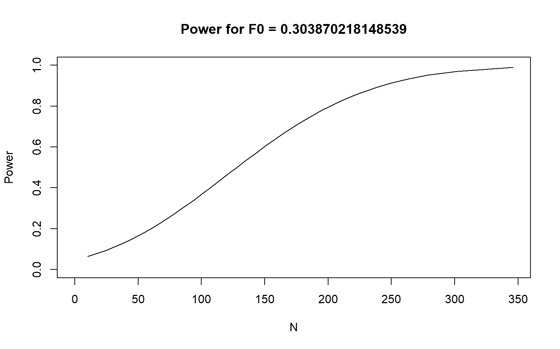
Figure 7: Power as a function of sample size for the population model (popModel)
Source: Analytical Power Analysis
The plot titled Power for $F_{0}$ = 0.304 shows a clear monotonic increase in power as sample size $N$ grows.
At the lower end of the sample-size range, power is very limited. For very small samples, the curve is close to $0.07$–$0.10$, indicating a low probability of detecting the effect represented by this $F_{0}$.
The curve enters a stronger growth region between approximately $N=120$ and $N=220$. In this interval, gains in sample size translate into substantial gains in power, with the curve moving from moderate sensitivity to clearly adequate sensitivity.
The conventional threshold of $0.80$ power is reached at approximately $N≈200$. This is the key empirical reading of the graph, because it marks the approximate sample size at which the analysis becomes adequately powered under the specified effect.
For larger samples, the curve approaches its ceiling. Around $N≈280$, power is close to $0.95$, and by the upper end of the graph, near $N≈340$ to $350$, power is close to $0.99$.
Overall, the graph indicates that small samples are clearly underpowered, sample sizes around $200$ are approximately sufficient for the usual $0.80$ criterion, and larger samples above that level provide increasingly strong detection probability, though with diminishing marginal gains.

3.4 Summary table
The table shows that the model-based approach is substantially more demanding in sample size than the model-free RMSEA-based approach, requiring roughly twice as many observations to achieve essentially the same target power. This difference suggests that, once the effect is defined from the population model itself, the analysis points to a more conservative and likely more realistic sample size requirement.
Table 3: Summary of analytical power analysis results
Method | N Required | Power | Implied RMSEA | df
Model-free a priori (RMSEA = .05) | 99 | 0.8008 | 0.0500 | 249
Model-based a priori (Population Model) | 202 | 0.8015 | 0.0349 | 249

Source: Analytical Power Analysis
 Limitations of the Analytical Approach
The RMSEA/$χ^{2}$-based analytical method classically assumes continuous, multivariate normal data and Maximum Likelihood estimation. It can yield severely biased optimal sample sizes when distributions are non-normal, data are ordinal, or missingness induces efficiency losses. Furthermore, it measures power regarding global misfit, telling us nothing about whether $N$ is adequate to detect a specific weak loading or structural path.

4 Monte Carlo Simulation: Ideal Conditions
This section presents a Monte Carlo framework for evaluating fit-based power in SEM under ideal conditions, that is, under a scenario in which the analyst fully specifies both the reference population model and the alternative population model before data are generated (Feng & Hancock, 2023; Jobst et al., 2023).
The central idea is to distinguish between two roles played by models in the simulation design: a data-generating model and an analysis model (Feng & Hancock, 2023). The data-generating model defines the population from which replicated samples are drawn, whereas the analysis model defines the structure that is repeatedly fit to each generated sample. This separation is essential because statistical power in SEM depends not only on sample size, but also on the discrepancy between the model used for estimation and the population structure that generated the data (Feng & Hancock, 2023; Jobst et al., 2023).
In this setup, the reference condition represents the benchmark of acceptable fit, while the alternative condition represents a population in which a theoretically relevant misspecification is present (Feng & Hancock, 2023). Repeatedly fitting the same analysis model to samples generated under both conditions makes it possible to compare their empirical fit-index distributions and quantify how well the chosen fit criteria separate well-fitting from misspecified situations (Jobst et al., 2023).
Varying $N$ across a predefined sequence turns the simulation into a sample-size planning exercise rather than a single-condition power check (Feng & Hancock, 2023). Conceptually, as $N$ increases, the sampling distributions under the reference and alternative conditions tend to become more distinguishable, so the probability of correctly flagging the misspecified condition increases as well (Feng & Hancock, 2023; Jobst et al., 2023).
Power based on fit indices is therefore interpreted here as the probability that a fit rule, calibrated from the reference condition, classifies data generated under the alternative condition as showing worse fit than expected under the benchmark model. In practical terms, this approach shifts the focus from testing a single parameter to evaluating whether global fit measures are sensitive enough to detect a substantively meaningful form of model misspecification across plausible sample sizes (Feng & Hancock, 2023; Jobst et al., 2023; Moshagen & Bader, 2024).
This logic is especially useful when the main research question concerns model adequacy at the global level, or when the inferential goal is to determine the sample size required for fit indices to reliably distinguish acceptable from unacceptable model-data correspondence under explicitly defined assumptions (Feng & Hancock, 2023; Jobst et al., 2023).
Below, we present the results of this simulation under ideal conditions. First, the power curve is shown for all four fit indexes (RMSEA, CFI, TLI, SRMR) across the range of sample sizes. Then, we compare the two generated distributions for the reference and alternative conditions across the four fit indices, showing how the separation between them evolves as $N$ increases.
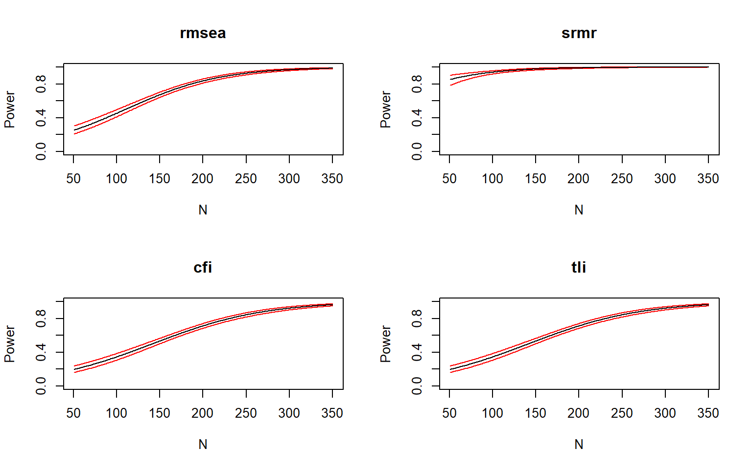
Figure 8: Power curves for fit indices under ideal conditions.
Source: Simulation — Ideal Conditions
The simulation under ideal conditions shows that power increases as sample size grows. At the lower end of the sample-size sequence, the fit indices remain below the target power threshold, indicating limited sensitivity to detect the imposed misspecification.
As $N$ increases, the power curves rise steadily, showing that the same degree of misspecification becomes easier to detect in larger samples. The point at which each curve crosses the conventional target level (e.g., .80) marks the approximate minimum sample size required for that fit index to achieve adequate discriminatory performance.
The graph also shows that the fit indices do not behave identically across the sample-size range. Some indices reach the target power earlier, which indicates greater sensitivity to the discrepancy built into the alternative model, whereas others require larger $N$ to attain the same level of power.
Taken together, the figure indicates that the required sample size depends on the specific fit criterion being used. Therefore, the most conservative planning decision is based on the fit index whose curve reaches the desired power threshold at the largest sample size.
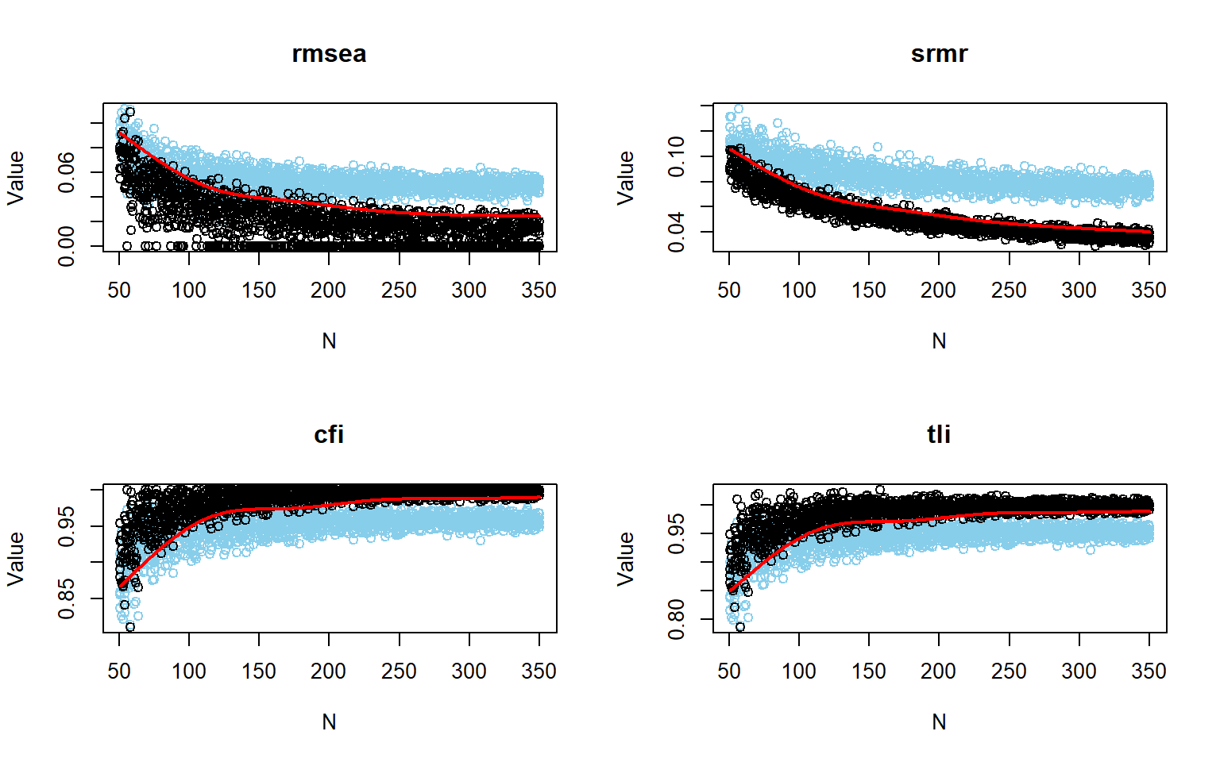
Figure 9: Power curves for fit indices under ideal conditions without logistic smoothing.
Source: Simulation — Ideal Conditions
The second figure shows the empirical distributions of the four fit indices under the reference and alternative conditions for each sample size. At the smallest $N$, the two distributions are heavily overlapping, which means that the fit indices have limited ability to distinguish between the well-fitting and misspecified scenarios.
As $N$ increases, the distribution under the alternative condition shifts towards worse fit values, while the distribution under the reference condition remains relatively stable. This growing separation between the distributions illustrates how the fit indices become more effective at detecting the misspecification as sample size increases, which is the empirical basis for the observed power curves.
This plot is best understood as a Monte Carlo view of discrimination between well-fitting and misspecified conditions in SEM, using fit indices as decision variables rather than relying only on a single observed estimate (Jobst et al., 2023; Moshagen & Bader, 2024). In simsem, plotPowerFit() is designed to visualize the sampling distributions of fit indices under an alternative condition and, when a null object is supplied, to relate them to cutoffs derived from the null-model distribution at a prespecified $α$ level. Conceptually, this turns power into a question of how often values generated under misspecification fall beyond the acceptance region implied by the null/reference model (Jobst et al., 2023).
When sample size varies across replications, the figure shows how the empirical behavior of indices such as CFI, TLI, RMSEA, or SRMR changes as information accumulates, which is central to power analysis in SEM because power depends on the separation between the null and alternative sampling distributions (Feng & Hancock, 2023; Jobst et al., 2023; Moshagen & Bader, 2024). In that sense, the graph is not just a display of fit indices; it is a visual representation of the decision process underlying rejection of inadequate models (Jobst et al., 2023).
The resulting figure therefore serves as a diagnostic complement to formal power summaries, helping the reader assess whether rejection is driven by clear distributional separation or by marginal boundary behavior around the cutoff (Moshagen & Bader, 2024). As $N$ increases, the indices move progressively to the rejection side, and this pattern becomes stable around $N=200−250$. RMSEA and SRMR are [more/less] visually separated from the cutoff than CFI and TLI, while among the incremental indices, [CFI/TLI] shows the earliest clear discrimination. The table below summarizes the power and cutoff values for each fit index at $N=231$.
Table 4: Power and fit index cutoff values under ideal conditions at N = 231.
 | RMSEA | SRMR | CFI | TLI
Power | 0.900 | 0.995 | 0.801 | 0.801
Cutoff | 0.039 | 0.058 | 0.965 | 0.961

Source: Simulation — Ideal Conditions
At $N=231$, the table shows that the estimated power was 0.9 for RMSEA, 0.995 for SRMR, and 0.801 for both CFI and TLI. Among the four indices, SRMR yielded the highest power, followed by RMSEA, whereas CFI and TLI produced the lowest and virtually identical power values.
The empirical cutoff values were 0.039 for RMSEA, 0.058 for SRMR, 0.965 for CFI, and 0.961 for TLI. In practical terms, the rejection rule is stricter for RMSEA and SRMR above their cutoffs, and for CFI and TLI below their cutoffs.
Taken together, the pattern of results is clear: SRMR > RMSEA > CFI/TLI in terms of power. Thus, within this specific analysis, SRMR provided the strongest discrimination, RMSEA also performed strongly, and CFI and TLI were just above the conventional $0.80$ threshold.

4.1 Traditional cutoff values for fit indices
When traditional cutoffs are used, the analysis adopts fixed threshold values such as $\text{RMSEA}≤.06$, $\text{CFI}≥.95$, $\text{TLI}≥.95$, and $\text{SRMR}≤.06$ as the decision boundaries for acceptable fit. Conceptually, this means that power is defined here as the proportion of replications in which the misspecified model crosses those predefined boundaries in the direction of worse fit.
This setup is convenient because it mirrors common applied practice, but the literature also emphasizes that such rule-of-thumb cutoffs are not universally valid and should be interpreted cautiously, since fit measures are influenced by model features beyond the focal misspecification itself (Jobst et al., 2023; Moshagen & Bader, 2024).
A simulation-based power display is especially informative in SEM because it shows how the sampling behavior of fit indices changes as sample size varies, rather than relying only on a single summary value (Moshagen & Bader, 2024). This is important because the same nominal cutoff may correspond to different practical rejection behavior depending on the model structure and the empirical distribution of the index under misspecification (Jobst et al., 2023; Moshagen & Bader, 2024).
For that reason, plotting fit-index-based power provides an intuitive bridge between formal power analysis and the applied decision rules researchers often use when judging model adequacy in substantive SEM work (Jobst et al., 2023).
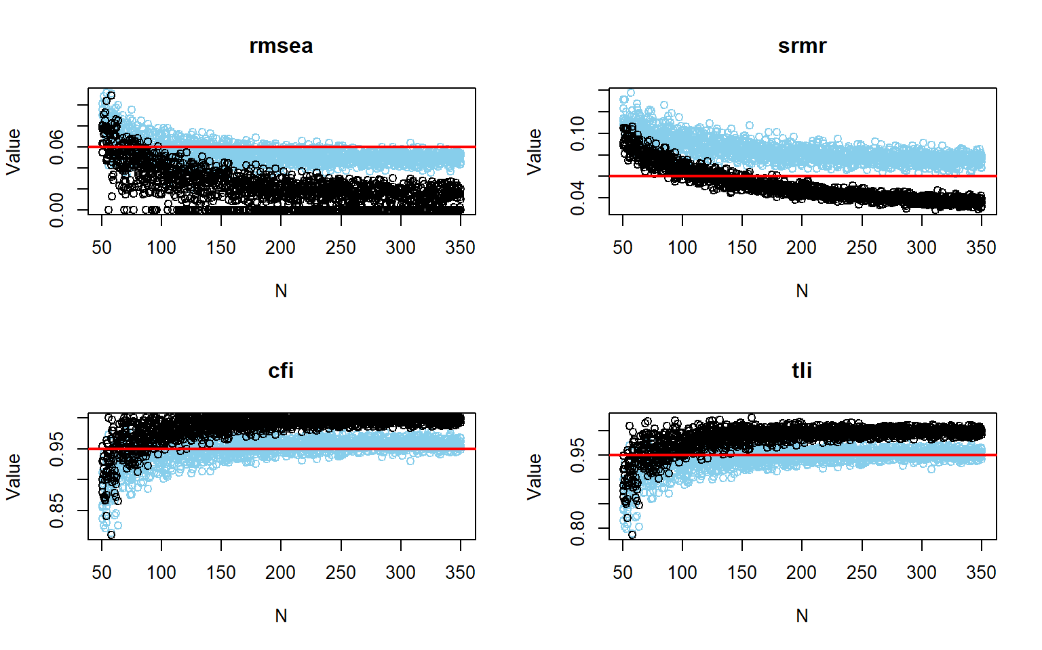
Figure 10: Power curves using traditional fit index cutoffs under ideal conditions.
Source: Simulation — Ideal Conditions
The figure shows that all four fit indices become more stable as sample size increases, with noticeably less dispersion from $N≈50$ to $N≈350$. At smaller sample sizes, the points are widely scattered in every panel, whereas at larger sample sizes the values concentrate into narrower bands.
For RMSEA, the black points decrease clearly as $N$ increases and are mostly well below the red cutoff line at moderate and large sample sizes. However, at the red line cutoff of $0.05$, the distinction is still weak because the light-blue points remain close to that threshold and there is substantial overlap. In practical terms, RMSEA would need a cutoff around $0.04$ or lower to provide a clearer distinction in this figure.
For SRMR, the separation is visually the strongest. The black points decline from roughly $0.09$ at low $N$ to around $0.03$ to $0.04$ at high $N$, while the light-blue points remain higher, mostly around $0.07$ to $0.09$. At the red cutoff of $0.06$, SRMR is the only index that begins to make a clear distinction, and this becomes visible only when $N$ is close to $200$ or larger.
For CFI, both sets of points increase with $N$, but at the red cutoff of $0.95$ the two clouds are not clearly separated. Many light-blue points stay around that same region, so the cutoff does not create a meaningful visual distinction between the two groups.
For TLI, the pattern is very similar to CFI. Although the black points approach values close to $1.00$, the light-blue points also cluster around the $0.95$ region, so at this cutoff the red line does not provide a clear distinction either.
Overall, when the red cutoff lines are used as the reference, only SRMR shows effective discrimination, and even then only after sample sizes approach $N≈200$. RMSEA shows some separation, but not enough at $0.06$, suggesting that a cutoff near $0.04$ would be more informative in this plot. At the $0.95$ cutoff, CFI and TLI do not provide any meaningful distinction.
The table below summarizes the power and cutoff values for each fit index at $N=231$ when traditional cutoffs are applied.
Table 5: Power for traditional fit index cutoffs under ideal conditions at N = 231.
 | CFI | TLI | RMSEA | SRMR
Power | 0.381 | 0.579 | 0.153 | > 0.98

Source: Simulation — Ideal Conditions

4.2 Targeting specific parameters
The previous analyses focused on global fit indices, which summarize overall model adequacy but do not directly address the power to detect specific parameter misspecifications. In this section, we evaluate power for a particular parameter (e.g., $Q8$ on the Physical factor) by defining the alternative condition as a population in which that parameter is set to zero, while the reference condition retains the original nonzero parameter. This approach allows us to assess the sensitivity of the analysis to detect a specific parameter misspecification rather than relying on global fit measures alone.
From this perspective, Monte Carlo summaries such as bias, standard error bias, and confidence-interval coverage are not secondary diagnostics. They indicate whether the estimator behaves as expected in finite samples, that is, whether $\hat{θ}$ is centered around the population value $θ$, whether the estimated uncertainty is calibrated, and whether the nominal interval actually contains the true parameter with approximately the intended frequency across replications (Pornprasertmanit et al., 2021).
In Table 6, Rel Bias refers to relative parameter bias, Rel SE Bias refers to relative standard-error bias, Coverage is the proportion of confidence intervals that contain the true value, and Power (Not equal 0) is the proportion of replications in which the parameter is detected as different from zero at the chosen significance level (Pornprasertmanit et al., 2021). A parameter may show high power and still be poorly recovered if its estimate is biased or its standard error is poorly calibrated, so detection and estimation quality should be evaluated separately (Jobst et al., 2023; Moshagen & Bader, 2024; Pornprasertmanit et al., 2021).
Overall, the results below are favorable for most parameters, but they also show that power, bias, standard-error bias, and coverage do not tell exactly the same story. The correct interpretation therefore needs to combine all four indicators, rather than relying only on power or only on the required $N$ (Jobst et al., 2023; Moshagen & Bader, 2024; Pornprasertmanit et al., 2021).
Table 6: Summary of parameter estimates under ideal conditions.
Parameter estimates under ideal conditions {quarto-postprocess='true'}
Parameter | Rel Bias | Rel SE Bias | Coverage | Power (Not equal 0)
psycho=~Q5 | -0.003 | -0.043 | 0.947 | 1.000
psycho=~Q6 | -0.005 | -0.084 | 0.937 | 1.000
psycho=~Q7 | -0.004 | -0.066 | 0.940 | 1.000
psycho=~Q11 | -0.005 | -0.050 | 0.945 | 1.000
psycho=~Q19 | -0.003 | 0.000 | 0.953 | 1.000
psycho=~Q26 | -0.006 | -0.079 | 0.938 | 1.000
physical=~Q3 | -0.011 | -0.063 | 0.947 | 1.000
physical=~Q4 | -0.006 | -0.066 | 0.945 | 1.000
physical=~Q10 | -0.010 | -0.062 | 0.947 | 1.000
physical=~Q15 | 0.068 | -0.106 | 0.871 | 1.000
physical=~Q16 | -0.011 | -0.061 | 0.941 | 1.000
physical=~Q17 | -0.010 | -0.090 | 0.931 | 1.000
physical=~Q18 | -0.011 | -0.077 | 0.938 | 1.000
social=~Q20 | -0.004 | -0.050 | 0.941 | 1.000
social=~Q21 | -0.003 | -0.025 | 0.952 | 1.000
social=~Q22 | 0.002 | -0.048 | 0.943 | 1.000
environment=~Q8 | 0.360 | -0.090 | 0.520 | 0.997
environment=~Q9 | 0.105 | -0.051 | 0.879 | 0.999
environment=~Q12 | -0.012 | -0.065 | 0.939 | 1.000
environment=~Q13 | -0.010 | -0.080 | 0.942 | 1.000
environment=~Q14 | -0.009 | -0.045 | 0.940 | 1.000
environment=~Q23 | -0.010 | -0.075 | 0.939 | 1.000
environment=~Q24 | -0.006 | -0.047 | 0.947 | 1.000
environment=~Q25 | -0.011 | -0.059 | 0.940 | 1.000
psycho~~physical | 0.039 | -0.069 | 0.941 | 0.751
psycho~~social | -0.002 | -0.069 | 0.935 | 0.727
psycho~~environment | 0.286 | -0.122 | 0.831 | 0.857
physical~~social | 0.046 | -0.047 | 0.944 | 0.760
physical~~environment | 0.239 | -0.091 | 0.875 | 0.839
social~~environment | 0.038 | -0.070 | 0.931 | 0.736
Q3~~Q4 | 0.007 | -0.050 | 0.944 | 0.775
Q5~~Q5 | -0.012 | -0.043 | 0.944 | 0.999
Q6~~Q6 | -0.017 | -0.039 | 0.934 | 1.000
Q7~~Q7 | -0.020 | -0.071 | 0.929 | 0.993
Q11~~Q11 | -0.014 | -0.073 | 0.926 | 1.000
Q19~~Q19 | -0.014 | -0.050 | 0.933 | 1.000
Q26~~Q26 | -0.018 | -0.038 | 0.933 | 1.000
Q3~~Q3 | -0.012 | -0.059 | 0.935 | 1.000
Q4~~Q4 | -0.015 | -0.040 | 0.944 | 1.000
Q10~~Q10 | -0.008 | -0.044 | 0.934 | 1.000
Q15~~Q15 | 0.105 | -0.068 | 0.896 | 1.000
Q16~~Q16 | -0.011 | -0.055 | 0.934 | 1.000
Q17~~Q17 | -0.008 | -0.084 | 0.934 | 0.999
Q18~~Q18 | -0.008 | -0.010 | 0.949 | 1.000
Q20~~Q20 | -0.004 | -0.091 | 0.943 | 0.848
Q21~~Q21 | -0.015 | -0.042 | 0.946 | 0.991
Q22~~Q22 | -0.018 | -0.050 | 0.933 | 1.000
Q8~~Q8 | 0.536 | -0.058 | 0.136 | 1.000
Q9~~Q9 | 0.028 | -0.059 | 0.944 | 1.000
Q12~~Q12 | -0.001 | -0.036 | 0.943 | 1.000
Q13~~Q13 | 0.004 | -0.042 | 0.936 | 1.000
Q14~~Q14 | -0.002 | -0.085 | 0.937 | 1.000
Q23~~Q23 | -0.001 | -0.029 | 0.945 | 1.000
Q24~~Q24 | -0.013 | -0.055 | 0.937 | 1.000
Q25~~Q25 | -0.007 | -0.058 | 0.942 | 1.000

Source: Simulation — Ideal Conditions
Most primary factor loadings behave very well under ideal conditions. The indicators of psycho, physical, and social follow the expected pattern: very high power, small bias, modest standard-error distortion, and coverage close to the nominal level.
The main exception is the loading of Q8 on environment, together with its residual variance. This parameter is easy to detect, but it is not well recovered, which means that the model would likely identify it as nonzero while still estimating it with noticeable distortion. A secondary warning appears for Q15, whose loading and residual variance are less stable than the rest of the measurement parameters.
The latent covariances are the most demanding part of the model. In particular, the correlations involving social and environment are harder to recover than the primary loadings, showing lower power and weaker coverage than the measurement parameters.
Among residual parameters, most residual variances are acceptable, but a few are more demanding. The residual covariance Q3 ~~ Q4 stands out as one of the least easily detected residual parameters, and this places it closer to the latent covariances than to the well-behaved primary loadings in terms of inferential difficulty.
The required $N$ depends on the focal null hypothesis, the magnitude of the underlying effect, the model degrees of freedom, and the full set of model parameters, so different parameters within the same model may require markedly different sample sizes to achieve the same target power $1−β$ (Jobst et al., 2023; Moshagen & Bader, 2024). For that reason, planning should be anchored in the substantively focal and hardest-to-detect parameters, not in generic rules of thumb or in the most easily detectable effects (Jobst et al., 2023; Moshagen & Bader, 2024).
Table 7: Sample size needed for 80% power under ideal conditions.
Parameter | N
environment=~Q8 | 51
environment=~Q9 | 51
psycho~~physical | 200
psycho~~social | 212
psycho~~environment | 138
physical~~social | 198
physical~~environment | 148
social~~environment | 208
Q3~~Q4 | 181
Q5~~Q5 | 51
Q7~~Q7 | 51
Q17~~Q17 | 51
Q20~~Q20 | 143
Q21~~Q21 | 51

Source: Simulation — Ideal Conditions
The findPower results make this contrast very clear. Many primary loadings and several residual variances reach the target power at the low end of the simulated sample-size range, whereas the latent covariances and the residual covariance Q3 ~~ Q4 require substantially larger samples.
For planning purposes, this means that the study can look well powered if the goal is only to detect the main factor loadings, but not if the substantive focus is on relations among factors or on specific residual parameters. In these results, the practical reference is therefore much closer to $N≈200$ than to $N≈50$, because the hardest parameters, not the easiest ones, should drive the sample-size decision (Jobst et al., 2023; Moshagen & Bader, 2024; Pornprasertmanit et al., 2021).
In short, the model performs very well for most of the measurement structure, but it still shows a clear weak point in Q8, a smaller warning sign in Q15, and substantially greater sample-size demands for the latent covariance psycho~~social (N = 212). So, if the goal is to support reliable inference not only for factor loadings but also for relations among the latent domains, the sample-size decision should be guided by those harder parameters rather than by the more stable measurement ones.

4.3 Recovering the population parameters

5 Parameter-level power under the naive model
Before turning to global fit, it is useful to examine power from the perspective of parameter recovery. In SEM, power is always tied to a specific hypothesis, so the required sample size may differ substantially depending on whether the focus is on overall model misfit or on individual parameters such as loadings, latent covariances, or residual covariances (Jobst et al., 2023; Moshagen & Bader, 2024).
This subsection therefore uses Monte Carlo simulation to identify the sample size required for each estimable parameter in the CFA model to attain a target power level of $ .80 $. The logic is straightforward: repeated samples are generated under the population model, the analysis model is fit to each sample, and power is summarized for each parameter across candidate values of $ N $ (Pornprasertmanit et al., 2021).
The purpose of this step is not to evaluate model fit as a whole, but to determine which parameters are easier or harder to recover under the assumed data-generating conditions. This is useful because some parts of a CFA model can be well powered at relatively small sample sizes, whereas others may require substantially larger samples, especially when the focal quantities are covariances or other comparatively subtle effects (Jobst et al., 2023; Moshagen & Bader, 2024).

5.0.1 Naive model
In this tutorial, the naive model serves as a simple benchmark for parameter-level planning under worst-case conditions. As such, this analysis provides a local perspective on sample size requirements that complements, but does not replace, the later global-fit analyses that are central to the main study design (Moshagen & Bader, 2024; Pornprasertmanit et al., 2021).
Table 8: Parameter estimates and required sample size for 80% power under naive conditions.
Parameter | Rel Bias | Rel SE Bias | Coverage | Power (Not equal 0) | Required N
psycho~~physical | 0.140 | -0.944 | 0.913 | 0.793 | 180
psycho~~social | -0.009 | -0.137 | 0.922 | 0.780 | 186
psycho~~environment | -0.003 | -0.089 | 0.931 | 0.817 | 164
physical~~social | 0.331 | -0.971 | 0.924 | 0.775 | 192
physical~~environment | 0.141 | -0.932 | 0.929 | 0.793 | 178
social~~environment | -0.014 | -0.123 | 0.928 | 0.780 | 184
Q3~~Q4 | -0.013 | -0.130 | 0.932 | 0.845 | 143

Source: Simulation — Ideal Conditions
The Table 8 shows that most factor loadings reach the target power of $ .80 $ with very small sample sizes, generally with $ N = < 60 $. This indicates that the loading structure is relatively easy to recover under the naive model in the ideal condition.
The more demanding results are found among the latent covariances. Their required sample sizes are substantially larger: $psycho∼∼physical$ = 180, $psycho∼∼social$ = 186, $psycho∼∼environment$ = 164, $physical∼∼social$ = 192, $physical∼∼environment$ = 178, and $social∼∼environment$ = 184.
The residual covariance $Q3∼∼Q4$ falls between these two groups, requiring $N$ = 143. It is clearly harder to recover than the loadings and residual variances, but still less demanding than the latent covariances.
The largest value in the table is $N$ = 192, associated with $physical∼∼social$. For this reason, this parameter determines the minimum sample size required to achieve at least $.80$ power for all reported finite parameters in this parameter-recovery analysis.
Taken together, the pattern is very clear: the measurement part of the model is well powered at relatively small $N$, whereas the associations among latent factors require a much larger sample. In this subsection, the recommended sample size is therefore $N$ = 192, because this is the smallest value that satisfies the $.80$ power criterion for the most demanding parameter.

5.0.2 Optimistic model
This subsection examines sample size requirements from a parameter-level perspective under the optimal model. The Monte Carlo setup used here evaluates how power changes as $N$ varies and then identifies the smallest sample size required for each parameter to attain the target power level of $.80$. In the simsem framework, this type of analysis is useful for planning studies when the main concern is whether specific model components can be detected under assumed population conditions (Pornprasertmanit et al., 2021).
Within the optimal scenario, this step provides a benchmark for how demanding the focal parameters are when the model is estimated under more favorable assumptions. Thus, the analysis complements later global-fit evaluations by showing the local sample size requirements implied by the same CFA structure (Moshagen & Bader, 2024; Pornprasertmanit et al., 2021).
Table 9: Parameter estimates and required sample size for 80% power under optimal conditions.
Parameter | Rel Bias | Rel SE Bias | Coverage | Power (Not equal 0) | Required N
Q3~~Q4 | -0.008 | -0.082 | 0.934 | 0.85 | 139

Source: Simulation — Ideal Conditions
The Table 9 shows a very sparse set of finite sample-size requirements under the optimal model. Only seven parameters remained with finite $N$ values after filtering (not shown in the table), which indicates that, within the simulated range, these are the parameters for which a specific minimum sample size could be directly reported.
The only parameter with a meaningfully larger requirement is the residual covariance $Q3∼∼Q4$, which required $N$ = 139 to reach $.80$ power. This value is much higher than the others in the table and clearly stands out as the most demanding finite parameter in the optimal model.
For that reason, the sample size decision implied by this table is governed by $Q3∼∼Q4$. If the goal is to ensure at least $.80$ power for all parameters with finite reported values in this output, the required sample size is $N$ = 139.
Overall, the result is highly concentrated: most reported parameters are already adequately powered at $N=51$, and only one parameter pushes the requirement upward. In practical terms, the optimal model appears easy to recover for the listed loadings and residual variances, while the residual covariance $Q3∼∼Q4$ is the sole finite bottleneck in this table.

5.1 Misspecification and population sensitivity

5.1.1 Fit-index-based power under the naive population
This section evaluates global power from the perspective of naive model as population model. The Monte Carlo setup is designed to assess how well fit indices can discriminate between the reference condition (data generated under the naive model) and the alternative condition (data generated under the H1 model), across a range of sample sizes (Jobst et al., 2023; Moshagen & Bader, 2024).
The power curves across sample size show how the probability of rejecting the misspecified model evolves as $N$ increases. This is consistent with the general theory of power in SEM, according to which power increases as the overlap between the null and alternative sampling distributions decreases, and that separation is strengthened by larger samples and clearer model discrepancy (Jobst et al., 2023; Moshagen & Bader, 2024).
In simsem, these curves can be displayed either as raw empirical patterns or as smoothed functions based on logistic regression when sample size varies across replications. The smoothed representation is useful because it summarizes the relation between the reject/retain decision and $N$ into a continuous power function, whereas the unsmoothed version helps inspect the empirical fit-index distributions more directly (Pornprasertmanit et al., 2021).
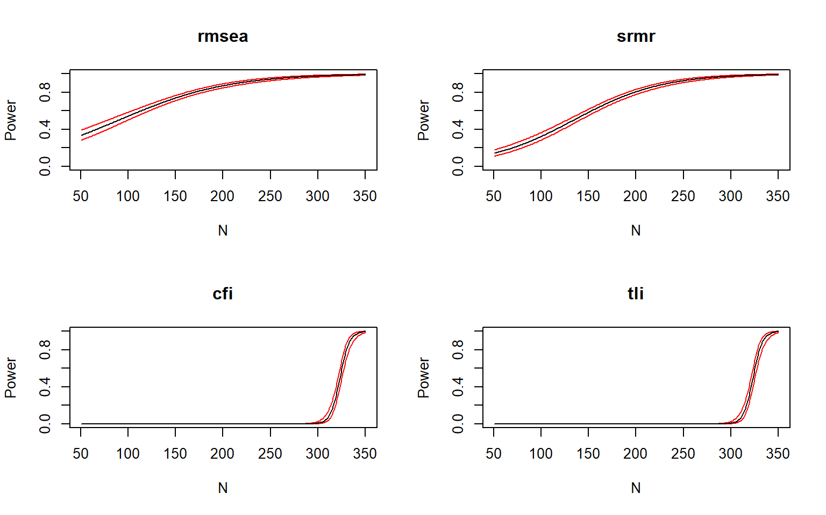
Figure 11: Power curves for fit indices using the naive population model.
Source: Simulation — Ideal Conditions
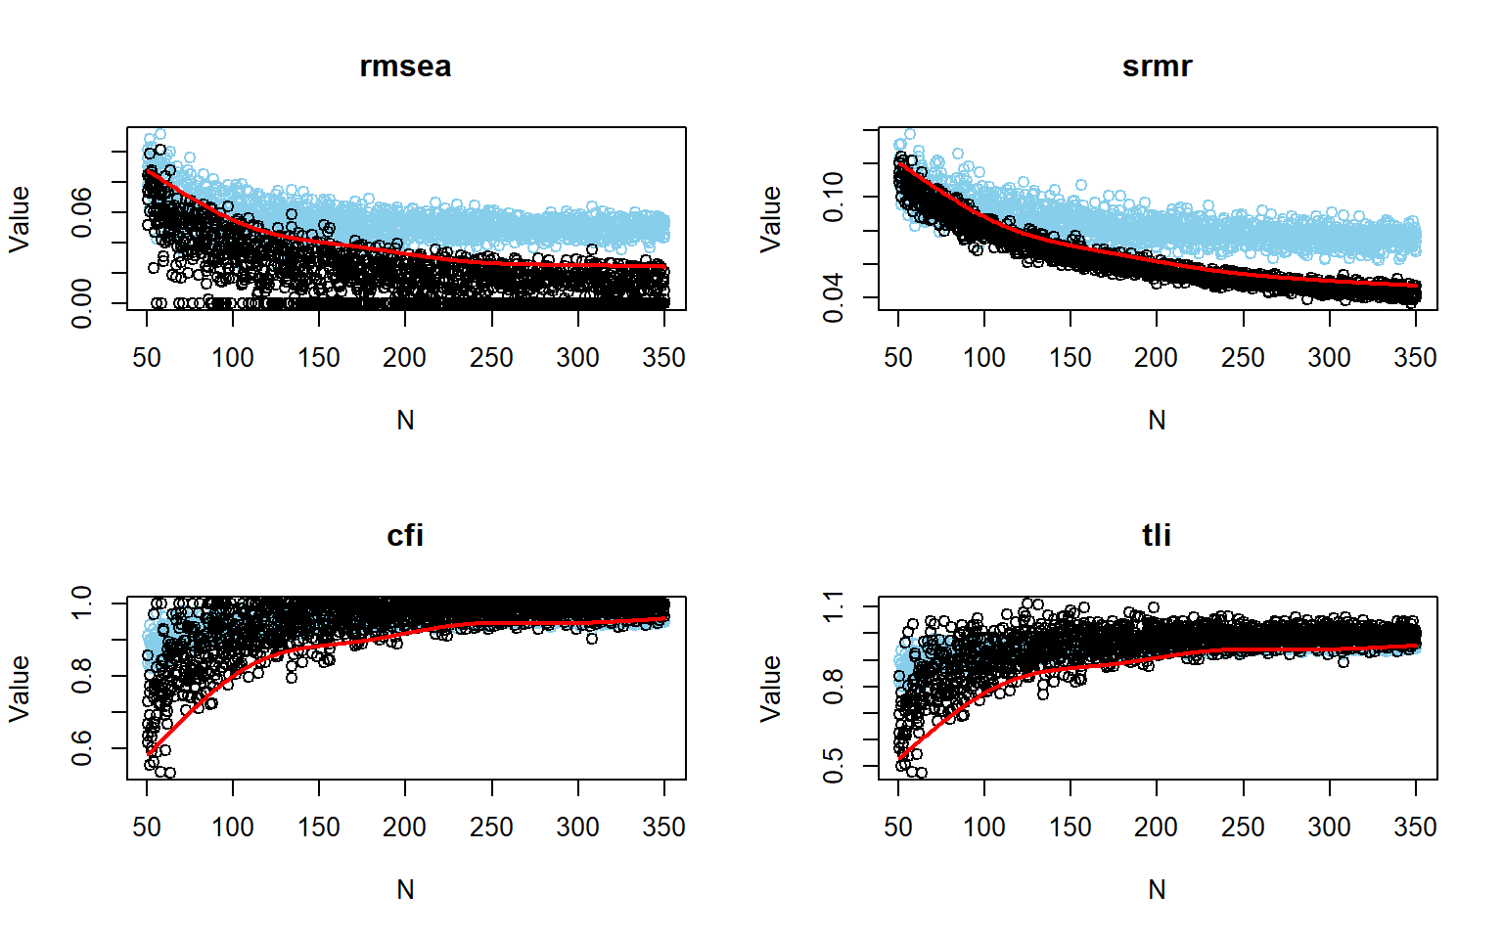
Figure 12: Power curves for fit indices using the naive population model without logistic smoothing.
Source: Simulation — Ideal Conditions
The power curves show two distinct patterns across the four fit indices. RMSEA and SRMR increase gradually and continuously with $N$, starting at moderate levels around $N=50$ and approaching 1.00 as sample size grows. In contrast, CFI and TLI remain close to zero for most of the range and then rise sharply only near the upper end of the sample-size grid, with the main increase concentrated around $N≈310$ to $340$.
In the raw fit-index plots, the separation between the two point clouds is very clear for RMSEA and SRMR across nearly the entire range of $N>200$. For these two indices, one distribution stays systematically higher while the other decreases as sample size increases, which visually matches their high power values. For CFI and TLI, the two clouds overlap more strongly at smaller and intermediate sample sizes, and the distinction becomes clearer only at larger $N$.
Table 10: Power and fit index cutoff values using the naive population model at N = 330.
 | RMSEA | SRMR | CFI | TLI
Power | 0.984 | 0.986 | 0.801 | 0.801
Cutoff | 0.022 | 0.047 | 0.964 | 0.959

Source: Simulation — Ideal Conditions
At $N=330$, the estimated power values were $>.80$ for all four indices, but they differed substantially in magnitude. RMSEA and SRMR showed very high power, with values close to $0.99$, while CFI and TLI were just above the $0.80$ threshold, indicating that they are less sensitive to the misspecification under these conditions.
These results indicate that SRMR produced the highest power, followed very closely by RMSEA. CFI and TLI yielded substantially lower power than RMSEA and SRMR, although both still reached the conventional $0.80$ threshold at $N=330$. The empirical cutoff values at $N=330$ were more pessimistic than the conventional thresholds. These cutoffs reflect the thresholds derived from the null-model distribution at the chosen $α$ level, which are used to determine whether the observed fit indices indicate a significant misspecification.
The cutoff table and the figures are consistent with each other. RMSEA and SRMR show very strong discrimination at $N=330$, with power near 0.99, whereas CFI and TLI appear to be operating at the minimum level typically considered acceptable, with power just above 0.80. Overall, at this sample size, RMSEA and SRMR perform more strongly than CFI and TLI for detecting the difference represented in this naive-population condition.

5.1.2 Optimistic model
In this simulation-based approach implemented in simsem, cutoff values are first derived from the sampling distribution of the fit indices under an optimistic null model (population model), and power is then defined as the proportion of replications from the alternative condition (H1 model) that cross those cutoffs in the direction indicating worse fit. For indices in which larger values indicate poorer fit, such as RMSEA and SRMR, rejection is based on exceeding the cutoff; for indices in which larger values indicate better fit, such as CFI and TLI, rejection is based on falling below the cutoff.
When sample size varies across replications, power can be represented as a function of $N$, which makes it possible to study how discrimination improves as information accumulates. In plotPowerFit(), this relationship may be shown either through logistic smoothing, which summarizes the rejection process continuously over $N$, or through the unsmoothed empirical pattern of simulated values and cutoff boundaries (Pornprasertmanit et al., 2021).
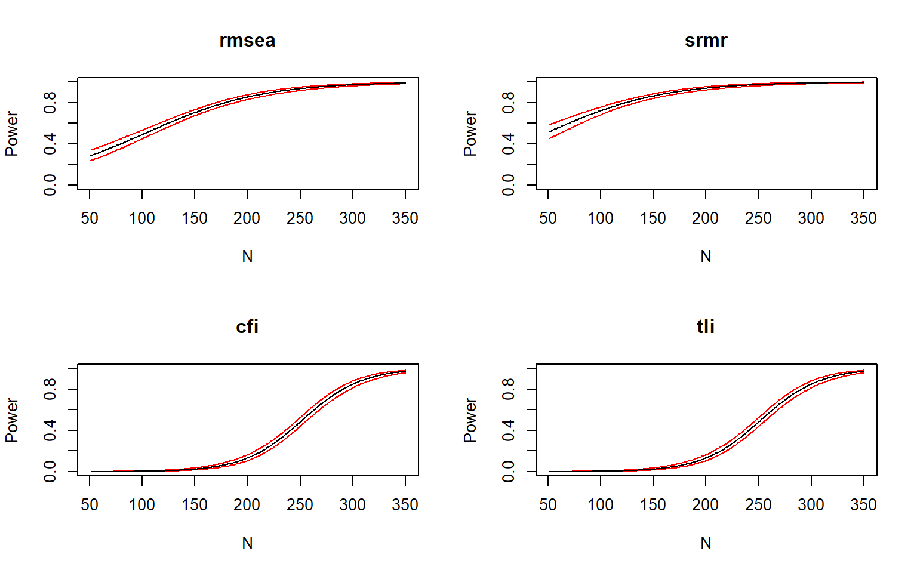
Figure 13: Power curves for fit indices using the optimal population model.
Source: Simulation — Ideal Conditions
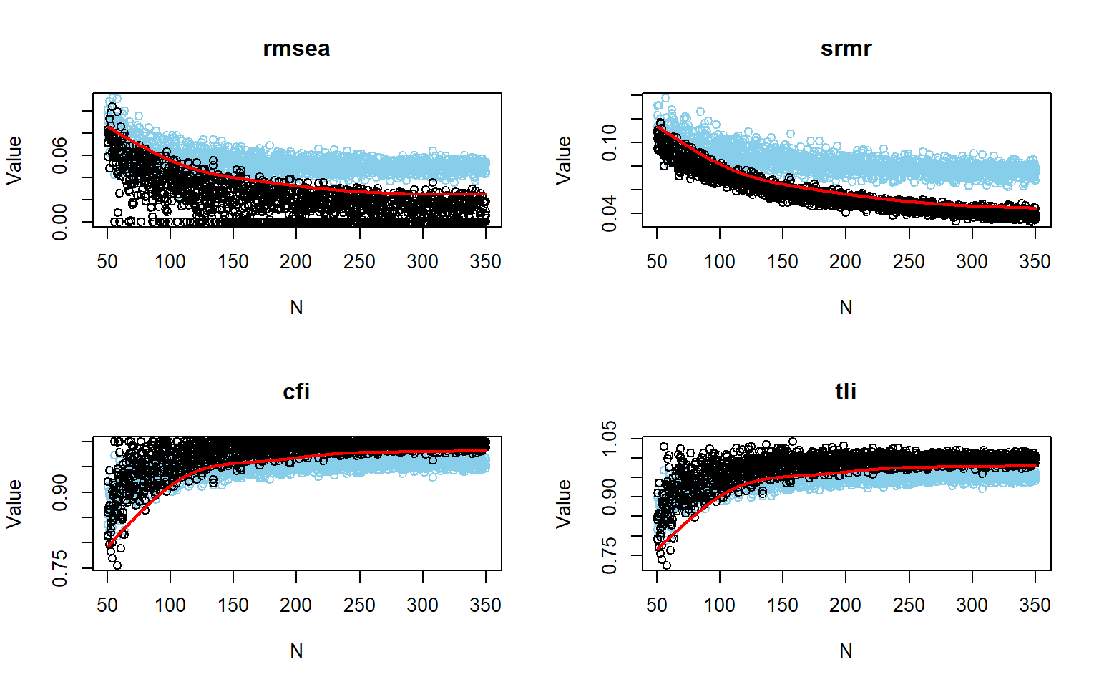
Figure 14: Power curves for fit indices using the optimal population model without logistic smoothing.
Source: Simulation — Ideal Conditions
The power curves show a clear increase in performance as sample size grows. RMSEA and SRMR rise earlier and more smoothly, reaching high power at smaller $N$ values than CFI and TLI.
Among the four indices, SRMR shows the strongest overall performance across the sample-size range. Its curve starts at a comparatively higher level and approaches $1.00$ more quickly than the others, indicating that it is the most sensitive index in this set for detecting the targeted discrepancy. RMSEA also performs very well, although it starts below SRMR at smaller sample sizes. Its increase is steady and pronounced, and the curve approaches very high power as $N$ moves into the upper half of the evaluated range.
CFI and TLI behave differently from RMSEA and SRMR. Both remain near zero power at smaller and moderate sample sizes, then increase sharply only in the higher-$N$ region, indicating that these indices require substantially larger samples before reaching adequate discrimination.
The unsmoothed plots reinforce this pattern. For RMSEA and SRMR, the simulated values from the two conditions are more clearly separated across the range of $N$, whereas for CFI and TLI there is more overlap at lower and intermediate sample sizes, with clearer separation emerging only as $N$ becomes larger.
Table 11: Power and fit index cutoff values using the optimal population model at N = 291.
 | RMSEA | SRMR | CFI | TLI
Power | 0.968 | 0.988 | 0.805 | 0.805
Cutoff | 0.028 | 0.051 | 0.970 | 0.966

Source: Simulation — Ideal Conditions
At $N=291$, the estimated power values are $>.80$ for all four indices, but they differ in magnitude. The power values at this sample size is show in Table 11. These values indicate that, at the target sample size, all four indices achieve at least acceptable power, but they do so with different margins. SRMR and RMSEA are well above the conventional $0.80$ benchmark, whereas CFI and TLI are just above that threshold.
The cutoff values at $N=291$ are more pessimistic than the conventional thresholds, reflecting the specific sampling distribution of the fit indices under the optimistic null model. These cutoffs are used to determine whether the observed fit indices indicate a significant misspecification in the alternative condition.
Taken together, the results indicate that RMSEA and especially SRMR provide very strong discrimination under the optimal model at $N=291$. In contrast, CFI and TLI are the more demanding indices in this setting, because their power at the same sample size is adequate but still comparatively limited.

6 Monte Carlo Simulation: Realistic Scenarios
Power analysis in structural equation modeling should be framed as a design-stage procedure that connects substantive expectations, model specification, and data conditions to the probability of obtaining informative statistical tests, rather than as a mechanical search for a single “minimum $N$” rule (Feng & Hancock, 2023; Wang, 2023).
SEM power analysis is strongest when it is anchored in a plausible population-generating mechanism rather than in generic rules of thumb or model-free calculators borrowed from simpler analyses (Feng & Hancock, 2023; Kyriazos, 2018).

6.1 Missing Data (MCAR)
Missing data must be treated as part of the design problem, not as a secondary complication to be handled only after estimation, because missingness reduces available information and therefore generally lowers estimation efficiency and statistical power (Feng & Hancock, 2023; Jak et al., 2021).
From this perspective, the relevant question is not only how many cases are planned, but how much usable information remains under the anticipated missing-data process (Feng & Hancock, 2023).
This is one reason Monte Carlo power analysis is especially valuable in SEM with missing data: it allows the analyst to generate data under a prespecified population model, impose realistic missingness mechanisms such as MCAR or MAR, fit the intended analysis model, and estimate power empirically under the same conditions expected in practice (Feng & Hancock, 2023; Moshagen & Bader, 2024).
Simulation-based power analysis is also advantageous when assumptions underlying purely analytical solutions become less credible, such as in the presence of incomplete data, non-normality, or more complex model structures (Feng & Hancock, 2023; Moshagen & Bader, 2024; Wang, 2023).
In this sense, the Monte Carlo approach is not merely a computational alternative, but a way to align sample size planning with the actual data-generating conditions anticipated for the study (Moshagen & Bader, 2024; Wang, 2023).
Conceptually, the purpose of the analysis is therefore twofold: first, to ensure enough sensitivity to test the focal theoretical relations, and second, to ensure enough sensitivity to evaluate whether the overall model remains substantively interpretable under the planned conditions (Feng & Hancock, 2023; Wang, 2023).
When missing data are expected, this dual objective becomes even more important, because power for parameter detection and power for fit evaluation may deteriorate at different rates as information is lost (Feng & Hancock, 2023; Wang, 2023).
A well-justified SEM power analysis thus rests on explicit assumptions about the population model, the magnitude of focal effects, the measurement structure, the estimation framework, and the expected missing-data mechanism (Jak et al., 2021; Moshagen & Bader, 2024; Wang, 2023).
Under this logic, the reported power results should be understood as conditional on a theoretically motivated scenario, not as universal guarantees, which is precisely why transparent documentation of assumptions is essential in reproducible SEM workflows (Feng & Hancock, 2023; Moshagen & Bader, 2024).
The Figure 15 shows the power curves for the four fit indices under the 10% missing MCAR missing-data scenario. The curves indicate that power is generally lower across the sample-size range compared to the ideal condition, which is expected due to the loss of information caused by missing data.
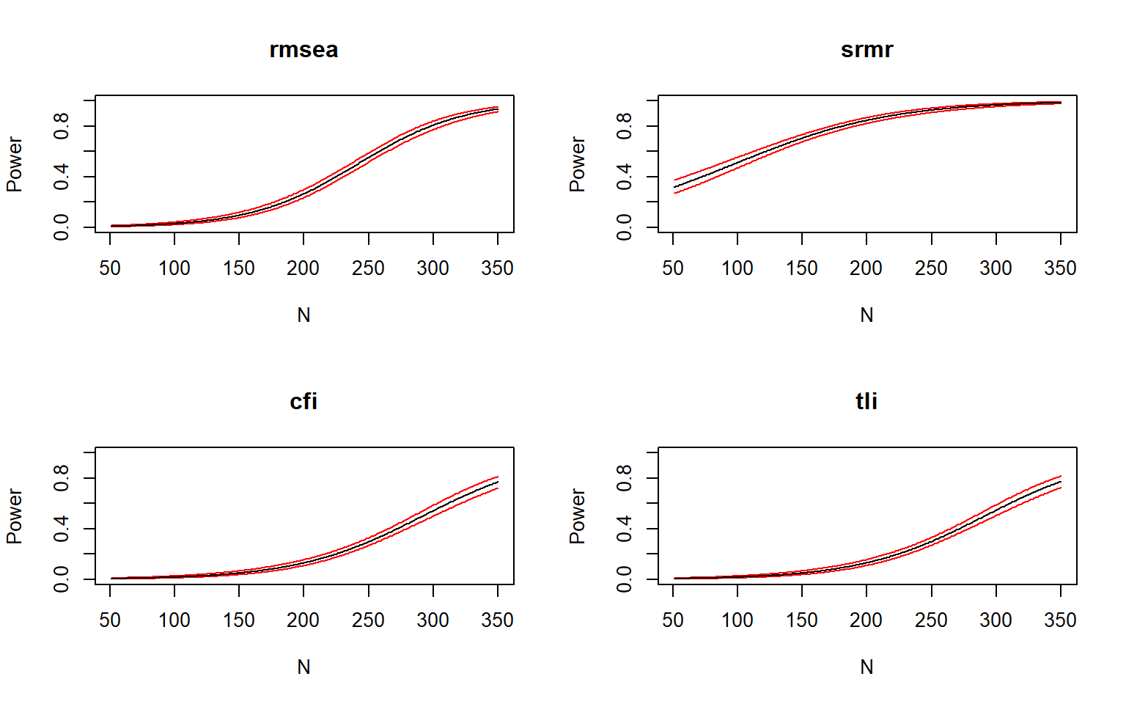
Figure 15: Power curves for fit indices under missing data conditions.
Source: Simulation — Realistic Scenarios
The Figure 16 shows the empirical distributions of the fit indices under the reference and alternative conditions with 10% MCAR missing data. The separation between the two conditions is less pronounced than in the ideal scenario, especially for CFI and TLI, which show more overlap in their distributions at smaller and intermediate sample sizes.
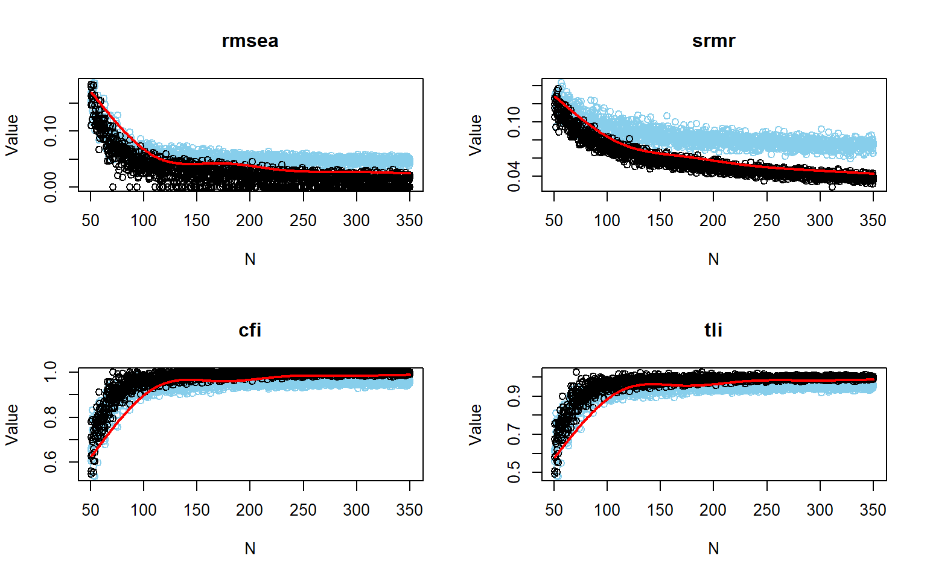
Figure 16: Power curves for fit indices under missing data conditions without logistic smoothing.
Source: Simulation — Realistic Scenarios
The Table 12 summarizes the power and cutoff values for each fit index at $N=359$ under the missing data scenario. The estimated power values are lower than in the ideal condition, with RMSEA and SRMR still showing relatively high power, while CFI and TLI have notably reduced power, indicating that they are more sensitive to the loss of information caused by missing data.
Table 12: Power and fit index cutoff values under missing data conditions at N = 359.
 | RMSEA | SRMR | CFI | TLI
Power | 0.947 | 0.987 | 0.802 | 0.806
Cutoff | 0.011 | 0.035 | 1.008 | 1.010

Source: Simulation — Realistic Scenarios
At $N=359$, the empirical power values are 0.947 for RMSEA, 0.987 for SRMR, 0.802 for CFI, and 0.806 for TLI.
These results show a clear difference in performance across indices. SRMR presents the highest power, RMSEA also shows very strong power, and both CFI and TLI are just above the conventional $0.80$ threshold.
This means that, at $N=359$, the sample size is more than sufficient for SRMR and RMSEA, while for CFI and TLI it is sufficient but still much closer to the minimum acceptable level.
The empirical cutoff values obtained at $N=359$ are 0.011 for RMSEA, 0.035 for SRMR, 1.008 for CFI, and 1.01 for TLI.
For RMSEA and SRMR, the cutoffs are very low, which is consistent with the strong discrimination shown by their power values.
For CFI and TLI, the cutoffs are slightly above $1.00$. In practical terms, this indicates that the classification boundary estimated from the simulation lies at the upper edge of the index scale, which helps explain why their power is only marginally above $0.80$ even at this sample size.
Taken together, the outputs indicate that the design performs very well for RMSEA and SRMR and only minimally adequately for CFI and TLI.
So, at $N=359$, the results support a stronger conclusion for RMSEA and SRMR, whereas for CFI and TLI the conclusion is more cautious because their power values are only slightly above the target level.

6.2 Non-Normality
This section focuses on the condition with mild non-normality, so power should be evaluated using robust fit indices rather than relying on normal-theory fit behavior. When available, the newer robust fit measures should be preferred over older scaled versions because they have better theoretical properties under non-normal data. However, for comparability with the ideal condition, the same set of indices is evaluated here.
The power curves show how often the misspecified model would be rejected as $N$ changes under this mildly non-normal condition. Here, the rejection rule is not based on generic cutoffs, but on empirical cutoffs obtained from the null-model sampling distribution at the chosen $α$ level (Pornprasertmanit et al., 2021).
The version with logistic smoothing emphasizes the general trend of power across sample sizes, whereas the version without smoothing shows the simulated fit-index values more directly (Pornprasertmanit et al., 2021). This is useful for checking how clearly the misspecified-model distribution separates from the null-based cutoff as $N$ increases (Pornprasertmanit et al., 2021).
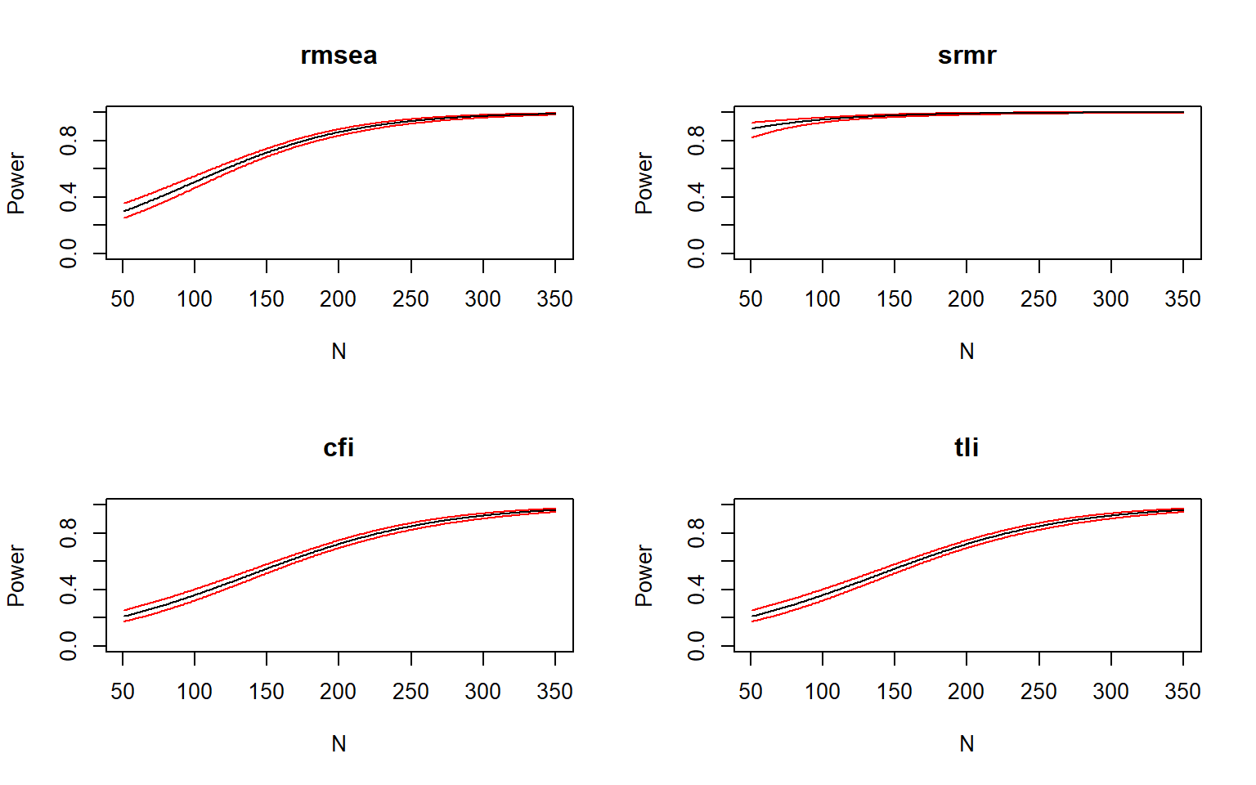
Figure 17: Power curves for fit indices under non-normal conditions.
Source: Simulation — Realistic Scenarios
Figure Figure 17 shows a clear increase in power as $N$ grows for all fit indices. SRMR is the strongest index across the entire range, starting already high at small samples and approaching $1.00$ quickly. RMSEA also increases steadily and reaches high power earlier than the incremental indices. CFI and TLI follow the same general pattern, but their curves rise more slowly and remain below RMSEA and SRMR over most of the sample-size range.
In practical terms, the ordering of sensitivity is stable throughout the figure: $\text{SRMR}>\text{RMSEA}>\text{CFI}≈\text{TLI}$. Around the mid-range of $N$, SRMR is already near ceiling, RMSEA is in a clearly high-power region, and CFI/TLI are still catching up. By the largest sample sizes, all four indices show strong power, although SRMR and RMSEA remain visibly ahead.
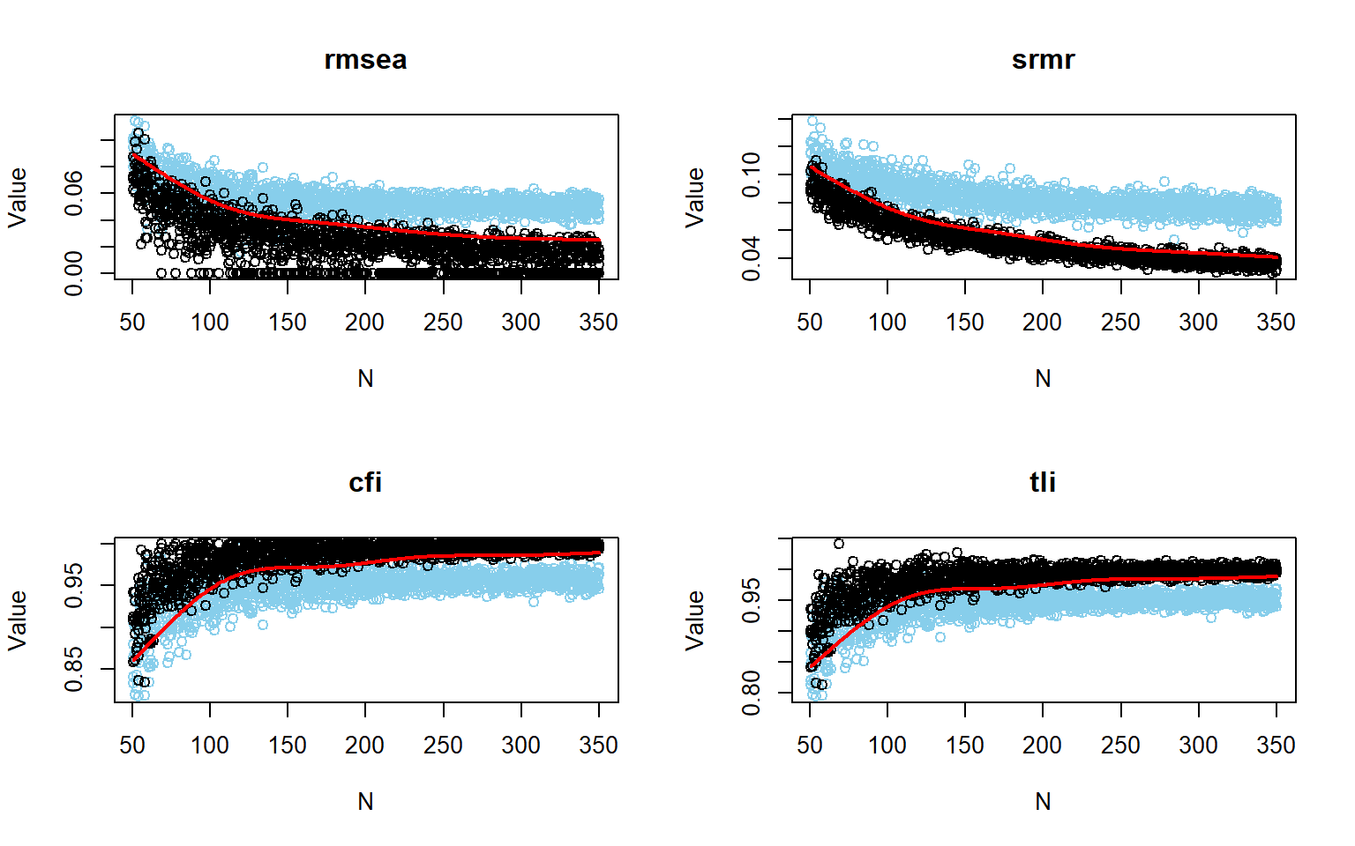
Figure 18: Power curves for fit indices under non-normal conditions without logistic smoothing.
Source: Simulation — Realistic Scenarios
Figure Figure 18 shows the same pattern without logistic smoothing and makes the separation between the simulated values more explicit. For RMSEA and SRMR, the distributions become increasingly distinct as $N$ increases, with less overlap and a clearer gap between the two sets of points. For CFI and TLI, the separation also improves with larger $N$, but the overlap is more evident at lower and moderate sample sizes, which is consistent with their slower increase in power.
Table 13: Power and fit index cutoff values under non-normal conditions at N = 228.
 | RMSEA | SRMR | CFI | TLI
Power | 0.91 | 0.994 | 0.800 | 0.80
Cutoff | 0.04 | 0.059 | 0.964 | 0.96

Source: Simulation — Realistic Scenarios
Table Table 13 summarizes the results at $N=228$. At this sample size, SRMR has the highest power 0.91, followed by RMSEA 0.994, followed by CFI 0.8. CFI and TLI both reach $0.800$, making them the least sensitive indices in this condition at the selected sample size.
The cutoff values at $N=228$ are 0.04 for RMSEA, 0.059 for SRMR, 0.964 for CFI, and 0.96 for TLI. These values are consistent with the pattern in the figures: SRMR and RMSEA show stronger discrimination at this sample size, whereas CFI and TLI require more favorable values to classify fit as acceptable. Overall, the results at $N=228$ show very strong rejection performance for SRMR, strong performance for RMSEA, and adequate performance for CFI and TLI.
The cutoff step at $N=228$ complements the curves by fixing the decision rule at a specific sample size under the same mildly non-normal setup (Pornprasertmanit et al., 2021). In this setting, power and cutoff values should be read together: the cutoff defines how strict the robust fit criterion is, and power indicates how often that criterion rejects the misspecified model (Pornprasertmanit et al., 2021).

6.3 Simulation with fixed N
Earlier sections used a priori Monte Carlo simulation to determine the minimum sample size needed for adequate power. Here, the goal is different: we hold $N$ fixed at a conservative value and examine whether that choice yields stable model discrimination across many replications.
This step is important because power analysis in SEM is not only about finding the smallest workable sample. It is also about understanding how reliably a chosen design can separate a defensible measurement model from a substantively relevant misspecified alternative when the data are repeatedly sampled from the assumed population model (Feng & Hancock, 2023; Moshagen & Bader, 2024).
In this tutorial, the focus remains on global model fit rather than on isolated parameters. That choice is theoretically appropriate because the CFA is being used here as one measurement component within a broader research program, so the practical question is whether the instrument as a whole can rule out a meaningful misspecification pattern, not merely whether one parameter at a time is detected (Jobst et al., 2023; Wang, 2023).
The section also highlights an important distinction between empirical and traditional fit criteria. Empirical cutoffs are derived from the simulated sampling behavior of the fitted model under the design at hand, whereas traditional thresholds are generic conventions; as a result, the two approaches need not lead to the same conclusion about power or model rejection (Jak et al., 2021; Pornprasertmanit et al., 2021).
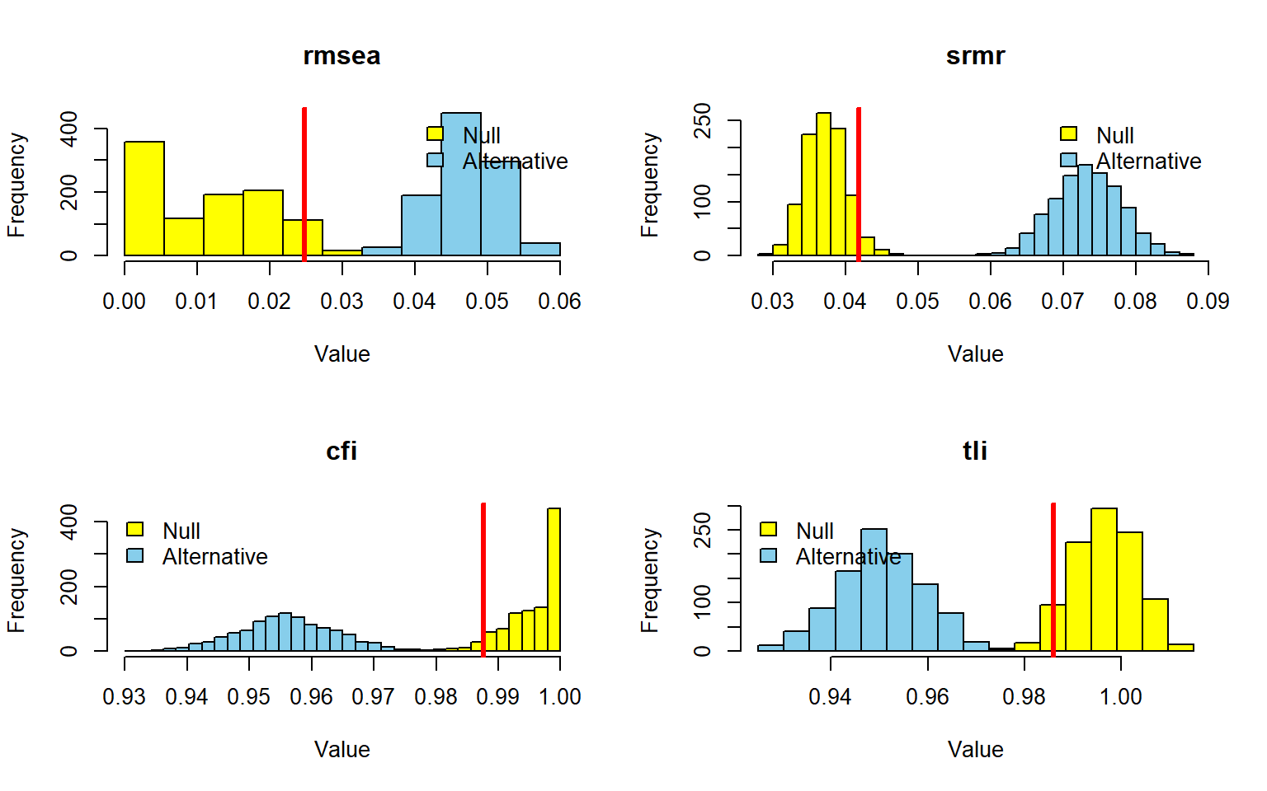
Figure 19: Power curves for fit indices with fixed sample size.
Source: Simulation with Fixed Sample Size
With $N=350$, the main analysis shows complete discrimination between the reference and misspecified conditions across the four global fit indices considered. Using empirical cutoffs derived from the simulated reference model, RMSEA, SRMR, CFI, and TLI all reached power equal to 1.000, indicating that this sample size separates the target model from the misspecified alternative with essentially perfect consistency in the ideal scenario.
The empirical cutoffs are also informative in their own right (Table 14). They indicate the level of fit that is typical of the correctly specified model under this design, and therefore define a data-driven benchmark for deciding when the misspecified model should be rejected. In the Figure 19, this appears as a clear separation between the null and alternative distributions, with the cutoff placed at a point that produces minimal overlap.
This pattern supports the use of $N=350$ as a conservative and stable design choice for the main comparison developed throughout the tutorial. At this stage, the aim is no longer to identify the minimum acceptable sample size, but to show that a fixed and defensible $N$ yields highly reliable rejection of the misspecified model when the data are generated from the population model.
Table 14: Power and fit index cutoff values with fixed sample size.
 | TRADITIONALCHI | RMSEA | SRMR | CFI | TLI
Power | 1.000 | 1.000 | 1.000 | 1.000 | 1.000
Cutoff | 0.025 | 0.042 | 0.988 | 0.986 | 0.025

Source: Simulation with Fixed Sample Size

6.3.1 Power analysis with traditional fits
The illustration based on traditional rule-of-thumb cutoffs leads to a very different picture. Under those generic thresholds, power remains very high for SRMR, but becomes weak for CFI and TLI and drops to zero for RMSEA (Figure 20). This contrast shows that conventional cutoffs may be poorly aligned with the sampling behavior of a specific model and can therefore understate the discriminating capacity revealed by the empirical simulation-based approach.
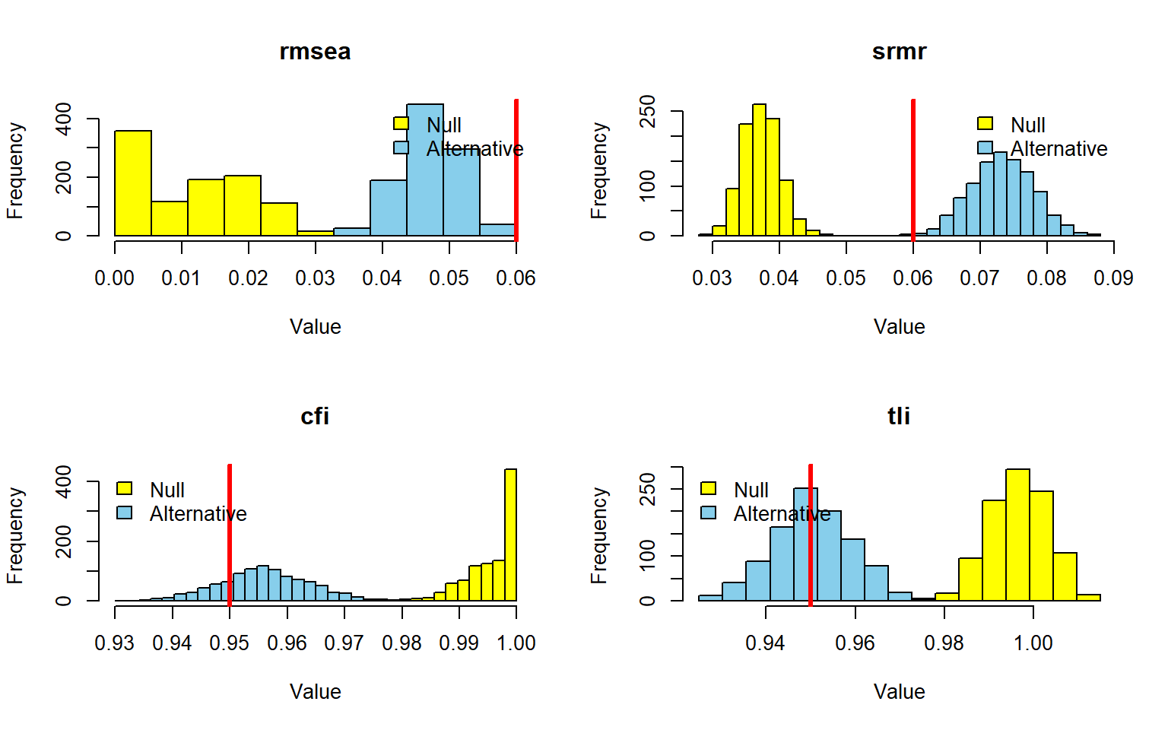
Figure 20: Power curves using traditional fit index cutoffs with fixed sample size.
Source: Simulation with Fixed Sample Size
Taken together, these results reinforce the main methodological message of this section: in Monte Carlo power analysis for CFA model fit, the adequacy of a fixed sample size depends not only on $N$ itself, but also on how the rejection criterion is defined. When cutoffs are calibrated to the population model and to the planned analysis, the chosen $N$ performs as a highly stable basis for global fit evaluation in the main comparison of the tutorial (Feng & Hancock, 2023; Jak et al., 2021; Moshagen & Bader, 2024; Pornprasertmanit et al., 2021).
Table 15: Power for traditional fit index cutoffs with fixed sample size.
 | CFI | TLI | RMSEA | SRMR
Power | 0.222 | 0.483 | 0 | 0.997

Source: Simulation with Fixed Sample Size

7 Post Hoc Power Analysis
Post hoc power analysis is used to evaluate how likely the study design was to reject a false structural model under the conditions actually assumed in the analysis, that is, with the fitted model, the reference model, the selected fit criteria, and the observed sample size already fixed. In SEM, this type of assessment is meaningful only with respect to a clearly defined focal hypothesis, because power is always attached to a specific model comparison rather than to a model in general (Jobst et al., 2023; Moshagen & Bader, 2024).
In this section, power is framed as the probability of identifying global misspecification, not as the probability of detecting an individual parameter. More specifically, the focus is on whether the hypothesized model can be rejected when the data-generating process follows an alternative structure, using fit-index thresholds derived from the null-model distribution at level $α$ (Jobst et al., 2023; Pornprasertmanit et al., 2021).

7.1 With Simulation
This simulation-based strategy is especially useful when the effect of interest is defined in model terms, because the discrepancy between $H_{0}$ and $H_{1}$ depends on the full parameterization of the model, not only on one isolated misspecification. In other words, the same nominal discrepancy may imply different statistical power depending on factor loadings, residual structure, latent correlations, and other features of the population model (Moshagen & Bader, 2024; Wang, 2023).
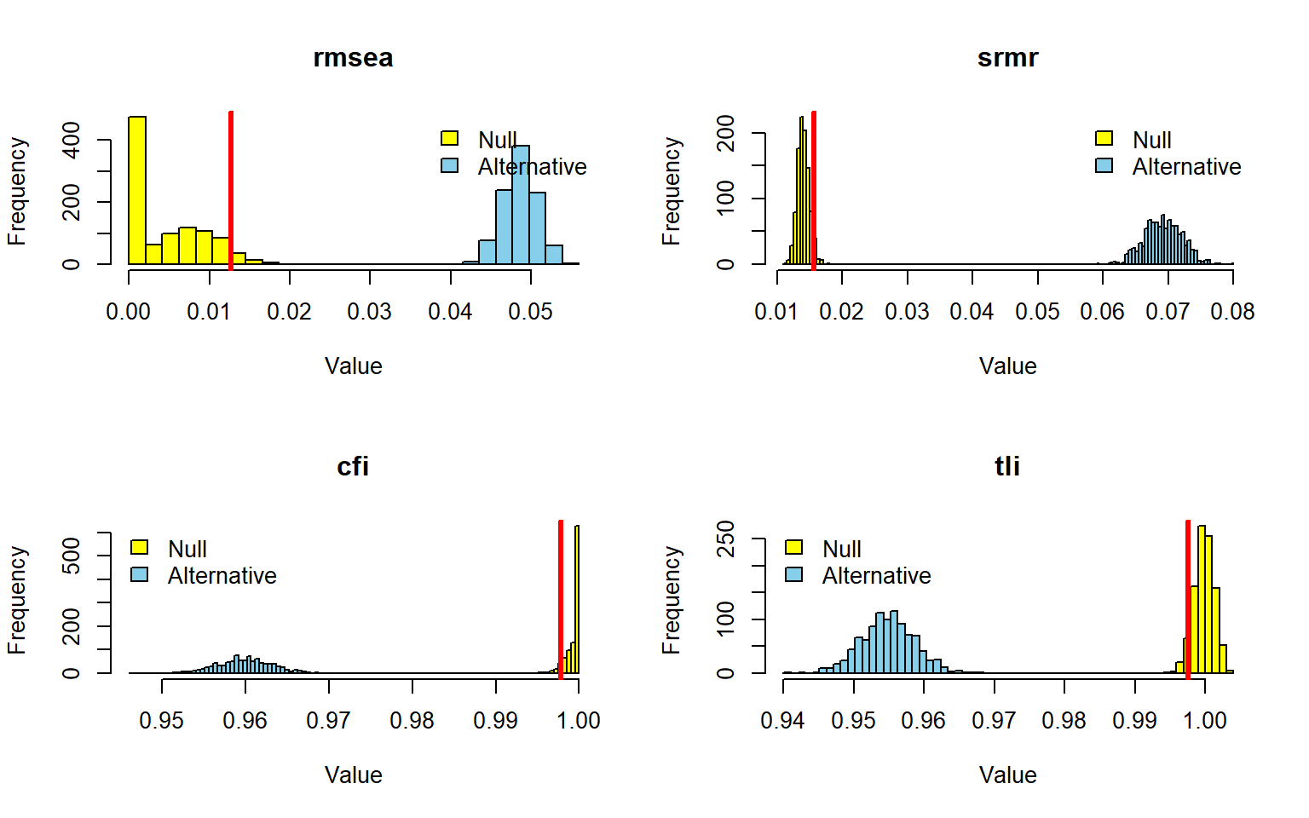
Figure 21: Power curve for post hoc analysis based on simulation.
Source: Post Hoc Power Analysis
All four fit indices reached power equal to $1.00$. This means that, in the simulated replications, RMSEA, SRMR, CFI, and TLI all rejected the alternative condition in $100\%$ of cases according to their respective cutoff rules.
The Figure 21 is fully consistent with these values. In every panel, the null and alternative distributions are clearly separated, and the red cutoff line falls between them with no visible overlap.
For RMSEA, the null distribution is concentrated near zero, whereas the alternative distribution is centered around approximately $0.05$. The cutoff is located between these two regions, so all alternative replications fall on the rejection side.
For SRMR, the null distribution is clustered around approximately $0.01$ to $0.02$, while the alternative distribution is concentrated around approximately $0.06$ to $0.08$. The separation is complete, which explains the power of $1.00$.
For CFI/TLI, the null distribution is concentrated very close to $1.00$, whereas the alternative distribution is centered around approximately $0.95$ to $0.97$. The cutoff line is placed between the two distributions, so every alternative replication is correctly classified.
Overall, the graphical pattern indicates perfect empirical discrimination for all four indices in this post hoc analysis. In practical terms, the results show no ambiguity in classification: the null and alternative conditions are entirely distinct for RMSEA, SRMR, CFI, and TLI. But note that RMSEA, CFI, and TLI are operating at the below the conventional threshold, which is a consequence of the specific cutoff values derived from the null-model distribution in this scenario.

7.2 With Analytical Solutions
In analytical power analysis, the effect is expressed through a noncentrality-based measure such as $F_{0}$ or RMSEA, because these quantities map directly onto the noncentrality parameter used in the likelihood-ratio test. For that reason, analytical post hoc power is especially convenient when the goal is to assess sensitivity to global model misfit without relying on simulation-based estimation (Jak et al., 2021; Moshagen & Bader, 2024).
The first specification (Figure 22) is model-free in the sense that the focal discrepancy is supplied directly as $RMSEA=0.05$, so power is evaluated for a global test of exact fit rather than for a specific substantive parameter. Conceptually, this treats misspecification as an overall degree of lack of fit per degree of freedom, which makes the analysis comparable across different SEM families as long as the same effect metric is used (Jak et al., 2021; Jobst et al., 2023; Moshagen & Bader, 2024).
semPower: Post hoc power analysis
F0 0.622500
RMSEA 0.050000
Mc 0.732531
GFI 0.950683
AGFI 0.940582
df 249
Num Observations 1047
NCP 651.1350
Critical Chi-Square 286.8077
Alpha 0.050000
Beta 4.771426e-48
Power (1 - Beta) > 0.9999
Implied Alpha/Beta Ratio 1.047905e+46
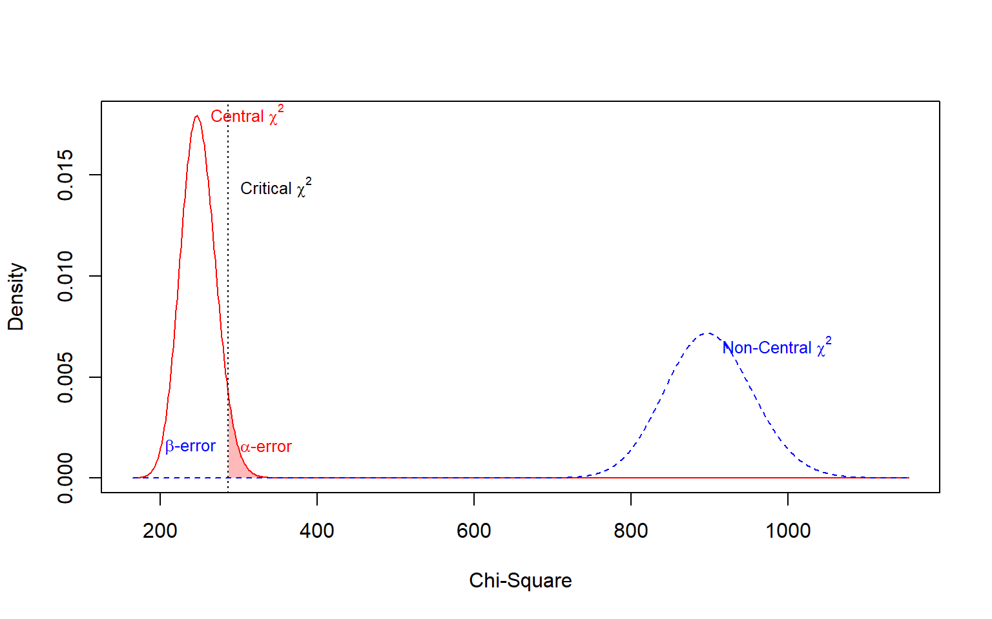
Figure 22: Post hoc power analysis for RMSEA = 0.05.
Source: Post Hoc Power Analysis
The Figure 22 shows an extremely high detection capacity for the tested discrepancy. With $F_{0}=$ 0.623, $RMSEA=$ 0.05, $df=$ 249, and $N=$ 1047, the noncentrality parameter reached $NCP=$ 651.135, while the critical value was only $χ_{crit}^{2}=$ 286.808.
As a result, power was effectively 1. In substantive terms, this means that, under this effect specification, the design was more than sufficient to detect the target misspecification.
The graph is fully consistent with this result. The noncentral $χ^{2}$ curve is located far to the right of the critical value, and the shaded $β$ region is essentially negligible, while the $α$ region remains fixed at $0.05$.
The model-based specifications (Figure 23) move one step closer to substantive hypotheses by deriving the effect from explicitly defined models. In this setup, the population model generates the covariance structure expected under the data-generating process, whereas the analysis model encodes the restrictions to be tested; the discrepancy between them is then translated into the population minimum of the fitting function and, from there, into analytical power (Jobst et al., 2023; Moshagen & Bader, 2024).
When only modelH0 is provided (Figure 23), the comparison is against the saturated model, so the power analysis concerns the ability to detect that the focal model does not reproduce the population moments exactly. This is a global hypothesis about overall fit, not a targeted test of one particular restriction, even though the model itself may embody many substantive assumptions (Jak et al., 2021; Moshagen & Bader, 2024).
semPower: Post hoc power analysis
F0 0.303870
RMSEA 0.034934
SRMR 0.175600
Mc 0.859044
GFI 0.975303
AGFI 0.970244
CFI 0.977582
df 249
Num Observations 1047
NCP 317.8482
Critical Chi-Square 286.8077
Alpha 0.050000
Beta 6.740368e-16
Power (1 - Beta) > 0.9999
Implied Alpha/Beta Ratio 7.417993e+13
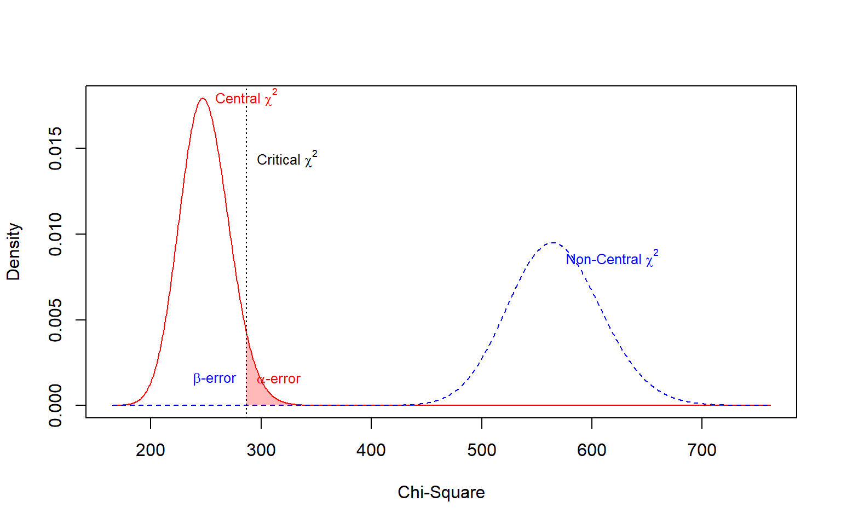
Figure 23: Post hoc power analysis for the real model.
Source: Post Hoc Power Analysis
The Figure 23 shows an extremely high detection capacity for the tested discrepancy. With $F_{0}=$ 0.304, $RMSEA=$ 0.035, $df=$ 249, and $N=$ 1047, the noncentrality parameter reached $NCP=$ 317.848, while the critical value was only $χ_{crit}^{2}=$ 286.808.
The graphical result shows the same pattern as in the previous case, although with less separation between the two distributions. Even so, the noncentral distribution still lies predominantly to the right of the cutoff, so the probability of failing to detect the effect is practically zero.
When both modelH0 and modelH1 are specified (Figure 24), the analysis becomes a nested-model comparison. In that case, power refers to the probability of detecting the additional restrictions imposed by $H_{0}$ relative to a less restrictive competitor, which is usually the conceptually preferable strategy when the research question concerns a particular constrained relation rather than the model as a whole (Jak et al., 2021; Jobst et al., 2023; Moshagen & Bader, 2024).
This distinction is important because the same sample size may imply very different power depending on the hypothesis under evaluation. A study can be adequately powered to detect overall misspecification against the saturated model and still be poorly powered for a more localized restriction, or the reverse, because power in SEM is always tied to the specific discrepancy being tested (Jobst et al., 2023; Moshagen & Bader, 2024; Wang, 2023).
semPower: Post hoc power analysis
F0 0.009082
RMSEA 0.055021
Mc 0.995469
df 3
Num Observations 1047
NCP 9.499715
Critical Chi-Square 7.814728
Alpha 0.050000
Beta 0.262955
Power (1 - Beta) 0.737045
Implied Alpha/Beta Ratio 0.190147
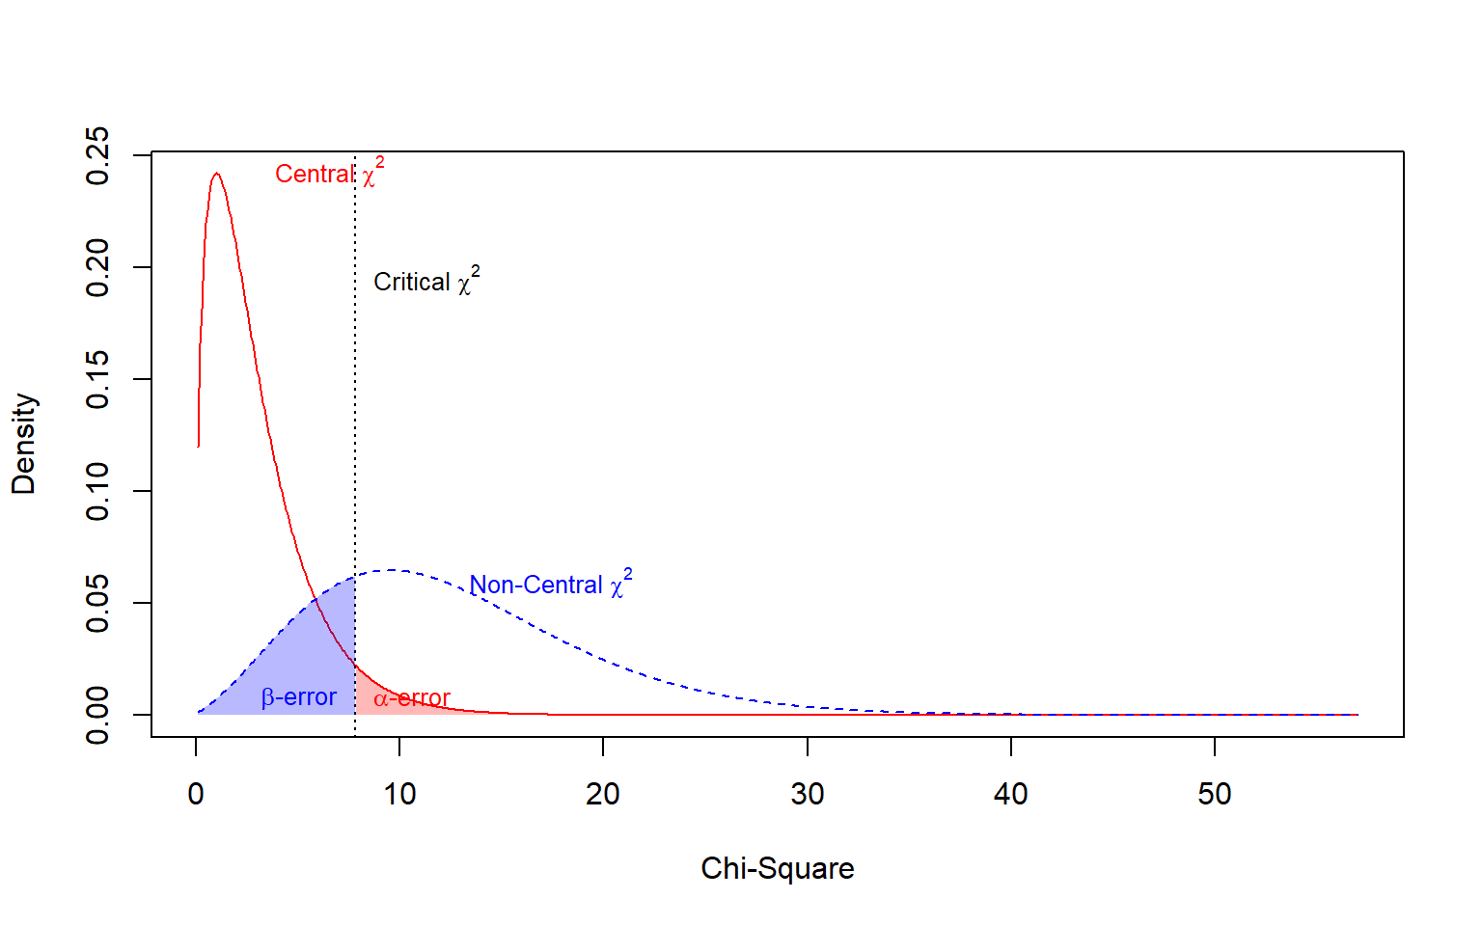
Figure 24: Post hoc power analysis for the misspecified model.
Source: Post Hoc Power Analysis
The Figure 24 yields a much more moderate result. Although the sample size was the same, the tested discrepancy was much smaller, with $F_{0}=$ 0.009, $RMSEA=$ 0.055 and only $df=$ 3, which led to a comparatively small $NCP=$ 9.5.
The critical value was $χ_{crit}^{2}=$ 7.815, and this time the overlap between the central and noncentral distributions was substantial. Accordingly, $β=$ 0.263 and power was 0.737, indicating that the analysis did not reach the conventional $0.80$ threshold.
The graph reflects this clearly. Unlike the first two plots, the noncentral curve is only moderately shifted to the right of the critical value, and the shaded $β$ area is visibly large, showing a nontrivial probability of not detecting the tested discrepancy.
More broadly, these chunks illustrate the two main analytical routes available in SEM post hoc power assessment: a model-free route based on a prespecified fit index value, and a model-based route in which the effect is induced by the discrepancy between population and analysis models. The latter is often more substantively interpretable, whereas the former is simpler and more general, especially when the main interest is sensitivity to a chosen level of global misfit (Jak et al., 2021; Moshagen & Bader, 2024).
Analytical post hoc power is typically preferred whenever its asymptotic assumptions are reasonable, because it is computationally immediate, free from Monte Carlo sampling error, and directly tied to the theoretical reference distributions of the SEM test statistic. Even so, its interpretation remains conditional on the chosen effect definition, the assumed fitting function, and the specific null-versus-alternative comparison encoded by the models (Jobst et al., 2023; Moshagen & Bader, 2024).

References
Feng, Y., & Hancock, G. R. (2023). Power Analysis within a Structural Equation Modeling Framework. In R. H. Hoyle (Ed.), Handbook of Structural Equation Modeling. The Guilford Press.
Jak, S., Jorgensen, T. D., Verdam, M. G. E., Oort, F. J., & Elffers, L. (2021). Analytical power calculations for structural equation modeling: A tutorial and Shiny app. Behavior Research Mehods, 53, 1385–1406. https://doi.org/10.3758/s13428-020-01479-0/Published
Jobst, L. J., Bader, M., & Moshagen, M. (2023). A tutorial on assessing statistical power and determining sample size for structural equation models. Psychological Methods, 28(1), 207–221. https://doi.org/10.1037/met0000423
Kyriazos, T. A. (2018). Applied Psychometrics: Sample Size and Sample Power Considerations in Factor Analysis (EFA, CFA) and SEM in General. Psychology, 09(08), 2207–2230. https://doi.org/10.4236/psych.2018.98126
Lin, L.-C., & Yao, G. (2022). Validation of the factor structure of the WHOQOL-BREF using meta-analysis of exploratory factor analysis and social network analysis. Psychological Assessment, 34(7), 660–670. https://doi.org/10.1037/pas0001122
MacCallum, R. C., Browne, M. W., & Sugawara, H. M. (1996). Power analysis and determination of sample size for covariance structure modeling. Psychological Methods, 1(2), 130–149. https://doi.org/10.1037/1082-989X.1.2.130
Moshagen, M., & Bader, M. (2024). semPower: General power analysis for structural equation models. Behavior Research Methods, 56(4), 2901–2922. https://doi.org/10.3758/s13428-023-02254-7
Mosqueira Taipe, C. M., Amador Campos, J. A., Krieger, V., Miasso, A. I., Molina, N. P. F. M., & dos Santos, P. L. (2026). Systematic review of the factor structure of WHOQOL-bref in adult population. Quality of Life Research, 35(17), 1–18. https://doi.org/10.1007/s11136-025-04115-6
Pornprasertmanit, S., Miller, P., Schoemann, A., & Jorgensen, T. D. (2021). Simsem: SIMulated Structural Equation Modeling. https://CRAN.R-project.org/package=simsem
Wang, Y. A. (2023). How to Conduct Power Analysis for Structural Equation Models: A Practical Primer [Preprint]. PsyArXiv. https://doi.org/10.31234/osf.io/4n3uk

